TRITORR Card BackOffice

User Training Guide

Contents:

How to use the TRITORR Card BackOffice user guide

Contacts

Key terms

Verification of Electronic Purchasing card Statement
1 Monthly electronic Purchasing card statement notification
2 TRITORR Card BackOffice Login (card holder)
3 Electronic Purchasing card statement verification
4 Amending the electronic Purchasing card statement
5 Confirmation of verified electronic Purchasing card statement

Approving of Electronic Purchasing card Statement
1 Verified electronic Purchasing Card statement notification
2 TRITORR Card BackOffice Login (approver)
3 Authorisation of the electronic Purchasing card statement
4 Amending the electronic Purchasing card statement
5 Confirmation of authorised electronic Purchasing card statement

Using the TRITORR Card BackOffice user guide

This user guide can be used as on-job-training. However, it is recommended that both Purchasing Card Holder and Approver read their relevant sections; in conjunction with viewing the TRITORR Card BackOffice windows, especially when viewing the TRITORR Card BackOffice electronic Purchasing card system for the first time.
The user guide should also be read in conjunction with the e-mail this user guide is attached to and any future published electronic up-dates.

Contacts
TRITORR Card BackOffice Administrator
Purchasing card Administrators
Contact the Accounts Payable Helpdesk - accountspayable@qmul.ac.uk
EXT 13-7527/ 7452

Key Terms
The following are a number of key terms that appear in this user guide. You should make yourself familiar with them before you progress to the guide.

Purchasing Card Approver
A person who has the authority to authorise the electronic Purchasing card statement.

- TRITORR Card BackOffice Administrators
The person who undertakes the process of administrating, sending and receiving electronic Purchasing card statements via e-mail and the web.

Purchase Card Holder
A person who was issued with the chargecard and has the authority to use the card for XXX’s purposes.

Purchasing Card Administrator
The company who has provided the Purchasing card to XXX
I.e. XXX

Confirmation
Evidence that the electronic purchasing card statement has been saved and approved and sent via e-mail to the next person in the procedure.

Electronic Purchasing card Statement
Statement which will replace the paper copy which is sent out on a monthly basis to each chargecard holder, providing purchases have been made.

Hyperlink
A hyperlink provides a shortcut to another screen. When you click on the hyperlink you go to the TRITORR Card BackOffice login screen.

Verifier
The person who has the responsibility to use the Purchasing card and is confirming the item lines and values of purchases made, before verifying and sending the statement to their Authorising Officer for authorisation.

Time frame
A period of time the Purchasing card Holder has to review and verify their electronic chargecard statement and the period of time given for the Authorising Officer to review and authorise the Chargecard Holders electronic statement.
- Verifier- five days form receiving email from the Purchasing Card Administrator.
- Approver– five days from receiving email from the verifier.

TRITORR Card BackOffice

The name of the electronic system used for sending, receiving and processing on-line electronic Purchasing card statements.

Verification of the Electronic Chargecard Statement

1 Notification of monthly electronic Purchasing statement

On a monthly basis the Purchasing Card Administrator will send out e-mails to all Purchase Card holders regarding their monthly Electronic Purchasing card Statement.
On receipt of the e-mail the Purchase card Holder is required to open the e-mail within the time frame as advised.
On opening the e-mail the Purchase card Holder will be asked to click on the attached Hyperlink, which will open up the Chargecard Holders Login Window.

2 TRITORR Card BackOffice Login

Chargecard Holder Login window

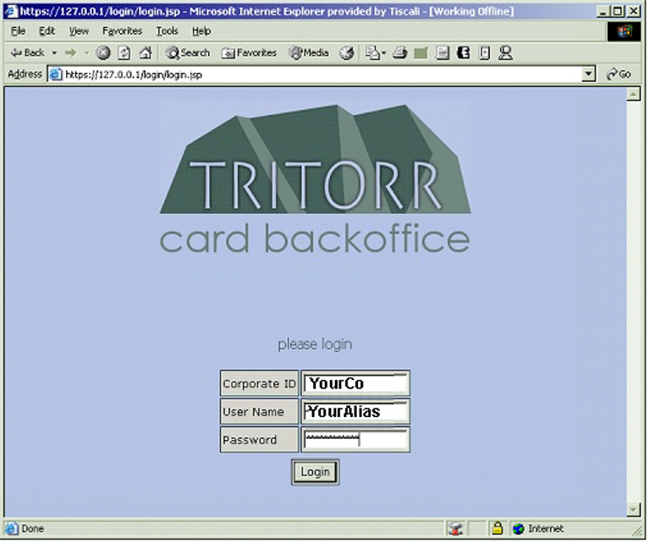

The Corporate ID and User Name will default into their respective fields.

2. Enter Password as provided in the accompanied e-mail into the Password field.

3. Click on the Login button or press Return. (↵)
The Statement Verification Window will open.

3 Electronic Purchasing card Statement Verification

Purchasing Card Statement Verification Window
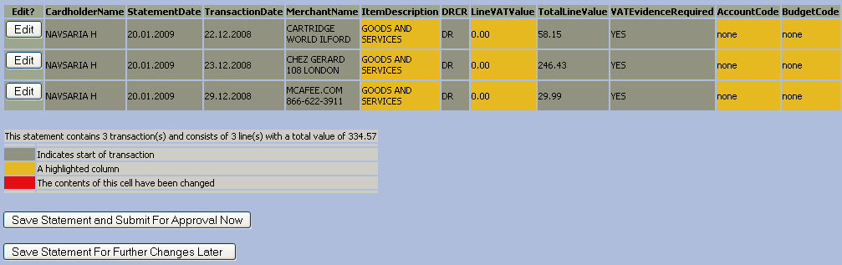

1. The Electronic Purchasing card Statement Verification Window will open and display the Electronic Statement Information Lines.

2. Review each Statement Information Line ensuring that all items and data are correct. This should be a mirror vision of you manual statement.

3. If all items and data are correct click on the Save Statement and Submit For Approval Now button and the statement will be verified, saved and submitted to the Approver for authorisation.

NB Purchase Card Holders have the option to save the electronic statement and carry out any amendments or investigations prior to submitting the electronic statement to the Approver for approval by clicking on the Save Statement For Further Changes Later button.

4 Amending Electronic Purchasing card Statement

1. On reviewing the electronic statement and finding the Item Description, Budget Code and/or GL Account Code are incorrect, click on to the Edit button and the Edit Window will open.
*NB Any other incorrect entries identified on the electronic statement must be reported directly to the supplier and/or the chargecard provider as previously actioned in the procedures.

Electronic Purchasing card Statement Edit Window

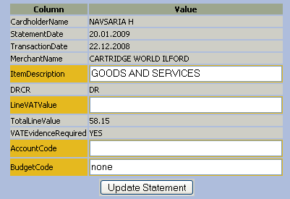

2. The following fields may be amended:
Item Description- (Please note that (GOODS AND SERVICES) is not acceptable).
Line VAT Value
GL Account Code
Budget Code

NB Please verify your statement and forward to your Approver within the given timeframe F. If you delay or incorrectly verify and charged to the wrong budget codein error . If this occurs it will be necessary for a manual journal to be completed by you or your Approver and submitted to General Ledger Dept Queens Building Mile End to correct the coding error.

3. Click into the field to be amended and overwrite the incorrect data with the correct; Item Description, Budget Code, Total Line Value and/or GL Account Code.

4. Once amendments have been completed click on the Update Statement button and you will be returned to the up-dated Statement Verification Window.

Up-dated Electronic Purcashing card Statement Verification Window

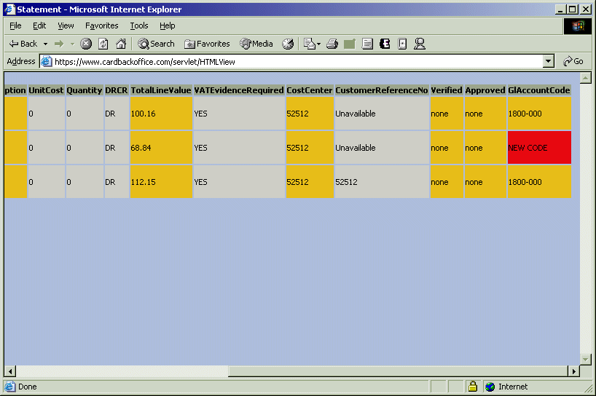

5. On returning to the Statement Verification Window any fields with amendments (Item Description, Total Line Value, Budget Code and GL Accounting Codes) will appear Red.

6. The electronic statement is ready to be Verified, Saved and Submitted to the Approver for authorisation. This is actioned by clicking on the Save Statement and Submit button.

NB If further changes or investigation is required click on the Save Statement For Further Changes Later button, this will allow amendments or verification to be actioned at a later date and/or time.

5 Confirmation of Verified Electronic Chargecard
Statement

Confirmation of Saved, Verified and Notification Window

1. Once the electronic statement has been Verified, Saved and Submitted to the Approver, the Confirmation Window will be displayed confirming the action carried out by stating; “your statement was saved and verified – the approver was notified”.

2. Close the TRITORR Card BackOffice window by clicking on the cross (Χ) in the top right-hand corner of the window and you will be returned to the e-mail from the Purchasing Card administrator which must also be closed.

Authorisation of the Purchase Card Holders Electronic Statement

1 Notification of the verified electronic Purchasing card statement
Once the Purchase Card Holder has verified their Electronic Purchasing Card Statement, the Card Approver will be notified by e-mail.
On receipt of the e-mail the Card Approver is required to open the e-mail within the time frame as advised.
On opening the e-mail the Card Approver will be asked to click on the attached Hyperlink and open up the Purchasing Approvers Login Window.

2 TRITORR Card BackOffice Login

Purchasing Card Approver Login Window
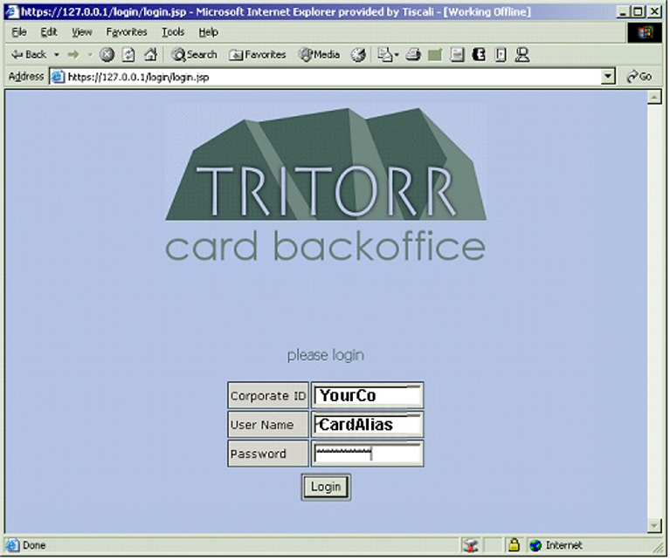

The Corporate ID and User Name will default into their respective fields.

Enter Password into the Password field as provided in the accompanied e-mail. Again if unsure of password please contact: Gemma Bowhill on Ext 13-3026 or Maria Borshchyk on Ext 13- 3619

Click on the Login button or press Return. (↵)

The Statement Approver Window will open.

3 Approving the Electronic Purchasing card Statement

Electronic Statement Authorisers Window

NB When reviewing the electronic statement any amendments which may have been made by the cardholder, will be identified by the amended fields being coloured Red.

The Statement Verification Window will open and display the Electronic Purchasing Card Statement Information Lines.
Review each Statement Information Line ensuring that all items and data are correct and making sure that Account and Budgets Codes are Active and valid.
If all items and data are correct click on to the Approve Now button and the statement will be saved and approved.
NB Approvers have the option to save the statement and carry out investigations and make amendments at a later date and/or time by clicking on the Approve Later button.

4 Amending the Electronic Purchasing Card Statement

On reviewing the electronic statement and finding the Item Description, Budget Code, Total line Value and/or GL Account Code are incorrect, click on to the Edit button and the Edit Window will open.

Electronic Chargecard Statement Edit Window

The following fields may be amended:
Item Description-(Please note that (GOODS AND SERVICES) is not acceptable).
Line VAT Value
GL Account Code
Budget Code
Once amendments have been completed click on the Update Statement button and return to the up-dated Purchasing Card Statement Authorisation Window.

Electronic Statement Approving Window

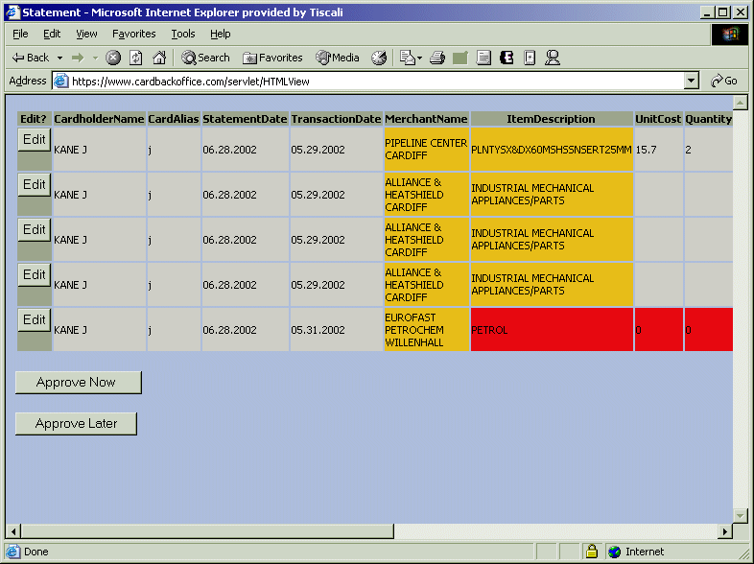

On returning to the Electronic Statement Authorisation Window, fields with amendments (Item Description, Budget Code, Total Line Value and/or GL Accounting Codes) will appear Red.

The up-dated electronic statement is ready to be Authorised and Saved. This is actioned by clicking on the Approve Now button.

NB If further changes or investigation is required click on the Approve Later button, this will allow amendments and/or authorisation to be actioned at a later date and/or time.

5 Confirmation of Authorised Electronic Purchasing Card
Statement

Authorisers Confirmation Window

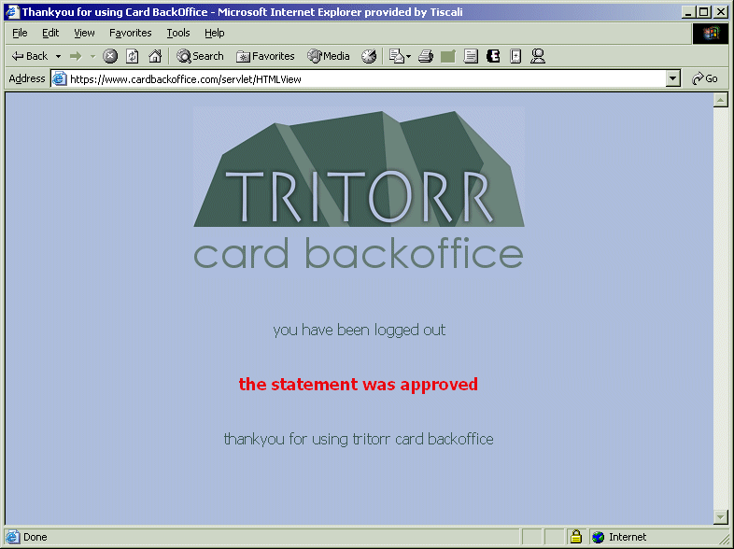

Once the Approve Now button has been clicked the electronic statement is Authorised and will be evidenced by the statement on the window stating “statement was approved”.

Close the TRITORR Card BackOffice window by clicking on the cross (Χ) in the top right-hand corner of the window and you will be returned to the e-mail from the chargecard holder which must also be closed.

