What is changing?
From 6 April 2010, doctors will issue “Fit Notes” instead of “Sick Notes” (also known as “GP’s certificates”). The fit note offers two main options; it will say either that the patient is ‘not fit for work’ or that they ‘MAY be fit for work’. For those who “may be fit for work” the doctor can suggest ways the employee can be supported to enable a return to work. There are tick boxes on the form to cover such options as phased return, altered hours, amended duties or adaptations to the workplace. There is space for the GP to comment on their assessment. A sample form is on page 3.

What difference will it make to you?
For most staff absence, nothing will change. Since a “fit note” is normally only required for absences greater than 7 days, current arrangements to self-certify for the first 7 days absence will carry on as before.

The main changes are:
The “fit for work” option has been removed from the form.
This means that the employee is no longer required, after extended illness, to show that they are fit to return to work. If the doctor certifies that the employee is not fit for work, there is a space on the form for them to state the period for which the employee will be unfit and whether or not the doctor needs to see them again. If no subsequent “fit note” is supplied by the doctor, you should assume that the employee is fit for work.

The “may be fit for work” option has been added to the form.
In essence, a “may be fit for work” fit note means that the doctor’s view is that the employee is not fit for a full return to work, but that with some adjustments they might be able to return. The fit note will include the doctor’s advice on what would make a return to work possible. For example, an individual may be able to complete some but not all of their normal duties; or they might benefit from amended working hours. You will need to discuss with the employee whether a return to work is possible. This should be done as soon as is practicable after the note is received. The employee has a duty to contact the College at the earliest opportunity. If, after discussion, you consider that making the suggested changes is not ‘workable’ then the employee should be treated as if they are ‘not fit for work’.

Line managers will need to assess each “may be fit to work” case on an individual basis, seeking advice from your sectoral HR Consultant/HR Advisor. A number of examples (reproduced from the guide for employers published by the Department for Work and Pensions) are given on pages 3 and 4.

Other points of note
The diagram overleaf sets out roles and responsibilities and is intended to help everybody concerned navigate through the decision making process. However, it is worth bearing the following points in mind as you navigate through it:
- Even if the fit note sets a period of time during which the advice should apply, if there is mutual agreement between the line manager and the individual, the employee may be able to return either to work or to normal duties before the end of the period without needing another medical statement.
- If the “fit note” recommends an Occupational Health assessment, line managers should consider whether this is appropriate (seeking advice as necessary). They are normally best placed to assess the practicalities of the case because they have a greater knowledge and understanding of the demands of the role. However, further specialist advice (through Occupational Health or HR) should always be considered for more complex and work-related conditions.
What to do if the doctor has ticked the box indicating ‘may be fit for work taking account of the following advice’

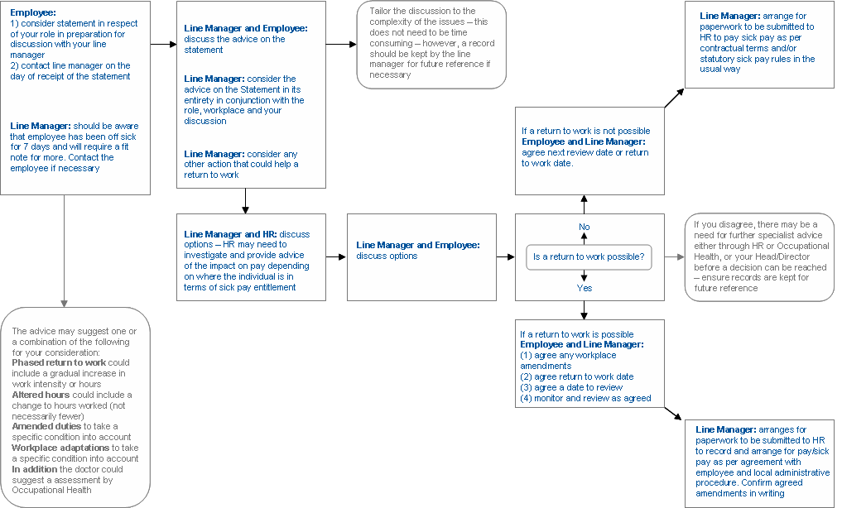

Sample form and case study examples
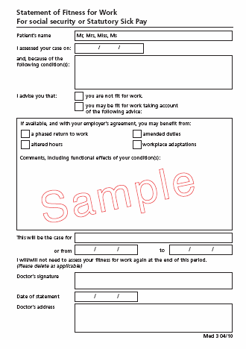

Example 1: Alison is a 35 year old contact centre worker. Her job requires taking customer calls. She has been off work for six weeks with mechanical back pain and this is her third episode in the past 12 months.

She goes to her GP for a new Statement and during the consultation they discuss her condition and the circumstances relating to returning to work. Her GP advises that she ‘may be fit for work taking account of the following advice’:
- Comments, including functional effects of your condition(s):
- referred for physiotherapy – may need time off to attend;
- need to avoid static postures by taking more frequent breaks and be able to sit/stand when needs to;
- review workstation; and
- consider a referral for occupational health advice.
- Ticked ‘a phased return to work’, ‘amended duties’ and ‘workplace adaptations’.
- This will be the case for eight weeks.
- I will need to assess your fitness for work at the end of this period.

Alison takes the latest Statement to her manager and they discuss the advice on the Statement and how her health condition affects her ability to do her usual job. They agree a phased return to work with more frequent breaks during her shifts. Alison returns to work immediately and after four weeks is back to her normal hours. Her manager has also organised for an occupational health assessment to identify any action that may help prevent future episodes.

Example 2: Kareena is 52 and works in a department store. She has chronic anxiety and has been off work for three weeks. Her job involves working on the customer complaints desk as well as general shop floor duties such as stocking shelves and working on the till.  She visits her GP for a new Statement and they discuss whether she can return to work. She would like to return but has concerns about coping with customer complaints that accounts for about a quarter of her duties. Her GP advises that she ‘may be fit for work taking account of the following advice’:  - Comments, including functional effects of your condition(s):  - phased return to work;  - avoid customer-facing duties; and  - consider creating a support network at work.  - Ticked ‘a phased return to work’, ‘amended duties’.  - This will be the case for three weeks.  - I will need to assess your fitness for work at the end of this period.  Kareena takes the Statement to her employer and they discuss the advice. They agree that Kareena should return to work on a phased return to non-complaints, non-customer facing duties before gradually returning to the complaints desk for shorter then longer periods. An experienced member of the team is nominated as a ‘buddy’ to support her and advise on techniques to deal with handling difficult customer issues. Kareena returns to work immediately and after three weeks returns to her normal duties. |  | Example 3: Dave is 30 years old and works in a warehouse of a small building merchant. His job requires lifting. He hurt his dominant (right) shoulder through sport two weeks ago and has been off work since.  He goes to see his GP, is referred for specialist opinion and is given a new Statement. His GP advises that he ‘may be fit for work taking account of the following advice’:  - Comments, including functional effects of your condition(s):  - avoid lifting or working above shoulder height.  - Ticked ‘amended duties’.  - This will be the case for six weeks.  - I will need to assess your fitness for work at the end of this period.  Dave takes the Statement to his manager and they discuss which parts of his job are affected by his injury. Dave’s normal duties involve the activities that the GP advised to avoid on the Statement. The manager investigates if there are any other suitable duties that Dave could do whilst he recovers, however there are currently none. As Dave’s employer cannot offer any appropriate work Dave remains off work. Dave and his employer use the Statement as if the GP had advised ‘not fit for work’, Dave does not return to his GP for a new Statement. While Dave is off work, he and his manager keep in regular contact to identify the point at which a (phased) return to work could begin. Dave returns to his GP at the end of the Statement period.

