Certification Scope:
The provision of managed information systems to Queen Mary University, London, by the IT Services department, in accordance with the Statement of Applicability version 1.0

Scope Diagram:
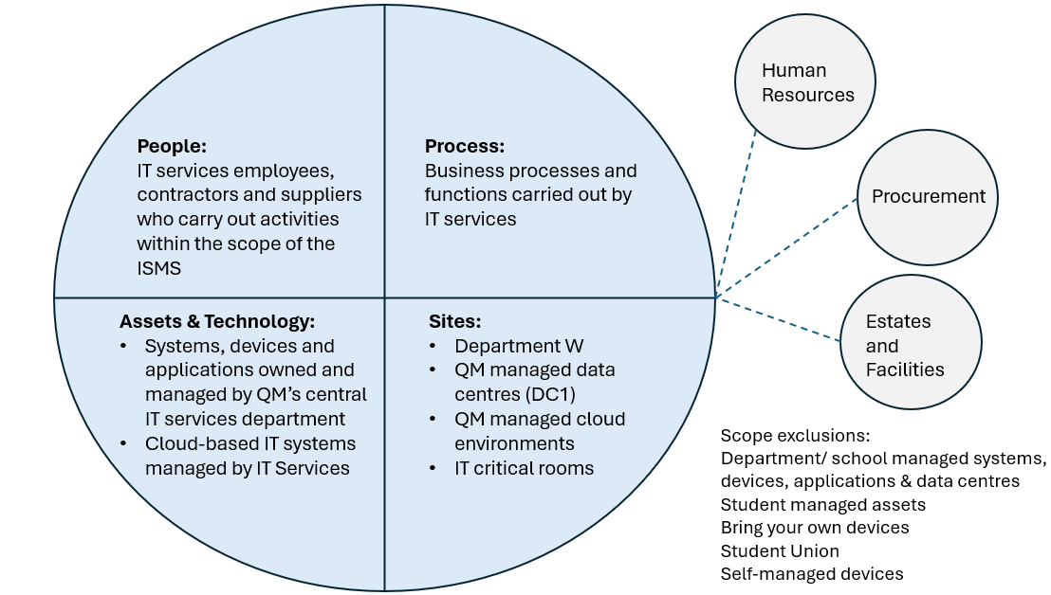

Scope Use Cases:
System Developer
As a System Developer employed within ITS, my role is to carry out modifications and enhancements to the Student Records System (SITS) using an ITS-managed laptop within Department W. For my role, the ISMS will mean I need to understand and adhere to the following policies:
- ISMS information security policy
- Information security incident management and reporting
- Configuration and change management
- Third party assessment and management
- Information classification
- Data retention
- Information transfer
- Access control
- Secure development lifecycle
- Acceptable use policy

Supplier Manager
As a Supplier Manager employed within ITS, my role is to assess and procure ITS-related services. I use an ITS-managed laptop within Department W. For my role, the ISMS will mean I need to understand and adhere to the following policies:
- ISMS information security policy
- Information security incident management and reporting
- Third party assessment and management
- Information classification
- Data retention
- Information transfer
- Acceptable use policy

HR specialist
As a HR specialist employed by the University but not specifically ITS, my role is to onboard and support members of staff as well as to handle leavers. I use an ITS-managed laptop within Department W. If the member of staff belongs to ITS, then I need to understand and adhere to the following policies:
- Acceptable use
- Joiners, movers and leavers
I also need to adhere to the memorandum of understanding between ITS and HR.

Project manager
As a project manager employed within ITS, my role is to lead internal ITS projects of various sorts. I use an ITS-managed laptop within Department W. For my role, the ISMS will mean I need to understand and adhere to the following policies:
- ISMS information security policy
- Information security incident management and reporting
- Configuration and change management
- Third party assessment and management
- Information classification
- Data retention
- Information transfer
- Acceptable use policy

Receptionist
As a receptionist employed within ITS, my role is to manage the reception desk in Department W. For my role, the ISMS will mean I need to understand and adhere to the following policies:
- ISMS information security policy
- Information security incident management and reporting
- Information classification
- Information transfer
- Physical and environmental security
- Acceptable use policy

