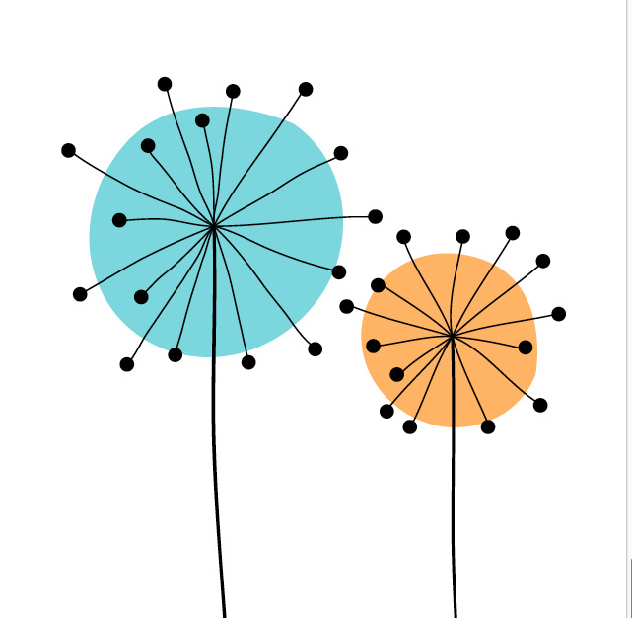SEED Award Reviewer Feedback

Applicant:

Reviewer:

The SEED award enables students to be recognised for the crucial role they contribute to the work of educators, the enhancement of pedagogy and the curriculum, as well as the development of student-educator partnerships. We wish to provide a robust and transparent approach to both application and feedback – we are here to support, facilitate, and aim to award.

Evaluator Opinion: record either Criteria Met, Criteria Not Yet Met, or Criteria Not Met Please check Appendix 1 for more information about the criteria

Criteria | Criteria Met | Criteria Not Yet Met | Criteria Not Met
Contribution including recommendations
Co-creation
Reflective
Impact
Supported and endorsed
Feedback comments:
Please provide feedback to the applicant, noting the strengths of the application and any areas that could be improved. If recommending improvements please be as clear and specific as possible, as this feedback may be sent to the applicant. Feedback should be factual and related to the criteria stated above. This can be displayed through bullet points in order to allow for easy relaying to the applicant.

Please record your overall decision (subject to discussion at the panel):

Award ☐ Award with revisions ☐ Refer ☐
Please tick the box if this application should be considered for the SEED prize - student ☐ (check Appendix II for criteria)
Please tick the box if this application should be considered for the SEED prize - educator ☐ (check Appendix II for criteria)

Appendix 1: Criteria to be considered when reviewing the applications

Criteria | Criteria Met | Criteria Not Yet Met | Criteria Not Met
Contribution including recommendations | The student has written a statement which explicitly reflects upon their contribution to an educational development activity and has clear recommendations. | The student describes an educational activity but their contribution is unclear and/or their recommendations are not clear. | The student has not demonstrated their contribution or there are no recommendations.  Or the contribution outlined in the application does not relate to the SEED Award
Co-creation | The student demonstrates engagement with others and co-creation in the activity. | The application outlines an appropriate example but their role in co-creation is not discussed or is unclear. | The student has not made links between the activity and the ability to co-create with others.
Reflective | The student’s contribution is integrated into a reflective, critically considered argument, using experiences as evidence. | The student demonstrates limited reflection on the experience, or provides limited experiences as evidence. | The student does not provide reflective account of their experiences or there are no experiences used to evidence the claim.
Impact | The student has evidenced a clear and verifiable impact. | The student has evidenced only association with the activity and/or evidences no verifiable impact. | The student does not demonstrate or evidence impact.
Supported and endorsed | The application supports a clear and endorsed claim as to how the student’s engagement and contribution in the activities has led to impact. | There is insufficient endorsement of the experience outlined and the impact claimed in the application. | There is no endorsement of the experience outlined and/or the impact claimed in the application.

Appendix II: Criteria to be considered when nominating applications for the SEED prizes

SEED Prize - students
This prize recognises the best reflective applications on:
(1) the experience of co-creation
(2) the impact of the project on the student co-creator
(3) contribution of the student work to the enhancement of teaching and learning across Queen Mary.

SEED prize - educators
This prize recognises:
(1) the extent to which the educator has engaged co-creatively with the student
(2) the extent to which the co-creative activities have led to impact

