*Date updated: 2 July 2024*

**Course title**

Finance Year-End Training (for Budget Holders and Finance Support Roles)

*Student Experience*

**Course objectives**

* Provide an overview of QM Finance Year-End and related tasks
* Explain the Year-End memo published by the QM Financial Accounting team
* Explain how to use Agresso to extract key information to support decision-making
* Explain accounting for goods or services in the period received (accruals)

**Format**

This course is delivered in 1 hour using real examples on-screen and suggesting activities for attendees e.g. running transaction reports from last year to identify invoice payments & accruals across financial years.

**Pre-requisites**

* Have access to Agresso - <https://agresso-web.qmul.ac.uk/BusinessWorld>
* *Awareness of any grant funded budgets (or research grants) which can carry across financial years without necessarily being ‘reset’ at the end of July*

Supporting information and guidance is available at:

<https://www.qmul.ac.uk/student-experience/intranet/finance--procurement/guidance/>

**Course topics**

1. Overview of the QM Year-End Process (15 mins)
2. Planning ahead to reduce work required at Finance Year-End (15 mins)
3. Automatic Accruals and Manual Accruals (15 mins)
4. Before and After – using Agresso to extract information (15 mins)

**Summary of key actions**

* Budget holders and requisitioners to maintain regular dialogue to coordinate required actions
* Regularly review open PO’s and ensure they are correctly goods receipted – [refer to the goods receipting user guide](https://www.qmul.ac.uk/finance/intranet/agresso/media/agresso/systems-training/195139.pdf).
* Contact Accounts Payable to help resolve any non-payment, purchase card or expense claim issues:

<https://www.qmul.ac.uk/finance/intranet/sections/accounts-payable/contacts/>

* Check the Agresso General Ledger Transactions web report for a complete picture of current activity including missing items.
* Contact suppliers if invoices remain unpaid, particularly under £500 net, which requires manual accrual.
* Consider any internal transfers due (in and out) and contact QM departments to action, if necessary.

**Course Tutor**

Hassan Mahmud

Directorate Administrative Officer (Operations and Improvement Team)

Student Experience

1. **Overview of the QM Year-End Process (15 mins)**

* 1. The Director agrees an annual Student Experience Directorate budget which budget holders work towards delivering for their own areas. This includes salary savings and additional cost savings or overspend (agreed in-year) captured in the forecast column which is referenced when anticipating your final year-end position (pay + non-pay MINUS income).
  2. Budget holders are asked to provide regular budget commentaries to help track progress throughout the financial year which should reduce the amount of investigative work required at year-end.
  3. General advice and guidance on the year-end process is provided by our Finance Partner, Nanda Beeharry, who can be contacted by Teams message or [n.beeharry@qmul.ac.uk](mailto:n.beeharry@qmul.ac.uk).
  4. The process starts in late May when a **memo with deadlines** is sent to all Agresso users – click below to open the 2023/24 memo and procedures – please read them carefully & raise any queries as soon as possible. If you are taking leave during July or early August, **please delegate your financial tasks to someone able to complete them in your absence** preceded by a detailed handover of duties.



NB: Purchase card holders should submit their monthly statement for July (and any other outstanding) in Agresso by 7th August 2024.

* 1. The memo and procedures documents provide key information for budget holders and finance support role. Some processes are outside of Agresso and the budget holder/finance support role should identify if any of the following are outstanding:
* Internal expenditure on Porterage, QM Catering, Copy Shop & IT Services etc.
* Internal recharges for other items between QM departments (in and out)
* HR one-off payments and Student Ambassador payments for work in July (missing the previous month-end deadline)
* Income generation (invoicing external organisations) or donations received in advance
* Payment of paper expense claims for externals or students (travel, accommodation etc.)
  1. The memo mentions Accruals several times which can be defined as adjustments for:

*1) Expenditure that have been incurred but are not yet recorded in the accounts, and*

*2) Revenues that have been earned but are not yet recorded in the accounts*

with related entries inputted so that financial statements report these amounts e.g. for a pending invoice.

*For example, your annual budget for home decorating is £1,000 and you have your fence repainted for £200 on 30 December which uses up the remaining budget. But the worker isn’t paid until January – does the cost apply to the following year’s decorating budget?*

QM financial regulations explain that pre-payments for goods or services are to be avoided – we pay for them in the financial year they were delivered. Please **don’t** goods receipt PO’s to pay in advance for the next financial year as payments can be adjusted by Finance into the correct accounting period.

Subscriptions above £5,000 net are charged to your budget across the full subscription period even if this falls across two different financial years i.e. January to January, where 5/12 and 7/12 are charged.

1. **Planning ahead to reduce the work required at Finance Year-End (15 mins)**
   1. Budget holders to regularly check that commitments turn into actual expenditure when reviewing their monthly report which includes total spend that month and total spend year-to-date compared to the full year budget. Monthly variances will be highlighted in green for underspend and red for overspend – remember to refer to the forecast column if an over/underspend is agreed and captured in-year.
   2. The period report is summarised by cost centre (containing budget codes) and **monthly** accruals (above £500 net) contribute towards the total – once the finance support role goods receipts an Agresso PO any amount above £500 net (per PO line) will be accrued each month until the actual invoice(s) are paid:

***Period 7 February*** - Accrue PO - 9473667, Feb 24 reversing Mar 24, CORE - Coaching by Darth Vader for Administrator @ £505 + VAT per session. ***£505 *ACCRUED ONCE GOODS RECEIPTED***

***Period 8 March*** - Reversing 481544 - Accrue PO - 9473667, Feb 24 reversing Mar 24, CORE - Coaching by Darth Vader for Administrator @ £505 + VAT per session. ***(£505) *ACCRUED MONEY RECEIVED INTO FOLLOWING PERIOD READY TO PAY INVOICE***

***Period 8 March*** - Accrue PO - 9473667, Mar 24 reversing Apr 24, CORE - Coaching by Darth Vader for Administrator @ £505 + VAT per session. ***£505 *INVOICE NOT PAID SO ACCRUAL PROCESS REPEATED***

***Period 9 April*** - Reversing 481544 - Accrue PO - 9473667, Mar 24 reversing Apr 24, CORE - Coaching by Darth Vader for Administrator @ £505 + VAT per session. ***(£505) *ACCRUED MONEY RECEIVED INTO FOLLOWING PERIOD READY TO PAY INVOICE***

In period 7 (February) a positive number was accrued into period 8 (March) using a negative number (reversal). Therefore in period 8 (March) and onwards both transactions cancel each other out - either by another accrual OR the invoice being paid.

In period 7 (February) this accrual contributed towards £505 + vat of actual expenditure in the budget report after being goods receipted but the invoice remains unpaid.

* 1. Regularly review the Agresso General Ledger Transactions Web Report to check commitments have been charged by invoice or other means in a timely manner. Alternatively, the ‘AP has an invoice been paid’ report shows payment information about specific POs without displaying accrual or other related information.
  2. ***Good practice includes****:*

1. Ensuring PO’s are goods receipted correctly and on time

2. Reminding suppliers to email invoices to [apinvoices@qmul.ac.uk](mailto:apinvoices@qmul.ac.uk) quoting the correct PO number

3. Pro-actively contacting suppliers about late invoices

4. Asking Accounts Payable to find out if any pending tasks (e.g. missing good receipt) are creating delays in the invoice being paid

Following this guidance will reduce the risk of invoices from earlier periods unnecessarily entering the Year-End process and creating additional finance work.

* 1. Always raise PO’s for goods and services in advance of them being delivered – you cannot accrue for a late invoice if there is no associated PO. This can happen when an invoice has turned up six months late into the next financial year (because no one was tracking the payment) & a new PO is required, thus the cost is allocated to the wrong financial year resulting in (avoidable) budget loss.
  2. PO’s for goods & services for the next financial year *can still be raised* in July but should NOT be goods receipted until 1st August onwards, unless there is a requirement to pay early – in this case include the date of delivery in the PO description so that Finance can move the cost into the following financial year.

1. **Automatic Accruals and Manual Accruals (15 mins)**
   1. The first step in determining what accruals are required is for budget holders and requisitioners to review their list of open PO’s which is circulated in an Excel sheet towards the start of June and shows receipt status and payment totals against raised PO’s. If all payments against a PO have been made, email the PO number to [servicedesk@qmul.ac.uk](mailto:servicedesk@qmul.ac.uk) requesting closure by the end of June.
   2. **Automatic accruals** are charged to the current financial year (2023/24) when the following conditions have been met:

* The PO was raised between P1 and P12 (current financial year)
* The PO has been goods receipted by 5pm on Wednesday 31 July 2024
* The PO or outstanding invoice value is **above** £500 net(per PO line item OR remaining amount to be invoiced)
* The invoice has **not** been paid
* If the amount accrued is above £2,500 net, please have ready on file evidence of delivery if requested by auditors

Info: Partial accruals can be made if you have received part of the goods or services, say 25% in 2023/24, by goods receipting the appropriate quantity in Agresso.

* 1. **Manual accruals** are generally required when any of the following apply:
* If the PO was originally raised in the 2022/23 financial year (question why is it still open?)
* The PO or outstanding invoice value is **under** £500 net(per PO line item OR remaining amount to be invoiced)
* Payment is outside of Agresso (HR One-Off payment, Student Ambassador payment, Paper expense claim for students or externals etc.)
* If the PO was **not** goods receipted in Agresso by 5pm on Wednesday 31 July 2024 despite the goods or services being delivered

***NB: Generally values below £500 NET are classified as immaterial in terms of their impact on the bottom line, but manual accruals can be requested providing evidence of delivery e.g. delivery note.***

The deadline for submitting manual accruals is 6th August 2024 where you have a short period of time (starting 1st August) to determine the current state of play – please do not rush this process and feel free to ask for a sense check of your draft return before submitting it.

First check Agresso to confirm the payment status is still outstanding on the 1st August. If yes, the template below (click icon to open) is used to provide a summary of the manual accruals required:



1. **Before and After – using Agresso to extract information (15 mins)**
   1. The ‘**Outstanding Purchase Orders**’ report shows all active PO’s raised against your cost centre - delete the default COSTC & BUDCODE text and enter your cost centre number and press the Search button.
   2. Check whether they are still required or can be closed because they relate to orders that were cancelled, where the PO was duplicated, or where the cost ended up being less than the original PO value.
   3. Information presented includes the goods receipted status of the PO (ordered, delivered) and on the furthest right column (to invoice) how much is to be invoiced against the original net PO amount. The screenshot below provides an example of the report:

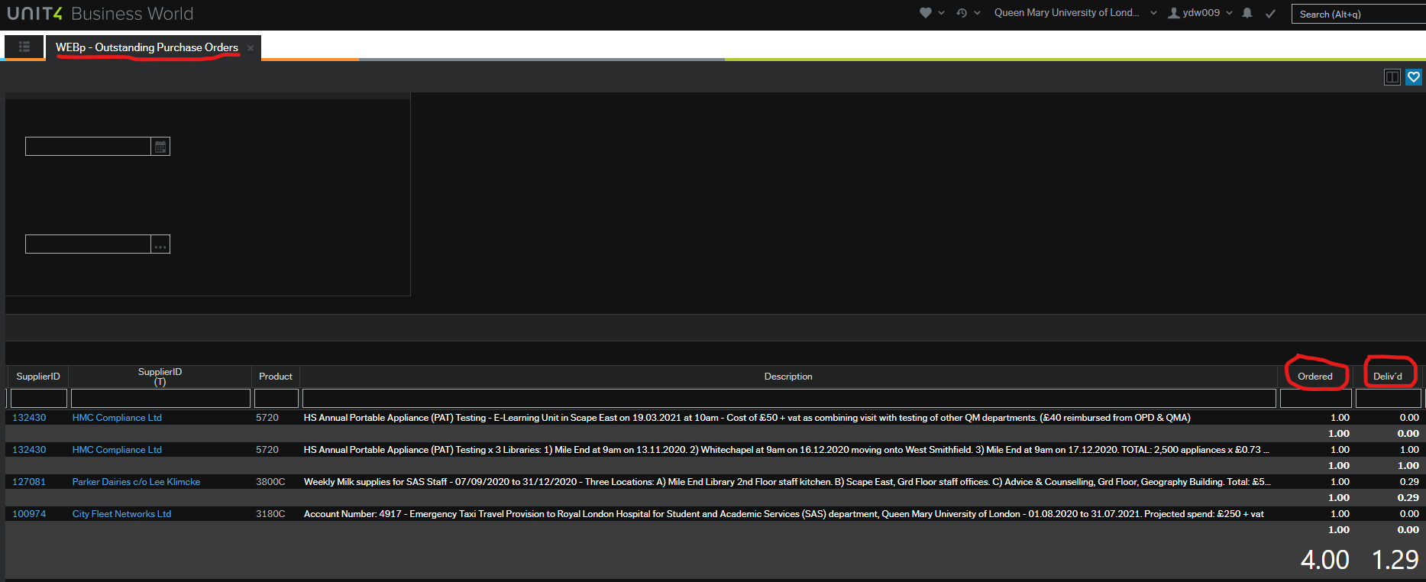

* 1. Check that all valid outstanding PO’s have been goods receipted correctly to confirm that goods/services were delivered by 31st July. If there are any discrepancies (Ordered compared to Delivered) please goods receipt them in the usual way & re-run this report to check the numbers were updated.
  2. Amounts which have been goods receipted but not invoiced/paid can be calculated using the Outstanding PO report: ‘*Amount delivered’ less ‘net amount paid’ (all figures exclude VAT).*
  3. The ‘**General Ledger Transactions**’ report shows whether outstanding invoices and other payments were made towards the end of July or start of August. Enter the cost centre or budget code & select the periods to review (P11, P12 etc.) then press the Search button.

See the screenshot below for an example:

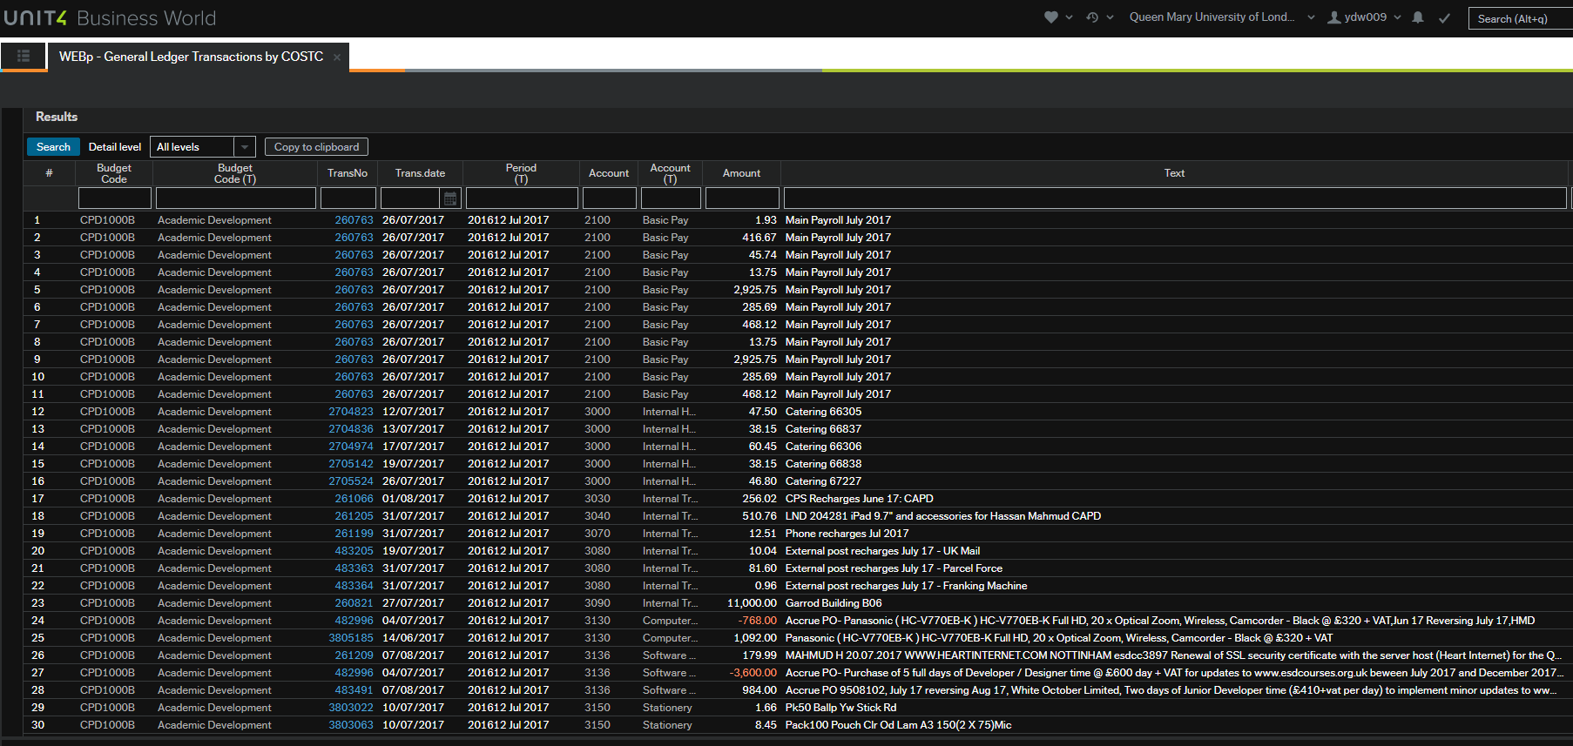

*NB: Clicking the transaction number (for Agresso PO’s) will open a copy of the paid invoice for information. Press the Export button to take the report data into Excel where it can be sorted etc.*

* 1. To identify real invoice payments from accruals, check if there is an invoice number in the relevant column for the transaction. If present, this confirms the invoice has been paid. Note that accrual transactions will not contain an invoice number.
  2. Barclaycard transactions can be identified by the name of the card holder submitting the expense being listed in the ‘Supplier (T)’ field of the report.
  3. The ‘**AP Has an invoice been paid’** report can help determine if an invoice is on the Accounts Payable system to be paid. Enter the related PO number to run this report.

* 1. Delete the default entry in the SuppID text box & press the Search button to run the report.
  2. The screenshot below shows that due invoices display a negative amount in ‘Amount Outstanding’ – clicking the transaction number will let you view and download invoice copies.
  3. Zero amount outstanding means the invoice is paid.

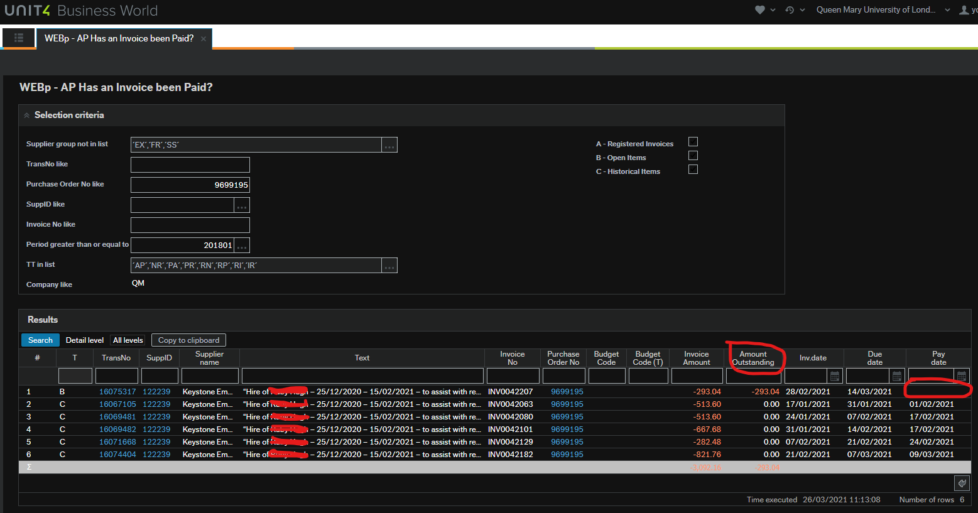

* 1. If an invoice doesn’t show up at all, this means it has not yet been processed by Accounts Payable and is likely to be part of the Year-End accrual process.
  2. Throughout the finance year, please remind Agresso requisitioners to be descriptive when entering purchase descriptions by including dates and product information using the first example below as good practice:
* *Star Wars Development conference place for Hans Solo – Date: 14.01.2024 – Time: 9am to 5pm – Location: Excel, London - Fee: Early Bird Rate: £700 + vat - Booking Ref No. 12345.*
* *~~Star Wars Development conference place~~*

QUESTION: When running an Agresso report e.g. outstanding PO’s which of the above PO descriptions helps identify if the related invoice payment is due/late with minimum effort?

* 1. **AND IT’S OVER** The Year-End deadlines have passed and you want to know what happened – wait until the start of September to check requested accruals for outstanding payments were posted by Finance successfully.
  2. Do this by re-running the General Ledger Transactions report - text of this nature will appear in Period 12 (202312) with positive number accruals appearing:

*23/24 Accruals-CORE - Coaching by Darth Vader for XXX 2,400.00*

*23/24 Accruals-Milk Supplies for the Star Wars Department 46.20*

*23/24 Accruals-Additional access control to rooms 3,104.92*

Then check Period 1 (202401) of the new financial year to confirm the reversals (negative numbers) have been recorded which will balance the budget when the invoice/other payments are paid:

*REV 261279-23/24 Accruals-CORE - Coaching by Darth Vader -2,400.00*

*REV 261279-23/24 Accruals-Milk Supplies for the Star Wars Department -46.20*

*REV 261279-23/24 Accruals-Additional access control -3,104.92*

* 1. You may wish to check that any manual accruals requested were posted using the above guidance and referring to your own manual accruals template, if submitted.

*Activity: Run the General Ledger transactions report for your budget to cover Periods 202212 to 202301 to find out what happened last Year-End (July 2023). You may be surprised by the results & complexity of the data but this will prepare you for the process ahead.*

* 1. For some budgets, there may be hundreds of monthly transactions making it time consuming to check outstanding invoices. An alternative is to request a ‘**supplier statement**’ from your suppliers to tell you what monies are currently owed.
  2. If an accrual wasn’t posted as expected, you cannot ask for it to be backdated – when the books close they close & the published financial reports represent the final position for the University.
  3. **End of course activity**: please consider & share any **lessons learned** or sticking points from last year so that we can collate this knowledge and learn from it.

**END**