William Harvey Research Institute
Laboratory Procedure and COSHH Risk Assessment

Group:
Assessment identifier: RA1
Date of assessment: July 2013
Date for review: August 2014
Title of Procedure: SDS PAGE and Western Blot
Location of Work:

Risk assessment RA-General must be followed at all times
Lab coats and Safety Glasses to be worn.

Section 1 – Description of Hazardous Material and Procedures including controls to be used

Separation of proteins according to mass by electrophoresis on sodium dodecyl sulphate polyacrylamide gels. Subsequent transfer of the proteins to a membrane for detection of specific proteins by immunodetection.

CHEMICALS

Pre-cast gels, sample loading buffer and running buffers are now routinely used in TCT. If there is a requirement to make gels please speak to the Lab Manager first.
SDS, where required is bought is as a 20% solution.

NuPAGE Gels. Signal Word: Not Hazardous (though may cause irritation is susceptible people – Wear Gloves when handling.

NuPAGE buffers (NP0001, and NP0007). Signal Word: Not Hazardous.

DTT. Signal Word: Warning

(Hazard statements: H302 Harmful if swallowed. H315 Causes skin irritation. H319 Causes serious eye irritation. H335 May cause respiratory irritation). Stock solution to be made up in fume hood, dissolve entire contents at once – do not weigh out.

SDS. Bought in as 20% solution to avoid using powder. Signal Word: Warning
(Hazard statements: H315 Causes skin irritation. H319 Causes serious eye irritation. H335 May cause respiratory irritation).

Methanol. Signal Word: Danger
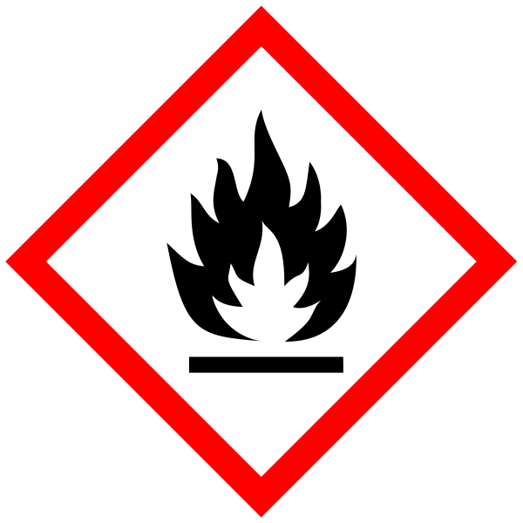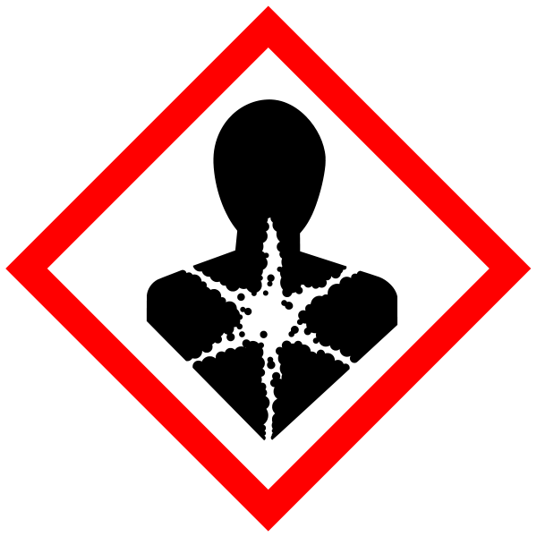
(Hazard Statements: H225 Highly flammable liquid and vapour. H301 Toxic if swallowed. H311 Toxic in contact with skin. H331 Toxic if inhaled. H370 Causes damage to organs). Must be handled in the fume hood. Waste to be collected for specialist disposal.

Ponceau S solution: Sigmal Word: Warning
(Hazard statements: H315 Causes skin irritation. H319 Causes serious eye irritation. H335 May cause respiratory irritation).

RUNNING GELS
Make up 500 ml running buffer. If required, add 5 ml 10% SDS BEFORE USE (i.e. 1 ml/100ml).
Fill up upper and lower compartments. Remove combs and load samples (15 μl per well).
Connect to power pack. Set to constant voltage. Run at 60 V until dye front is through stack. Turn up voltage. 100 - 150 V usually OK. (200 V max.). When dye front is about 0.5 cm from the bottom, switch off, disassemble and either stain gel with Coomassie blue or prepare for Western blotting. Note: Exact details for assembly and running of gels will vary depending on the make of apparatus. The above protocols refer to the Bio-Rad mini protean system.
Always switch off power before removing lid of gel apparatus. Always disconnect the leads from the power supply.

WESTERN BLOTTING
Solutions
Note. Handle stock bottle of methanol in a fume hood

Transfer buffer (1L) 100 ml 10x running buffer
100 ml Methanol
1 ml 10% SDS
800 ml distilled water

TBS/Tween 100 ml 10x TBS (200 mM Tris pH7.6,1.5 M NaCl)
10 ml 10% Tween 20
890 ml water

Block/dilution buffer TBS/Tween with 1% blot qualified BSA
Alkaline phosphatase (AP) buffer 0.1 M Tris pH 9.5, 0.1 M NaCl, 5 mM MgCl2

PROTEIN TRANSFER
Wet PVDF membrane with methanol.
Place “Scotchbrite” pads, filter paper, and wetted PVDF into transfer buffer.
Remove bubbles from PVDF by gentle rubbing After disassembling gel, quickly rinse gel in transfer buffer. Set up sandwich as in Figure. 1 and place in pre-filled tank. Put cooling unit in place. Run at constant voltage at 100V for 70 minutes or 30V overnight with stirring.
If running overnight – a sign should be put by the equipment.
(These 3 last steps apply only to the Bio-Rad system-other systems may vary)
Always switch off power before removing lid of gel apparatus. Always disconnect the leads from the power supply.

Waste transfer buffer (containing methanol) to be stored for specialist disposal.

IMMUNO-DETECTION
After transfer disassemble sandwich stain PVDF membrane with Ponceau S solution.
If appropriate cut lanes into individual strips, narrow enough to fit into slotted tray.

Cover membrane with block buffer, incubate with shaking for 1 hour.
Remove block buffer. Cover membrane with primary antibody diluted in dilution buffer.
Incubate for 1 hour with shaking. Remove antibody solution. Wash 3 x 5 min with TBS Tween. Cover with alkaline phosphatase or HRP-conjugated secondary antibody diluted in dilution buffer.
Incubate for 1 hour with shaking. Remove antibody solution.
Wash 3 x 5 min with TBS/Tween, 3 x 5 min with TBS. (Tween causes a smear effect).

ECL REACTION
Prepare reagents as per manufacturer’s instructions. Incubate membrane for required time. Place membrane in plastic-wrap and expose to film. Use the developer in the darkroom according to the instructions. CARE – Always wear gloves, labcoat and safety glasses when handling developer or fixer solutions.

SECTION 2 - Review of assessment
The person writing the assessment and the Head of Group must sign off the assessment.

Name of assessor: Signature:…………………

Name of Head of Group: Signature:…………………

………………………………………………………………………………………..

SECTION 3 - User Declaration
I have read this laboratory procedure and COSHH risk assessment and understand the risks and the measures that must be taken to control such risks. I will notify the lab manager/head of group of any changes to the methodology described here which may affect the Health & Safety of myself or others.
NAME: Please print | SIGNATURE | DATE

