William Harvey Research Institute
Laboratory Procedure and COSHH Risk Assessment

Group:
Assessment identifier: RA-10
Date of assessment: July 2013
Date for review: August 2014
Title of Procedure: (Para)formaldehyde Fixation
Location of Work:

Risk assessment RA-General must be followed at all times
Lab coats and Safety Glasses to be worn.

Section 1 – Description of Hazardous Material and Procedures including controls to be used

Formaldehyde fixative (freshly prepared from Paraformaldehyde (prilled form must be used as it is more granular) – required particularly for immunofluorescence) is used in varying concentrations up to 4% to fix biological material for a variety of techniques (light & electron microscopy).

IMPORTANT NOTE.
Paraformaldehyde is a polymerised form of formaldehyde. When paraformaldehyde powder is solubilised at the appropriate pH and temperature, the polymers are hydrolysed to release monomeric formaldehyde. So the solutions are, in fact, formaldehyde and therefore regulations (exposure limits etc) concerning formaldehyde should be followed.

Chemicals:
Paraformaldehyde. Signal Word: Danger
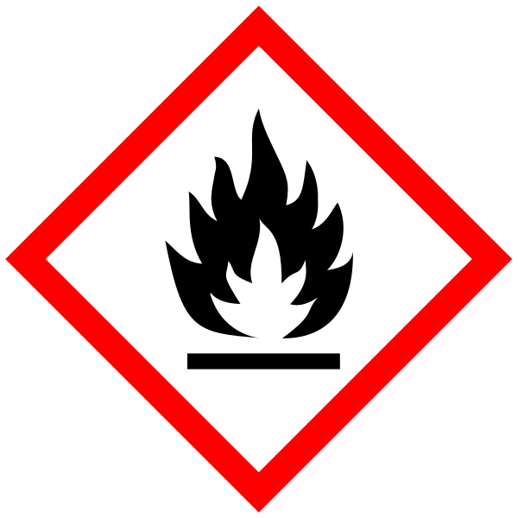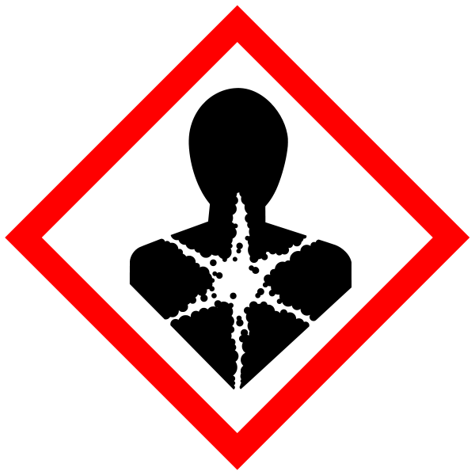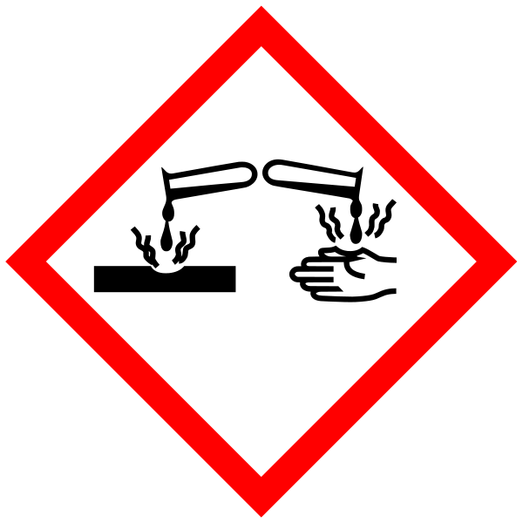
(Hazard statements: H228 Flammable solid. H302 Harmful if swallowed. H315 Causes skin irritation. H317 May cause an allergic skin reaction. H318 Causes serious eye damage. H332 Harmful if inhaled. H335 May cause respiratory irritation. H351 Suspected of causing cancer.

10X PBS. No Hazards

1M NaOH solution. Signal Word: Danger
(Hazard statement: H314 Causes severe skin burns and eye damage.

(Para)formaldehyde solution waste must be stored for disposal via specialist contractor.

Fixative preparation: (per 100ml) for 2% paraformaldehyde Solution in PBS

1) Heat 50ml of distilled water to near boiling point on magnetic stirrer in fumehood. Place warning sign next to stirrer.
2) 2g prilled paraformaldehyde are weighed in a weighing boat on enclosed chemical balance, (this cannot be performed in the fume hood due to the air flow blowing the light powder about) WEAR MASK and EYE PROTECTION. Add powder to the distilled water in the fume hood. Wipe balance and bench with damp paper towels after weighing out – dispose via clinical waste.
3) After stirring for 5 minutes add 1 drop of 1M NaOH (WEAR EYE PROTECTION) to clear the solution. Add 10 ml 10X PBS and make up to 100ml with distilled water.
Fixative can be made in batches and frozen.

Switch off hotplate – leave warning sign in place until hotplate cool.

All bottles/containers containing fixative should be clearly labelled.

Methods:
All procedures involving (para)formaldehyde solutions are to be carried out in a fumehood. Put a notice by you experiment to inform others of the procedure being carried out.

Perfusion of hearts
This is carried out to obtain more thorough fixation of the heart tissue via the coronary arteries. Hearts are removed from the animal and canulated via the aorta. This is carried out in a fumehood. PBS is perfused through followed by 5 ml of paraformaldehyde. The waste paraformaldehyde solution is collected in the appropriate waste container (located in the cupboard under the fumehood). The heart is then immersed in fixative for up to 30 minutes. Fixative is then collected in waste container. The heart is then thoroughly washed with PBS - Waste from the first wash is collected in the waste container. Subsequent wash waste can be disposed of via the fumehood sink. The heart can then be manipulated on the open bench.

Tissue sections on glass slides are immersed in fixative in a Coplin jar in the fume hood for required amount of time (5 to 30 minutes). Coplin jars hold about 50 ml of liquid. The fixative is then poured off and collected in the appropriate waste container (in cupboard under fumehood) and replaced with PBS buffer. The slides are washed 3 times with PBS before continuing with labelling on the open bench. The waste from the first wash is collected in the waste collection container. The waste from the remaining washes can be disposed down the fumehood sink.

Cultured cells for labelling are usually grown on chamber slides. Cells are washed twice with PBS and then moved to the fumehood where the fixative added to the chambers (0.5 ml per chamber for 2-well chamber slides). Incubate for the appropriate time. Aspirate fixative with disposable plastic Pasteur and collect in the appropriate waste container (in cupboard under fumehood). Wash 3 times with PBS and continue labelling on the open bench. Waste from the first wash should be collected in the waste container. Subsequent waste can be disposed via the fumehood sink.

Spillage procedure
Any spillage of (para)formaldehyde should only occur in the fumehood. Spillage should be adsorbed using absorption granules or paper towel which should be sealed in pastic bags for specialist disposal.

SECTION 2 - Review of assessment
The person writing the assessment and the Head of Group must sign off the assessment.

Name of assessor: Signature:…………………

Name of Head of Group: Signature:…………………

………………………………………………………………………………………..
SECTION 3 - User Declaration
I have read this laboratory procedure and COSHH risk assessment and understand the risks and the measures that must be taken to control such risks. I will notify the lab manager/head of group of any changes to the methodology described here which may affect the Health & Safety of myself or others.
NAME: Please print | SIGNATURE | DATE

