William Harvey Research Institute
Laboratory Procedure and COSHH Risk Assessment

Group:
Assessment identifier: RA-22
Date of assessment: July 2013
Date for review: August 2014
Title of Procedure: RNA isolation using Phenol based products
Location of Work:

Risk assessment RA-General must be followed at all times
Lab coats and Safety Glasses to be worn.

Section 1 – Description of Hazardous Material and Procedures including controls to be used

Solubilisation of tissue or cells using Trizol (contains phenol) for the isolation of RNA. This method is used when the yield of RNA needs to be high, for example, when using small amounts of precious samples. Yield is about 3 times greater than from spin column kits.

CHEMICALS
Trizol (Phenol 50%-Guanidine Thiocyanate): Signal Word: Danger
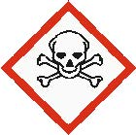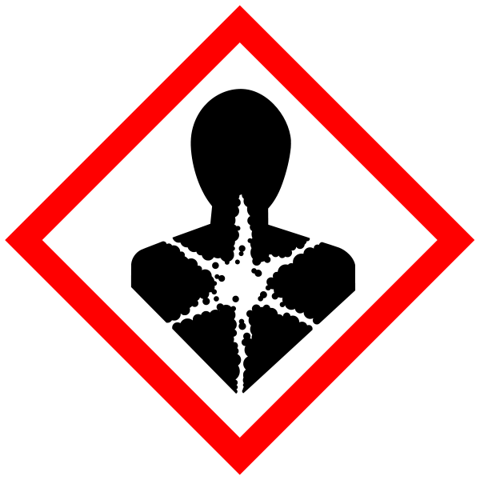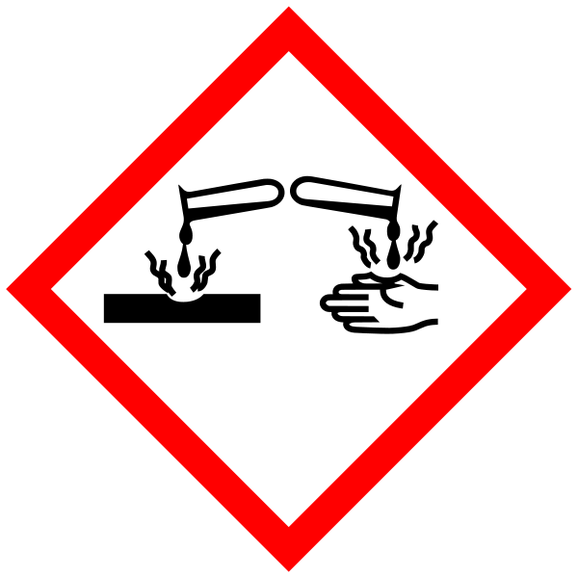
Hazard statements: H301 Toxic if swallowed. H311 Toxic in contact with skin. H314 Causes severe skin burns and eye damage. H331 Toxic if inhaled. H341 Suspected of causing genetic defects. H373 May cause damage to organs through prolonged or repeated exposure. H412 Harmful to aquatic life with long lasting effects. Must be used in Fume Hood

Chloroform: Signal Word: Warning
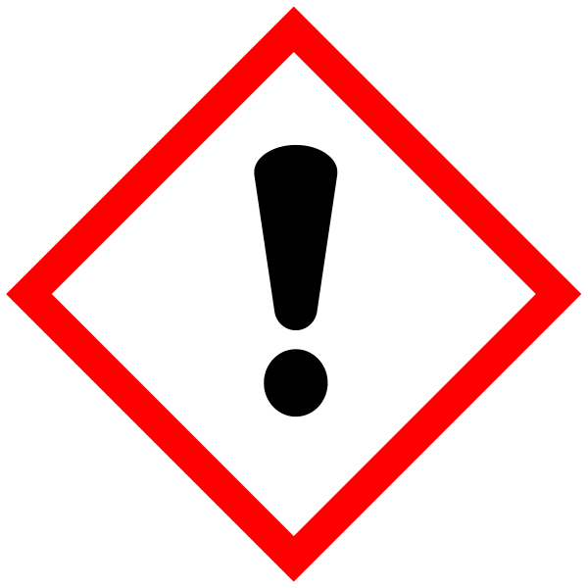
Hazard statements: H302 Harmful if swallowed. H315 Causes skin irritation. H351 Suspected of causing cancer. H373 May cause damage to organs through prolonged or repeated exposure. Must be used in Fume Hood

Isopropanol: Signal Word: Danger
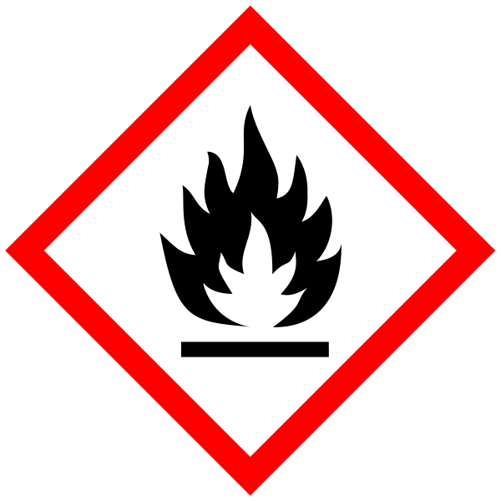
(Hazard statements: H225 Highly flammable liquid and vapour. H319 Causes serious eye irritation. H336 May cause drowsiness or dizziness).

METHODS:

Know the location of the phenol spill kit and what to do in the event of a phenol spill before starting work.

Always Work in a fumehood.
Sample (frozen powdered tissue) is disrupted and homogenized in an adequate volume of trizol (10μl of trizol is needed per 1mg of tissue).
All waste containing phenol to be stored in labelled container for specialist disposal.
During the procedure, the lid of any vessel containing phenol must be closed securely before proceeding to the next step.
All work must be carried out on a spill tray with a disposable liner.
Chloroform is added and the mixture centrifuged to partition RNA into the upper aqueous phase.
The aqueous phase is removed and RNA precipitated using isopropanol. The lower organic phase is stored in a designated glass bottle.
The RNA is pelleted by centrifugation and the pellet washed with absolute ethanol and resuspended in RNase-free water.

Disruption and homogenization of plated, cultured cells:
Cells are washed twice in ice-cold PBS. Cells are lysed directly in the dish by adding an appropriate volume of trizol, swirling the dish to ensure coverage of whole area and collecting the cell lysate with a rubber policeman.

NOTES
Trizol must be stored doubled contained.
Change gloves regularly – phenol breakthrough time for nitrile gloves is 6 minutes.
All waste to be stored for specialist disposal.
If GM material used then the relevant GM risk assessments must be adhered to (GMRA…).

Accident / spillage / emergency procedure
In the event of accidental spillage of Trizol (phenol) – follow procedure on “Emergency Procedure” notice – in the lab and at the end of this assessment.

SECTION 2 - Review of assessment
The person writing the assessment and the Head of Group must sign off the assessment.

Name of assessor: Signature:…………………

Name of Head of Group: Signature:…………………

………………………………………………………………………………………..

SECTION 3 - User Declaration
I have read this laboratory procedure and COSHH risk assessment and understand the risks and the measures that must be taken to control such risks. I will notify the lab manager/head of group of any changes to the methodology described here which may affect the Health & Safety of myself or others.
NAME: Please print | SIGNATURE | DATE

 KNOW YOUR PHENOL/TRIZOL

Emergency Procedures

Dealing with spillages
Phenol spills over 5mls outside the fume hood
Evacuate the laboratory IMMEDIATELY and lock the room. Inform the Lab Manager immediately (8234)
Phenol spills in the fume hood or under 5mls outside the fume hood
- Do not wear nitrile gloves to clean up phenol spills. Wear gloves in Phenol spill kit located at: Shelf in main lab……………. Also wear a fastened labcoat.
- Wipe up spill using glycerol and paper towel – immediately!
- Report incident to Lab Manager. Dispose of contaminated tissues by sealing into an empty reagent bottle; label it appropriately and place in fume hood.
- Arrange for disposal via the Laboratory manager.

- Phenol is Highly Toxic by inhalation (2ppm), contact and ingestion (Trizol contains phenol).
- It is caustic and rapidly absorbed through the unbroken skin. It is an anaesthetic, so significant skin burns can occur before pain is felt.
- Before you start work with it, make sure that PEG 300 and Glycerol is to hand. Work only in a fume hood.
- Nitrile gloves must be changed frequently as they only slow penetration (breakthrough time approx 6mins) but do not prevent it!

 Phenol First Aid 

In all cases contact a first aider as soon as possible

Splashes to skin
- IMMEDIATELY flush area with soap and running water for at least 15 minutes. Do not use anything that may scratch the affected area. Speed is essential.
- Prevent washed off Phenol from running over unexposed areas (particularly eyes and mouth if splash is on face).
- Start decontamination of affected area by wiping with PEG300/IMS solution. The PEG300/IMS bottle is located at:…………………………………….
Splashes to eyes
Do not use PEG300/IMS mixture on eye exposures. Remove any contact lenses and flush eyes with water for 15 minutes.
Ingestion
Do not induce vomiting. If possible give casualty milk.
Inhalation
Remove to fresh air.

First aiders and those assisting
- Wearing labcoat, phenol spill kit gloves (non nitrile) and safety specs, begin first aid while calling for further assistance
- For advice on emergency action for spills on skin, during the 15 minute washing procedure get someone else to immediately contact NHS Direct (0845 46 47) giving an estimate of the volume and concentration spilt on the skin.
- In the event of any ingestion or eye contamination ask someone else to call for an ambulance (3333).
- Avoid contaminating own clothing and skin. All contaminated material (clothing, wipes etc) must be placed in an operational fume cupboard or sealable container to prevent phenol fumes contaminating others.
- IT IS ESSENTIAL TO OBTAIN MEDICAL ADVICE IMMEDIATELY – there is no antidote to phenol.

