William Harvey Research Institute
Laboratory Procedure and COSHH Risk Assessment

Group:
Assessment identifier: RA-23
Date of assessment: July 2013
Date for review: August 2014
Title of Procedure: Crushing Frozen Tissue
Location of Work:

Risk assessment RA-General must be followed at all times
Lab coats and Safety Glasses to be worn.

Section 1 – Description of Hazardous Material and Procedures including controls to be used

Hazard

Liquid Nitrogen: Signal Word: Warning
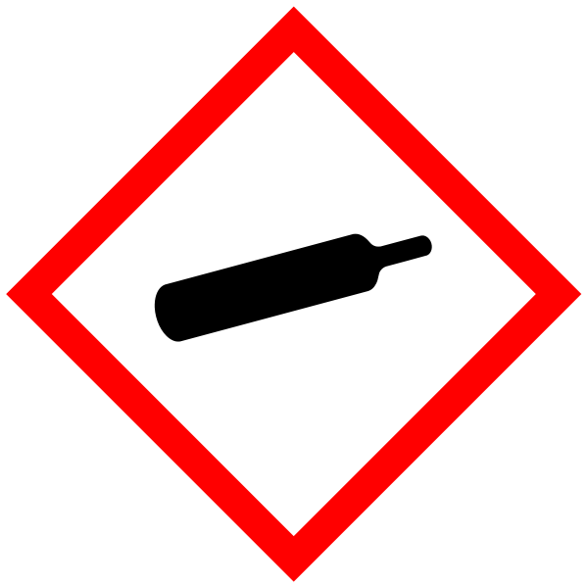
Hazard Statements: H281: Contains refrigerated gas; may cause cryogenic burns or injury. EIGA-As: Asphyxiant in high concentrations.

Frozen pieces of tissue are crushed under liquid nitrogen to provide material for western blots samples, RNA and DNA extraction.

Thermal protection gloves to be worn when handling the liquid nitrogen.
Do NOT sit at the bench while carrying out this procedure.

A pestle and mortar are cooled with liquid nitrogen and the mortar secured in a polystyrene box with the underside in contact with liquid nitrogen. Tissue is then placed in the mortar and crushed to a fine powder with the pestle. The powdered tissue is transferred to a screw-cap cryotube (with safety gasket) and stored at -80°C or under liquid nitrogen.

The mortar can be wiped out with tissue between different samples without the need to let it warm up. Do NOT try to wash as a rapid change in temperature will cause the pestle and mortar to shatter.

Liquid nitrogen to be transported in an appropriate dewar.
See notice on liquid nitrogen decant rooms for how to dispense and handle liquid nitrogen.

Use minimum volume of liquid nitrogen required (5L should be plenty). 1L liquid nitrogen will give 696L gas. If 5L evaporated spontaneously (I.E., all the liquid nitrogen spilt at once) this would give 3480L of nitrogen gas which is about 0.35% of the volume lab B20 (975m³ = 975,000L). Therefore the oxygen concentration would decrease minimally (to 20.9% from 21%). 19% oxygen is classed as an oxygen deficient atmosphere and the room should be evacuated. For normal use and rate of evaporation, the air-change rate in the lab prevents any risk of asphyxiation. The volume of liquid nitrogen used must never exceed 15% of room volume without extra ventilation, use the following equation

Litres of liquid nitrogen x 0.7 x 100 = 15
Volume of room in m³

In the case of lab B20, this would be approximately 208 litres which would have to evaporate to cause a sufficient reduction in oxygen concentration (bear in mind that there is ventilation but there are storage dewars also present).

If GM material used then the relevant GM risk assessments must be adhered to (GMRA…).

SECTION 2 - Review of assessment
The person writing the assessment and the Head of Group must sign off the assessment.

Name of assessor: Signature:…………………

Name of Head of Group: Signature:…………………

………………………………………………………………………………………..

SECTION 3 - User Declaration
I have read this laboratory procedure and COSHH risk assessment and understand the risks and the measures that must be taken to control such risks. I will notify the lab manager/head of group of any changes to the methodology described here which may affect the Health & Safety of myself or others.
NAME: Please print | SIGNATURE | DATE

