William Harvey Research Institute
Laboratory Procedure and COSHH Risk Assessment

Group:
Assessment identifier: RA-24
Date of assessment: July 2013
Date for review: August 2014
Title of Procedure: Stripping membranes for re-probing
Location of Work:

Risk assessment RA-General must be followed at all times
Lab coats and Safety Glasses to be worn.

Section 1 – Description of Hazardous Material and Procedures including controls to be used

After detection of proteins on western blots using an ECL-based method, the membranes can be stripped and re-probed with another antibody.

Chemicals

2-mercaptoethanol: Signal Word: Danger
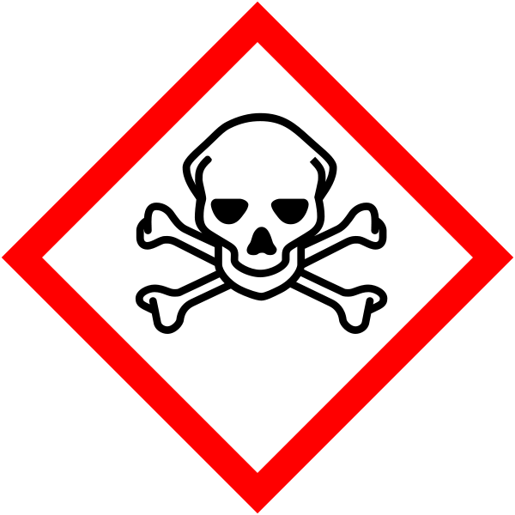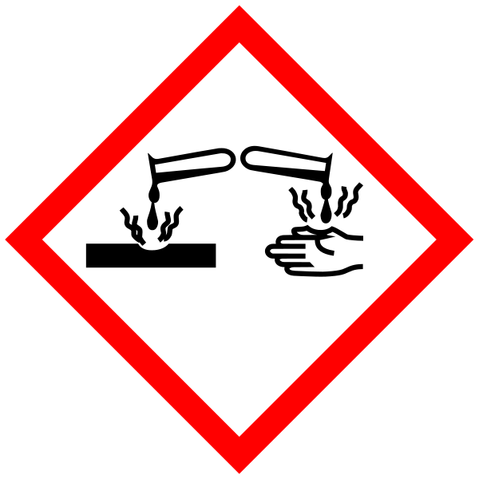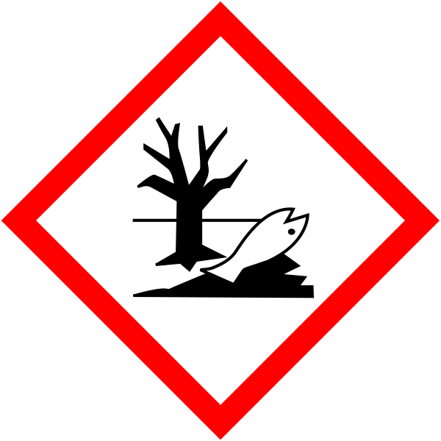
Hazard statements: H301 Toxic if swallowed. H310 Fatal in contact with skin. H315 Causes skin irritation. H317 May cause an allergic skin reaction. H318 Causes serious eye damage. H330 Fatal if inhaled. H410 Very toxic to aquatic life with long lasting effects.

SDS. Bought in as 20% solution to avoid using powder. Signal Word: Warning
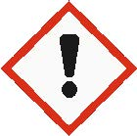
(Hazard statements: H315 Causes skin irritation. H319 Causes serious eye irritation. H335 May cause respiratory irritation).

Method

Must be carried out in a fumehood.
Submerge the membrane in stripping buffer (100mM 2-mercaptoethanol, 2% SDS, 62.5mM Tris-HCl pH6.7). Incubate at 50°C for 30 minutes with occasional agitation.
(If more stringent conditions required, incubation can be carried out at 70°C or for longer period.

After incubation, carefully remove membrane from buffer and wash with PBS-tween. Stripping buffer should be left to cool and poured into waste container – for specialist disposal. First wash should also be poured into waste container.

The membrane should be washed 2 x 10min (can now be on open bench) and waste poured down the sink.

Continue with detection method (i.e. block, 1st antibody, wash……).

SECTION 2 - Review of assessment
The person writing the assessment and the Head of Group must sign off the assessment.

Name of assessor: Signature:…………………

Name of Head of Group: Signature:…………………

………………………………………………………………………………………..

SECTION 3 - User Declaration
I have read this laboratory procedure and COSHH risk assessment and understand the risks and the measures that must be taken to control such risks. I will notify the lab manager/head of group of any changes to the methodology described here which may affect the Health & Safety of myself or others.
NAME: Please print | SIGNATURE | DATE

