William Harvey Research Institute
Laboratory Procedure and COSHH Risk Assessment

Group:
Assessment identifier: RA-27
Date of assessment: July 2013
Date for review: August 2014
Title of Procedure: Picrosirius red staining (Sirius red staining)
Location of Work:

Risk assessment RA-General must be followed at all times
Lab coats and Safety Glasses to be worn.

Section 1 – Description of Hazardous Material and Procedures including controls to be used

Picrosirius red stains collagen and staining is usually carried out to determine any changes in the deposition of collagen in tissue samples. Staining can be carried out on frozen or wax embedded sections.

Hazards
Picric Acid. Signal Word: Danger
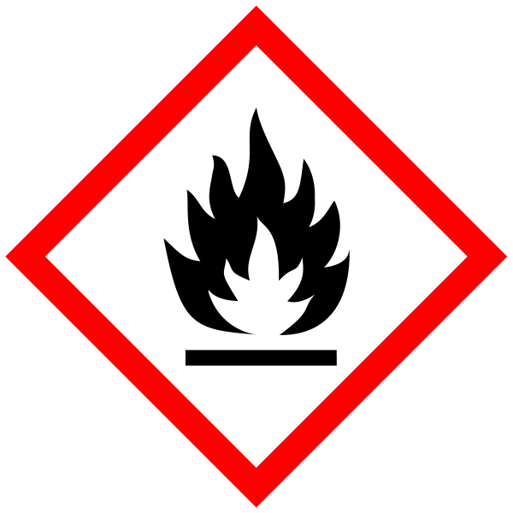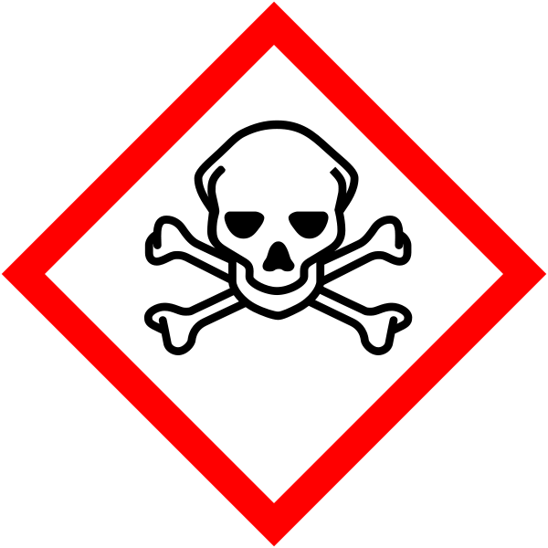
Hazard statements: H228 Flammable solid. H301 Toxic if swallowed. H311 Toxic in contact with skin. H332 Harmful if inhaled.
(Notes: Explosive when dry. Forms very sensitive explosive metallic compounds). Smallest quantity to be purchased (10g, 35% water). Stock bottle (double-contained) checked monthly (records kept). Stored in Flammables cupboard. In the event of a spill of picric acid – material should be absorbed onto paper towel which should be placed in a non-metallic container kept wet with water, sealed and disposed via specialist contractor.

Phosphomolybolic acid. Signal Word: Danger
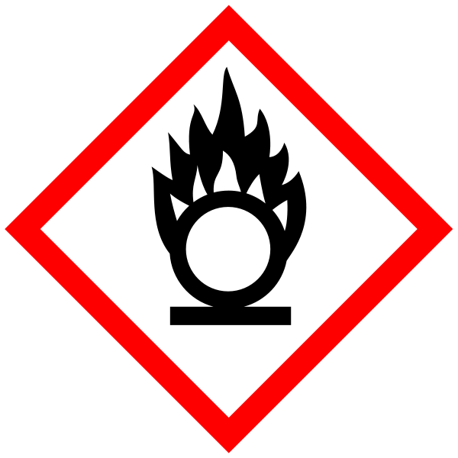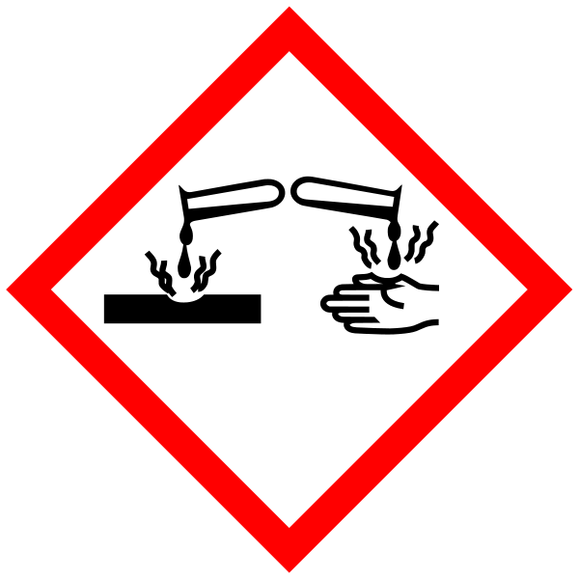
Hazard statements: H272 May intensify fire; oxidiser. H314 Causes severe skin burns and eye damage.

Xylene. Signal Word: Warning

Hazard statements: H226 Flammable liquid and vapour. H312 Harmful in contact with skin. H315 Causes skin irritation. H332 Harmful if inhaled.

DPX Mounting Medium. Signal Word: Danger
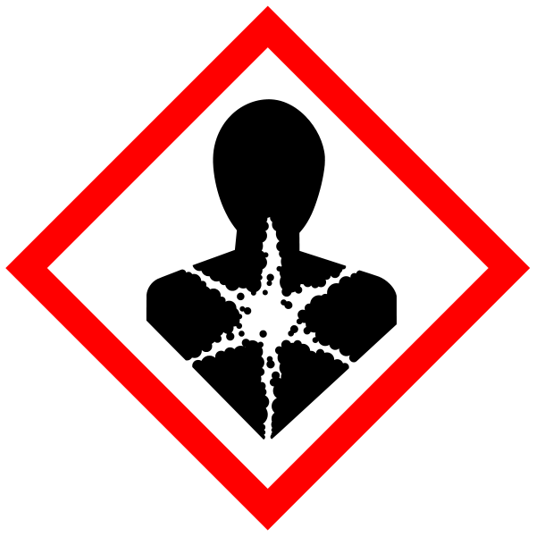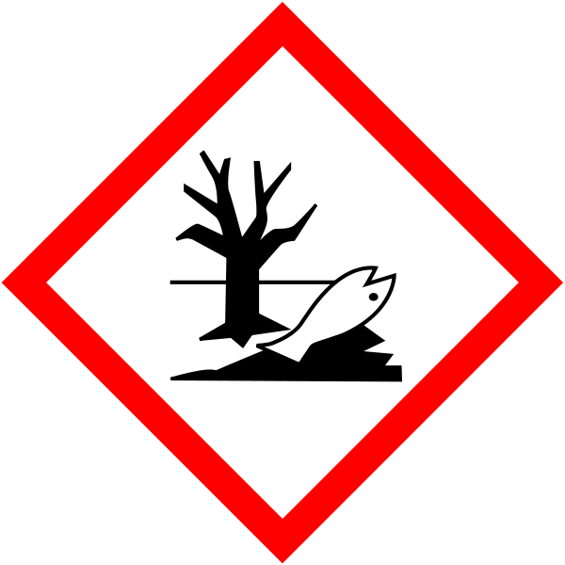
Hazard statements: H226 Flammable liquid and vapour. H312 Harmful in contact with skin. H315 Causes skin irritation. H332 Harmful if inhaled. H360Df May damage the unborn child. Suspected of damaging fertility.
H400 Very toxic to aquatic life.
Also contains Xylene – see above

Solutions required
Phosphomolybolic acid (Sigma, 22185-6) 1.5% in water
Concentration of this chemical is critical to reduce background red staining.

Sirius red (Sigma/Fluka, 43665 Direct red 80)
0.1% in saturated picric acid (saturated picric acid should be around 1.3% w/v concentration. Solution stable at 4°C.

Procedure

All steps to be carried out in a fume hood.
- slides must be dried prior to staining
- immerse in phosphomolybolic acid at RT for 10min
- wash in H2O twice
- immersed in Sirius red at RT for 15min~ 30min (max 60min)
- wash in H2O
- wash in 0.5% acetic acid
- Dehydration 100% EtOH twice, xylene twice
To maintain Sirius red stain as much as possible, washing must be done ASAP after staining, dehydration as well.
- mount using DPX

SECTION 2 - Review of assessment
The person writing the assessment and the Head of Group must sign off the assessment.

Name of assessor: Signature:…………………

Name of Head of Group: Signature:…………………

………………………………………………………………………………………..
SECTION 3 - User Declaration
I have read this laboratory procedure and COSHH risk assessment and understand the risks and the measures that must be taken to control such risks. I will notify the lab manager/head of group of any changes to the methodology described here which may affect the Health & Safety of myself or others.
NAME: Please print | SIGNATURE | DATE

