William Harvey Research Institute
Laboratory Procedure and COSHH Risk Assessment

Group:
Assessment identifier: RA-28
Date of assessment: July 2013
Date for review: August 2014
Title of Procedure: CHEF Genomic DNA Plugs & RE Digestion
Location of Work:

Risk assessment RA-General must be followed at all times
Lab coats and Safety Glasses to be worn.

Section 1 – Description of Hazardous Material and Procedures including controls to be used

This is to prepare genomic DNA gel plugs for analysis by pulse-field gel electrophoresis. The restriction enzyme digest is carried out with the gel plugs to reduce damage to the DNA (shearing during pipetting etc).

Chemicals

PMSF (phenylmethanesulfonyl fluoride). Signal Word: Danger
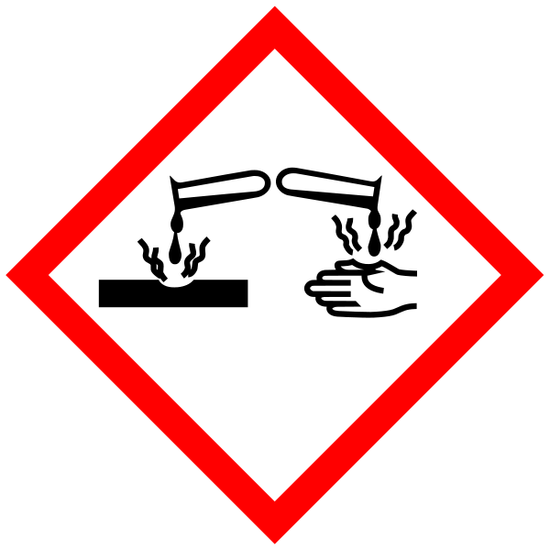
Hazard statements: H301 Toxic if swallowed. H314 Causes severe skin burns and eye damage.

Isopropanol. Signal Word: Danger
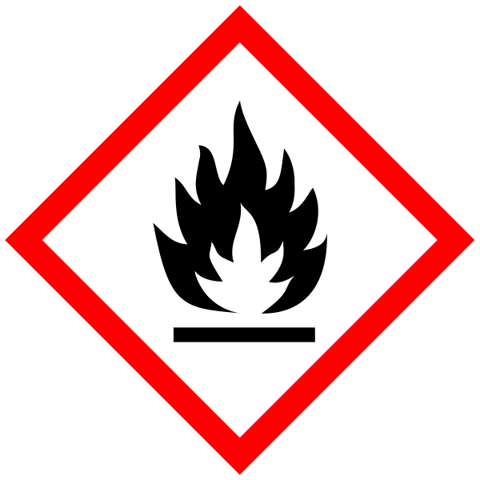
(Hazard statements: H225 Highly flammable liquid and vapour. H319 Causes serious eye irritation. H336 May cause drowsiness or dizziness).

Equipment
Water bath (50°C) – Switch off after use. Keep topped up with water.
Haemocytometer
Microscope

Reagents
CHEF Genomic DNA Plug Kit (100) Bio-Rad 170-3593

CleanCut Agarose (12ml) Bio-Rad 170-3594

PMSF Sigma P7626-5G (TOXIC)
100mM – add 0.174g to 10ml of 100% isopropanol (HIGHLY FLAMMABLE) – solution stable @ RT for 1 year. Make up solution in fumehood.

HinfI (1000 units → 20 plugs) Invitrogen 15223-019

PROTOCOL
Preparation of Agarose-Embedded Mammalian DNA
- Prepare cell suspension in isotonic saline or tissue medium WITHOUT BSA
- Count cells & remove 5 x 10⁵ cells per ml of agarose plugs to be made (use 100μl/plug for disposable mould or 300μl/ml for reusable mould) – place on ice
- Melt 2% CleanCut agarose solution carefully in microwave (Container lid must be loosened) and equilibrate solution to 50°C in water bath
- Calculate amount of Cell Suspension Buffer and CleanCut agarose required
- For final conc of 0.75% agarose use 0.63ml Cell Suspension Buffer per ml of agarose plugs
- Use 0.37ml of 2% CleanCut Agarose per ml of agarose plugs
- Centrifuge cell suspension @ 1000g for 5 mins @ 4°C
- Re-suspend cells in Cell Suspension Buffer (calculated above) and equilibrate @ 50°C
- Combine calculated volume of 2% CleanCut Agarose with cell suspension and mix GENTLY.
- Keeping mix @ 50°C, use a sterile transfer pipette to transfer the mix to plug moulds
- Allow agarose to solidify – can be expedited by placing moulds @ 4°C for 10-15 mins.
- Using 50ml conical centrifuge tube – add 100μl Proteinase K stock to 2.5ml Proteinase K Reaction Buffer for each ml of plugs
- Push solidified plugs into the 50ml tube & incubate o/n @ 50°C WITHOUT agitation
- Wash plugs 4 x 1 hour each @ RT in 1x Wash Buffer with gentle agitation (for each plug use 1ml of 1x Wash Buffer)
- If plugs are to be digested → wash in 1mM PMSF during the 2nd or 3rd wash to inactivate residual Proteinase K (FUME HOOD)
- Store plugs @ 4°C in 1x Wash Buffer (stable for 3 months)

Digestion of Plugs
- Place one plug per digest in sterile 1.5ml microfuge tube
- Wash once in 1ml of 0.1x Wash Buffer
- Decant and re-suspend in sufficient fresh 0.1x Wash Buffer to cover plugs
- Aspirate Wash Buffer
- Add 1ml of 1x restriction enzyme buffer for 1 hour with gentle agitation @ RT
- Aspirate enzyme buffer
- Add 0.3ml fresh 1x restriction enzyme buffer
- Add restriction enzyme (30-50U per 100μl plug)
- Incubate o/n @ 37°C
- Remove buffer
- Incubate in 1ml 1x Wash Buffer for 30mins with gentle agitation
- Remove Wash Buffer
- Equilibrate plug in appropriate concentration of gel running buffer
- Load ¼ to 1/3 of a plug per well (approx 50ug DNA)
- Reduce the volume in subsequent gels if necessary
Desired Agarose  Concentration | CleanCut Agarose 2%* | Cell Suspension Buffer*
1% | (0.5) x Vol = | (0.5) x Vol =
0.75% | (0.375) x Vol = | (0.625) x Vol =
0.5% | (0.25) x Vol = | (0.75) x Vol =

Table 1: Agarose concentrations

* Vol is the total volume of plugs to be made @ 75μl/plug i.e. for 5ml of plug @ 0.75% final conc, add (0.375) x 5ml = 1.9ml of 2% agarose to (0.625) x 5ml – 3.4ml cell suspension.

Accidental spillage
Absorb PMSF solution onto paper towels or absorption granules – seal waste in bag for disposal.

Disposal
Aqueous, non-toxic solution to the sink.
PMSF/Isoppropanol – stored for specialist disposal.

If GM material used then the relevant GM risk assessments must be adhered to (GMRA…).

SECTION 9 - Review of assessment
The person writing the assessment and the Head of Group must sign off the assessment.

Name of assessor: Signature:…………………

Name of Head of Group: Signature:…………………

………………………………………………………………………………………..
SECTION 3 - User Declaration
I have read this laboratory procedure and COSHH risk assessment and understand the risks and the measures that must be taken to control such risks. I will notify the lab manager/head of group of any changes to the methodology described here which may affect the Health & Safety of myself or others.
NAME: Please print | SIGNATURE | DATE

