William Harvey Research Institute
Laboratory Procedure and COSHH Risk Assessment

Group:
Assessment identifier: RA-29
Date of assessment: July 2013
Date for review: September 2014
Title of Procedure: Real-time Quantitative Telomere Repeat Amplification Protocol (RTQ-TRAP)
Location of Work:

Risk assessment RA-General must be followed at all times
Lab coats and Safety Glasses to be worn.

Section 1 – Description of Hazardous Material and Procedures including controls to be used

Based on the method of Hou et al., Clin Chem, 2001.

Hazards
Low risk procedure.
CHAPS buffer. Signal Word: Danger
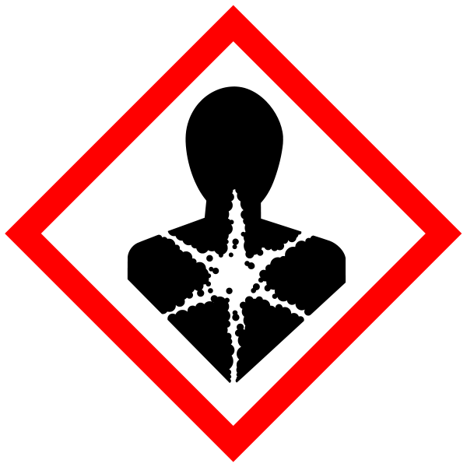
Hazard statements: H315 Causes skin irritation. H319 Causes serious eye irritation. H335 May cause respiratory irritation. H360D May damage the unborn child.

Competence with PCR equipment required – high temperatures.

Reagents
Primer TS Sigma
Primer CX Sigma
SbrGreen Mastermix ABI

Method
- Lyse cells (1-2 x 10⁶) in 50μl CHAPS buffer containing RNase inhibitor
- Incubate for 30mins @ 4°C
- Centrifuge lysate @ 12,000g for 20mins @ 4°C
- Collect supernatant
- Determined protein concentration using Coomassie Protein Assay using BSA as standard and adjusted to 250 ng/ml (we can use the NanoDrop for this step)
- Human cell line, PC3, used to set up standard curve
- Human cell line, MCF10, used as a positive control

PCR
- 25μl total volume
- 1x SybrGreen mastermix (ABI)
- 0.1ug primer TS (5’-AATCCGTCGAGCAGAGTT-3’)
- 0.05ug primer ACX (5’-GCGCGG[CTTACC]₃CTAACC-3’)
- PCR – (competence required)
  - 25°C for 20 mins
  - 95°C 10 mins
  - 40 cycles of
    - 95°C, 20s
    - 60°C, 30s
    - 72°C, 90s
- Telomerase activity based on the Ct value

Notes: Assay time approx 3 hours.
Results are relative to the cell line used as a control.
Low activity picked up (missed by commercial TRAP-ELISA)

If GM material used then the relevant GM risk assessments must be adhered to (GMRA…).

Disposal
Small volumes, low hazard – to the sink with plenty of water.

SECTION 2 - Review of assessment
The person writing the assessment and the Head of Group must sign off the assessment.

Name of assessor: Signature:…………………

Name of Head of Group: Signature:…………………

………………………………………………………………………………………..
SECTION 3 - User Declaration
I have read this laboratory procedure and COSHH risk assessment and understand the risks and the measures that must be taken to control such risks. I will notify the lab manager/head of group of any changes to the methodology described here which may affect the Health & Safety of myself or others.
NAME: Please print | SIGNATURE | DATE

