William Harvey Research Institute
Laboratory Procedure and COSHH Risk Assessment

Group:
Assessment identifier: RA3
Date of assessment: July 2013
Date for review: August 2014
Title of Procedure: Use of Isofluorane Anaesthesia Apparatus
Location of Work: BSU, John Vane Science Centre

Risk assessment RA-General must be followed at all times
All Local BSU Rules must be followed at all times
Personal Home Office licence must be held by user

Section 1 – Description of Hazardous Material and Procedures including controls to be used

This assessment covers the use of the isofluorane anaesthesia apparatus located in Room LG12 the BioScience Unit (BSU) for the purpose of anaesthetising animals for termination.

CHEMICALS
Isofluorane: Anaesthetic. Irritant, R36-37-38. Stock bottle volume 250ml.

Pregnant and breast-feeding mothers should avoid exposure to isofluorane.

Main risk is causing general anaesthesia in worker.

Calculation to determine level of risk of this event occurring.

Largest volume of isofluorane handled is 250ml
Molecular weight = 184.5
Density = 1.496g/ml. Therefore 250ml = 374g
374g = 374/184.5 = 2 moles

In general 1 mole of gas occupies 22.4 litres
Therefore 2 moles of isofluorane will occupy 45 litres

If room is 4m x 5m x 2.5m = 50 m³ = 50000 litres

Therefore maximum theoretical concentration of isoflurane = 0.1%

0.5% isofluorane causes general anaesthesia in 7 to 10 mins.

Note. This is if all 250 ml of isofluorane evaporates at once and does not allow for the fact that the room is well ventilated.
If stock bottle is dropped, leave room. Lock room. Notify bioscience manager and lab manager. With the level of ventilation, room should clear in a matter of a few hours.

PROTOCOL
Carry out inspection of tubing and connections to ensure integrity of the system. Two people and cylinder trolley must be used when cylinder changed. Gas regulator on cylinder must be correct type and must be exchanged every 5 years.

Before starting, check the level of isofluorane in evaporator (see fig1) and make sure it contains a sufficient amount of anaesthetic (above the low level mark on the indicator).

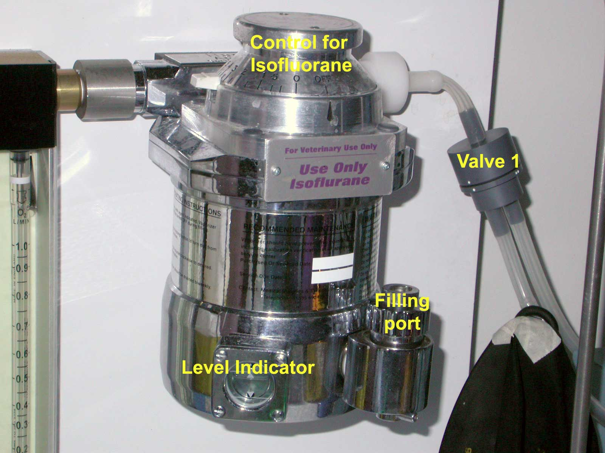
Fig 1

If the unit requires filling, get bottle of isofluorane from the medicines cabinet, take lowest numbered stock bottle, unscrew filling port and pour in isofluorane to the max level on indicator. DO NOT USE PLASTIC PIPETTES. Re-seal filling port and stock bottle. Mark level of isoflurane on bottle and date it, fill in controlled medicines log book. Lock stock bottle back in medicines cabinet.

Check the weight of the isofluorane adsorption pack (Should not exceed 1400g) Weight should be checked weekly and recorded on sticker on pack). Exchange pack when 1400g reached. Used packs to be sealed in bags provided with new packs and disposed via clinical waste (yellow bag waste).

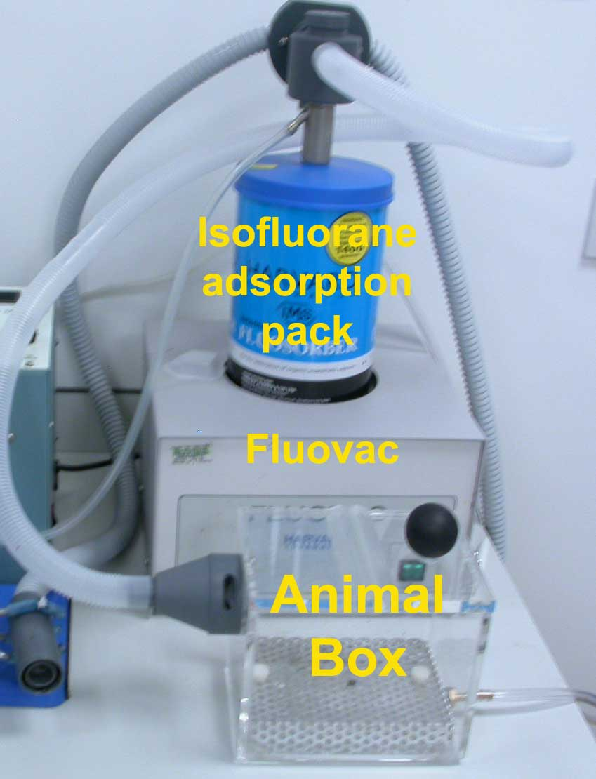

Fig 2

Connect the appropriately sized animal box to the unit.
Switch on the air at the main cylinder control (Fig 3) or switch on pump. Air pressure should be no greater than 20 psi. Make sure valve 1 (closest to the evaporator – Fig 1) is in the correct position, line up dots to close the tube not required – see Fig 4. Follow tube path to determine which tube is which. Isofluorane to go towards the animal box, not the ventilator (for surgery use only).

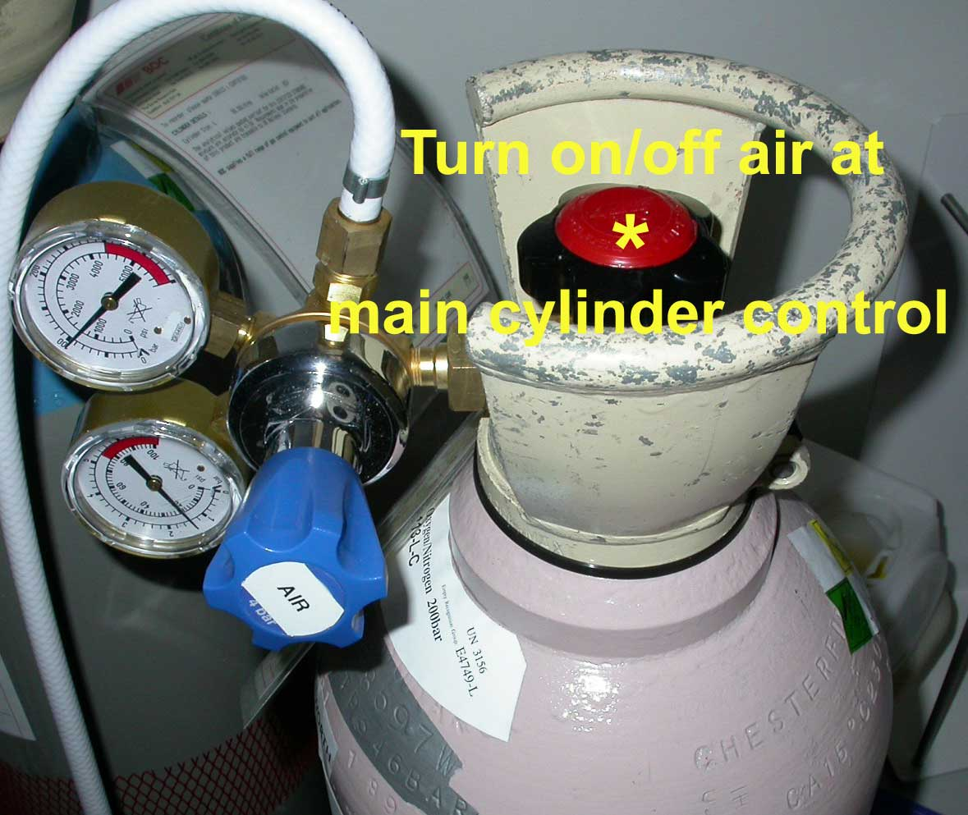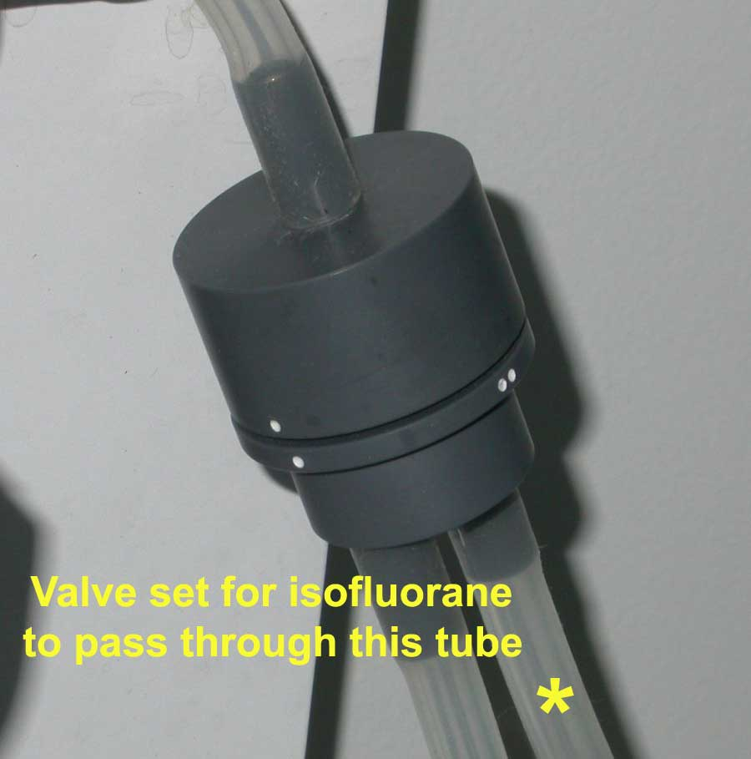
Fig 3 Fig 4

Make sure valve 2 is in the correct position for the isofluorane to go to the animal box (see Fig 5). Line up dots to block the other tube. Follow tube path to determine which tube is which.

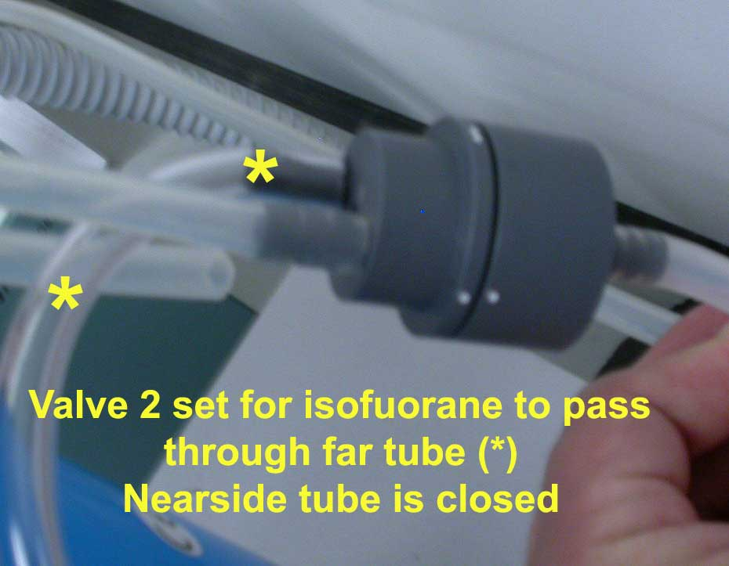

Fig 5

Switch on fluovac.
Make sure vents on outlet pipe from animal box are open (Fig 6) and that valve on top of fluovac is set to draw gas from the animal box (Fig 7).

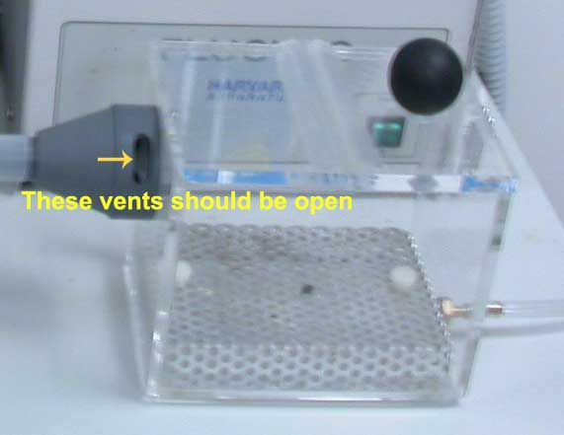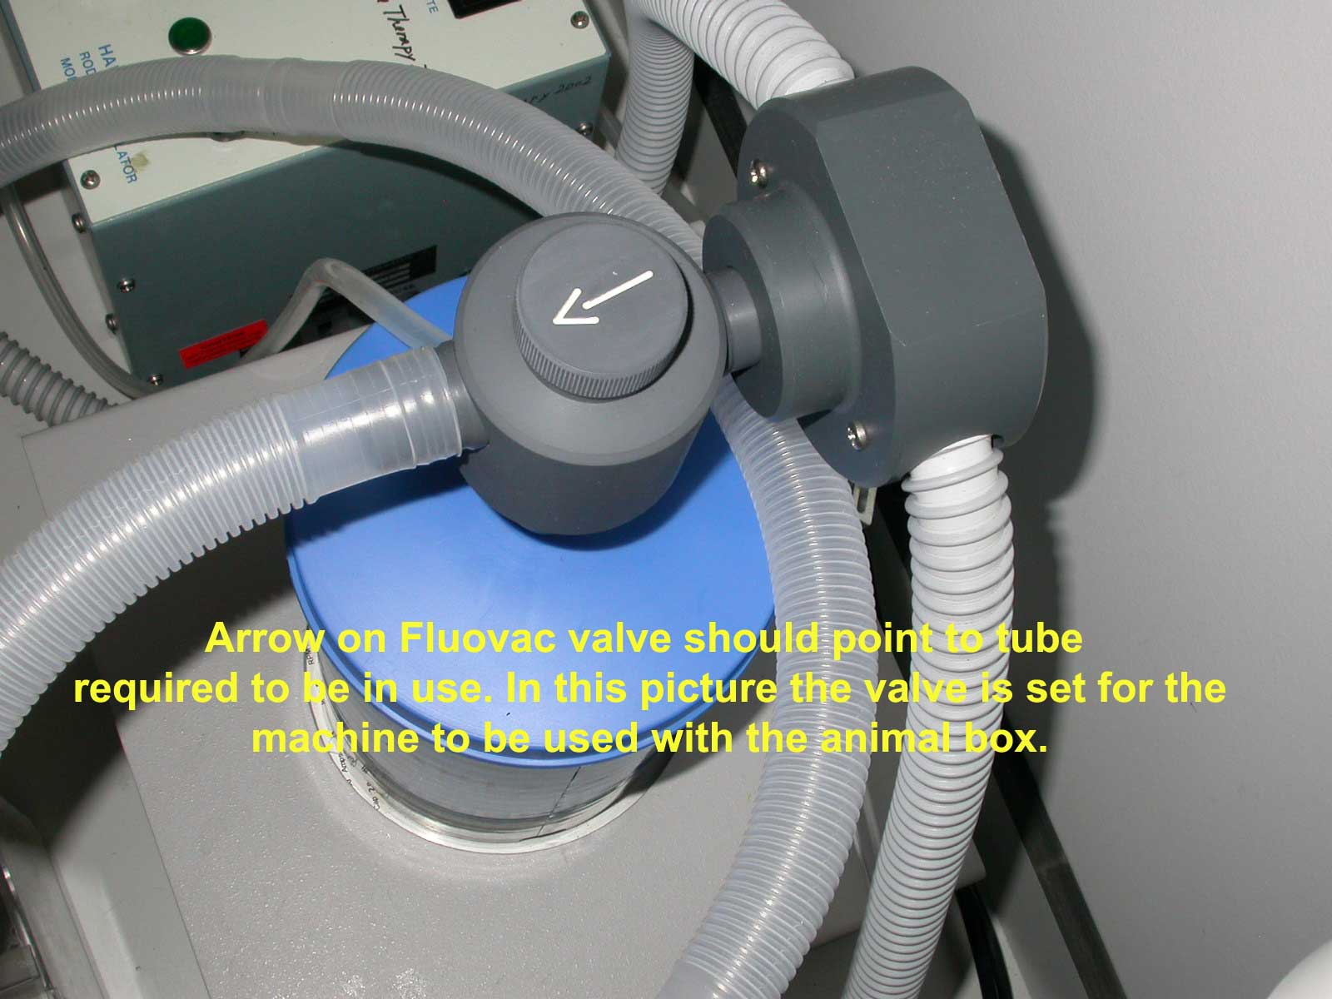
Fig 6 Fig 7

Turn the air flow rate valve (Fig 8) to give 0.5 to 0.7 air flow.

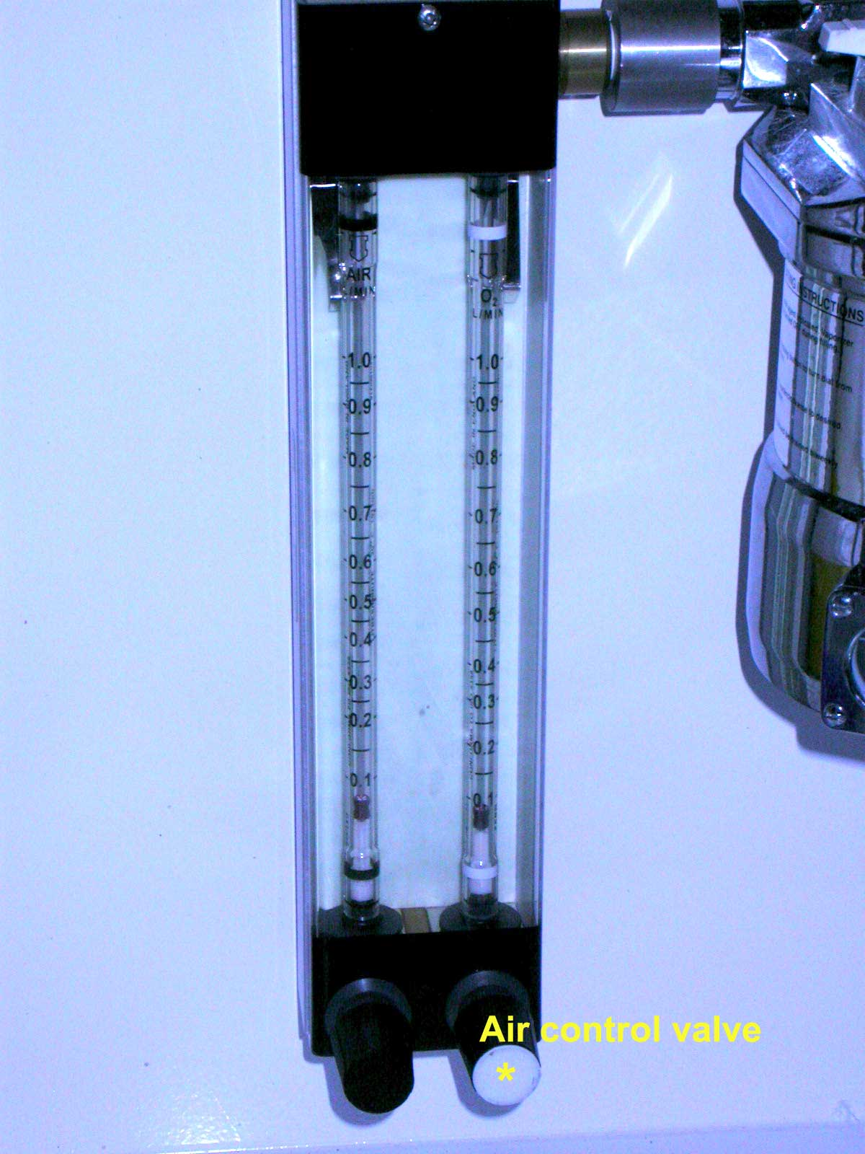
Fig 8

Turn on isoflorane – turn control to 5 – see Fig 1.

The animal can now be placed inside the animal box. General anaesthesia should occur in 2 to 3 minutes.
Once animal is unconscious, turn off isofluorane and air at flow rate valve and at the main cylinder control. Leave Fluovac running to adsorb remaining isofluorane.
The animal should now be killed.
Switch off Fluovac.

SECTION 2 - Review of assessment
The person writing the assessment and the Head of Group must sign off the assessment.

Name of assessor: Signature:…………………

Name of Head of Group: Signature:…………………

………………………………………………………………………………………..
SECTION 3 - User Declaration
I have read this laboratory procedure and COSHH risk assessment and understand the risks and the measures that must be taken to control such risks. I will notify the lab manager/head of group of any changes to the methodology described here which may affect the Health & Safety of myself or others.
NAME: Please print | SIGNATURE | DATE

