William Harvey Research Institute
Laboratory Procedure and COSHH Risk Assessment

Group:
Assessment identifier: RA-30
Date of assessment: July 2013
Date for review: August 2014
Title of Procedure: Senescence Associated (SA)-β-Galctosidase Assay
Location of Work:

Risk assessment RA-General must be followed at all times
Lab coats and Safety Glasses to be worn.

Section 1 – Description of Hazardous Material and Procedures including controls to be used

This assay is to determine the degree of senescence of cultured cells.

HAZARDS

Dimethylformamide. Signal Word: Danger
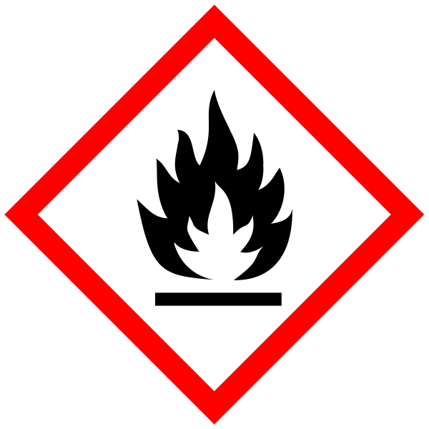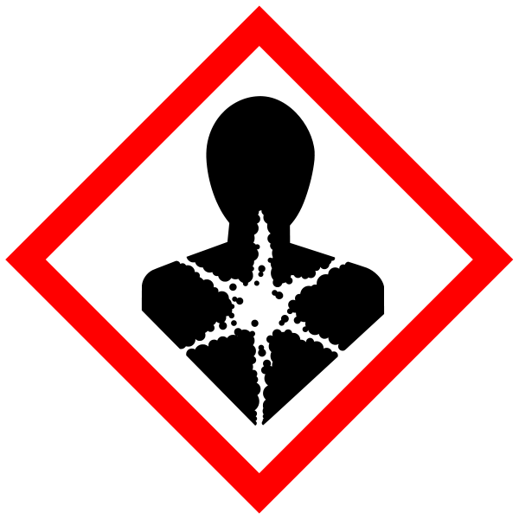
Hazard statements: H226 Flammable liquid and vapour. H312 Harmful in contact with skin. H319 Causes serious eye irritation. H332 Harmful if inhaled. H360D May damage the unborn child.

Potassium Ferrocyanide. Signal Word: None.
Hazard statement: H412 Harmful to aquatic life with long lasting effects.
NOTE: Contact with acids liberates very toxic gas.

Potassium Ferricyanide, Signal Word: None

NOTE: Contact with acids liberates very toxic gas.

Formaldehyde solution. Signal Word: Danger
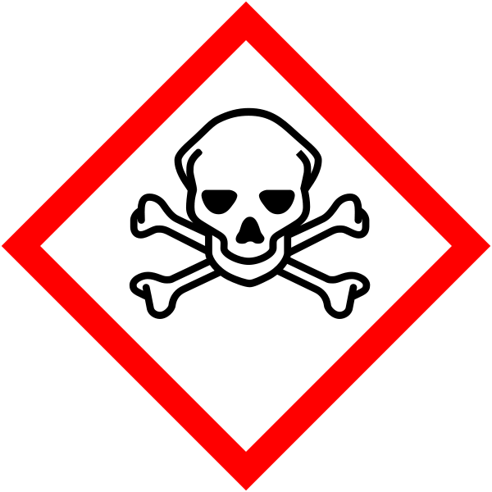
Hazard statements: H301 Toxic if swallowed. H311 Toxic in contact with skin. H314 Causes severe skin burns and eye damage. H317 May cause an allergic skin reaction. H331 Toxic if inhaled. H335 May cause respiratory irritation. H351 Suspected of causing cancer. H370 Causes damage to organs.

Methanol. Signal Word: Danger
(Hazard Statements: H225 Highly flammable liquid and vapour. H301 Toxic if swallowed. H311 Toxic in contact with skin. H331 Toxic if inhaled. H370 Causes damage to organs). Must be handled in the fume hood.

Paraformaldehyde (If this is used in place of formaldehyde solution then risk assessment TCT-10 must be read and understood). Signal Word: Danger
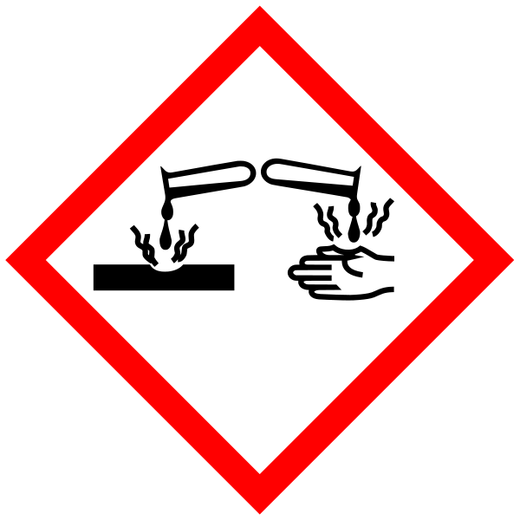
(Hazard statements: H228 Flammable solid. H302 Harmful if swallowed. H315 Causes skin irritation. H317 May cause an allergic skin reaction. H318 Causes serious eye damage. H332 Harmful if inhaled. H335 May cause respiratory irritation. H351 Suspected of causing cancer.

All the above must NOT to be disposed of via the sink – store for specialist disposal.

SOLUTIONS

X-gal stock in DMF (Made up in fumehood)
20 mg/ml X-Gal (5-bromo-4-chloro-3-indoly-beta-D-galactopyranoside) in dimethylformamide
Store -20°C
X-Gal is not stable in water and should be added to the Staining Solution just before use

Formaldehyde solution (37%) – Sigma. Note: Contains Methanol (15%). Only to be used in fumehood.

Other stocks:
100mM Potassium Ferrocyanide (K4Fe(CN)6) -fumehood
100mM Potassium Ferricyanide (K3Fe(CN)6) - fumehood
1M MgCl2
5M NaCl
Citric acid/phosphate buffer:
0.1M Citric acid
0.2M Sodium phosphate dibasic (Na2HPO4)
pH to 6.0

Staining Solution (prepare fresh)- fumehood:
1ml of X-gal solution (1mg/ml final)
1ml of 100mM potassium ferricyanide (5mM final)
1ml of 100mM potassium ferrocyanide (5mM final)
40ul of 1M MgCl2 (2mM final)
600ul of 5M NaCl (150mM final)
4ml of Citric acid/phosphate buffer (30mM final)

Solution MWt Stock Conc. Amount for 50ml
Potassium Ferrocyanide 422.39 100mM 2.11g
Potassium Ferricyanide 329.26 100mM 1.65g
Magnesium chloride 95.21 1M 4.76g
Sodium chloride 58.44 5M 14.61g

Citric acid/ 192.12 0.1M 0.96g
sodium phosphate buffer 141.96 0.2M 1.42g
pH to 6.0

Staining solution:
Final conc Total 20ml Total 50ml
X-gal 1mg/ml 1ml 2.5ml
Potassium Ferrocyanide 5mM 1ml 2.5ml
Potassium Ferricyanide 5mM 1ml 2.5ml
Magnesium chloride 2mM 40ul 100ul
Sodium chloride 150mM 600ul 1.5ml
Citric acid/ 30mM 4ml 10ml
sodium phosphate buffer
dH2O 12.36ml 30.9ml

METHOD

Wash cells 2x in PBS
Fix cells in 3% formaldehyde - RT for 5 mins In Fumehood.
Wash 2x PBS
Add staining solution for 2-16hrs @ 37C (NOT in incubator) Staining solution to be used in the fumehood.
Observe under light microscope - blue colour is indicative of SA-beta-Gal activity

Waste Disposal
Formaldehyde – put in specified waste container (labelled PFA waste).
Potassium ferrocyanide, potassium ferricyanide, dimethylformamide – put in specified waste container (labelled formamide waste)

If GM material used then the relevant GM risk assessments must be adhered to (GMRA…).

SECTION 2 - Review of assessment
The person writing the assessment and the Head of Group must sign off the assessment.

Name of assessor: Signature:…………………

Name of Head of Group: Signature:…………………

………………………………………………………………………………………..
SECTION 3 - User Declaration
I have read this laboratory procedure and COSHH risk assessment and understand the risks and the measures that must be taken to control such risks. I will notify the lab manager/head of group of any changes to the methodology described here which may affect the Health & Safety of myself or others.
NAME: Please print | SIGNATURE | DATE

