William Harvey Research Institute
Laboratory Procedure and COSHH Risk Assessment

Group:
Assessment identifier: RA-31
Date of assessment: July 2013
Date for review: August 2013
Title of Procedure: Telomere Fluorescent in situ Hybridisation
Location of Work:

Risk assessment RA-General must be followed at all times
Lab coats and Safety Glasses to be worn.

Section 1 – Description of Hazardous Material and Procedures including controls to be used

HAZARDS
Methanol. Signal Word: Danger
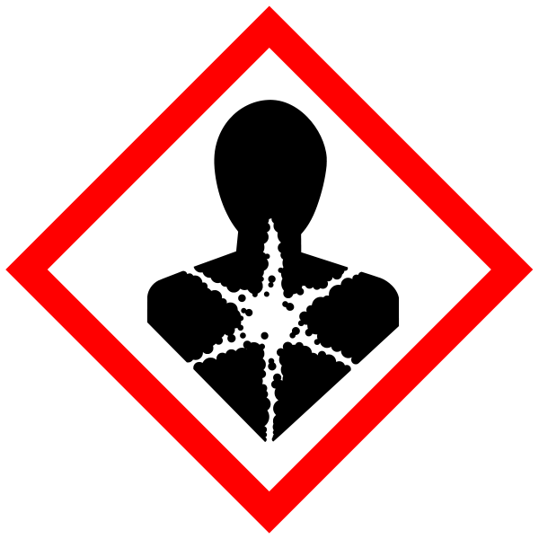
(Hazard Statements: H225 Highly flammable liquid and vapour. H301 Toxic if swallowed. H311 Toxic in contact with skin. H331 Toxic if inhaled. H370 Causes damage to organs). Must be handled in the fume hood. Waste to be collected for specialist disposal.

Acetic Acid. Signal Word: Danger

(Hazard statements: H226 Flammable liquid and vapour. H314 Causes severe skin burns and eye damage).

Formaldehyde solution. Signal Word: Danger

Hazard statements: H301 Toxic if swallowed. H311 Toxic in contact with skin. H314 Causes severe skin burns and eye damage. H317 May cause an allergic skin reaction. H331 Toxic if inhaled. H335 May cause respiratory irritation. H351 Suspected of causing cancer. H370 Causes damage to organs.

Formamide. Signal Word: Danger
Hazard statement: H360D May damage the unborn child.
Triton X100. Signal Word: Danger
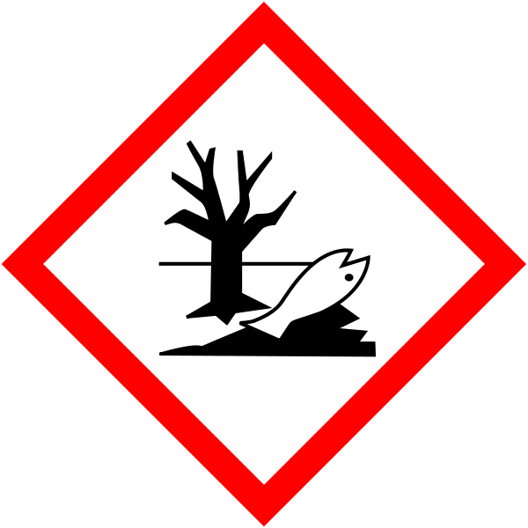
Hazard statements: H302 Harmful if swallowed. H318 Causes serious eye damage. H411 Toxic to aquatic life with long lasting effects.

DAPI. Not hazardous

Materials

Cells of interest
Cell-specific tissue culture medium supplemented with growth factors
10 µg/ml Colcemid (Life Technologies)
75 mM hypotonic KCl buffer (12.3 mM HEPES/0.53 mM EGTA/64.4 mM KCl; or commercially available from Stem Cell Technologies or Life Technologies).
3:1 (v/v) methanol/glacial acetic acid fixative (Fisher; BDH) CARE
70%, 90%, 95%, and 100% ethanol
Phosphate buffered saline, pH 7.4 (PBS; without Ca²⁺ and Mg²⁺, Stem Cell Technologies; also see recipe)
37% formaldehyde, reagent-grade (BDH) CARE – used only in Fumehood
Pepsin (Sigma-Aldrich)
1 N HCl, pH 2.0
Hybridization mixture (see recipe)
Wash solution I (see recipe)
Wash solution II (see recipe)
Mounting medium containing antifade and DAPI (see recipe) CARE
25-cm² tissue culture flasks with vented blue plug seal caps (BD)
15- and 50-ml polypropylene conical tube (Becton Dickinson)
Precleaned microscope slides for hematology and histology
Lint-free paper towels
Phase-contrast microscope
100- and 150-ml glass slide staining jars and corresponding slide rack
Coverslips (22 × 60–mm; VWR)
Thick metal plate (∼1-cm aluminum), e.g., 6 ×10–in.
80°C oven CARE
Molded plastic slide box for 25 slides (Fisher)
Parafilm
Platform shaker
Light-protected slide storage box

Recipes

BSA stock solution, 10%

PBS 10×stock solution (pH 7.4)
1 PBS tablet in 100ml = 1x
50 in 500ml = 10x

Blocking Reagent
Roche 10x Blocking Reagent

1M MgCl2 Solution
20.3g MgCl2.6H2O
dH2O to 100ml

MgCl2 Buffer
82mM NaH2PO4 (MWt 119.98)
9mM citric acid (MWt 192.12)
20mM MgCl2 hexahydrate, pH 7.4 (203.30)

1M Tris.Cl Solution
Dissolve 12.1g Tris Base in 60ml dH2O
Adjust to pH 7.4 with HCl
dH2O to 100ml

Hybridization mixture
For 100-µl mix (5 slides):
70 µl formamide (de-ionized if available) CARE – used only in fumehood
10 µl Roche Blocking Reagent
5 µl 0.1 M Tris·Cl pH 7.4
5 µl 10 µg/ml PNA Cy3-telomere probe
5 µl MgCl₂ buffer
5 µl distilled H₂O
Store up to a week at 4°C

Mounting medium
To 100 μl Fluorescent Mounting Medium, add 1 µl of DAPI stock solution (20 μg/ml in water) to give final concentration of 200 ng DAPI/ml of antifade.
Store up to a week at 4°C. CARE

Peptide nucleic acid probes
Good results will be obtained with FITC or Cy3-OO-CCCTAACCCTAACCCTAA-carboxy-terminus. More information on how to order and use PNA probes can be found at the website of Applied Biosystems (http://www.appliedbiosystems.com/).

Wash solution I made up & used in fumehood
Final volume (ml) 500 100 40
1M Tris.Cl pH 7.4 5ml 1ml 400 μl
Formamide (70% v/v final) 350ml 70ml 28ml
10% BSA (0,1% w/v final) 5ml 1ml 400 μl
dH2O 140ml 28ml 11.2ml

Check pH and adjust to pH 7.4, if necessary, with 1 M NaOH or 1 M HCl
Store up to a week at 4°C

Wash solution II
Final volume (ml) 500 100
1M Tris.Cl pH 7.4 50ml 10ml
1.5M NaCl (0.15M final) 43.83g 8.76g
Tween 20 (0.1% v/v final) 0.5ml 0.1ml
dH2O 400ml 80ml

Store up to a week at 4°C

METHODS

NOTE: All incubations are performed in a humidified 37°C, 5% CO₂ incubator unless otherwise specified. Some media (e.g., DMEM) may require altered levels of CO₂ to maintain pH 7.4.

Prepare metaphase-arrested cells
Culture cells for several days - It is important to maximize the fraction of dividing cells in order to obtain sufficient mitotic cells and metaphase cells (chromosomes) in subsequent steps.
Add 10 µg/ml Colcemid to the culture medium (final 0.05 µg/ml) prior to harvesting (1:200 dilution)
Harvest the cells by trypsinization and/or pipetting as required and transfer to 15-ml tubes.
Centrifuge cell suspension 8 to 10 min at 200 to 300 ×g, room temperature.
Remove supernatant, resuspend pellet in remaining supernatant (<0.5 ml) by vortexing the tube and add 2 to 10 ml of prewarmed (37°C) 75 mM hypotonic KCl buffer depending on the size of the pellet.
Incubate 20 to 30 min in a 37°C water bath

Fix cells
Centrifuge cells 8 to 10 min at 200 to 300 ×g, room temperature, remove all but 0.5 ml of the hypotonic KCl solution, resuspend the cell pellet by hand tapping the tube (ensure cells are re-suspended at this point BEFORE adding the fixative), and add 1 to 5 ml of fresh 3:1 methanol/glacial acetic acid fixative with a Pasteur pipet. Let stand 15 min at room temperature.
Centrifuge the tubes again as in step 7, discard supernatant, and suspend the cells in 1 to 5 ml fresh 3:1 methanol/glacial acetic acid fixative. Repeat this step one or two times until a suitable cell pellet is obtained.
A suitable preparation will show nuclei devoid of cytoplasm as judged by microscopy after dropping the cells onto slides.
After the last fixation, cells can be stored in fixative in a closed tube for at least 3 months at −20°C prior to the preparation of slides. However, typically, slides are prepared within 7 days.

Prepare Slides
Resuspend the cells in a small amount of fresh 3:1 methanol/glacial acetic acid fixative until the suspension looks slightly turbid (∼5 ×10⁶ cells/ml). Drop 3 to 4 drops evenly on a slide covered with a thin film of distilled water. After the slide is completely dry, examine with a phase-contrast microscope to check the cell density and spread of metaphase chromosomes.
If the cell density is too high, add a few more drops of fixative to the cell suspension. If the cell density is low, centrifuge the suspension and re-suspend the pellet in a smaller amount of fixative.
With a Pasteur pipet, let two drops of cell suspension fall onto each cleaned, wet slide. Mark the slide with a diamond pen or a pencil.
Air dry slide(s) overnight in the fume hood.
Pour 150 ml PBS without Ca²⁺ and Mg²⁺ in a 150-ml staining jar with a removable slide rack. Place slides in glass slide rack and immerse in PBS to rehydrate for 15 min at room temperature.

Fix slides in formaldehyde FUMEHOOD
In a fume hood, prepare 4% formaldehyde (5.4 ml of 37% formaldehyde stock solution to 50 ml 1x PBS OR dissolve 4g FA powder in boiling 90ml dH2O, and 1 drop of NaOH and add 10ml 10x PBS - See separate risk assessment TCT-10.
In the fume hood fix for 2 min. Save fixative so it can be reused in step 18.
Wash slide(s) in three changes of fresh PBS for 5 min each change.

Treat slides with pepsin (this is an optional step - seems to result in poor results)
Prepare pepsin solution by dissolving 224 mg pepsin in 224 ml of 0.01N HCl, pH 2.0 (6ml 0.37M HCl + 216ml dH2O). Pour the pepsin solution into a staining jar and equilibrate in a 37°C water bath. Prepare this solution during PBS washes (step 15).
Transfer slide(s) to pepsin solution and incubate 10 min at 37°C. Wash slides two times, 2 min each, in PBS.
Repeat the fix and wash steps (steps 17 and 18 above).
Dehydrate slide(s) in an ethanol series: 5 min each in 70%, 90%, and 100% ethanol.

Hybridize PNA probe
Leave slides in a vertical position to air dry or use air stream to dry.
Deposit two 10-µl drops hybridization mixture, with a micropipet, onto a clean 22 × 60–mm coverslip.
Gently place the slide(s) with fixed cells (upside down) on top of the coverslip (placed on a bench or glass plate). Turn slide so that coverslip faces up prior to complete spreading of the hybridization mixture between the slide and the coverslip.
Avoid introducing air bubbles by holding the slide under a slight angle prior to contacting the drops of hybridization mixture on the coverslip.

Heat denature DNA
Denature chromosomal DNA by placing the slide(s), coverslip up, on a heating block @ 80°C for 3 min (the time can be altered, but MUST be optimised). CARE
Place the slide(s) in a plastic slide box and place this box into a plastic beaker containing a damp paper towel.
Cover the beaker with Parafilm and let the sample hybridize for 1 to 2 hr at room temperature.

Wash slides
Prepare Wash Solution I and II.
In the fume hood, remove coverslips by soaking the slides in 40 ml of Wash Solution I. Use gloves and forceps to place slides back into a glass slide rack that fits into glass staining jars. Wash the slide(s) two times, 15 min each, in the remaining solution I.
Do not force the coverslips off the slides, as this will damage the cells.
Wash the slide(s) three times, 5 min each, in Wash Solution II on a platform shaker.
Dehydrate the cells 5 min each in 70%, 90%, and 100% ethanol and allow the sample to air dry.
Place two 10-µl drops of mounting medium containing anti-fade and DAPI on a fresh coverslip.
Place the sample slide(s) on top of the coverslip (as in step 22).
Lift the slide (coverslip attached) and incubate in the dark, in a light-protected slide storage box, for at least 15 min to allow DAPI staining of DNA.
The slides are now ready for analysis and can be stored in a light-protected storage box for several weeks at 4°C prior to fluorescence microscopy and Q-FISH analysis.

Telomere FISH with Antibody Labelling

(Adapted from: Richter et al. TRF2 over-expression diminishes repair of telomeric single-strand breaks and accelerates telomere shortening in human fibroblasts. Mech. Ageing Dev. (2007) vol. 128 (4) pp. 340-5)

Materials
Chamber-slides
TRF2 (H-300): sc-9143 rabbit polyclonal (Santa Cruz)

Cell Culture
Culture cells in chamber slides until at required confluence
Optional - treat with 10 μgml Colcemid (0.05 μg/ml final) XXX mins/hours prior to harvesting
Fixation
Aspirate media
Wash 2 x 5 mins in 1x PBS
Fix cells in fresh ice-cold 3:1 methanol/acetic acid for 15 mins
Wash 2 x 5 mins in ice-cold 1x PBS

Permeablization
Incubate in 1x PBS + 0.25% Triton-X for 10mins @ RT
Wash 3 x 5 mins in 1x PBS

Blocking & Incubation
Incubate slides for 30 mins with 1% BSA in PBST (PBS-Tween -- 1xPBS pH 7.4 + 0.05% Tween 20)
Incubate slides for 1 hour @ RT in a humid chamber in primary Ab diluted in 1% BSA in PBST
Aspirate primary and wash 3 x 5 mins in 1x PBS
Incubate with secondary antibody in 1% BSA for 1 hour @ RT in the dark
Aspirate secondary and wash 3 x 5 mins in 1x PBS

Hybridize Telomere PNA probe
Dehydrate slide(s) in an ethanol series: 5 min each in 70%, 90%, and 100% ethanol
Leave slides in a vertical position to air dry
2 x 10-µl drops of hybridization mixture onto a clean coverslip
Place the slide(s) with fixed cells (upside down) on top of the coverslip (placed on a bench or glass plate). Turn slide so that coverslip faces up prior to complete spreading of the hybridization mixture between the slide and the coverslip.
Denature chromosomal DNA by placing the slide(s), coverslip up, on a heating block @ 80°C for 3 min (the time can be altered, but MUST be optimised). CARE
Hybridize for 1 to 2 hr at room temperature in a humid container

Wash slides
Prepare Wash Solution I and II.
In fume hood, remove coverslips by soaking the slides in 40 ml of Wash Solution I.
Wash 2 x 15 min in the remaining solution I.
Wash 3 x 5 min in Wash Solution II on a platform shaker.
Dehydrate the cells 5 min each in 70%, 90%, and 100% ethanol and allow the sample to air dry.
Place two 10-µl drops of mounting medium containing antifade and DAPI on a fresh coverslip.
Place the sample slide(s) on top of the coverslip (as in step 22).
Lift the slide (coverslip attached) and incubate in the dark, in a light-protected slide storage box, for at least 15 min to allow DAPI staining of DNA.
The slides are now ready for analysis and can be stored in a light-protected storage box for several weeks at 4°C prior to fluorescence microscopy and Q-FISH analysis.

Action to be taken in the event of a spillage

Spillage of the acetic acid, formamide, Triton-X100 and formaldehyde – absorb onto spillage granules or paper towels and seal into an impervious bag for disposal. Notify lab manager.

Waste disposal
Formaldehyde – put in specified waste container (labelled PFA waste).
Formamide – put in specified waste container (labelled formamide waste).

Aqueous, non-toxic solutions can be disposed via the sink with plenty of water.

If GM material used then the relevant GM risk assessments must be adhered to (GMRA…).

SECTION 2 - Review of assessment
The person writing the assessment and the Head of Group must sign off the assessment.

Name of assessor: Signature:…………………

Name of Head of Group: Signature:…………………

………………………………………………………………………………………..
SECTION 3 - User Declaration
I have read this laboratory procedure and COSHH risk assessment and understand the risks and the measures that must be taken to control such risks. I will notify the lab manager/head of group of any changes to the methodology described here which may affect the Health & Safety of myself or others.
NAME: Please print | SIGNATURE | DATE

