William Harvey Research Institute
Laboratory Procedure and COSHH Risk Assessment

Group:
Assessment identifier: RA-32b
Date of assessment: July 2013
Date for review: August 2014
Title of Procedure: Whole Mount in situ Hybridisation (with Glutaraldehyde).
Location of Work:

Risk assessment RA-General must be followed at all times
Lab coats, Gloves and Safety Glasses to be worn.

Section 1 – Description of Hazardous Material and Procedures including controls to be used

After much testing it has been found that the whole mount in situ hybridisation on embryos only gives good, reliable results (fewer embryos lost through disintegration) with glutaraldehyde fixation. You must discuss your intention to use Glutaraldehyde with DSC, Steven Coppen well before starting – Health Surveillance by Occupational Health may be required required as glutaraldehyde can cause occupational asthma. The exposure limit is 0.05 ppm (0.2 mg/m³).

HAZARDS
Hydrogen peroxide: Signal Word: Danger
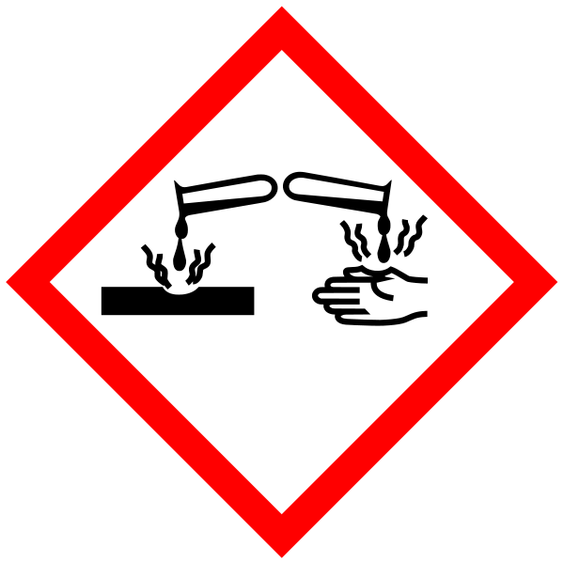
Hazard statements: H302 Harmful if swallowed. H318 Causes serious eye damage.

Paraformaldehyde: Signal Word: Danger
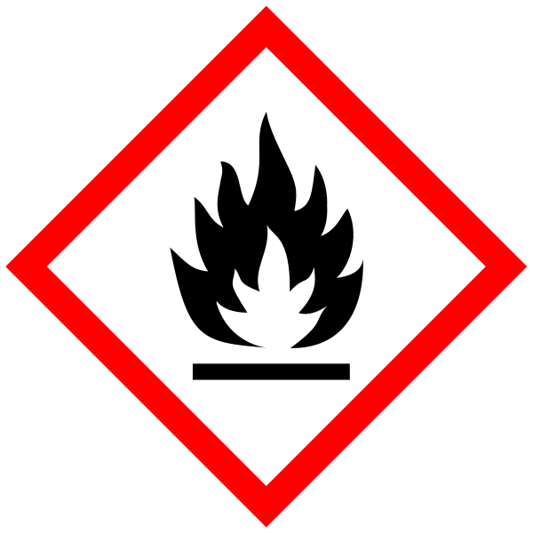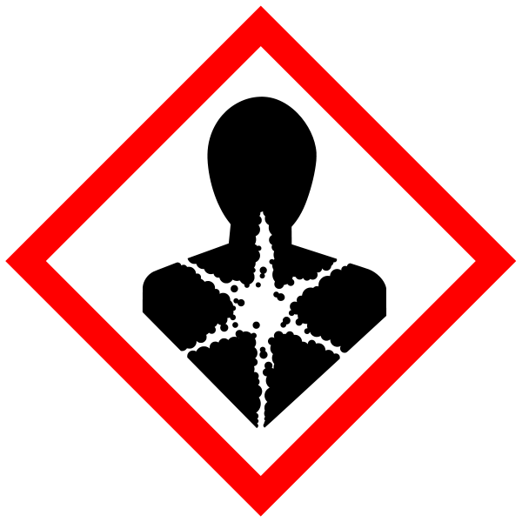
(Hazard statements: H228 Flammable solid. H302 Harmful if swallowed. H315 Causes skin irritation. H317 May cause an allergic skin reaction. H318 Causes serious eye damage. H332 Harmful if inhaled. H335 May cause respiratory irritation. H351 Suspected of causing cancer.

Formamide: Signal Word: Danger
Hazard statement: H360D May damage the unborn child.

Glutaraldehyde: Signal Word: Danger
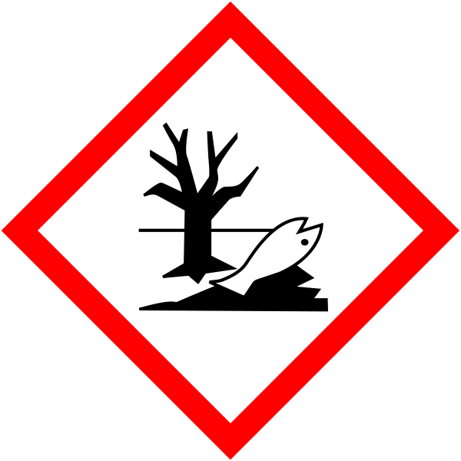
Hazard statements: H302 Harmful if swallowed. H314 Causes severe skin burns and eye damage. H317 May cause an allergic skin reaction. H332 Harmful if inhaled.
H334 May cause allergy or asthma symptoms or breathing difficulties if inhaled. H370 Causes damage to organs. H400 Very toxic to aquatic life.

Dimethyformamide: Signal Word: Danger
Hazard statements: H226 Flammable liquid and vapour. H312 Harmful in contact with skin. H319 Causes serious eye irritation. H332 Harmful if inhaled. H360D May damage the unborn child.

Phenol: Signal Word: Danger

Hazard statements: H301 Toxic if swallowed. H311 Toxic in contact with skin. H314 Causes severe skin burns and eye damage. H330 Fatal if inhaled. H341 Suspected of causing genetic defects. H373 May cause damage to organs through prolonged or repeated exposure. Fumehood. Know the spill procedure.

Chloroform: Signal Word: Warning
Hazard statements: H302 Harmful if swallowed. H315 Causes skin irritation. H351 Suspected of causing cancer. H373 May cause damage to organs through prolonged or repeated exposure. Must be used in Fume Hood

CHAPS: Toxic. Signal Word: Danger
Hazard statements: H315 Causes skin irritation. H319 Causes serious eye irritation. H335 May cause respiratory irritation. H360D May damage the unborn child.

SDS: Bought in as 20% solution to avoid using powder. Signal Word: Warning
(Hazard statements: H315 Causes skin irritation. H319 Causes serious eye irritation. H335 May cause respiratory irritation).

Sodium Hydroxide: Signal Word: Danger
(Hazard statement: H314 Causes severe skin burns and eye damage.

Methanol: Signal Word: Danger
(Hazard Statements: H225 Highly flammable liquid and vapour. H301 Toxic if swallowed. H311 Toxic in contact with skin. H331 Toxic if inhaled. H370 Causes damage to organs). Must be handled in the fume hood. Waste to be collected for specialist disposal.

Acetic Acid: Signal Word: Danger
(Hazard statements: H226 Flammable liquid and vapour. H314 Causes severe skin burns and eye damage).

Glutaraldehyde, Paraformaldehyde, Formamide, Dimethylformamide, Phenol, Chloroform and Methanol must only be used in the fume cupboard. Disposal of these substances must be by a specialist, therefore all waste must be collected and stored in the correct “labelled” containers.

Solutions
•PBS
(20 x PBS stock)
Na2HPO4-12H2O | 28.7g 57.4g
NaH2PO4-2H2O | 3.3g 6.6g
NaCl | 85.0g 170.0g
milli-Q H2O | 450ml 900ml
Total | 500ml 1000ml

Preparing DIG incorporated ribo-probes for whole mount in situ hybridization

1. Digest plasmids* containing from 0.5 to 0.7kbp insert with 5’-protruding restriction enzyme: at 5’ end of insert for antisense probe, and at 3’ end for sense probe. *use a vector with RNA polymerase promoter such as pGEM or pBS

plasmid | 5ug
buffer | 10ul
H2O
BSA or Triton-X100 if necessary
Restriction enzyme | 20+20U
Total | 100ul
At first, add 20U enzyme and incubate for two hours and then add more 20U enzyme and incubate for two hours.

- Protinase K Treatment
Add
template DNA | 100ul
2M Tris (pH7.5) | 8ul
10% SDS | 20ul
10mg/ml ProtenaseK | 4ul
dH2O | 68ul
Total | 200ul

20ul of 10% SDS, 8ul of 2M Tris (pH7.5), 68ul of dH2O and incubate for 30min at 37°C

The alternative Detergent mix:

 | Finalconc
NP40 (IPGAL), (10% ) | 1.0 % | 0.5 ml
SDS (10%) | 1.0 % | 5.0 ml
Deoxycholate (Na salt*) (5% in H2O) | 0.5 % | 5.0 ml
Tris-Cl pH 8.0, (2M) | 50mM | 0.65 ml
EDTA pH8.0, (0.5M) | 1.0 mM | 0.1 ml
NaCl (5M) | 100μg/ml | 1.25 ml
DEPC H2O |  | 37.5 ml
 | Total | 50 ml
*Sodium Deoxycholate is easy to dissolve in H20 while Deoxycholate can dissolve in H2O in addition to 500 ul of 10N NaOH. If Deoxycholate powder is used, add it in H2O and Tris. It is hard to dissolve in lower pH than 7.5 and high salt condition. Protect from light.

Phenol/Chloroform extraction twice and then once with Chloroform. In Fumehood. Know the location of the phenol spill kit and what to do in the event of a phenol spill before starting work.
All waste containing phenol to be stored in labelled container for specialist disposal.
Chloroform waste stored in designated waste bottle.

- Add 20ul of NaOAc and 400ul of Ethanol then precipitate by centrifugation 15000rpm for 15min. Rinse with 70% Et-OH and dissolve in 10ul TE (RNA grade).
- Polymerase reaction
Warm the 4 components (*) listed below to room temperature in order to avoid the possibility that the template DNA may be precipitated by the high concentration of spermidine in the transcription buffer.

*template DNA | 2μl
*H2O | 10μl
*transcription buffer 5x (10x) | 4μl (2μl)
*10x DIG mix | 2μl
RNase inhibitor (40U/ul) | 1μl
RNA polymerase (10U/ul) | 1μl
Total | 20μl
mix gently but do not vortex, then spin down.
Incubate for 1-2 hours at 37°C for T3 and T7 , and at 40°C for SP6.
*Order of adding solutions is important.

- Ethanol precipitate
add 1ul of EDTA/LiCl sol.(Ambion), or 1ul of 0.5M EDTA and 8M LiCl
and then add 75ul Et-OH.
15000rpm, 15min.
rinse with 70% Et-OH and dissolve in 100μl of H2O
Repeat once more (5μl of EDTA/LiCl and 375μl Et-OH).

- Dissolve in 50ul of H20 and add 0.5ul of RNase inhibitor (40U/μl). Store at -20°C (non defrost freezer) or -80°C.
- Alkaline hydrolysis
(optional) In the case that insert length is longer than 1 kbp, hydrolyzing the probe will make the signal stronger.
0.2M Na2CO3 (212mg/10ml)
0.2M NaHCO3 (168mg/10ml)
mix two solutions above and stored at -20°C (PK box, for in situ regents)
- Add 50μl of Na2CO3/Na2HCO3 mix to 50ul of RNA probe in 7
- incubate for time T* at 60°C.
*: T={(starting kb)-(desired kb)}/{0.11 x (starting kb) x (desired kb)}
usually desired kb is 0.5
add 3μl of 3M NaOAc (pH5.0) and 5μl of 10% glacial Acetic acid
and Precipitate by adding 375μl of Et-OH.

Products (in 7 and 8) should be confirmed by electorophoresis with 1% gel which is prepared just before use.

This protocols was modified from of Domingos Henrique and David Ish-Horowicz, ICRF Dev. Biol. Unit, Oxford, UK.
Note hybridization in much reduced salt concentration (i.e. at high stringency) and omission of RNAse digestion. This gives specificity, sensitivity and low background.

Dissections
1. Dissect embryos in PBS; remove as much of the extra-embryonic membranes as possible.
2. Fix in 10ml 4% paraformaldehyde in PBS, 4°C (Prepare just before use), o/n. (Can use MEMFA buffer for Xenopus.)
3. Wash twice in PBT.
4. Wash with 50% MeOH/ PBT, 75% MeOH/ PBT, then 100% MeOH twice; can store at this point at –20 or -80°C (for less than one month).

Pretreatments and HYBRIDIZation
5. Rehydrate embryos through 75%, 50%, MeOH/ PBT (allowing embryos to settle).
6. Incubate in 6% H2O2 in PBT at RT for 1hr and rinse twice with PBT
Either:

EARLY STAGE EMBRYOS
7. Treat with 10% SDS (in place of proteinase K):
For mice: 6.5 days – 5min at RT; thereafter 5min extra/day up to 10.5d.
7.5 days – 10 min; 8.5 days – 15-20 min ; 9.5 days – 20-35 min;
10.5 days – 30-45 min; 11.5 days – 35-50 min.
For chick embryos, time of incubation in min ≈ stage no.Xenopus: gastrulae – 10min; neurulae – 15min; >stage 25 – 30min.
8. Remove SDS, rinse briefly (care !) with 2mg/ml glycine in PBT, and then once with PBT.
Go to step 9

Or
LATE STAGE EMBRYOS
7. Treat with 10μg/ml proteinase K in PBT:
For mice: 6.5 days – 5min at RT; thereafter 5min extra/day up to 10.5d.
7.5 days – 10 min; 8.5 days – 15-20 min ; 9.5 days – 20-35 min;
10.5 days – 30-45 min; 11.5 days – 35-50 min.
For chick embryos, time of incubation in min ≈ stage no.Xenopus: gastrulae – 10min; neurulae – 15min; >stage 25 – 30min.

8. Remove proteinase, rinse briefly (care !) with 2mg/ml glycine in PBT, and then once with PBT.

9. Post-fix for 20min in 4% PFA + 0.2% Glutaraldehyde in PBT.
If glutaraldehyde is used – this MUST be contained in the fumehood at all times using the minimum volume necessary (0.75ml in this case). Waste must be collected and stored for specialist disposal.

10. Rinse and wash twice with PBT.
11. Rinse with 0.5 ml hybridization mix (for ~9.5 dpc embryos). Let embryos settle.
12. Replace with 0.5 ml hybridization mix and incubate horizontally ≥1h/65°C (for Xenopus, we used 60°C here and in subsequent high temperature incubations).
• [Can store at -20°C before or after prehybridizing. Do not repeat freezing and thawing in this hybridization mix. Signals will decrease and backgrounds will increase. For long term storage or repeating freezing and thawing, the hybridization mix described in Wilkinson’s protocol works better than this hybridization mix. Embryos can be stored in Wilkinson’s mix for more than several years and back grounds do not increase after freezing and thawing.

13. Add 1μl of DIG-labelled RNA probe @ ~μg/ml (possibly 0.1 µg/ml is enough). Immediately place at 65°C .

14. Incubate o/n on a tube stand at 65°C (60°C for Xenopus) [Rocking.].
Hybridization mix:
 | Final concn.
Formamide (Fluka 47670) | 50% | 25ml
SSC (20x pH5 w citric acid!!) | 1.3xSSC | 3.25ml
EDTA (0.5M, pH8) | 5mM | 0.5ml
Yeast RNA (50mg/ml) (Sigma R-6625) | 50μg/ml | 50μl
Tween-20 (10%) | 0.2% | 1ml
CHAPS (10%) | 0.5% | 2.5ml
Heparin (50mg/ml) (Sigma H-7005) | 100μg/ml | 100μl
H2O |  | 17.5ml
 | Total | 50ml

• All steps (2-9) are carried out in 1ml solution in 1.5ml microtube (clear type) During hybridization, 1.5ml tube works well. and have no problem. 2ml microtube may better for rocking embryos order than 9.5dpc. In this recipe, rinses are immediate, and washes are for 5min unless otherwise stated.
• Between step5 and 8, (after treatment of protease) embryos are so fragile that solutions should be carefully put in and out and embryos should not be move vigorously.
• 4% paraformaldehyde/PBS (PFA) should be made on day of use when embryos were dissected and fixed. For fixation after protease treatment, PFA made before day can use.

Post-HYBRIDIZation washes
1. Rinse twice with prewarmed (65°C) hybridization mix.
2. Wash 2 x 30 min/65°C with 1.5ml prewarmed hyb mix.
3. Wash 10 min/65°C with 1.5ml prewarmed 1:1 hyb mix/MABT.
4. Rinse 2x with 1.5ml MABT (=100mM Maleic acid, 150mM NaCl, pH7,5, 0.1% Tween-20).
5. Wash 1 x 15min with 1.5ml MABT
6. Incubate 1h w 1.5ml MABT + 2% Boehringer Blocking Reagent (BBR).
7. Incubate ≥1h in 1.5ml MABT + 2% BBR + 20% heat-treated serum
8. Incubate o/n at 4°C (or 4h at RT) in (fresh) 1ml MABT + 2% BBR + 20% serum + 1/2000 dilution of AP-anti-DIG antibody (Boehringer).

5xMAB(T)= | Maleic Acid (M-0375) | 11.6g | 29.0g
 | NaCl | 8.7g | 21.8g
 | Tween-20 | 11g | 27.5g
 | H2O | ~185ml | 411ml
 | 10N NaOH (NaOH crystal) | 20.5ml (8g) | 51ml (20g)
 | Total | 200ml | 500ml
[Weigh, dissolve and pH maleic acid before adding other ingredients].
*: If the solution is autoclaved, Tween-20 will be add after autoclaving
• Steps 2 and 3: incubate in oven with the tubes horizontal. Steps 5-8: roll at room temperature.
• After each 65°C wash, let embryos settle by incubating tube vertically at 65°C in a heating block, then change supernatants individually so samples don't cool. Keep wash solutions at 65°C in water-bath.
• Sheep serum is heat-treated at 55-60°C, 30 min and stored in quick-frozen aliquots at –20°C. Thawed aliquots can be stored at 4°C with addition of azide to 0.1% (See risk assessment RA-7).
• Boehringer Blocking Reagent (#1096 176). Make 10% stocks in MAB (no Tween) heating to dissolve, then autoclave, aliquot and freeze. Works better than "embryo powder", and is easier and more reproducible to make. We have used MABT thereafter for consistency, but maleate does not buffer well, and alternative buffers probably substitute as well or better.

Post-antibody washes and histochemistry
1. Rinse 3 times with 1.5ml MABT. Transfer to glass scintillation vial.
2. Wash 3x1h with 10-20ml MABT, by rolling.
3. Wash 2x10 min with 10-20ml NTMT.
4. Incubate with 1.5ml NTMT + 4.5l/ml NBT (75mg/ml in Dimethyl Formamide) + 3.5μl/ml BCIP (X-phosphate; 50mg/ml in 70% DMF). Rock for first 20min, then incubate at room temp. for 30min to 3days. Optional: doubling the NBT and BCIP concentration speeds up staining and doubles the cost. (Optional: staining develops faster at 37°C but monitor very careful).
5. When colour has developed to the desired extent, rinse 1x and wash ≥2x with PBT. Refix in 4% Paraformaldehyde/PBT for 2h (at room temp) or o/n (at 4°C). Rinse 1x and wash 2x 10min with PBT. Store at 4°C in PBT + 0.1% azide (See risk assessment RA-7).

NTMT: | 5M NaCl | 1ml
 | 2M TrisHCl pH9.5 | 2.5ml
 | 2M MgCl2 | 1.25ml
 | 10% Tween-20 | 5ml
 | H20 | 40.25ml
 | Total | 50ml

Make from stocks on day of use. NB, final Tween concentration is 1%.
• [Can re-use antibody; store with 0.025% azide.]
• Final note: Though not necessary in our hands, reducing the salt during hybridization (to 1xSSC) may improve background further. Washes at higher stringency are irrelevant because, once formed, mismatch RNA-RNA hybrids never melt.
• Hybridization for two O/N will improve strength of signainput.docling

SECTION 2 - Review of assessment
The person writing the assessment and the Head of Group must sign off the assessment.

Name of assessor: Signature:…………………

Name of Head of Group: Signature:…………………

………………………………………………………………………………………..
SECTION 3 - User Declaration
I have read this laboratory procedure and COSHH risk assessment and understand the risks and the measures that must be taken to control such risks. I will notify the lab manager/head of group of any changes to the methodology described here which may affect the Health & Safety of myself or others.
NAME: Please print | SIGNATURE | DATE

