William Harvey Research Institute
Laboratory Procedure and COSHH Risk Assessment

Group:
Assessment identifier: RA-33
Date of assessment: July 2013
Date for review: August 2013
Title of Procedure: In Situ Hybridisation on Tissue Sections
Location of Work:

Risk assessment RA-General must be followed at all times
Lab coats and Safety Glasses to be worn.

Section 1 – Description of Hazardous Material and Procedures including controls to be used

This assessment is for In Situ hybridisation as carried out on tissue cryo-sections (See Risk Assessment RA-12).

Main Hazards

Formamide: Signal Word: Danger
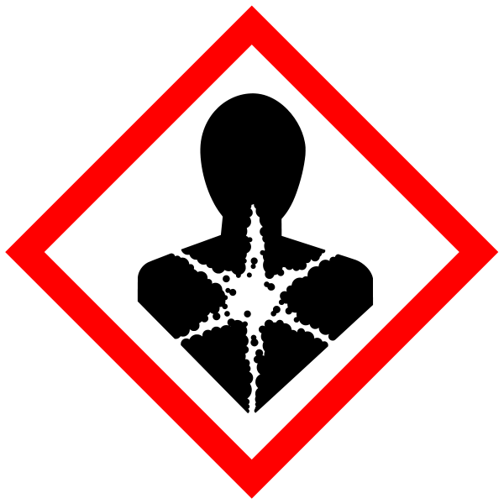
Hazard statement: H360D May damage the unborn child.

Acetic Anhydride: Signal Word: Danger
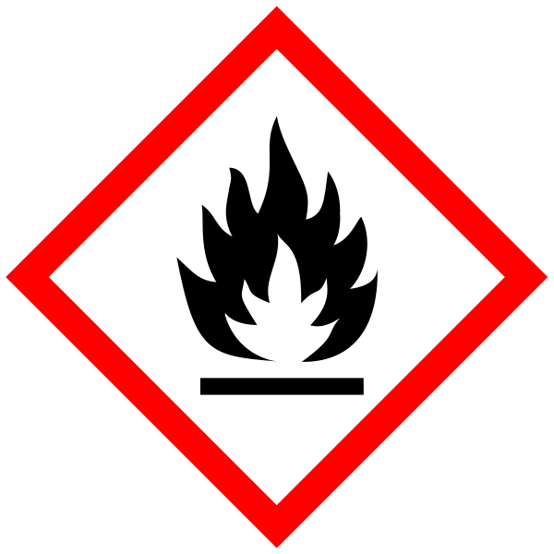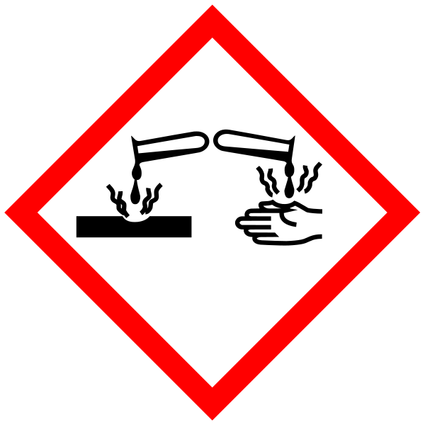
Hazard statements: H226 Flammable liquid and vapour. H302 Harmful if swallowed. H314 Causes severe skin burns and eye damage. H332 Harmful if inhaled.

Concentrated Hydrochloric acid: Signal Word: Danger
Hazard statements: H314 Causes severe skin burns and eye damage. H335 May cause respiratory irritation.

Paraformaldehyde (PFA): Signal Word: Danger
(Hazard statements: H228 Flammable solid. H302 Harmful if swallowed. H315 Causes skin irritation. H317 May cause an allergic skin reaction. H318 Causes serious eye damage. H332 Harmful if inhaled. H335 May cause respiratory irritation. H351 Suspected of causing cancer. (See Risk Assessment RA-10). Waste to be collected.

Triethanolamine (TEA): Not Hazardous

Levamisole: Signal Word: Danger
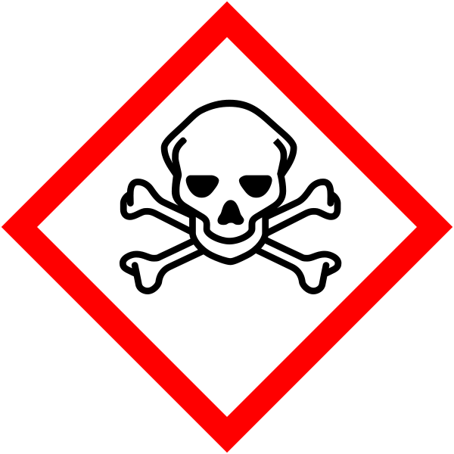
Hazard statement: H301 Toxic if swallowed. Waste collected (Formamide waste).

Protocol

All the chemicals listed above must only be used in a fumehood and disposed as described.

RNA probe preparation

1. In vitro transcription reaction mixture (total 20ul)
dH2O* 10ul
5 X buffer 4ul
DIG RNA labelling mixture 2ul
Purified template DNA (1ug/ul)** 1ul
RNase inhibitor (40 U/ul) 1ul
T3 or T7 RNA polymerase (10U/ul) 2ul
*Do not use DEPC water. **Plasmid is cut by appropriate restriction enzyme (5' overhanging or 5' blunt end is required).
2. Incubate for 90min at 37°C.
3. Check the probe with agarose gel electrophoresis.
4. If the amount of DIG-labelled riboprobe is not adequate, add more 1 ul of RNA polymerase, and incubate for more 1hour. Check the probe with mini-gel.
5. Add
RNase inhibitor (40 U/ul) 1ul
t-RNA (10ug/ul) 2ul
TE 78ul
2M NaOAc (pH 5.2) 10ul
100% EtOH 250ul
* LiCl is better than NaOAc. Contamination of template DNA is no problem.
** Rnase free DNase I treatment is also OK.
*** Contaminating nucleotides may generate the background signal.
If so, column purification enables us to reduce this background signal.

6. 20min，-80°C.
7. 80% EtOH wash, twice.
8. Suspend in 50ul of DEPC H2O.
9. Store at -80°C.

Pre-treatment of sections FUMEHOOD, Store waste for disposal

1. Refix in 4% paraformaldehyde (PFA)/PBS for 15 min at RT.
Without this step, section will be degraded completely!
2. Rinse in PBS for 2min.
3. Incubate in Proteinase K/proK buffer or PBS at 37°C.
Usually, 15 min incubation is OK.
proK buffer: 10mM Tris-HCl pH 8.0/1mM EDTA pH 8.0
4. Refix in 4% PFA/PBS for 10min at RT.
5. Rinse in PBS for 2min.
6. Incubate in 0.2M HCl for 10 min.
7. Rinse in PBS for 1min.
8. Incubate in 0.1M Triethanolamine (TAE)-HCl pH8.0 for 1min.

for 150ml TEA(Sigma) 2ml
conc.HCl(Sigma) 0.54ml
DEPC H2O to 150ml

9. Acetylation.
Incubate in 0.1M TEA-HCl pH 8.0/0.25% Acetic Anhydride for 10min.

for 150ml TEA (Sigma) 2ml
conc. HCl(Nacalai) 0.54ml
Acetic anhydrite 375ul
DEPC H2O to 150ml
10. Rinse in PBS for 2min.
11. Dehydrate in ethanol series, 15 seconds each
70%, 80%, 90%, 100%, 100%
12. Air dry completely.

Hybridization

1. Prepare Hybridization solution in FUMEHOOD
50% Formamide, 5xSSC pH 5.0, 1%SDS, 50ug/ml yeast tRNA, 50ug/ml Heparin
100 ul is required for each section.

for 1ml
Formamide(Merck) 500ul
20xSSC pH5.0 250ul
10% SDS 100ul
10mg/ml tRNA 5ul
20mg/ml Heparin 2.5ul
DEPC H2O (142.5-x)ul
probe xul

2. Dilute probe with hybridization solution up to 1ug/ml.
Usually x1/100 dilution gets this concentration.
If the background signal is high, try to use lower concentration probe (up to 100ng/ml).
3. Denature probe at 85°C for 5min.
4. Prepare the moisture chamber. This Moisture chamber must be RNA grade.
5. Apply the probe mixture onto the slides.
6. Cover the sections with parafilm.
7. Incubate at 55°C for 16hours in moisture chamber.

Wash

From here onwards, RNA garde is not required.
1. Dislodge parafilm in 5xSSC pH 5.0 at 55°C. Correct disposal required.
2. FUMEHOOD Incubate in 50% formamide/2xSSC pH 5.0 at 55°C for 15min. Correct disposal required.
3. Incubate in TNE at 37°Cfor 5min.
for 500ml 2M Tris-HCl pH8.0 2.5ml
5M NaCl 50ml
0.5M EDTA pH8.0 1ml
dH2O to 500ml
4. Incubate in 10ug/ul of RNase A in TNE at 37°C for 30min.
Do not throw away RNase contaminated solution into the sink in the lab!
5. Incubate in TNE at 37°C for 5min.
6. Incubate in 2xSSC pH5.0 at 50°C for 15min, twice.
7. Incubate in 0.2xSSC pH5.0 at 50°C for 20min, twice.

Immunodetection

1. Incubate in TBST at RT for 5min.
2. Incubate in 1%blocking reagent/MABT for 60min at RT.
3. Prepare a moisture chamber (non-RNA grade).
- Apply x1/2000 diluted anti-DIG Ab-AP/1%blocking reagent/MABT and incubate 60min at
RT or at 4°C overnight in moisture chamber.
5. Incubate in 2mM levamisole/MABT for 10min at RT. X2 Correct disposal required
6. Incubate in 2mM levamisole/APB for 15min at RT. Correct disposal required

For 150ml of 2mM levamisole /APB
5M NaCl 3ml
1M MgCl2 7.5ml
2M Tris-HCl pH9.5 7.5ml
10% Tween20 1.5ml
2M levamisole 150ul
dH2O to 150ml
- Apply BM purple substrate precipitate (Roche) on slide and incubate in humid chamber at 37°C for several hours.
8. Check colour development.
9. If positive signal is not obvious, incubate overnight.
10. Check colour development.
11. If positive signal is not obvious, wash the slides in APB-lev, replace the BM purple substrate, and incubate at 37°C. Up to 3~4 o/n.
12. If the colour intensity is good enough, stop reaction in TE or PBS.
13. Dehydrate→Mount

Appendix

20XSSC pH5.0:
Sodium Citrate (3Na・2H2O) 88.2g
NaCl 175.3g
dH2O to 1000ml
acidified with 1M Citrate
10XTBST:
NaCl 16g
KCl 0.4g
2M Tris-HCl (pH 7.5) 25ml
10% Tween20 20ml
dH2O to 200ml

tRNA (Sigma R8759) 10mg
Heparin: Sigma
Proteinase K (PCR grade): Roche 3115887
Formamide : Merck 1.09684.1000 (4°C)

2M levamizole levamizole-HCl (Sigma L-9756) 2.408g
dH2O 5ml
Store at -20°C.

Triethanolamine Sigma

5xMAB(T)= | Maleic Acid (M-0375) | 11.6g | 29.0g
 | NaCl | 8.7g | 21.8g
 | Tween-20* | 11g | 27.5g
 | H2O | ~185ml | 411ml
CARE | 10N NaOH (NaOH crystal) | 20.5ml (8g) | 51ml (20g)
 | Total | 200ml | 500ml

[Weigh, dissolve and pH maleic acid before adding other ingredients].
* If the solution is autoclaved, Tween-20 will be add after autoclaving

Action to be taken in the event of a spillage

Spillage of formamide, and formaldehyde (should only occur within the fumehood) – absorb onto spillage granules or paper towels and seal into an impervious bag for disposal. Notify lab manager.
Acetic anhydride will readily decompose to acetic acid and can be disposed via the sink with plenty of water.

SECTION 2 - Review of assessment
The person writing the assessment and the Head of Group must sign off the assessment.

Name of assessor: Signature:…………………

Name of Head of Group: Signature:…………………

………………………………………………………………………………………..

SECTION 3 - User Declaration
I have read this laboratory procedure and COSHH risk assessment and understand the risks and the measures that must be taken to control such risks. I will notify the lab manager/head of group of any changes to the methodology described here which may affect the Health & Safety of myself or others.
NAME: Please print | SIGNATURE | DATE

