William Harvey Research Institute
Laboratory Procedure and COSHH Risk Assessment

Group:
Assessment identifier: RA- 34
Date of assessment: July 2013
Date for review: August 2013
Title of Procedure: Use of 5-Azacytidine
Location of Work:

Risk assessment RA-General must be followed at all times
Lab coats and Safety Glasses to be worn.

Section 1 – Description of Hazardous Material and Procedures including controls to be used

To induce the differentiation of various primary cells (e.g., bone marrow cells (BMC), embryonic stem cells) into cardiac-like cells, the cells will be grown in culture medium containing a maximum of 2.5mg/L of 5-Azacytidine.

5-Azacytidine. Signal Word: Danger
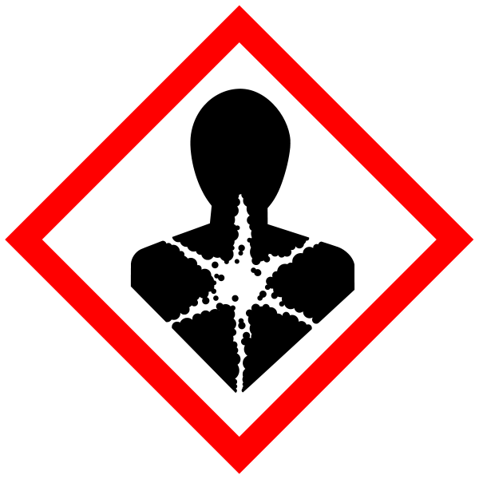
Hazard statements: H302 Harmful if swallowed. H350 May cause cancer.

See also Cell Culture assessment, TCT-4.

GM regulations (GMRA…) need to be followed if cells are isolated from transgenic animals (e.g. GFP expressing animals).

All staff are to be made aware of the risks.

The 5-Azacytidine is to be solubilised in the bottle in which it is supplied – DO NOT weigh out powder. (10ml acetic acid/water (1:1) for 100mg). The solution is then aliquoted and stored frozen in clearly labelled vials in a storage box. The 5-azacytidine will be added to cell culture medium to give the required concentration – NO GREATER than 2.5mg/L which will then be added to the BMC cells.

Disposal

5-azacytidine is unstable in aqueous solution. 10% loss in 2-3 hours at room temperature. Culture at 37°C will speed up the degradation.

Spent medium will be collected, stored in a clearly labelled, closed container, prior to flushing down the sink with plenty of water 2 days later.

SECTION 9 - Review of assessment
The person writing the assessment and the Head of Group must sign off the assessment.

Name of assessor: Signature:…………………

Name of Head of Group: Signature:…………………

………………………………………………………………………………………..
SECTION 3 - User Declaration
I have read this laboratory procedure and COSHH risk assessment and understand the risks and the measures that must be taken to control such risks. I will notify the lab manager/head of group of any changes to the methodology described here which may affect the Health & Safety of myself or others.
NAME: Please print | SIGNATURE | DATE

