William Harvey Research Institute
Laboratory Procedure and COSHH Risk Assessment

Group:
Assessment identifier: RA-35
Date of assessment: July 2013
Date for review: August 2014
Title of Procedure: SilverQuest Silver staining kit
Location of Work:

Risk assessment RA-General must be followed at all times
Lab coats, Safety Glasses and Gloves to be worn.

Section 1 – Description of Hazardous Material and Procedures including controls to be used

This is a commercially supplied kit for the staining of proteins in polyacrylamide gels and is compatible with mass spectrometry.
Full protocol instructions are given in the instruction booklet provided with the kit and the user must read and understand the protocols given prior to starting the procedure.

The main hazards and required controls are included in this risk assessment. If the protocol used is different from the manufacturer’s then this risk assessment must be updated to include any changes made.

Main Hazards

SilverQuest Sensitizer: Contains N,N-Dimethylformamide: Signal Word: Danger
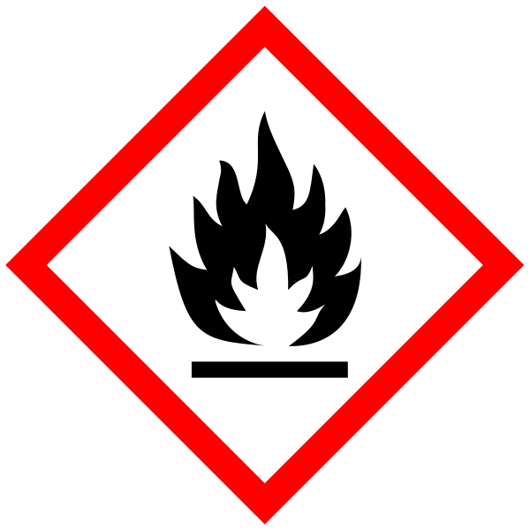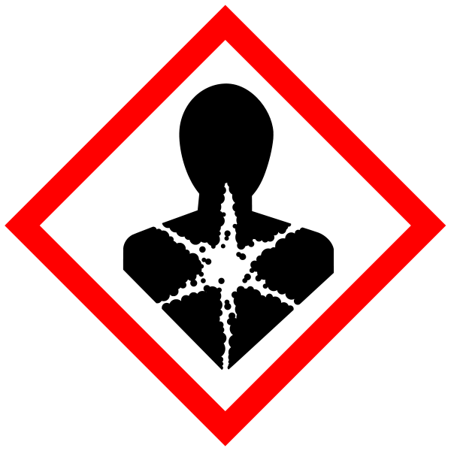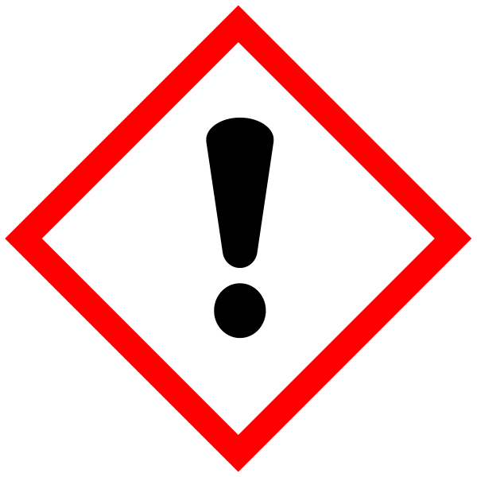
Hazard statements: H226 Flammable liquid and vapour. H312 Harmful in contact with skin. H319 Causes serious eye irritation. H332 Harmful if inhaled. H360D May damage the unborn child. Solutions to handled in a fumehood. Waste must be collected.

SilverQuest Stainer: Contains silver nitrate: Signal Word: Danger
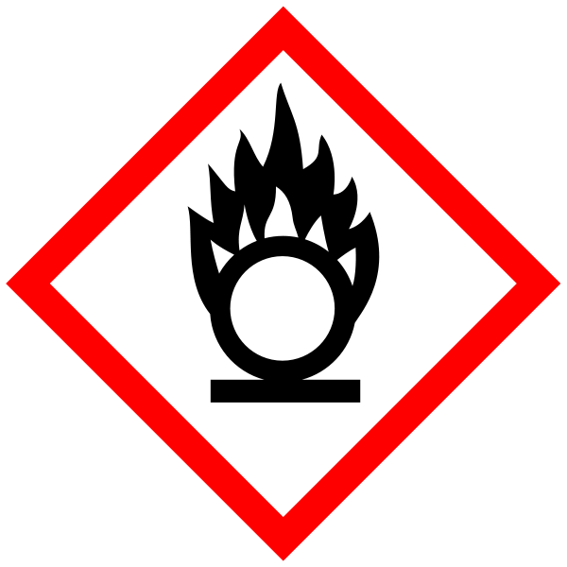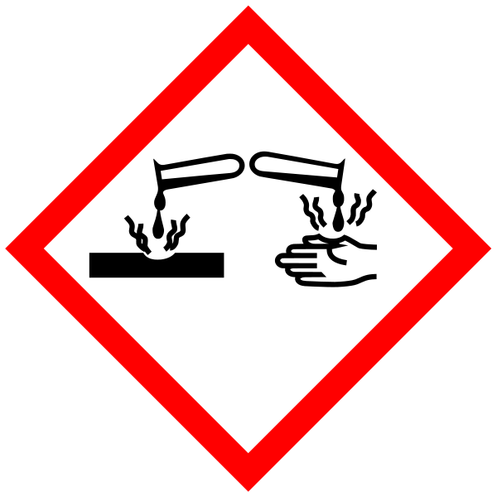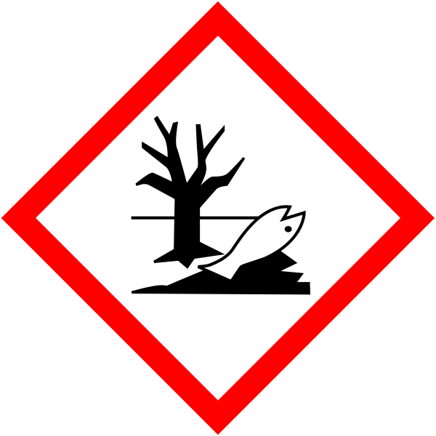
Hazard statements: H272 May intensify fire; oxidiser. H314 Causes severe skin burns and eye damage. H410 Very toxic to aquatic life with long lasting effects. Waste must be collected.

SiverQuest Developer enhancer: Contains formaldehyde: Signal Word: Danger
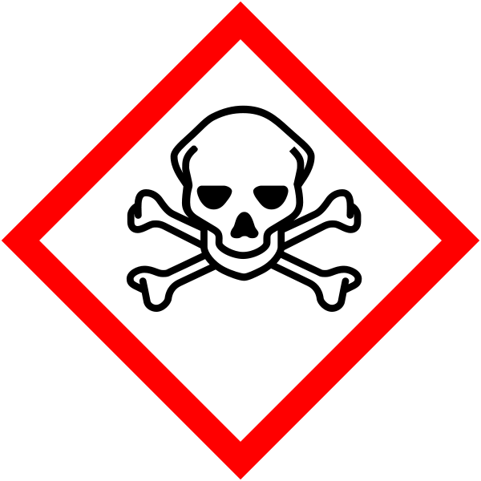
Hazard statements: H301 Toxic if swallowed. H311 Toxic in contact with skin. H314 Causes severe skin burns and eye damage. H317 May cause an allergic skin reaction. H331 Toxic if inhaled. H335 May cause respiratory irritation. H351 Suspected of causing cancer. H370 Causes damage to organs. Must only be used in a fumehood. Waste must be collected.

Methods

Staining protocols are given in the manufacturer’s user manual. All warning given in the manual should be followed. In addition the following controls should be adhered to:
SilverQuest Sensitizer should be transported in a closed container and the solutions decanted in a fumehood. Waste must be stored for specialist disposal (with formamide waste).
Waste SilverQuest Stainer must be stored for specialist disposal (separate container).
SilverQuest Developer Enhancer must only be used in a fumehood. Waste must be stored for specialist disposal (with formaldehyde waste).

Waste Disposal

As described above for sensitiser, stainer and enhancer. All other solutions can be disposed via the sink with plenty of running water.
Spillage of sensitizer, stainer or enhancer solutions should be absorbed onto spillage granules or paper towels, sealed in bag/container and stored for specialist disposal.

SECTION 2 - Review of assessment
The person writing the assessment and the Head of Group must sign off the assessment.

Name of assessor: Signature:…………………

Name of Head of Group: Signature:…………………

………………………………………………………………………………………..
SECTION 3 - User Declaration
I have read this laboratory procedure and COSHH risk assessment and understand the risks and the measures that must be taken to control such risks. I will notify the lab manager/head of group of any changes to the methodology described here which may affect the Health & Safety of myself or others.
NAME: Please print | SIGNATURE | DATE

