William Harvey Research Institute
Laboratory Procedure and COSHH Risk Assessment

Group:
Assessment identifier: RA-36
Date of assessment: July 2013
Date for review: October 2014
Title of Procedure: Telomere Analysis in Clinical Samples
Location of Work:

Risk assessment RA-General must be followed at all times
Lab coats, gloves and Safety Glasses must be worn.

Section 1 – Description of Hazardous Material and Procedures including controls to be used

DNA will be isolated from blood from recruited patients for the analysis of telomere length and telomerase activity.

HAZARDS
Human blood. Following QMUL policy these should be classed as Hazard group 2. Therefore all manipulation of the blood after collection must be in the Class 2 microbiological safety cabinet in lab 213.

Blood samples will be taken at Barts and the London Hospital and transferred to the laboratory in secondary containment within a cooler bag. Samples will be processed within 24 hours of collection. Blood samples will be stored in the Fridge (…) in lab ….

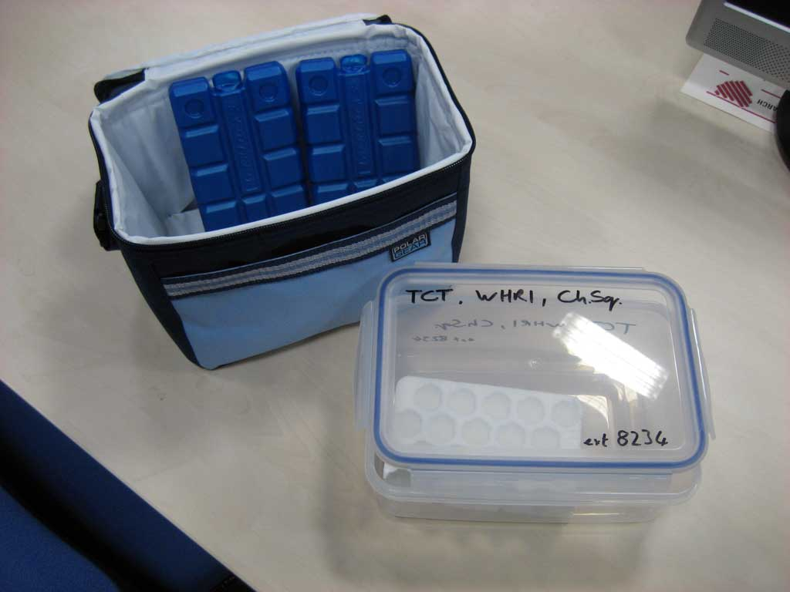

PROCEDURE (once in Lab …)

Sharps (needles, blades) must not be used. Glassware must not be used.
Make sure fellow workers are aware that you are working with clinical samples and what to do in the event of a spillage.

Samples to be transported from storage fridge (…) to the microbiological safety cabinet in secondary containment.

For all centrifuge steps – tubes must be loaded into buckets in the safety cabinet and bucket lids attached. Likewise, at the end of a spin the whole buckets must be taken to the safety cabinet for unloading.

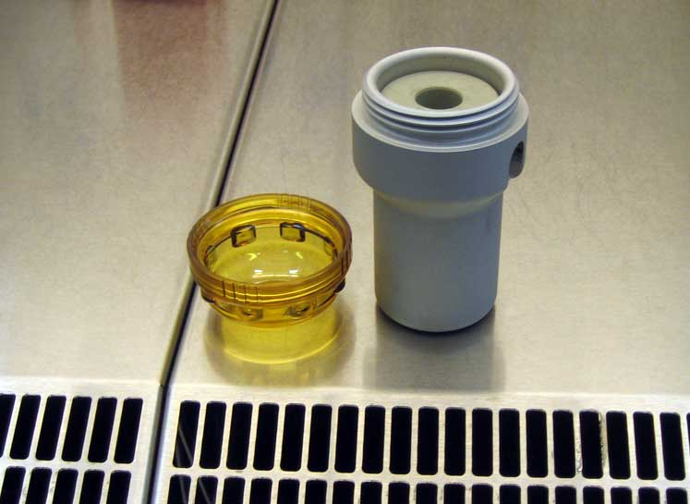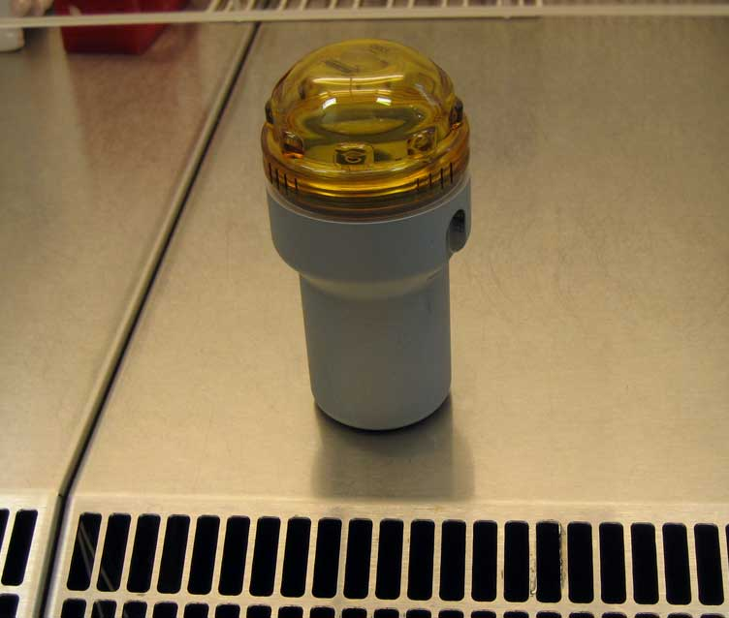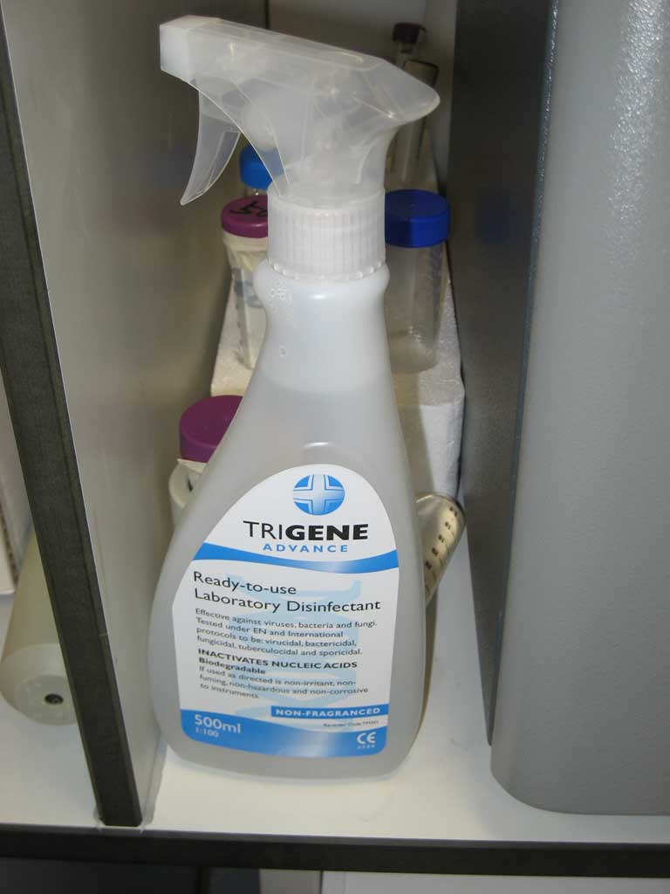

Centrifuge must be cleaned with Distel (new name for Trigene) at the end of each day.

1. Isolation of peripheral blood lymphocytes – “Buffy Coats”

Equipment:
- Sigma Accuspin Tubes (A1805)
- 1ml sterile cryovials
- 3ml sterile Pasteur pipettes
- 10ml serological pipettes
- 15ml sterile Falcons
- Laminar flow hood

Reagents:
- RPMI 1640 media (Sigma R0883)
- Pen/strep, 100X (Sigma P0781)
- L-Glutamine, 200mM (Sigma F2442)
- Dimethylsulphoxide (Sigma D2650)
- Histopaque-1077 (Sigma H8889) – must be stored in the dark at 4°C

Solution Preparation:
Wash Mix (used to wash cells, and as a base for the freeze mix)
- To a 500ml bottle of RPMI 1640 add
- 5ml Pen/Strep
- 5ml 200mM L-glutamine

Freeze Mix (50ml)
- 30ml Wash Mix
- 15ml FBS
- 5ml DMSO
- Store 50ml aliquot at -20°C

Method
Isolation of lymphocytes
- Fresh blood taken into citrate tubes
- Blood CAN be stored at 4°C for 2-3 days – NO LONGER
- Remove Wash Mix and Histopaque from fridge and allow to warm to room temperature (Histopaque must be kept in the dark)
- Thaw sufficient Freezer Mix for the volume of blood samples
- Add 3ml Histopaque-1077 to the Accuspin tubes and centrifuge at 800g for 30 seconds. The Histopaque will be below the fret
- Briefly spin the Accuspin tube to ensure the Histopaque is below the fret (why – what was the point of the previous spin)
- Mix/shake the blood
- Add 5ml to labelled Accuspin tube – use as many tubes as required (i.e. 4 tubes if we have 20ml blood). Perform this step in a flow-hood.
- Centrifuge at 2,500rpm for 20 mins at room temperature

- If the monocyte/lymphocyte layer is NOT totally separated from the red blood cells, spin again for longer

- If the blood has been in the fridge for longer than 3 days then even after a longer spin the separation may still be poor. In this case add 2ml Histopaque to a fresh Accuspin tube (that already contains 3ml i.e. 5ml Histopaque in total) and carefully transfer the layered sample and repeat the spin
- A clear lymphocyte layer should now be apparent

Collection of lymphocytes
- Using a 3ml sterile pastette pipette carefully remove the uppermost layer of fluid (plasma) and discard into a disposal jar (see waste disposal below).
- Transfer the lymphocyte layer to a 15 ml centrifuge tube.
- Alternatively you can carefully pipette out the lymphocyte layer from beneath the plasma layer and transfer it to a 15ml centrifuge tube.

Cryopreservation of lymphocytes
- Once cells have been transferred, they require washing. Add enough pre-warmed Wash Mix to fill the tube (approx 14mls).
- Centrifuge at 1,000 r.p.m (210xg) for 10 minutes at room temperature.
- Discard the supernatant (see waste disposal below).
- Label two cryovials.
- Using a pipette, gently resuspend the cells in 2ml of Freezer Mix and aliquot 1ml into each of the labelled cryovials.
- Place tubes into Mr Frosty and place in the -80°C overnight – this must be done ASAP as prolonged exposure to the DMSO in Freeze Mix will kill the cells
- On the following day transfer vials to liquid nitrogen for long-term storage

2. Genomic DNA isolation from 1-2ml Buffy Coats

Isolation of genomic DNA from the previously prepared Buffy Coats is performed using QIAgen FlexiGene Kits (QIAgen 51206).

Anticipated yield is approximately 240 μg per 1ml Buffy Coat (based on 3x10⁷ white cells/ml).

All spins are carried out at room temperature in a swing-out rotor using conical tubes.

Once DNA has been isolated – work can continue on the normal bench.

HAZARDS
Buffer FG2: Contains guanidine hydrochloride: Signal Word: Warning

(Hazard statements: H319 Causes serious eye irritation. H315 Causes skin irritation. H302 Harmful if swallowed).

QIAGEN Protease: Contains subtilisin: Signal Word: Danger
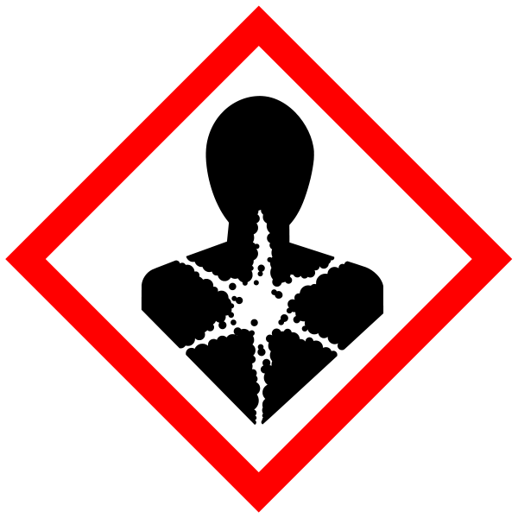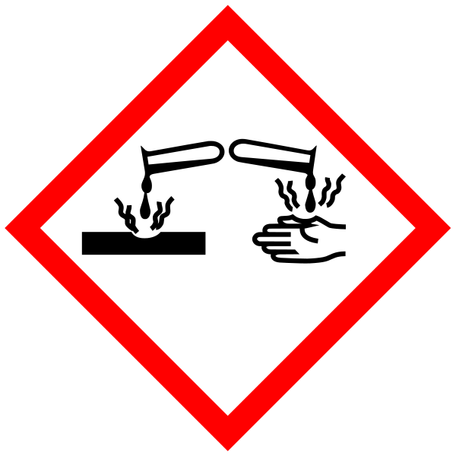
Hazard statements: H315 Causes skin irritation. H318 Causes serious eye damage. H334 May cause allergy or asthma symptoms or breathing difficulties if inhaled. H335 May cause respiratory irritation.

Reagents volumes per volume of Buffy Coat:

 | 1.0ml | 1.5ml | 2.0ml
Buffer FG1 (ml) | 2.5 | 3.75 | 5.0
Buffer FG2/QIAgen Protease (ml) | 1.0 | 1.5 | 2.0
100% isopropanol (ml) | 1.0 | 1.5 | 2.0
70% ethanol (ml) | 1.0 | 1.5 | 2.0
Buffer FG3 (μl) | 300 | 350 | 400

Things to do BEFORE starting:
- Frozen Buffy Coat should be thawed quickly in a 37°C water bath with mild agitation and stored on ice prior to starting the DNA isolation
- Resuspend the lyophilized QIAgen Protease in the following volumes of FG3 (hydration buffer):
- 0.3 ml when using 50 ml FlexiGene DNA Kit
- 1.4 ml when using the 250 ml FlexiGene DNA Kit.
- Dissolved QIAGEN Protease should be stored at 2–8°C (short-term) or in aliquots at –20°C (long-term)
- Calculate the total volume of Buffy Coat to be processed. For every 1ml of Buffy Coat mix 1ml Buffer FG2 (Denaturation Buffer) and 10μl reconstituted QIAgen Protease. This mixture should be prepared within one hour of use
- Set heating block or water bath to 65°C

Volumes of Buffer FG2 and QIAgen Protease required for different batch volumes:

Total volume of Buffy Coat in batch (ml) | 1 | 3 | 5 | 10 | 30 | 50 | 60
Volume of Buffer FG2 (ml) | 1 | 3 | 5 | 10 | 30 | 50 | 60
Volume of QIAgen Protease (μl) | 10 | 30 | 50 | 100 | 300 | 500 | 600

Method
- Pipet 5 ml Buffer FG1 into a 15 ml centrifuge tube. Add 2 ml buffy coat and mix by inverting the tube 5 times
- Centrifuge for 5 min at 2000 x g in a swing-out rotor
- Discard the supernatant (see waste disposal below). and leave the tube inverted on a clean sheet of absorbent paper for 2 min, taking care that the pellet remains in the tube.

Note: In rare cases the pellet may be loose, so pour slowly. Inverting the tube onto absorbent paper minimizes backflow of supernatant from the rim and sides of the tube onto the pellet.

- Add 2 ml Buffer FG2/QIAGEN Protease (see “Things to do before starting”), close the tube, and vortex immediately until the pellet is completely homogenized. Inspect the tube to check that homogenization is complete.
- Note: When processing multiple samples, vortex each tube immediately after addition of Buffer FG2/QIAGEN Protease. Do not wait until buffer has been added to all samples before vortexing.
- Usually 3–4 pulses of high-speed vortexing for 5 s each are sufficient to homogenize the pellet. However, traces of pellet with a jelly-like consistency (often barely visible) may remain. If these traces are seen, add a further 300 μl Buffer FG2 and vortex again.
- Invert the tube 3 times, place it in a heating block or water bath, and incubate at 65°C for 10 min.
- Add 2 ml isopropanol (100%) and mix thoroughly by inversion until the DNA precipitate becomes visible as threads or a clump.
- Note: Complete mixing with isopropanol is vital to precipitate the DNA and must be checked by inspection.
- Centrifuge for 3 min at 2000 x g.
- Note: If the resulting pellets are loose, centrifugation can be prolonged or a higher g-force can be used.
- Discard the supernatant (CARE – do NOT add virkon, safe to dispose down sink with plenty of water) and briefly invert the tube onto a clean piece of absorbent paper, taking care that the pellet remains in the tube.

Note: In rare cases the pellet may be loose, so pour slowly.

- The DNA should be visible as a small white pellet.
- Add 2 ml 70% ethanol and vortex for 5 s.
- Centrifuge for 3 min at 2000 x g.
- Note: If the resulting pellets are loose, centrifugation can be prolonged or a higher g-force can be used.
- Discard the supernatant and leave the tube inverted on a clean piece of absorbent paper for at least 5 min, taking care that the pellet remains in the tube.

Note: In rare cases the pellet may be loose, so pour slowly. Inverting the tube onto absorbent paper minimizes backflow of ethanol from the rim and sides of the tube onto the pellet.
- Air-dry the DNA pellet until all the liquid has evaporated (at least 5 min).

Note: Avoid over-drying the DNA pellet, since over-dried DNA is very difficult to dissolve.

- Add 400 μl Buffer FG3, vortex for 5 s at low speed, and dissolve the
- DNA by incubating for 1 h at 65°C in a heating block or water bath.

Note: If the DNA is not completely dissolved, prolong the incubation until the DNA is dissolved. If a reduced volume of Buffer FG3 is used, incubation may need to be prolonged.

WASTE DISPOSAL
All liquid waste to be inactivated using virkon (1% final concentration) – incubation for minimum 30 minutes (overnight for preference).
All plastic waste to be soaked in virkon (1%) for 30 minutes minimum prior to disposal via clinical waste.

ACCIDENT/SPILLAGE PROCEDURES
In the event of spillage of the clinical samples use the Biohazard spill kit as per instructions – Familiarise yourself with the instructions (below) prior to starting the work.

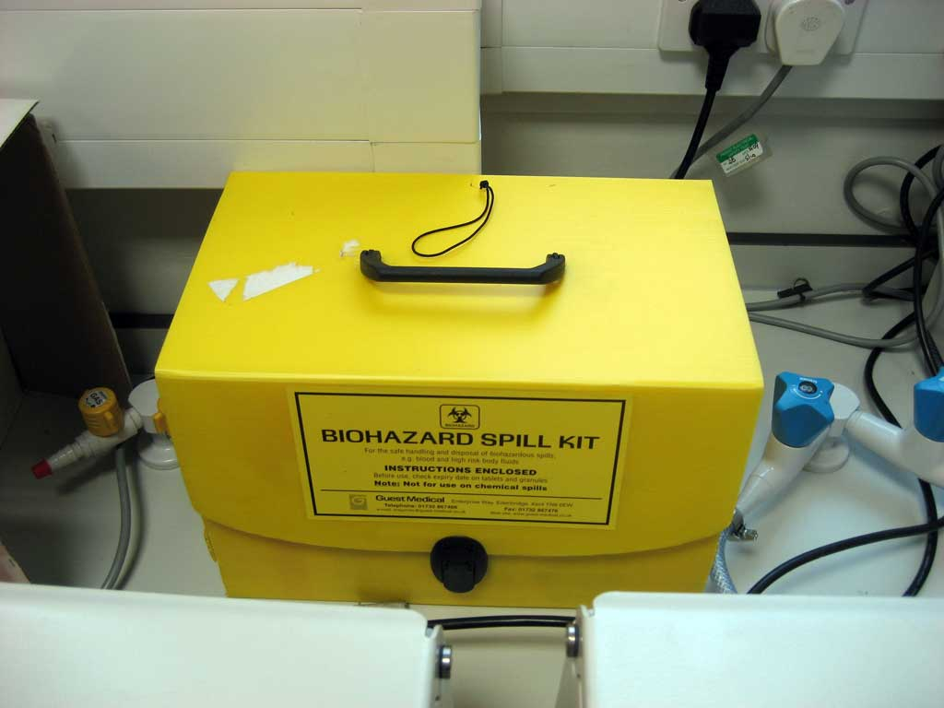

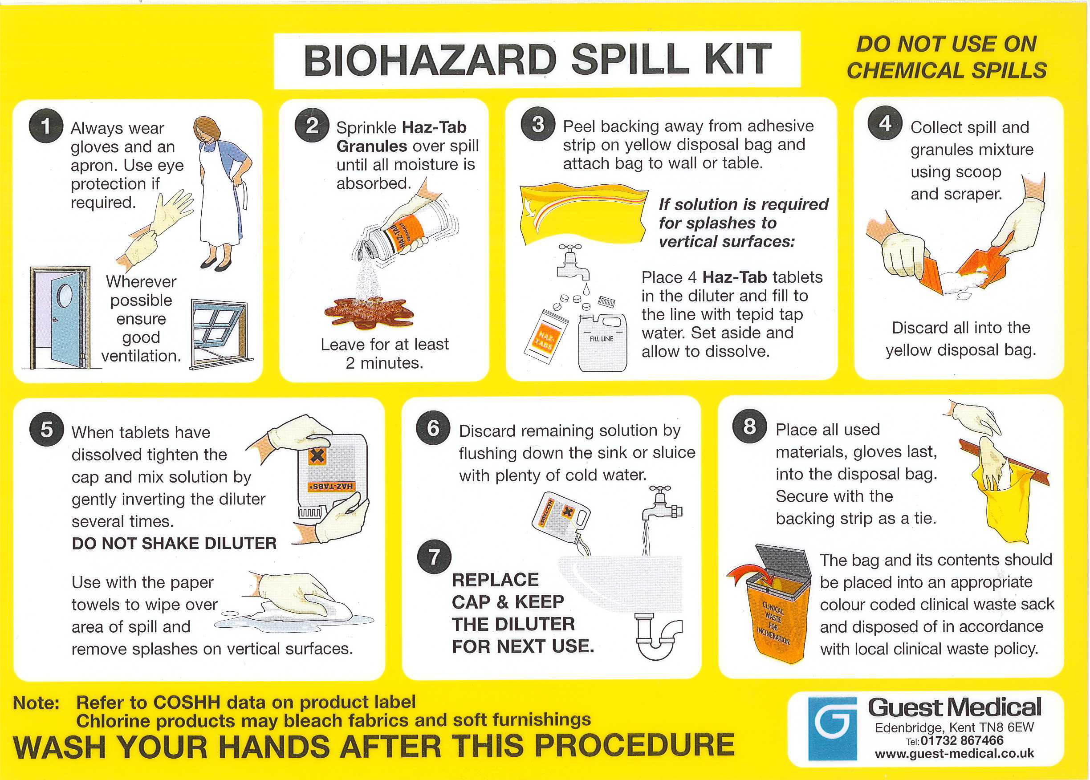

In the event of a splash incident (to your eyes or mouth) follow the first aid instructions at the end of this assessment – also posted in the laboratory.

In the event of centrifuge failure – the centrifuge must be switched off, left closed overnight with warning not to open. Next day – wearing full PPE, open centrifuge with emergency mechanism, spray with Distel, close – leave for 20 minutes. Open and wipe up with paper towel – dispose via clinical waste

SECTION 2 - Review of assessment
The person writing the assessment and the Head of Group must sign off the assessment.

Name of assessor: Signature:…………………

Name of Head of Group: Signature:…………………

………………………………………………………………………………………..
SECTION 3 - User Declaration
I have read this laboratory procedure and COSHH risk assessment and understand the risks and the measures that must be taken to control such risks. I will notify the lab manager/head of group of any changes to the methodology described here which may affect the Health & Safety of myself or others.
NAME: Please print | SIGNATURE | DATE

SHARPS OR SPLASH INCIDENTS
First Aid
For contaminated sharps / needlestick incidents
Encourage bleeding by squeezing where skin is punctured
Wash thoroughly with soap and warm water; do not use a scrubbing brush or alcohol hand rub.

For fluid splashes
If eyes or broken skin areas are involved irrigate immediately with water.

If mouth is involved rinse with plenty of water but do not swallow.

After a contaminated sharps or splash injury contact:

During working hours (Monday to Friday 09.00-16.00)
The Occupational Health Service at:
Ground Floor Geography Building, Mile End Campus
Reception: 0207 882 8700

Out of working hours
16.00 – 09.00 Monday - Friday, Weekends and Bank Holidays
Go to the nearest Accident and Emergency Department.
Inform the Occupational Health Service as soon as you can.

Have available details of the substance involved in the exposure
e.g. the risk assessment.

Contact the Occupational Health Service
tel: 0207 882 8700

Complete an Accident and Dangerous Occurrence Report form.

