William Harvey Research Institute
Laboratory Procedure and COSHH Risk Assessment

Group:
Assessment identifier: RA-37
Date of assessment: July 2013
Date for review: August 2014
Title of Procedure: β-Gal Labelling of Embryos
Location of Work:

Risk assessment RA-General must be followed at all times
Lab coats and Safety Glasses to be worn.

Section 1 – Description of Hazardous Material and Procedures including controls to be used

You must discuss your intention to use Glutaraldehyde with Steven Coppen well before starting – Health Surveillance by Occupational Health may be required as glutaraldehyde can cause occupational asthma. The exposure limit is 0.05 ppm (0.2 mg/m³).

HAZARDS

Glutaraldehyde: Signal Word: Danger
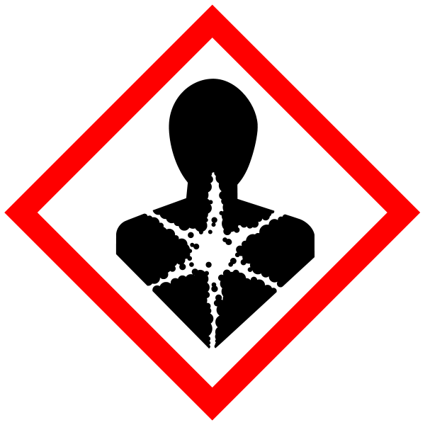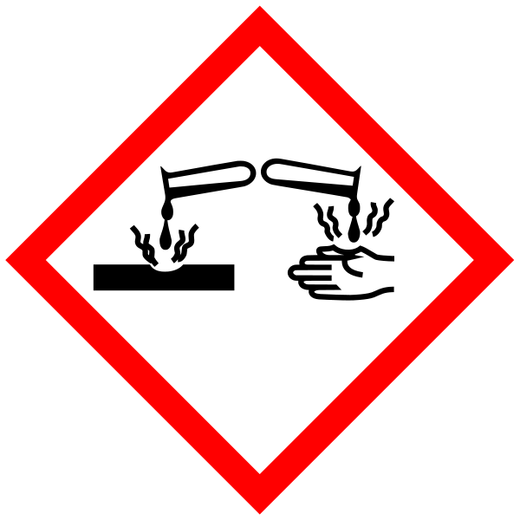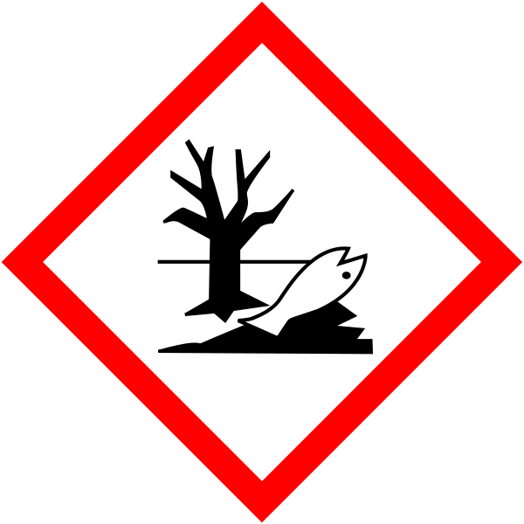
Hazard statements: H302 Harmful if swallowed. H314 Causes severe skin burns and eye damage. H317 May cause an allergic skin reaction. H332 Harmful if inhaled. H334 May cause allergy or asthma symptoms or breathing difficulties if inhaled. H370 Causes damage to organs. H400 Very toxic to aquatic life.

Paraformaldehyde (If this is used in place of formaldehyde solution then risk assessment RA-10 must be read and understood). Signal Word: Danger
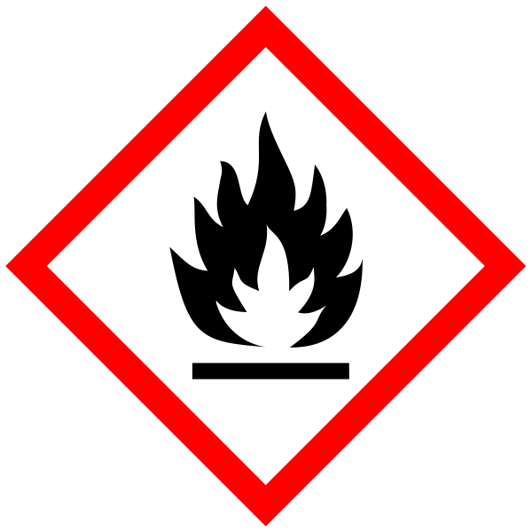
(Hazard statements: H228 Flammable solid. H302 Harmful if swallowed. H315 Causes skin irritation. H317 May cause an allergic skin reaction. H318 Causes serious eye damage. H332 Harmful if inhaled. H335 May cause respiratory irritation. H351 Suspected of causing cancer.

Methanol. Signal Word: Danger
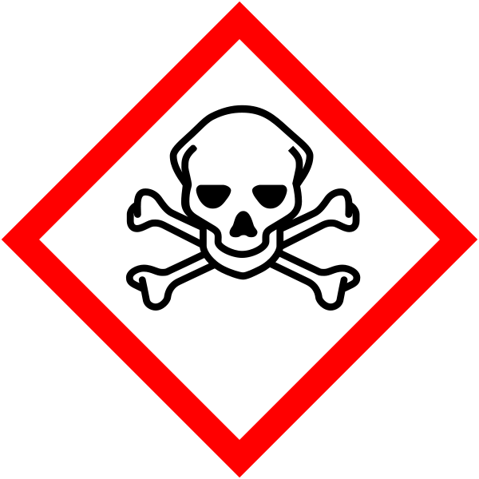
(Hazard Statements: H225 Highly flammable liquid and vapour. H301 Toxic if swallowed. H311 Toxic in contact with skin. H331 Toxic if inhaled. H370 Causes damage to organs). Must be handled in the fume hood.

Potassium Ferrocyanide. Signal Word: None.
Hazard statement: H412 Harmful to aquatic life with long lasting effects.
NOTE: Contact with acids liberates very toxic gas.

Potassium Ferricyanide, Signal Word: None
NOTE: Contact with acids liberates very toxic gas.

All the above must NOT to be disposed of via the sink – store for specialist disposal.

SOLUTIONS

Chemicals
1. 25% glutaraldehyde solution ( Nakarai #170-03, storege at 4oC )
2. 4% PFA, prepare before use.
3. X-Gal stock sol. (Sigma, Nova-biochem or Wako)
4. K-ferricianide (K3Fe(CN)6, MW329)
5. K-ferrocianide (K4Fe(CN)6・3H2O, MW422)
6. 10% NP40
7. 1M MgCl2
8. PBS
9. PBS-0.02% NP40 (PBN)
10. PBS-0.02% NP40-2mM EDTA (PBN-EDTA)

Fixative: PGN
1%PFA (4%PFA: 2.5ml)
0.2% glutaraldehyde (25% glutaraldehyde: 80ul)
0.02% NP40 (10% NP40: 20ul)
in PBS /total vol. 10ml

Solution A (stock)
A solution
K-ferri : 164.6mg (4mM)
K-ferro : 211.0mg (4mM)
1M MgCl2 : 200ul
in PBS (pH7.3)/ total 100ml
Stored at -20oC. Do not repeat freezing and thawing.

X-Gal stock sol. (40mg/ml in DMSO, stored at -20oC)

Staining solution: 10ul of X-Gal in 400ul A-sol. Prepare it just before use.
*Both X-Gal and A-sol stocks must be protected from light at -20 oC

Procedure
1. Rinse embryos in PBS
2. Fix in the freshly prepared PGN for 10 min at Room Temp. or for more than 15min on ice ( for 7.5-8.5dpc embryos).
3. Rinse them in PBN for 5 min. three times.
4. Stain in the staining solution protected from light at 37 oC (a few hours - over night) or at 30oC for over night (The back ground is less at 30 oC.).
5. Rinse PBN-EDTA four times
6. Fix in 4% PFA or 10% formalin sol. For taking photograph, after fixation, dehyderate with Mt-OH/PBT series and incubate in 50% glycerol and then store 80% glycerol at 4 oC.
Note: Me-OH dehydration slightly decreases the staining.

Waste Disposal

Glutaraldehyde, Paraformaldehyde and Methanol must only be used in the fume cupboard. Disposal of these substances must be by a specialist therefore all waste must be collected and stored in the correct “labelled” containers. Potassium ferrocyanide, potassium ferricyanide, dimethylformamide – put in specified waste container (labelled formamide waste)

If GM material used then the relevant GM risk assessments must be adhered to (Suzuki GM1.1, Suzuki GM 1 bsu in vitro and Suzuki GM 2 lentivirus).

SECTION 2 - Review of assessment
The person writing the assessment and the Head of Group must sign off the assessment.

Name of assessor: Signature:…………………

Name of Head of Group: Signature:…………………

………………………………………………………………………………………..
SECTION 3 - User Declaration
I have read this laboratory procedure and COSHH risk assessment and understand the risks and the measures that must be taken to control such risks. I will notify the lab manager/head of group of any changes to the methodology described here which may affect the Health & Safety of myself or others.
NAME: Please print | SIGNATURE | DATE

