William Harvey Research Institute
Laboratory Procedure and COSHH Risk Assessment

Group:
Assessment identifier: RA- 38
Date of assessment: July 2013
Date for review: August 2014
Title of Procedure: Tamoxifen Administration
Location of Work:

Risk assessment RA-General must be followed at all times
Lab coats and Safety Glasses to be worn.
All local BSU rules must be followed in the BSU.

Section 1 – Description of Hazardous Material and Procedures including controls to be used

To induce recombination and gene expression in Cre recombinant mice, Tamoxifen is administered orally to the mice.

Hazards

Tamoxifen. Signal Word: Danger
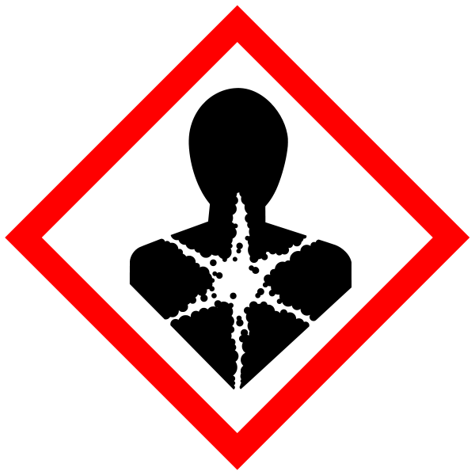
Hazard statements: H350 May cause cancer. H360 May damage fertility or the unborn child. H362 May cause harm to breast-fed children.
All staff are to be made aware of the hazards.

Preparation of 10 mg/ml stock solution
0.2g of Tamoxifen is dissolved in 20 ml of PEANUTS oil in a 50ml conical tube covered with aluminum foil (to protect from light). It takes a few hours on shaker at RT. Stored at 4C ( or -20C). Option: Dispense into aliquots in 2ml tube and store at 4C or 20C.

Administration of Tamoxifen (Tmx)
Feeding of the Tmx solution is better than SQ or IV injection.
Quick absorbency of Tmx, less stress for mice and shorter stay of the hormone in the mother, which reduce side effects of Tmx on development of embryos.
Cf. International Journal of Pharmaceutics 313 (2006) 144–149
Feeding needle (1.5 -2 inch ) is necessary .

Dose of Tamoxifen |  | 10mg/m peanuts oil Stock solution
Dose of Tmx/10g |  | 0.4mg/10g | 0.8mg/10g | 1.0mg/10g | 1.2mg/10g
(body weight) |  | 100% | 200% | 250% | 300%
15 |  | 0.06 | 0.12 | 0.15 | 0.18
16 |  | 0.064 | 0.128 | 0.16 | 0.192
17 |  | 0.068 | 0.136 | 0.17 | 0.204
18 |  | 0.072 | 0.144 | 0.18 | 0.216
19 |  | 0.076 | 0.152 | 0.19 | 0.228
19.5 |  | 0.078 | 0.156 | 0.195 | 0.234
20 |  | 0.08 | 0.16 | 0.2 | 0.24
20.5 |  | 0.082 | 0.164 | 0.205 | 0.246
21 |  | 0.084 | 0.168 | 0.21 | 0.252
21.5 |  | 0.086 | 0.172 | 0.215 | 0.258
22 |  | 0.088 | 0.176 | 0.22 | 0.264
22.5 |  | 0.09 | 0.18 | 0.225 | 0.27
23 |  | 0.092 | 0.184 | 0.23 | 0.276
23.5 |  | 0.094 | 0.188 | 0.235 | 0.282
24 |  | 0.096 | 0.192 | 0.24 | 0.288
24.5 |  | 0.098 | 0.196 | 0.245 | 0.294
25 |  | 0.1 | 0.2 | 0.25 | 0.3
25.5 |  | 0.102 | 0.204 | 0.255 | 0.306
26 |  | 0.104 | 0.208 | 0.26 | 0.312
27 |  | 0.108 | 0.216 | 0.27 | 0.324
28 |  | 0.112 | 0.224 | 0.28 | 0.336
29 |  | 0.116 | 0.232 | 0.29 | 0.348
30 |  | 0.12 | 0.24 | 0.3 | 0.36
31 |  | 0.124 | 0.248 | 0.31 | 0.372
32 |  | 0.128 | 0.256 | 0.32 | 0.384
33 |  | 0.132 | 0.264 | 0.33 | 0.396
34 |  | 0.136 | 0.272 | 0.34 | 0.408
35 |  | 0.14 | 0.28 | 0.35 | 0.42
36 |  | 0.144 | 0.288 | 0.36 | 0.432
37 |  | 0.148 | 0.296 | 0.37 | 0.444
38 |  | 0.152 | 0.304 | 0.38 | 0.456

SECTION 9 - Review of assessment
The person writing the assessment and the Head of Group must sign off the assessment.

Name of assessor: Signature:…………………

Name of Head of Group: Signature:…………………

………………………………………………………………………………………..
SECTION 3 - User Declaration
I have read this laboratory procedure and COSHH risk assessment and understand the risks and the measures that must be taken to control such risks. I will notify the lab manager/head of group of any changes to the methodology described here which may affect the Health & Safety of myself or others.
NAME: Please print | SIGNATURE | DATE

