William Harvey Research Institute
Laboratory Procedure and COSHH Risk Assessment

Group:
Assessment identifier: RA-39
Date of assessment: July 2013
Date for review: August 2014
Title of Procedure: β-Gal Labelling of cultured Embryos treated with hydroxyTamoxifen
Location of Work:

Risk assessment RA-General must be followed at all times
Lab coats and Safety Glasses to be worn.
All local BSU rules must be followed

Section 1 – Description of Hazardous Material and Procedures including controls to be used

You must discuss your intention to use Glutaraldehyde with Steven Coppen well before starting – Health Surveillance by Occupational Health may be required as glutaraldehyde can cause occupational asthma. The exposure limit is 0.05 ppm (0.2 mg/m³).

HAZARDS

Glutaraldehyde: Signal Word: Danger
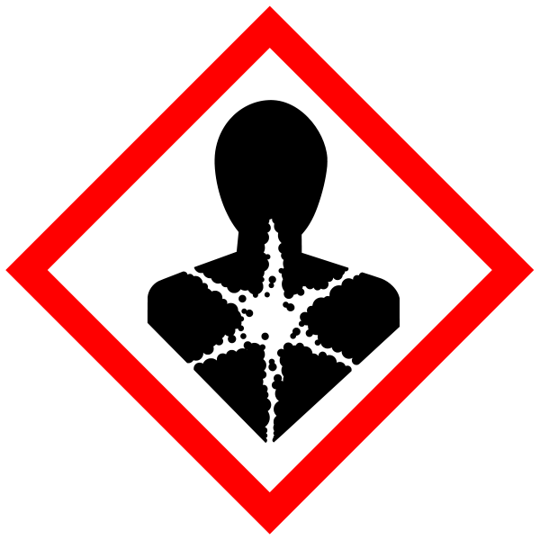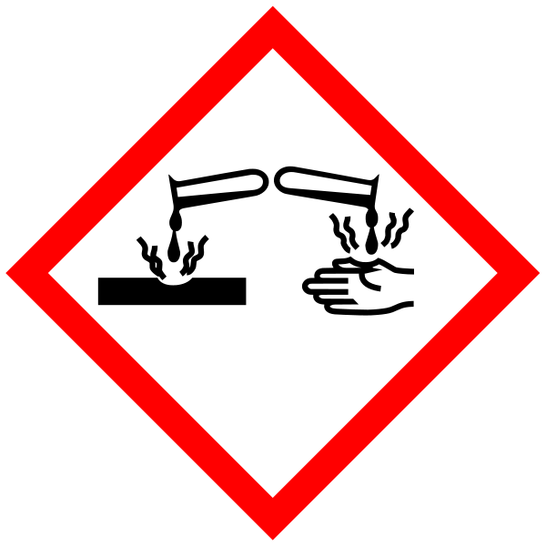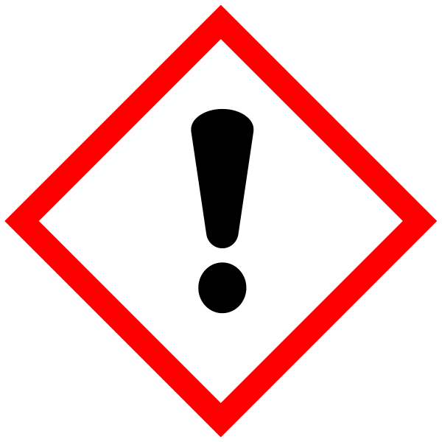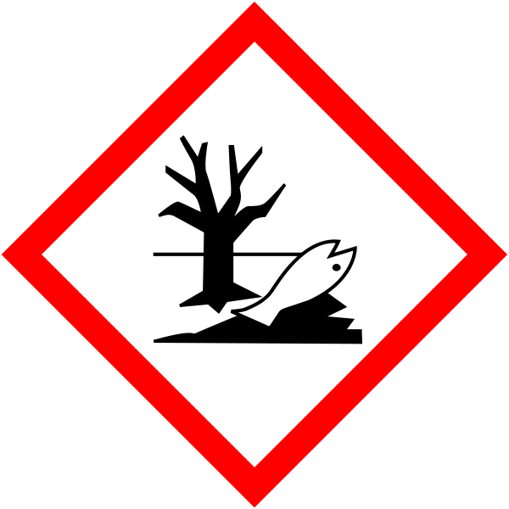
Hazard statements: H302 Harmful if swallowed. H314 Causes severe skin burns and eye damage. H317 May cause an allergic skin reaction. H332 Harmful if inhaled. H334 May cause allergy or asthma symptoms or breathing difficulties if inhaled. H370 Causes damage to organs. H400 Very toxic to aquatic life.

Paraformaldehyde (If this is used in place of formaldehyde solution then risk assessment RA-10 must be read and understood). Signal Word: Danger
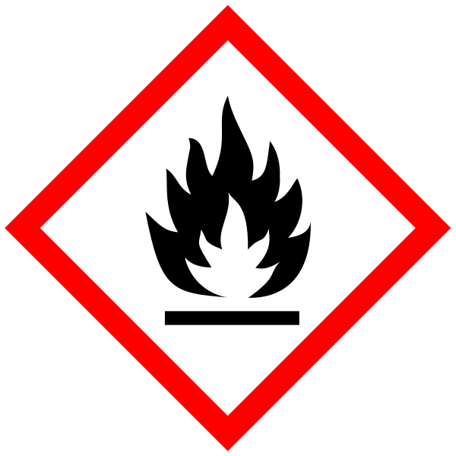
(Hazard statements: H228 Flammable solid. H302 Harmful if swallowed. H315 Causes skin irritation. H317 May cause an allergic skin reaction. H318 Causes serious eye damage. H332 Harmful if inhaled. H335 May cause respiratory irritation. H351 Suspected of causing cancer.

Methanol. Signal Word: Danger
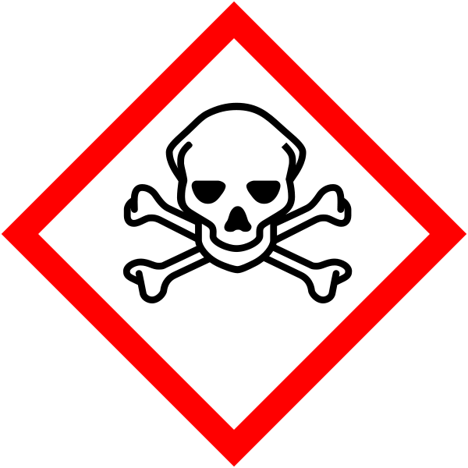
(Hazard Statements: H225 Highly flammable liquid and vapour. H301 Toxic if swallowed. H311 Toxic in contact with skin. H331 Toxic if inhaled. H370 Causes damage to organs). Must be handled in the fume hood.

Potassium Ferrocyanide. Signal Word: None.
Hazard statement: H412 Harmful to aquatic life with long lasting effects.
NOTE: Contact with acids liberates very toxic gas.

Potassium Ferricyanide, Signal Word: None
NOTE: Contact with acids liberates very toxic gas.

All the above must NOT to be disposed of via the sink – store for specialist disposal.

4-Hydroxy Tamoxifen: Signal Word: Warning
Hazard statements: H302 Harmful if swallowed. H312 Harmful in contact with skin. H332 Harmful if inhaled. H361 Suspected of damaging fertility or the unborn child. All staff must be made aware of the hazards. Waste culture medium can be flushed down the sink. Disposal of stock solutions must be via specialist disposal.

Whole embryonic culture protocol with 4(OH)tamoxifen
Written by K Yashiro 20 Mar 2012

Required chemicals/equipment
- Rat serum derived from male (immobilized)
- DMEM (high glucose)
- DMEM Hepes buffered, high glucose (Gibco)
- Penicillin/streptomycin (PS) for cell culture (x100 concentrated; Gibco)
- 4(OH)tamoxifen; Sigma H7904
5mg of 4(OH)Tam is once dissolved in 516ul of EtOH, which is equivalent to 10mM.
Practical final conc. for culture is usually 1uM.
- Rotator
- 50ml of Falcon tube
- CO2 Incubator for cell culture
- Paraform aldehyde
- 25% glutaraldehyde solution (Sigma; G5882)
Fixative: PGN
1%PFA (4%PFA: 2.5ml)
0.2% glutaraldehyde (25% glutaraldehyde: 80ul)
0.02% NP40 (10% NP40: 20ul)
in PBS /total vol. 10ml
- 1M MgCl2
- K-ferricianide (K3Fe(CN)6, MW329)
- K-ferrocianide (K4Fe(CN)6・3H2O, MW422)

Solution A (stock)
A solution
K-ferri : 164.6mg (4mM)
K-ferro : 211.0mg (4mM)
1M MgCl2 : 200ul
in PBS (pH7.3)/ total 100ml
Stored at -20oC. Do not repeat freezing and thawing.
- X-Gal
X-Gal stock sol. (40mg/ml in DMSO, stored at -20oC)
- 10% NP40
- PBS
- PBS-0.02% NP40 (PBN)
- PBS-0.02% NP40-2mM EDTA (PBN-EDTA)
*Both X-Gal and A-sol stocks must be protected from light at -20 oC

Procedure
- DMEM/75% rat serum/PS in 50ml of Falcon tube is left in CO2 incubator to allow it to be equilibrated. Iml of medium for up to 5 embryos
- In DMEM buffered by Hepes, dissect the embryos from the pregnant females of ROSA-reporter mice which is intercrossed with CreERT2 males. Be careful not to injure the embryos.
- Transfer the dissected embryos into the culture medium.
- Add 4(OH)Tamoxifen into culture medium. Stock solution is 5000 times concentrated.
- Falcon tube with embryo is set on the rotator in CO2 incubator.
- Culture the embryo with moderately rotated in CO2 incubator until the embryos grow up to the appropriate stage. If you need culture over 24 hours, you should change the medium once in 24 hrs. You can culture for at least 48 hrs.
- Rinse embryos in PBS
- Fix in the freshly prepared PGN for 10 min at Room Temp. Or for more than 15min on ice ( for 7.5-8.5dpc embryos).
- Rinse them in PBN for 5 min, three times.
- Stain in the staining solution protected from light at 37 oC (a few hours - over night) or at 30oC for over night (The back ground is less at 30 oC.).
If the background signal is strong or the embryo is larger than E12.5, add 2M Tris buffer to make the final conc. 20 mM into the staining solution.
Staining solution: 10ul of X-Gal in 400ul A-sol.
Prepare it just before use.
- Rinse PBN-EDTA four times
- Fix in 4% PFA or 10% formalin sol. For taking photograph, after fixation, dehyderate with Mt-OH/PBT series and incubate in 50% glycerol and then store 80% glycerol at 4 oC.
Note: Me-OH dehydration slightly decreases the staining.

Waste Disposal

Glutaraldehyde, Paraformaldehyde and Methanol must only be used in the fume cupboard. Disposal of these substances must be by a specialist therefore all waste must be collected and stored in the correct “labelled” containers. Potassium ferrocyanide, potassium ferricyanide, dimethylformamide – put in specified waste container (labelled formamide waste)

If GM material used then the relevant GM risk assessments must be adhered to (GMRA…).

SECTION 2 - Review of assessment
The person writing the assessment and the Head of Group must sign off the assessment.

Name of assessor: Signature:…………………

PI for this project: Signature:…………………

………………………………………………………………………………………..
SECTION 3 - User Declaration
I have read this laboratory procedure and COSHH risk assessment and understand the risks and the measures that must be taken to control such risks. I will notify the lab manager/head of group of any changes to the methodology described here which may affect the Health & Safety of myself or others.
NAME: Please print | SIGNATURE | DATE

