William Harvey Research Institute
Laboratory Procedure and COSHH Risk Assessment

Group:
Assessment identifier: RA-40
Date of assessment: July 2015
Date for review: August 2016
Title of Procedure: Using Liquid Nitrogen
Location of Work:

Risk assessment RA-General must be followed at all times
Lab coats and Safety Visor to be worn.

Section 1 – Description of Hazardous Material and Procedures including controls to be used

Hazard

Liquid Nitrogen: Signal Word: Warning
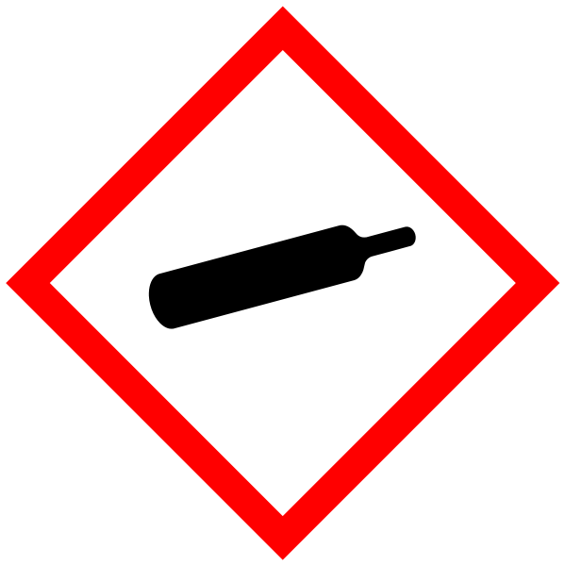
Hazard Statements: H281: Contains refrigerated gas; may cause cryogenic burns or injury. EIGA-As: Asphyxiant in high concentrations.

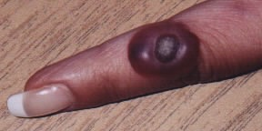

Liquid nitrogen is used to rapidly freeze various biological samples. Tissue samples can be crushed under liquid nitrogen for further analysis (See RA23). Also used for long-term storage of samples.

Thermal protection gloves and full-face visor to be worn when handling the liquid nitrogen.

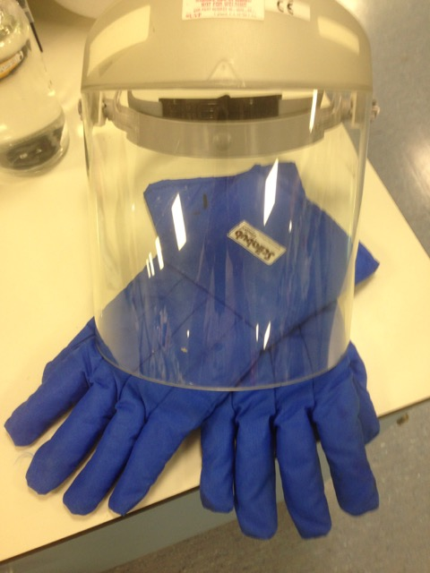

Do NOT sit at the bench while carrying out procedures using liquid nitrogen.

Liquid nitrogen to be transported in an appropriate portable dewar (with ventilation so that there is no internal build up of pressure.

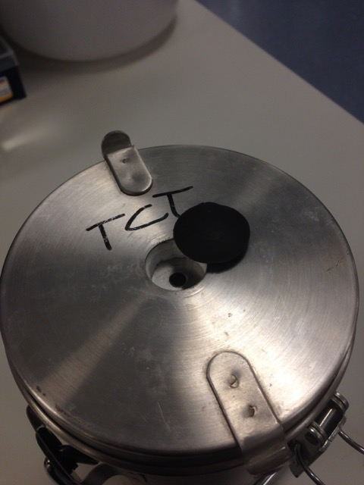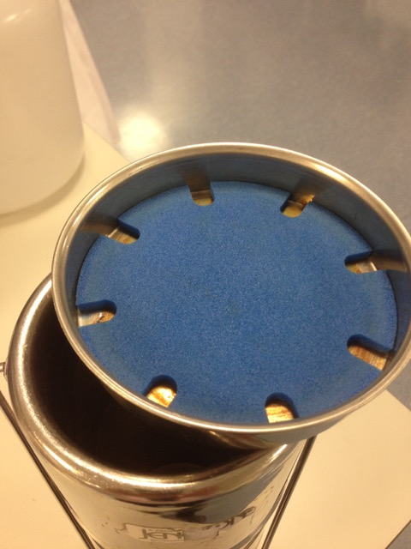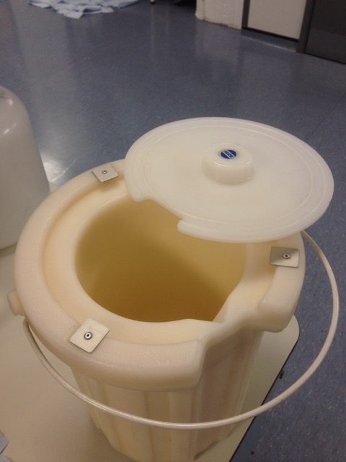

Liquid nitrogen should be dispensed from an appropriate dispenser dewar with hose attachment. Do NOT lean over the portable dewar as you dispense as an initial eruption of gas and liquid from the portable dewar can occur – straight into your face!

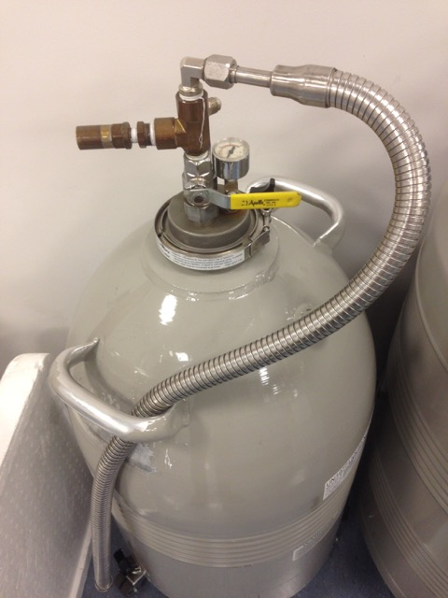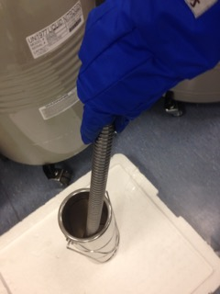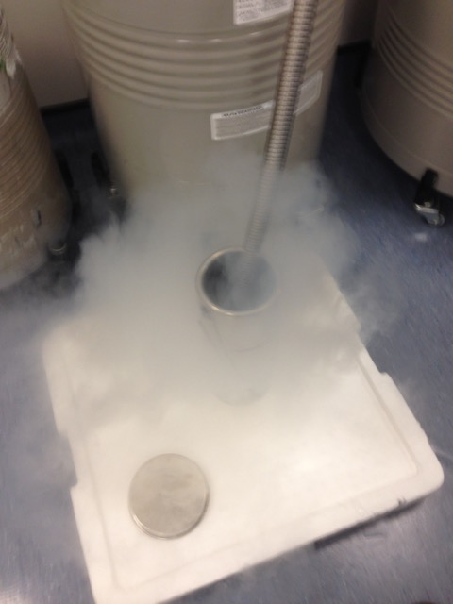

Only screw-cap cryotube with safety gaskets should be used for sample storage.

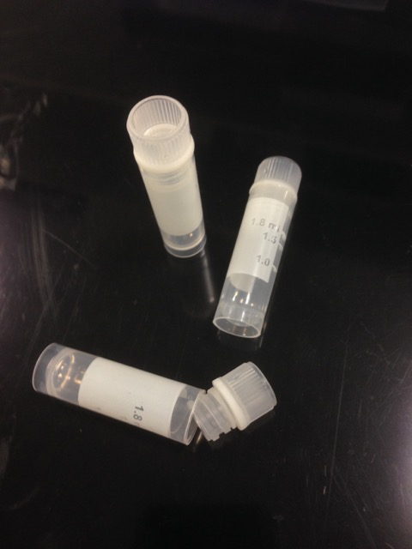

For transport of samples between locations – use dry ice rather than liquid nitrogen if possible.

Use minimum volume of liquid nitrogen required (5L should be plenty). 1L liquid nitrogen will give 696L gas. If 5L evaporated spontaneously (i.e., all the liquid nitrogen spilt at once) this would give 3480L of nitrogen gas which is about 0.35% of the volume lab B20 (975m³ = 975,000L). Therefore the oxygen concentration would decrease minimally (to 20.9% from 21%). 19% oxygen is classed as an oxygen deficient atmosphere and the room should be evacuated. For normal use and rate of evaporation, the air-change rate in the lab prevents any risk of asphyxiation. The volume of liquid nitrogen used must never exceed 15% of room volume without extra ventilation, use the following equation

Litres of liquid nitrogen x 0.7 x 100 = 15
Volume of room in m³

Litres of liquid nitrogen = 15 x Volume of room (m³)
70

YOU MUST NEVER TRAVEL IN A LIFT WITH ANY VOLUME OF LIQUID NITROGEN.

SECTION 2 - Review of assessment
The person writing the assessment and the Head of Group must sign off the assessment.

Name of assessor: Signature:…………………

Name of Head of Group: Signature:…………………

………………………………………………………………………………………..

SECTION 3 - User Declaration
I have read this laboratory procedure and COSHH risk assessment and understand the risks and the measures that must be taken to control such risks. I will notify the lab manager/head of group of any changes to the methodology described here which may affect the Health & Safety of myself or others.
NAME: Please print | SIGNATURE | DATE

