

William Harvey Research Institute

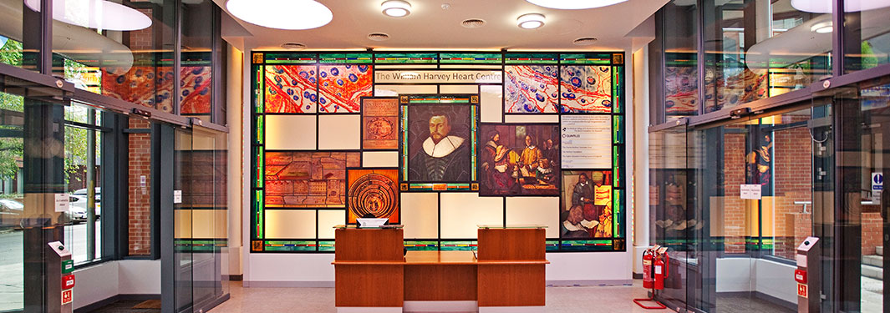

### GENERAL GUIDANCE ON PREPARING FOR THE POTENTIAL IMPACT OF THE CORONOVIRUS

**Information from QMUL, which is updated daily, can be found** [**here**](https://www.qmul.ac.uk/coronavirus/)

This document provides important information and guidance for the William Harvey Research Institute in response to the coronavirus outbreak and in preparation for the potential closure of the University. The [WHRI intranet pages](https://www.qmul.ac.uk/whri/) will also provide Institute-specific information, beginning with this document.

### Please bear in mind that, for the majority of people, coronavirus infection tends to cause a flu-like disease which resolves within 7-14 days. It is mainly in the elderly or those with underlying health conditions where a more severe form of the disease can occur.

Contents

1. SELF-ISOLATION 3
2. WHEN TO WORK FROM HOME 3
3. HOW TO WORK FROM HOME 4
4. LABORATORY WORK 5
5. CLINICAL STAFF 5
6. CLINICAL TRIALS & TISSUE BANKS 5
7. GENERAL OFFICE PROCEDURES 7
8. MEETINGS 7

APPENDIX 8

* 1. General Emergency contact details 8
  2. IT Emergency contact details 8
  3. Important links to WHRI or QMUL resources 9
  4. How to divert your desk phone 9
  5. Clinical Trials – Noclar’s advice 10

# SELF-ISOLATION

1. If you feel unwell and have any of the following symptoms, **DO NOT COME** to work, but stay at home and self-isolate for 14 days.
   1. If someone in your household is showing these symptoms, you should also stay at home and self-isolate, even if you are not yourself symptomatic.
2. Contact your line manager and let them know immediately.
3. Line managers should send home anyone who presents with symptoms and inform the Director’s and Institute Manager (g.mclaren@qmul.ac.uk).
4. Main symptoms of coronavirus:

* A high temperature/fever
* A new continuous cough

Other flu-like symptoms to look out for include:

* Aches, sore limbs
* Tiredness/exhaustion for no reason
* Difficulty waking; needing to sleep
* Sore throat
* Congestion or a runny nose

Please also refer to NHS advice on self-isolation which you will find [here](https://www.nhs.uk/conditions/coronavirus-covid-19/).

1. HR and IT are working to design and add new absence reasons to MyHR for staff to record actual sickness absence relating to Coronavirus and other associated absences that do not constitute sick leave, e.g. self-isolating. This will enable both the recording and the measurement of impact to Queen Mary.
2. Once this is in place, then you or your line manager must record your absence in MyHR.

# WHEN TO WORK FROM HOME

1. Currently, the University remains open and QMUL policy is that we work as normal. If the advice from the UK Government or QMUL changes, we will update everyone immediately.

The three exceptions to this are:

* 1. If you are unwell as described above in Point 1 on self-isolation.
  2. If you have an underlying medical condition that would make you vulnerable to a respiratory infection. In this case, you are advised to work from home with immediate effect.
  3. If you have vulnerable people at home. The process for this is:
     + Discuss this with your line-manager so that they know you will be working from home.
     + Stay away from work until you are informed that it is safe to return
     + For advice on IT matters contact the [IT-Helpdesk](https://www.its.qmul.ac.uk/support/helpdesk/).

1. Undergraduate and MSc students will **not be expected** to come on to campus for lectures or other classes from **Monday 23 March 2020**. You will be contacted separately by the Education office ([n.ravic@qmul.ac.uk](mailto:n.ravic@qmul.ac.uk)) who will provide further details for you about your courses.
2. Advice for [UK](https://www.qmul.ac.uk/coronavirus/) and [International](https://www.qmul.ac.uk/coronavirus/international-students/) Students, and specifically for [PhD students](https://www.qmul.ac.uk/doctoralcollege/covid-19-faqs---pgr/) is available from QMUL. International students have the choice of returning home if they prefer to do so.
3. New PhD students and associate placement students who were expected to start in the next few months will have their start dates deferred. The Research Degrees Office will contact any supervisors directly.
4. For staff who are from abroad and wish to return home immediately, you will need to take annual leave for the duration of your absence.
5. If it is possible for you to work from your home on appropriate tasks whilst you are abroad, then this will be at the discretion of your line manager, who will indicate that you no longer require to book annual leave.

# HOW TO WORK FROM HOME

* 1. Line managers should agree this with each member of their team and ensure that it is clear what work is expected from their staff and students whilst they are working from home. Line managers should keep in routine contact with their personnel.
  2. Tasks that can be completed at home may include, for example, data analysis, project/thesis writing, literature reviews, drafting manuscripts, publications and grant applications.
  3. The University has promoted OneDrive (please refer to Appendix C) as a means of storing data or working from home. If you use this application you should be careful to employ University regulations on GDPR when using it.
  4. Research groups should also make full use of LabArchives for saving data and files.
  5. The University has also promoted Microsoft Teams for connectivity between groups of staff (please refer to Appendix C).
  6. Staff and PhD Students will be paid as normal during any absence which is a result of the coronavirus outbreak, though you will be expected to work from home
  7. Staff who are able to work from home but choose not to do so whilst staying at home may be put on unpaid leave at the discretion of their line manager.

# LABORATORY WORK

* 1. You should continue your research as normal whilst the University remains open.
  2. Discuss your planned experiments with your group leader or supervisor.
  3. Consideration should be given to winding down wet-lab experiments, wherever possible.
  4. It would be unwise to start anything new at this time, especially any experiments that will run for more than a week.
  5. Freeze down any critical resources where it is feasible to do so, such as primary cultures, antibodies, animal sperm for important colonies etc.
  6. Do not order reagents or equipment that cannot be delivered within a working week.
  7. Even if the University is closed, QMUL will provide key staff who will come in to ensure facilities such as the BSU are maintained, and equipment (e.g. freezers, incubators, gas and water supplies) is checked.
  8. Core WHRI services will be shut down in the event of the University closing.

# CLINICAL STAFF

1. It has been agreed that clinically qualified staff may be released from their academic duties to work in the hospital, if requested.
2. It is a personal decision to decide or decline to work in the hospitals.
3. If asked to help in the NHS, you should first discuss this with your academic line manager and seek their agreement and guidance.
4. Clinical academics and CRFs should keep a record of their time spent in the hospital.

# CLINICAL TRIALS & TISSUE BANKS

* 1. With immediate effect, tissue bank and trials staff will stop going to any hospital site to collect tissue or for any other reason.
  2. All non-essential staff should not enter any NHS sites.
  3. Guidance from the JRMO can be found here: [http://www.jrmo.org.uk/news-and-](http://www.jrmo.org.uk/news-and-training/covid-19/) [training/covid-19/](http://www.jrmo.org.uk/news-and-training/covid-19/)
  4. More information from Noclor is provided in Appendix E.

# BIOLOGICAL SAFETY UNIT

Contingency plans for BSU use.

The BSU’s aim will be to maintain the BSU’s in regard to husbandry and welfare as far as the availability of staff (including temp and agency staff) will allow.

At the moment the priority is to maintain the ongoing experimental animals, while ensuring their care and welfare. Therefore, please avoid starting new mid-long studies, and avoid any procedures that will considerable care & monitoring (particularly protocols under severe PPLs).

Our Named Veterinary Surgeon (NVS) Jordi Lopez Tremoleda will advise on all veterinary and welfare matters and will advise as we progress with any necessary changes.

We will continue to monitor the National situation and local arrangements and if things change significantly we will provide updates and amendments as quickly as possible.

Currently the BSU staff **will not** undertake the following tasks:

* Training of licensees
* Conducting inductions or granting access to new licencees; it is vital we do not have new researchers in a potentially understaffed facility for both welfare and health and safety reasons
* Arranging or accepting overseas imports/exports as at present flights and access to other countries is liable to sudden changes

Currently BSU staff **will** continue to:

* Order animals from suppliers (but please consider the feasibility of new studies in light of any effect on your research groups or the BSU or University closure)
* Use the ARMIS system for health alerts etc as at present
* Carry out requests for assistance once discussed and agreed by local managers (we have licenced technicians should their help be required; but this must be agreed by managers)

**The BSU have asked researchers to commit to the following:**

* Provide a mobile contact number to your local manager; contact details at the end of this for all staff currently holding animals in a BSU. Include a backup contact for contingency should the primary licensee not be able to attend work
  + These numbers will be used to contact individuals should any issues occur if there are restrictions to staff attending work
* At this time, limit the number of researchers entering the BSU’s if for duties others can carry out; the BSU staff are exposed to a high number of researchers and we are seeking to limit this where possible
  + If minor duties such as checking, dosing etc. can be conducted by BSU staff, contact the manager to arrange
* Do not start new experiments that require additional monitoring; are on severe protocols or require continuous attendance in the BSU for procedures
* Do not increase breeding stocks at this time, the staff will have to continue to provide all husbandry whether researchers are attending work and stocks could increase significantly

The contact details for the staff making decisions at present are:

Sue Keefe [s.e.keefe@qmul.ac.uk](mailto:s.e.keefe@qmul.ac.uk) please contact me with any concerns/issues

Jordi Lopez Tremoleda NVS [j.lopez-tremoleda@qmul.ac.uk](mailto:j.lopez-tremoleda@qmul.ac.uk) , all welfare and research concerns.

Charterhouse Square:

Michelle Murphy – Manager [michelle.murphy@qmul.ac.uk](mailto:michelle.murphy@qmul.ac.uk)

Reiss Browning – Deputy [r.browning@qmul.ac.uk](mailto:r.browning@qmul.ac.uk)

Whitechapel:

James Gillett – Manager [j.gillett@qmul.ac.uk](mailto:j.gillett@qmul.ac.uk)

Mile End:

Daniel Holly – Manager [d.holly@qmul.ac.uk](mailto:d.holly@qmul.ac.uk)

# GENERAL OFFICE PROCEDURES

* 1. Ensure that your contact details are up to date on MyHR.
  2. If you have a desk phone:
     1. Divert it to your home or mobile phone. Instructions can be found in the Appendix D
     2. Change your voicemail message to include your email address.

# MEETINGS

* 1. Remove any non-essential meetings from your diaries that were due to be held over the next few weeks.
  2. The University has provided you with access to **Microsoft Teams** to allow you to set up online group meetings, videoconferencing and general messaging (much like Whatsapp) which can be used on desktops or mobile phones. Information can be found [here](https://www.its.qmul.ac.uk/support/digital-workplace/teams-guide/).
  3. Any meetings or events planned by the WHRI over the next few weeks will be cancelled and we will be sending out cancellations.

# APPENDICES

## General Emergency contact details

|  |  |  |
| --- | --- | --- |
| **Order** | **Staff** | **Students** |
| 1 | Institute Manager: Gerald McLaren Email: [g.mclaren@qmul.ac.uk](mailto:g.mclaren@qmul.ac.uk) | Education Manager: Nina Ravic  Email: [n.ravic@qmul.ac.uk](mailto:n.ravic@qmul.ac.uk) |
| 2 | Deputy Institute Manager: Steven Coppen: [s.r.coppen@qmul.ac.uk](mailto:s.r.coppen@qmul.ac.uk) | Education Lead: Fu Ng Email:[f.ng@qmul.ac.uk](mailto:f.ng@qmul.ac.uk) |
| 3 | Institute Director: Amrita Ahluwalia: [a.ahluwalia@qmul.ac.uk](mailto:a.ahluwalia@qmul.ac.uk) | Deputy Institute Manager: Steven Coppen: [s.r.coppen@qmul.ac.uk](mailto:s.r.coppen@qmul.ac.uk) |
| 4 | Institute Director: Mark Caulfield:  [Mark.Caulfield@genomicsengland.co.uk](mailto:Mark.Caulfield@genomicsengland.co.uk) | Institute Manager: Gerald McLaren Email: [g.mclaren@qmul.ac.uk](mailto:g.mclaren@qmul.ac.uk) |

## IT Emergency contact details

Please contact the QMUL IT helpdesk in the first instance:

<https://www.its.qmul.ac.uk/support/helpdesk/>

## Important links to WHRI or QMUL resources

General information on some commonly use applications including OneDrive, Teams and other resources can be found here: <https://www.its.qmul.ac.uk/support/digital-workplace/how-to-access-services/>

* 1. [E-mail and calendar](https://mail.qmul.ac.uk)
  2. [MyHR](https://myhr.qmul.ac.uk/dashboard/dashboard-ui/index.html%23/landing)
  3. [Agresso](https://agresso-web.qmul.ac.uk/BusinessWorld/Login/Login.aspx?ReturnUrl=%2fBusinessWorld)
  4. [IGrasp](https://ig24.i-grasp.com/qmul/)
  5. [MySIS](https://mysis.qmul.ac.uk/urd/sits.urd/run/siw_lgn)
  6. [Student Services](http://www.arcs.qmul.ac.uk/students/)
  7. [Multi-factor authentication](https://www.its.qmul.ac.uk/support/self-help/multi-factor-authentication/)
  8. [Remote teaching resources](https://elearning.qmul.ac.uk/announcements/remote-teaching-at-qmul/)

## How to divert your desk phone

* 1. 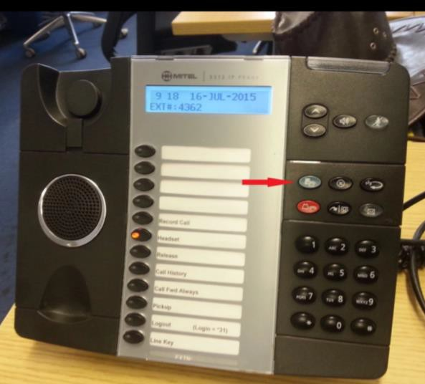Press the blue menu button (arrowed on the adjacent image)
  2. Then press # twice until you get to the “call forward” option on the menu screen.
  3. Press * for “YES” on the screen.
  4. Press * again to select 'Review' on the screen
  5. Press * again to select “Change” on the screen.
  6. Press * again to select “Program” on the screen
  7. You will see “TO:” on the screen; enter 9 and then the phone number to which you wish to forward your calls.
  8. Press the down key to save.
  9. Press the blue menu key to exit.
  10. Repeat 1-5 then press # to TurnOn or off
  11. Press the blue menu key to exit

# E. COVID-19: **Noclor’s Operational Plans for Clinical Research**

In the context of the current COVID-19 outbreak and to ensure NHS R&D activities are aligned with COVID-19 NHS Operational Plans, research activities will need to be limited in each Trust to:

 Reduce or minimise visits to the Trust sites by patients, research participants and other research- related visitors including study monitors

 Reduce the activities of non-essential research staff and research support staff

 Reduce the risk of placing participants at greater risk of COVID-19 infection and/or of more severe illness, if infected

Detailed below is what research activities will be suspended, permitted, where exceptions may apply or where a member of the Noclor R&D office will be in contact.

## Research Studies Not Yet Approved or Initiated at Site

* **No new research will be approved by Noclor R&D**
* **No research studies should be initiated at NHS sites**

*Exceptions:*

*-Research studies which are directly related to COVID-19 which will be prioritised and expedited through the HRA/R&D approval processes*

*-Research which does not involve attendance at an NHS site if staff resources required to deliver the study are not required to be deployed elsewhere*

Email: [contact.noclor@nhs.net](mailto:contact.noclor@nhs.net)

## Clinical Research Sponsored by a Noclor Partner NHS Trust

* A member of Noclor's Sponsorship team for non-CTIMPs will be in contact with Chief Investigator's regarding their study and agree actions & communication plans.

Email: [sponsor.noclor@nhs.net](mailto:sponsor.noclor@nhs.net)

## Open/Active Research Hosted by a Noclor Partner NHS Trust

* **Recruitment activities are suspended on all studies unless otherwise notified by R&D**

*For any studies exempt from this suspension the PI will be notified directly by Noclor’s R&D Service Director*

## All non-essential face to face meetings should be cancelled

|  |  |
| --- | --- |
| * **Clinical drug trials (CTIMPs)** | Noclor’s CTIMP Lead, Nicki Collins will contact PIs & sponsors directly to inform them of suspension to recruitment at site and discuss plans for the trial and patients currently on trial.  Email: [nickicollins@nhs.net](mailto:nickicollins@nhs.net) |
| * **Interventional Research Studies (Non-CTIMPs)** | Noclor’s Research Delivery Manager, Nick Green will be in contact with PIs  & sponsors to inform them of suspension to recruitment at site and discuss plans for the study and patients currently in the study.  Email: [nicolas.green@candi.nhs.uk](mailto:nicolas.green@candi.nhs.uk)  For Whittington studies Nicki Collins will be in contact with PIs & sponsors. Email: [nickicollins@nhs.net](mailto:nickicollins@nhs.net) |
| * **All other non- interventional research** | Recruitment activities should be suspended (*unless notified exempt). Non-essential face to face meetings/visits/interviews should be cancelled.  The sponsor may make changes to the protocol in regard to how research data is obtained to avoid exposing patients/staff to COVID-19 and/or to reduce the burden on clinical services. These changes should be handled as amendments as per HRA guidance. In some cases, the sponsor may place the study on a temporary halt or close the study early. R&D must be notified of any amendments to the study protocol, temporary halts or closure as below.  Where a research protocol does not involve direct face to face contact with patients/staff and does not burden clinical services the research activities can continue according to the protocol/local approval, where local research support resources are available to do so. |

* + **All amendments** should be notified to Noclor R&D [contact.noclor@nhs.net](mailto:contact.noclor@nhs.net) by the sponsor in accordance with existing COVID-19 specific HRA guidance.
  + If the Sponsor needs to implement a **temporary halt** to the research this should be handled as an amendment as per existing HRA guidance and Noclor R&D notified by email - [contact.noclor@nhs.net](mailto:contact.noclor@nhs.net)
  + Study sponsors should arrange for any **monitoring** to be conducted remotely
  + If PI's are taken off clinical trials where patients remain actively on trial /in follow-up during the COVID -19 outbreak the R&D Service Director must be informed by the PI directly.

Email: [lynislewis@nhs.net](mailto:lynislewis@nhs.net)

* + **Any Urgent Safety Measures (USM)** to clinical trials should be implemented and notified as per usual sponsor procedures.
* **Adverse events/incidents** resulting from COVID-19 response must be notified to sponsor as per protocol and in line with local Trust policy. Noclor's R&D Service Director should also be informed by email - [lynislewis@nhs.net](mailto:lynislewis@nhs.net)

## Closing/Closed Research Hosted by a Noclor Partner NHS Trust

* Research studies that are being closed down early as a result of COVID-19 or are in the process of closing down anyway should be notified to R&D as per usual process.

Email: [contact.noclor@nhs.net](mailto:contact.noclor@nhs.net)

* Where a close out visit or non-essential contact with patients/staff is required to officially close down the site; these activities should be postponed until research staff are notified that non- essential face to face meetings can resume.

*This guidance is subject to change at short notice and will be updated on a regular basis until the situation improves. This guidance complements that provided by the Trust to all patients, staff and visitors. Where guidance from external organisations proves inconsistent, instructions from Noclor will take precedence*