Elements – Uploading Newly Accepted Papers

Once you have been notified that a manuscript has been accepted, inform the WHRI Open Access Monitor (Steven Coppen) and log into Elements at
https://elements.qmul.ac.uk/

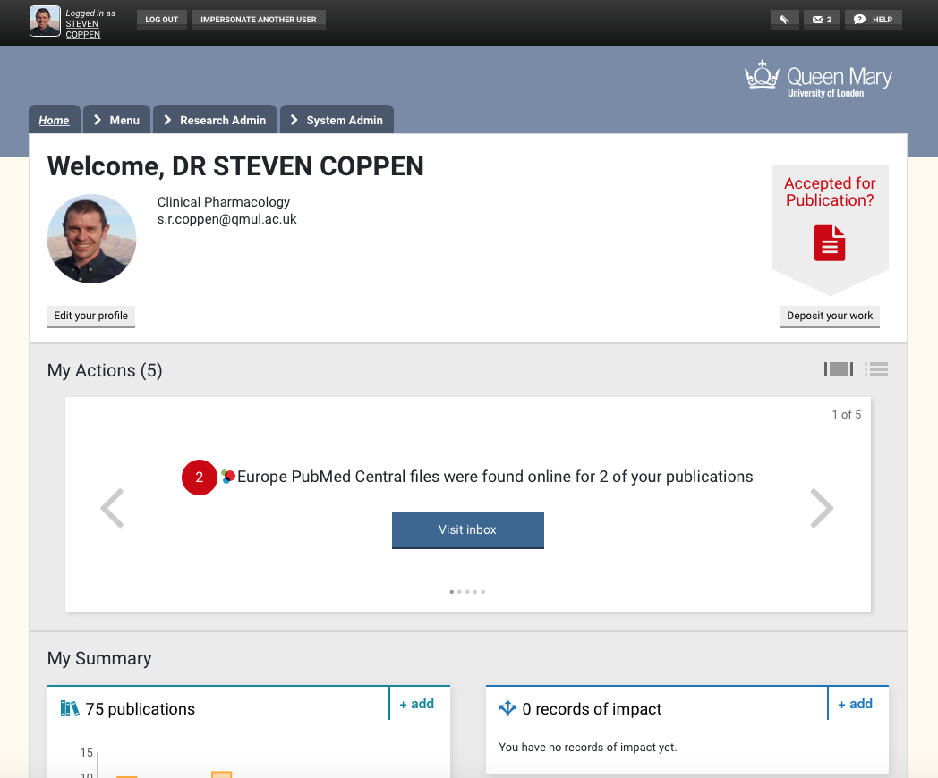

Click the “Accepted for Publication?” button


Then click whether you are submitting a Conference or Journal article.
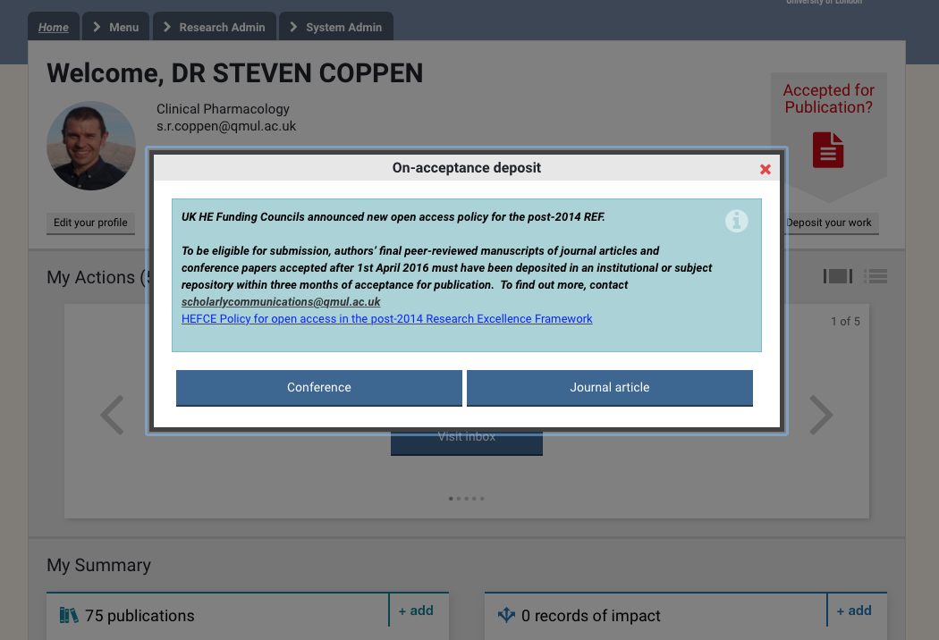
There is a very good chance that a record for your newly accepted manuscript may already exist in Elements – as it receives data from a number of databases. So type the first few words of your title in the search box “Title or DOI” and hit search

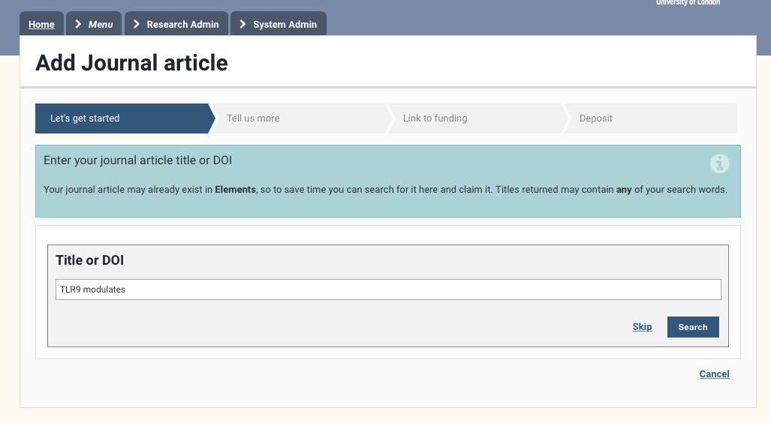

A number of results may be found both in Elements and external databases. (If none of these or no papers are found then click on the “Go to next step” and enter a manual record from scratch). Otherwise when you find your paper, click on it if it is in Elements or “Claim” if it is in an external database.

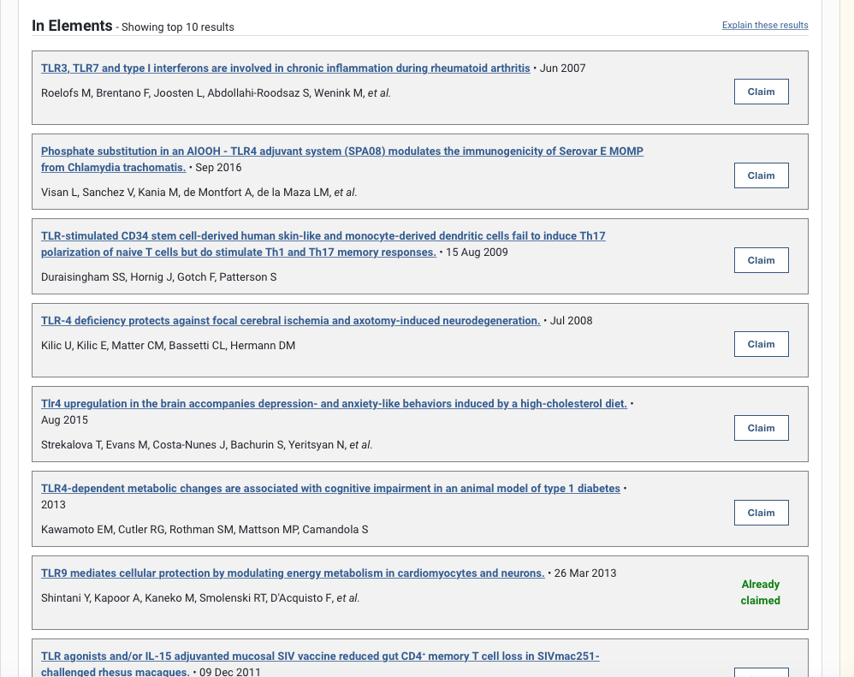

You will then see the record of your paper
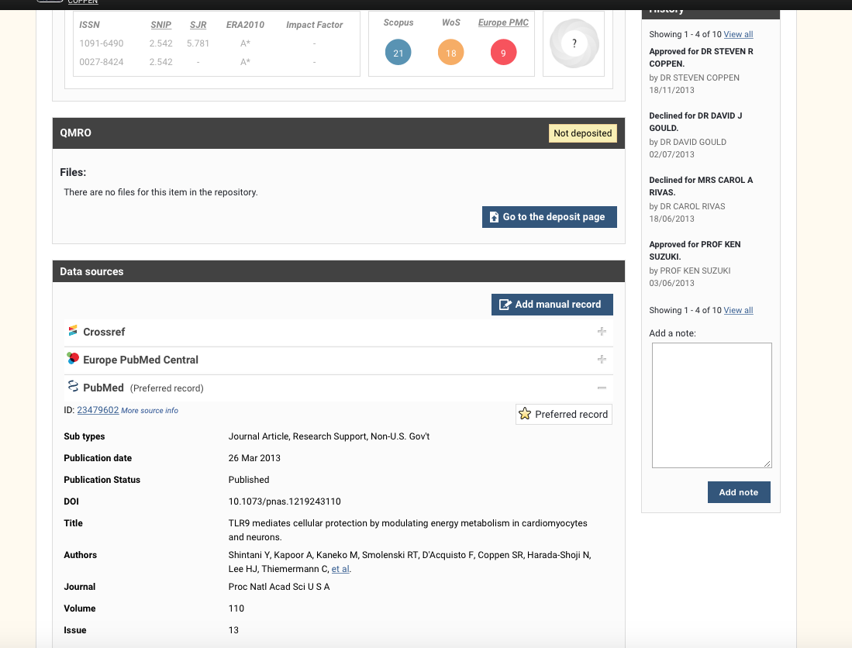

To be REF compliant you must make sure that the Date of Acceptance is input and then upload the accepted version of the manuscript. To input the date of acceptance, click on “Add manual record”
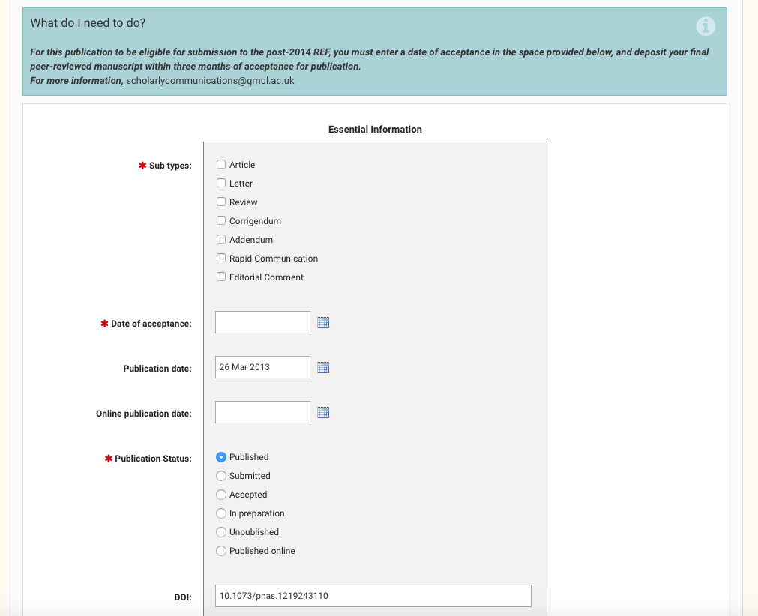
You will need to select the sub type (most commonly “article”) and enter the Date of acceptance. All the other required information should be automatically filled. Click “Save” at the bottom of the page.

You then need to click the “Go to the deposit page” button
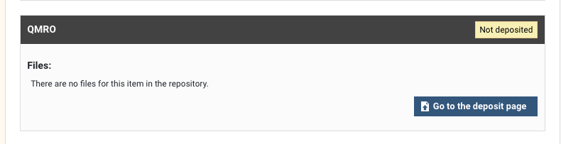

You will then get some information relating to the specific Journal in which your paper has been accepted. This will indicate which version of your manuscript is allowed by the Journal to be archived to the QMRO. The accepted version is allowed and should be the version you upload. On the right, there is the box where you can upload the accepted version of your manuscript.
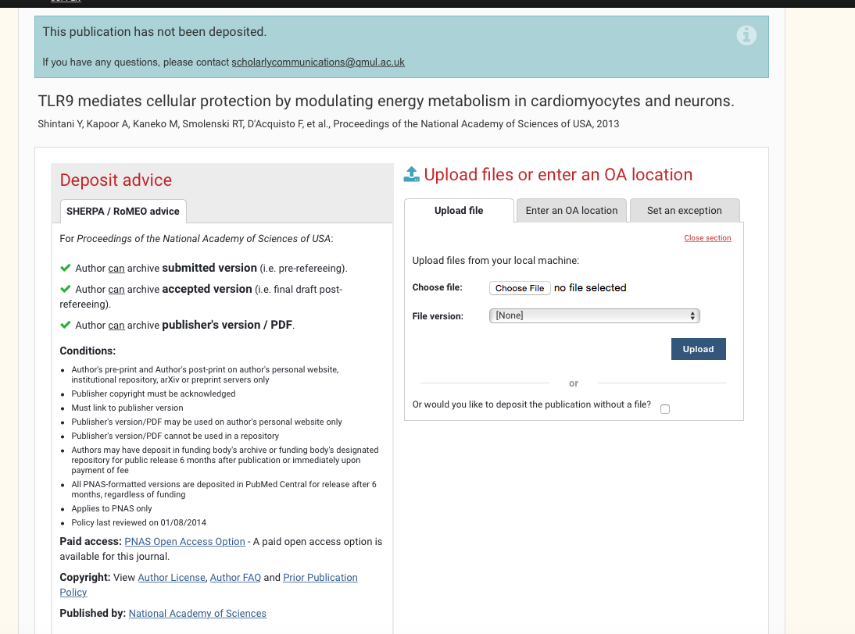

If the accepted manuscript has already been uploaded to another Open Access database, you can click on the “Enter an OA location” tab and input the URL of the database.
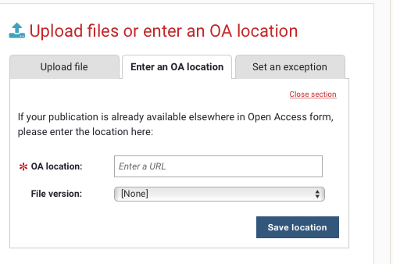
Exceptions can be entered by clicking on the “Set an exception” tab.

Once this has all been completed the Library staff check the records in relation to the Journal requirements and any embargos that may be in place. The Record will then be set as Compliant.

The WHRI OA Monitor will check the submissions regularly and contact you if they show up as non-compliant and is also the point of contact for any issues you may have.

