**Desk Booking Guidance**

*Desks are available for booking 14 days in advance in Space Connect. You can either book a specific time slot or a full day.*

*If you are in meetings for the majority of the day, please avoid booking a desk for a full day and consider booking a specific time slot or sitting in a social space or non-bookable space inbetween meetings. Upon arrival, please ensure you check-in.*

**Step by Step Instructions on Booking & Checking In**

**​​​​​​​Map view:**

* In a web browser, navigate to [https://spaceconnect.qmul.ac.uk](https://spaceconnect.qmul.ac.uk/) (or <https://app.spaceconnect.co/>)
* Choose “Sign in with Microsoft” - if you aren’t logged in to Office 365, you will have to sign in with your QM username and password.
* If you cannot access Space Connect, please raise a ticket with the IT helpdesk.
* ​​​​​​​You can make your desk booking based on the floor map view.  
    
  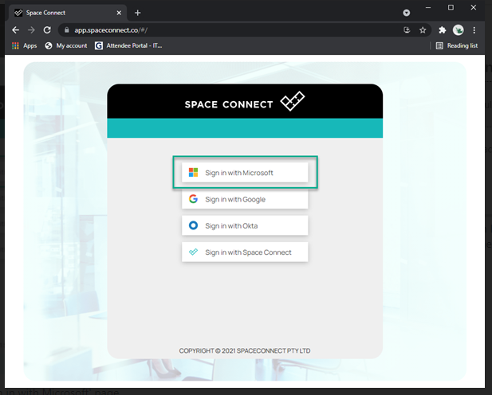

Space Connect 'Sign in with Microsoft' page

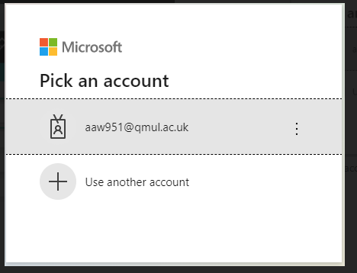

Pick an account from list to sign in with your QM username and password

* Select the date and time (1),
* Which floor you want to book on (2),
* Select your preferred desk (3) from the available pool (green dots on the map)
* To maximise the map, disable the option “Enable Information Panel’ (4)
* ​​​​​​​​​​​​​​When you click on a desk, you’ll see its description and you’ll get an option to confirm your booking.
* After clicking **Book**, you will see the booking confirmation on the screen.
* You will also receive an email with a calendar event, which you can add to your Office 365 calendar in Outlook.

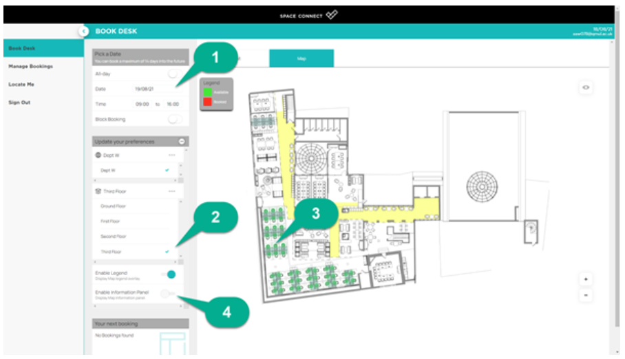

Example of the map view when trying to book a room

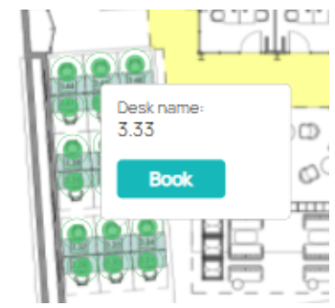

Example of a room being selected to be booked

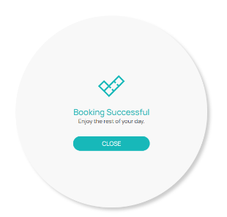

Booking Successful button

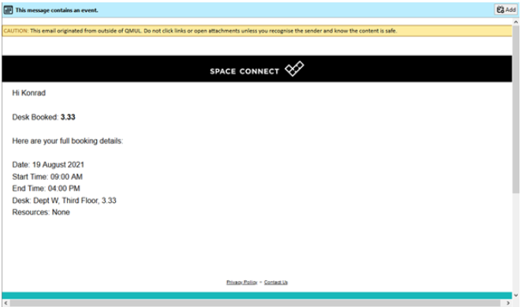

Example of an email confirmation for a completed room booking

**List view:**

* Alternatively, you can make a booking using the list view, instead of the map.
* ​​​​​​​Click on the list view at the top of the page.​​​​​​​

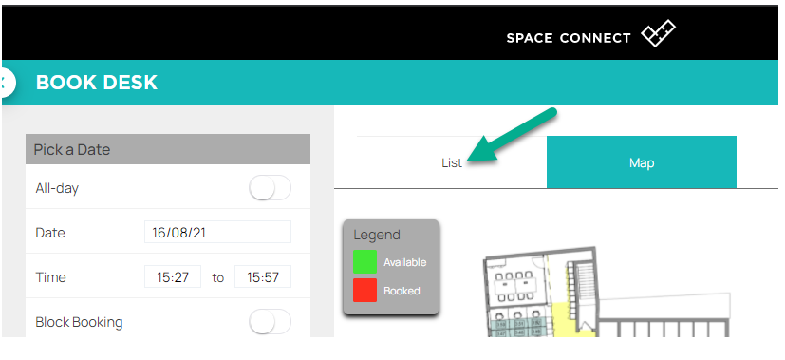

* Select the date and time (1), which floor you want to book on (2), and then select  your preferred desk by clicking “Book” next to its description (3)

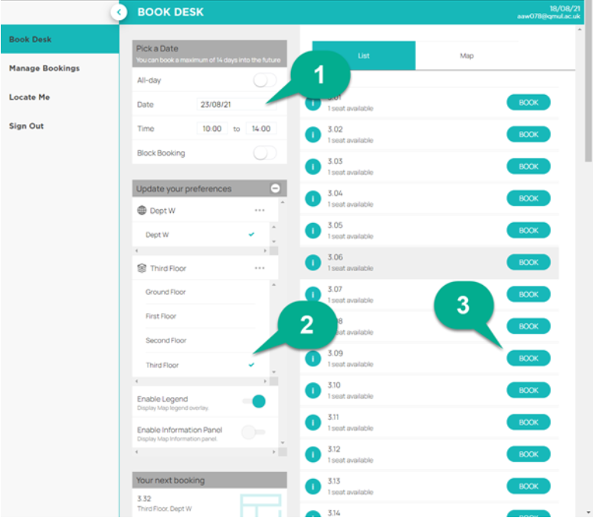

**Check in:**

You can check in by scanning the**QR code**on the desk with your mobile phone camera or by selecting ‘Check-in’ under the Manage Booking section on the site or in the app.  
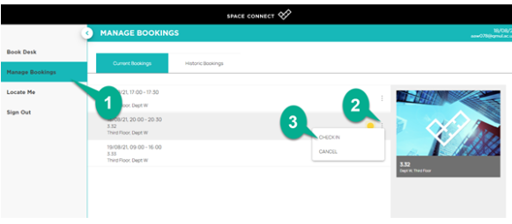

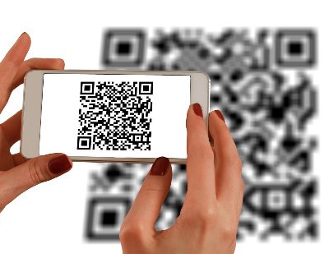

**Download the SpaceConnect mobile app:**

You can make bookings on the go by using the handy SpaceConnect app on your mobile phone. Go to your app store (Google or Apple store) and search for 'SpaceConnect app'.  
  
The user interface and booking process is similar to the procedure described above.

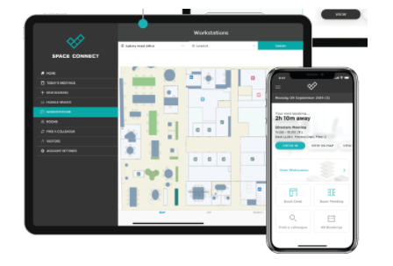

Image of the app on a tablet or mobile device