WOLFSON INSTITUTE OF POPULATION HEALTH
NEWSLETTER
ISSUE 11: 14 APRIL 2022

In this issue of our Wolfson Institute of Population Health Newsletter, we celebrate the achievements and work of staff and students in March.
FROM OUR DIRECTOR
Dear All

As the spring sunshine streams through the window and the buds burst into blossom and fresh green leaves across Charterhouse Square, it’s a pleasure to wish everyone a peaceful April break. I’ve been cheered by the renewal of face to face collaborative meetings over the last fortnight. Prof Larry Kessler is visiting for several months on a Fulbright Scholarship from the University of Washington, Seattle, and he gave the Institute a fascinating talk about the promise and perils of Tumour Genomic Testing. We also had an excellent cancer symposium last week with Prof Jon Emery and Dr Sibel Saya, visiting from the University
of Melbourne. These productive visits have reinforced the value of informal conversations, as well as more formal presentations, as we develop our research portfolios with existing and new colleagues.  Best wishes – and stay well!  Fiona |  |  | 
FROM OUR LEADERSHIP TEAMS AND REPRESENTATIVES
Interested in developing a PhD proposal?
Steph Taylor (Director of Research)

Look out for the WIPH Research Directorate’s snappy, two-part Spring Workshop on “Building a PhD Proposal”. Part 1 will relate to planning good supervision, Part 2 will be on planning a good PhD project. More information to follow shortly.

Deborah Swinglehurst (Theme Lead: Complexity and Social Science)

Deborah Swinglehurst is leading the development of a new 15-credit MRes module Qualitative Methods for Health Research which will be offered as a compulsory module for students in the Wellcome Health Data in Practice programme from September 2022. The module will introduce learners to the principles of interpretive research practice and to a broad range of qualitative methods and methodologies. Throughout the course we will teach learners the importance of integrating social science theory at all stages of the research process, from design to analysis.

Megan Clinch (Theme Lead: Public Advisory Panel)

The Public Advisory Panel has now been formed and consists of members from all Centres and career stages across both academic and professional services. We are currently working on collecting information and resources on Public and Patient Involvement and Engagement and Civic Engagement (across research and teaching) activity, which will eventually have a home on the WIPH intranet. We have also begun a process to map all activity across the WIPH, which will form the basis of our strategy and offer of support and collaboration to local stakeholders. We will be in contact with all Centres and Units in the next few weeks to commence this mapping work.

GENERAL INSTITUTE NEWS

Age-related cognitive decline: Commentary in the Times
1 March (Alastair Noyce. Centre for Prevention, Detection and Diagnosis)

A report in the Times on a new study of participant speed in answering online tests includes commentary by Alastair Noyce on age-related cognitive decline. The study of 1.2 million people aged 10-80 found that average mental speed levels were quite stable until age 60. Alastair warned that many risk factors for poor brain health (eg: lack of exercise, social isolation, and stress) will have increased in the past two years. He added that improvements in cardiovascular health, particularly through exercise, as well as weight control and not smoking, already seem to be helping to keep our brains young: “We have seen evidence from epidemiological studies that there has been a reduction overall in the incidence of dementia, once age is taken out. The most likely candidate for causing this improvement is work done to improve the population’s cardiovascular health”. |  | 

Non-pharmacological interventions for schizophrenia in 12 Southeast European countries 1 March (Nikolina Jovanovic. Centre for Psychiatry and Mental Health)

 |  | A study of schizophrenia treatment guidelines has identified recommended non-pharmacological interventions, explored the supporting evidence base, and evaluated intervention implementation in Albania, Bosnia and Herzegovina, Bulgaria, Croatia, Greece, Moldova, Montenegro, North Macedonia, Serbia, Kosovo (UN Resolution), Romania, and Slovenia. Experts were surveyed to assess availability of non-pharmacological treatments in leading mental health institutions, staff training, and inclusion in the official service price list. Most countries had published treatment guidelines for schizophrenia focused on pharmacotherapy (except for Kosovo, Romania, and Slovenia). The median number of recommended interventions was seven, and family therapy and psychoeducation were recommended in most treatment guidelines. Most of the recommended interventions had a negative or mixed randomized controlled trial evidence base. Authors concluded that interventions recommended in the treatment guidelines seem to be rarely implemented in mental health services in these countries.

Genetic Databases Are Too White 1 March (Sarah Finer. Centre for Primary Care)

Clinical Senior Lecturer in Diabetes and deputy lead on the Genes & Health study, Sarah Finer, has talked about recruitment for the study in a piece about the white bias of genetic databases published in WIRED UK. Most genetic research is done on people of European descent, which has led to misdiagnoses, inaccurate tests, and missed opportunities for new treatments. The Genes & Health initiative is working to analyze the genes of 100,000 Bangladeshi and Pakistani people, the biggest ethnic minority groups in East London. Recruitment has now reached the halfway point, and is mostly conducted in either primary care settings or places like mosques and shopping centres. Sarah told author Grace Browne that many of the community researchers are also of Bangladeshi or Pakistani ethnicity, which means that “as soon as somebody is asked to volunteer and join the study, there is an immediate connection and trust, because they are being invited to the study by people they can identify with”. |  |     

Increased frequency of rare placental insufficiency condition during second COVID wave in London 2 March (Stamatina Iliodromiti. Centre for Public Health and Policy)

 |  | A preliminary study of placentas referred to Barts Health Histopathology during the second Covid wave in London has found an increased frequency of a rare lesion, usually reported in <1% of pregnancies. Massive perivillous fibrin deposition (MPFD) causes placental insufficiency, leading to poor pregnancy outcomes, including severe intrauterine growth restriction and stillbirth. Of 224 placentas referred in December 2020 and January 2021, 11 (5%) cases of MPFD were identified. No cases had been identified in the same months in the previous year, and only one in the comparable period in the year prior to that. Of 33 placentas investigated, 30 were from COVID-19 positive mothers, 11 with MPFD. All 11 placentas with MPFD were Covid positive, and of these six were successfully sequenced and found to be positive for the alpha variant. Authors conclude that the observed increase in MPFD cases during the alpha wave of the pandemic and these histopathological results suggest that Covid can cause MPFD, but that further studies are needed to confirm this finding.
The Electronic Personal Health and Record system for migrants and refugees in Europe
2 March (Dominik Zenner.Centre for Public Health and Policy)

A cross-sectional study of migrants attending reception centre health clinics in Bulgaria, Croatia, Cyprus, Greece, Italy, and Serbia between 2016 and 2019 has used data from the International Organization for Migration electronic Personal Health Record (ePHR) system to describe health and illness among this migrant population. The paper describes findings from 19,564 clinical episodes among 14,436 individuals, most of whom were refugees (75%), or asylum seekers (22%), from 92 different nationalities. The emerging picture is of a mostly healthy population, with many acute infectious disease episodes, particularly in children, but also with a significant number of chronic conditions, and less frequent injuries. In about 4.5% of this population, mental health problems were recorded. First author Dominik Zenner said: “By using ePHR we were able to identify and describe the main disease burden in migrants arriving in Europe, providing guidance for resource allocation, and establishing appropriate health care services. This is a valuable tool to efficiently collect health-related data to better address migrant health issues.” |  | 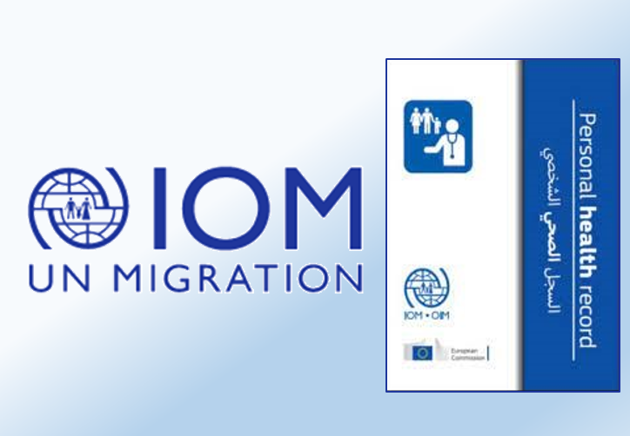
Risk factors and early presentations of Parkinson’s in Primary Care in East London
7 March (Cristina Simonet, Jonathan Bestwick, Sheena Waters, Charles Marshall, Ruth Dobson, John Robson, Ben Jacobs, Jack Cuzick, Alastair Noyce. Centres for Prevention, Detection and Diagnosis/Primary Care)

 | The first study to investigate the pre-diagnostic manifestations of Parkinson’s that present to primary care in a diverse and deprived urban-dwelling population with universal healthcare access has identified a broad range of “symptoms” reported up to a decade before diagnosis. Early features of Parkinson’s described through population-based studies over-represent white, affluent groups, and may not be generalisable. This nested case-control study used electronic healthcare records from 1,055 patients with Parkinson’s and over a million controls from primary care in East London from 1990 to 2018. Tremor and “memory symptoms” were reported up to 10 and 5 years before diagnosis respectively, and were strongly associated with a Parkinson’s diagnosis. Several recognised pre-diagnostic features were replicated, but novel temporal associations between epilepsy and hearing loss with subsequent Parkinson’s were observed. No association with future Parkinson’s diagnosis was found for ethnicity or deprivation index, but the prominence of “memory symptoms” hints at an excess of cognitive dysfunction in early Parkinson’s in this population, or difficulty in correctly ascertaining symptoms in traditionally under-represented groups.
Celebration of 27 Years at QMUL
9 March (Sandra Eldridge. Centre for Evaluation and Methods)

At an event on 9 March we were finally able to formally farewell Sandra Eldridge, former Director of the Pragmatic Clinical Trials Unit. The event, postponed on two previous occasions due to COVID, was a celebration of Sandra’s 27 years at Queen Mary University of London, and the values that that have shaped her work. Link here to a recording of Sandra’s talk. |  | 
“After Progress” exhibition launched
11 March (Maria Grazia Turri. Centre for Psychiatry and Mental Health )

 |  | A piece of creative writing delivered by Maria Turri in collaboration with past students from the Creative Arts and Mental Health MSc is part of an online exhibition which has just been launched. The piece, entitled “Futuring mental health”, features in the After Progress exhibition, now available to view online.

Covid-19 lockdown and domestic violence in England and Wales

15 March (Anna De Simoni, Chris Griffiths. Centre for Primary Care)

COVID-19 lockdowns have made it harder for survivors of domestic violence and abuse (DVA) to disclose abuse and access support services. A study using anonymised data on daily GP referrals to DVA services in 33 areas in England and Wales has found that the 2020 lockdown led to a reduction of 27% in referrals, compared with the periods before and after, and 19% fewer referrals compared with the same period in the year before. Reduced referrals were also evident during school holidays, as families, including the perpetrator, are together at these times. These findings highlight the need for future planning to provide adequate access and support for people experiencing DVA during future national lockdowns and during the school holidays. |  | 
Nutritional profile of snacks in meal deal promotions
15 March (Action on Salt team. Centre for Public Health and Policy)

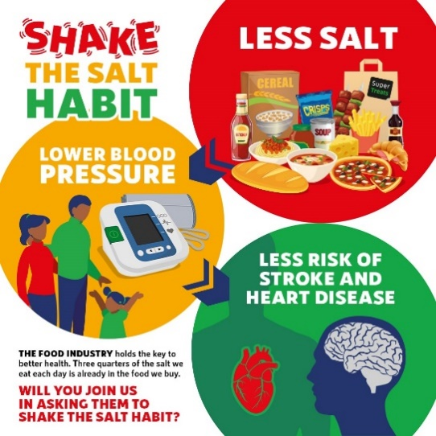 |  | To mark Salt Awareness Week, Action on Salt has released research highlighting the proportion of snacks included in high street meal deals that still exceed their respective salt targets, and called for mandatory targets to be put in place immediately. 70% of ‘meal deal’ snacks on the high street are dangerously high in salt, saturated fat, and sugar, with some contributing up to a third of the maximum daily recommended adult salt intake. Action on Salt is demanding that Government introduce mandatory comprehensive salt reduction targets, with penalties for food companies that fail to comply.
Vitamin D Deficiency in primary school children in Cape Town
16 March (Neil Walker, David Jollife. Centre for Evaluation and Methods)

A cross sectional study has addressed the gap in knowledge of vitamin D status among children in South Africa. The study investigated the prevalence and determinants of vitamin D deficiency in 1825 primary school children (age 6-11) in a sub district of Cape Town between April 2017 and May 2019. The sub-district is an underserved, multi disease burdened, peri-urban area. Residents are predominantly African Black and coloured (mixed race) individuals. Prevalence of vitamin D deficiency was 7.6%, with variation determinants including older age, higher BMI, and most significantly month of sampling (prevalence ranging from 1.4% in January-March to 22.8% in July-Sept). These results are similar to those reported among children living in more northern areas of South Africa, but lower than anticipated based on the prevalence of vitamin D deficiency previously reported among adults in the Western Cape. |  | 

Ukraine: The volunteers racing aid from the UK to the front line

16 March (Dennis Ougrin. Centre for Psychiatry and Mental Health)

 |  | WIPH child psychiatrist Denis Ougrin was among a convoy of volunteers racing medical supplies from the UK to the Ukrainian front line during the early days of the Soviet invasion. Over two days, 1000 miles, and six countries, they transported vans loaded with trauma kits, oxygen regulators, and ultrasound machines. The convoy, organised by the Ukrainian Medical Association of the UK, was made up of Ukrainian doctors and nurses working in the UK. Interviewed by the BBC team travelling with the convoy, Denis said: I’m a child psychiatrist – I’m not very good at the military stuff….but one has to prioritise the needs”.
Risk reducing strategies for ovarian cancer
16 March (Ranjit Manchanda. Centre for Prevention, Detection and Diagnosis)
In an interview published in the European Society for Gynaecological Endoscopy news journal, Ranjit Manchanda has discussed his keynote lecture at the 30th annual ESGE Annual conference. The interview provides a useful summary of current and future approaches to prevent ovarian cancer and the philosophy of prevention strategies. |  | 
Opioid reduction intervention package for evaluation in I-WOTCH RCT
16 March (Stephanie Taylor. Centre for Primary Care)

 |  | A paper in BMJ Open describes the design, development, and pilot of a multicomponent intervention to support opioid withdrawal for people with chronic non-malignant pain. The intervention is suitable for future evaluation in the Improving the Wellbeing of people with Opioid Treated CHronic pain (I-WOTCH) randomised controlled trial. The final I-WOTCH intervention is a multicomponent self-management support package, consisting of an 8-10 week programme incorporating education, problem-solving, motivation, group and one to one tailored planning, reflection, and monitoring. Co-author Steph Taylor said: “This is the largest published study of opioid tapering and one of the very few studies to identify an effective intervention. Study participants reduced their opioid use without any adverse effects on pain or pain related disability. This intervention has the potential to help people reduce their opioid use and improve their overall quality of life.”
Unravelling the threads of race, racism, and medicine
21 March (Dipesh Gopal. Centre for Primary Care)

In recognition of International Day for the Elimination of Racial Discrimination, we celebrated the work of Dipesh Gopal, NIHR In Practice Fellow with the WIPH Centre for Primary Care. Dipesh splits his time between being a GP and a pre-PhD researcher, but has nonetheless produced an impressive body of work on racial inequalities and the effects of race and racism on health. In the last year alone, his publications include Vaccination uptake amongst older adults from minority ethnic backgrounds, Re-thinking the inclusion of race in British hypertension guidance, Playing hide and seek with structural racism, and Implicit bias in health care. Please do listen to this recording of his opening plenary at the International Association for Medical Education (AMEE) conference last summer. |  |   
Study points to worrying fitness levels in some young teens
25 March (Alina Rodriguez. Centre for Psychiatry and Mental Health)

 |  | A study of almost 20,000 Polish 12-14 year olds has revealed insights into early adolescent levels of obesity and fitness, and the lifestyle factors involved. Results showed that 38.6% of subjects had poor or very poor cardiorespiratory fitness, and 18.6% of girls and 24.7% of boys were overweight or obese. Girls were less likely to be involved in sport than boys, but boys were eating more fast food and drinking more sugary drinks. Blood tests showed higher than expected levels of uric acid, a potential marker for adolescent prediabetes, in those who were obese. Girls who were obese had lower than expected iron levels, suggesting that they could be under-nourished. Lead researcher Alina Rodriguez said: “This is a crucial time in children’s development when they are beginning to go through puberty and developing eating and activity habits that may continue for the rest of their lives.” These findings could also be important for the UK, where overall obesity levels are even higher than in Poland.
Impact of long COVID within ethnic minority groups
25 March (Dipesh Gopal. Centre for Primary Care)

Dipesh Gopal will work with colleagues at the Universities of Westminster, Keele, and Southampton on an NIHR-funded study to determine the impact of long COVID in ethnic minority groups. The research will examine symptoms, healthcare, wider support and treatment needs, impact on daily lives, and challenges to accessing support. This work will be of vital importance to ethnic minority communities which have been disproportionately affected by acute COVID 19 infections. The team will also explore ways to facilitate user engagement with long COVID healthcare approaches that meet the needs of diverse groups (eg. by better involving family). The study will seek to understand what broader systems of support, such as religion and traditional healing, are utilised by minority groups for long COVID, to inform better management of the condition. Dipesh said: “We want to ensure that those from ethnic minority backgrounds have a voice in how to best treat the long-term consequences of COVID-19 infections as well as improving the access to, and the quality of healthcare for all racially minoritised people.” |  | 
Protocol for RCT on effectiveness of the DIALOG+ intervention in treating chronic depression
28 March (Philip McNamee, Aleksandra Matanov, Lauren Jerome, Neil Walker, Yan Feng, Stefan Priebe, Vicky Bird. Centres for Psychiatry and Mental Health/ Evaluation and Methods)

   |  | Few specifically designed interventions exist to treat chronic depression, but the DIALOG+ technology-assisted intervention has been shown to be an effective treatment for patients with psychotic disorders. Researchers have now published the protocol for a definitive multi-site, cluster randomised controlled trial to evaluate the clinical- and cost-effectiveness of DIALOG+ for people with chronic depression. Clinical and social outcomes (including costs) will be assessed at baseline and 3, 6 and 12 months post randomisation. The primary outcome will be subjective quality of life at 12 months. If shown to be effective for this patient population, DIALOG+ could be used to improve outcomes of mental health care on a larger scale, ensuring that patients with complex and co-morbid diagnoses can benefit. The trial makes up a substantial part of the NIHR-funded Tackling Chronic Depression (TACK) programme.
Problems with the Canadian National Breast Screening Studies
29 March (Stephen Duffy. Centre for Prevention, Detection and Diagnosis)

The Canadian Breast Screening Studies (CNBSS) have long been the subject of considerable debate over the possibility of non-random allocation to screening or control, the appropriateness or otherwise of design aspects of the studies, and the quality of mammography. In an invited editorial Stephen Duffy assesses the evidence in the light of two new papers. In the first, a survey of professionals involved in the CNBSS, the responses clearly show that the quality of mammography was often inadequate, and that symptomatic women were not excluded from the CNBSS. The second paper discusses the possibility that the randomization procedure in the CNBSS was violated to preferentially include women with a suspicion of breast cancer in the screening arm, evidenced by an excess of advanced tumours at initiation in this arm, and an eyewitness statement that such preferential allocation took place. It also notes the inclusion/exclusion policy which allowed recruitment of symptomatic women, as well as poor quality of mammography. Both papers conclude that the CNBSS can no longer be considered safe as evidence to inform screening policy, and Professor Duffy reaches the same conclusion. Noting that the CNBSS are still cited prominently as evidence against breast cancer screening, particularly in the age 40-49 subgroup, he calls for an urgent re-review of the evidence, excluding CNBSS data, particularly in terms of target age groups for screening. |  |   
Engaging youth in Malawi: adaptation of a mental health literacy intervention
29 March (Sandra Jumbe. Centre for Evaluation and Methods)

 |  | Limited knowledge exists on how to tackle mental health problems among youth in Africa, and literature describing community engagement approaches in low/middle-income countries health research is sparse. Community engagement with youth from these countries can help steer and shape culturally relevant interventions for stigmatised topics, like mental health, resulting in better healthcare experiences. In this recent paper in PLOS ONE, Sandra Jumbe and colleagues share their experience of engaging youth in Malawi through advocacy organisations to inform cultural adaptation of a mental health literacy intervention.
The quest to prevent Multiple Sclerosis
30 March (Ruth Dobson. Centre for Prevention, Detection and Diagnosis)

A news article in Nature about the challenge of preventing MS poses questions of whether a vaccine against Epstein Barr Virus might be the answer, and ponders the routes by which research might progress towards a solution, with pragmatic answers to the author’s questions provided in quotes from Ruth Dobson. A prevention trial vaccinating infants against Epstein Barr Virus is not feasible as MS typically strikes between ages 20-40, so results would take decades: “I would have to have infinite money and infinite follow-up to do this trial” she says. Are biobanks the answer? “Biobanks are a really hard sell. And then everybody loves them once all the hard work has been done,” says Dobson. The long view is needed for clinical trials, too, she adds. Trials have to sign up the right people and find clear ways to measure success, but she warns: “If we don’t start thinking about these trials now, we’ll be in the same place 15 to 20 years from now.” The author concludes that, “For Dobson, the keys to success are preparation and patience.” |  | 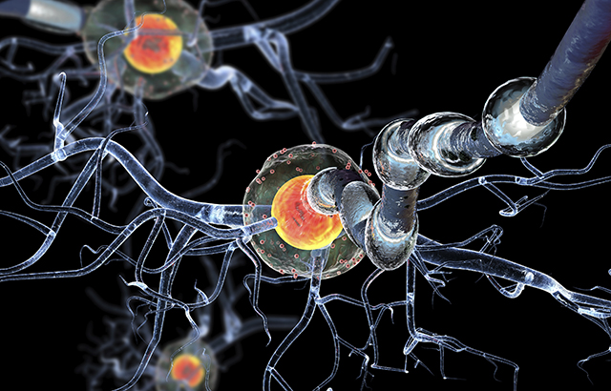
Public Lecture: MSc Global Public Health
31 March (Jonathan Filippon. Centre for Public Health and Policy)

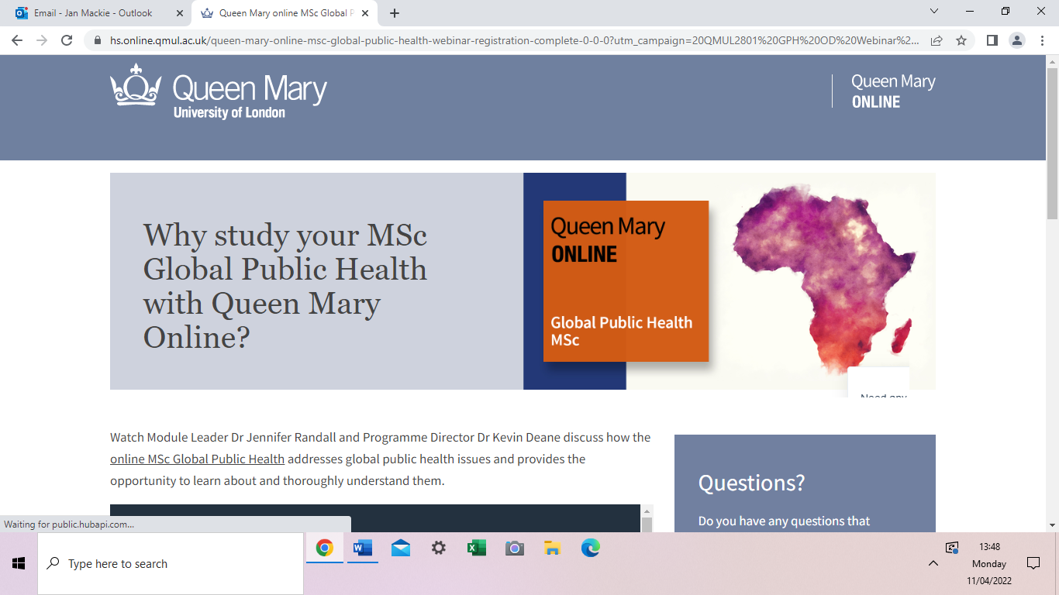 |  | Dr Halima Mohamed delivered a detailed and grounded view of health emergencies and disaster relief, drawing from years of experience in Somalia during a harsh drought and COVID-19. She shared with us the reality of working in Global Health, and negotiating with starkly different stakeholders - from armed militia and the Somali local government, to international donors and WHO. Her key message was that none of the multiple entities involved are above the local populations and their needs. The role of informed Global Health actors is to give these communities a space for their voice.

Major Barts Charity funding for Optimally designed Clinical Trials

31 March (Rhian Gabe, Fiona Walter, Richard Hooper. Centres for Evaluation and Methods/Prevention, Detection and Diagnosis)

Barts Charity has awarded almost £3 million in funding for the Advancing substantial improvements in health through optimally designed Clinical Trials (ACT) research programme. Funding for 60 months from 1 June will build on existing capabilities as well as supporting 11 new posts. Well designed and executed clinical trials provide evidence of benefit of healthcare interventions, and are a crucial step in improving the lives of patients and the public. ACT will provide expertise to enable the development and successful funding of innovative studies. This funding will allow scientists, clinicians, and other innovators to translate findings into promising health interventions and provide definitive evidence of benefits. The objective is to contribute to a reduction in mortality and morbidity from major disease through effective, efficient clinical trials research, producing tangible benefits. Research will be prioritised where there is a high disease burden for the local community, national or global impact, and where there is synergy with respect to growing research themes covering inequalities and targeted interventions across health settings. |  |     
Many thanks to all who so enthusiastically contribute. Please send any news items for the next newsletter to j.a.mackie@qmul.ac.uk

