WOLFSON INSTITUTE OF POPULATION HEALTH
NEWSLETTER
ISSUE 9: 14 FEBRUARY 2022

In this issue of our Wolfson Institute of Population Health Newsletter, we celebrate the achievements and work of staff and students in the first half of February.
FROM OUR DIRECTOR
Dear All

The first half of February has yielded a bumper crop of publications, with almost twice as many WIPH research papers appearing in print than in any two week period since the Institute was established. This is a testimony to the industriousness and dedication of our research teams to furthering our cause of improving population health, both here in the UK, and globally- many congratulations. On a local note, this week sees the start of industrial
action. Please ensure that you are up to date on information about what you can expect if you are not taking part in the action and what to do if you are intending to take strike action- thank you.  Best wishes  Fiona |  | 
FROM OUR LEADERSHIP TEAMS AND REPRESENTATIVES

Integrating teaching
Mark Freestone (Director of Education)

In a further move towards integrating our teaching in the new merged Institute, this month the education leadership team have revised the structure of our Research Methods training, offering an integrated programme spread across two modules: one leaning to theory, and one to applied research. This revision will come into effect in September 2022, and will mean closer working and integration between our global and mental health programmes, as well as a stable platform for us to offer more advanced methods training in the future, such as the new Health Data in Practice module on Qualitative Methods for Health Research, convened by Deborah Swinglehurst.

Research Directorate Activities
Steph Taylor (Director of Research)

At the recent WIPH Research Committee meeting there was discussion about a series of workshops to support PhD and grant applications, and the Research Directorate has now met to plan the first two of these, which will cover planning a PhD proposal. The session will be in two parts – the first on supervision and the importance of planning the correct supervisory team, and the second on the PhD proposal. We hope that these sessions may count as QM mandatory supervisor update training. On behalf of our WIPH researchers, the Research Directorate are also exploring the use of ELEMENTS to host research protocols, so they can be open access (a requirement for some journals before publishing with them), and how to work more effectively with JRMO on research sponsorship. In other news, our “How I Got My Fellowship” seminars are proving a great success, and will shortly be available online.

Equality, Diversity and Inclusion update
Beatriz Ratton (Deputy Lead WIPH EDI)

The first EDI meeting for 2022 was very positive. In response to our request for feedback on the top three 2022 EDI agenda items, the following priorities were identified: 1) Better staff recruitment/retention strategies: including contracts that are not just fixed term, more mentoring on how to achieve career progress, more diverse selection boards, and more diverse senior staff. This item was overwhelmingly supported by almost all attending, and was clearly very important to staff. 2) More inclusive socials: more social interaction at work, so people feel more comfortable around each other. 3) More engagement with communities: mentoring, and moving closer to communities that are excluded from university/academia.

GENERAL INSTITUTE NEWS

TACK project funded for one-year extension
26 January (Victoria Bird. Centre for Psychiatry and Mental Health)

The TACK project (TACKling chronic depression – adapting and testing a technology supported patient-centred and solution-focused intervention (DIALOG+) for people with chronic depression) is a five-year NIHR-funded research programme. The DIALOG+ app-based intervention, developed by the CPMH Unit for Social & Community Psychiatry, is being assessed for clinical and cost-effectiveness in 350 patients, by over 120 clinicians across nine UK sites. The trial was paused during the pandemic, but funding awarded to extend the project for a further year will allow completion of the RCT. Chief Investigator Vicky Bird said: The extension will allow us to follow everyone for a year to see if DIALOG+ is effective and cost effective, and to complete our staff training work package for a range of inpatient, forensic, Improving Access to Psychological Therapies (IAPT), and primary care teams. | 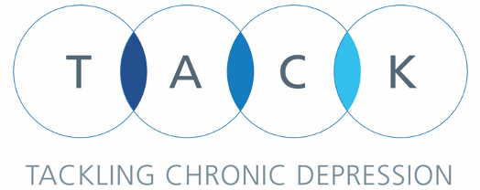    
‘Delayed quitters’ more likely to relapse than smokers who quit on target date
31 January (Peter Hajek. Centre for Public Health and Policy)

  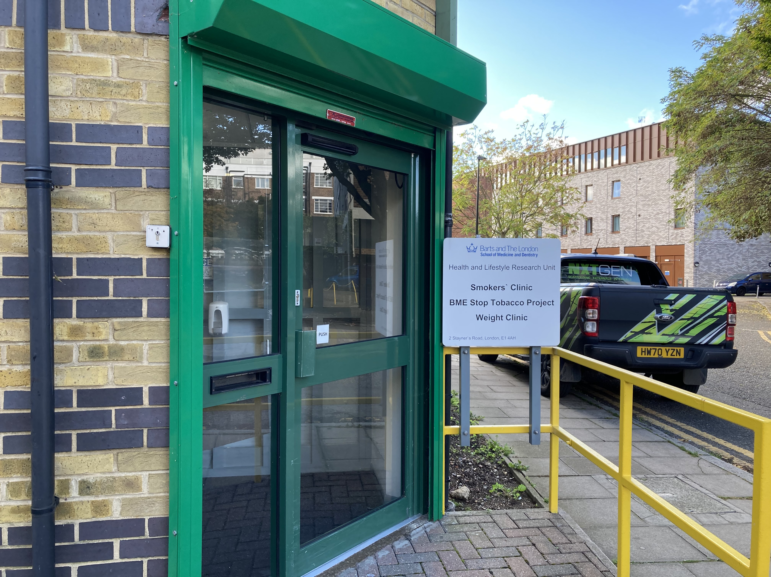 | Most smokers who initially succeed in quitting return to smoking within the first few months, but identifying sub-groups at higher risk of relapse could help in relapse prevention efforts. A retrospective analysis of records from the Health and Lifestyle Unit’s stop smoking clinic has examined relapse rates in short-term abstainers who stopped smoking on their target quit date, compared with those who needed more time to quit completely. The study of 308 subjects, published in Nicotine & Tobacco Research, found that one-year relapse rates were 53% for immediate quitters and 77% for delayed quitters, an association that remained highly significant when controlling for potential confounders. The effect was not explained by baseline variables. To date, no previously suggested behavioural relapse prevention strategies have been shown to be clearly effective. Co-author Peter Hajek said: “Encouraging smokers to adhere to their target quit date could improve treatment results. Relapse prevention efforts such as extended support and extended medication are likely to be particularly useful for delayed quitters.”
Interval breast cancer incidence after screening using mammography plus tomosynthesis
1 February (Stephen Duffy. Centre for Prevention, Detection and Diagnosis)

Adding digital breast tomosynthesis (an advanced form of mammography that produces 3D images) to digital mammography improves breast cancer screening sensitivity, but how this affects mortality and other end points has been unknown. A randomized trial comparing interval breast cancer incidence after screening with tomosynthesis plus mammography (experimental arm) with mammography alone (control arm) has found that in women under age 50, the benefit of early diagnosis seemed to be appreciable. For women over 50, the higher sensitivity of tomosynthesis plus mammography was not matched by a subsequent reduction in cancers at the next screening examination or in the intervening interval. Baseline cancer detection was higher in the experimental arm (101 of 13 356 women vs 61 of 13 521 women). | 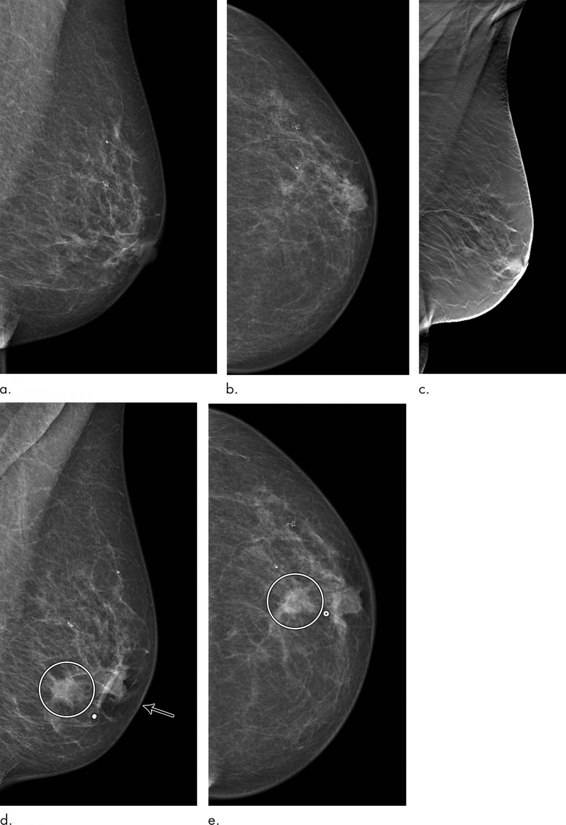
DNA methylome of cervical cells can predict the presence of ovarian cancer
1 February (Ranjt Manchanda. Centre for Prevention, Detection and Diagnosis)

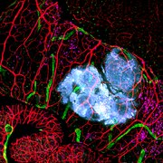 | Earlier detection may improve treatment outcomes for ovarian cancer, 75% of which is diagnosed at a late stage. A new study evaluates the WID-OC (Women’s risk IDentification for Ovarian Cancer) index signature, a test developed from DNA methylation (epigenetic) analysis of cervical smears. Researchers found that the WID-OC signature, which is not driven by tumour DNA, is associated with an increased risk of ovarian cancer, and can also identify women at risk of endometrial cancer. Co-author Ranjit Manchanda said: “These results show potential to improve risk prediction and help develop improved targeted screening and preventive strategies for women. Large scale prospective population based trials are needed to validate these findings prior to clinical applicability.”
Projected impact of cessation of breast cancer screening in England due to COVID-19 lockdown
2 February (Stephen Duffy, Jonathan Myles, Daniel Vulkan. Centre for Prevention, Detection and Diagnosis)

A paper in the British Journal of Cancer has estimated the number of breast cancers for which detection may be delayed because of the suspension of population screening due to the COVID-19 pandemic, and the potential impact on cancer deaths over ten years. From observed NHS Breast Screening System data, authors estimated that screening was delayed for 1,489,237 women by around 2 to 7 months between July 2020 and June 2021, leaving 745,277 outstanding screens. Additional breast cancer deaths were estimated from asymptomatic tumours progressing to symptomatically diagnosed disease, invasive tumours which remain screen-detected but at a later date, and ductal carcinoma in situ (DCIS) progressing to invasive disease by detection. Depending on how quickly this backlog is cleared, around 2500 to 4100 cancers would shift from screen-detected to symptomatic cancers, resulting in 148 to 452 additional breast cancer deaths. There would be an additional 164 to 222 screen-detected tumour deaths, and 71 to 97 deaths from DCIS that progresses to invasive cancer. Lead author Stephen Duffy said: ”This estimation is important for policy makers to understand the potential magnitude of the impact. It is crucial that the screening backlog is addressed as soon as possible to minimise the impact of the screening delay.” |   
Co-locating welfare services in healthcare settings benefits participants and demonstrates clear financial gains
2 February (Trevor Sheldon. Centre for Public Health and Policy)

  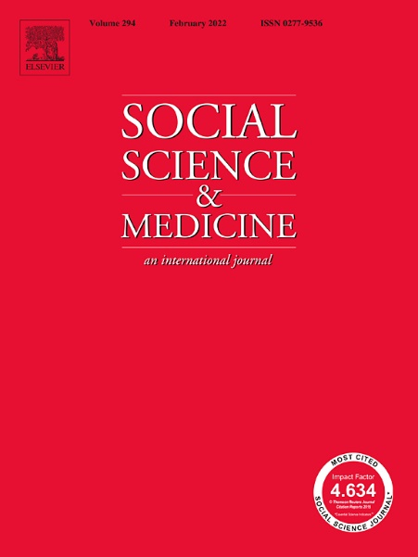 | Co-locating welfare advice services in healthcare settings demonstrates clear financial gains and improved mental health and wellbeing, according to results from a newly published systematic review. Authors identified 14 studies published from January 2010 to November 2020, and used a theory of change model as an analytical framework against which to map the evidence on how the services work. All studies demonstrated improved financial security for participants, and some studies reported improved mental health for individuals accessing services. Benefits to the health service were demonstrated through reduced workload for healthcare professionals. The study concludes that health and wellbeing is improved by addressing key social determinants of health, and that co-located services provide early intervention for those most in need of support. Co- author Trevor Sheldon said: “Research so far has a significant under-representation of ethnic minority groups, despite them being amongst those with the greatest need. Further research needs to be conducted to ensure co-located services are best able to reach those most in need and rigorously evaluate the health and social impacts of the services for these groups.”
Swiss television programme on meat alternatives
4 February (Sonia Pombo. Centre for Public Health and Policy)

Swiss TV channel RTS (Radio Télévision Suisse) has interviewed Action on Salt’s Sonia Pombo for a story about alternative meat products available in the United Kingdom, to be broadcast in March as part of their business programme, A Bon Entendeur. Following the November 2021 publication of the Research and Action on Salt and Obesity unit’s paper examining the nutritional profile of meat alternatives, the journalist interviewed Sonia about the findings and the health implications of eating these processed products. | 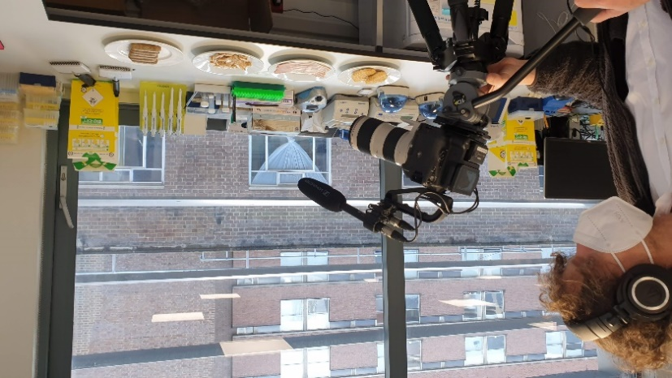
Post-pandemic breast screening: should we focus on uptake?
4 February (Stephen Duffy, Daniel Vulkan. Centre for Prevention, Detection and Diagnosis)

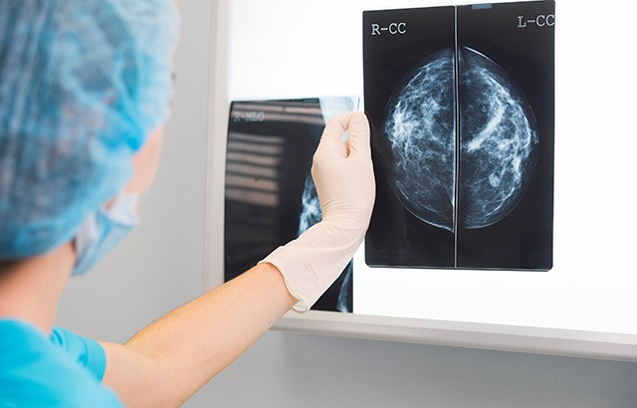  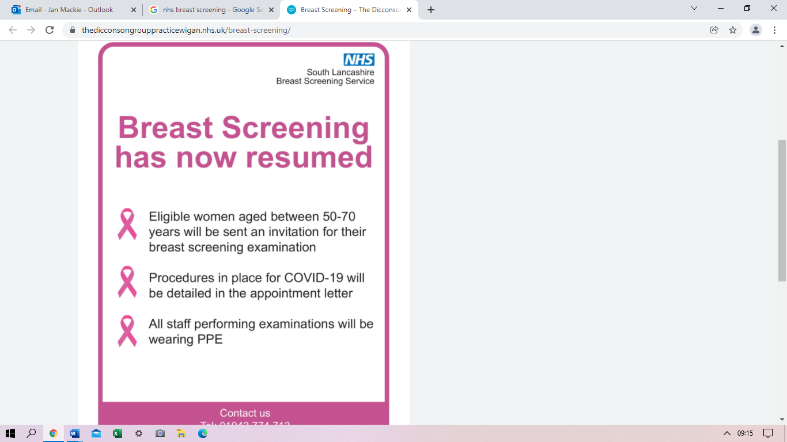 | A study estimating numbers of breast cancers detected through the NHS screening programme in England using different round lengths (time between screens) and uptake rates has found that a 4-year round length with uptake of 62% (as observed with timed appointments in London before the pandemic) would result in 295 screen detected cancers per 10,000 invited, compared with 222 cancers with a 3-year round and uptake of 46% (as observed in London during the pandemic recovery period). The NHS breast screening programme in England invites around three million asymptomatic women and detects around 19,000 breast cancers each year. The programme currently issues open invitations, following which women have to actively make an appointment. This leads to lower uptake than the previous policy of sending an appointment date, time, and place with the invitation, although it means faster coverage of the eligible population by invitation, and therefore closer adherence to a round length of three years. Authors conclude that it may be more productive for early detection to focus on uptake, rather than round length, in the programme’s recovery from the pandemic.
The potential utility of smell testing to screen for neurodegenerative disorders
7 February (Jonathan Bestwick, Alastair Noyce. Centre for Prevention, Detection and Diagnosis)

In a review appraising the evidence for and likelihood of the use of smell testing in large screening programmes to detect early neurodegeneration, researchers from the PNU conclude that even if disease modifying therapies were available for neurodegenerative disease, smell tests alone are unlikely to have high enough predictive power to be used in a future screening programme. They note, however, that they could be a valuable component of a short battery of tests, or part of a stepwise process that, together, could more accurately identify early neurodegeneration in large populations. | 
Children play important role in lowering family salt intake in China
10 February (Feng J He, Changqiong Wang, Monique Tan, Jing Song, Graham A MacGregor. Centre for Public Health and Policy)

 | Results from an NIHR-funded RCT by WIPH researchers in collaboration with the George Institute for Global Health in China show that, through smartphone app-based learning, school children can help their families to reduce salt intake. The study was conducted through 54 primary schools from three provinces in China in 2018-19, with 12-month follow up in 287 children and 546 adults in the intervention group, and 278 children and 526 adults in the control group. Children in the intervention group were taught about salt reduction using a smartphone app (AppSalt). The app was installed on parents’ or grandparents’ phones, and the children’s homework was to remind their family to complete the learning and tasks with them. Around 80% of salt intake in China is added by consumers. No country has yet demonstrated a successful salt reduction programme in such a setting. Average salt intake before the intervention was 10g/day for adults (double the WHO recommended level), but after a year this was reduced by 8% (0.82g/day), accompanied by a significant fall in systolic blood pressure. Researchers estimate that scaling up this approach across China would prevent around 250,000 stroke and heart disease events per year.
Programme launch: Addressing falling rates of preschool immunisations in London
10 February (Carol Dezateux, Ana Gutierrez, Zaheer Ahmed, Isabel Dostal, Milena Marszalek, Gill Harper, Nicola Firman, Kate Homer, Megan Clinch, Anna Billington. Centre for Primary Care)

Preschool immunisations in London, especially against measles, mumps, and rubella, are among the worst in England, and at a ten year low. Too many of London’s children are not fully protected, and this is worse in deprived areas and among certain ethnic groups. In response, the Clinical Effectiveness Group (CEG) has launched a quality improvement programme to help primary care turn this around. The programme includes a software tool, developed by CEG, which practices run on their patient records, making it easy to call and recall children so they are immunised on time. On 10 February, practice staff from across North East London joined a webinar to see the tool in action. Feedback was extremely positive, and 134 people have now downloaded the tool, covering almost half the practices in the region. The programme benefits from funding as a London Health Data Strategy ‘pathfinder’ research project, and from a Barts Charity REAL Health programme grant and the NHS Digital First programme. Following the North East London launch, South East and North West London will follow later in 2022. | 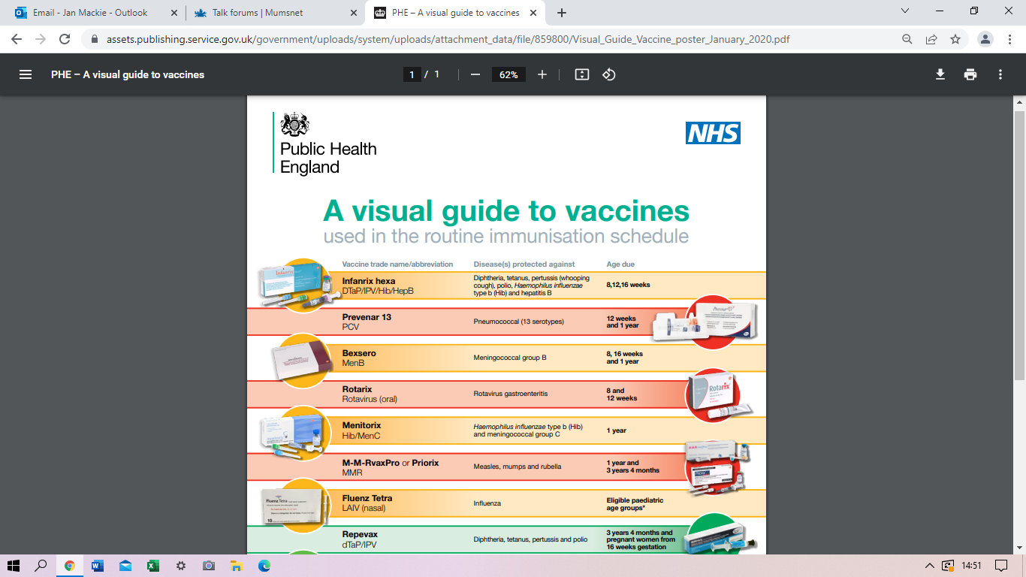
Ethnicity and deprivation independently associated with dementia risk in East London
11 February 2022 (Phazha Bothongo, Sheena Waters, Isabelle Foote, Jack Cuzick, Ruth Dobson, Alastair Noyce, Jon Bestwick, Charles Marshall. Centre for Prevention, Detection and Diagnosis)

 | In a nested case-control study in The Lancet Regional Health Europe, WIPH authors have examined the association between dementia risk and ethnicity and socioeconomic deprivation in a population of over a million patients from four inner East London boroughs. Black and Asian ethnic underrepresentation in existing dementia research cohorts has made it difficult to identify the mechanisms responsible for variation by ethnicity. It has been hypothesised that ethnicity acts as a proxy for other risk factors (eg: access to health services, differential burden of vascular risk factors, racism, and socioeconomic deprivation), but previous pooled evidence has not clearly demonstrated that these factors are sufficient to account for differences in dementia risk. Using data from primary care medical records from 2009-2018, researchers on this Barts Charity-funded study found that Black and South Asian ethnicity were both associated with increased risk of dementia (odds ratios 1.43 and 1.17 respectively) and a younger age at diagnosis (odds ratios 0.70 and 0.55 respectively) relative to White. Population attributable risk was higher for ethnicity (9.7%) and deprivation (11.7%) than for any established modifiable risk factor in this population. First author Phazha Bothongo said “These results show that ethnicity and area-level deprivation are independently associated with dementia risk in East London, and that this effect may not be attributable to the effect of known risk factors.”
International Day of Women and Girls in Science
11 February (Emma Atakpa. Centre for Evaluation and Methods)

To celebrate International Day of Women and Girls in Science, the Breast Cancer Now research charity has profiled postdoctoral data scientist Emma Atakpa as “just one of the incredible female researchers who are carrying out research that could save lives”. Emma is part of a team aiming to improve breast cancer screening and prevention, using data from over 200,000 women to create a tool to identify those with a higher chance of developing the disease, and the type of breast cancer they are more likely to get. A model to identify women at a greater risk of the disease could help women to take preventive action to reduce their risk, or help women to be diagnosed and treated earlier. | 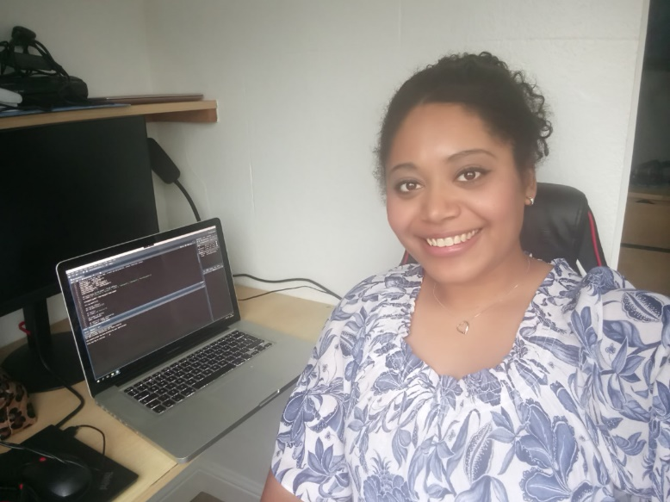  
FORTHCOMING EVENTS

14 February: 2022 London Clinic Lecture, Royal Society of Medicine  Ranjit Manchanda will deliver a presentation on how preventive population genomics enables population stratification for targeting effective screening and cancer prevention strategies, and offers the prospect of tailoring care and interventions to those at greatest risk in society. Book here. | 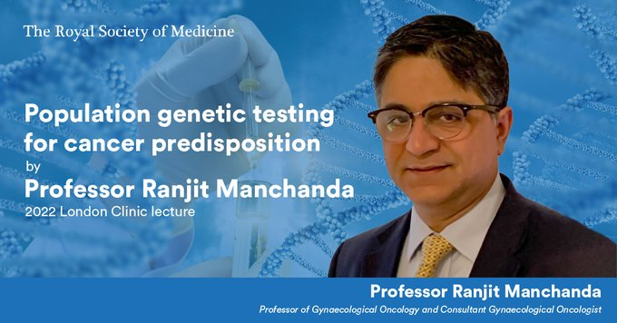
17 February : Talk on The Frailty of the Rule of Law in Times of Pandemic- Corruption in Ecuador and Peru  The Queen Mary Latin American Network (QLAN) and FLACSO, ECUADOR are pleased to present this talk by Professor Raúl Salgado (Departamento de Estudios Internacionales y Comunicación, FLACSO, Ecuador), to be held on Zoom at 5:30pm on 17 February. The talk will be chaired by Doreen Montag. Please register here in advance of the meeting. After registering, you will receive a confirmation email with details on how to join. | 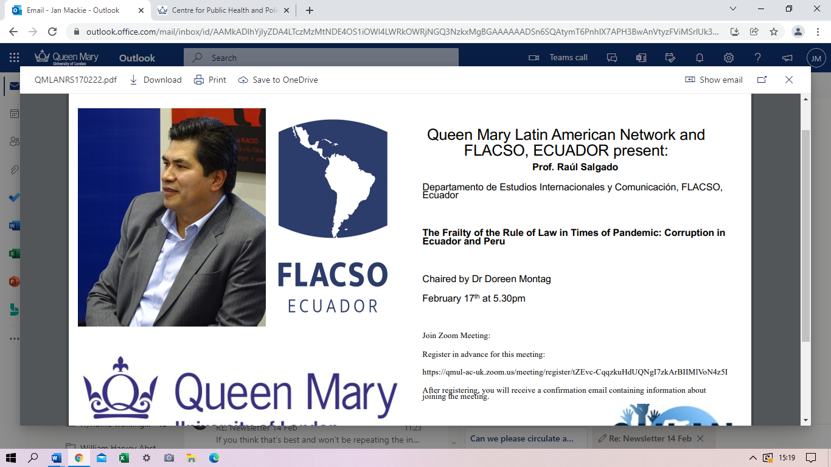
24 February: Programme launch - Addressing falling rates of preschool immunisations in London  The Clinical Effectiveness Group will host a launch event with a range of external guest speakers to inform general practices, NHS commissioners, and public health teams across London about this quality improvement programme and its ambitions to improve childhood immunisation rates in London. The event will be held on MS Teams from 1-1:45pm on 24 February. All WIPH staff are welcome to register to attend. | 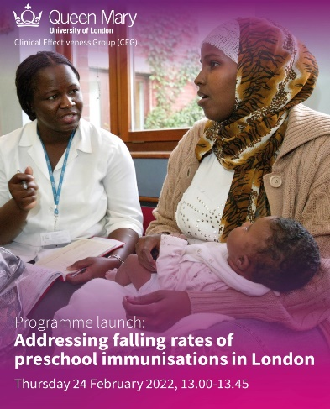
25 February: New WIPH Pilot Studies Research Group First Meeting  The first meeting of the new WIPH pilot studies research group being set up by Clare Robinson and Claire Chan (Centre for Evaluation and Methods) will be held on Friday 25 February 10-11am via teams. This friendly and supportive group will meet approximately once a quarter, and aims to identify what research involving pilot studies is being conducted in the Institute, share ideas and problems, discuss papers and new methodology involving pilot studies, and explore ideas for collaborations. No experience is necessary, and the organizers welcome you to join, even if you have not been involved in pilot studies before, but would like to learn more about them. Please email Claire or Clare to be added to the email distribution list for these meetings. | 
9 March: Faculty EDI Seminar  At the next Faculty EDI Seminar (11am, 9 March) Grace Spence Green will speak about her experience as a disabled medical student and junior doctor, working to challenge the narratives surrounding disability, medicine, and identity. Register here. | 
Many thanks to all who so enthusiastically contribute. Please send any news items for the next newsletter to j.a.mackie@qmul.ac.uk

