WOLFSON INSTITUTE OF POPULATION HEALTH
NEWSLETTER
ISSUE 22: 14 OCTOBER 2022

In this issue of our Wolfson Institute of Population Health Newsletter, we celebrate the achievements and work of staff and students in late September and the first weeks of October.

GUEST EDITORIAL: ELLIE STEWART (WIPH MANAGER)
Dear Colleagues

I am delighted to introduce this edition of the Wolfson newsletter as we move into autumn and the new academic year. The WIPH is now just over one year old and we have seen a sustained period of growth with some fantastic new appointments, substantial new grants, and of course our new cohort of students, as highlighted in the last newsletter. I am very pleased to announce that we have been given approval to appoint five new posts into the Administration team in order to continue supporting our rapid expansion and our strategic ambitions. Recruitment will be taking place in the coming weeks, so please look out for announcements of the new appointments and do extend a warm welcome to the new members of the team when they join us.

Thank you to everyone who contributed to the Staff Survey 2022. The results are now in. The leadership team are reviewing the responses and a separate communication will be circulated shortly, summarising the outcomes for the Wolfson and what to expect next.

Finally, we have also turned our thoughts towards the upcoming festive season (yes, it really is never too early to think about Christmas) and are exploring options for holding an Institute party at one of our campuses. Any ideas or suggestions for what we could do would be warmly welcomed. As ever, we need to operate within some fairly restrictive financial constraints, but we are confident we can come up with something fun.  Very best wishes to all  Ellie |  |  | 
FROM OUR LEADERSHIP TEAMS AND REPRESENTATIVES

Student Recruitment success (Mark Freestone, Director of Education)

We are delighted to report that WIPH met all of its targets for student recruitment across global health, mental health, and distance learning pathways. A total of 438 new postgraduate students have joined us for the 2022-23 academic year, an increase of 11% on the previous year’s intake of 384 and well ahead of our recruitment targets. More than half of these students (220) are from overseas, meaning the majority of our student body is non-UK.

This is great news in a year where a lot of other QMUL departments have struggled to recruit postgraduate students to target, and it is a testimony to the hard work of our core Education Team and the academic teachers on the Global Health and Mental Health courses for attracting students by promoting the courses, tirelessly responding to questions and following up on recruitment issues to ensure all students who meet their conditions and want to enrol are assisted to do so.

QMUL Research Culture Survey (Tor Kemp, Research Manager)

Please take the opportunity to share your views on current QMUL research culture, and what you would like our research culture to be. If you are a post graduate researcher, a researcher at any career stage from postdoc to professor, a technician or a member of a professional services team that supports research, please do take the time to fill the survey. You can access it here. The survey will only take 10 minutes for you to complete and will be open until 8am on Monday 17 October. NB: "Staff ID" is your QMUL username, e.g. xxx000

GENERAL INSTITUTE NEWS

Using primary care patient records to target lung cancer screening candidates
21 September (Sammy Quaife. Centre for Prevention, Detection and Diagnosis)

Eligibility for Lung cancer screening is largely determined by tobacco consumption, and primary care smoking data could guide invitation and eligibility assessment. Using data from the SUMMIT study, researchers have found that self-reported smoking status was concordant with primary care records in 75.3% of individuals, but inconsistencies between historic and recent smoking status existed in 10.3%. Quantified tobacco consumption information was frequently missing. Invitation eligibility should use both current and historic smoking status, and lung cancer screening programmes require provision for individual level eligibility assessment. Authors conclude that direct eligibility assessment from primary care data is impracticable with some demographic bias. Work is needed to identify those without smoking status in primary care records and those with missing or erroneous "never-smoker" status, which is crucial for equitable invitation to screening. | 
CRUK awards £2.5 million funding for the CANDETECT project
28 September (Fiona Walter, Oleg Blyuss, Suzanne Scott, Rhian Gabe, Boby Mihaylova, John Robson, Sammy Quaife. Centres for Prevention, Detection and Diagnosis/Evaluation and Methods/Primary Care)

 |  | Cancer Research UK has awarded £2.5 million to fund the CANDETECT project, led by Fiona Walter with Steve Pereira (UCL), to run for five years from January 2023. The project, to accelerate detection of upper gastro-intestinal cancers using a multi-cancer early detection platform in primary care, is a collaboration with partners at UCL, Exeter, Newcastle and Kings. Outcomes for the commonest upper gastro-intestinal cancers (pancreatic, gastric, oesophageal) are very poor, with most patients presenting in primary care with potentially relevant symptoms on multiple occasions. Detecting these cancers earlier would enable more opportunities for curative treatment and improve disease outcomes. Patients with non-specific symptoms will benefit from a ‘local, smart, one-stop’ approach, integrating clinical, biomarker, and imaging data for rapid triage and appropriate management, from urgent referral to adequate safety-netting in primary care for those found to be at low risk. If this multi-cancer early detection primary care platform proves effective, feasible and acceptable, the results will underpin an application for a large, phase III trial.
Cohort profile for the COVIDENCE UK study of COVID-19 in UK adults
29 September (Hayley Holt, Clare Relton, Mohammad Talaei, David Jolliffe, Florence Tydeman, Chris Griffiths, Seif Shaheen. Centres for Public Health and Policy/Evaluation and Methods/Primary Care/Prevention, Detection and Diagnosis)

The COVIDENCE UK study launched on 1 May 2020 and closed recruitment with 19981 participants on 6 October 2021. The cohort was established to investigate COVID-19 risk factors and impacts in UK residents aged ≥16, and to address a need for population-based longitudinal studies to complement research conducted in secondary and tertiary care by identifying risk factors for developing predominantly mild/moderate COVID-19 that did not present to hospital. Participants consented to 5-year follow-up with medical record linkage, and completed a detailed online baseline questionnaire capturing self-reported information relating to their sociodemographic characteristics, occupation, lifestyle, quality of life, weight, height, long-standing medical conditions, medication use, vaccination status, diet and supplemental micronutrient intake. A unique feature is the capacity to support trial-within-cohort studies to evaluate interventions for prevention of COVID-19 and other acute respiratory illnesses. At April 2022 18388 (92%) participants remained in follow up. |  | 
Faculty of Medicine and Dentistry Staff Awards
29 September (Charlotte Edwards Roscamp. Centre for Primary Care)

 |  | Congratulations to CPC Manager Charlotte Edwards Roscamp, who received the award for Institute Emerging Professional Services Leader at the FMD Staff Award Ceremony on 29 September. The award recognises an individual who has made significant contributions to the effective running of the Faculty and the development of others. Charlotte was nominated as: “A highly professional administrator who has performed exceptionally well over the last 12 months; a role model for professional services staff, demonstrating ambitious standards, pride in her Centre, and a highly collegial approach to newly appointed professional service, academic, and teaching staff; and a creative thinker, with a superb grasp of University processes.” Bravo Charlotte.
UK National Screening Committee recommends targeted lung cancer screening
29 September (Stephen Duffy, Rhian Gabe, Sammy Quaife, Daniel Vulkan. Centres for Prevention, Detection and Diagnosis/Evaluation and Methods)

New recommendations from the UK National Screening Committee support the introduction of targeted lung cancer screening in the UK. The committee recommended that the four UK nations should move towards implementing a targeted national lung cancer screening programme, integrated with smoking cessation services, for people at high risk. The supporting evidence review cites 13 references published by WIPH researchers (Duffy, Gabe, Quaife, Vulkan) between 2015 and 2021. | 
Developing learning health systems in the UK: Priorities for action
30 September (CEG Team, Centre for Primary Care)

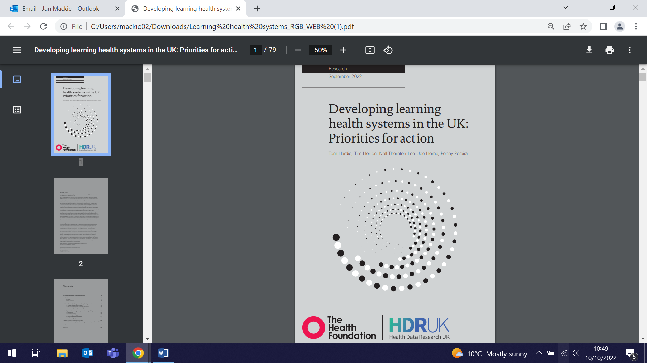 | Work by the Clinical Effectiveness Group has been cited as a case study in The Health Foundation’s publication: Developing learning health systems in the UK: Priorities for action. Case Study 5 notes that CEG facilitates data-enabled improvement for 272 north-east London GP practices, serving 2.2 million patients, with a facilitator team making around 300 GP practice visits a year. Their standardised templates allow practices to enter high quality data into patient records at point of care, and software tools, searches, and on-screen prompts turn these data into actionable insights within practices. CEG cardiovascular disease tools have contributed to improvements in blood pressure control, statin use and management of other associated long-term conditions in local populations. They also create interactive dashboards showing performance across a region, identifying areas requiring improvement and using this evidence to design and deliver local guidelines and programmes to reduce unwarranted variation in outcomes, most recently in a programme to reduce inequalities in childhood immunisations. CEG is working with other integrated care systems in London to support this approach in other areas as part of the London Health Data Strategy.
Suicide risk almost 7 times higher after diagnosis of young onset dementia
3 October (Charles Marshall. Centre for Prevention, Detection and Diagnosis

A study of nearly 600,000 people in England shows that suicide risk in the first three months following a dementia diagnosis for patients aged under 65 is nearly 7 times higher than in patients without dementia. The population-based case-control study of medical records from 2001–2019 found that patients receiving a dementia diagnosis before age 65 (“young onset dementia”) had 2.82 times increased risk of suicide and patients (of any age) within 3 months of receiving a dementia diagnosis had 2.47 times increased risk of suicide when compared with those without a dementia diagnosis. Patients with dementia who died by suicide had been diagnosed at a younger median age (76.05) than patients with dementia who died from other causes (80.50). Nearly 2% of patients with a dementia diagnosis died from suicide. Authors conclude that early recognition and a timely accurate diagnosis of dementia, combined with specialist support, are hugely important factors in reducing the distress caused by a young onset diagnosis. At 10 October this paper had been mentioned by 190 news outlets and had an Altmetric track of 1489, placing it in the top 5% of over 22 million tracked research outputs. | 
Protocol for study into long Covid in black and minority ethnic groups in UK
3 October (Dipesh Gopal. Centre for Primary Care)

 | A study of the lived experience of long Covid among people from ethnically diverse backgrounds in the UK will use qualitative interviews and art-based methods to better understand wider systems of support and healthcare support needs. Long Covid is the condition where symptoms of Covid, such as fatigue, chest pain and breathlessness, headache, and cognitive impairment persist for >12 weeks following initial infection. A purposive sampling strategy will be used to gain diverse experiences of Long Covid, sampling by demographics and geographic locations. Adults from Black and ethnic minority backgrounds who self-report Long Covid symptoms will be invited to take part in a semi-structured interview, and a sub-sample of participants will be invited to co-create visual artwork to further explore shared narratives of Long Covid, enhance storytelling, and increase understanding about the condition. The study aims to include people from Arab, Black, South Asian or mixed backgrounds, whose perspectives about their illness experiences, healthcare needs, and wider support seeking have been largely unheard.
Statin use for secondary cardiovascular disease prevention in Scotland
3 October (Boby Mihaylova. Centre for Evaluation and Methods)

A Scotland-wide cohort study has examined the extent of suboptimal statin use for secondary prevention of cardiovascular disease at different stages of the treatment pathway, to identify at risk patient groups. Researchers used linked NHS Scotland data for 167,978 adults hospitalised for an atherosclerotic cardiovascular disease (ASCVD) event from 2009 to 2017, and separately examined treatment following myocardial infarction, ischaemic stroke, and peripheral arterial disease hospitalisations. Of the patients hospitalised with ASCVD, only 81% initiated statin therapy, 40% of whom used high-intensity statin. Following myocardial infarction, 88% of patients initiated therapy, compared with 81% following ischaemic stroke and 75% following peripheral arterial disease events. Characteristics associated with lower odds of statin initiation included being female, aged <50 or >70, living in the most deprived areas, and having a history of mental health-related hospital admission. Authors conclude that statin use remains suboptimal, and that improving this would offer substantial population health benefits at low cost. | 
Policies on sexual behaviour of inpatients with severe mental disorders in Europe
3 October (Christophe Clesse. Centre for Psychiatry and Mental Health)

 | A systematic literature review investigating policies, guidelines, and recommendations regarding inpatient sexual behaviour in psychiatric units, institutions, and supported housing across Europe has found that few or no policy documents and guidelines have been reported, and it was therefore not possible to assess policy impact. The review also aimed to assess attitudes held by mental health professionals and inpatients toward existing policies. Surveyed mental health professionals and inpatients typically showed opposing attitudes regarding inpatient sexual behaviour, with the former generally deeming such behaviour unsafe, and inpatients emphasizing it as their human right.
6th International Clinical Trials Methodology Conference
3-6 October (Saskia Eddy, Sandra Eldridge, Chair Xie, Rachel Phillips, Olivier Quintin, Bev Nickolls, Siobhan Titre-Johnson. Centre for Evaluation and Methods)

The CEM fielded an impressive presence at the ICTM conference from 3-6 October in Harrogate. Among those presenting: Saskia Eddy and Sandra Eldridge contributed to a workshop on good practice in planning, conducting and reporting pilot trials. Oral presentations included Saskia Eddy (on her methodological systematic review of how to justify sample size for a pilot trial), Charis Xie (the use of routine healthcare data in improving the efficiency of randomised implementation trials), and Rachel Phillips (visualising harms in randomised controlled trials, a presentation following her BMJ paper earlier this year). Poster presentations were made by Olivier Quintin (on a new R Shiny App he has created to help estimate intra-cluster correlations for cluster randomised trials), Bev Nickolls (on approaches to informed consent for randomised controlled trials with usual care comparators) and Siobhan Titre-Johnson (on her narrative review of ethnic minority clinical trial participation and barriers to recruitment). These presentations showcased an amazing array of research, with an admirable emphasis on work from some of our CEM PhD and Early Career Researchers. | 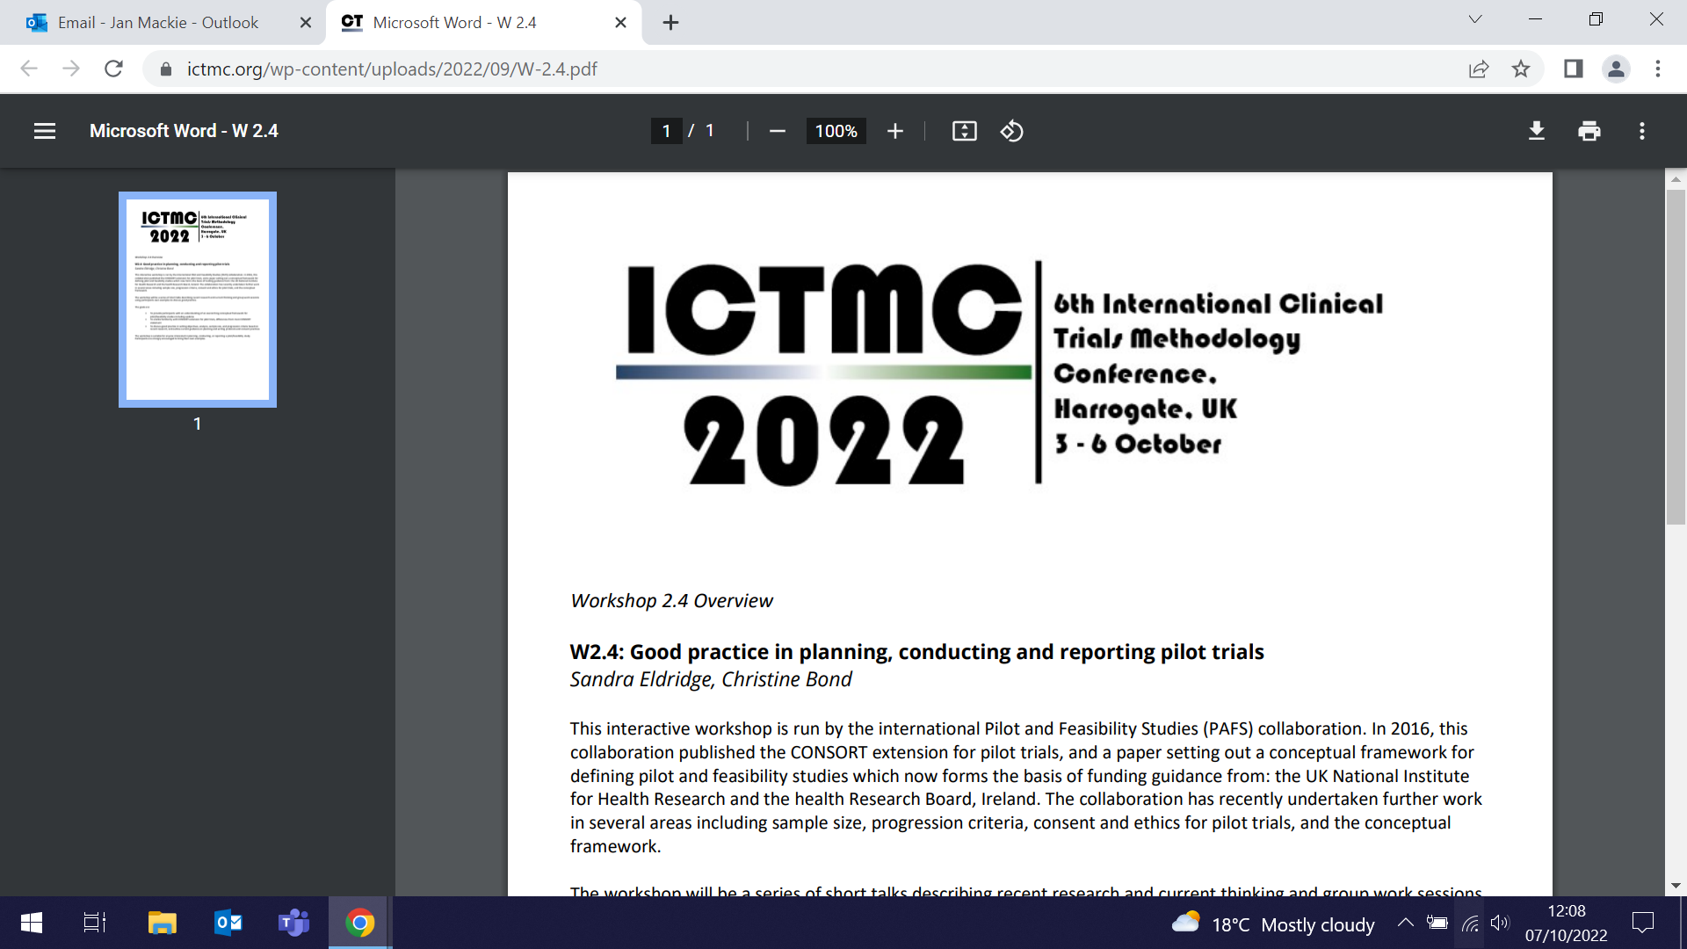  
Potentially harmful biomarkers in people switching from smoking to vaping
8 October (Peter Hajek, Centre for Public Health and Policy)

 | A secondary analysis of a Cochrane systematic review of trials of e-cigarettes for smoking cessation has found that switching from smoking to vaping, or dual use of both smoking and vaping, appears to significantly reduce levels of potentially harmful biomarkers. The research was based on nine studies, including 1300 adults in Greece, Italy, Poland, UK, and USA, in which carbon monoxide and 26 other biomarkers were measured. In pooled analyses, exhaled carbon monoxide was lower in e-cigarette users than in those using either e-cigarettes and cigarettes, or cigarettes alone, and lower in dual users compared with smokers. In comparisons of other markers, 12 of 13 biomarkers were significantly lower in e-cigarette users than smokers. Comparing e-cigarette use with dual use of e-cigarettes and smoking, 12 out of 25 biomarkers were lower for electronic cigarette use, and five were lower for dual use.
Global burden of disease: Long Covid
10 October (Oleg Blyuss. Centre for Prevention, Detection and Diagnosis)

An assessment of the global burden of Long COVID has modelled estimates of the proportion of individuals with at least 1 of 3 self-reported Long COVID symptom clusters (persistent fatigue with bodily pain or mood swings; cognitive problems; or ongoing respiratory problems) 3 months after symptomatic COVID infection. The study used data from 54 studies and 2 medical record databases, for 1.2 million individuals from 22 countries, to estimate the proportion of males and females, distribution by age, and duration of symptoms among those who had Long COVID symptoms in 2020/21. Findings show that 6.2% of individuals who had symptomatic COVID experienced at least 1 of the 3 Long COVID symptom clusters. Among those aged 20 or older, symptom clusters were more common in women than men. Mean duration of symptoms was 9 months for hospitalized individuals and 4 months among those not hospitalized. Among those with persisting symptoms 3 months after symptomatic COVID, 15% continued to experience symptoms at 12 months. | 
“Shopping around” for treatment not a solution to cancer backlog
10 October (Fiona Walter. Centre for Prevention, Detection and Diagnosis)

  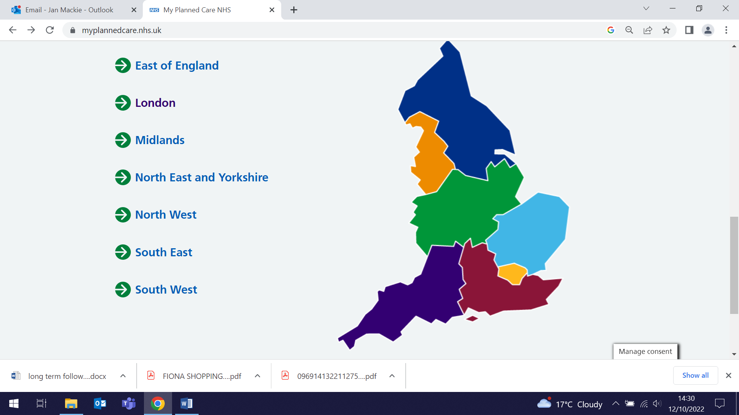 | An analysis in the BMJ argues that relying on patient choice to cut waiting times for cancer treatment is over simplistic, and likely to widen access inequalities. Due to backlogs in UK cancer pathways, only 65% of patients receive treatment within 2 months of referral for suspected cancer. The authors suggest that the Government’s My Planned Care service, enabling patients to “shop around” for hospitals with shortest waiting lists, fails to consider the complexity of patient choice, disparities in quality of cancer care, or the challenges in coordinating diagnosis and treatment. They note that marginalised patient groups are less likely to travel beyond their nearest hospital for care, and are therefore less likely to access or benefit from hospitals reporting shorter waiting times or better quality care. Without universal improvement in the quality of cancer care, patient choice could worsen waiting times, widen inequalities, and burden cancer patients with extra decisions about their treatment without improving outcomes. The authors contend that a more effective, low cost solution could come from using routinely collected data about cancer care to enable cancer teams to advise what treatments newly diagnosed patients should receive, and also where they should receive it, and from a restructure of cancer referral pathways across the health system.
Babies up to 25th centile birthweight at risk of early childhood development concerns
11 October (Abiodun Adanikin, Matina Iliodromiti. Centre for Public Health and Policy)

A population-based cohort study of 686,284 infants born in Scotland from 37 weeks’ gestation has examined child developmental assessments at age 2-3.5 and found that birthweight up to the 25th centile is associated with child developmental concerns. Little has been known about how the whole range of birthweights is associated with early childhood developmental concerns. Researchers examined measurements of fine motor, gross motor, communication, and social developmental concerns, and found that babies born from 37 weeks with birthweight up to the 25th centile were at higher risk compared with those between the 25th-74th centiles. The results indicate that developmental concerns are associated with babies at higher birthweight centiles than the conventional threshold used to define small for gestational age (<3rd or 10th centile). The authors conclude that “mild to moderate small for gestational age” (<25th centile) is an unrecognised and potentially important contributor to the prevalence of developmental concerns, and that closer surveillance, appropriate parental counselling, and increased support during childhood may reduce the risks associated with lower birthweight centiles. | 
Surge in young people with mental ill health in Malawi
11 October (Sandra Jumbe. Centre for Evaluation and Methods)

 | A recent study by WIPH researcher Sandra Jumbe has been quoted in a Guardian article. Health workers and support groups in Malawi have noted a dramatic rise in cases of young people with mental ill health over the past 2-3 years. Most young people in Malawi keep their struggles to themselves, with poverty and unemployment being common factors contributing to mental health problems. Sandra’s paper, ‘We do not talk about it’: Engaging youth in Malawi to inform adaptation of a mental health literacy intervention, is cited as evidence, having reported a “vicious cycle of poverty and mental health problems” for young Malawians.
Chronic kidney disease: primary care coding and subsequent hospitalisations and deaths
11 October (Sally Hull. Centre for Primary Care)

The association between primary care percentage coding of chronic kidney disease (CKD) and the risks of death or hospitalisation with cardiovascular events or heart failure is examined in a retrospective cohort study using healthcare records from 637 English general practices. The study followed 167 208 patients with stages 3–5 CKD for 3.8 years for hospital outcomes, and 4.3 years for deaths. Rates of hospitalisations with cardiovascular events and heart failure were lower in practices with higher percentage CKD coding, but no substantial change in rate of deaths was observed as CKD coding increased. Researchers estimate that 9% of cardiovascular event hospitalisations and 16% of heart failure hospitalisations could be prevented by improving practice CKD coding from 55% to 88%. Prescription of antihypertensives was the most dominant predictor of a reduction in hospitalisation rates for patients with CKD, followed by albuminuria testing, and use of statins. | 

Tower Hamlets awarded £5million for research to address health inequalities

11 October (Trevor Sheldon, Carol Dezateux, Megan Clinch. Centres for Public Health and Policy/ Primary Care)

 | NIHR funding of £5 million awarded to Tower Hamlets Council and its partners, including QMUL, will establish a Health Determinants Research Collaboration, which will support research on health inequalities. Tower Hamlets has several poorer than average health outcomes and significant variation in these outcomes exists, particularly by deprivation and ethnicity. The funding bid, led by Trevor Sheldon, builds on the strong partnership between WIPH and the Council, established through Act Early. Carol Dezateux will work with the Council to unlock the potential of linked health and council data to examine wider determinants of health, and address health inequalities. Initial work will focus on housing and household overcrowding, and on the Council’s extended free school meals offer. Co-production and involvement of residents is central, and Megan Clinch will support the approach to public involvement and engagement and alignment with QMUL funding, to develop community researchers, working with Alison Blunt and the Centre for Public Engagement.
Using timed breast screening appointments in London could have detected 100 more cancers during covid-19 recovery period
12 October (Stephen Duffy. Centre for Prevention, Detection and Diagnosis)

Results from a new study suggest that an additional 100 breast cancers could have been detected by screening in London from September 2020 - March 2021 if timed appointments, rather than open invitations, had been used throughout. To address the post-pandemic backlog of women awaiting breast screening, the NHS in 2020 opted to issue open invitations, asking women to contact the screening service to book an appointment, rather than standard pre-booked timed appointments. During this transition period, both appointment types used. The study included women invited to one of the six London breast screening services from 1 September 2020, grouped according to type of invitation. Of women offered a timed appointment, 60.6% attended within 6 months. In the open invitation group, 53.1% attended over the same time period. Results suggest that during this period over 12,000 London women, who would have been expected to attend if sent the standard timed appointment, received an open invitation and did not attend. In an urban population of high ethnic- and socio-diversity, timed breast screening appointments were associated with a substantial and significant increase in uptake compared with open invitations. | 
Using the ISARIC 4C score to predict mortality risk in COVID-19 patients
12 October (Jonathan Myles, Adam Brentnall, Rhian Gabe, Stephen Duffy. Centres for Prevention, Detection and Diagnosis/Evaluation and Methods)

 | In collaborative work with Barts Hospital colleagues, WIPH researchers have evaluated the dynamic use of the ISARIC 4C mortality score at different points in the covid inpatient journey to predict mortality risk. Accurate assessment of covid patients at highest risk of death is needed to guide resource use and clinical management. The ISARIC 4C mortality score, designed to predict mortality risk based on demographic and physiological parameters at admission, was here used at different points following admission for 6,373 Barts Health NHS Trust hospitals patients from 1 August 2020-19 July 2021. Scores were calculated every 48 hours for 28 days. Patients still in hospital at day 6 were more likely to die if they had a higher score at day 6 than others also still in hospital who had the same score at admission. Discrimination of dynamic scoring in those still in hospital was superior at admission and by day 8. Authors conclude that dynamic use of the ISARIC 4C score is likely to provide accurate and timely information on mortality risk during a patient’s hospital admission.
Psychologically Informed Planned Environments in prisons and bail hostels
13 October (Mark Freestone, Kam Bhui. Centre for Psychiatry and Mental Health)

The Ministry of Justice has published a major report, authored by WIPH researchers, on the use of Psychologically Informed Planned Environments (PIPEs), showing that within prisons the intervention can lead to improved social and relational functioning, associated with improving social climate and positive staff disposition. PIPEs interventions are designed to support residents with offender personality disorder in their journey through the Criminal Justice System and into the community. Staff working in PIPEs are trained and supported in working with offenders in a psychologically informed way, with close attention to how those who live and work there relate to one another. Quantitative data from prison sites found residents in prison PIPEs reported better social and relational skills than those in comparator wings, with statistically significantly lower levels of problematic social problem solving and relating styles, particularly those related to ‘personality disorder’. Staff and residents also reported improved working relationships and a better sense of safety. Residents engaged in pro-social behaviour, corroborated by staff, who felt they had reduced their use of force. Staff reported a sense of mattering in their role, noting that what they did was meaningful and that they felt particularly supported through supervision. | 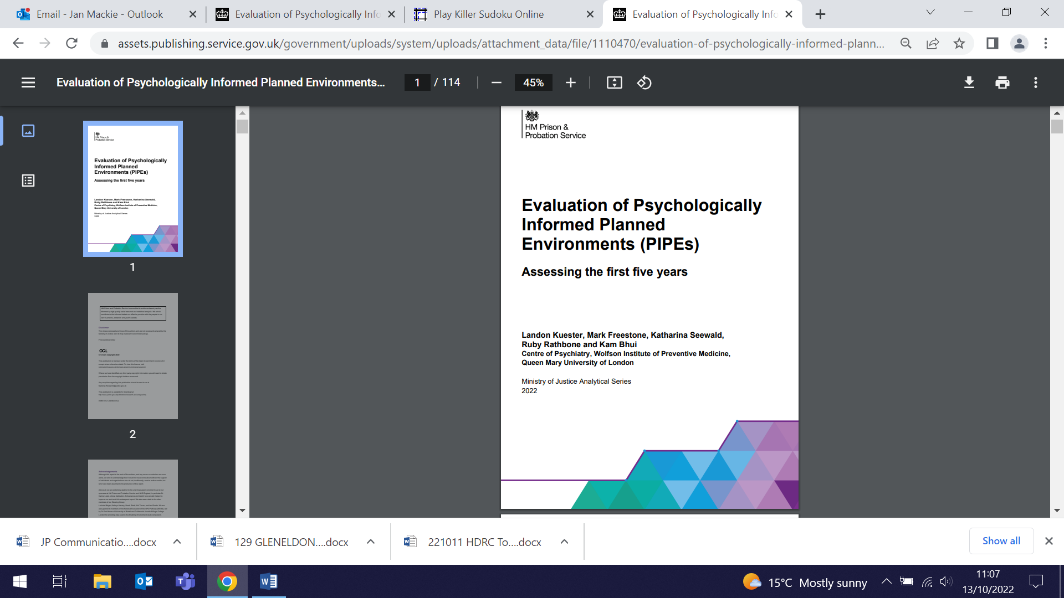
Liver, visceral, and subcutaneous fat in adults of South Asian and white European descent
13 October (Matina Iliodromiti. Centre for Public Health and Policy)

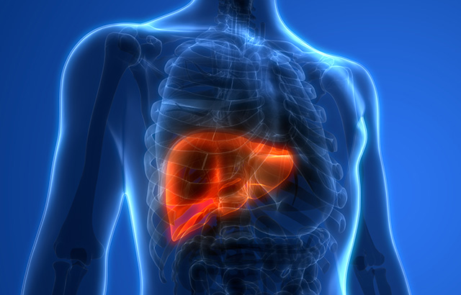 | South Asians have a 2- to 5-fold higher risk of type 2 diabetes than people of white European descent, and greater central adiposity and ectopic fat storage is a potential contributing mechanism. In a systematic review, researchers collated data from 8 published and 3 unpublished datasets, comparing subcutaneous, visceral, and liver fat in South Asian (1156 men, 697 women) with white European (2891 men, 2271 women) adults. Results show that South Asian men and women appear to store more ectopic fat in the liver compared with their white European counterparts with similar BMI levels. Given the emerging understanding of the importance of liver fat in diabetes pathogenesis, these findings help to explain the greater diabetes risks in South Asians.
FORTHCOMING EVENTS

Pandemic Research Symposium (11 November)

The QMUL Crisis and Resilience Multidisciplinary Theme will host a Pandemic Research Symposium on Friday 11 November from 09:30am-17:00pm in the Drapers Lecture theatre, Mile End. The symposium will bring together academics from across QMUL, including WIPH researchers Belinda Nedjai and Suzanne Scott, to showcase their work and celebrate the magnitude of our response to the COVID-19 Pandemic. The symposium will look back on the experience of delivering research in the pandemic, and to the future for new collaborations, research, innovation, and impact in pandemics and other impending global crises. Register here | 
Many thanks to all who so enthusiastically contribute. Please send any news items for the next newsletter to j.a.mackie@qmul.ac.uk

