WOLFSON INSTITUTE OF POPULATION HEALTH
NEWSLETTER
ISSUE 24: 15 NOVEMBER 2022

In this issue of our Wolfson Institute of Population Health Newsletter, we celebrate the achievements and work of staff and students from the last days of October through to mid-November.

FROM OUR DIRECTOR OF EDUCATION
Dear Colleagues

Fiona is away at a conference this week, and so it falls to me to open this edition of our newsletter. It was a great pleasure to attend the Faculty Education Away Day on 27 October, an event that allowed us to take stock as a medical school of where we are and where we need to be in relation to our student targets, as well as sharing some innovative ideas from colleagues across the faculty about how to get there. WIPH was acknowledged as the only Institute to hit its challenging student recruitment targets this year. Over the coming months we will be working to identify new educational opportunities through an extensive scoping process, so if you have an idea for a course or module we will be keen to speak with you.

I would also like to acknowledge the successes of our outgoing student cohort who will be graduating on 5 January. As well as some excellent results across the board, Tetiana Lunova from the MSc Global Health and Policy was one of only three students in the Faculty to receive a college award; a fantastic result for Tetiana and the global health team.  I am looking forward to seeing many of you at the events planned in the coming weeks, including the Integrated Academic training workshop on 23 November, which was a real pleasure to attend last year despite COVID-related disruption - full of innovative ideas and enthusiasm for clinical research.  Mark |  |  | 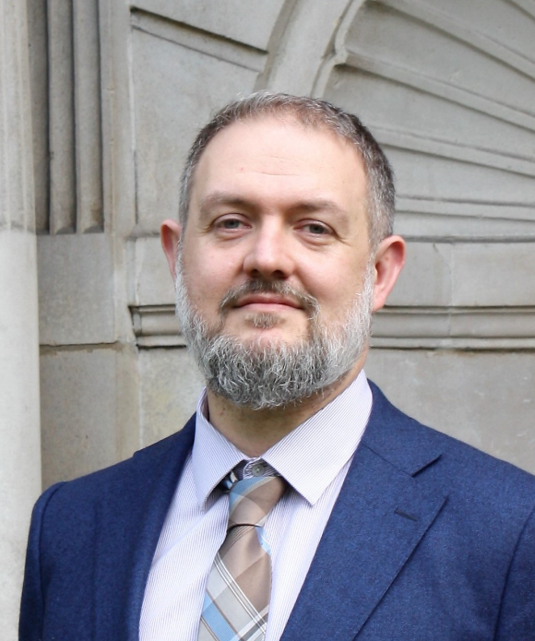
FROM OUR LEADERSHIP TEAMS AND REPRESENTATIVES

RESEARCH NEWS (Victoria Kemp, Research Manager)

(i) PROCESS FLOW DIAGRAMS NOW AVAILABLE ONLINE

Pre- and post-award process flow diagrams (presented at the last WIPH All Staff meeting, and circulated already to academic staff) are now available. These provide guidance on key actions at both stages. The diagrams outline where responsibility lies, and also include indicative timeframes for the different actions. If you have any questions please email v.kemp@qmul.ac.uk

(ii) LINKS TO RECENT DEVELOPMENTAND FUNDING OPPORTUNITIES
The links below are now available to recent development and funding opportunities:

Seminars, Workshops and Conferences

SAPC SE Regional Meeting 2023 | Application for oral presentations open | deadline 18 Nov

In-person event: Blizard Institute Research Seminar Prof John Connelly | 21 Nov 2.30-3.30pm

Hybrid event: NIHR Academy Members Conference 2022 | registration deadline 22 Nov

Virtual event: Landing Multiple Long-Term Conditions (MLTC) research in the health and care system | NIHR | 22 Nov

Virtual event: PPI workshop by HDRUK | 23 Nov

Hybrid delivery course | Evidence In Practice: An introductory course | deadline 28 Nov

DERI Sandpit: AI for Synthetic Data and its Applications | 29 Nov
Funding

MRC mid-range (>£100k) equipment call: deadline 21 Nov

NIHR SPARC and LA SPARC awards of £5k and £15k for career development & collaboration | deadline 24 Nov

BBSRC mid-range (£200k -£1.5M) equipment call: deadline 15 Dec

Brazil Accelerator Fund II: deadline Sunday 15 Jan 2023

International Research and Innovation Funding Opportunities Oct-Nov 2022

EDUCATION AWARDS (Mark Freestone, Director of Education)

The education team have two award news stories to celebrate this month:

WIPH was awarded three Commonwealth Scholarship awards for postgraduate study for 2023/24 - two in Global Public Health and Policy, and one in Public Mental Health. Sincere thanks to Jon Filippon and Richard Grose for supporting this process. More information about the scholarships is available at https://cscuk.fcdo.gov.uk/.

Outgoing MSc Global Public Health and Policy student Tetiana Lunova was awarded a College Prize for her academic performance, achieving over 70% in her dissertation and a distinction award overall. Only three College Prizes are awarded across over 1100 PGT students in the entire Faculty so Tetiana’s achievement is exceptional, perhaps even more so as an overseas student from Ukraine. Very well done Tetiana!

STAFF NEWS

Farewell to Heidrun Bien (Centre for Psychiatry and Mental Health)

Dr Heidrun Bien, who has been part of the Wolfson Institute at QMUL since 2012, will sadly be leaving us at the end of next week. She has contributed a great deal to the development and quality of our postgraduate programmes in mental health over the years, and most recently has acted as Elearning lead and postgraduate School Exam Board chair for the Wolfson since September 2021. We are very sad to see her go, and wish her all the best for the future. Colleagues who would like to mark her departure are welcome to contribute to Thymic UK, a charity for those affected by thymic cancers, which Heidrun set up in 2018. | 
GENERAL INSTITUTE NEWS

RCOG Showcase: the COVID Maternity Equality Project
21 October (Matina Iliodromiti. Centre for Public Health and Policy)

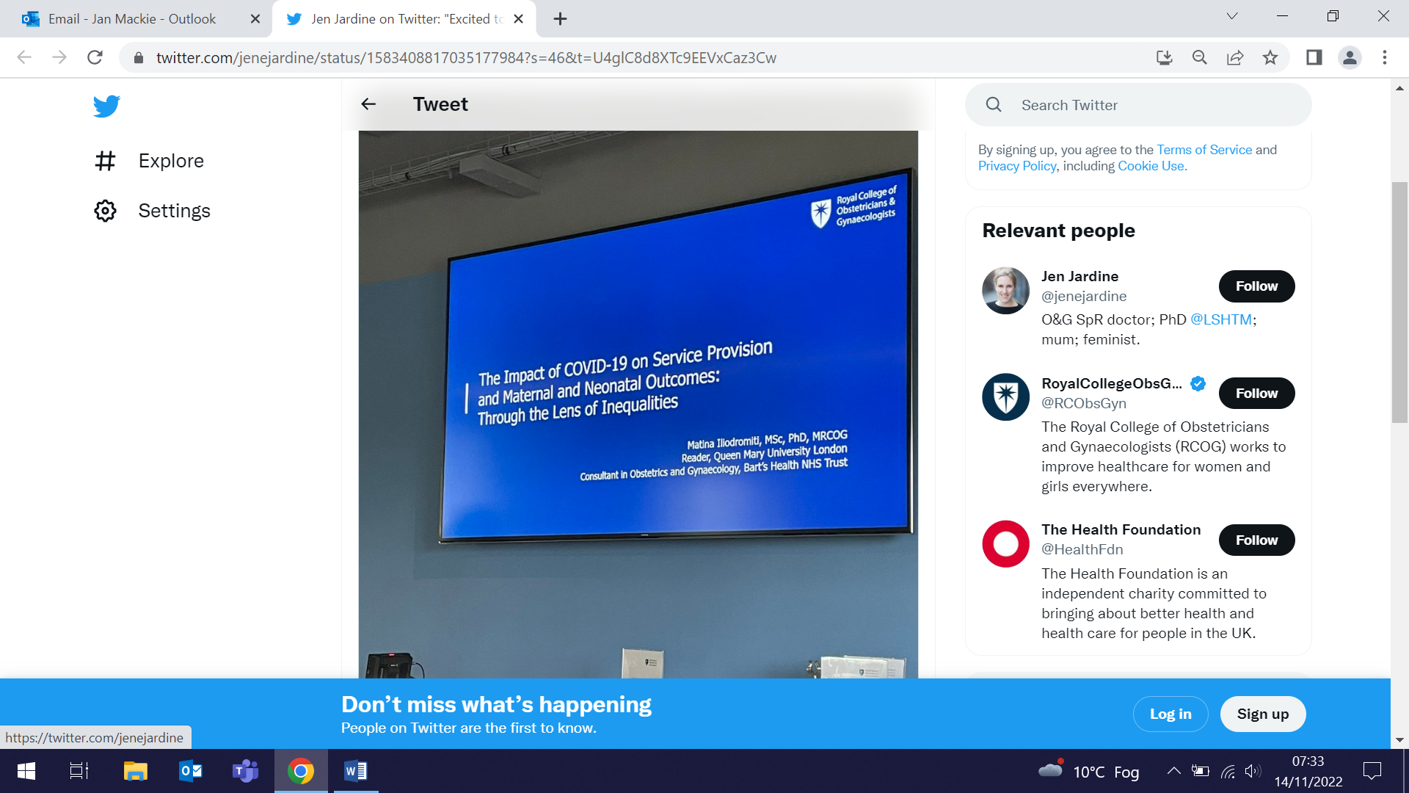  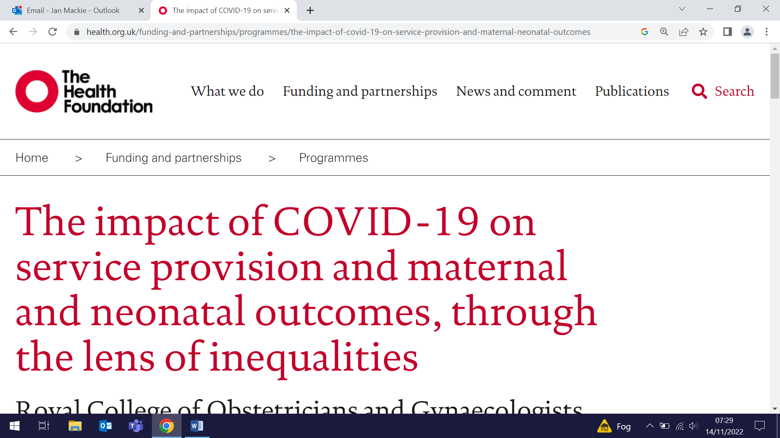 | Results from the Health Foundation-funded COVID Maternity Equality Project were presented by PI Matina Iliodromiti at an RCOG showcase on 21 October. In the UK, Black women are four times more likely to die during pregnancy, birth and the postpartum period than white women. During the pandemic, care provision was modified and maternity units faced staffing shortages. This research used routinely collected maternity data to identify “positive deviant trusts”, units with substantial maternal and perinatal outcome reductions, where the pandemic had narrowed existing gaps in outcomes between women from different ethnic groups. The study found that the pandemic was a catalyst for the identified trusts to build a culture of proactivity and team working which, with productive use of changed staffing resources, enabled a reduction in inequalities. The findings will inform recommendations on how to improve quality and safety to ensure that all woman have access to safe maternity care.
Faculty Education Away Day
27 October (Attendees: Hannah Jones, Jon Filippon, Megan Clinch, Hanif Ali, Fiona Walter, Ellie Stewart)

The Faculty of Medicine and Dentistry Education Away Day was held at the Royal College of Pathologists in London on Thursday 27 October. Among the excellent presentations was one by Megan Clinch on transforming the curriculum, using the MSc in Global Public Health as an example of how to undertake a review and produce a sustained improvement in student satisfaction. Workshops included contributions from Jon Filippon, Hannah Jones, Fiona Walter, Hanif Ali, and Ellie Stewart. WIPH was acknowledged by the Vice Principal as the only Institute in the Faculty to have exceeded our 2022/23 student recruitment and tuition fee income targets, in what was otherwise a tough financial year for the Faculty. | 
BMJ Editor in Chief cites WIPH paper in Editorial on Sunak’s legacy
27 October (Fiona Walter. Centre for Prevention, Detection and Diagnosis)

 |  | BMJ Editor-in-Chief Kamran Abbasi has cited a recent paper by Fiona Walter and colleagues in an editorial entitled: “Health and climate crises will shape Sunak’s legacy”. He reflects that a healthy economy is not one in which commercial determinants detrimental to health are allowed to flourish, and that the principles of the market don’t readily transfer to the complex business of patient care, referencing the paper “Shopping around for treatment is not a solution to cancer backlog” published in the BMJ on 10 October. Abbasi concludes that: “As our health and care services descend further into the abyss, Sunak may well find that, despite his economic priorities, it is health and social care that shape his political future and determine the final verdict on his leadership.”
Predictors of long-term smoking abstinence in TB patients
1 November (Rhian Gabe. Centre for Evaluation and Methods)

Studies of TB patients suggest an association between behavioural support and smoking cessation at 6 months (when most patients complete their TB treatment), but it is unknown if this association persists at 12 months. A secondary analysis of data from a double-blind RCT of smoking cessation among mainly male TB patients in Pakistan and Bangladesh has examined 12 month continuous abstinence among 2442 participants. On average, participants had smoked for 23.3 years and were using tobacco 11.8 times/day. At 12 months 29% had achieved continuous abstinence. Receipt of behavioural support, mono-tobacco use (vs. poly-use), less frequent tobacco use, and lower nicotine dependence were associated with higher odds of 12-month continuous abstinence. Authors say these findings show that the association between behavioural support and smoking cessation is long term, and that behavioural support is a cost-effective approach especially relevant to low resource settings, where pharmacotherapy is unavailable. | 
COVER-ME Study website launched
1 November (Dominik Zenner, Tahreem Chaudhry, Felicity Morrow, Patricia Tum, Chris Griffiths, Rhian Gabe. Centres for Public Health and Policy/Primary Care/Evaluation and Methods)

   | A website has been launched for COVER-ME, the Barts Charity-funded study examining experiences and decision-making related to COVID vaccination in the communities of Tower Hamlets and Newham. Using interviews and focus group discussions, the study aims to develop and test a patient engagement tool to support awareness and decision making around vaccination. The project seeks to understand the social determinants of vaccine uptake in East London taking into account the cultural and socioeconomic nuances within these communities, and then use this to inform policy and to support individuals and their GPs in making informed decisions about vaccination. Ethnic minority groups will be invited to participate to share their experiences and perceptions of COVID-19 vaccine and other vaccination programs. Patients from six GP practices from Tower Hamlets and Newham will either receive the Patient Engagement Tool or routine care to understand the usefulness and suitability of the tool.
Hormone measurement prior to fertility treatment predicts ovarian response
1 November (Matina Iliodromiti. Centre for Public Health and Policy)

A retrospective observational cohort study of 1248 women has found that a serum hormone measurement taken up to six months before fertility treatment can predict ovarian response and oocyte yield. Measurement of the anti-Müllerian hormone (AMH) before women underwent gonadotropin-releasing hormone (GnRH) antagonist ovarian stimulation predicted ovarian response, with a strong positive correlation observed between AMH level and oocyte yield (Spearman's rho=0.74, P<0.001). Authors conclude that this accurate prediction will optimize patient counselling. | 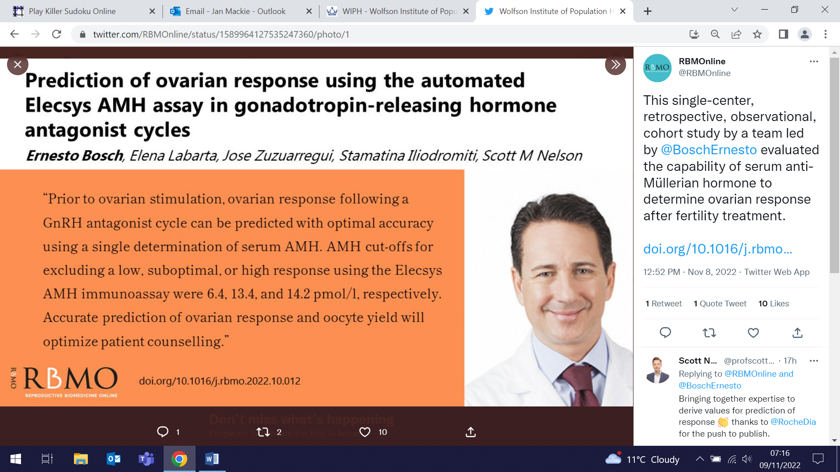
New Global Health Research Centre launched in Latin America
3 November (Vicky Bird, Renata Peppl. Centre for Psychiatry and Mental Health)

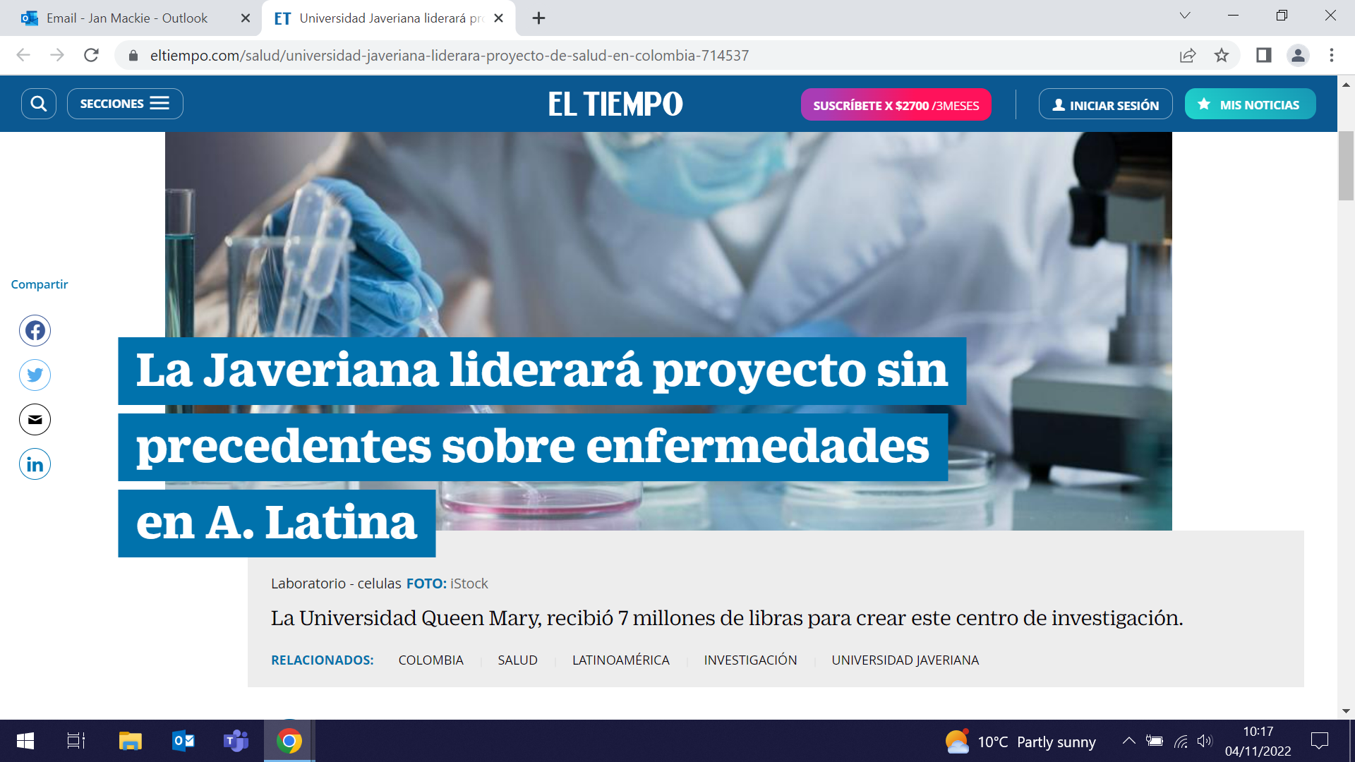 | The new NIHR-funded Global Health Research Centre has received front page media attention, including from the leading newspaper in Columbia (El Tiempo), as work commences on the project with Latin American partners. The official launch on 3 November was attended by representatives from the local government and indigenous leaders, and formed part of a three day meeting with members of the NIHR Global Health Centres, the UK Department of Health, and partners from Guatemala, Bolivia, and Colombia. The teams will work with communities to develop innovative, low-cost solutions to improve healthcare for non-communicable diseases, with a key focus on indigenous populations.
Research and implementation interactions in a social accountability study
3 November (Heather McMullen. Centre for Public Health and Policy)

A study of how researchers interact with those who are delivering and implementing an intervention or activity examines how this relationship was managed in the CaPSAI (Community and Provider driven Social Accountability Intervention) Project for family planning and contraceptive service provision. In this project, recommendations from the MRC guidance on process evaluation of a complex intervention were operationalised, including (i) working with programme developers and implementers; (ii) communication of emerging findings between researchers/evaluators and implementers; and (iii) overlapping roles of the intervention and research/evaluation. Tools including standard operating procedures, contact lists, and manuals were co-developed, and activities such as training sessions, regular calls, and meetings were conducted to enable a good working relationship between the different partners. The authors conclude that the MRC guidance is useful for making interaction issues explicit and establishing procedures. Planning procedures for dealing with research and implementers’ interactions could be more comprehensive and better adapted to social accountability interventions if both researchers and implementers are involved. | 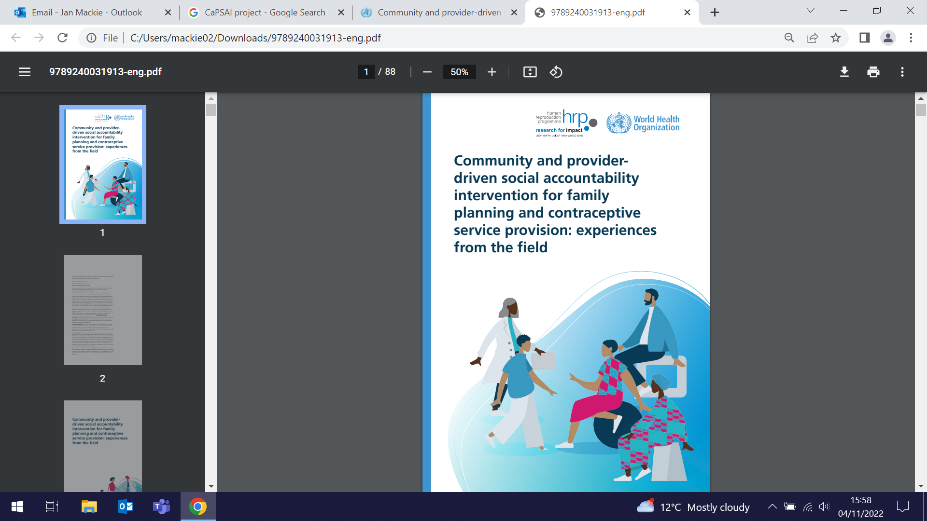
BaBi project milestones – new East London site now recruiting
3 November (Matina Iliodromiti, Dee Patel. Centre for Public Health and Policy)

 | A new site in East London has been added to the BaBi network of local birth cohort studies, working together to link existing data across health, education, and social care. With consent from pregnant women, the programme collects routinely recorded data, such as mothers’ blood pressure measurements or details of babies’ height and weight, which is joined together anonymously. On 3 November the network reached a recruitment milestone of 14,000, with BaBi East London recruiting 60 participants in their first month of operation. The data collected will provide valuable insights into patterns that may be used to identify poor health and development outcomes for early life and beyond. The knowledge obtained through this electronic East London birth cohort study will help to transform future health care and improve service provision in our local communities. All pregnant women receiving care at Bart’s Health are eligible to be part of the study.

NIHR Alert issued on use of e-cigarettes to help pregnant women quit smoking

4 November (Peter Hajek, Dunja Przulj, Francesca Pesola, Chris Griffiths, Katie Myers Smith. Centres for Public Health and Policy/Primary Care)

The National Institute for Health and Care Research has issued an Alert based on the evidence presented in a paper published by Peter Hajek and colleagues showing that e-cigarettes may be more effective than nicotine patches for pregnant women trying to quit smoking. The alert highlights the primary findings from the paper, noting that pregnant women are advised to quit smoking because of the damage it can cause to developing babies, but many find this difficult. Current guidelines state that nicotine products (such as patches, gum and mouth spray) can help, but this research suggests that pregnant women could also consider e-cigarettes. The study also found that the safety profiles of e-cigarettes and patches were similar, but that low birthweight was less frequent in the e-cigarette arm. | 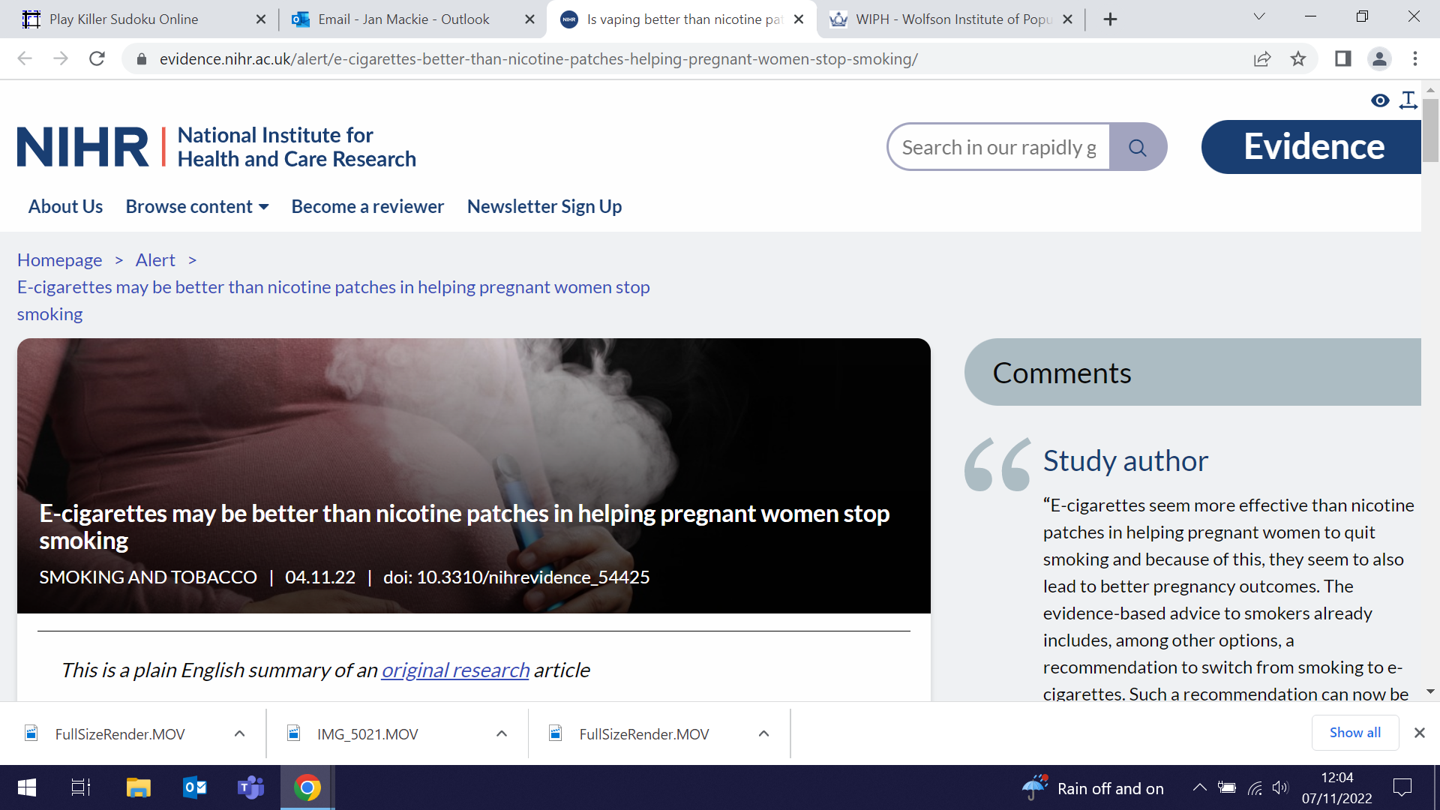
Keynote Address to 29th annual AGOI conference
5 November (Ranjit Manchanda. Centre for Prevention, Detection and Diagnosis)

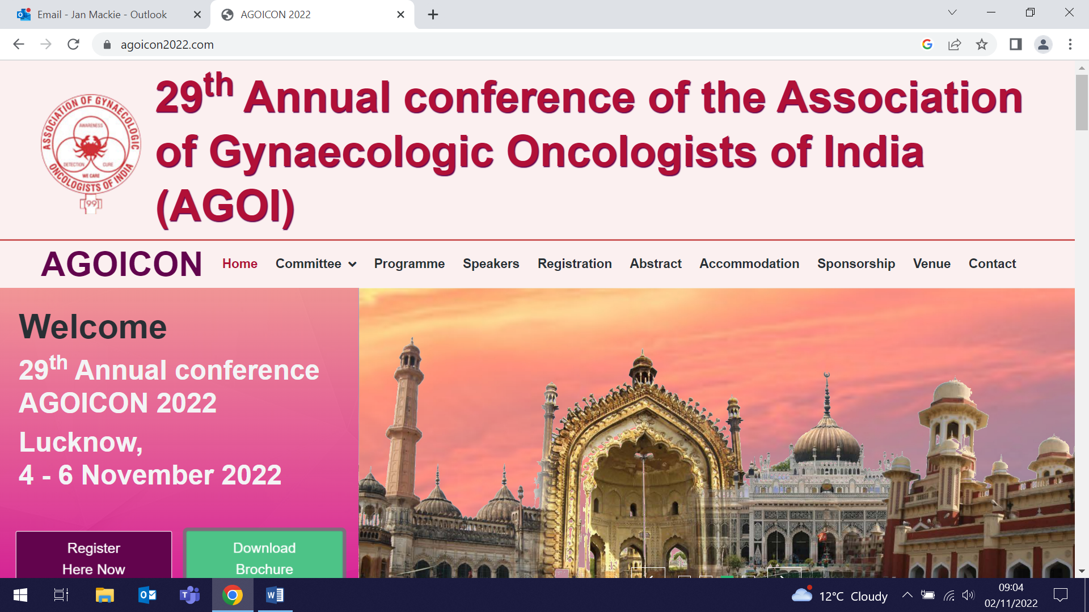 | Ranjit Manchanda delivered a Keynote address at the 29th Annual conference of the Association of Gynaecological Oncologists of India on 5 November. His talk, Mainstream genetic testing in cancer diagnosis, was delivered to delegates attending the conference held in Lucknow, India, from 4-6 November.
Cancer research across Africa
7 November (Fiona Walter. Centre for Prevention, Detection and Diagnosis)

A study assessing cancer research outputs from all 54 African countries from 2009 to 2020 provides cancer research performance metrics that enable benchmarking, both between African countries, and in comparison with other world regions. Subanalysis included collaboration patterns, site and domain-specific focus of research, and understanding authorship dynamics, by both position and sex. Authors say that the intelligence provided should inform national cancer control strategies across Africa to support research, and also international policy towards supporting the building of research capacity and capability. Among their recommendations are the overt inclusion of research into national cancer control planning, and a commitment from middle income African countries to spend 10% of a notional 1% gross domestic expenditure on research and development on cancer. | 
Vitamin D genetic risk scores in multiple sclerosis
7 November (Nicky Vickaryous, Ben Jacobs, Ruth Dobson. Centre for Prevention, Detection and Diagnosis)

 | Observational cohort and case-control studies have consistently shown that lower serum vitamin D is associated with an increased risk of MS, but it has been unclear whether vitamin D supplementation is able to modify disease activity in people with MS. In a new study, researchers developed and validated a vitamin D-weighted genetic risk score in UK Biobank participants without MS. In a cohort of people with MS, they then measured serum vitamin D, and genotyped six vitamin D-associated single nucleotide polymorphisms, and compared these results against matched controls, to assess predictors of serum vitamin D concentration. Their findings suggest that vitamin D supplementation is the major determinant of vitamin D level in people with MS, with genetic determinants playing a far smaller role. Authors say that the study provides evidence that supplementation probably trumps the relatively minor effects of common genetic variation in determining vitamin D status.
BJGP Open Top Ten 2021 papers
8 November (Suzanne Scott, Fiona Walter. Centres for Prevention, Detection and Diagnosis)

A qualitative study of GP views on the impact of the COVID-19 pandemic on cancer assessment in primary care authored by Suzanne Scott and Fiona Walter has been selected in the BJGP Open Top 10 papers of 2021. Coming in at number 8, the study provided new evidence on the impact of the pandemic on assessing symptomatic patients, and made recommendations to inform safe and effective primary care clinical practice. | 
Study protocol: adapting DIALOG+ for post-conflict school settings in Columbia
9 November (Bird VJ, Priebe S, van Loggerenberg F. Centre for Psychiatry and Mental Health)

 | An exploratory mixed methods study will evaluate the DIALOG+ digital intervention among adolescents in post-conflict school settings in Columbia. Colombia has a long history of armed conflict, with children and adolescents particularly affected by mental health disorders. DIALOG+ is a patient-centred digital intervention developed to facilitate the interaction between the clinician and patients with mental health issues. The published protocol for the study describes 3 phases: (i) Adaptation: to identify potential changes to the intervention based on data from focus groups with teachers and students, (ii) Exploration: a cluster randomized trial with teachers and school counsellors to assess the intervention for adolescents in school settings, and (iii) Consolidation: with focus groups of teachers and student to assess acceptability. Study recruitment was completed in March 2022
Despatches from COP 27
10 November (Natasha O’Sullivan and Heather McMullen. Centre for Public Health and Policy)

On 10 November Natasha O'Sullivan took part in the COP 27 Green Zone Panel: Youth Voices on Climate Impacts on Sexual and Reproductive Health and Rights, Gender and Marginalised Communities. Natasha presented the results of a review she has co-led with Heather McMullen, of 111 Nationally Determined Contribution policies for content related to Sexual and Reproductive Health and Rights, gender, health, population dynamics, rights and vulnerability, and youth. Also participating in the panel was Kwolanne Felix, social commentator and history student specialising in the African diaspora at Columbia University, who shared insights from collaborative work undertaken by the United Nations Population Fund and the WIPH QMUL team on the impact of climate change on the sexual and reproductive health and rights of people of African descent. The reports will be released later this year. | 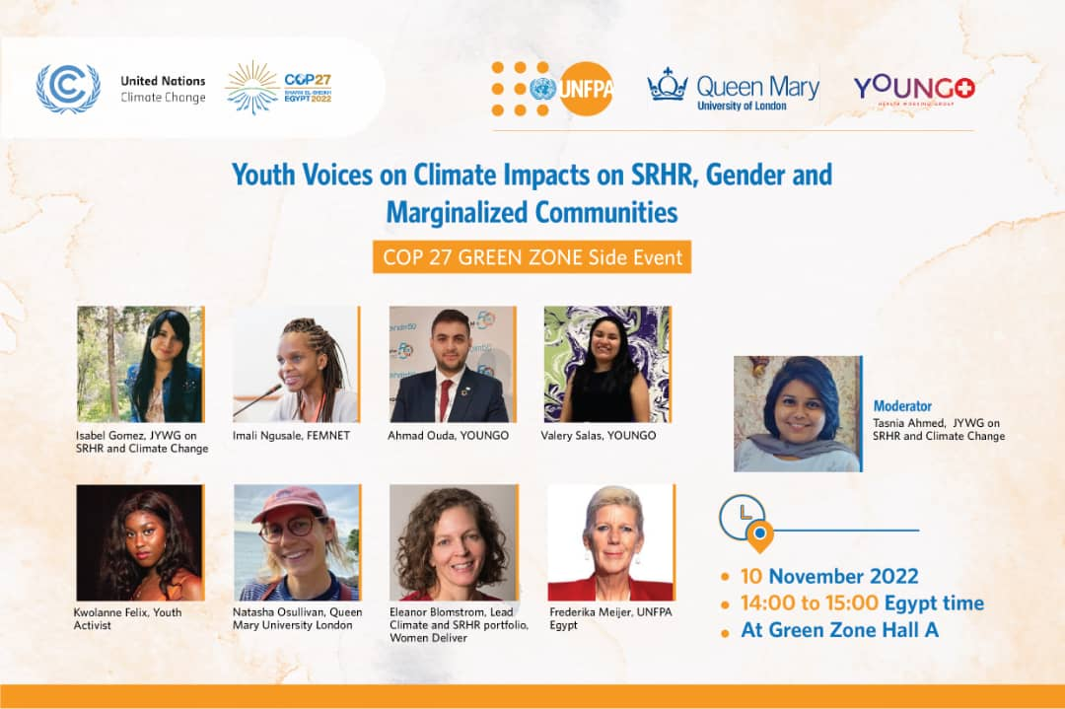
Social determinants of health in multiple sclerosis
11 November (Ruth Dobson, Rachel Horne. Centre for Prevention, Detection and Diagnosis)

 | Assessing and addressing social determinants of health, the conditions in which people are born, grow, live, work and age, could fundamentally improve health and healthcare in MS. A new narrative review examines the evidence supporting an effect of many of social determinants of health, including racial background, employment, and social support, on MS outcomes. Authors note that while the existing evidence supports a potentially major effect of social determinants of health on outcomes in people with MS, the evidence is limited and does not adequately address the potential bidirectional and complex relationships, which involve multiple confounding factors. There is an important and urgent need for rigorous studies of interventions to ameliorate the effect of poor social determinants of health. The paper concludes that although addressing many social determinants of health is outside the role of neurologists, it is increasingly clear that ignoring the societal context of someone living with MS would be to neglect a potentially substantial effect on disease outcomes.
CEG featured in new King’s Fund cardiovascular disease report
11 November (John Robson, Stuart Rison and CEG team. Centre for Primary Care)

Work by the Clinical Effectiveness Group (CEG) is featured as a case study in a new report by The King’s Fund: Cardiovascular disease in England: Supporting leaders to take actions. The report calls for urgent action by government, national and local leaders to tackle the large and unequal burden of disease and mortality associated with cardiovascular disease - much of which is potentially preventable through timely, evidence-based public health measures and health care. Presenting case study 4 (p48) the authors describe the ‘Clinical Effectiveness’ approach as: “Making it easier for GPs to do the right thing using digital decision-support and review tools; providing actionable insight and tailored local data analysis; motivating teams; innovation; and measuring equity.” The case study notes that N.E. London was the highest-performing sustainability and transformation partnership nationally on the 2019/20 Quality and Outcomes Framework, with some of the highest rates of statin usage and blood pressure control in people with ischaemic heart disease, stroke, hypertension, and diabetes. This is particularly notable as the region has some of the most ethnically diverse and deprived populations in England, with a high prevalence of cardiovascular disease and diabetes. | 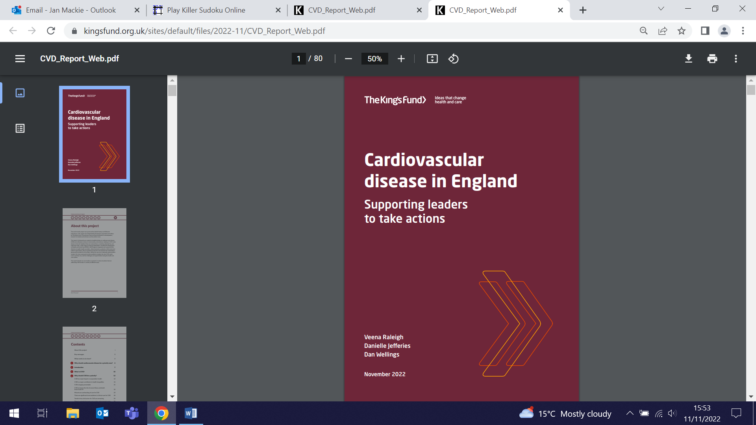
Outcome Reporting following Fertility-Sparing Surgery for Cervical Cancer
11 November (Michail Sideris, Matina Iliodromiti, Ranjit Manchanda. Centres for Prevention, Detection and Diagnosis/Public Health and Policy)

 | A literature review of 104 studies including 9535 women who have undergone fertility-sparing surgery for cervical cancer investigates variation in reported outcomes following surgery. Most studies (97) reported on oncological outcomes, followed by fertility and pregnancy (86), post-operative complications (74), intra-operative complications (72), and quality of life (5). Authors conclude that although there is significant heterogeneity in the reported outcomes, an agreed Core Outcome Set would enable future studies to effectively harmonise reported outcomes that are measurable and relevant to patients, clinicians, and researchers.
FORTHCOMING EVENTS

NIHR Integrated Academic Trainees Showcase (23 November)

All are welcome to join us for the WIPH NIHR Integrated Academic Trainees showcase, to be held from 14:30-17:00 on 23 November at the Clark Kennedy Lecture Theatre, Walden Street, Whitechapel. This meeting will be for our GP Academic Clinical Fellows (ACFs), their mentors and supervisors, clinical trainers, and other colleagues. We will be hearing from the ACFs and celebrating their achievements. Profs Fiona Walter and Arunthathi Mahendran will also present on career development as a clinical academic. Please do join us for refreshments afterwards. Click here to join the meeting on Teams. Meeting ID: 323 383 899 327 Passcode: NJsoDY | 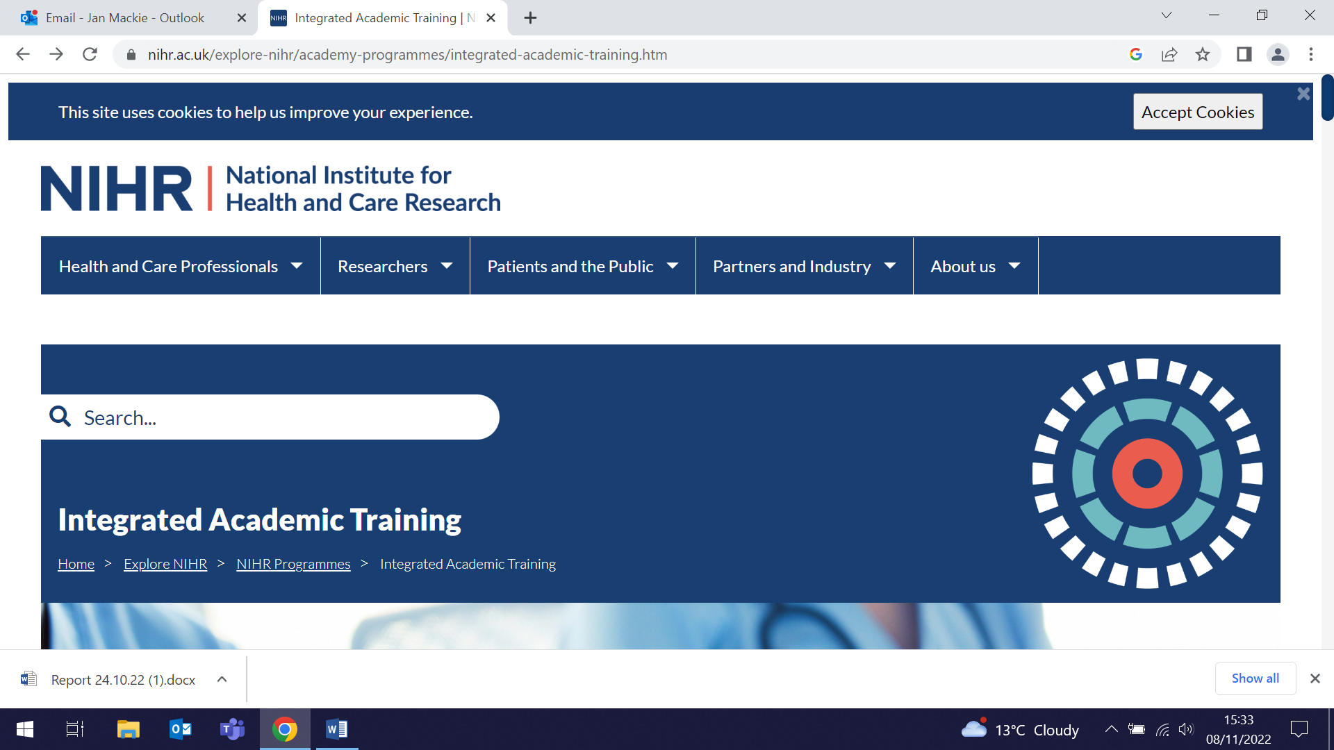
Women’s Health Research Team Annual Showcase (15 December)

The WIPH Women’s Health Research Team invite you to attend their Annual Showcase Event from 1-4:30pm on 15 December at the Octagon, Mile End campus. The Unit undertakes multidisciplinary research to understand why a woman and her unborn child become ill, and what can be done to prevent this and to help them stay healthy. The event will provide an overview of ongoing projects, including co-production research with our award-winning patient public involvement group hosted by the Katie’s Team unit. Katie’s Team members will also be offering one-to-one “surgeries” on PPI in women’s health. This event will provide an opportunity for networking, generating ideas for future research, working together collaboratively, and increasing the impact of both your and our work. Refreshments will be provided. For further details please contact Deepali Patel, or Register to attend. | 
Many thanks to all who so enthusiastically contribute. Please send any news items for the next newsletter to j.a.mackie@qmul.ac.uk

