WOLFSON INSTITUTE OF POPULATION HEALTH
NEWSLETTER
ISSUE 17: 27 JULY 2022

In this issue of our Wolfson Institute of Population Health Newsletter, we celebrate the achievements and work of staff and students throughout July.

FROM OUR DIRECTOR
Dear Colleagues
Thanks to everyone who attended and contributed to our Showcase Event, including support staff, students, and colleagues from all five Centres. Despite the warmth in the lecture theatre, we had an inspiring afternoon of talks, which gave us a fascinating overview of the breadth of work undertaken across our Institute. We also heard from our Director of Education Mark Freestone about the range of our under- and post-graduate education, and from our VP-Health Prof Sir Mark Caulfield about his vision for our Faculty of Medicine and Dentistry. Many later told me how inspiring they found Megan Clinch’s presentation, with Farah Dualeh from the Women’s Inclusive Team, exemplifying the importance of the ongoing development of our Public Advisory Panel and collaborations with local communities.

The excellent reception and BBQ on the lawn that followed was a great opportunity to network across our Centres. We plan to develop this into a full day showcase next year, so do let me know any ideas you may have for this.  With warm wishes to all  Fiona | 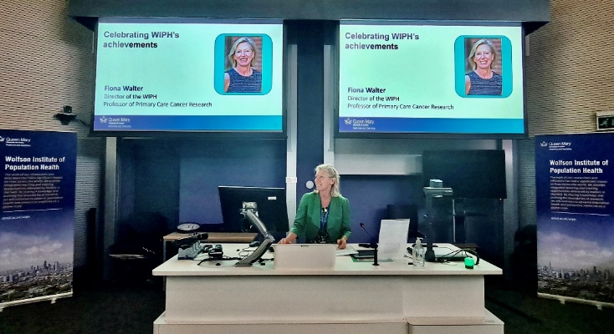
FROM OUR LEADERSHIP TEAMS AND REPRESENTATIVES

DO YOU HAVE AN EDUCATION IDEA?
Mark Freestone, Director of Education

Have you considered contributing a lecture, seminar or dissertation topic to our Mental Health or Global Health postgraduate programmes? If you have an idea for a topic and would be willing to record a video, choose some readings and give a live session to our engaged and lively postgraduate students, or if you would be willing to co-supervise a master’s project or dissertation, please get in touch with us via the Education Lead Mark Freestone.

GENERAL INSTITUTE NEWS

Disease modifying therapy and COVID-19 vaccination side effects in people with MS

3 July (Ruth Dobson. Centre for Prevention, Detection and Diagnosis)

A study of adverse effects of COVID-19 vaccination in 193 people with Multiple Sclerosis (MS) shows that post-vaccination symptoms were similar to those in the non-MS population, and were mostly temporary. Participant questionnaires and a retrospective review of health records to the end of September 2021 were used to investigate symptoms experienced after each vaccination according to type of disease modifying therapy being administered. 87% and 75% of people with MS experienced symptoms at first and second vaccinations respectively. Most symptoms resolved within a short time and no severe adverse effects were reported. There was evidence that some treatment groups were at reduced risk of reporting symptoms at second vaccination. Authors conclude that SARS-CoV2 vaccination is generally well tolerated in people with MS. | 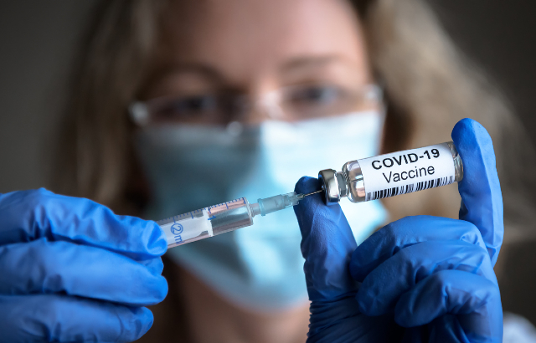
The Psychological Fingerprint of the Pandemic
6 July (Evangelos Katsampouris. Centre for Prevention, Detection and Diagnosis)

 |  | Post-doc Research Fellow in Behavioural Science Evangelos Katsampouris has published a book entitled “The Psychological Imprint of the Pandemic”. The book, published in Greek, provides the first comprehensive analysis and discussion of the peer-reviewed literature available on the psychosocial impact of the COVID-19 pandemic. The authors explore the impact of the pandemic on mental health, with five chapters discussing issues related to the mental health of children and adolescents, addictive behaviours, and the need to develop public health policies to cope with future humanitarian crises.
NIHR ARC North Thames ECR Summer Showcase
8 July (Esca van Blarikom. Centre for Primary Care)

PhD student Esca van Blarikom has been awarded the Judges’ Prize for a presentation at the NIHR ARC North Thames Early Career Researchers Summer Showcase. The topic for the Three Minute Thesis Competition was “Patient and community involvement and engagement”, and Esca’s presentation was entitled: Using participatory photography to tell stories about living with multiple, long-term health conditions. Congratulations Esca! |  | 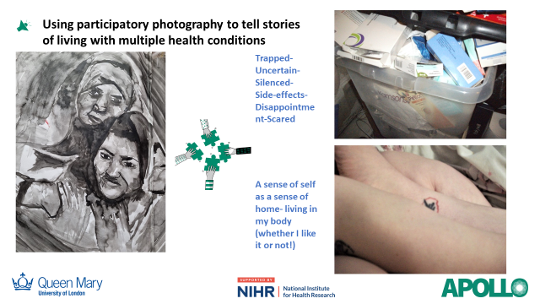
New ABN guidelines for Anti-CD20 therapies in pregnancy and when breastfeeding
8 July (Ruth Dobson. Centre for Prevention, Detection and Diagnosis)

   |  | A new evidence review presents Association of British Neurologists guidelines for the use of Anti-CD20 therapies for women of childbearing age. Anti-CD20 therapies act through B cell depletion and are increasingly used to treat neurological diseases, but are unlicensed for use in pregnancy. In the absence of guidelines, many patients of childbearing age have been advised to stop treatments prior to trying to conceive due to perceived risk to the fetus. This review examined observational and biological evidence and concludes that it is safe to conceive during anti-CD20 therapy, that women should not be denied clinically indicated treatment during pregnancy, and that anti-CD20 therapies can be safely given whilst breastfeeding.
The Muslim News IBN Sina Award for Excellence in Health
8 July (Kawther Hashem. Centre for Public Health and Policy)

Congratulations to Kawther Hashem, of the Research and Action on Salt and Obesity Unit, who has received The Muslim News IBN Sina Award for Excellence in Health in recognitions of her work in helping to uncover and publicize the amount of salt and sugar added to foods. Kawther used the opportunity to speak at the award ceremony about the Government’s u-turn on restrictions on advertising and promotions, which will have a major detrimental effect on children’s health. | 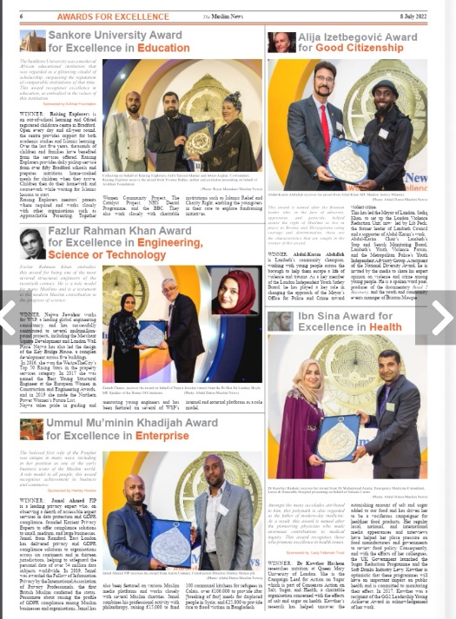
Children at risk of delayed primary vaccination in the UK
13 July (Carol Dezateux. Centre for Primary Care)

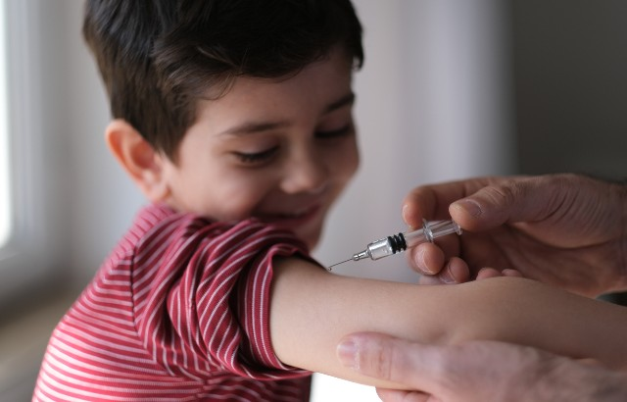 | A study of 1782 children in Wales born in 2000-2001 explores sociodemographic factors associated with delayed primary vaccination, one of the strongest predictors of subsequent incomplete immunisation. Analysis of child, maternal, family, and area characteristics associated with delayed first dose of the Diphtheria, Tetanus and Pertussis (DTP) vaccine showed that 1.4% of studied children did not receive the DTP, and that delayed primary vaccination was more likely among children with older natural siblings, those admitted to special/intensive care, those with birthweight >4Kg, and boys. There was a reduced risk of delayed vaccination with increasing maternal age, and for babies born to graduate mothers. This study demonstrates the benefits of linking cohort data to routinely-collected child health data. Identifying children at risk of incomplete immunisation may enable targeted interventions to decrease vaccine-preventable illness.
Barts Charity Clinical Research Training Fellowship
13 July (Katie Newman, Matina Iliodromiti, Elena Greco. Centre for Public Health and Policy)

A Barts Charity Clinical Research Training Fellowship has been awarded to MDRes student Katie Newman, to study blood pressure trajectories and perinatal outcomes in a multi-ethnic pregnancy cohort in East London. Katie will be supervised by Matina Iliodromiti and Elena Greco, and will be working on her project within the BEGOTTEN (Blood pressure GrOwth TrajecTories EthNicity) prospective cohort study. BEGOTTEN aims to investigate blood pressure patterns in pregnancy for a multi-ethnic population booked at the Royal London Hospital Maternity Unit. The study will also investigate biomarkers for pre-eclampsia between different ethnic groups, with the objective to better understand how hypertensive disorders of pregnancy present and affect pregnancies within our local community in East London. | 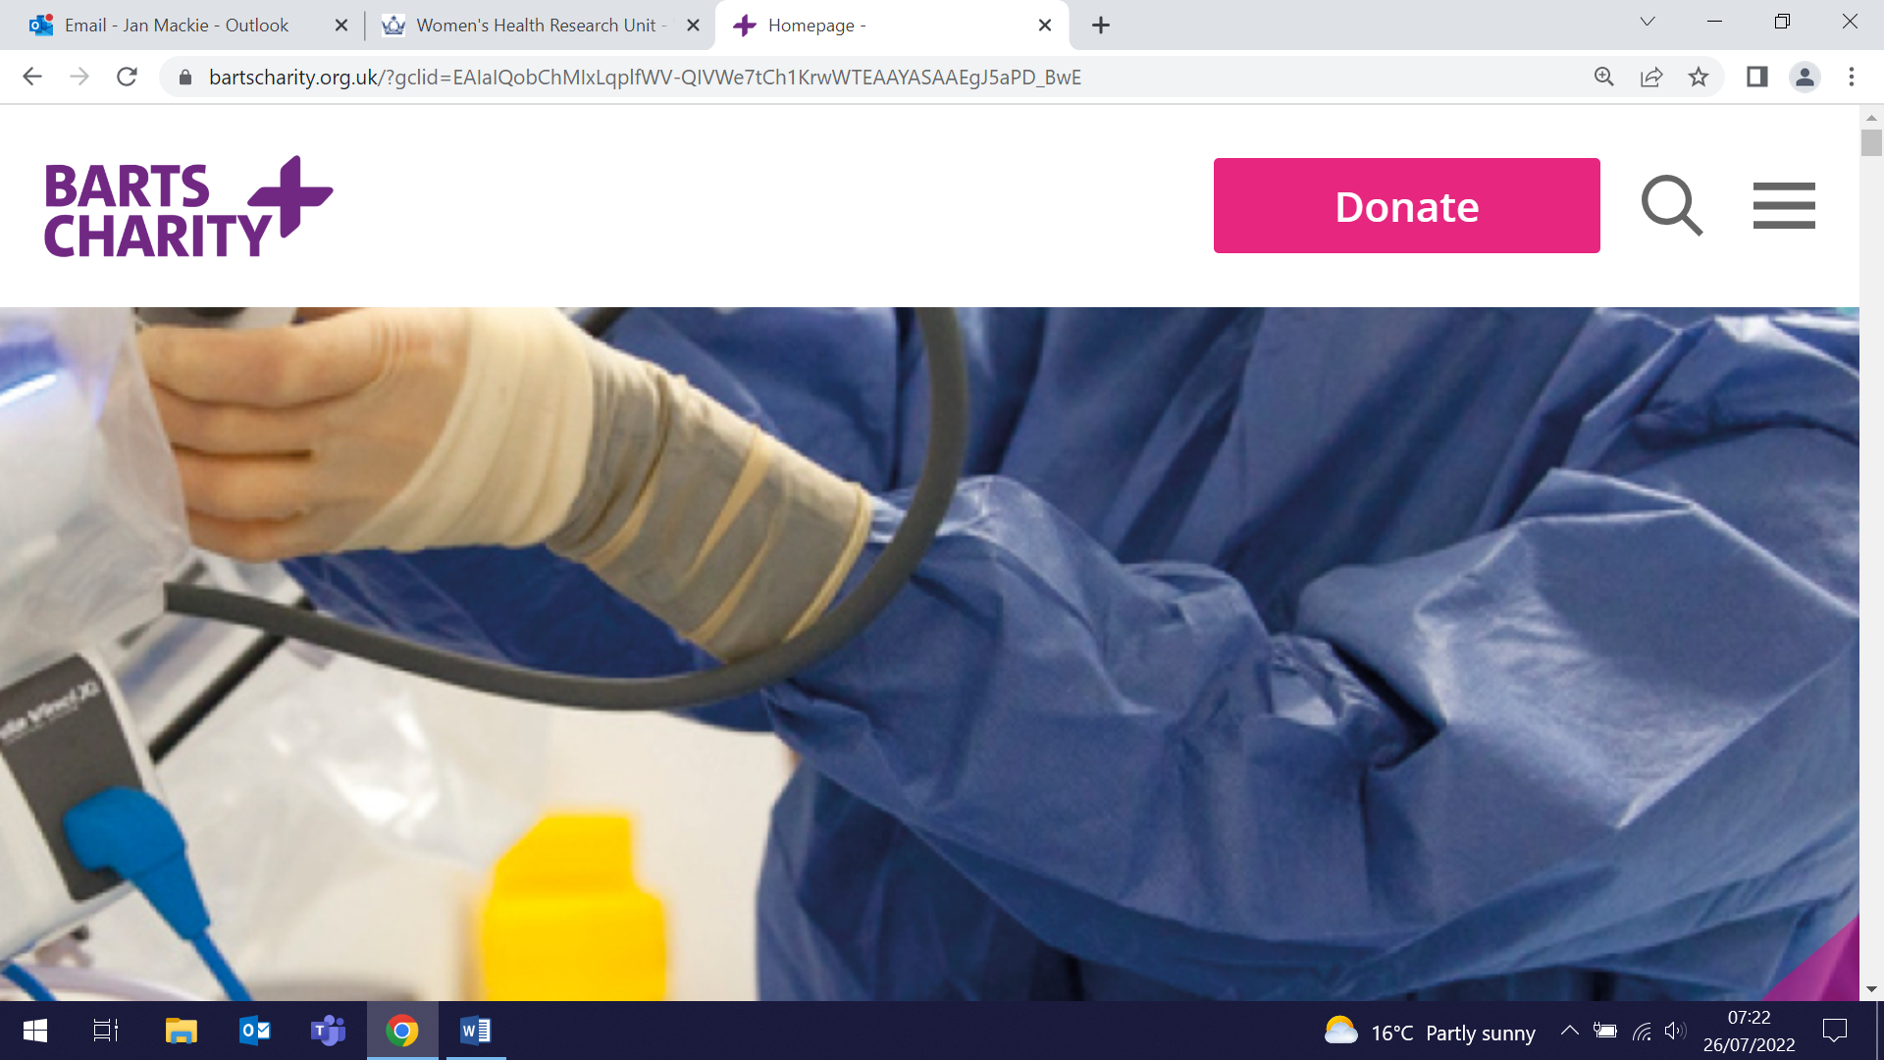  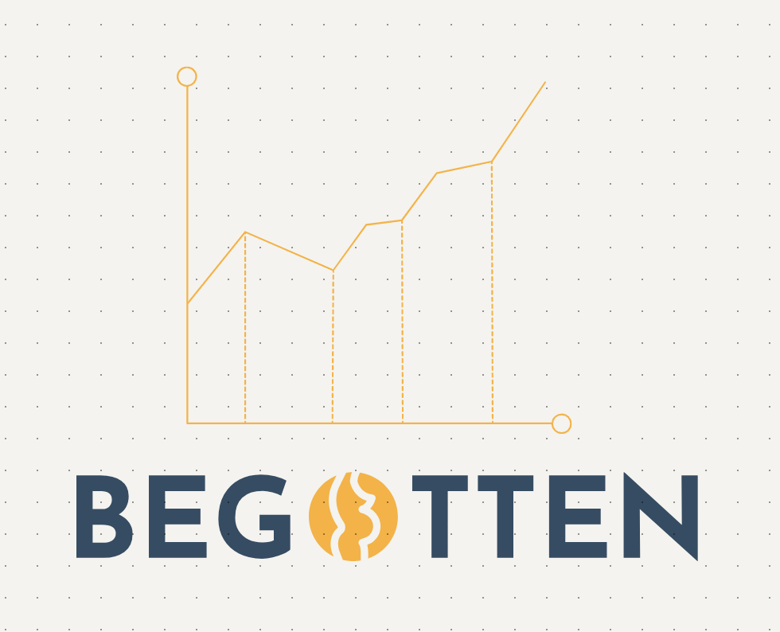
Salt content in UK Children’s Meals
14 July (Research and Action on Salt and Obesity Unit, Centre for Public Health and Policy)

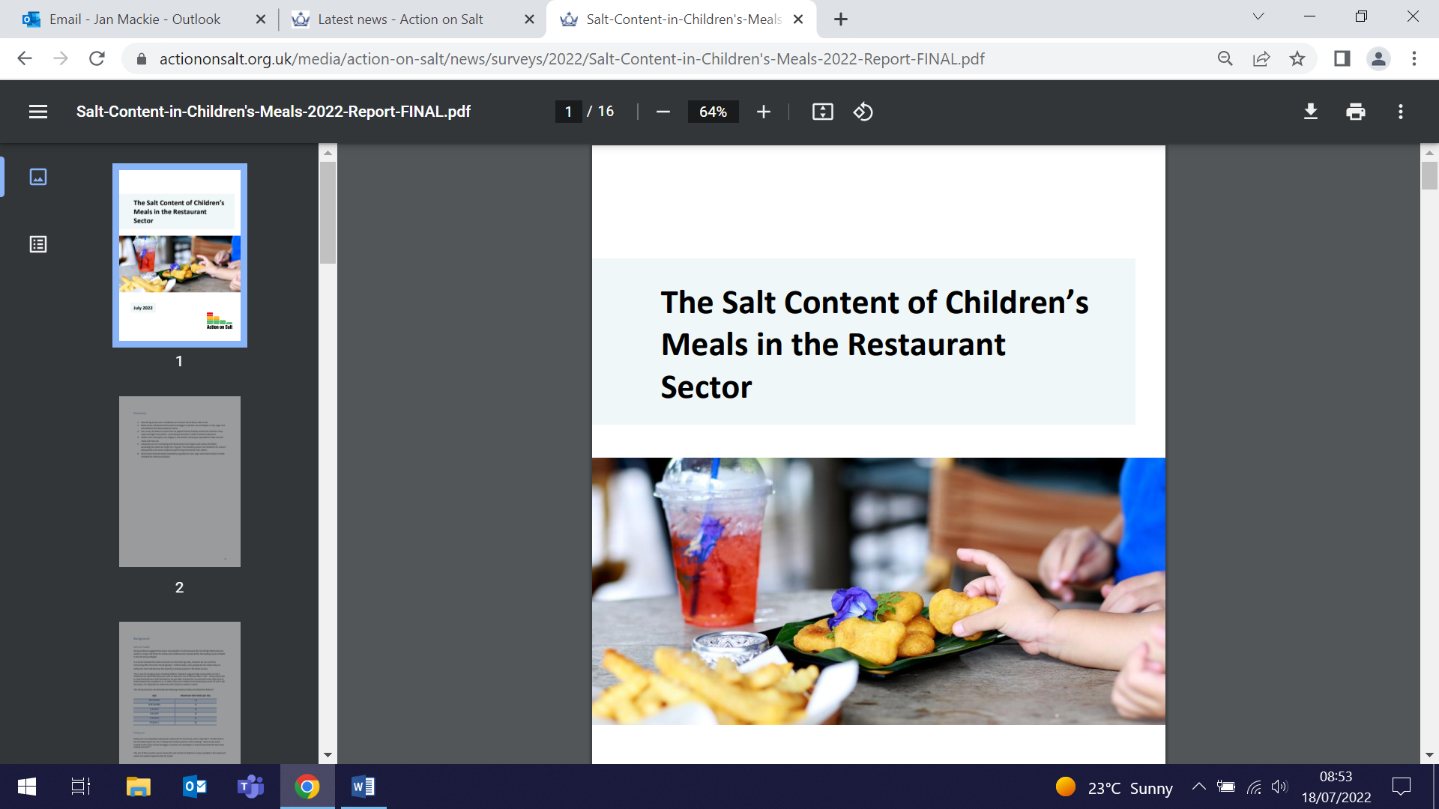 | New research from the Action on Salt and Obesity Unit has found that 34% of children’s meals in restaurants contain ≥2g of salt, equal to two-thirds of the maximum daily limit for a 4-6 year old. The study found that 43% of 302 meals analysed from 15 UK restaurant chains exceeded the maximum Department of Health salt target, with one cheeseburger with skinny fries meal from Gourmet Burger Kitchen containing 4.8g of salt. Researchers say that the lack of consistency and labelling means parents are unable to determine how much salt their children are consuming, and that stricter standards are needed for child health, to include mandatory regulation on salt, sugar, and calorie levels in foods intended for children’s consumption. The study authors say that failure to act will have a detrimental impact on the future health and wellbeing of children, as well as the economy.
RCGP Vice Chair-elect for External Affairs
15 July (Victoria Tzortziou Brown. Centre for Primary Care)

The Royal College of General Practitioners has announced the election of WIPH Clinical Lecturer in Primary Healthcare, Dr Victoria Tzortziou Brown, as the new RCGP Vice Chair-elect for External Affairs. Victoria has been an east London GP for almost 20 years, and in her new role she will provide College leadership on external affairs and health policy and research. She has previously served as the RGCP Honorary Secretary, London Faculties Chair, and more recently as co-chair of the RCGP Health Inequalities Standing Group. The RCGP represents over 53,000 GPs worldwide. Many congratulations to Victoria on this appointment. | 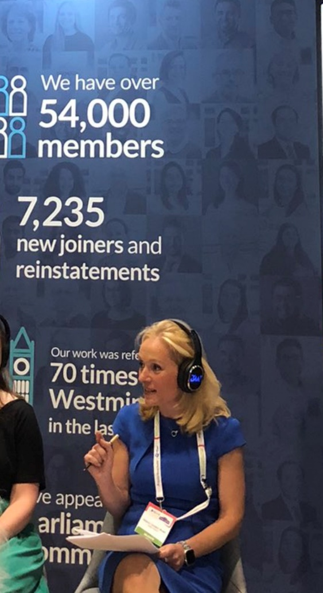
Mental health impact of COVID-19 in Iran
18 July (Vladimir Gordeev. Centre for Evaluation and Methods)

 | Policy makers in Iran are focused on mitigating the economic and social impacts of the COVID-19 pandemic, but the pandemic has also exacerbated factors adversely affecting mental health, and the long-term consequences are being overlooked. In 2020-21 suicide incidence in Iran increased 7.8% from the previous year to 6·6/100,000 people, reaching 16·5/100,000 in some provinces, with 33.9% of these deaths occurring in those aged 18-29. Factors such as family disputes, social isolation, fear of contagion, uncertainty, chronic stress, hopelessness, feelings of entrapment and burdensomeness, substance misuse, loneliness, domestic violence, child neglect or abuse, unemployment, and economic difficulties have all been exacerbated, but there has been concurrent reduction in access to mental health services. Calling on Iranian policy makers to address this issue, the authors of this correspondence piece say that mental health services should be widely available to the public, screening should be provided in primary healthcare centres, and that treatment costs should be covered: “Policy makers must apply a systems-thinking approach to mental health”.
Cancer Symptom Detection as a Partner to Screening
18 July (Fiona Walter. Centre for Prevention, Detection and Diagnosis)

A JAMA Viewpoint article examines the often overlooked non-screening cancer diagnostic pathway in the United States. While screening is the main strategy for early cancer detection, only a small fraction of all cancers are diagnosed through these progammes. Many cancers are detected after people present with symptoms. Although at this stage disease may have progressed to be less amenable to treatment, decreasing the time from symptom detection to diagnosis can improve outcomes. The authors note that the UK NHS emphasizes both symptom detection and screening in its national early cancer detection strategy pathway, and suggest that the US could adopt a national strategy combining screening and early diagnosis of symptomatic cancers to reduce cancer deaths. | 
Little evidence of overdiagnosis in NHS Breast Screening Programme in England
19 July (Oleg Blyuss, Amanda Dibden, Nathalie Massat, Dharmishta Parmar, Jack Cuzick, Stephen Duffy. Centre for Prevention, Detection and Diagnosis)

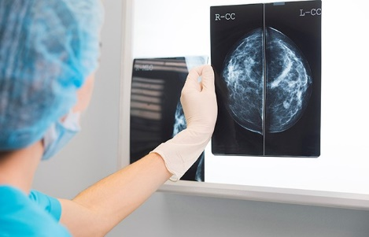 | The NHS Breast Screening Programme in England shows little, if any, evidence of overdiagnosis, according to a new NIHR-funded study. Despite the known benefits of breast screening, debate continues over potential harm from overdiagnosis, the detection of slow growing cancers that would never cause symptoms. Overdiagnosis estimates vary widely, from <5% to >30% of screen detected cancers. To quantify this in the NHS programme, researchers studied 57,493 breast cancer cases diagnosed in 2010/2011, matched with 105,653 controls, and estimated the effect of screening on breast cancer risk. Results were combined with national incidence data to estimate absolute rates of overdiagnosis, calculated as the cumulative excess of cancers diagnosed in women aged 50-77 attending 3-yearly screening between ages 50-70, compared with women attending no screens. The estimated number of cases of overdiagnosis in women attending all screens was just under 3 per 1000, corresponding to an estimated 3.7% of screen detected cancers overdiagnosed, and considerably lower than has been suggested in the past.
GP safety netting for patients with lung cancer symptoms
20 July (Fiona Walter. Centre for Prevention, Detection and Diagnosis)

An analysis of interviews with patients who had recently consulted a GP about low risk lung cancer symptoms has shown how patients respond to GP “safety netting” advice about how to monitor and reconsult for their symptoms. Patients selected by postcode for low socioeconomic status and sampled for diversity in ethnicity, gender, and age were interviewed in 2019-20 after presenting with symptoms such as cough, anaemia, fatigue, shortness of breath, chest pain, weight loss or appetite loss. Results showed that patients preferred active safety netting that included advice and actions that actively promoted reconsultation or follow-up (eg. booking a follow up appointment). Passive or ambiguous safety netting may be perceived as dismissive and cause delayed reconsultation. Telephone consultations and the diagnostic overshadowing of COVID-19 on respiratory symptoms affected GPs’ safety netting strategies and patients’ appetite for active follow up measures. Researchers concluded that GP safety netting strategies in potential lung cancer consultations are not always understood, potentially causing patient worry and dissatisfaction. | 
Sharing experiences of data driven improvements in primary care with Thai colleagues
20 July (Presenters: Rohini Mathur, Sarah Finer, Jo Tissier, Sally Hull, John Robson, Carol Dezateux. Centre for Primary Care)

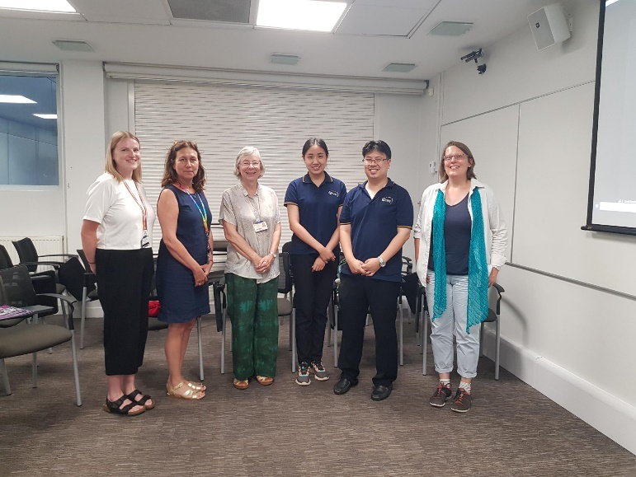  L-R Laura Dexter, Jo Tissier, Sally Hull, Nutchar Wiwatkunupakarn, Chaisiri Angkurawaranon, Dorothea Nitsch (LSHTM) | The Clinical Effectiveness Group and Genes & Health on 20 July hosted two visiting Thai family doctors, Chaisiri Angkurawaranon and Nutchar Wiwatkunupakarn from Chiang Mai University, to share experiences of using data to drive improvements in UK primary care. The visit was coordinated by WIPH and London School of Hygiene and Tropical Medicine staff as part of a Thai-UK collaboration funded by the British Council to establish a collaborative network for research into chronic condition management. Presentations and discussions included the role of primary care, factors supporting behaviour change, and the availability and use of health data sources, with CEG colleagues presenting examples of Quality Improvement programmes that led to discussions on how this approach could be applied in the Thai healthcare system.
Telephone-based risk assessment for lung cancer screening: Results from the SUMMIT Study
21 July (Sammy Quaife. Centre for Prevention, Detection and Diagnosis)

In person assessment of lung cancer risk as a first step to determine eligibility for screening may be costly and inefficient, but results from the SUMMIT Study show that a prior telephone-based risk assessment significantly increases the proportion of face to face attendees who are actually eligible. In the first 12 months of recruitment in this prospective observational cohort study, results show that for the 14714 individuals who completed phone screening and attended a lung health check, the level of agreement between phone screener and health check responses was substantial or ‘almost perfect’ for all categorical variables except educational status. The level of agreement was lowest in those from an Asian ethnic group and those aged 55–59, and highest in the white ethnic group and those aged over 75. Authors conclude that the results support telephone-based risk assessment as an efficient way to optimise selection for lung cancer screening appointments. Further research should investigate validated multilingual translations, cultural variations in the acceptability of telephone-based approaches, and the inclusion of diverse educational categories to ensure equitability and accuracy. | 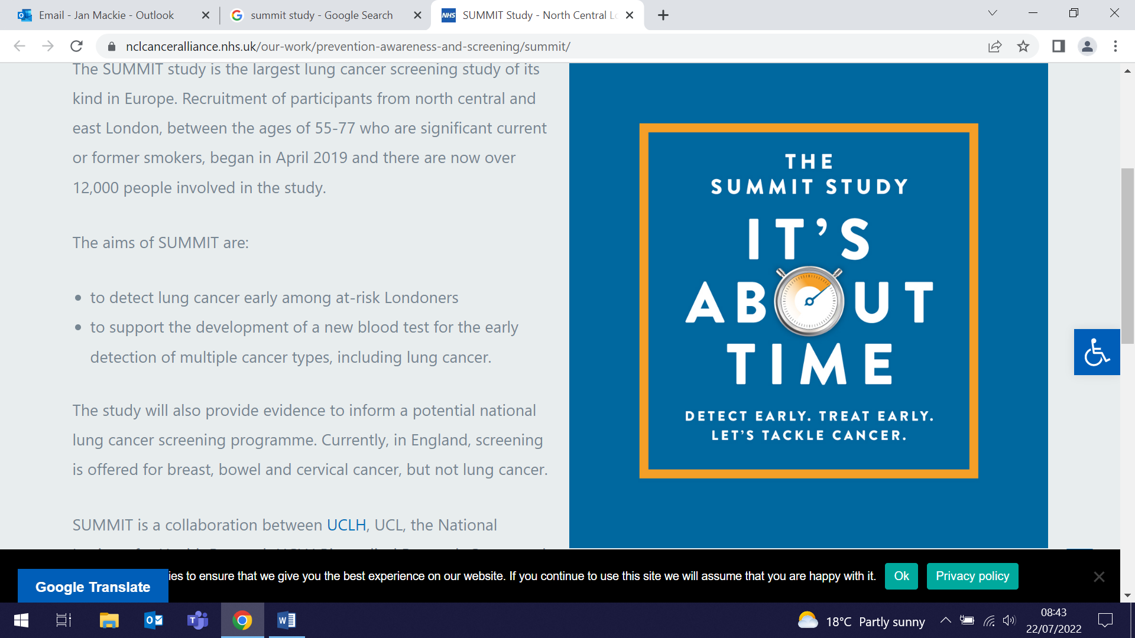
Underrepresented Populations in Parkinson's Genetics Research
22 July (Alastair Noyce. Centre for Prevention, Detection and Diagnosis)

 | A systematic review of research on Parkinson's disease genetics in underrepresented populations up to October 2021 has set a baseline to measure the future impact of current efforts in those populations. On behalf of the Global Parkinson’s Genetic Programme (GP2), the international collaboration of researchers observed imbalances in Parkinson’s genetic studies among underrepresented populations, with Asian participants from Greater China described in 57% of the articles published, but Blacks represented in just 4%. Most of the 1037 studies analysed a limited number of genetic variants, with just nine using a genome-wide approach including underrepresented populations. The authors say that this research highlights the immediate need for better representation: “Concerted efforts are needed to recognize diversity as a driver of equality and scientific discoveries”.
Feasibility of digital BRCA genetic testing in routine NHS breast cancer care
22 July (Rhian Gabe, Ranjit Manchanda. Centres for Evaluation and Methods/Prevention, Detection and Diagnosis)

Results from pilot research undertaken within the large BRCA-DIRECT study indicate that a digital pathway for NHS diagnostic genetic testing in unselected patients with breast cancer is acceptable, safe, and effective in comparison with appointment-based counselling. Germline genetic testing affords multiple opportunities for women with breast cancer, but the current NHS model for delivery, using appointment-based pathways and counselling, is clinician-intensive and only accessible in a minority of breast cancer cases. The digital pathway for delivery of germline BRCA-testing (BRCA1/BRCA2/PALB2) was piloted in 130 unselected patients with breast cancer. Preliminary data from a randomised comparison of delivery of pretest information digitally (fully digital pathway) or via telephone consultation with a genetics professional (partially digital pathway showed uptake of 98.4%, with good satisfaction for both the full and partial pathways. Similar outcomes were observed in both arms regarding patient knowledge score and anxiety, with <5% of patients contacting the genetics specialist hotline. Authors say these results support proceeding to a full powered study for evaluation of non-inferiority of the fully digital pathway, detailed quantitative assessment of outcomes, and operational economic analyses. | 
Covert cerebrovascular disease and risk of Parkinson’s disease
22 July (Alastair Noyce. Centre for Prevention, Detection and Diagnosis)

 | A study investigating whether covert cerebrovascular disease is associated with subsequent Parkinson’s disease has found that incidentally-discovered white matter disease is associated with subsequent Parkinson's disease. The association strengthened with younger age and increased white matter disease severity. An association was not found for incidentally-discovered covert brain infarction. The study, of 230,062 subjects with median follow up of 3.72 years, was conducted among patients aged ≥50 receiving routine neuroimaging for non-stroke indications in the Kaiser Permanente Southern California system from 2009 to 2019. Parkinson’s disease was identified in 1941 patients (median time to event 2.35 years). Authors conclude that white matter disease may possibly contribute to the development of Parkinson’s disease, and that, together with other risk factors, this result may help identify patients at high risk for Parkinson’s disease, and potentially identify targets for Parkinson’s disease prevention.
“If you love True Crime…”
23 July (Mark Freestone. Centre for Psychiatry and Mental Health)

Mark Freestone, author of Making a Pscyhopath, appeared in The Costa Reading Room as part of the Starfest Stage at the CARFEST event on the Bolesworth Estate in Cheshire on 23 July. “If you love true crime, join us to meet a man who has worked on some of the most disturbing psychopath cases of recent times, with people society would rather forget.” The event is held annually with funds raised going to a ranges of charities, in particular those supporting children with cancer and other serious illnesses. | 
Many thanks to all who so enthusiastically contribute. Please send any news items for the next newsletter to j.a.mackie@qmul.ac.uk

