WOLFSON INSTITUTE OF POPULATION HEALTH
NEWSLETTER
ISSUE 10: 28 FEBRUARY 2022

In this issue of our Wolfson Institute of Population Health Newsletter, we celebrate the achievements and work of staff and students in the second half of February.
FROM OUR DIRECTOR
Dear All

There are signs of a gradual but steady improvement regarding our public health landscape, and last week the government set out the next phase of its COVID-19 response. I share with our staff and students a genuine desire to return to normality and encourage everyone to return to the workplace. But the pandemic is not over, and I ask that we all continue to behave responsibly and be mindful of others, including strongly encouraging anyone who has tested positive for COVID-19 to follow advice on self-isolation, and minimise their risk of transmission to others. As restrictions are dropped, vaccination remains one of the best methods of defence against the further spread of COVID-19, so please do continue to encourage uptake among friends and family.

Several research groups have had fascinating publications over the last few weeks. I’d like to shine a spotlight on the work of the Research & Action on Salt & Obesity Unit (see below), who have done an amazing job over the last few years in moving from what was primarily
an action group, to a fully-fledged internationally recognised research team.  Finally, in continuing solidarity and support for our colleagues with family and friends in the Ukraine,  Best wishes  Fiona |  | 
GENERAL INSTITUTE NEWS

Global availability of Parkinson’s Disease treatment
8 February (Alastair Noyce. Centre for Prevention, Detection and Diagnosis)

The global burden of Parkinson’s Disease (PD) has more than doubled over the last three decades, to 6.1 million individuals in 2016. Treatment options to reduce symptoms and improve quality of life include drugs, and device-aided / non-pharmacological therapies. A survey of the International Parkinson and Movement Disorders Society has shown significant discrepancies in availability of PD treatments between countries and in relation to national income. Responses were received from 352 members in 76 countries (28% of responses from low middle- and low income countries). The drug Levodopa was widely available across all income groups, but availability of other PD drugs and device-aided therapies decreased with national income. Occupational therapy and speech and language therapy were less available in low middle and low income countries. Corresponding author Alastair Noyce said: “These results are concerning, given the significant symptomatic benefit patients gain from treatment, and the fact that PD prevalence among low income countries has risen at a higher rate than that in high income countries. Improving equitable access to PD treatment should be prioritised.” | 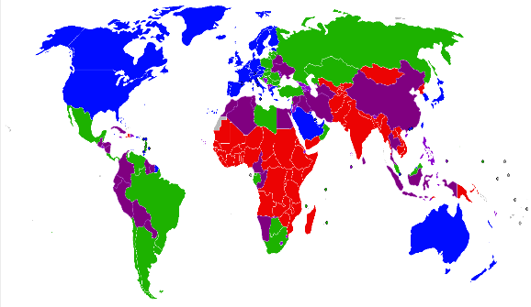  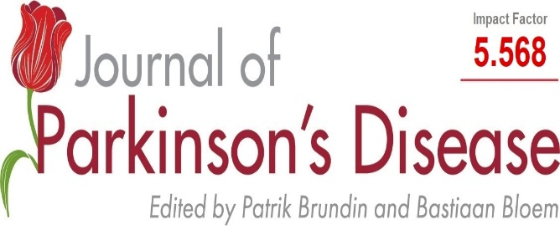
Can children play a role in reducing families’ salt intake?
14 February (Feng He, MacGregor GA. Centre for Public Health and Policy)

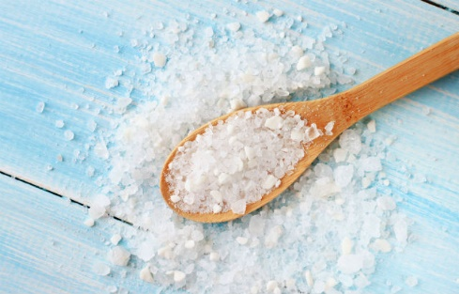   | In an invited BMJ opinion piece, authors from the Research & Action on Salt & Obesity unit reflect on lessons learned from their recently published research on an app-based education programme for primary school children to reduce family salt intake in China. In many developed countries processed foods are responsible for 70-80% of salt intake, but successful population intake reduction has been possible by lowering processed food salt targets. This policy is not generalizable to developing countries, such as China, where 80% of salt is added during home cooking, and average intake per person is over twice the WHO recommended maximum. In this piece the authors reflect on how they refined their approach to achieving salt reduction through primary education, and the obstacles they overcame in this process (eg: children living with grandparents who did not have a smartphone). They conclude that this intervention could be scaled up across China, and adapted by other countries in settings where most dietary salt is added in home cooking.
Barts Charity Funding for interventions to tackle covid vaccine hesitancy in East London
14 February (Dominik Zenner, Chris Griffiths, Adam Brentnall. Centres for Public Health and Policy/Primary Care /Evaluation and Methods)

A Barts Charity Large Project Grant of £325k has been awarded to WIPH researchers to develop and evaluate community-based interventions to tackle covid vaccine hesitancy in East London. Through interviews and focus groups with members of migrant and ethnic minority communities, a cross-centre WIPH team will undertake a qualitative study exploring beliefs regarding COVID-19, social and cultural concepts, perceptions, and attitudes regarding vaccines. Participatory workshops will enable the team to examine the viability of culturally adapted educational support, considering content, design, and mode and timing of message delivery, and to create a public engagement tool. A randomised pilot study will evaluate the feasibility and implementation aspects of a subsequent larger trial if the public engagement tool increases COVID-19 uptake in the target population. PI Dominik Zenner said: “This exciting research explores ideas and views from our local population on what does and doesn't work to co-design interventions to promote vaccine uptake among those people who need it most.” |   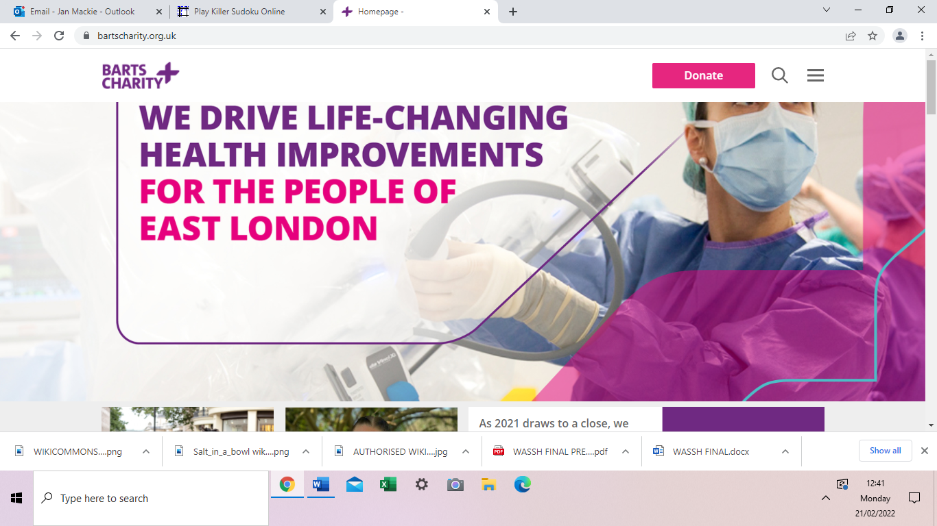

Sodium and Health: Old Myths and a Controversy Based on Denial
14 February (Feng He, Graham MacGregor. Centre for Public Health and Policy)

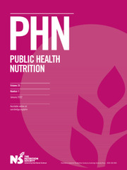 | Despite the global scientific consensus that high sodium intake increases blood pressure and contributes to cardiovascular disease, eight articles published in the European Heart Journal in 2020 and 2021 have propagated a myth that lower sodium might increase cardiovascular disease risk. A consortium of leading world experts, including WIPH authors, has analysed these papers in a new review, summarising the misleading claims and considering the reasons behind them. The authors call on journal editors to take on greater responsibility in ensuring that unfounded claims about sodium intake are rigorously challenged in the review process, and to ensure that conflicts of interest, particularly in relation to food industry funding, are accurate and transparent.

Sodium content of restaurant dishes in China
17 February (Monique tan, Feng He. Centre for Public Health and Policy)

In 2017, three million deaths were attributable to high salt intake, with about half of these occurring in China. A cross-sectional survey of the sodium content of restaurant dishes in China has found that 62% of single servings exceeded the WHO recommended daily intake of 2000mg, and that cooking salt was the leading source of sodium. Using data obtained from the 2019 restaurant intervention study, WIPH researchers determined that the median sodium content in restaurant dishes was over 2500mg per serving. The authors conclude that coordinated sodium reduction initiatives targeting the main sources of sodium in restaurant dishes are urgently needed. | 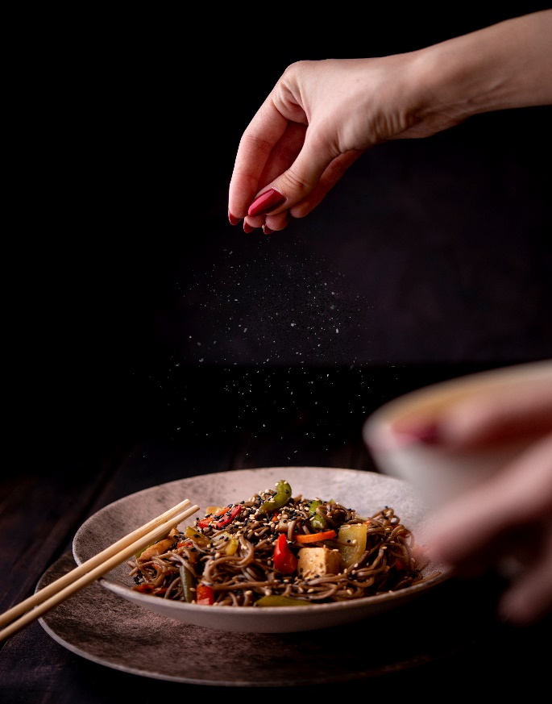
Funding to test the feasibility of the CUE1 medical device for alleviating Parkinson’s Disease symptoms
17 February (Alastair Noyce, Cristina Simonet. Centre for Prevention, Detection and Diagnosis)

   | Innovate UK Funding has been awarded for a 24 month Knowledge Transfer Partnership project between Queen Mary University of London and Charco Neurotech, to test the feasibility of the CUE1 novel medical device to relieve symptoms of Parkinson’s disease. The project will assess tolerability of the device and its effect on clinical outcome measures, assessing optimal stimulation settings and positioning, accessing patients with Parkinson’s Disease, and designing a formal clinical trial. Parkinson's Disease may be the fastest growing degenerative condition of the nervous system worldwide, with progressive deterioration in movement the most recognisable feature. Drug treatment administered multiple times per day can manage this symptom but, over time, symptom control deteriorates, rendering the patient either immobile or suffering from excessive involuntary movement, and causing significant disability and poor life quality. The CUE1 device, worn on the sternum, uses vibrations and external sensory cues to reduce balance problems, falls, and involuntary muscle movements, and to improve dexterity. Efficacy and tolerability need to be demonstrated in a clinical setting before the device can be widely 'prescribed', and QMUL clinical expertise will shape the design of an intervention study to assess the real clinical effects. WIPH Knowledge Base team Alastair Noyce and Cristina Simonet said: “We are very excited to have the opportunity to partner with Charco Neurotech and investigate the role that the CUE1 device has in treating challenging symptoms of Parkinson’s. We know that it is beautifully designed and has yielded benefits for some patients, but now it is time to investigate just how much it can offer to a wider group with Parkinson’s.”
Delayed US sodium targets may cost 250,000 lives
21 February (Jing Song, Mhairi Brown, Graham MacGregor, Feng He. Centre for Public Health and Policy)

In 2016 the US Food and Drug Administration (FDA) proposed short term (2yr) and long term (10yr) voluntary sodium-reduction targets for >150 processed- and prepared-food categories. Short term targets were finalized 4.3 years later in 2021, but the 10 year targets are yet to be confirmed. In a new study, authors from the Research and Action on Salt and Obesity Unit modelled the health benefits of implementing FDA sodium reduction targets, and assessed the health loss due to delay in finalizing targets. Their results project that up to 446,000 deaths might be prevented in the next 10 years, depending on whether the long-term targets are finalized by April 2024 and to what degree the sodium reduction targets are achieved. Net deaths due to the FDA’s 4.3-year delay in finalizing the targets might be as high as 265,000 between 2017-2031. First author Jing Song said: These findings highlight the enormous health costs due to the FDA’s delay in finalizing the sodium-reduction targets, and the great potential health benefits of industry compliance with FDA’s finalization of its short- and long-term targets in the coming 10 years. | 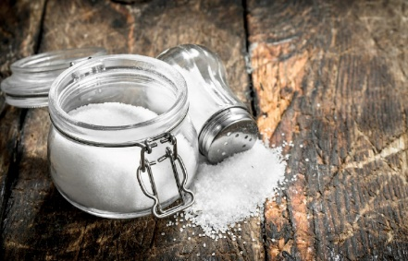

Determinants of pre-vaccination antibody responses to SARS-CoV-2 in the UK
22 February (Mohammad Talaei, Hayley Holt, David Joliffe, Giulia Vivaldi, Chris Griffiths, Seif Shaheen. Centres for Primary Care/ Prevention, Detection and Diagnosis)

 | A prospective population-based study of >11,000 UK adults not vaccinated against or testing positive for COVID-19 before enrolment in the COVIDENCE study has found that higher alcohol consumption and lower light physical exercise are new, modifiable risk factors for COVID infection. Previous large population-based serology studies have not considered risk factors related to lifestyle, diet, or levels of physical activity. In this study, researchers used online questionnaires to collect information on 88 potential sociodemographic, behavioural, nutritional, clinical and pharmacological risk factors. Serological population-based studies test members of a population uniformly, including people who might not be captured by routine testing. This approach reduces the risk of bias and can uncover previously undetected asymptomatic infections. In this research, responses to SARS-CoV-2 spike glycoprotein in dried blood spots taken from Nov 2020 to April 2021 showed that 15.2% (1696) of participants were seropositive. Recognised associations between South Asian ethnic origin and obesity and higher risk of SARS-CoV-2 seropositivity were independent of other sociodemographic, behavioural, nutritional, clinical, and pharmacological factors investigated. Among seropositive participants, higher titres of anti-Spike antibodies in people of South Asian ancestry and in obese people were not explained by greater COVID-19 disease severity in these groups. First Author Mohammad Talaei said: “The links we have shown between South Asian ethnicity and modifiable lifestyle factors and higher risk of seropositivity, as well as associations with antibody titres for factors like ethnicity, dairy intake, and anxiety and depression, are subjects for future research to understand underlying mechanisms and to plan preventive measures better.”
ITV evening news interview on BRCA genetic testing
23 February (Ranjit Manchanda. Centre for Prevention, Detection and Diagnosis)

On 23 February Ranjit Manchanda was interviewed on ITV Border news in relation to a story about BRCA genetic testing. He was asked about the risks associated with the gene, and how testing is carried out, and was also able to explain the implications for women in relation to ovarian cancer, detailing the different surgical options for women who have and have not completed their families. | 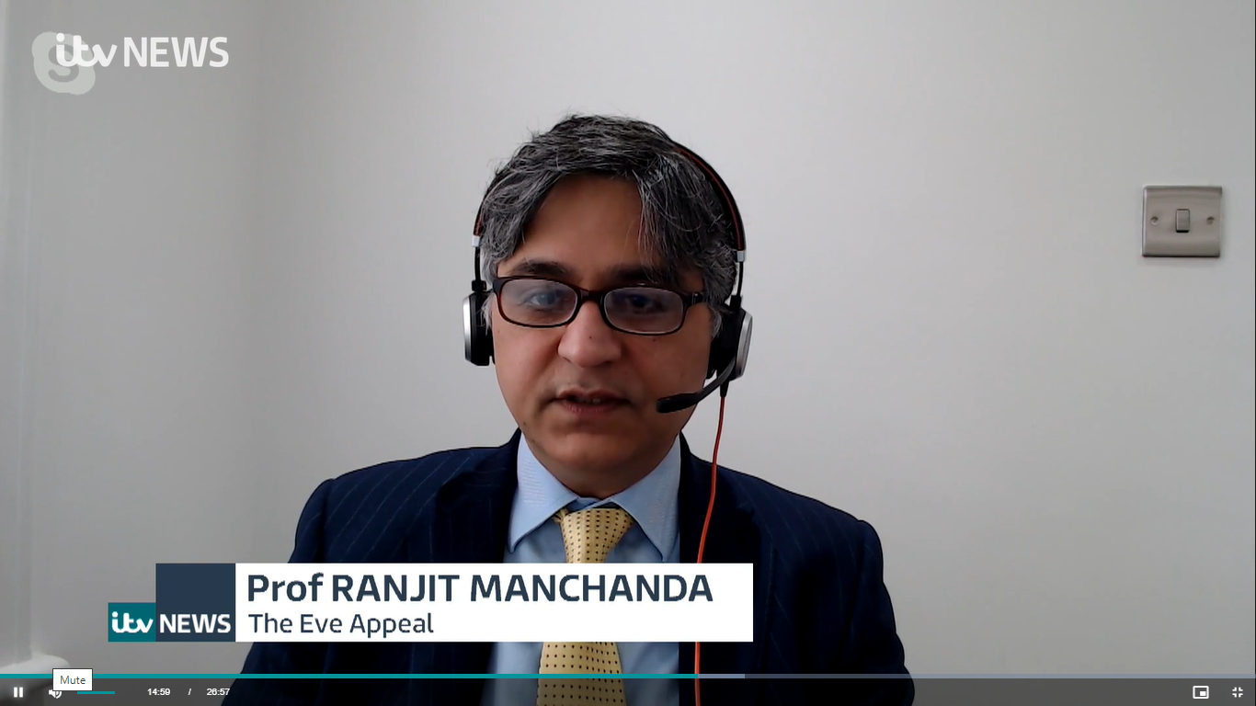
All India Institute of Medical Sciences – Infosys Chair in Oncology
24 February (Ranjit Manchanda. Centre for Prevention, Detection and Diagnosis)

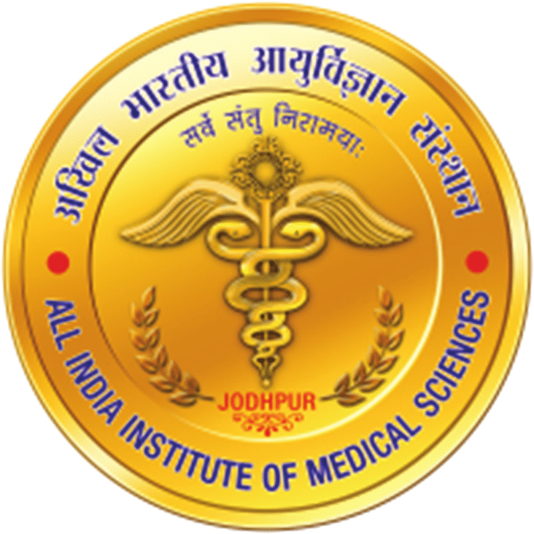 | Congratulations to Professor Ranjit Manchanda on being awarded the Infosys Chair in Oncology at the All India Institute of Medical Sciences (AIIMS). AIIMS in New Delhi is India’s leading medical school and institute for medical training, education (including post graduate training), and research.
FORTHCOMING EVENTS

3 March: Vigil in remembrance of victims of gender-based violence  A vigil to commemorate a year since Sarah Everard's death, and in remembrance for all victims of gender based violence will be held on 3 March. This will be a quiet, contemplative event where attendees can light candles and pay respects to the victims of violence against women. The group will walk from Mile End station at 5pm, to the meet in front of the Garrod Building for 6pm for the vigil. All WIPH staff and friends are invited to attend. | 
14-20 March Salt Awareness Week  The next National Salt Awareness Week Campaign will take place 14-20 March 2022, to shine a spotlight on a simple yet effective approach that will improve our health – asking the food industry to shake their salt habit. Salt reduction policies targeted specifically at the food industry are necessary and proportional: three quarters of the salt the UK eats each day is already in packaged and prepared foods. This cannot be removed by the consumer, so simply telling people to eat less salt will not work when our food is full of it. | 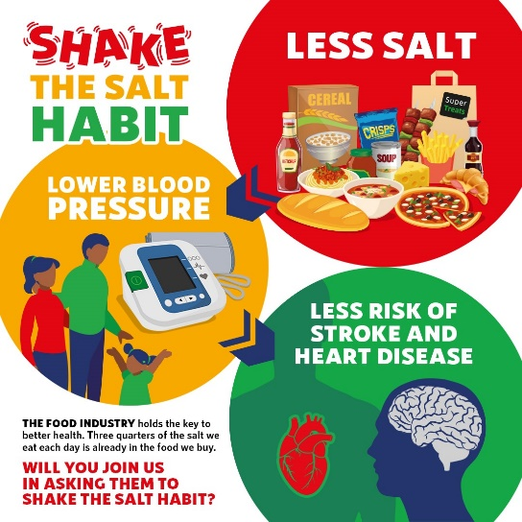
Many thanks to all who so enthusiastically contribute. Please send any news items for the next newsletter to j.a.mackie@qmul.ac.uk

