WOLFSON INSTITUTE OF POPULATION HEALTH
NEWSLETTER
ISSUE 8: 31 JANUARY 2022
In this issue of our Wolfson Institute of Population Health Newsletter, we celebrate the achievements and work of staff and students in the second half of January.
FROM OUR DIRECTOR

Dear All

As we reach the half-year anniversary since our WIPH launch, I’ve been reflecting on our achievements so far. I’ve had excellent feedback from all the Centre Leads following the Centre Away(half)Days, from which the same themes of enthusiasm for our new structure and how it can support innovative, collaborative, and multi-disciplinary research and education emerged. I plan to make AwayDays a regular feature, as they give us a chance to get away from our desks and meet with colleagues, hopefully in person from now on. I am also pleased that the senior team are steadily doing a better job of conveying the quality of the science and education here, the excitement of the environment, and that we are joined-up and outward-looking. On the theme of meeting in-person, I should emphasise our message for all staff to return under hybrid working arrangements, of 2-3 days per week in the office, as soon as they can. We are taking a rigorous approach to safety, expecting
everyone
to continue to use face coverings (unless exempt) in communal spaces, make sensible decisions about ventilation and social distancing, and use lateral flow tests regularly. I look forward to seeing many more of you around our sites in the coming weeks.  Best wishes  Fiona |  | 
FROM OUR LEADERSHIP TEAMS AND REPRESENTATIVES
Welcoming new staff
Mark Freestone (Director of Education)

In mid-January we welcomed two new members of staff, Dr Rob Blakey (Lecturer in Mental Health) and Dr Federica Biotti (Teaching Fellow in Psychopathology) to the WIPH education team. Both will be based in the Centre for Psychiatry and Mental Health.

Curiosity workshops
Deborah Swinglehurst (Theme Lead: Complexity and Social Science)

Our Curiosity workshops got off to a flying start for this year on 5 January, with 28 people in attendance. WIPH PhD student Caroline French invited us to share some of her thinking on how process evaluations are defined, valued, and shaped in the context of pragmatic randomised controlled trials, and got us all wrestling with some difficult concepts as she shared insights into her emerging findings. (Thankyou Caroline!) If you are curious about being curious, and would like to learn and share more about qualitative research, please contact Charlotte to join the mail list. Our next workshop is scheduled for 1000-1100 on 2 February.

GENERAL INSTITUTE NEWS

Inaugural WIPH Epidemiology Group meeting
14 January (Seif Shaheen. Centre for Prevention, Detection and Diagnosis)

The newly formed WIPH Epidemiology Group has launched, with over 30 staff attending the first meeting and 50 people signing up to the mailing list. One aim of the meetings is to clarify epidemiological research interests and expertise across QM, and thereby to identify potential collaborations. At this first meeting, Seif Shaheen and Mohammad Talaei highlighted their recent and current research activities. The plan is to populate a register of epidemiology interests and expertise, and then possibly to form more focused epidemiology groups according to sub-specialties (eg. genetic/molecular epidemiology). Once the meetings are established, high profile external epidemiologists will be invited to speak, and the group will identify methodological topics of interest. The next meeting will be held at 11am on 17 February. To join the group please email Mohammad Talaei. | 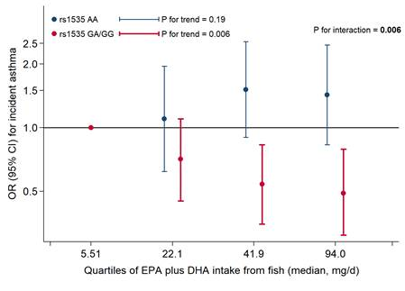
AWACAN-ED Programme receives £2.99 million NIHR Global Health Research Award
18 January (Fiona Walter. Centre for Prevention, Detection and Diagnosis)

 | A £2.99 million NIHR Global Health Research Award has been made to fund the AWACAN-ED (Advancing Early Diagnosis of Cancer in Southern Africa) programme. Funding will run until September 2025, for research being conducted in Zimbabwe and South Africa by a partnership of the Wolfson Institute of Population Health with the Universities of Cape Town and Zimbabwe, and Kings College London. In Southern Africa, people with symptoms of cervical, breast, and colorectal cancers are diagnosed when they self-present, usually at an advanced stage and with associated poor outcomes. AWACAN-ED aims to shift this paradigm to earlier stage at diagnosis, through research assessing the time intervals from symptom awareness to referral and diagnosis, and the factors influencing these intervals. Researchers will develop and evaluate symptom assessment e-Tools for primary care providers and the public, to promote more timely presentation and referral. Co-PI, WIPH Director Fiona Walter said: This vital funding will allow us to continue to answer important questions about how to encourage appropriate help-seeking among people in these settings with possible cancer symptoms and how to deliver high-quality, accessible and equitable cancer referral and diagnosis services in community healthcare and primary care facilities.
Social determinants of neurological disease: tackling inequalities
19 January (Ruth Dobson, Charles Marshall, Alastair Noyce. Centre for Prevention, Detection and Diagnosis)

Researchers from the Preventive Neurology Unit have published a summary of outcomes from their recent symposium on Inequalities and Social Determinants of Neurological Disease in The Lancet Neurology. The symposium in November 2021 aimed to increase awareness of these topics for researchers, clinicians, and funders, and to generate new research ideas for equity and inclusivity in research and in the clinic. The way that social inequalities cause or affect disease and potential interventions to address these factors have not been well studied, but with the current backdrop of social awareness, there is a window of opportunity to improve inequities. The authors conclude: “It is vital to improve representation within research topics, participants, and researchers. Researchers need to focus on what the research process gives back at all levels, in terms of training, infrastructure, and relevant findings that inform personalised interventions and/or policy. This requires investment from research funders. Doing truly inclusive research carries considerable financial and time cost, but is essential to allow us to start to address the impact of social inequalities.” | 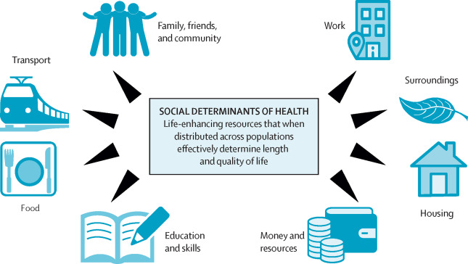    
The power of language in mental healthcare: Talk now online
20 January (Sandra Jumbe. Centre for Evaluation and Methods)

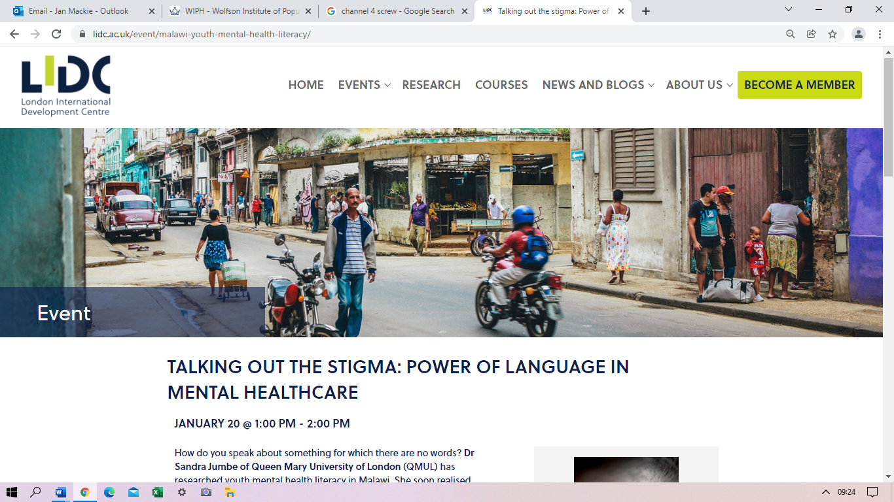 | Sandra Jumbe’s talk for the London International Development Centre is now available to watch online. The well attended presentation covered her experience, observations, and challenges of researching and working on youth mental health literacy in Malawi.
Primary Care – Building Back Better?
20-21January (Stuart Rison, Dipesh Gopal. Centre for Primary Care)

WIPH was well represented at the South-East Annual Scientific Meeting of the Society of Academic Primary Care 2022, hosted virtually by UCL on 20 and 21 January. The theme for the event was Primary Care – Building Back Better?, and discussions focused on health inequality and change, including digital healthcare and innovative tools to address disparities in health care. Among our WIPH participants, Dipesh Gopal was awarded the Dragon’s Den Prize for his idea for a randomised controlled trial on continuity of care, and Stuart Rison presented in the Optimising Healthcare agenda session. | 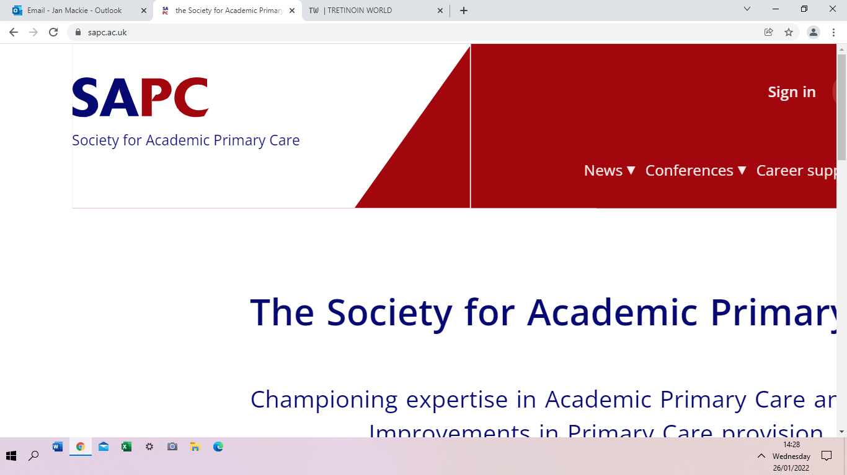  
Developing a NICE Guideline on Familial Ovarian Cancer
24 January (Ranjit Manchanda. Centre for Prevention, Detection and Diagnosis)

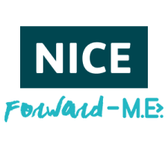   | Ranjit Manchanda has been appointed as the Topic Advisor for the development of the recently announced Nice Guideline on Familial Ovarian Cancer. NICE guidelines are evidence-based recommendations for health and care in England, setting out care and services suitable for people with a specific condition. While a guideline has existed for familial high risk breast cancer screening, familial ovarian cancer is a new enterprise. The first meeting of the group was held on 24 January, and publication is expected in March 2024. Ranjit said: “I am delighted to be appointed Topic Advisor, and am looking forward to working with colleagues and stakeholders in developing and delivering this guideline. This is extremely important work which will help guide and improve future care for individuals at increased risk of ovarian cancer.”
Manufacturers lag behind retailers in compliance with salt targets
25 January (Action on Salt. Centre for Public Health and Policy)

Research on chilled cooked sliced meats has revealed that two thirds of these products sold by leading grocery retailers are high in salt (>1.5g/100g), with 35% failing to meet the national salt reduction targets. Meat and processed meat products are the second key contributor of salt intake in UK diets (26%). This new report, based on 555 products from 38 companies, shows that while 69% of retailer’s own label products in this category met salt standards, food manufacturers have made dismal progress, with only 37% of their products hitting the targets. Tesco is the leading retailer in compliance with the targets, with Waitrose lagging furthest behind (97% and 7% respectively). Wide variations in salt content among products (a 23-fold difference across all products assessed) demonstrate that vastly reduced levels of salt are achievable. Action on Salt is calling for mandatory, comprehensive, salt reduction targets, with penalties for manufacturers who fail to comply. |   
Mental health services are failing the criminal justice system
26 January (Jeremy Coid. Centre for Psychiatry and Mental Health)

  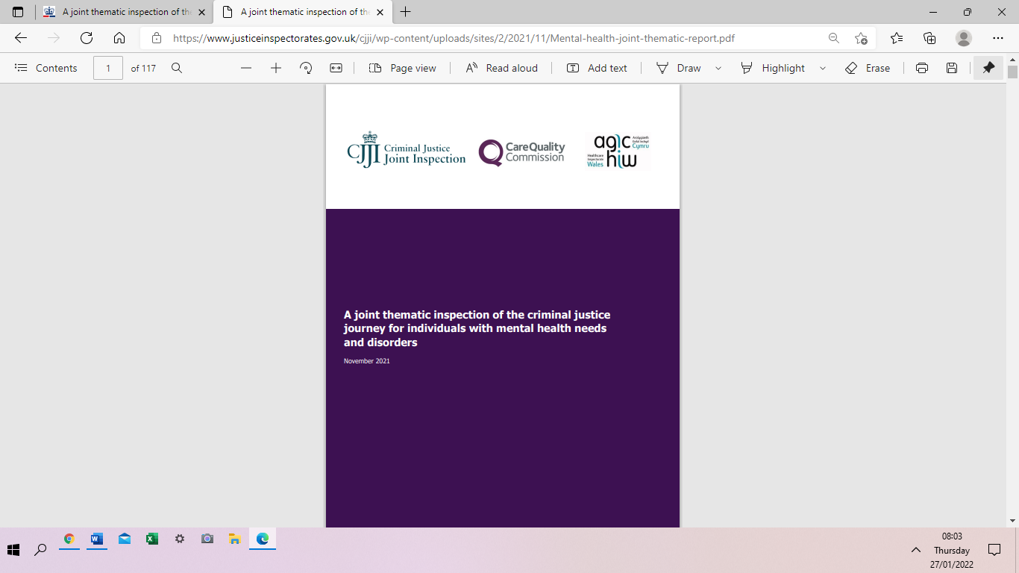 | A BMJ editorial co-authored by WIPH Emeritus Professor of Forensic Psychiatry Jeremy Coid has called for an urgent national review to reverse the decline in mental health provision to the criminal justice system. The recent joint report by HM Inspectorates of Constabulary, Prisons, and Probation highlights that the criminal justice system is seriously failed by mental health services in England and Wales, finding poor information exchange at every stage of the criminal justice pathway. This editorial suggests that by far the biggest problem is access to high quality mental healthcare and treatment, which has worsened since the start of the Covid-19 pandemic. The authors conclude that a national review of this failed system of care is urgently needed to identify how the progressive withdrawal of mental health provision from the criminal justice system can be reversed, and that the proposed changes to the Mental Health Act designed to control rising compulsory mental health admissions will result in more vulnerable people being criminalised for public protection, increasing pressure on the criminal justice system.
Early Career Researcher Media Training
26 January

Twelve WIPH Early Career Researchers have participated in an online training session on Promoting Research to the Media. Led by Sophie McLachlan, Communications Manager for the QM School of Medicine and Dentistry, this introduction to media training covered a range of topics under the broad categories of What the media is and why it matters, What makes a good media story, Press releases, and Other ways to promote research. One topic that particularly caught our ECRs’ attention was the role of the Science Media Centre, and how to sign up to their mailing lists with a view to expanding and improving reputation, and moving into a more active role in public discussions surrounding scientific research. | 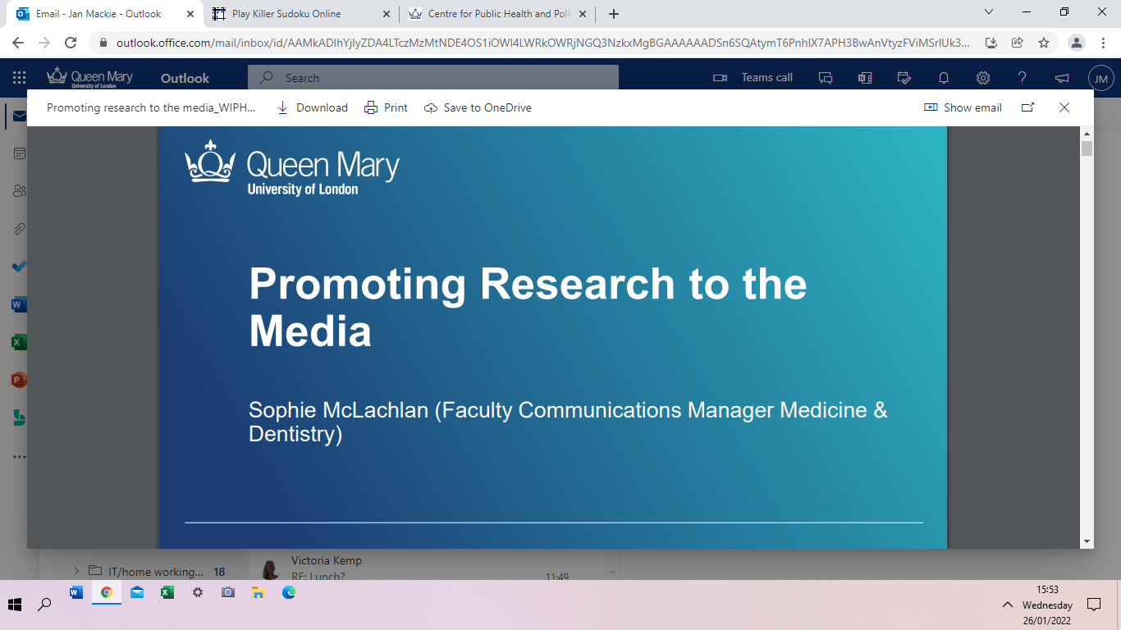  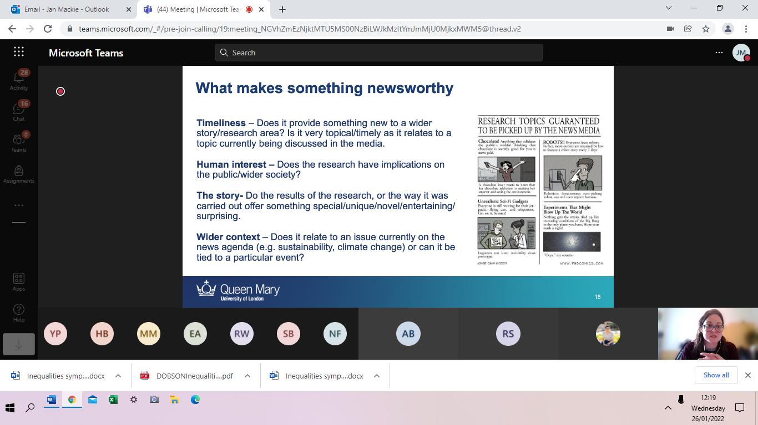
Better Late Than Never: The FDA’s Sodium reduction Targets
26 January (Mhairi Brown, Jing Song, Graham MacGregor, Monique Tan, Feng He. Centre for Public Health and Policy)

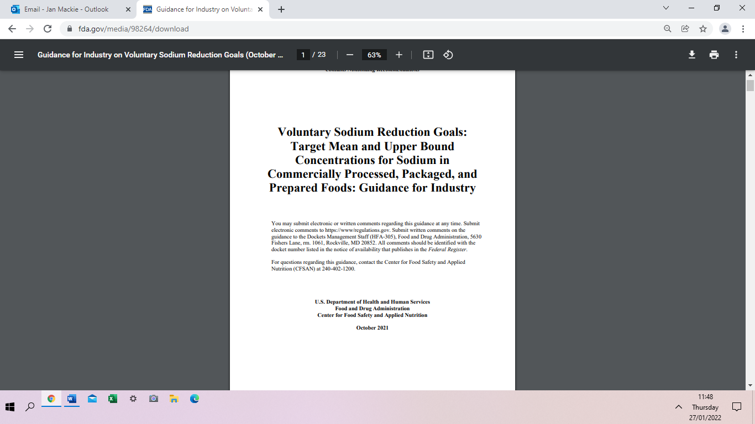   | In an editorial in the American Journal of Public Health, authors from the Research & Action on Salt & Obesity team summarise the international outlook on sodium reduction in light of the recent announcement of FDA short term, voluntary sodium reduction targets. The editorial reflects on the 2009 National Salt Reduction Initiative, a coalition of more than 100 health organizations led by the New York City Department of Health which, in the face of no action from the US federal government, helped to kick start US sodium reduction efforts. The NSRI model of sodium reduction became the template for the FDA, leading to their draft 2-year and 10-year targets in 2016, and the 2021 announcement of short-term targets. The authors note that there are many things the UK did well which the FDA should consider, but that the reasons for failures in UK policy will be just as important for the FDA to learn from. They conclude that, in a globalized world, multinational food companies headquartered in the US being subject to a US-based sodium reduction strategy will have huge importance for both US and global health.
British Thoracic Oncology Group Annual Conference
27 January (Evangelos Katsampouris. Centre for Prevention, Detection and Diagnosis)

WIPH Research Fellow in Behavioural Science, Evangelos Katsampouris, presented his work on Rates of acceptance between opt-out vs opt-in smoking cessation referral strategies among current smokers attending a Lung Health Check offering lung cancer screening at the BTOG 2022 virtual conference on 27 January. His abstract, one of four selected for an oral presentation from over 100 submitted, reports on a randomised controlled trial embedded within the Lung Screen Uptake Trial. The results show a high uptake of both opt-out and opt-in smoking cessation referral strategies offered during Lung Health Check appointments, supporting the acceptability and implementation of opt-out referrals as a minimum standard of care. The authors, including Stephen Duffy and Sammy Quaife, conclude that future research should assess subsequent uptake of smoking cessation referrals. | 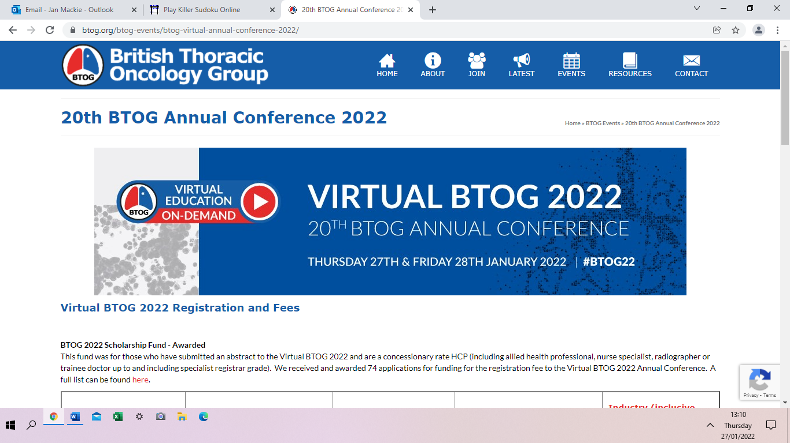  
Prioritising global primary care respiratory research needs
28 January (Steph Taylor. Centre for Primary Care)

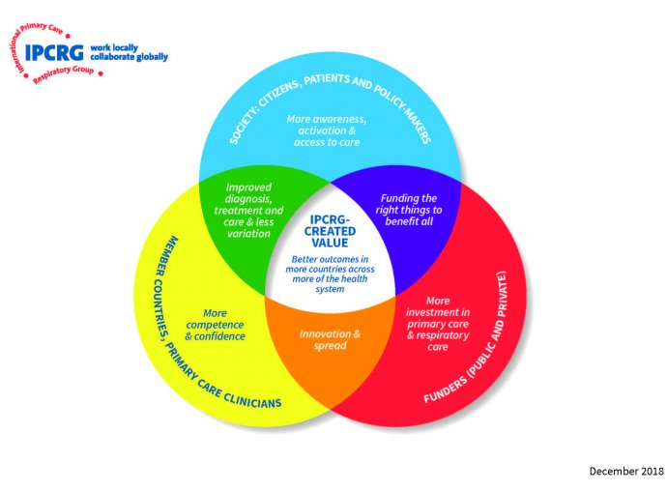  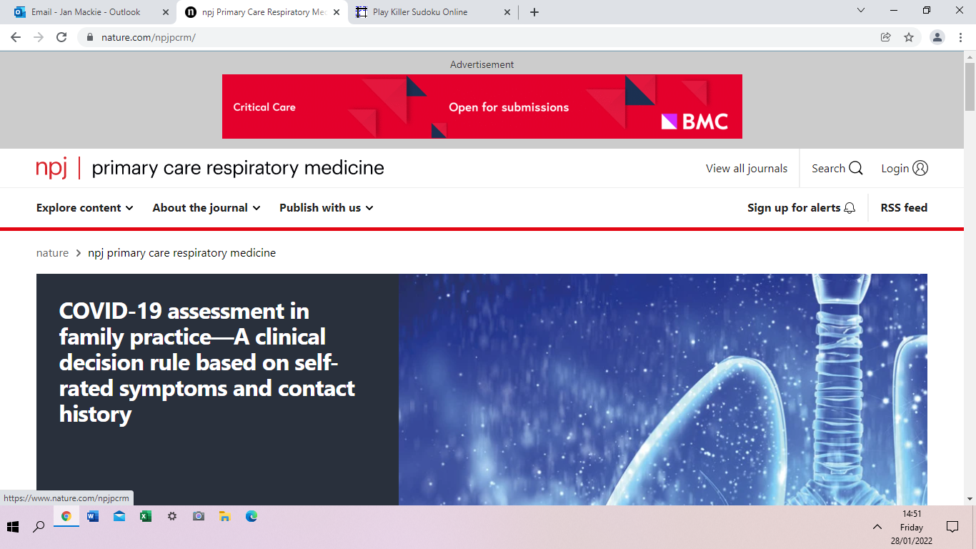 | The International Primary Care Respiratory Group has published results from a 2020 global e-Delphi exercise designed to identify and prioritise the current respiratory needs of primary care health professionals. Primary care plays a central role in the prevention, diagnosis, and management of respiratory conditions, which impose a significant burden of morbidity and account for 7.7 million deaths a year. From research questions suggested by 112 community-based physicians, nurses, and other healthcare professionals across 27 countries, 49 questions reached 80% consensus for importance, covering diagnosis, management, monitoring, self-management and prognosis of asthma, COPD, and other respiratory conditions. Themes identified were: a need for more effective training of primary care clinicians; evidence and guidelines specifically relevant to primary care, adaption for local and low-resource settings; empowerment of patients to improve self-management; and the role of the multidisciplinary healthcare team. The prioritised list of questions provides a new agenda for primary care respiratory research, with consensus on the most important of these from the perspective of practising primary care healthcare professionals representing a wide range of backgrounds and settings worldwide.
FORTHCOMING EVENTS
1 February: How I got my fellowship Seminar

The first 2022 How I got my fellowship seminar will be held from 12:15-13:00 on 1 February. Ana Sobrido will talk about her experience of being awarded a UKRI Future Leaders Fellowship, from idea to proposal writing and interview process. She will also discuss her experience with unsuccessful fellowship applications. The session will be chaired by Trevor Sheldon who will bring to the table his valuable knowledge of different fellowship schemes, and what funders are looking for in a good fellowship application. The session will be mainly targeted at our early career researchers, but all staff are welcome to join. The second 2022 seminar will be held on 15 March.

Many thanks to all who so enthusiastically contribute. Please send items for the next newsletter to j.a.mackie@qmul.ac.uk

