WOLFSON INSTITUTE OF POPULATION HEALTH
NEWSLETTER
ISSUE 27: 13 JANUARY 2024

In this issue of our Wolfson Institute of Population Health Newsletter, we celebrate the achievements and work of staff and students in late December and early January.

FROM OUR DIRECTOR
Dear Colleagues

Wishing you all a very Happy New Year, and hoping you managed to have a good break over the holiday season. Our Christmas Party last night at the Shield was a great event, and it was wonderful to see so many of you as we start the new year.

Our Equality Diversity and Inclusion action plan saw some real progress in 2022. Outgoing EDI Professional Service reps Maria D’Amico and Beatriz Ratton (with support from Tracy Connelly behind the scenes) have ensured that we continue to review processes and policies, enabling WIPH to be one of the most equitable QMUL institutes. Our senior leadership is now more diverse than ever before, our appointment panels now have EDI representation, and WIPH staff have led a number of initiatives over the year, but this doesn’t mean there isn’t more work to do. Evangelos Katsampouris will now lead our EDI subgroup, and we look forward to seeing initiatives arising from this. Look out for the meeting invites in your inbox.

New initiative - Meet WIPH

There are difficulties inherent in working in an institute split across multiple sites, even without the additional complications of hybrid working and train strikes. One of the challenges we face is that many people working in WIPH have never met. With this in mind, we plan to feature some of our wonderful staff in the newsletter, including a bit about what people do, but more about who we are - ‘the person behind the role’. In the first of these features, below, we meet Tracy Connelly, Deputy Institute Manager. Stay tuned for future instalments!  Warm wishes to all  Fiona | 
MEET WIPH

Meet: Tracy Connelly (Deputy Institute Manager)

How would you describe your roles and responsibilities?
Jack of all trades, master of none! As DIM, my responsibilities range from management of our central administration team, space management, estates/infrastructure, HR matters, H&S coordinator. No two days are the same, which has its advantages and disadvantages.

What has been your greatest professional achievement?
Mentoring, which helps support advance and champion people to believe in their capacity and capability, ie: discovering their hidden selves.

What aspects of your role do you enjoy the most?  I’m a people-person, so working with different pockets of people within WIPH and across QM.  What would be your second choice as a profession?  Midwife.  What do you enjoy doing outside work?  Anything food and drink-related! Family and friends are key. I’ve recently stopped playing netball and I am an Arsenal football fan, even though my nephew plays for West Ham.  Something most people don’t know?  I’m a nanna and a foster carer and I’m looking forward to abseiling down the Royal London this year! | 
FROM OUR LEADERSHIP TEAMS AND REPRESENTATIVES

Research News (Juliet Henderson, Project Manager)

Three research projects in the School for Primary Care have been successful in bids for NIHR funding:

Assessing the potential of assistive technology in people with chronic obstructive pulmonary disease
Ratna Sohanpal PI, Steph Taylor Co-PI: This study will determine whether assistive technology (AT) can improve health, wellbeing and quality of life of people with COPD, and investigate how access and use of AT can be improved to support independent living for these patients.

TARGET-ID Phase 2: Digitally Targeted Testing For Blood-borne Virus Infections
Werner Leber PI, Co-apps Chris Griffiths and John Robson: The first phase of this project created a new collaboration through SPCR, bringing together people with lived experience of HIV, Hepatitis B and C, and charity sector leaders, with experts in infectious disease screening research. The project will aim to identify people at the highest risk of testing positive (targeted testing), to determine the test acceptability, and support newly diagnosed people in receiving treatment. Phase 2 will refine and test the robustness of the scoring system developed, first using information from patients in East London, and then from patients across the UK. Workshops including people with lived experience of blood-borne viruses will allow collaborative design of the best way to offer testing.

Non-cancer Diagnoses and their Potential For Missed Opportunities In Symptomatic Cancer Diagnosis: A Mixed Methods Study
Sarah Price, Exeter University, PI, in collaboration with Fiona Walter, Suzanne Scott and Georgia Black: This research aims to understand when interim diagnoses represent missed opportunities to diagnose cancer. Using thousands of anonymised medical records the study will look for patterns of interim diagnoses before a cancer diagnosis, and the consequences for patients. The study will also use qualitative approaches to gain an in-depth understanding of interim diagnoses as possible missed opportunities from the perspectives of patients and healthcare providers.

GENERAL INSTITUTE NEWS

NCRI Gynaecological Working Group
14 December (Ranjit Manchanda. Centre for Prevention, Detection and Diagnosis)

  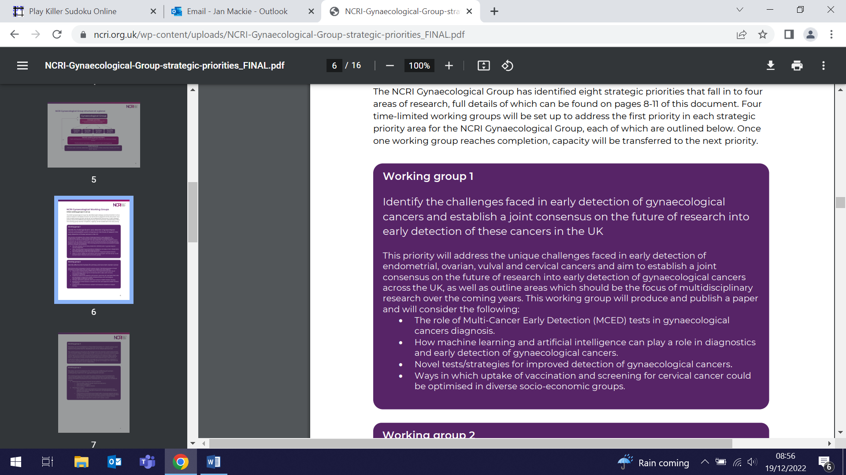 | The National Cancer Research Institute has appointed Ranjit Manchanda as Chair of its Gynaecological Cancer Working Group on Early Detection. The role will include setting the agenda and priorities for early detection and prevention of gynaecological cancers. The Working Group will produce and publish a joint consensus on the future of UK research in this field.
RCT Results: Sodium Reduction in Restaurant Food in China
14 December (Feng He, Jing Song. Centre for Public Health and Policy)

Results from an RCT testing an intervention to reduce sodium in restaurant food in China show a modest 8% reduction in salt content. Mean sodium values of the five best-selling dishes for 66 control and 88 intervention restaurants were assessed from baseline to the end of the trial, conducted between 2019 and 2020. Intervention activities included salt information materials delivered regularly to restaurants for display, multiple choice menus (normal, 70%, or 50% salt) for consumers, training for chefs to reduce sodium in meals, and encouraging waiting staff to proactively recommend lower-sodium choices to customers. Authors conclude that further strengthening of the intervention package is required, and that an effective, sustainable salt reduction programme is urgently needed due to the rapid increase in the consumption of restaurant food in China. | 
Smoking cessation intervention using personalised lung screening scan images
15 December (Sammy Quaife. Centre for Prevention, Detection and Diagnosis)

 | Researchers on the Yorkshire Enhanced Stop Smoking study have worked with patients and the public to develop a personalised smoking cessation and relapse prevention intervention incorporating medical imaging collected during screening. Focus groups were conducted in deprived areas of Yorkshire and South Wales with members of the public who were current smokers or recent quitters, and stakeholder workshops were held to refine the intervention. Public participants considered individual scan images of the lungs and heart to be most impactful, and felt that a trained practitioner to present the intervention and emphasise the short-term benefits of quitting was important. Presenting absolute and relative risks of lung cancer and lung age were considered highly demotivating due to reinforcement of fatalistic beliefs. Authors conclude that the personalised intervention booklet, utilising scan images and to be delivered by a trained smoking cessation practitioner, is an acceptable intervention.
MRC funds study to investigate whether toxic metal exposure is contributing to ethnic and social inequalities in young people
15 December (Seif Shaheen. Centre for Prevention, Detection and Diagnosis)

The MRC has awarded a grant of £863k to Seif Shaheen to lead a three year epidemiological project to determine whether toxic metal exposure is contributing to ethnic and social health inequalities in children and young adults in England. Lead, cadmium, and arsenic exposure in the UK may be higher in South Asians (through food and spices), and exposure to lead may be higher in deprived areas of old housing (with lead water pipes and paint). The study, to begin in April, will investigate concentrations of these toxic metals in young people from ethnic minorities (especially South Asians) compared with Whites, and in more, versus less, socially deprived individuals. It will also determine whether higher concentrations are associated with poorer lung function, cognitive function/educational attainment, and higher blood pressure, and if they partly explain ethnic and social health inequalities. | 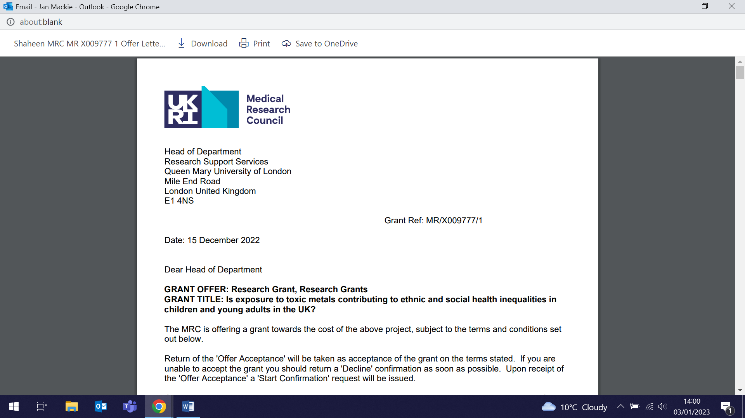  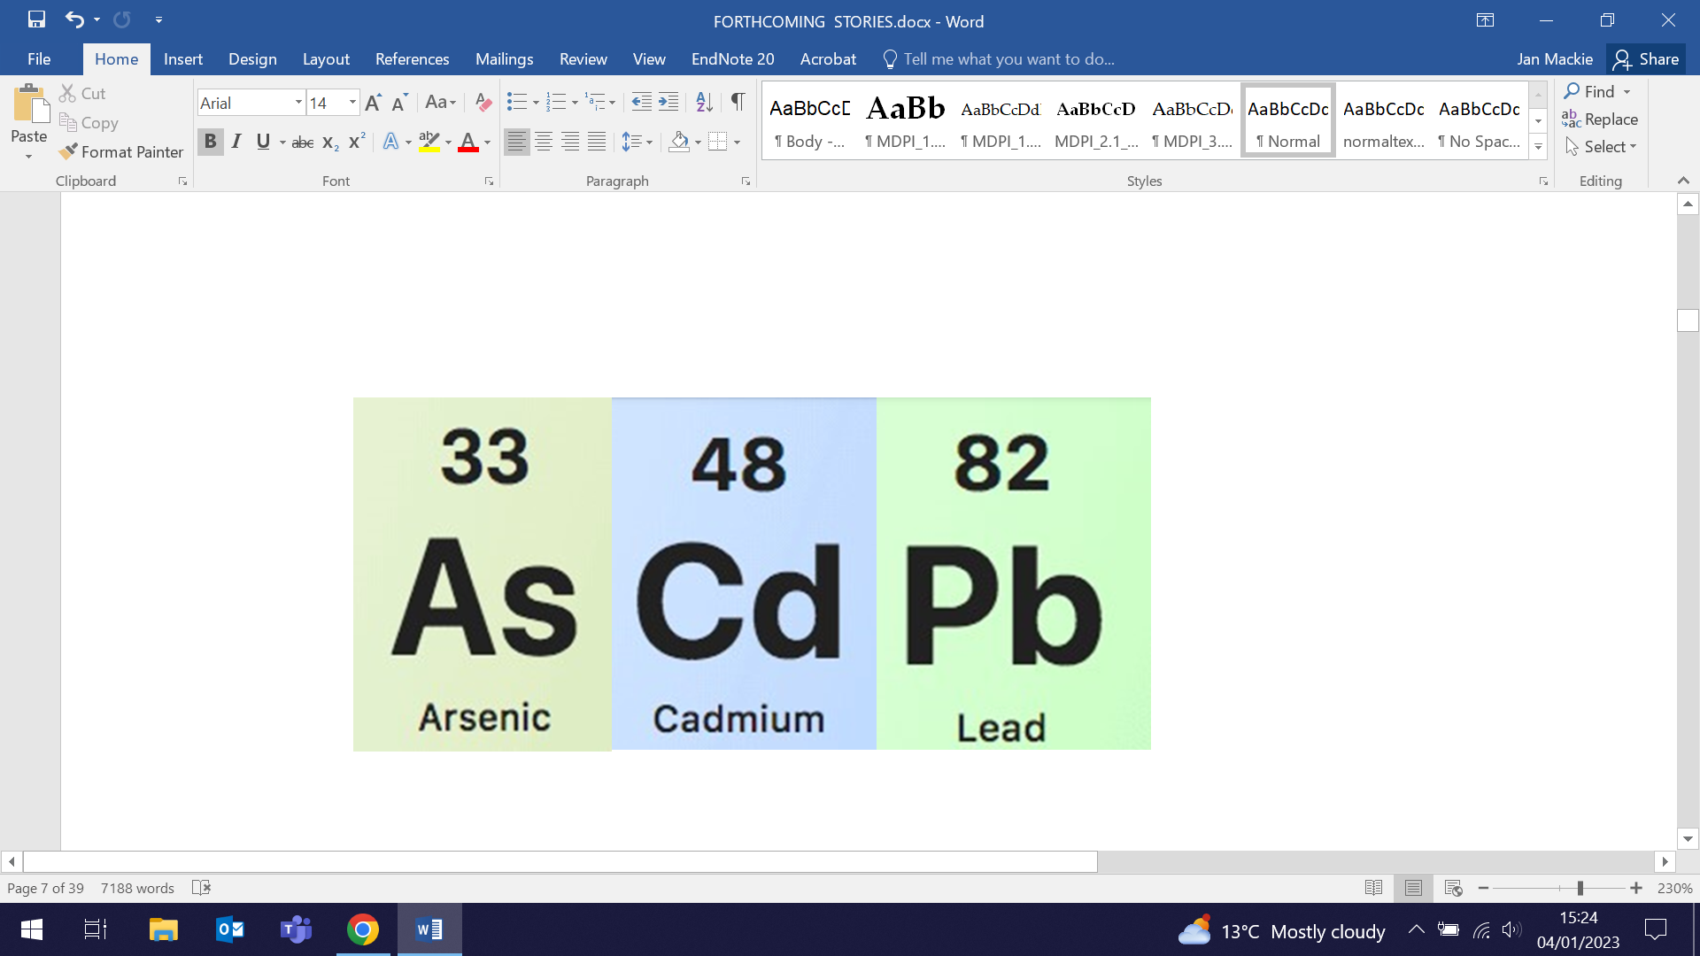
2022 CISNET meeting, Washington DC
15 December (Oleg Blyuss. Centre for Prevention, Detection and Diagnosis)

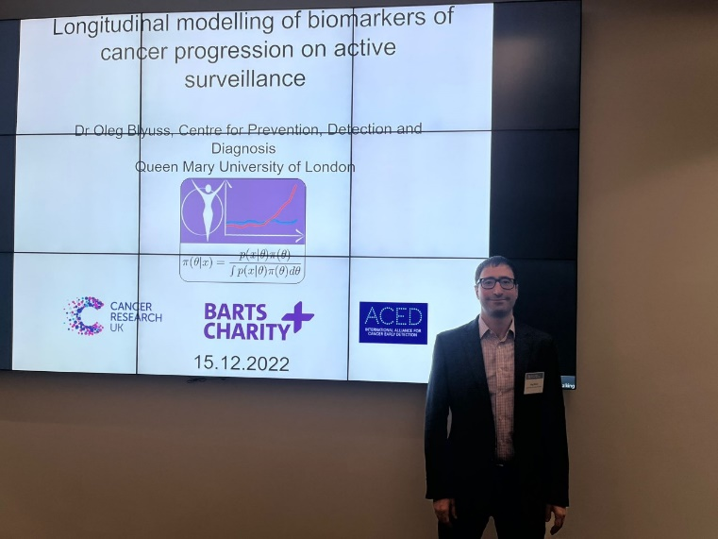 | Oleg Blyuss presented his research on Longitudinal modelling of biomarkers of cancer progression on active surveillance at the annual Cancer Interventions and Surveillance NETwork (CISNET) meeting in the USA. The event was held at the Natcher Conference Center in the National Institutes of Health complex in Washington DC, with separate programmes for research on each of ten different types of cancer. Oleg was participating in the prostate cancer programme.
Supportive self-management for people with chronic headaches and migraine
16 December (Sandra Eldridge, Sian Newton, Steph Taylor. Centres for Evaluation and Methods/Primary Care)

An RCT and economic evaluation have conclusively shown the lack of benefit of a brief group education and supportive self-management programme in improvement in headache related quality of life in people with chronic migraine. The study randomised 727 participants with migraine, recruited primarily from UK general practices, to either the CHESS (Chronic Headache Education and Self-management Study) intervention (376) or usual care (351). The intervention consisted of a two-day group education and self-management programme, a one-to-one nurse interview, and telephone support. At 12 months, there was no between group difference in headache related quality of life, measured using the Headache Impact Test. The incremental cost-effectiveness ratio for the intervention was £8,617 per QALY gained. Authors conclude that the study provides Class III evidence that the CHESS intervention does not increase the probability of improvement in headache related quality of life in people with chronic migraine. | 
Filming begins for QMUL Research Highways Phase 2
19 December (Vicky Bird. Centre for Psychiatry and Mental Health)

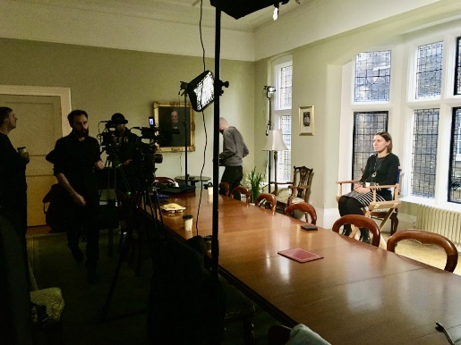 | The Research Highways (2) project has commenced filming, interviewing Vicky Bird as their first recording. Research Highways will showcase selected QM research that tackles major societal issues and is collaborative, inclusive, and impactful. Of the ten FMD features selected, five are from WIPH. Vicky spoke about her work on PIECES (Improving outcomes for people with psychosis in Pakistan and India – enhancing the Effectiveness of Community-based care), a four-year NIHR-funded study adapting and testing DIALOG+, and promoting up-scale through the development of an implementation toolkit and the use of participatory arts methodologies and community engagement. Our other WIPH interviews are scheduled through January.
Feasibility study protocol for proposed EXCALIBUR RCT
19 December (Beth Stuart. Centre for Evaluation and Methods)

The protocol has been published for a study to determine the feasibility of a proposed RCT (EXCALIBUR), using a Chinese herbal medicine in addition to usual care for acute exacerbations of chronic obstructive pulmonary disease (AECOPD). Most exacerbations are not caused by bacteria, but up to 70% of UK primary care patients with AECOPD are prescribed antibiotics as part of standard care. Authors hypothesize that the herbal medicine Shufeng Jiedu may improve symptoms and reduce the necessity for antibiotics, the risk and duration of admission to hospital, and the risk of relapse. The feasibility study of 80 UK primary care patients with AECOPD for whom a GP is considering antibiotic use, will assess trial recruitment process, retention, intervention management and procedures, and will also explore participants’ experiences and views. | 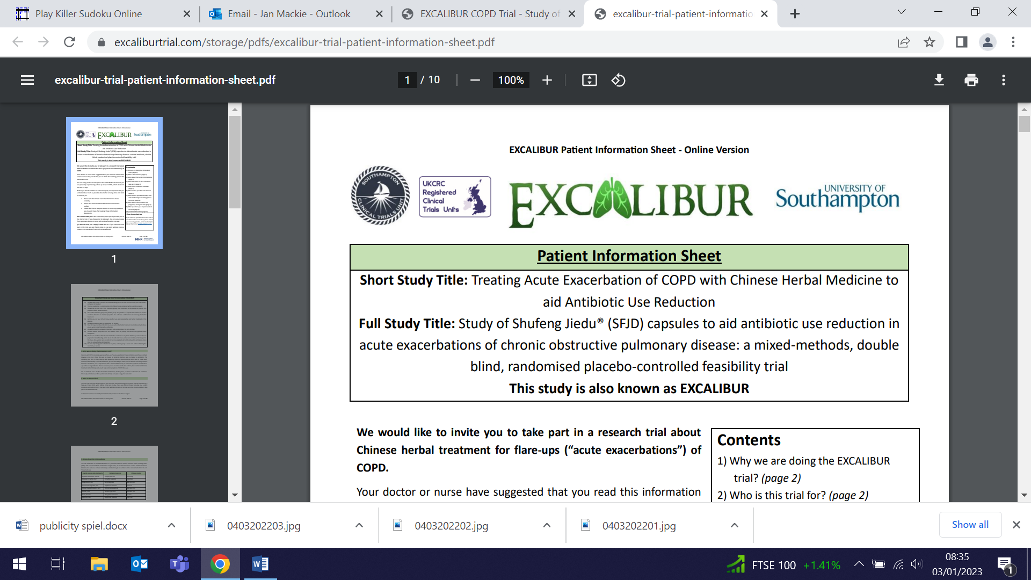  
International Society for Bipolar Disorders Early Mid-Career Committee Goals
21 December (Georgina Hosang. Centre for Psychiatry and Mental Health)

  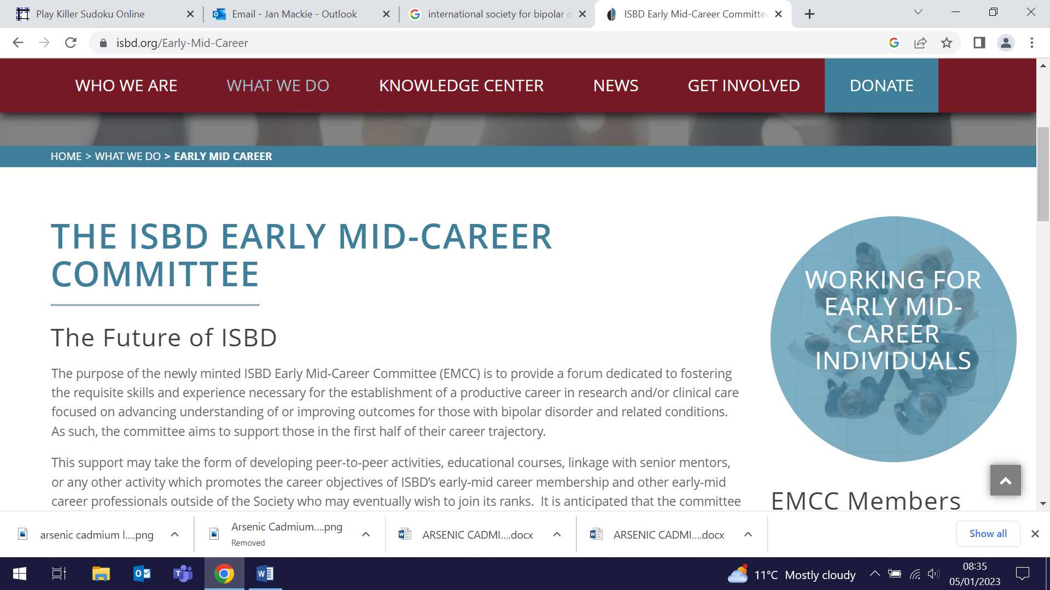 | In 2022 the International Society for Bipolar Disorders appointed Georgina Hosang Co-Chair of their newly formed Early and Mid-Career (EMC) Committee, a global initiative to support researchers and clinicians working in the field of bipolar disorder. An editorial in Bipolar Disorders outlines the rationale and goals of the group, and summarizes the development of a worldwide needs assessment survey. The survey was completed by 441 participants, providing data on challenges faced by EMC researchers and clinicians working on bipolar disorder and possible solutions that the Society could feasibly offer. The Committee hopes that maximizing effective and continued support to upcoming EMC researchers and clinicians will ensure increasing understanding and progress in treatment strategies for the millions of people affected by bipolar disorder worldwide.
REM sleep behaviour disorder: importance of early identification in primary care
21 December (Alastair Noyce. Centre for Prevention, Detection and Diagnosis)

When presenting in otherwise healthy individuals, REM sleep behaviour disorder (characterised by vivid dreams and dream enactment behaviour such as kicking, shouting, and punching), known as idiopathic or isolated REM sleep behaviour disorder (iRBD), is associated with an 80–90% risk of progression to a neurodegenerative disease within ten years of diagnosis. A clinical practice article asserts that while it is unclear whether the trajectory of iRBD can be changed, early presentation provides an opportunity for dementia risk reduction through managing potentially modifiable dementia risk factors. Authors note that GPs play a vital role in recognising potential iRBD, applying preventive medicine approaches to try to alter iRBD trajectories, but that they can perform a similarly vital role in timely referral to specialist settings when cognitive impairment and/or Parkinsonism emerge. The article concludes that identifying iRBD provides a rare opportunity to modify future risk of neurodegeneration, and that there are anticipated opportunities for these patients to enrol in neuroprotective drug trials to prevent progression to an overt neurodegenerative disease. | 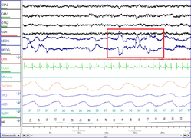
Adverse childhood experiences and clinical expressions of bipolar disorder
22 December (Athina Manoli, Lucy Wright, Sania Shakoor, Georgina Hosang. Centre for Psychiatry and Mental Health)

 | An investigation into the association between clinical expression of bipolar disorder and childhood bullying victimisation and maltreatment has found that adults who were subjected to both of these report significantly more suicidality compared with adults exposed to either or neither of these adverse experiences. Existing literature has mainly focused on childhood maltreatment (abuse and neglect), with little attention to other forms of adversity, such as childhood bullying victimisation. In this study, 63 individuals with a bipolar disorder diagnosis completed retrospective bullying and the childhood trauma questionnaires, with results used to measure exposure to both experiences. Authors believe that their results underscore the need to account for bullying victimisation when considering the adverse childhood experiences-bipolar disorder relationship, and especially its clinical expression.
No evidence for association between alcohol consumption and MS risk
22 December (Ben Jacobs, Ruth Dobson. Centre for Prevention, Detection and Diagnosis)

Researchers using UK Biobank evidence on 2100 individuals with Multiple Sclerosis (MS) and 407,128 controls have found no evidence for an association between alcohol consumption and MS risk in a new study. Existing evidence to support a relationship between alcohol consumption and MS risk has been inconsistent across cohorts. Researchers used multivariable logistic regression models adjusted for age and sex, with empirical power calculations indicating 85% statistical power to detect a protective effect of alcohol consumption of relative risk ≤ 0.7. No evidence of statistical interaction between non-drinking and MS risk was found, on either the multiplicative or additive scale. Authors suggest that the inconsistent association seen between other studies may reflect limited statistical power to detect a weak effect, differences in population characteristics, or the lack of a true causal association. | 
Theatre as Intersubjective Space for the Mediation of Collective Identity
22 December (Maria Turri. Centre for Psychiatry and Mental Health)

 | Maria Turri has authored a chapter in a newly published, two-volume book on Theater(s) and Public Sphere in a Global and Digital Society. Maria’s chapter, entitled “Theatre as Intersubjective Space for the Mediation of Collective Identity” introduces the concept of unconscious intersubjectivity into theatre studies, and argues that to understand the social impact of theatre, we must attend to the transpersonal unconscious dimension of emotional communication. She notes that this poses many challenges, including the development of adequate methodologies. The essay includes details of an example from an audience experiment Maria conducted at the Globe theatre in collaboration with Bridget Escolme (QMUL Professor of Theatre and Performance).
The SUMMIT Study: 'Next Steps' information booklet for participants
24 December (Sammy Quaife. Centre for Prevention, Detection and Diagnosis)

An evaluation of the ‘Next Steps’ information booklet for participants in the SUMMIT lung cancer screening study finds that written information is a useful resource and a helpful adjunct to written communication of results for large scale LCS programmes. LCS communication methods must prepare participants for a range of outcomes of varying significance. SUMMIT study participants received the results preparation information booklet outlining potential results, their significance, and timelines for follow up, at their baseline appointment. Perceptions of the booklet were assessed among participants with indeterminate pulmonary findings before their three-month interval scan. Of the 70% of participants who remembered receiving the booklet, 72% found it quite or very useful and 68% reported that it contained the right amount of information. | 
Protocol for trial to evaluate intervention for homecare workers caring for clients with dementia
26 December (Claudia Cooper. Centre for Psychiatry and Mental Health)

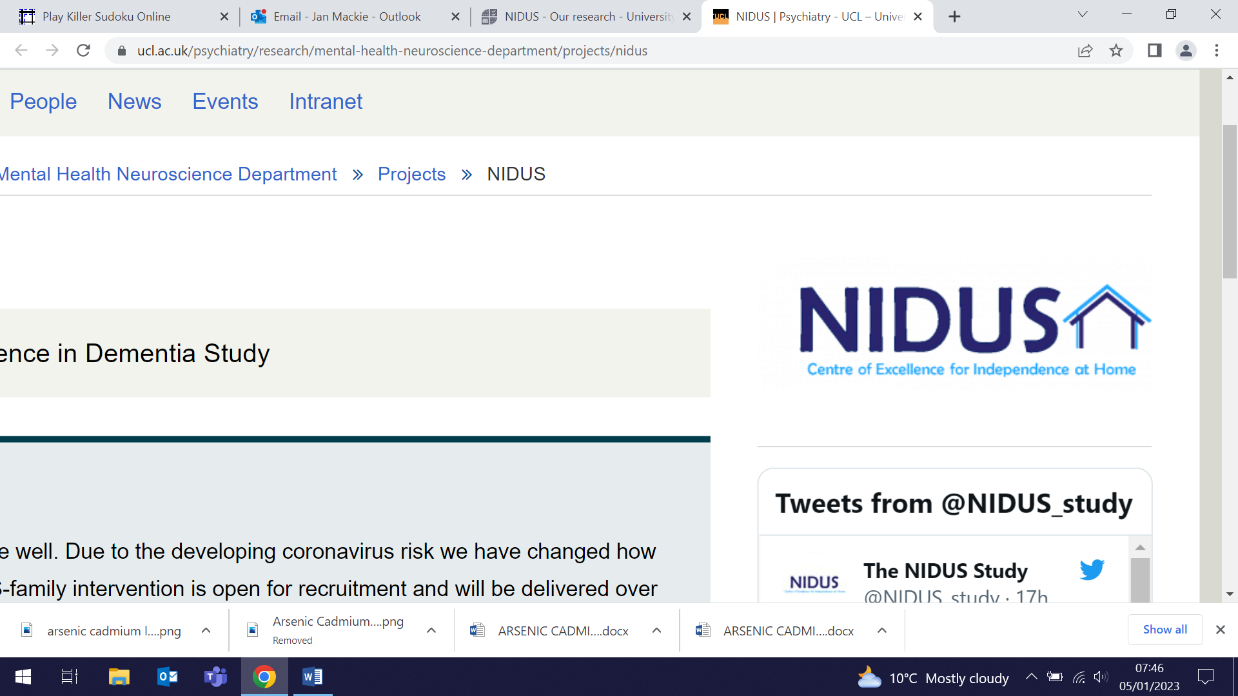  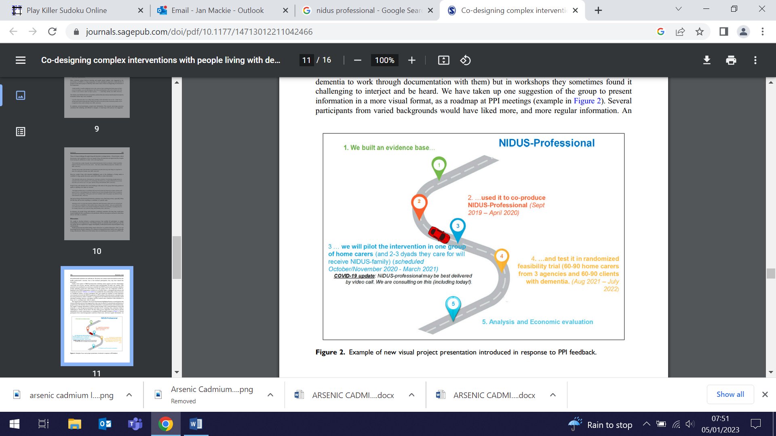 | A newly developed training and support programme (NIDUS Professional: New Interventions in Dementia Study) for homecare workers caring for people with dementia will be evaluated in a multi-site trial feasibility trial. The published protocol lists trial objectives assessing (i) the acceptability of the intervention among homecare workers and employing agencies, and (ii) the feasibility of homecare workers, people living with dementia, and their family carers completing the outcomes of intervention in a future RCT. Researchers aim to recruit 60-90 homecare workers, 30-60 clients living with dementia, and their family carers, through 6-9 English homecare agencies. In the intervention arm, homecare staff will be offered six video call group sessions over three months, followed by monthly group sessions in the subsequent three-month period. Outcome measures will be collected at baseline and at six months.
Anti-epileptic drugs linked to increased risk of Parkinson’s
27 December (Daniel Belete, Ben Jacobs, Christina Simonet, Jon Bestwick, Sheena Waters, Charles Marshall, Ruth Dobson, Alastair Noyce. Centre for Prevention, Detection and Diagnosis)

New research identifies an association between commonly used UK anti-epilepsy drugs (lamotrigine, levetiracetam, and sodium valproate) and increased risk of Parkinson’s. The risk increased with the number of different anti-epileptic drugs prescribed, and with the number of anti-epileptic drug prescriptions issued. The association between sodium valproate and incidence of Parkinson’s was most robust, and remained even after adjusting for epilepsy diagnosis. The nested case-control UK study included 1433 individuals with a Parkinson’s diagnosis and 8598 controls, and used prescription records and healthcare data from the UK Biobank. Recent studies have highlighted an association between epilepsy and Parkinson’s, but the role of anti-epileptic drugs has not previously been explored and authors believe this is the first study to identify the link. | 
Mental health literacy programme for Filipino migrant domestic workers in UK
28 December (Jennifer Lau. Centre for Psychiatry and Mental Health)

 | Preliminary findings from a pilot study of an online mental health literacy programme designed to improve the help-seeking behaviour of Filipino migrant domestic workers in the UK show that the programme is generally acceptable, appropriate, and feasible, and support its possible effectiveness. The intervention programme, 'Tara, Usap Tayo!' (C'mon, Let's Talk), was delivered in three 2-hour online sessions to 21 participants. Authors conclude that a further feasibility study or large-scale RCT is needed to confirm these preliminary findings.
Call for better resources to understand and combat youth loneliness
28 December (Jennifer Lau. Centre for Psychiatry and Mental Health)

Youth advisors and scientific researchers have joined forces to author an editorial calling for better definitions of loneliness. Previous research suggests that loneliness in young people is linked with persistent mental health problems such as anxiety, depression, and eating disorders, and that it could worsen outcomes associated with other neurodevelopmental or social communication problems. This editorial identifies a need to delineate chronic from transient loneliness, to identify those most at-risk for poorer health outcomes. Authors note that most support resources for young people experiencing chronic loneliness are not tailored to managing loneliness, treating it instead as a side effect of other primary medical or psychiatric problems. They discuss barriers that some groups of young people, often those most at-risk of loneliness, may face in accessing support, and call for researchers and policymakers to take note of these gaps in planning future studies and policies. | 
Protocol for review of integrated community pharmacy and general practice working
29 December (Nina Fudge. Centre for Primary Care)

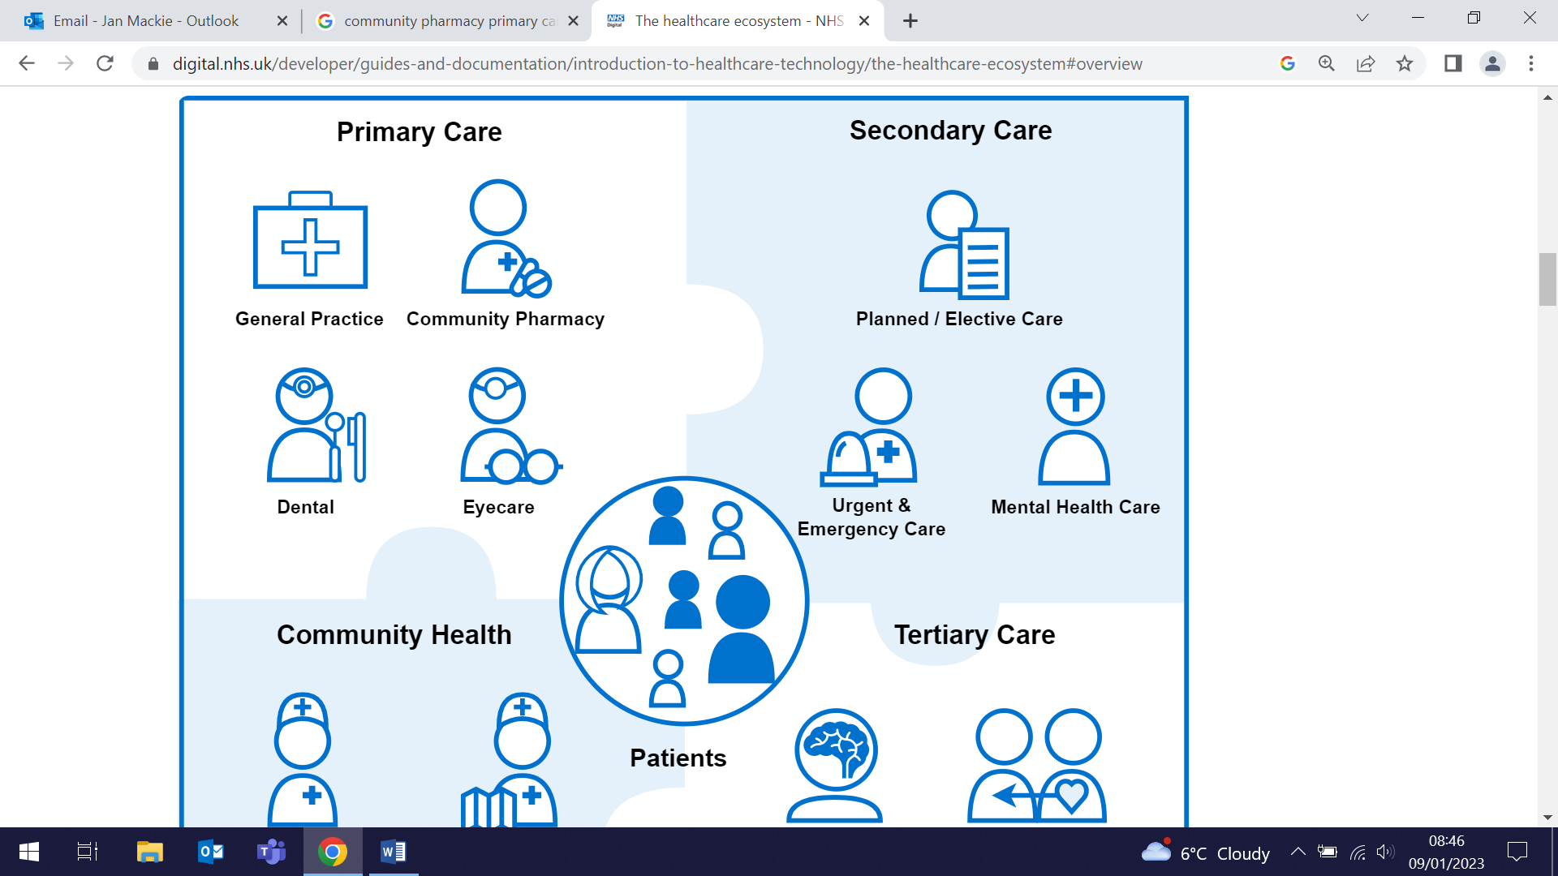 | Increasing collaborative and integrated working between general practice (GP) and community pharmacy (CP) has been proposed to improve coordination of care, but how this can be achieved in practice is not clear. The protocol has been published for a review to understand how integrated GP-CP working arrangements can provide the conditions necessary for optimal communication, decision-making, and collaboration. Researchers plan to synthesise evidence from grey literature, qualitative, quantitative, and mixed-methods research, and work with key stakeholders throughout the review process to refine the review focus and the programme theory. It is hoped that the refined programme theory will explain how collaborative and integrated working between GP and CP works, for whom, how, and under which circumstances.
Household food insecurity in Nigeria, Kenya, Pakistan, and Bangladesh slum sites
30 December (Lola Oyebode. Centre for Public Health and Policy)

Little research exists on food insecurity in low and middle income countries, despite it being a severe hazard for health. A cross-sectional study investigating food security in over 6000 households in seven slum settings across Nigeria, Kenya, Pakistan, and Bangladesh has found consistent associations between food security and household head working status and national wealth quintiles. Households that owned agricultural land were less likely to report food insecurity. While the study found a high (41%) prevalence of reported household food insecurity, this varied across slum sites and household characteristics. Authors conclude that food security in slum settings needs context-specific interventions and further causal clarification. | 
Factors associated with successful reintegration for male offenders
31 December (Georgina Mathlin, Mark Freestone, Hannah Jones. Centre for Psychiatry and Mental Health)

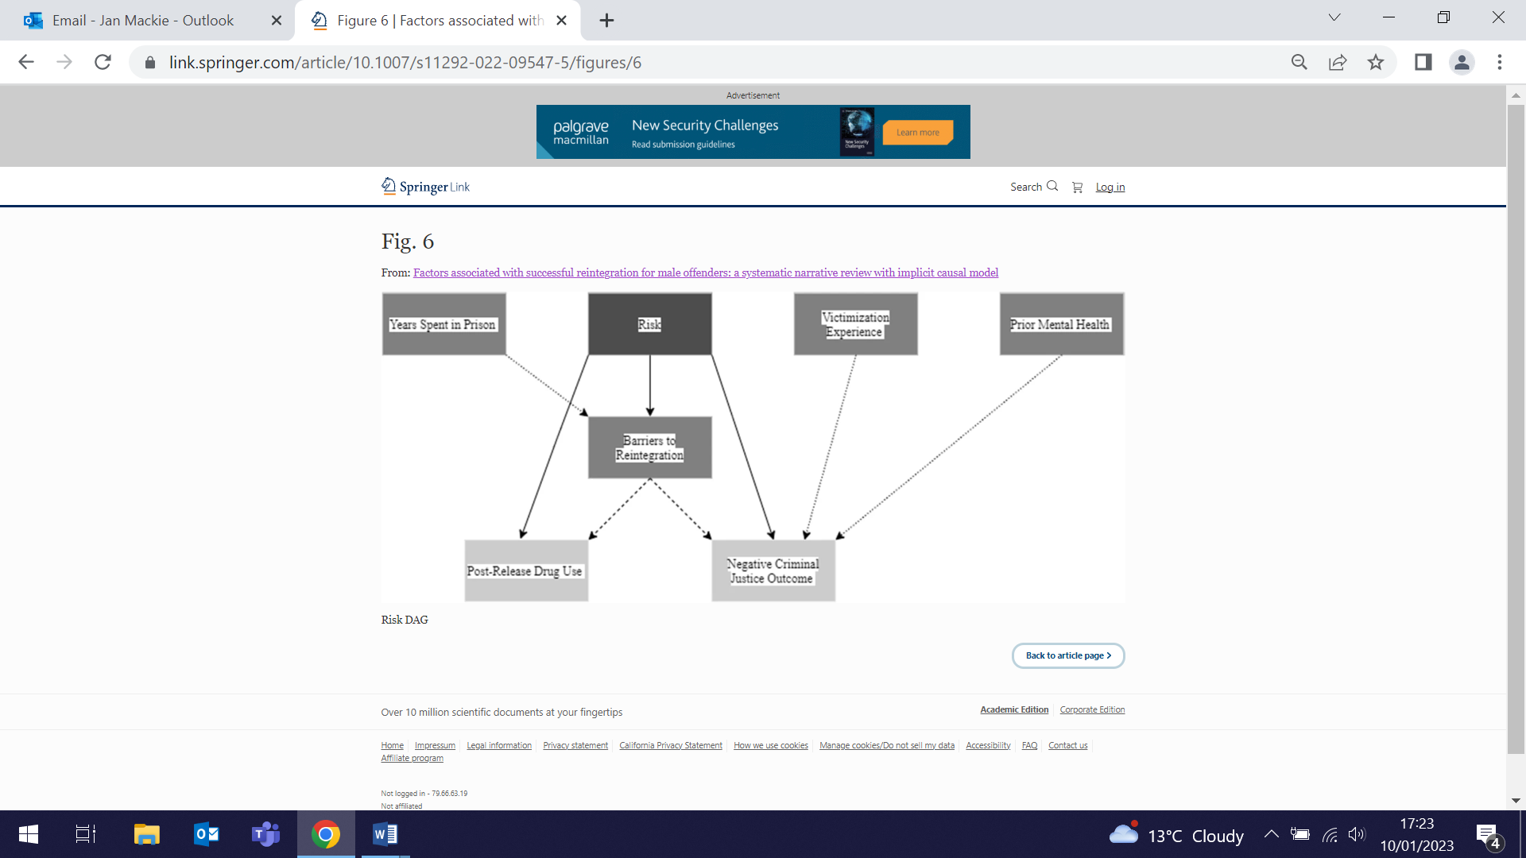 | A systematic review has identified factors that may be causally related to reintegration for male offenders. From 34 studies found to meet the inclusion criteria, Risk-Need-Responsivity based interventions had the strongest evidence for reducing post-release offending, and 14 good-quality studies were identified. Six exposure variables (prison visits, witnessing victimisation, recovery perception, risk assessment, in-prison treatment, and pre-prison health) were found to link to several post-release outcomes (criminal justice outcomes, drug use, mental health, housing, and reintegration barriers) and confounding variables (demographics, offending history, prior reintegration barriers, substance misuse and attitudes). Authors conclude that these factors warrant further empirical investigation.
Queen Mary Academy Fellowship
1 January (Jonathan Kennedy. Centre for Public Health and Policy)

Reader in Politics and Global Health, Jonathan Kennedy, has been awarded a Queen Mary Academy Fellowship for 18 months. Jonathan started work on 1 January, and will be seconded one day a week to work with the Academy and the International Office, on a project to explore the potential for virtual educational exchanges to improve student access to international opportunities. The work builds on a student exchange sponsored by the Fulbright Commission between QM and UC Santa Cruz, which Jonathan ran last term. | 
Patient descriptions of abdominal symptoms v GP consultation notes
5 January (Fiona Walter. Centre for Prevention, Detection and Diagnosis)

 | A study exploring how abdominal symptoms are communicated during primary care consultations has found that symptoms that are well defined or communicated as ‘pain’ by patients are more likely to be documented by GPs than those expressed vaguely, or as ‘discomfort’. Abdominal symptoms, common in primary care, may infrequently be due to an upper gastrointestinal cancer, but patients’ descriptions may affect how information about these symptoms are documented. Using video recordings of 28 consultations, researchers identified 10 categories of different clinical features of abdominal symptoms discussed. Comparison of the transcripts with the GP notes showed that the GP documentation about these features commonly did not match what patients described, with misalignments more common than alignments (67 vs 43 instances, respectively). The paper concludes that variable documentation of abdominal symptoms in medical records may have implications for the development of clinical decision support systems and decisions to investigate possible upper gastrointestinal cancer.
Medical student exchange programme with Showa University
6 January (Ania Korszun and Ali Ajaz. Centre for Psychiatry and Mental Health)

Student applications are invited for electives for the next academic year as part of a new medical student exchange programme with Showa University in Tokyo, following the signing of a Memorandum of Understanding during a late 2022 visit to Japan by Ania Korszun and Ali Ajaz. The programme is funded by The Great Britain Sasakawa Foundation through the Butterfield Award, which aims to further collaboration between the UK and Japan in medical research and public health practice. The visit to Japan continued collaborative projects in medical education with colleagues from Showa and Kyoto Universities, following 2020 meetings that uncovered shared interests in promoting student wellbeing and challenging stigmatising attitudes in Medicine. Work also continued with partners from the Universities of Kyoto and Nagoya on another Sasakawa-funded project, WellMed: a cross-cultural curriculum in wellbeing and resilience for medical students, which is studying cultural differences in building resilience. The QM team look forward to welcoming their Japanese colleagues and exchange students to Whitechapel later in the year. | 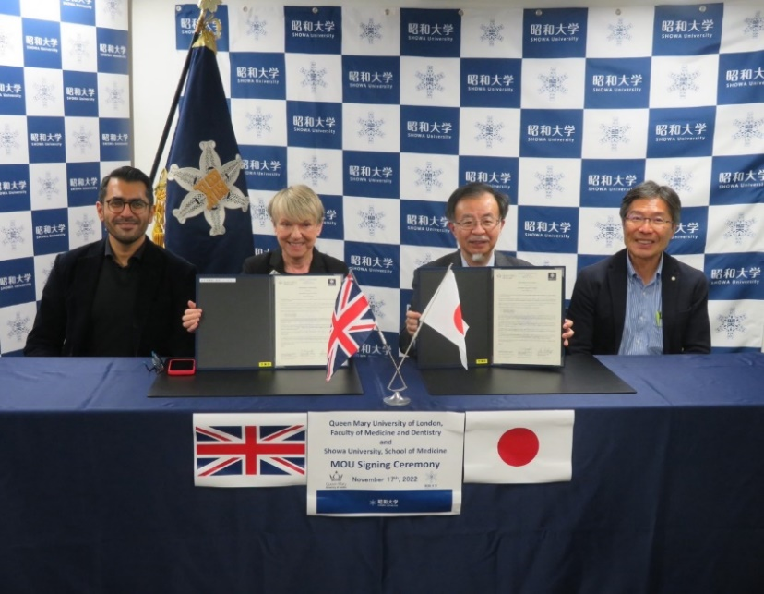  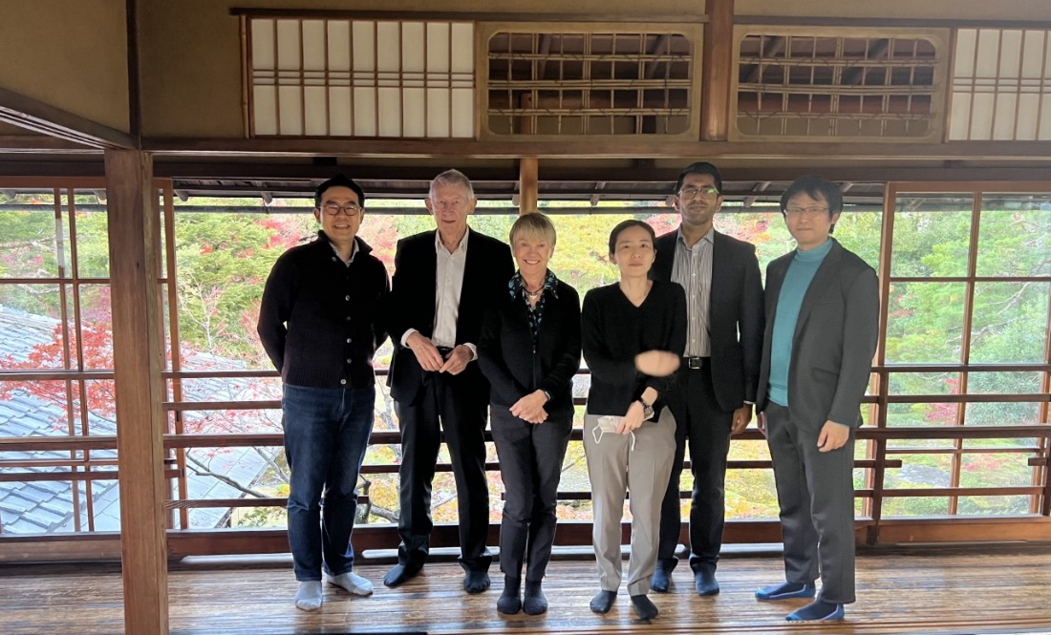
Process evaluation of the CHESS Study
7 January (Steph Taylor, Centre for Primary Care)

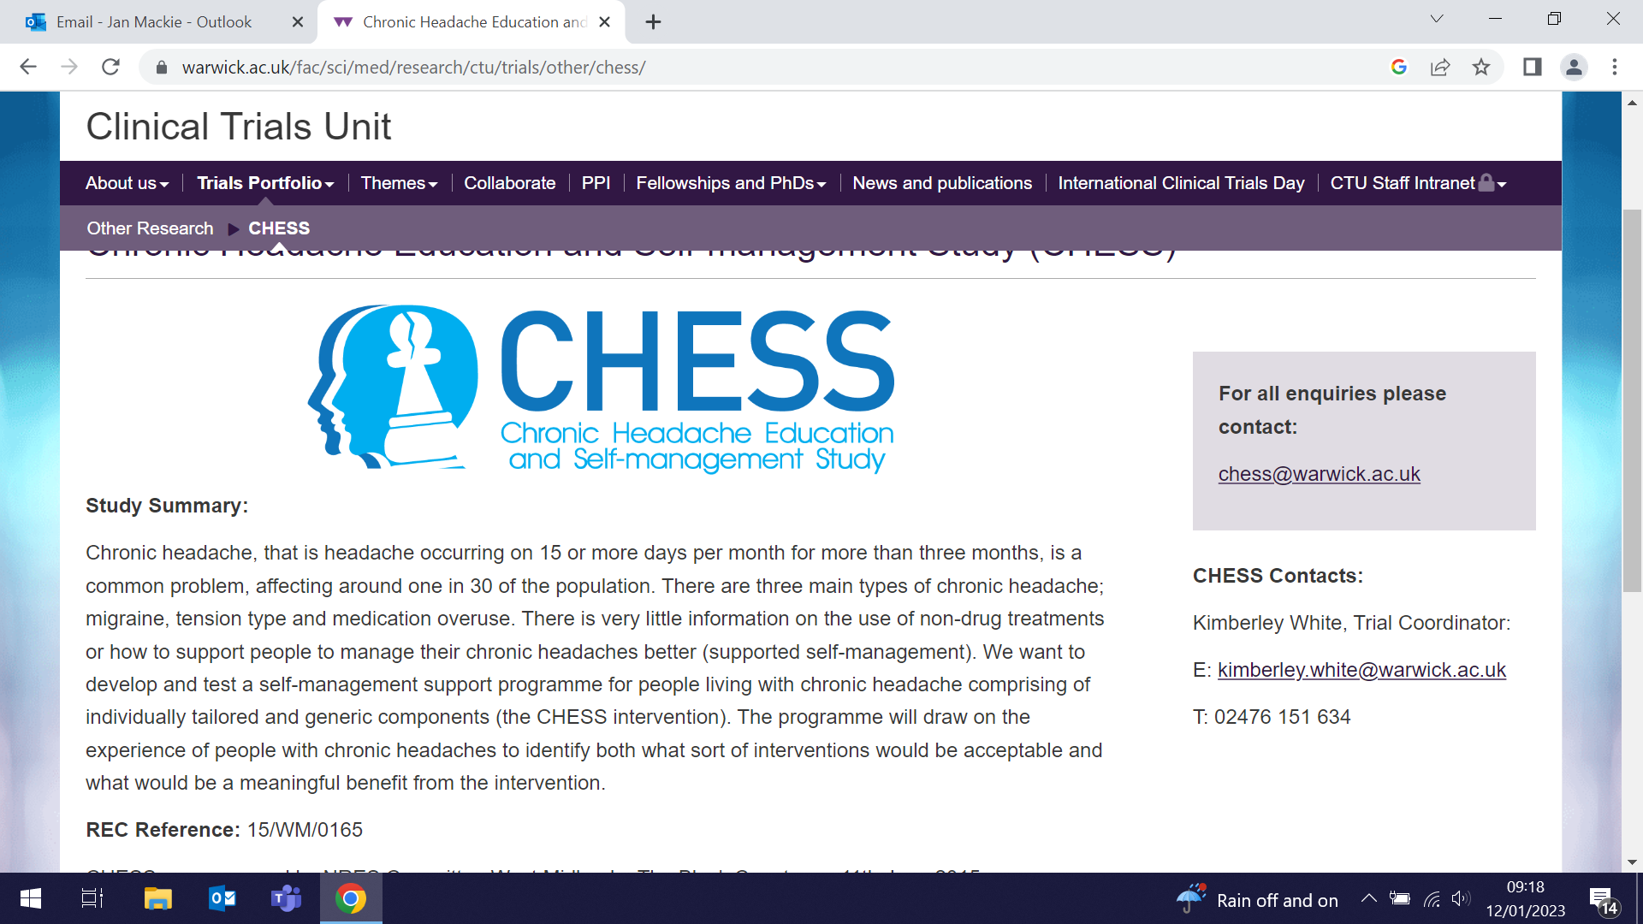  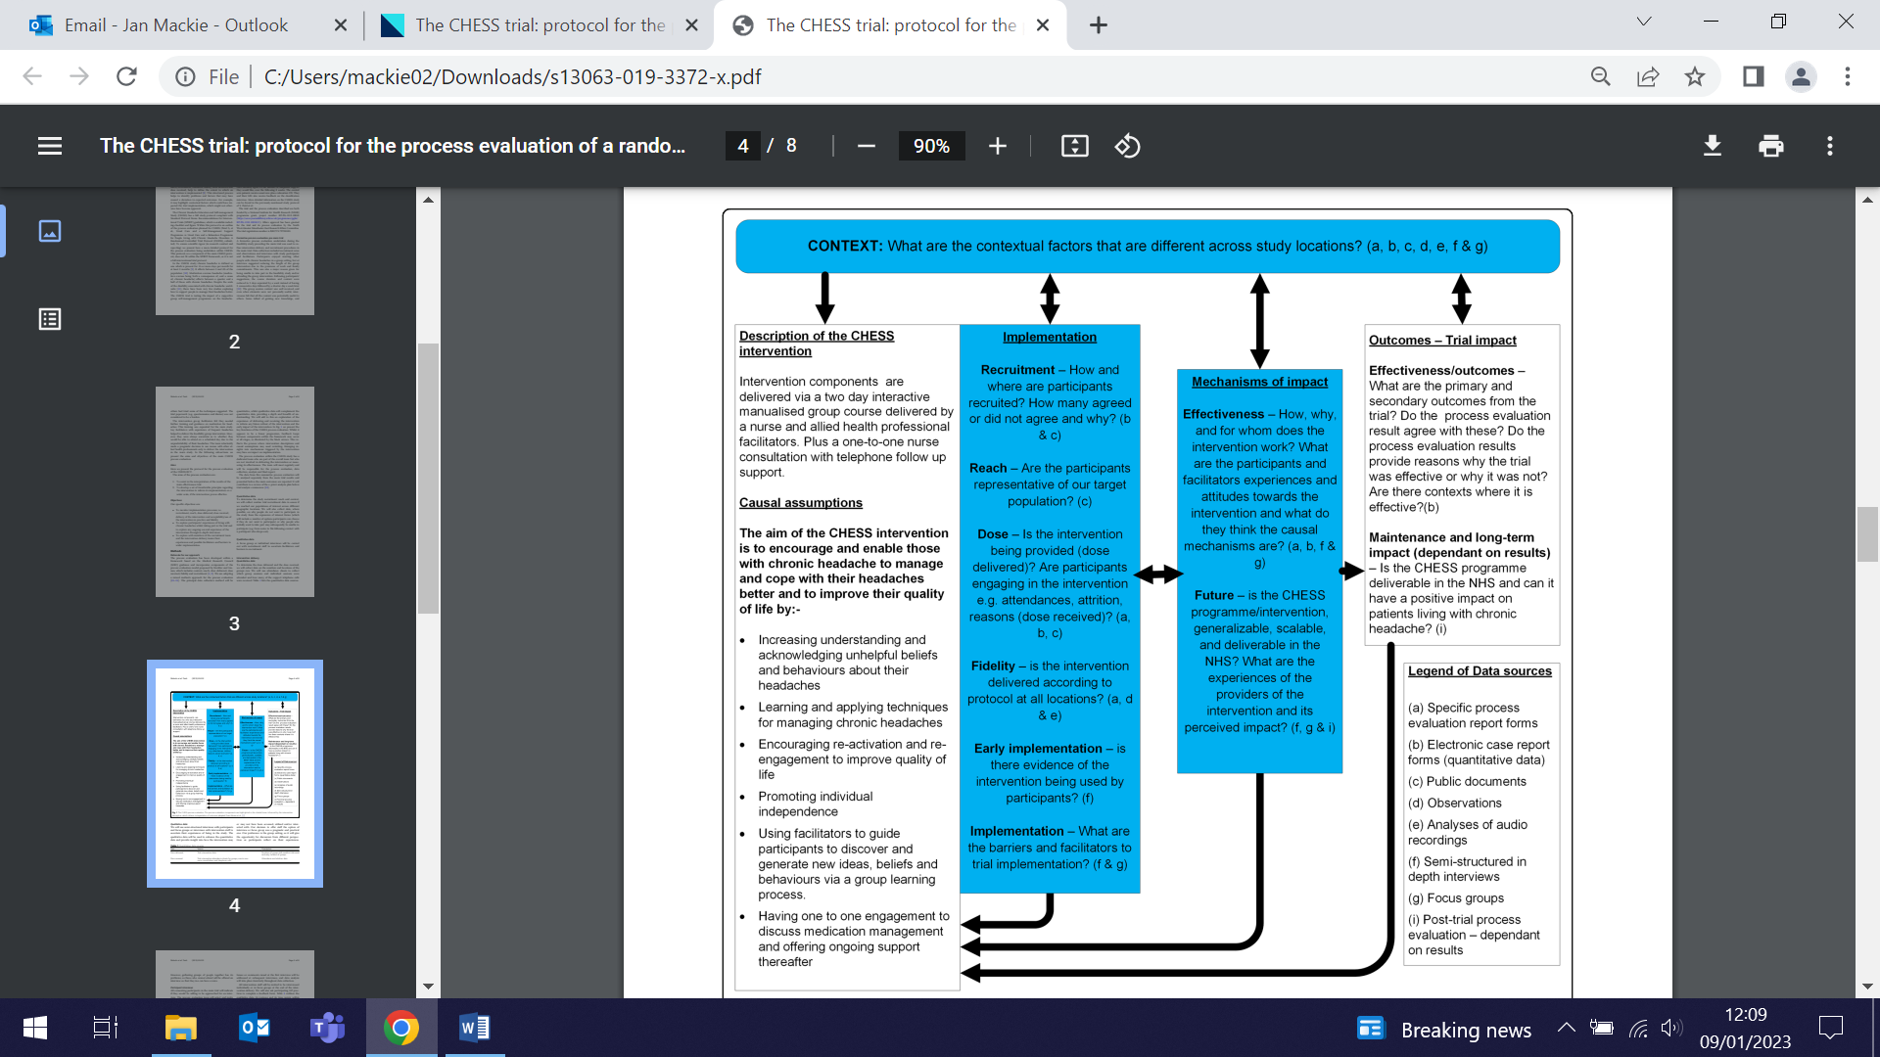 | A process evaluation exploring potential explanations for the lack of positive effects from the Chronic Headache Education and Self-Management Study (CHESS) intervention has not produced a clear understanding of why the trial outcome was negative. The trial evaluated the impact of a group education and self-management support intervention for people living with chronic headache disorders. The post-trial evaluation considered context, reach, recruitment, dose delivered, dose received, fidelity and experiences of trial participants, and included participants and trial staff. Findings showed that the trial reached out to a large diverse population and recruited a representative sample, the expected ‘dose’ of the intervention was delivered to participants, and intervention fidelity was high. Attendance (dose received) fell below expectation, although 69% received at least the pre-identified minimum dose. Authors conclude that a better understanding is needed of how those who live with chronic headache can be helped to manage the condition more effectively over time.

Funding boost for NE London Integrated Care System
9 January (Victoria Tzortziou Brown. Centre for Primary Care)

The North East London Integrated Care System (NEL ICS) has secured nearly £100,000 in NHS funding to develop a research engagement network to benefit the health and wellbeing of local communities. The new network will drive the work of ICS partners to encourage greater public participation in research, and ensure that it reflects the diversity of local communities, helping them tackle health inequalities and shape services around people’s needs. NEL ICS Research Innovation Lead Victoria Tzortziou Brown said: It’s important that any future research agenda is set by those on whom it will have impact, so it directly addresses the real needs of patients and service users. Victoria would like to hear from other WIPH colleagues, to collect brief details on initiatives that they may already have tried to connect with diverse local communities. The aim is to map these, and consider the possibility of upscaling them, whilst identifying gaps that would benefit from new approaches to engagement. If you have developed or used such initiatives, please complete this short form and share your experience. |   
WHO benchmarks v Australian 2020 reformulation targets for sodium reduction
10 January (Feng He. Centre for Public Health and Policy)

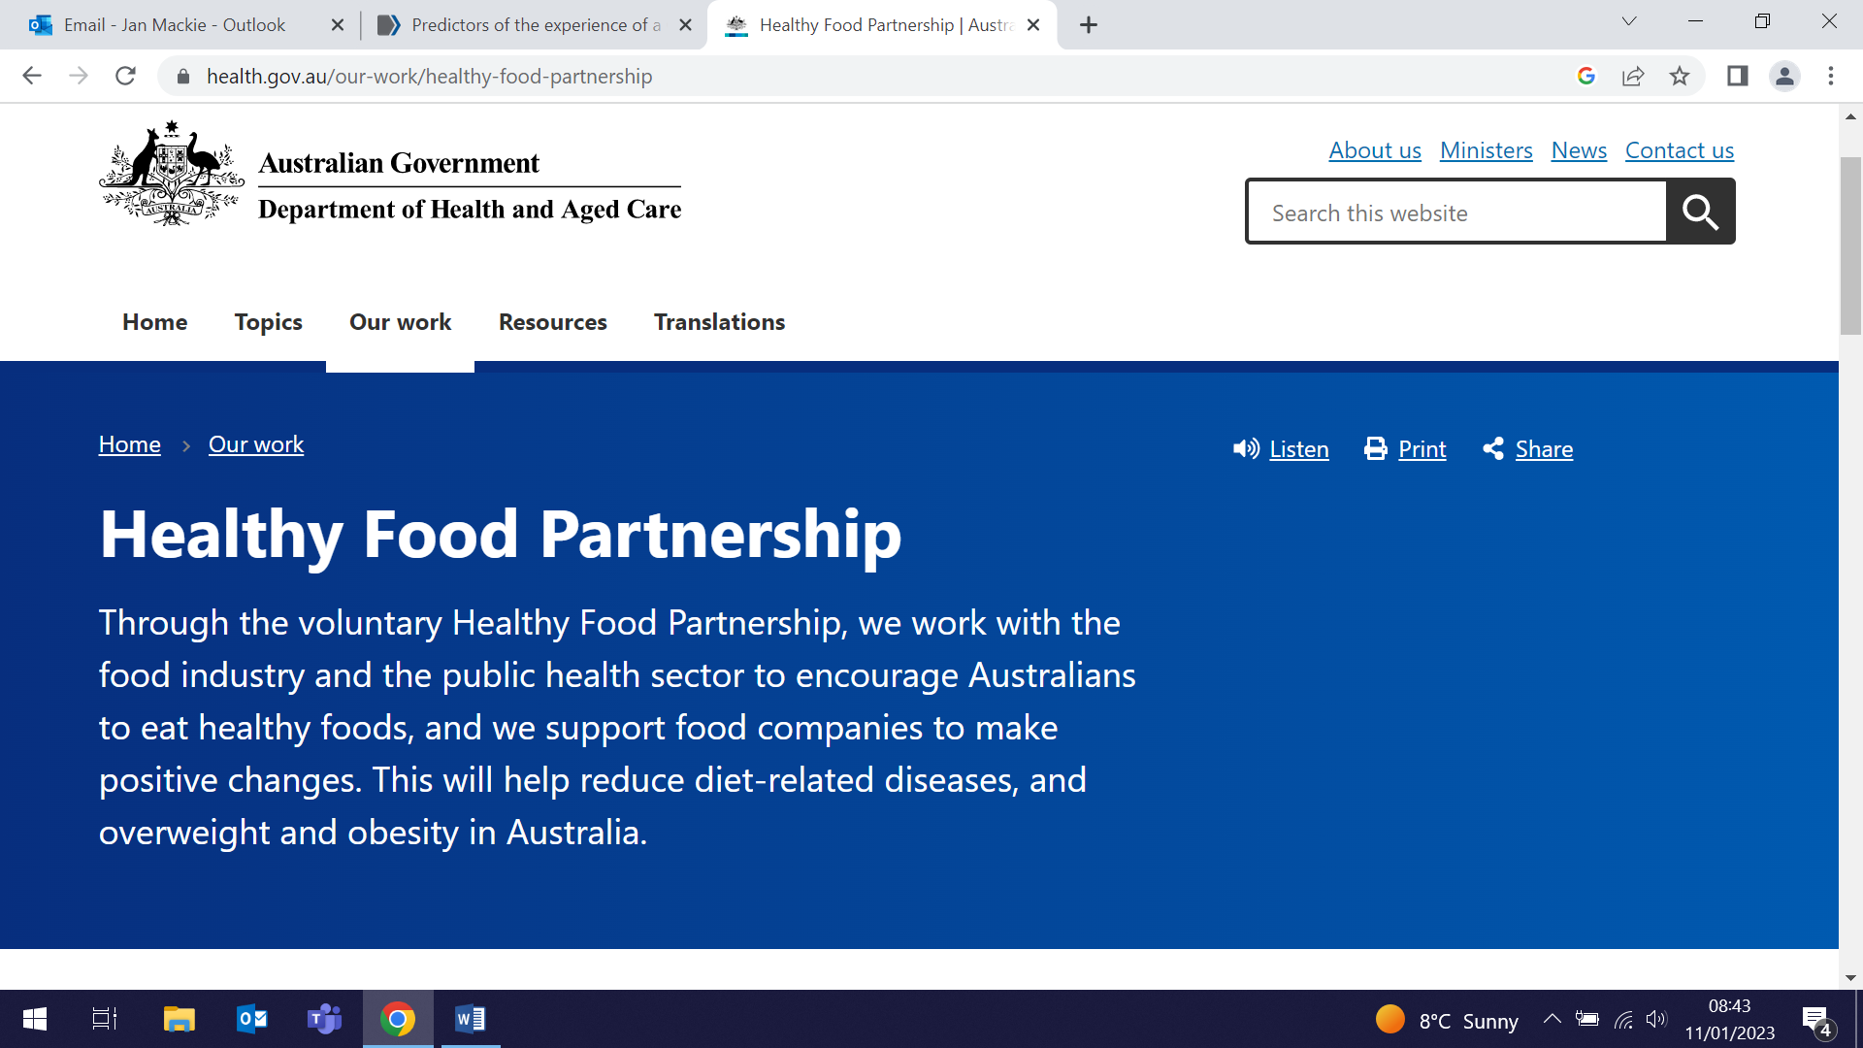 | A comparison of the potential health impacts for Australia of adherence to WHO 2021 sodium benchmarks versus Australia’s 2020 sodium reformulation targets shows that a greater effect could be achieved if the Australian government adopted the more stringent WHO benchmarks. In this study comparative risk assessment models were used to estimate potential deaths, incidence, and disability-adjusted life years averted from cardiovascular disease, chronic kidney disease, and stomach cancer based on the reductions in sodium intake from the two policies. Compliance with the WHO benchmarks for packaged foods in Australia could lower mean adult sodium intake by 12%, preventing about 1770 deaths per year compared with around 510 deaths averted under the Australian sodium benchmarks.
Predictors of experience of a Cytosponge test
10 January (Judith Offman, Fiona Walter. Centre for Prevention, Detection, and Diagnosis)

While overall patient experience with the Cytosponge device used in the diagnosis of Barrett’s oesophagus is positive, researchers from the BEST3 trial have investigated the factors associated with the least positive experiences. Using results from a 22-item patient satisfaction questionnaire completed 7-14 days after the test, the study identified the 167 (of 1458) participants with the least positive experience, defined by the 90th percentile. Eleven patient characteristics and one procedure-specific factor were assessed as potential predictors of the least positive experience. High/very high anxiety and a failed swallow at the first attempt were highly significant predictors, with sex, height, alcohol intake, and education level also statistically significant predictors. Identifying anxiety, discussing concerns with patients, or giving tips to help with swallowing the capsule might help improve their experience. | 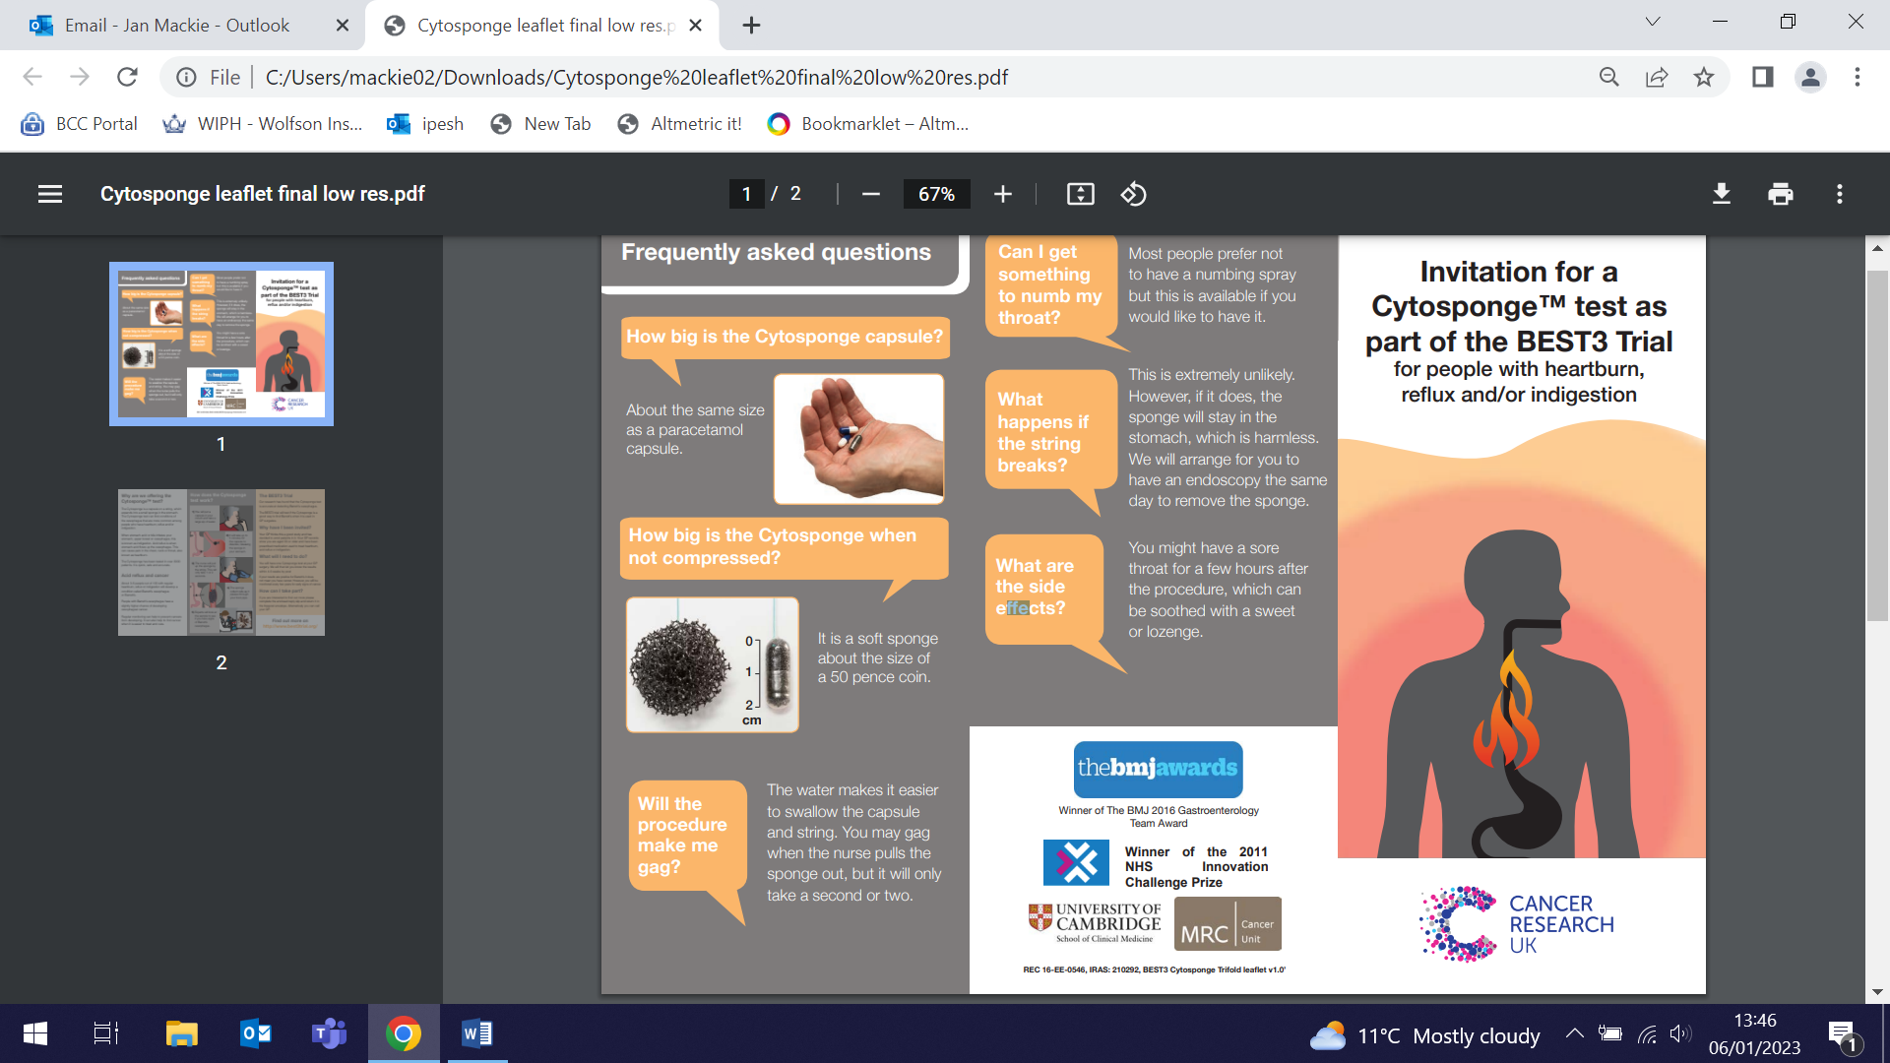
FORTHCOMING EVENTS AND NOTICES

How I got my industry funding: Launch of new seminar series
Thursday 26 January 12:15-1300

At the first seminar in this new WIPH “How I got my industry funding” series, we will hear from the QMUL Business Development Team and Queen Mary Innovation about the types of industry partnerships available, opportunities they see for WIPH based on our research strengths, and the type of support they can offer. This is the launch of a series of talks in which we will hear from WIPH colleagues who have won industry funding, providing tips based on their journeys so far. We hope the series will build awareness and confidence around industry funding, and look forward to seeing many of you at the launch. Please join using the MS Teams link below. The talk will be followed by a Q&A.

Microsoft Teams meeting: Join on your computer, mobile app or room device
Click here to join the meeting
Meeting ID: 328 833 478 082
Passcode: WU8dwJ
Download Teams | Join on the web

Many thanks to all who so enthusiastically contribute. Please send any news items for the next newsletter to j.a.mackie@qmul.ac.uk

