WOLFSON INSTITUTE OF POPULATION HEALTH
NEWSLETTER
ISSUE 31: 21 MARCH 2023

In this issue of our Wolfson Institute of Population Health Newsletter, we celebrate the achievements and work of staff and students through the second half of February and into March.

FROM OUR DIRECTOR
Dear Colleagues

On 8 March we celebrated both International Women’s Day, and National No Smoking Day, each of which has special significance for us in WIPH. In addition to the focused work of our Women’s Health Research Unit, many of our teams carry out vital research on issues in women’s health, including women’s cancers, and sexual and reproductive rights. This year’s theme of Embracing Equity is a goal we can all support and work towards, and our International Women’s Day activities (see story for details) were wonderfully well presented and attended.

National No Smoking Day was also an occasion for celebration, with a visit to our Quit Right Tower Hamlets team by Deputy Chief Medical Officer Dr Jeanelle de Gruchy. Despite the snowy conditions the visit went very well (see photos). Our no smoking work in inner London boroughs is an outstanding example of research being put into practice, and it was great to be present to see the team in action in the community.  As the spring blossom slowly emerges, warm wishes to all  Fiona | 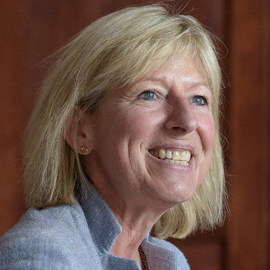
MEET WIPH

Meet: Anna De Simoni (Clinical Reader in Primary Care Research, Centre for Primary Care)

How would you describe your roles and responsibilities?

I am leading the AD HOC programme which aims to help people with asthma better control their symptoms and improve their quality of life by engaging with others in an online community. I am also a co-investigator in two other NIHR programme grants. My main goal is to improve self-management and medication adherence among patients with long-term conditions in primary care. I also supervise undergraduate, PhD, and postdoctoral researchers, and practice as a GP, including in A&E settings.

What has been your greatest professional achievement?
Securing funding for the AD HOC programme, in collaboration with an exceptional patient co-investigator and a team of expert professionals from various disciplines.

What aspects of your role do you enjoy the most?
I enjoy the collaborative aspect of my role the most, particularly when minds work together generating new research ideas or discovering new insights. The energy that is created and released during the process is phenomenal, and creates a buzz that is truly invigorating.

What would be your second choice as a profession?
I can’t think of second choice! In an alternate life. I would love to be an architect or civil engineer specializing in public buildings. It would be incredibly rewarding to generate results that not only exist on paper but also stand for centuries (such as the St John’s College Chapel pictured in this photo).

What do you enjoy doing outside work?
I enjoy taking walks with others, and then finding pleasant places to unwind and relax afterwards.

Something most people don’t know?  My hometown, Crema in Italy, was featured in the movie Call Me By Your Name and its main square was a central location in the film. The town was destroyed by Frederick Barbarossa in 1160 and it later gained its characteristic appearance as a part of the Republic of Venice. I have been going to the square coffee shop since childhood, and I still enjoy visiting it to this day. Napoleon himself once stopped there for a cup of herbal tea. | 
FROM OUR LEADERSHIP TEAMS AND REPRESENTATIVES

Health and Safety Update (Tracy Connelly, Deputy Institute Manager)

Please would all staff familiarise yourselves with revised details of your Institute /building Emergency contacts. Signage can be viewed across all our buildings, but if you are unsure who to contact you can call Security on the emergency number (0207 882 3333 or x3333 internally) if first aid assistance is required and no local first aiders are available. Please direct any queries, in the first instance, to your Centre Administrator, as Health and Safety Officer.

We are always looking for volunteers as Fire Marshalls, First Aiders, and Mental Health First Aiders. If you are interested please sign up via MySafety page and notify your Health and Safety Officer. There is also an online first aid awareness course which is available for all staff to complete via QMPlus. Whilst this will not mean you are qualified as a first aider, it will provide you with a basic understanding and give you confidence to be able to call for assistance and support first aiders in attendance.

Research News (Victoria Kemp, Research Manager)

Register online | QMUL PostDoc Conference | 27 March
This conference will bring together postdoc researchers across all faculties to co-create a vision for how to improve the future postdoc experience at QMUL. Speakers will include experts on different facets of postdoc life and culture, and will include current and former QM researchers and others sharing their career journeys. Postdocs will get a chance to meet and network with the speakers, other postdocs, and come up with solutions to improve their and future postdocs’ QMUL experience. Monday 27 March, 09:00-17:00, at the Octagon, Mile End.

Register online | Communicating Research to Industry | 28 March
The QMUL impact team has organised BBSRC-funded training to support researchers and academics in their engagements with industry. This workshop: Communicating Research to Industry, will be delivered by Vitae at an in-person event at the Robin Brook Centre in Boyle Seminar Room 4, West Smithfield Campus. The event gives participants the opportunity to explore how to generate research impact through an understanding of the business/industrial context, identifying the potential benefits and beneficiaries of that research, and recognising the economic aspects of research activity. It addresses the importance of researchers developing positive engagement with industry, aiming to increase researchers’ capability for communicating research and its outcomes, as well as assisting them in first identifying and approaching those audiences in order to form successful collaborations.

Register online | QMUL Impact Forum | 24 April
Based on the feedback from the first Impact Forum, this one will entirely be focusing on REF-lessons learned. The session will kick off with a panel discussion about REF 2021 to explore features that stood out in 4* case studies and what was missing in lower scored case studies. We will also discuss the differences and similarities between Units of Assessments (UoAs). In breakout rooms, you can deepen this discussion, swap expertise, share best practice and benefit from the support of our Impact Community. The Impact Forum welcomes everyone at QMUL, from impact newcomers, experienced and established researchers, to Professional Service colleagues. April 24, 2-3:30pm, online.
Register online |QMUL Industry Connect Day Cancer | 10 May
QMUL are hosting an industry connect day focused on cancer. The day promises thought-provoking discussions on the direction of the cancer field and dedicated networking sessions will provide collaborative partnering opportunities to enable impactful progression in oncology. When: Wed, 10 May 2023, 09:00-18:00 BST, Where: Derek Willoughby Lecture Theatre 50 Clerkenwell Road London EC1M 5PS

Research Seminar series| School of Math Sciences on Mathematical modelling for Health
The Mathematical Modelling for Biology, Health, and Environment seminar will run on Monday afternoons during term time from 15:00-16:00 UK time. It is open to anyone who has an interest in how mathematics can be used to advance interdisciplinary scientific research. Spearheaded by a team of five researchers from the School of Mathematical Sciences, this series is a strategic move by the School to open a dialogue with researchers from other fields.

GENERAL INSTITUTE NEWS

Polygenic risk score prediction of MS in individuals of South Asian ancestry
22 February (Josh Breedon, Charles Marshall, Ruth Dobson, Ben Jacobs. Centre for Prevention, Detection and Diagnosis)

Polygenic risk scores (PRS) estimate overall genetic risk for specific traits or disease but those derived from European populations underperform in other ancestral groups, potentially reinforcing health inequalities. Researchers have examined whether European-derived PRS underperform in predicting Multiple Sclerosis (MS) in a S.Asian population compared with a European-ancestry cohort, using data from two genetic cohort studies: Genes & Health (~50,000 British-Bangladeshi and British-Pakistani individuals) and UK Biobank (~500,000 predominantly White British individuals). As expected, European-derived MS-PRS performed poorly in the Genes & Health cohort, suggesting that PRS prediction of MS based on European populations is less accurate in a South Asian population. Genome wide association studies of ancestrally-diverse populations are needed to ensure that PRS can be useful across ancestries. | 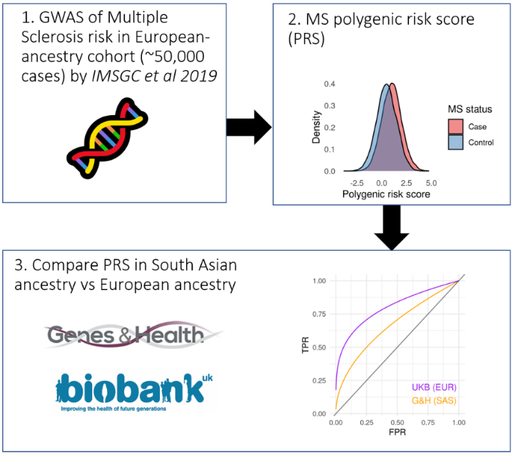
The challenges of diffusely infiltrating breast cancer
24 February (Stephen Duffy. Centre for Prevention, Detection and Diagnosis)

 | Diffusely infiltrating breast cancer has complex clinical, imaging, and histopathologic features that challenge current diagnostic and therapeutic management practices. Researchers used RCT and population screening data with over 40yrs of follow up to correlate images of breast cancers diagnosed as diffusely infiltrating with their mammographic tumour features and long-term patient outcomes. Results show that architectural distortion is a dominant feature of this subtype, which forms concave contours with the surrounding adipose connective tissue, making it difficult to detect on mammograms. Women with this malignancy have a 60% long-term survival. The immunohistochemical biomarkers are deceptive, indicating a cancer with favourable prognostic features predictive of a good long-term outcome, and the low proliferation index is usually indicative of a breast cancer with a good prognosis, but in this subtype the prognosis is poor. Authors conclude that to improve the “dismal outcome” of this malignancy, it will be necessary to clarify its true site of origin.
NHS Digital Diabetes Prevention Programme: influences on patient uptake and engagement 28 February (Jamie Ross. Centre for Primary Care)

An interview study exploring the key influences on uptake and engagement decisions of people offered the NHS Healthier You: Digital Diabetes Prevention Programme (NHS-digital-DPP) has identified 7 themes: knowledge and understanding, referral process, self-efficacy, self-identity, motivation and support, advantages of digital service, and reflexive monitoring. Previous assessments of digital-DPPs largely focused on programme participants, but this study includes subjects who declined the invitation. Results showed that perceptions of programme accessibility and convenience were important for uptake, and that the referral process and health care professionals' engagement were reported barriers. Authors say these results suggest that digital-DPPs can overcome many barriers to the uptake of face-to-face DPPs in supporting lifestyle changes aimed at diabetes prevention. | 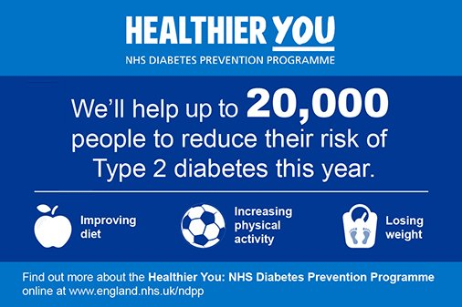
Consent pathways in clinical trials: challenges for underserved groups
28 February (Beverley Nickolls. Centre for Evaluation and Methods)

   | Obtaining informed consent is fundamental for trial participation, but challenging among participants with communication or other disabilities, and the complexity of designing and conducting trials with alternative consent pathways contributes to these populations being underserved in research. A new commentary describes a UK-wide collaboration, a sub-group of the Trial Conduct Working Group in the MRC-NIHR Trials Methodology Research Partnership, formed to address these challenges, assessing current research and guidance, and future research needs. Members represent disciplines including bioethics, qualitative research, trials methodology, healthcare professions, and social sciences. The sub-group sets out key recommendations for future research, and notes that recognising and addressing these challenges is essential to support trials involving these populations, and to ensure that they have equitable opportunity to participate in, and benefit from, research.
WHO Eastern Mediterranean Region: Expert Meeting on Policy Action for Healthy Diets
28 Feb-1 March (Mhairi Brown. Centre for Public Health and Policy)

International Projects Lead for the Research & Action in Salt & Obesity Unit, Mhairi Brown, attended the WHO Eastern Mediterranean Regional Expert Meeting on Policy Action for Healthy Diets in Dubai from 28 Feb-1 March. The meeting aimed to develop an action plan to improve diets in the region, and to encourage commitment to issues like reducing salt/sugar in food and drinks, implementing front of pack labelling, developing guidelines to improve food served in schools, and improving fortification of staple foods. Mhairi was invited as an adviser, to review the action plan and deliver a presentation sharing experience of what has worked well and what have been the barriers with salt and sugar reduction in the UK. The Research & Action team has worked with the WHO regional office in recent years on their project to accelerate salt reduction progress in the region (and specifically Morocco), and the Dubai meeting was linked to the project deliverables. | 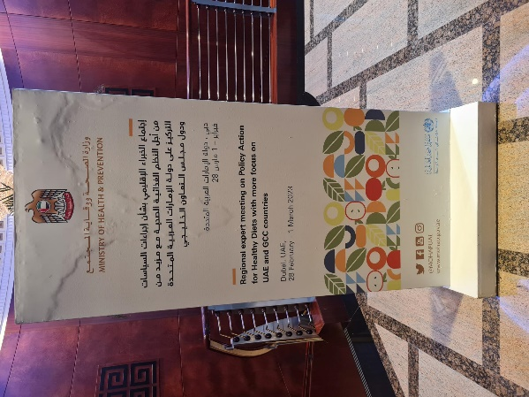
Two WIPH Professors appointed as 2023 NIHR Senior Investigators
1 March. (Claudia Cooper and Steph Taylor. Centres for Psychiatry and Mental Health/ Primary Care)

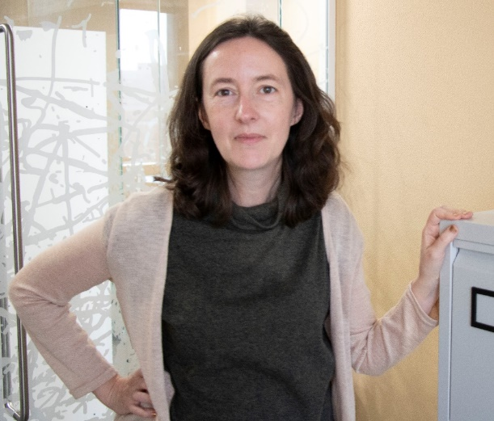 | We are proud to announce that two of our outstanding Professors, Claudia Cooper and Steph Taylor, have been appointed as NIHR Senior Investigators. Claudia (Centre Lead, CPMH) and Steph (Interim Lead, CPC) join a group of the most prominent and prestigious researchers funded by the NIHR, as new members of the NIHR Academy. Congratulations to both on selection in this highly competitive process, and for the well-deserved recognition as some of the most impressive leaders of patient- and people-based research within the NIHR community.
Proton Beam Therapy for Early Breast Cancer
1 March (Jo Haviland. Centre for Evaluation and Methods)

Adjuvant proton beam therapy (PBT) for breast cancer patients achieves better planned dose distributions than standard photon radiotherapy, but whether it reduces the associated risks is unknown. A new systematic review of 32 studies (7 of scattering PBT, 22 of scanning PBT, 2 using both PBT types, 1 with PBT type unspecified) presents a quantitative summary of published clinical outcomes after adjuvant PBT for early breast cancer. Results show that adverse events were less severe after scanning PBT than after scattering PBT, and varied by clinical target. For partial breast PBT, 498 adverse events were reported. None were categorized as severe after scanning PBT. For whole breast or chest wall +/- regional lymph nodes PBT, 1344 adverse events were reported. After scanning PBT, 4% of events were severe. Authors note that ongoing randomized trials will provide information on longer-term safety compared with standard photon radiotherapy. | 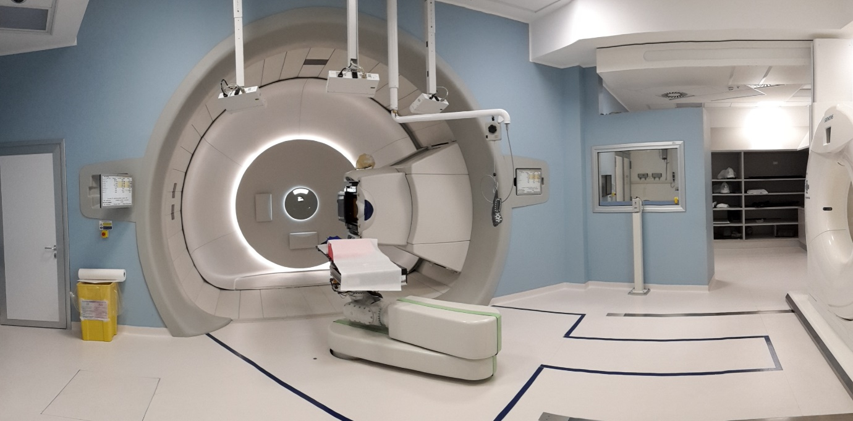
Proportion of unhealthy products from five major global food manufacturers
1 March (Research & Action on Salt & Obesity Unit. Centre for Public Health and Policy)

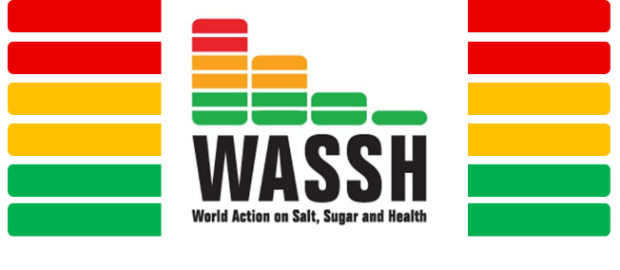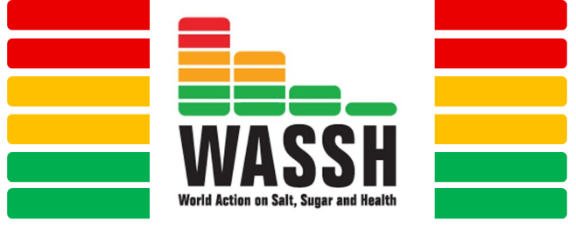  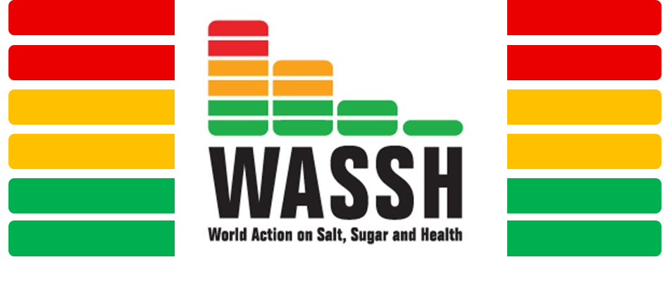 | In collaboration with the charity ShareAction, World Action on Salt, Sugar and Health (WASSH) has released results of a project assessing the proportion of products from five major global food manufacturers classed as ‘unhealthy’. The project examined the nutritional profile of 2346 food and drink products from Danone, Kellogg’s, Kraft Heinz, Nestlé and Unilever in three of their biggest markets, Australia, France, and Mexico. The proportion of unhealthy products from these manufacturers was 65%, 63%, and 60% respectively in Australia, France, and Mexico. In the UK, manufacturers Premier Foods, AG Barr and Britvic are setting voluntary targets to help increase the longer-term sales of healthy foods. In the absence of mandatory regulation, ShareAction and WASSH urge all global food manufacturers to adopt similar practices.
Reducing the TB burden among migrants to low TB incidence countries
1 March (Dominik Zenner. Centre for Public Health and Policy)

Migrants to low TB incidence countries are disproportionately affected by TB compared with the native population, with increased risk for both transmission and disease due to a range of personal, environmental and socio-economic determinants experienced during the four phases of migration (pre-departure, transit, arrival and early settlement, return travel). A review paper provides a current overview of the determinants driving the TB burden among migrants, and of effective and feasible interventions to address this for each migration phase. Results show that to lower risk of TB transmission and disease among migrants, the most effective interventions are improving their socio-economic position pre-, during, and after migration, ensuring universal health coverage, and providing tailored and migrant-sensitive care and prevention activities. As well as migrant-sensitive health services and cross-border collaboration between low TB incidence countries, international financial and technical support for endemic countries is needed. | 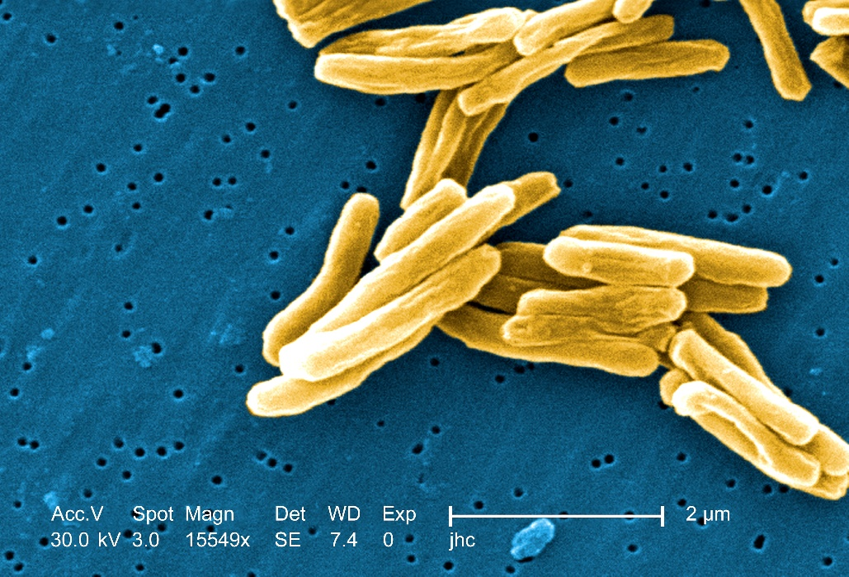
Dramatherapy to alleviate emotional distress and support well-being of young people
1 March (Ellie Keiller, Megan Tjasink, Dennis Ougrin, Catherine Carr, Jennifer Lau. Centre for Psychiatry and Mental Health)

 | Dramatherapy may be a useful treatment for child and adolescent mental health, and has a growing evidence base. A systematic review conducted to evaluate research on dramatherapy among young people experiencing emotional distress has found the evidence base to be small and methodologically flawed. Review results showed that dramatherapy was often delivered in schools (46%) and clinical settings (20%), and was more frequently delivered to adolescents (53%) than children under age 11 (26%). It has been used as a treatment for diagnostically heterogeneous groups, for emotional and behavioural difficulties, and following a shared, traumatic, experience. Of the 7 studies reporting relevant quantitative data, only 3 were controlled. None were blinded. Samples were small, and participant response to treatment was not always consistent. The largest effects were in dramatherapy employed following trauma and in clinical settings. Larger, methodologically robust trials are needed to test the efficacy of dramatherapy.
UK PARABLE trial: proton beam therapy in breast cancer patients
2 March (Jo Haviland. Centre for Evaluation and Methods)

The NIHR-funded UK PARABLE Trial (Proton beAm theRapy in pAtients with Breast cancer: evaluating early and Late Effects), is an RCT comparing proton beam therapy (PBT) with optimal photon radiotherapy in breast cancer patients with a 2% or higher risk of late radiation-induced heart side-effects. In this small group, cardiac risks of proton radiotherapy are higher due to young age, higher mean heart dose, and/or presence of cardiac risk factors. PBT can deposit dose to the target at a defined depth, while reducing dose to heart, lungs, and contralateral breast. In this trial, eligible patients are being randomised to either tailored photon radiotherapy or PBT. Primary endpoints are mean heart dose, and patient-reported normal tissue toxicity in the breast 2 years after radiotherapy. Researchers stress the importance of evaluating the benefits of PBT, which is expensive and not widely available in the UK, in a clinical trial. | 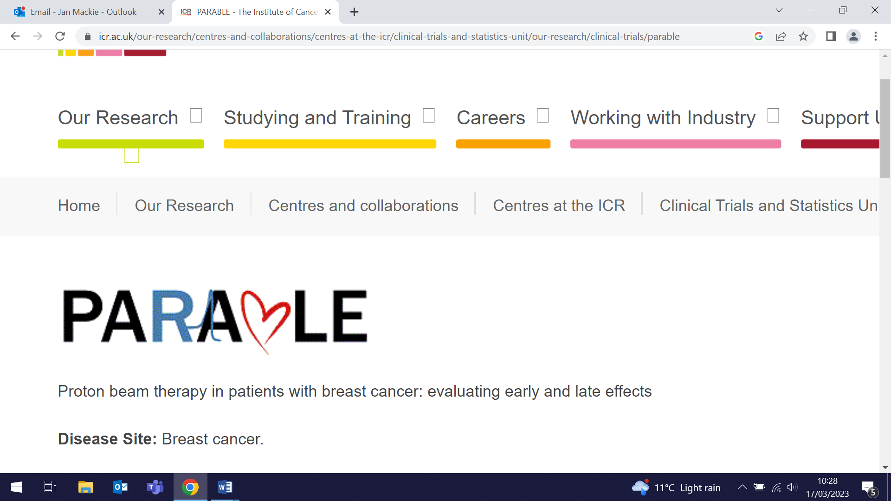  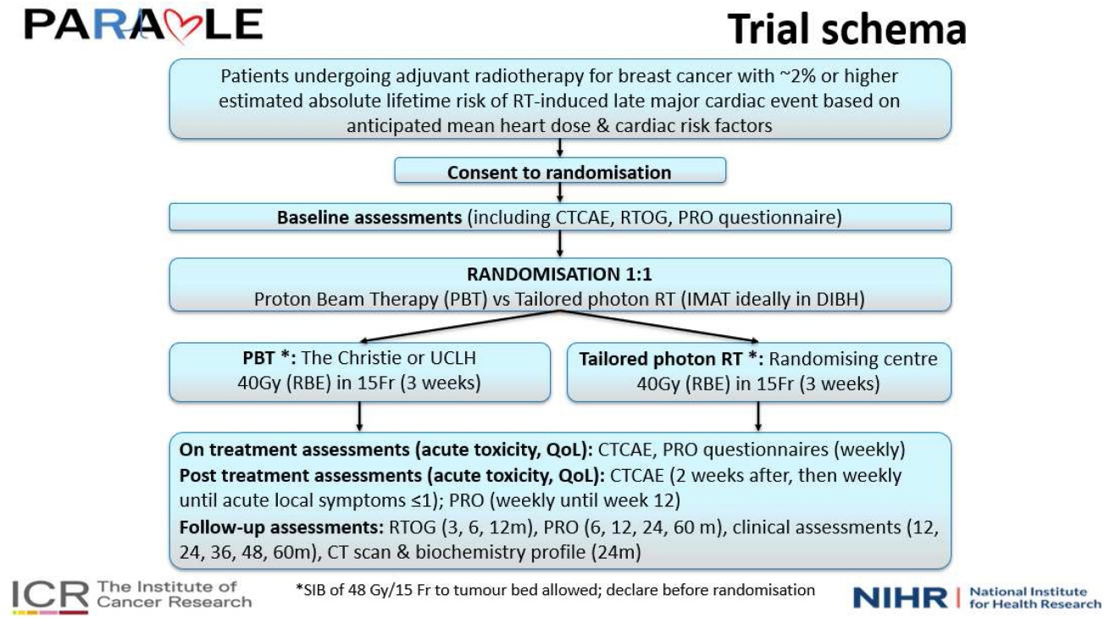
When patients tell a story we have not yet learned to hear
3 March (Stephen Hibbs. Centre for Primary Care)

 | In a personal account of a meeting with a young woman with acute leukaemia, Stephen Hibbs discusses narrative medicine and the way clinicians talk with patients about cancer. Mapping this conversation, he notes the importance of avoiding both military references (eg. invading cells or fighting the leukaemia) that can worsen patients’ feelings of fatalism and depression, and suggestions to stay positive, which can lead patients to blame their own negative thoughts if the cancer comes back. Stephen reflects on a book by sociologist Arthur Frank, The Wounded Storyteller, that presents three diagnostic narratives: restitution (“you are ill now, we are going to do something about it, and we are going to get you better”), chaos, and quest. He notes that restitution was his own narrative to the young leukaemia patient, but that Frank’s writings remind us that patients are doing the hard work of remaking sense of their own stories, now that they have been interrupted by illness, and they might not tell the same story that we do.
Food marketing through social media in Mexico
3 March (Isabel Valero-Morales. Centre for Public Health and Policy)

An analysis of the digital food marketing landscape using the WHO CLICK methodology examines the campaigns of top selling food products and brands in Mexico on Facebook, Instagram and YouTube. In Sept-Oct 2020, 926 posts from 12 food and beverage products and 8 brands were analysed. Facebook was the social media platform with the most posts and greatest engagement, and the most prevalent marketing techniques were brand logo, image of packaging, image of the product itself, hashtags, and engagement to consume. Researchers found that 50% of posts were appealing to children, 66% to adolescents, and 80% to either category. Using the Mexican warning labels nutrient profile, 91% of promoted products were unhealthy. Authors conclude that these data contribute to evidence supporting the strengthening of food marketing regulations in Mexico. | 
Hackathon for training in data science, genomics, and collaboration using Parkinson's data
4 March (Brook Huxford, Jonggeol Jeff Kim, Sumit Dey, Alastair Noyce. Centre for Prevention, Detection and Diagnosis)

   | To facilitate the advancement of Parkinson’s disease (PD) research, a 3-day virtual "hackathon" event attended by 49 early-career scientists from 12 countries was held in May 2021. The event combined scientists from the International Parkinson’s Disease Genomics Consortium (IPDGC) and the Global Parkinson’s Genetics Program (GP2). Nine teams were formed and allocated project goals, including developing post-genome-wide association studies analysis pipelines, downstream analysis of genetic variation pipelines, and various visualization tools. At the end of the event each team presented their progress and results, and within the following week, teams refined their Github content or deployed their apps, and the final tools are now available to the public to aid future research.
Breast cancer risk and mortality after salpingo-oophorectomy in BRCA carriers
6 March (Oleg Blyuss, Alex Tan, Samuel Oxley, Ranjit Manchanda Centres for Prevention, Detection and Diagnosis/Public Health and Policy)

Women with BRCA1/2 gene mutations are at increased risk of breast and ovarian cancer, and may undergo risk-reducing salpingo-oophorectomy (RRSO) surgery to remove their ovaries to prevent ovarian cancer. A systematic review and meta-analysis investigating the effect of RRSO on breast cancer risk shows that the surgery is linked to reduced risk of breast cancer when considering BRCA2 carriers alone, but not when considering BRCA1/2 carriers combined. RRSO after developing breast cancer was not related to a reduced chance of developing cancer in the other breast. However, surgery was associated with improved breast cancer survival both when considering BRCA1/2 carriers together, and BRCA1 carriers alone. Authors say these findings may have important implications for counselling women in clinic. | 
Provision and support of care for long-term conditions in dementia
7 March (Claudia Cooper. Centre for Psychiatry and Mental Health)

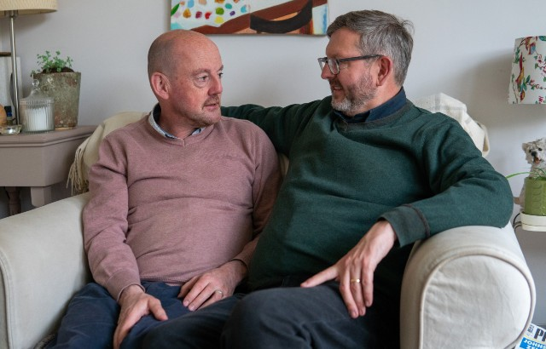 | Managing multiple long-term conditions is challenging for people with dementia, as the presence of dementia complicates healthcare delivery, and clinical guidelines and health systems are often designed around single condition services. In a study exploring how care for long-term conditions is provided and supported for people with dementia in the community, consecutive telephone or video-call interviews were conducted with people with dementia, their family carers, and healthcare providers. From 18 participants in 8 case studies, 6 main themes were identified: 1) Balancing support and independence, 2) Implementing and adapting advice for dementia contexts, 3) Prioritising physical, cognitive and mental health needs, 4) Competing and entwined needs and priorities, 5) Curating supportive professional networks, 6) Family carer support and coping. Researchers conclude that realistic self-management plans which are deliverable in practice must consider the intersection of physical, cognitive and mental health needs and priorities, and family carers needs and resources.
International Women’s Day 2023: Embracing Equity
8 March (Ruth Dobson, Deputy Academic EDI Lead. Centre for Prevention, Detection and Diagnosis)

In the introduction to the 2023 FMD International Women’s Day newsletter, Ruth Dobson delivered an inspiring and personal view of the theme for 2023: Embracing equity means enabling everyone to achieve their potential, regardless of gender, ethnicity or other personal characteristics. Diversity in researchers brings diversity of ideas, approaches, and scientific questions. However, factors such as workplace bias and inflexible systems, caring responsibilities, and being unable to move impact unequally on women, and for many can adversely affect career progression. When this leads to women leaving research, the loss is everyone’s loss. Across my career I’ve worked with some brilliant people who have enabled me to work flexibly, appreciate what I bring, and have supported me when things have been tough. This support has enabled me to build a fantastic research group within WIPH who support each other to be our best. Not everyone is this lucky, and this needs to change. My research has highlighted inequity that women living with chronic disease face around treatments, and I’ve been able to make a positive impact for patients. International Women’s Day reminds us that women worldwide face challenges in their everyday lives. It is up to us all to enable an equitable footing wherever we can. | 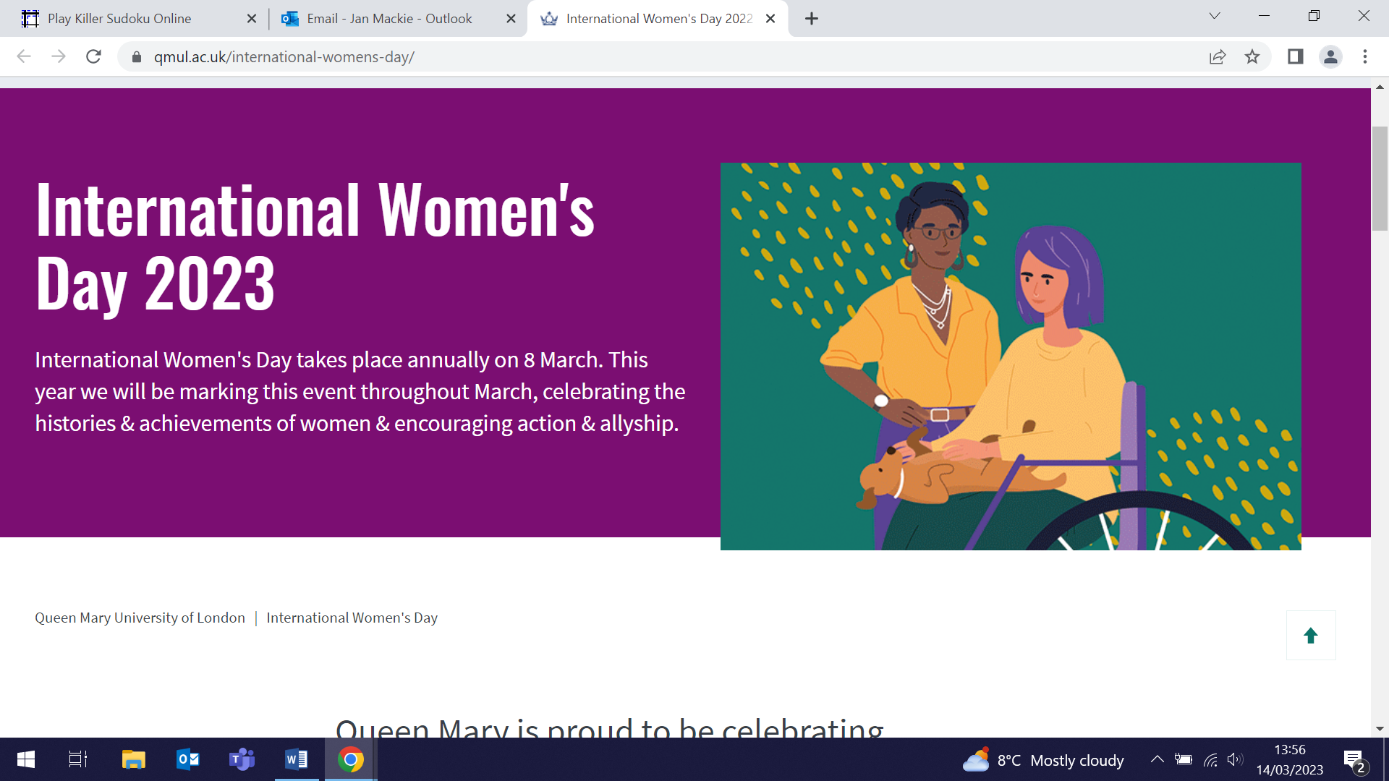
WIPH International Women’s Day Showcase
8 March (Ellie Keiller, Belinda Nedjai, Ratna Sohanpal, Alison Thomson. CPMH/CPDD/CPC)

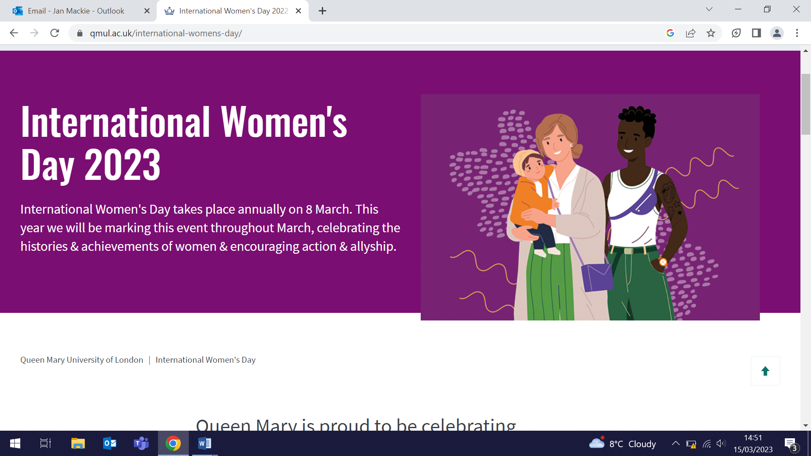    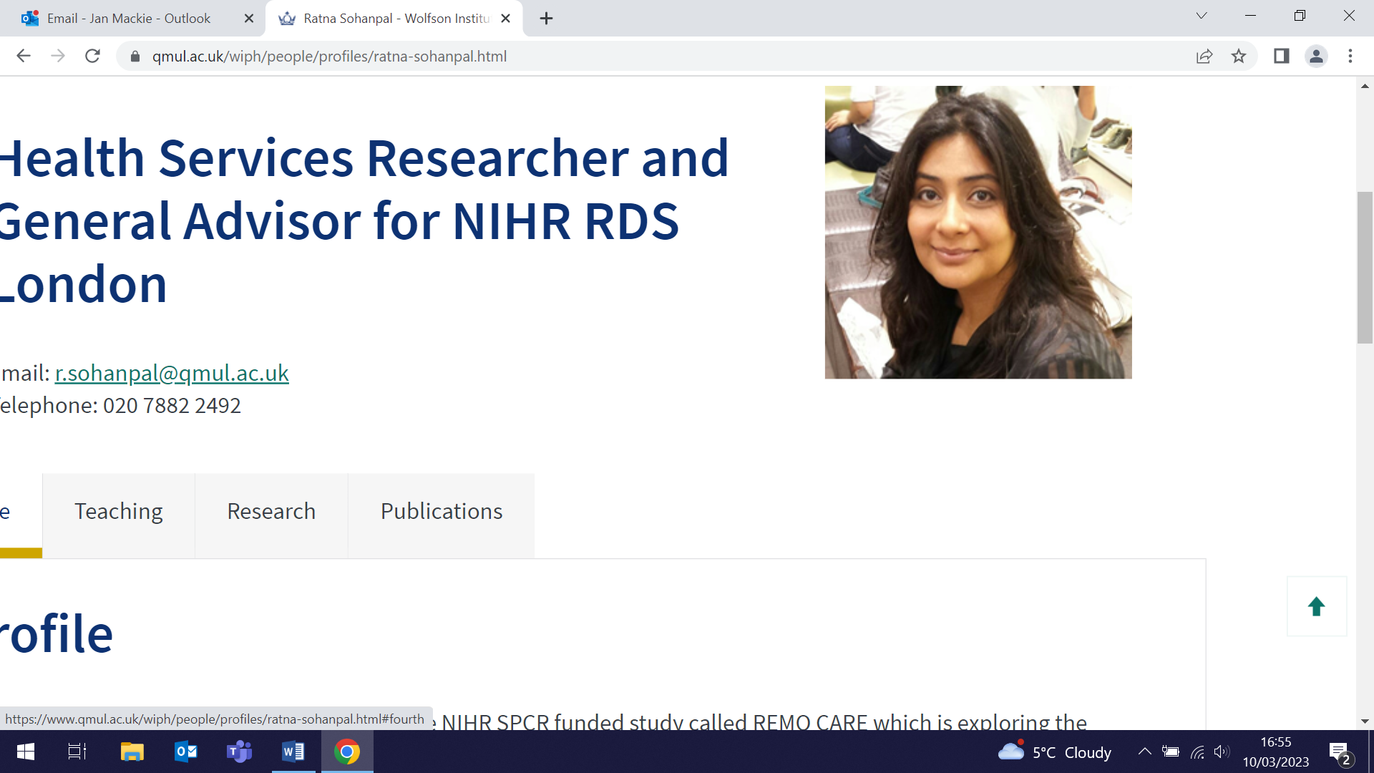 | The WIPH IWD2023 showcase event featured four of our own outstanding women in research. Ellie Keiller (trained dramatherapist) spoke about her journey to become a doctoral researcher, sharing how she has overcome the challenges she has faced so far, and her hopes for the future, including ‘keeping the door open’ and making space for others who come after her. Belinda Nedjai (Reader in Cancer Biomarkers and Epigenetics) focused on different paths to academia, and how changing paths on the way may not matter. Having spent years in industry, she reflected on how fulfilling it was to embrace other ways to work, suggesting that resilience is a vital skill in an academic career. Ratna Sohanpal (trained in dentistry) spoke about her path into health services research, working to improve health for people with chronic obstructive pulmonary disease, and to increase research opportunities for people from diverse ethnic communities. She paid tribute to mentors and colleagues who helped her achieve a rewarding research career. Alison Thomson (lecturer in Patient Public Involvement) reflected that returning to work as a mother brings daily challenges but has also made her a better designer, researcher, colleague and mentor. She added that more work is needed to better value and support the roles of women in academia and to create inclusive environments for women to thrive.
No Smoking Day 2023
8 March (Shamsia Begum Foreman and the Health and Lifestyle Research Unit team, Centre for Public Health and Policy)

On No Smoking Day 2023 the campaign focus was on improving brain health and raising awareness around reducing the risk of dementia by quitting. At an event in Tower Hamlets the WIPH stop smoking service Quit Right Tower Hamlets was on hand to encourage people from the local community to quit, with support from a visit by the Deputy Chief Medical Officer for England, Dr Jeanelle de Gruchy. The team engaged with 123 people on the day, with 34 signing up to receive stop smoking support. In the past year the service has helped 1260 smokers successfully quit. | 
New software tool to support referrals to NHS Diabetes Prevention Programme
9 March (Toyin Omisore, Zaheer Ahmed, Isabel Dostal, Shaine Mehta, John Robson, Anna Billington. Centre for Primary Care)

 | The Clinical Effectiveness Group has launched a new software tool to GP practices in North East London. APL-NDPP is an ‘Active Patient Link’ tool to help practice teams easily identify patients eligible for behaviour change programmes through the NHS Diabetes Prevention Programme (DPP), and prepare a prioritised list of people to invite for referral. Practice teams run a single search in their clinical system and import the results into the tool to list all eligible patients registered with their practice. They can rank patients according to the number and importance of their relevant risk factors, filter according to whether they have already been referred or have declined referral, and see relevant details for each patient without leaving the tool. ‘Interpreter needed’ and 'language' fields allow coordination of language-based referrals across an area. The NHS DPP provider in N.East London can arrange language-specific groups if they receive referrals within a similar timeframe, so this has the potential to help address access inequity.
Funding awarded for AMPLIFY project
9 March (Abi Thomson. Centre for Psychiatry and Mental Health)

A CPE Small Grants award has been made for the AMPLIFY (A Meaningful Peer-Led Involvement space For Young people) project. The project is a co-produced, peer-led involvement network for young people (16-18) with lived experience of mental health problems. A team from the WIPH Unit for Psychological Medicine will work collaboratively to develop a sustainable space where young people can inform, develop, and act as peer researchers for current work on child and adolescent mental health. The project aims to engage young people in a meaningful dialogue, as equal partners with researchers, equipping them with skills and resources to make their voices heard. | 
Potential of social prescribing in individual-level type 2 diabetes prevention
13 March (Sara Calderon-Larranaga, Megan Clinch, John Robson, Isabel Dostal, Fabiola Eto, Sarah Finer. Centres for Primary Care/Public Health and Policy)

 | An evaluation exploring the potential contribution of social prescribing (SP) to prevent type 2 diabetes (T2D) in a multi-ethnic, socio-economically deprived population in London shows that SP may offer an opportunity for individual-level prevention to shift away from standardised, targeted and short-term strategies, to approaches that are increasingly personalised, inclusive and long-term. SP usually involves linking patients in primary care with services provided by the voluntary and community sector. Researchers analysed anonymised primary care electronic health record data of 447,360 adults, and interviews with primary care clinicians, social prescribers, community organisations, and SP users at high risk of T2D. People at high risk of T2D were four times more likely to be referred into SP than the eligible general population, and more people at risk of T2D were referred to SP than to the NHS Diabetes Prevention Programme.
TAM-01 trial of low dose tamoxifen for breast cancer recurrence: 10 year follow up
14 March (Andrea DeCensi. Centre for Prevention, Detection and Diagnosis)

Five year data from the phase III trial TAM-01 showed that low-dose (5mg/day) tamoxifen administered for 3yrs in 500 women with intraepithelial neoplasia reduced the recurrence of invasive breast cancer or ductal carcinoma in situ by 52%. Researchers now present updated results showing that after a median follow-up of 9.7yrs, 25 breast cancers had been diagnosed in the tamoxifen group and 41 in the placebo group (annual rate per 1,000 person-years, 11.3 with tamoxifen v 19.5 with placebo). Number needed to treat to prevent one case of breast event with this tamoxifen therapy was 14 in 10yrs. The benefit was seen across all patient subgroups. Tamoxifen 5mg daily for 3yrs significantly prevents recurrence from noninvasive breast cancer 7yrs after treatment cessation, without long-term adverse events. | 
Family planning considerations in people with multiple sclerosis
15 March (Ruth Dobson. Centre for Prevention, Detection and Diagnosis)

 | Multiple sclerosis (MS) is often diagnosed in patients who are planning a family. A new review on family planning in MS provides an overview of relevant aspects for these patients, including fertility and contraception, and counselling before, during, and after pregnancy. MS does not negatively influence most pregnancy outcomes, but withdrawal of some disease modifying therapies (DMTs) during pregnancy can modify the natural history of MS, resulting in a substantial risk of pregnancy-related relapse and disability. The review evaluates findings on the short- and long-term risk of relapse during and after pregnancy, and provides updated safety information and recommendations on DMTs during pregnancy and breastfeeding, concluding that MS should not be undertreated due to pregnancy desire and that with appropriate planning, most women with MS are able to safely have children. Authors note that periodic updates will be needed to provide up to date guidance on how best to achieve MS stability during pregnancy and post-partum, balanced with fetal and newborn safety.
Dietary patterns and lung function in childhood
16 March (Mohammad Talaei, Seif Shaheen. Centre for Prevention, Detection and Diagnosis)

Data from the Avon Longitudinal Study of Parents and Children have been used to investigate the relationship between dietary patterns and respiratory outcomes in childhood. Based on questionnaires about children aged 7, three dietary patterns, processed, traditional, and health conscious were identified and compared with respiratory function measured at age 15.5. Results showed that a health-conscious diet in mid-childhood was associated with higher subsequent lung function, while a diet high in processed food was associated with lower lung function. The study found no association between the traditional pattern and lung function. | 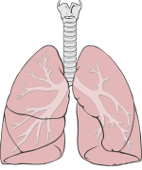
Impact of national lateral flow testing on COVID-19 trends in Austria
16 March (Werner Leber. Centre for Primary Care)

 | Impact of the introduction of population-wide LFT testing in the second COVID-19 wave in Austria in 2020 is explored in a study correlating trends in LFT testing with COVID-19 positive rates, hospitalisations, and deaths. Stratifying districts into high medium and low FLT activity, researchers found that trends in LFT activity were similar to positivity and hospitalisations, but the association with deaths was only present in the cohorts with high LFT activity. The high-activity cohort also had steeper daily reduction in the post-peak trend in positive rates and hospitalisations.
Group antenatal care: findings from a pilot RCT of REACH Pregnancy Circles
16 March (Tahania Ahmad, Thomas Hamborg, Sandra Eldridge. Centres for Public Health and Policy/Evaluation and Methods)

A pilot RCT of group antenatal care (Pregnancy Circles), combining conventional aspects of care with group discussion and support, has investigated this model as an alternative to traditional UK individual care which has limitations in particular for those from deprived populations. From three Pregnancy Circles in an inner London NHS trust with high levels of deprivation and diversity, pilot data were collected through session observations and through interviews with participants, midwives, and other stakeholders. Data were assessed against 5 feasibility measures: available recruitment numbers, recruitment rate, intervention uptake and retention and questionnaire completion rates. Findings indicate that, subject to a few adjustments in recruitment processes, language support, accessibility of intervention premises, and outcome assessment, a full RCT is feasible. | 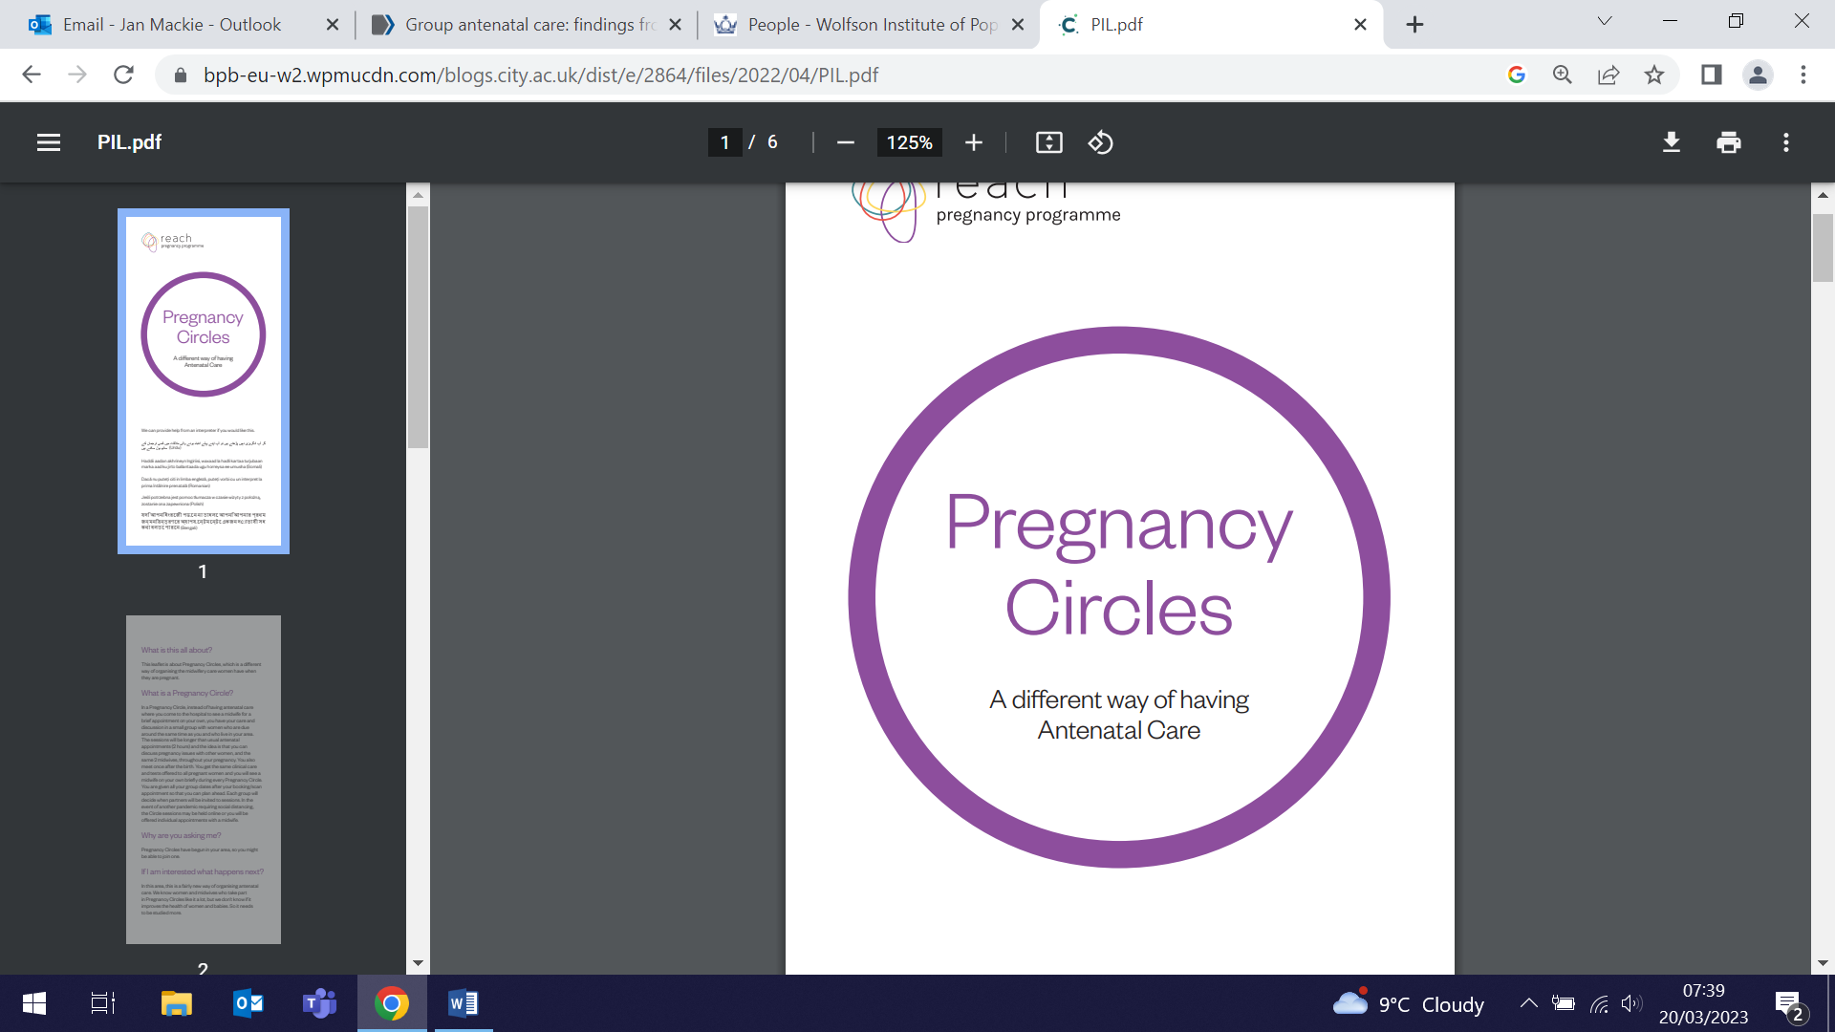
Barriers to Colonoscopy among UK Ethnic Minority Groups
16 March (Stephen Duffy. Centre for Prevention, Detection and Diagnosis)

 | People from ethnic minority backgrounds are less likely to attend colonoscopy following colorectal screening, and so are more likely to be diagnosed with colorectal cancer at an advanced stage. An interview study among screening-eligible men and women of Black-African, Black-Caribbean, S. Asian, and white British descent highlights targets for culturally tailored interventions to make colonoscopy more equitable. The study identifies 5 themes: 'Locus of control', 'Cultural attitudes and beliefs', 'Individual beliefs, knowledge and personal experiences with colonoscopy and cancer', 'Reliance on family and friends' and 'Health concerns'. Differences were observed between ethnic groups, with black and S. Asian participants frequently describing the decision to attend colonoscopy as lying with God (Muslims, specifically), the doctor, or family, and also reporting relying on friends and family for language, transport and emotional support. Black-African participants, specifically, described cancer as socially taboo.
FORTHCOMING EVENTS AND NOTICES

Women and Crisis Research Symposium (28 March)

The Women and Crisis Research Symposium, hosted by the Crisis and Resilience Network, The Sexual Health and HIV All East Research (SHARE) Collaborative, and the Medical Women’s Federation, is a showcase of original research currently being conducted at QMUL, along with other universities and NGO's in and around London. The symposium will provide an opportunity to listen and learn from renowned speakers in multidisciplinary fields, and will explore current and future research directions for women. Register here to attend. | 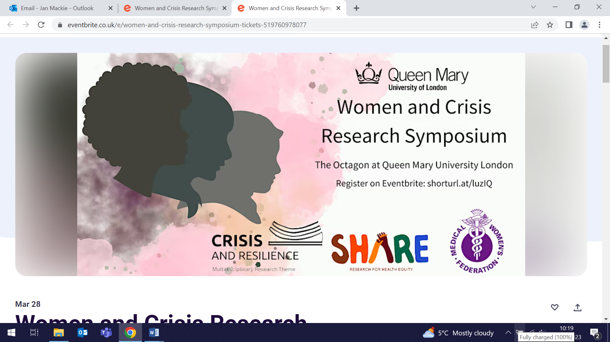
Seminar: Current and new UK funding opportunities (30 March)

All are welcome and encouraged to attend this seminar by Bryony Butland, QMUL Director of Research and Innovation. The presentation will cover the current UK R&D funding landscape, how this will change in the next few years, and what this may mean for QMUL researchers. Bryony will focus on public sector funding for R&D, drawing on her ≈20yrs experience in R&D policy and funding for Government and UKRI. She will cover how funding decisions around the science budget are made in government, policy direction, and future funding schemes being developed by UKRI, offering her guidance, and answering arising questions. Thursday 30 March, 12:15-1pm, Derek Willoughby Lecture theatre, John Vane Science Centre, Charterhouse Square. To join on Teams: Click here to join the meeting Passcode: karK2J Meeting ID: 383 872 754 367 | 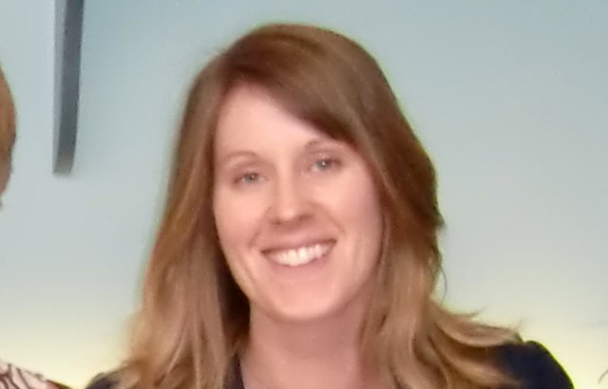
Festival of Communities (application deadline 30 March)

The QMUL Festival of Communities will take place this year on Saturday 10 and Sunday 11 June. The Festival is a great example of QM working in partnership with our local communities, and is a fantastic opportunity to engage thousands of local residents with everything that makes us unique: our teaching, research, and a wealth of wider initiatives, with everything from arts and culture through to environmental sustainability. Funding is available, and the Centre for Public Engagement team will support you in developing activity ideas. Please make use of their information webinars, dedicated training, 1:1 advice sessions, and funding of up to £500 per project. NB: deadline for applications is Thursday 30 March. | 
Inaugural Lecture: Ranjit Manchandra (13 April)

Ranjit Manchanda will deliver his Inaugural lecture, My journey: A tryst with cancer prevention”, on Thursday 13 April at an event starting at 5:30pm in the G02 Lecture Theatre in the Joseph Rotblat building. Ranjit will describe and reflect on his journey, covering trials and research in population-based genetic testing, mainstreaming genetic testing, population risk stratification, targeted screening, targeted cancer prevention, related health economic issues, and a commitment to teaching and training. Please register here to attend. | 
Many thanks to all who so enthusiastically contribute. Please send any news items for the next newsletter to j.a.mackie@qmul.ac.uk

