WOLFSON INSTITUTE OF POPULATION HEALTH
NEWSLETTER
ISSUE 37: 5 JULY 2023

In this issue of our Wolfson Institute of Population Health Newsletter, we celebrate the achievements and work of staff and students through the second half of June and early days of July.

FROM OUR DEPUTY INSTITUTE MANAGER
Dear All

Can you believe we blinked and it’s already the beginning July and hopefully our summer months? The energy crisis is thinning out just in time for us to recoup our finances in debit (well mine anyway) and maybe have a little left over to enjoy a well-earned summer vacation - just make sure it’s not underwater! Remember you are entitled to carry forward 5 days of holiday but no more (bar extenuating circumstances). So use or lose it by 31 July 2023.

We witnessed a great turnout for our Summer showcase last Wednesday which was a resounding success. We shared numerous presentations of our achievements, personnel, growth and developments, with the awards ceremony being a first for us recognising attainments, although I think everyone should give themselves a pat on the back for your own contributions. We would still be there today if we had to give everyone a certificate and award, but we are aware that the Institute is where it is, because of you.

Staff survey results are out which you can view via QM Connect, but our rescheduled ASM will discuss our highlights, lowlights and improvements that must be addressed. Please ensure you join and converse - we can’t be better and do better if you don’t share your opinions.

ITS Refresh: a big plea to get on board and discuss with your Centre Managers please, if you haven’t upgraded your IT equipment device. The Institute is preparing to implement the NWOW from 1 September, and we need to show QM we are following the agile hybrid ways of effectively working. I know there are concerns, and a working group will be compiled, as developments are continually evolving. Further details to follow.  Thank you and have a wonderful week  Tracy | 
MEET WIPH

MEET WIPH – Hattie Burt (Centre for Public Health and Policy)

How would you describe your roles and responsibilities?
I'm a Registered Associate Nutritionist (ANutr) and a Senior Policy and International Projects Officer in the Research and Action on Salt and Obesity Unit. My job is to contribute towards improving population health by reducing unnecessary salt, sugar and calories in the UK diet. I also work with teams internationally to provide resources and advice to enable the development and implementation of salt and sugar reduction programmes worldwide.

What has been your greatest professional achievement?
Since starting in my current role, publishing an analysis piece in the BMJ 'Salt: the forgotten foe in UK public health policy' with my esteemed colleagues Mhairi, Feng and Graham. Have a read!

What aspects of your role do you enjoy the most?
I love the variety of my job - one day I can be writing an article for a trade magazine on the need to reduce excess salt and sugar in processed food, the next I could be meeting with environment NGO Feedback Global to discuss how we can combine health and land use policy to reduce sugar production.

What would be your second choice as a profession?  This role in public health nutrition is already a second career for me after a long stint in project and programme management, but maybe a gardener.  What do you enjoy doing outside work?  Long walks, the odd night of camping, trying out new restaurants, spending time with my sister and niece, travelling to other countries.  Something about you that most people don’t know?  Most Saturdays I do my local Parkrun at aptly-named Hilly Fields - last week was my 76th. | 
FROM OUR LEADERSHIP TEAMS

Research News from Tor Kemp (Research Manager)
Leadership courses – Postgraduate Certificate | NIHR-AoMRC Clinician Researcher Credentials Framework |Autumn 2023

Could you be a Research Delivery Leader? Are you looking for new ways to develop the next generation of Research Delivery Leads? Applications are open for postgraduate clinical research delivery leadership courses aligned with the NIHR-AoMRC Clinician Researcher Credentials Framework. These qualifications are open to prospective learners from all healthcare professions and will commence in autumn 2023. Designed for learners with busy work schedules studying part time, the courses provide a forum to develop the necessary networks, skills and confidence for healthcare practitioners from any regulated profession to support and lead clinical research delivery. Full and part bursaries for the course fees are available for early applicants. The earliest bursary application deadline is 23 July 2023. APPLY NOW. (Please note: Learners who apply for the courses will be asked if they also wish to apply for a bursary, at which point further information about the bursary application process will be provided).

EDI News
(Evangelos Katsampouris – Equality Diversity and Inclusion Lead)

The WIPH EDI Group on 26 June hosted a virtual seminar on Responding to Bullying and Harassment, delivered by Christina Govier. If you wish to receive the presentation slides, please email the EDI Group. You can read more about Christina’s work here, or reach out to her at c.govier@qmul.ac.uk.

If you are keen to become involved in the WIPH EDI Group, or to raise and discuss an EDI-related issue, please email us.

GENERAL INSTITUTE NEWS

Methodology Research Unit Meeting
20 June (Centre for Evaluation and Methods)

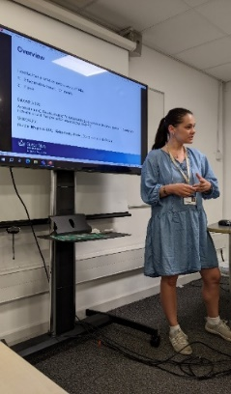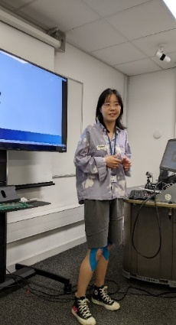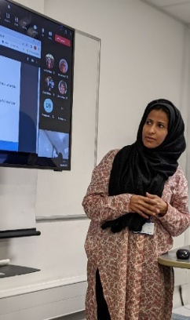 | The third meeting of the Methodology Research Unit was held on 20 June. PhD students Nadine Marlin, Laetitia De Abreu Nunes, Saskia Eddy, Charis Xuan Xie, Abeer Althobety and Huda Alsulami each delivered short presentations on their research, including doctoral projects on randomised pilot trials and healthcare data in randomised implementation trials.
Call for Papers on GP crisis in Europe
20 June (Giuliano Russo. Centre for Public Health and Policy)

As associate editor of the Springer Nature journal Human Resources for Health, Giuliano Russo is putting together a special collection of papers on the GP crisis in Europe. The call for papers, now open, is seeking evidence and analysis on the causes, impacts, and solutions of and to the primary care medical workforce crisis in Europe. Submission deadline is 31 March 2024. Please consider contributing. | 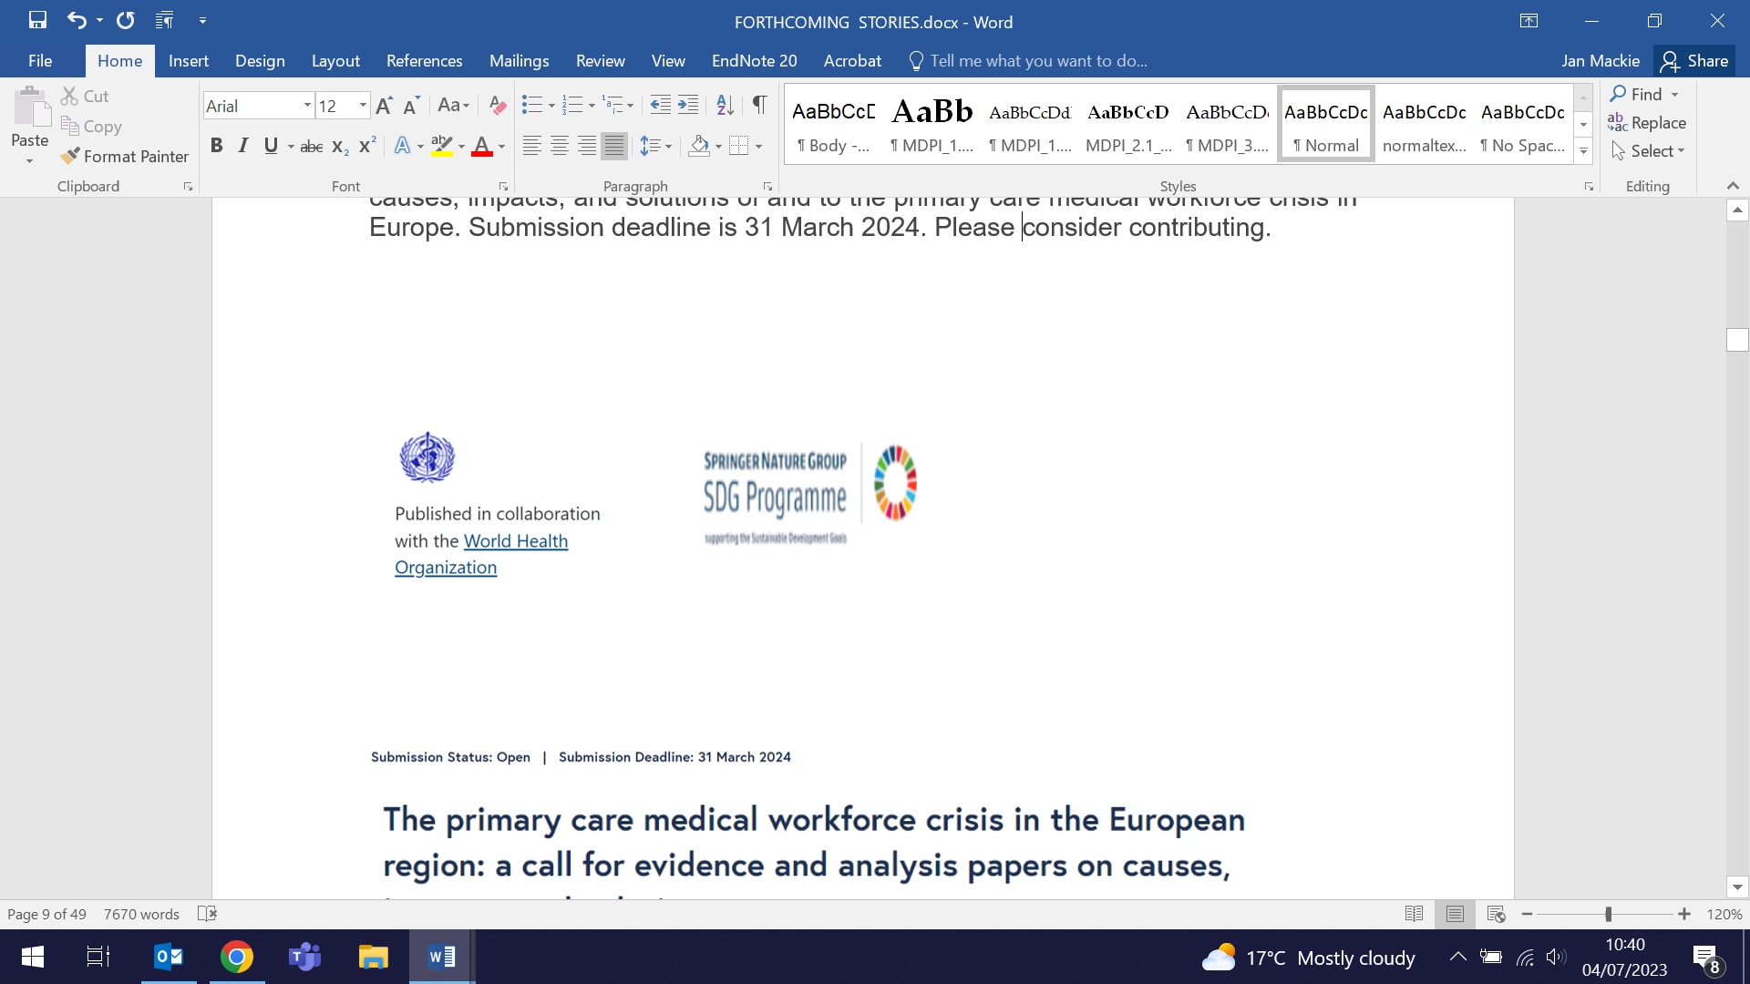  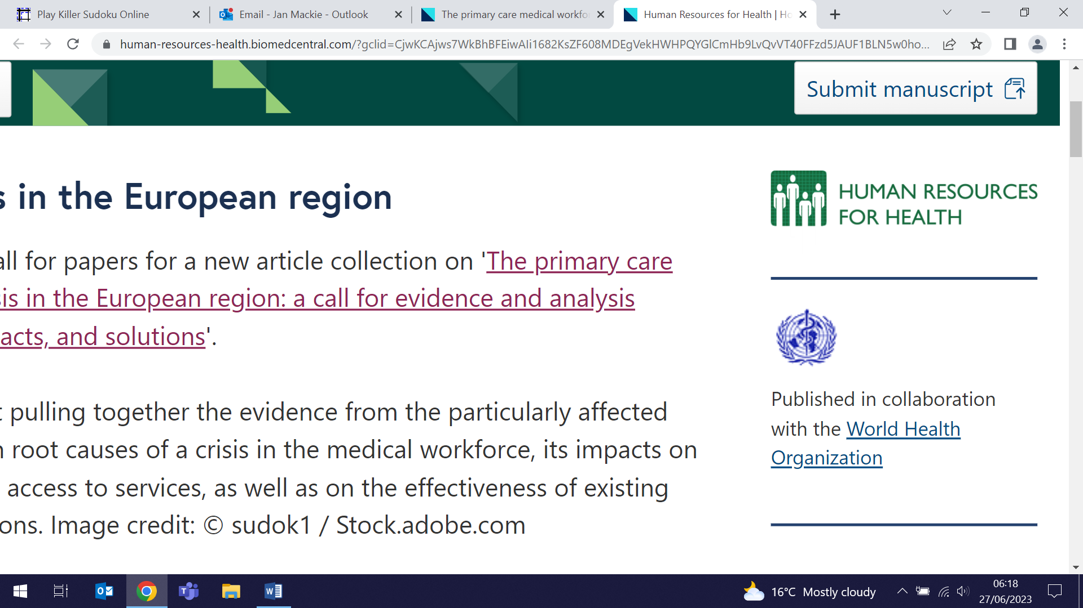
CHESS self-management intervention for people with chronic headaches
21 June (Sandra Eldridge, Sian Newton, Steph Taylor. Centres for Evaluation and Methods/Primary Care)

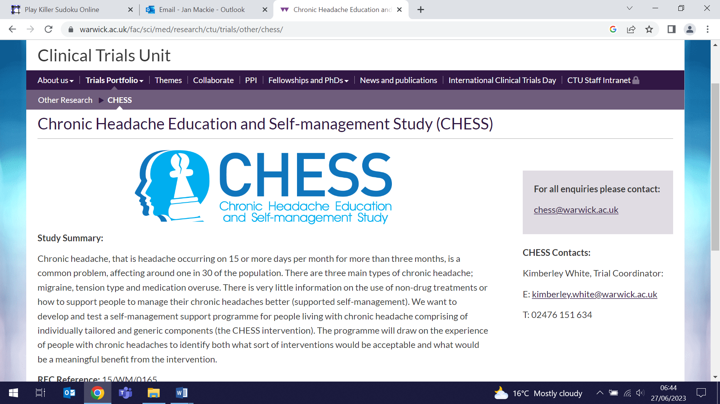 | An RCT of over 700 participants from 164 general practices in the Midlands and London has evaluated the CHESS intervention, a non-pharmacological alternative treatment for chronic headache. The intervention included two 1-day education and self management group sessions to promote behaviour change and support learning strategies to manage chronic headaches, followed by a nurse consultation and telephone support. The control group received a headache management leaflet and a relaxation CD. At 12 months, results showed no between-group difference based on headache-related QoL measured using the Headache Impact Test-6. Authors conclude that the intervention is unlikely to be effective for the treatment of people with chronic headaches and migraine.
New tool to help GPs manage patients with chronic kidney disease
22 June (John Robson, Zaheer Ahmed, Isabel Dostal, Pritt Kallah, Fae Wilkins, Anna Billington, Thomas Bradshaw. Centre for Primary Care)

A new Active Patient Link tool APL-Renal produced by the Clinical Effectiveness Group will enable GP practices to list all registered adult patients with indicators of chronic kidney disease (CKD) coded in their health record, and filter the list into cohorts to take action. The tool allows practices to quickly identify and review critical falls in estimated glomerular filtration rates, identify patients for follow-up for overdue measures, and improve CKD coding for more accurate disease registers. It can also export lists of patients to send appointment messages, and relevant information about a patient to send with a referral. The tool is available free to GP practices in the NHS North East London region, with supporting user guides, video, and help from CEG’s primary care facilitators to install and use it effectively. | 
Symposium Mammographicum
22 June (Stephen Duffy. Centre for Prevention, Detection and Diagnosis)

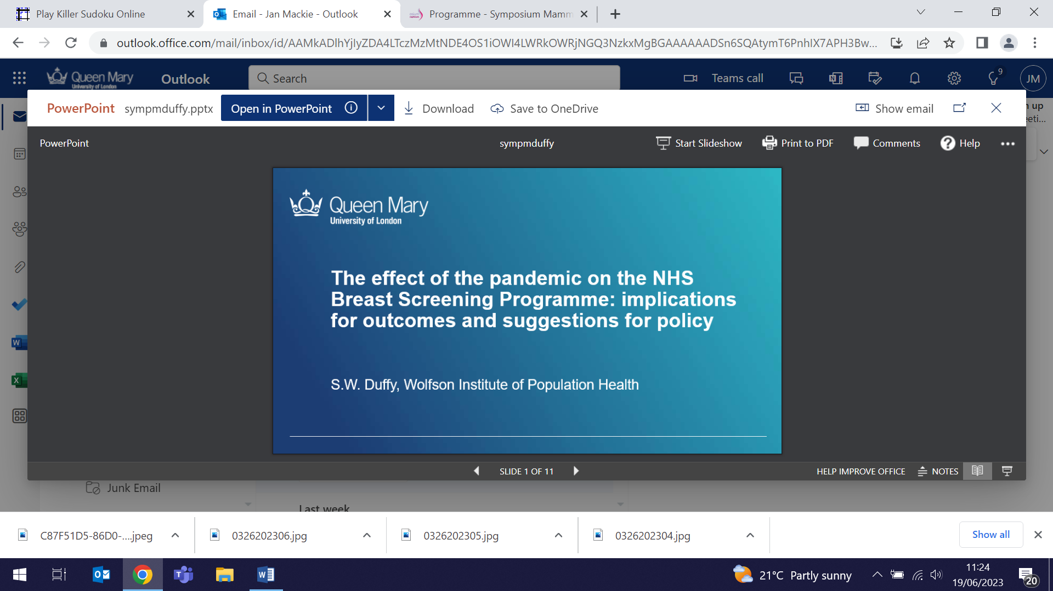  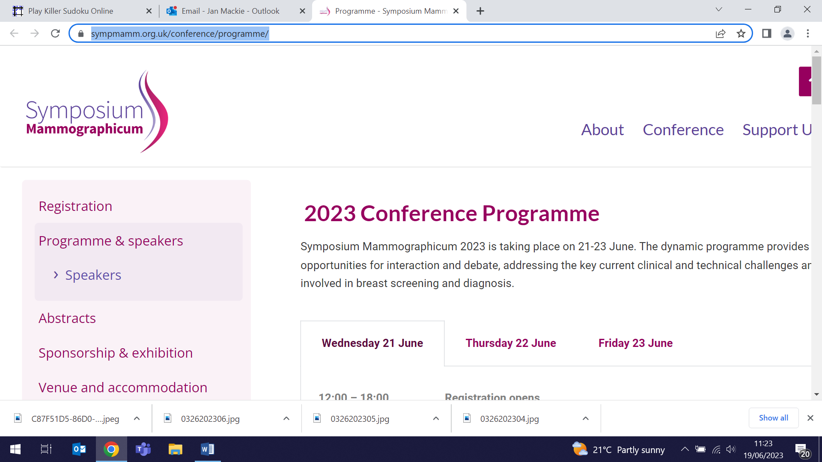 | Stephen Duffy presented his work on the effect of the pandemic on NHS breast screening, including suggestions for policy, to the Symposium Mammographicum, held from 21-23 June in Glasgow. The Symposium is a charitable organisation instigated in the 1970s to disseminate knowledge and education in breast imaging. The annual conference now embraces all aspects of the breast patient pathway.
Georgia Black elected to QMUL Senate
22 June (Georgia Black. Centre for Prevention, Detection and Diagnosis)

Congratulations to Georgia Black on her election to the QMUL Senate to serve a four-year term. Senate meets quarterly, with members elected through a faculty ballots. Georgia’s particular interests are inclusive and diverse research and staff recruitment; early and mid-career development, coaching and mentoring; fostering multidisciplinary research across healthcare and social science; and promotion of high quality teaching. As we heard from the Principal at the recent WIPH All Staff meeting, some decisions do not fall under his remit, and are referred to the Senate. Thanks to Georgia for stepping up to represent us in this forum. | 
Evaluating tumour cells to predict post radical prostatectomy cancer recurrence
23 June (Tom Duffy, Laura White, Rhian Gabe. Centre for Evaluation and Methods)

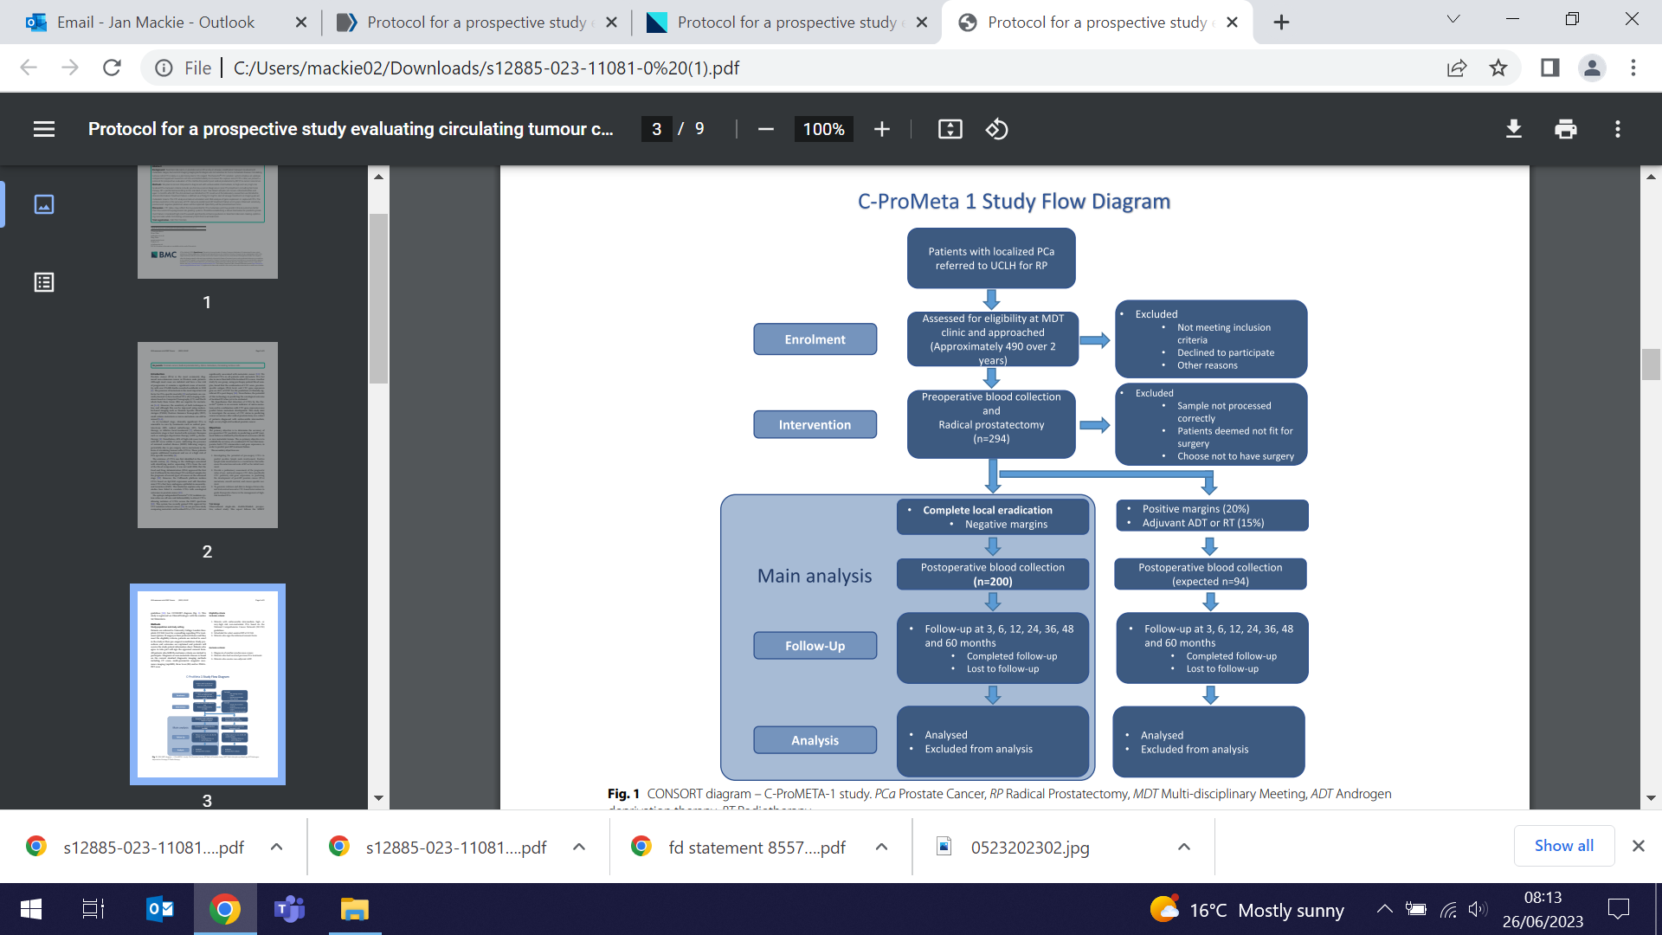 | Researchers have published the protocol for a study to evaluate circulating tumour cell (CTC) status as a method to predict post radical prostatectomy cancer recurrence. Treatment decisions in prostate cancer rely on disease stratification, but imaging technologies are not sensitive to micro-metastatic stages. Using the Parsortix® CTC isolation system, CTC rate will be analysed in blood samples collected before and after radical prostatectomy from 294 patients with unfavourable intermediate-very high risk localised prostate cancer. Primary outcome is the accuracy of CTC status to predict post-RP treatment failure at 4.5 yrs. A robust biomarker for predicting treatment failure in localized high-risk prostate cancer would significantly enhance guidance in treatment decision-making, optimizing cure rates while minimizing unnecessary harm from overtreatment.
2022 Gerald L. Klerman Young Investigator Award
23 June (Georgina Hosang. Centre for Psychiatry and Mental Health)

Georgina Hosang travelled to Chicago to receive her 2022 Gerald L Klerman Young Investigator Award at the International Society for Bipolar Disorders Conference. The Depression and Bipolar Support Alliance (DBSA) Scientific Advisory Board Klerman Award committee noted that they were “most impressed with the scope and impact” of her research on bipolar disorder and major depression. Georgina also took part in a symposium, sharing developments, results and initiatives that came out of a needs survey deployed to learn about facilitators and barriers in pursuing a career in bipolar disorders. | 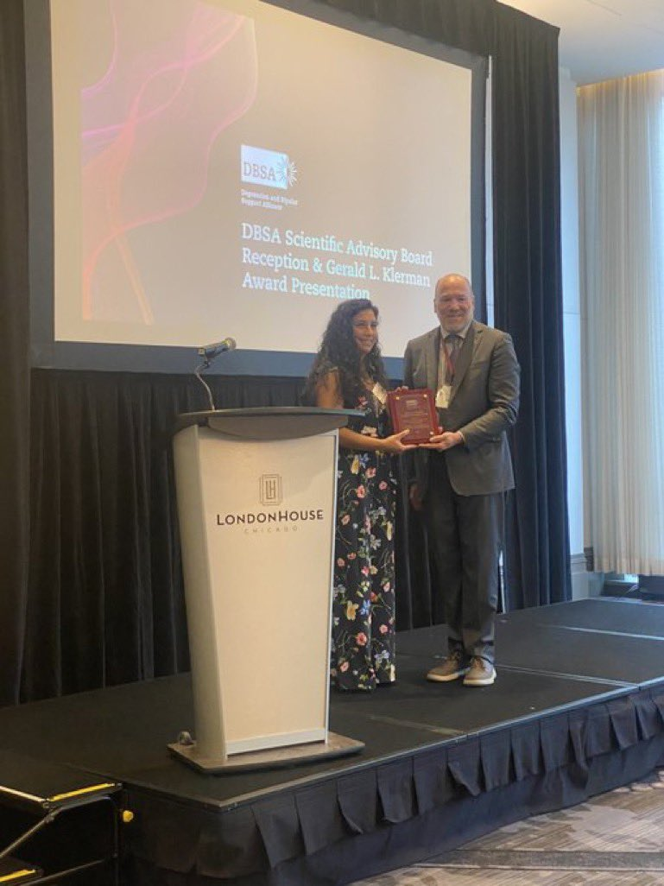
European Society of Human Reproduction and Embryology (PCOS)
26 June (Matina Iliodromiti. Centre for Public Health and Policy)

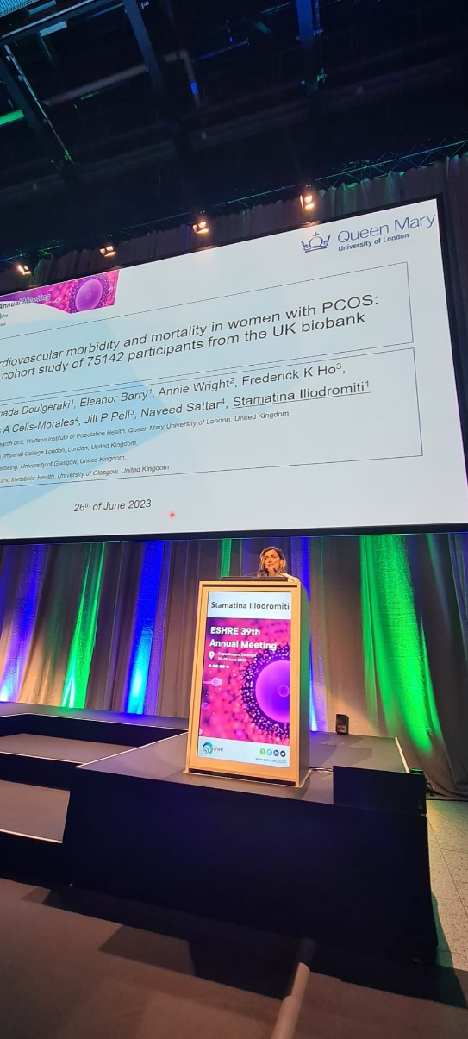 | In a fully attended session on new concepts in the study of Polycystic Ovary Syndrome at the European Society of Human Reproduction and Embryology annual meeting in Copenhagen, Matina Iliodromiti presented her work on cardiovascular morbidity and mortality in women with PCOS, based on a cohort study of 75142 participants from the UK Biobank. Her results showed that PCOS is not directly associated with CVD risk, but women with PCOS do have higher risk of Type 2 Diabetes and hypertension.
RCOG India Day Meeting
28 June (Ranjit Manchanda. Centre for Prevention, Detection and Diagnosis)

Ranjit Manchanda participated in a panel on Opportunities and implementation of collaborative research at the 28 June India Day meeting co-ordinated by the RCOG in collaboration with the Federation Obstetricians and Gynaecologists of India, the All India Co-ordination Committee, and RCOG India Liaison Group. The one day event was an opportunity to debate and compare practices and forge opportunities to collaborate and innovate between the two countries. | 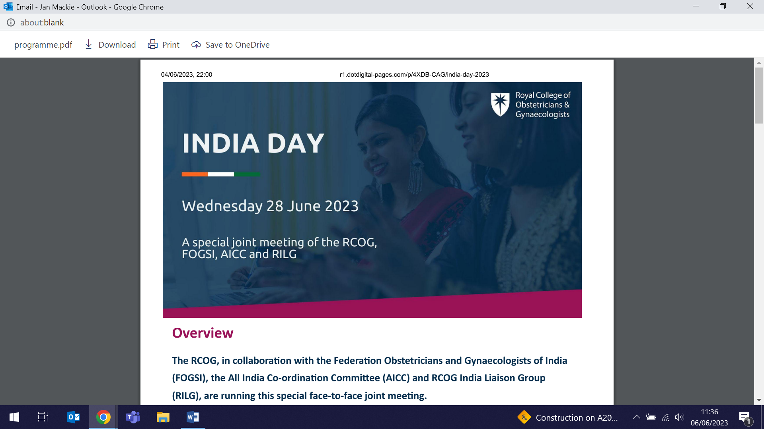
WIPH Showcase 2023
28 June

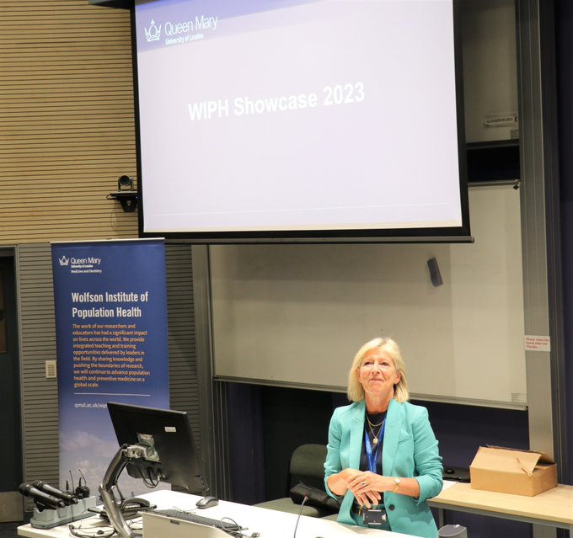  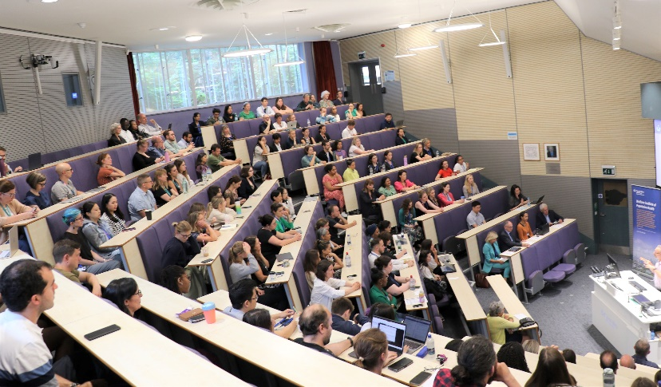 | Over 180 WIPH staff attended our second annual showcase event on 28 June. Throughout the day we heard presentations from groups across all centres, VP Mark Caulfield, and from Peter Sasieni, who leads the new cancer research group joining us from King’s in September. In addition we celebrated the achievements of our staff, with our inaugural WIPH prize giving. Winners were: for Outstanding Professional Support, Olivia Downey, Emily McLean, Charlotte Edwards Roscamp; Outstanding Team Contribution, the SURECAN team and the APPLE TREE and NIDUS team; Outstanding Citizenship, Libor Vlach and Megan Clinch; Outstanding Contribution to Public Engagement, Ratna Sohanpal and Rifah Anjum and Avinash Chandra; Outstanding Contribution to Research: Adam Brentnall and Liz Steed; and Outstanding Contribution to Education, Stephen Duffy. Congratulations to all.
Nitrous oxide: legitimate uses and appropriate controls
29 June (Alastair Noyce, Alvar Paris, Devan Mair. Centre for Prevention, Detection and Diagnosis)

In a response coordinated by the PNU to the Government’s ‘Nitrous oxide: legitimate uses and appropriate controls’ consultation, 16 neurologists and related health workers support the option to license for import/export, production, and supply, and exempt possession for legitimate purposes. Their letter to the Home Office notes that ending profiteering from N2O sales for recreational use would prevent harm in a substantial proportion of patients, but threat of prosecution for possession could lead to delayed medical presentation, increasing marginalisation in already disadvantaged user groups and disproportionately affecting young Asian communities, exacerbating structural racism and compounding the negative effects on health. Authors call for funding for a national education campaign in schools and mainstream media to ensure public understanding of the risks posed by N2O misuse and request a meeting with the Minister to discuss how the legislation can be enacted in a way that minimises the negative impact of N2O on health. | 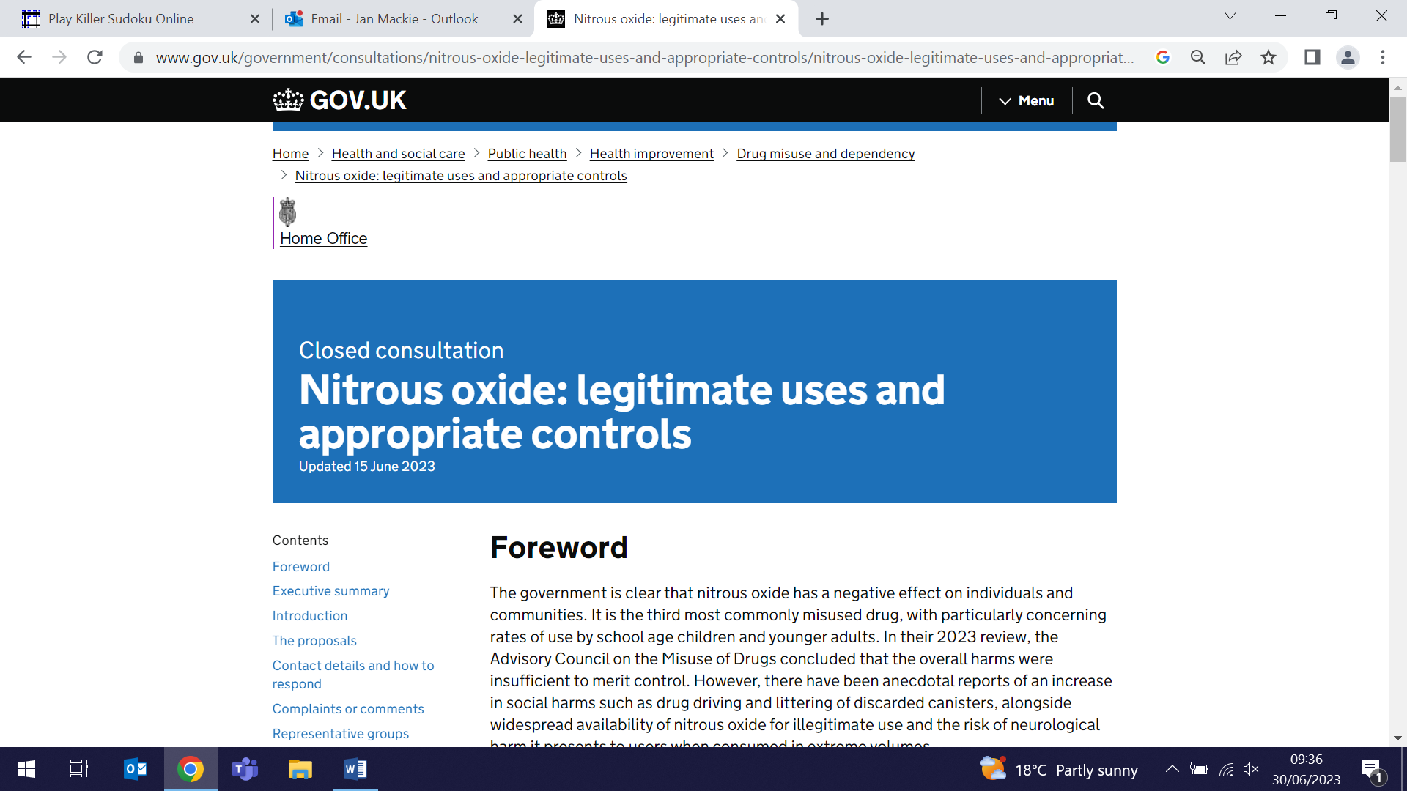    
Predicting COVID-19 risk in people immunocompromised by antibody testing
29 June (Beth Stuart. Centre for Evaluation and Methods)

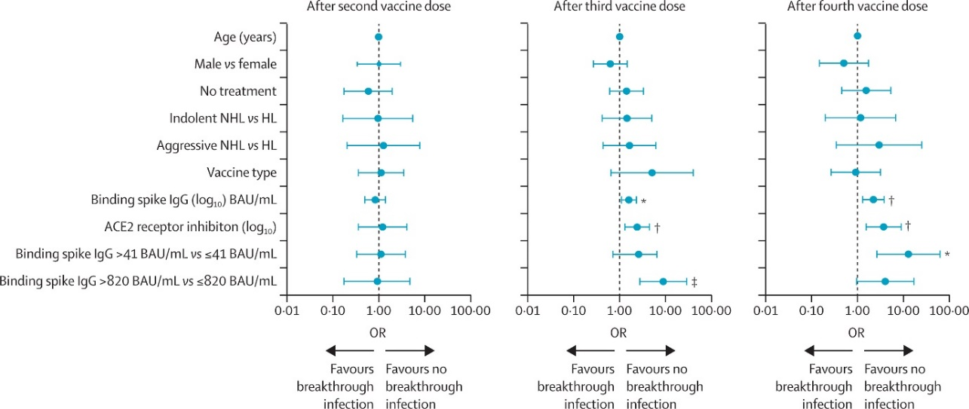  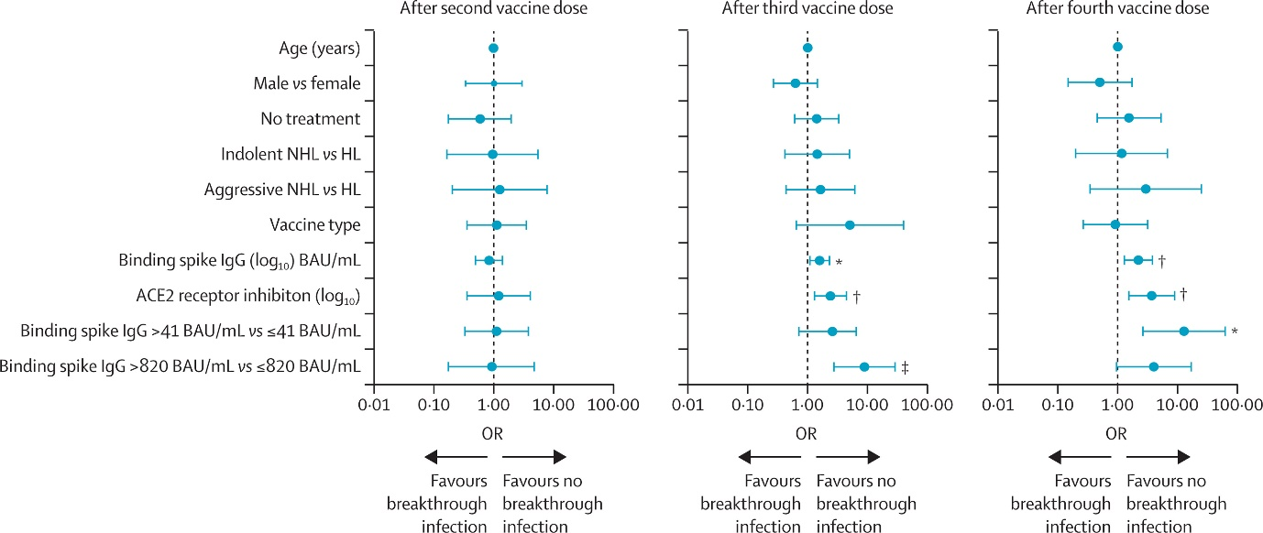 | Results from the first study to successfully establish an association between antibody and T-cell responses and clinical outcomes from COVID-19 disease in people who are immunocompromised are reported in the Lancet. In the PROSECO study, blood tests were taken pre/post COVID-19 vaccines from participants with lymphoma, with 396 subjects completing a questionnaire after vaccination. Results show 6% of breakthrough infections occurred after 2 vaccine doses, 13% after 3, and 14% after 4. Of participants with breakthrough infections 13% were admitted to hospital, mostly after 3 and 4 vaccine doses, and 56% of these patients had absent T-cell responses (v 16% in non-hospitalised participants). The optimal antibody titre predicting breakthrough infection/ no breakthrough infection was 20-fold lower after 4 vaccine doses than after 3, implying that lower antibody titres are required to protect against breakthrough infection with increasing vaccine doses. Authors advocate routine antibody testing in immunocompromised people to focus efforts to protect the most vulnerable groups.
Uptake of antenatal & immunization services in The Gambia during COVID-19
29 June (Abdourahman Bah, Giuliano Russo. Centre for Public Health and Policy)

An interview study of health workers and female patients from four health facilities in The Gambia explores the unintended consequences of epidemic control measures during the COVID-19 pandemic on the uptake of antenatal and immunization services. Researchers found that patients were fearful of being infected in the facilities, of being quarantined, and about passing on infections to family. They were also influenced by reluctance on the part of partners and family members, perceived negligence and disrespect by health workers, misinformation in the community and mistrust of vaccines. Practical issues such as shortage of health workers, closures of health facilities, lack of personal protective equipment and essential medicines, and the shortage of transport options were also cited. | 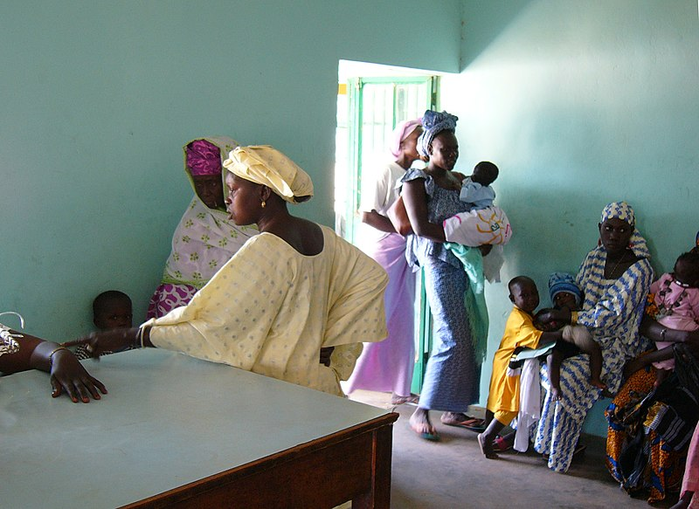
Balint work and the flourishing practitioner
29 June (Sally Hull. Centre for Primary Care)

   | Sally Hull has published the text of her Michael Balint Memorial Lecture 2023, reflecting on the difficulties inherent in practising primary care in unsympathetic contexts, and without a culturally shared understanding that differentiates it from technical biomedicine. Despite the benefit of the long history, training, and esteem that generalist doctors have in the UK, the discipline of general practice remains marginalised within the wider discipline of medicine. In facing the growing demands of complex multimorbidity in an ageing population, Sally concludes that while the history of general practice in the UK provides hope in challenging times, reflective processes need support from practising GPs, as well as those in professional and academic organisations, so that the self-understanding of general practice continues to be effectively renewed.
WIPH team to form part of new NIHR Research Support Service
29 June (Richard Hooper. Centre for Evaluation and Methods)

A new NIHR Research Support Service will launch in October across four Universities - Imperial, UCL, King’s, and QMUL. The RSS, which replaces the previous NIHR Research Design Service, has been awarded funding of £8.7million for five years, £1.7million of which will come to WIPH. Richard Hooper, PI on the QM section of the Service, will also chair the RSS Methodology and Training Committee across all four Colleges, and from October will co-lead at QM together with Liz Steed and Jill Russell. Success in this bid helps confirm the key role of WIPH in enabling and delivering high impact research in health and social care. | 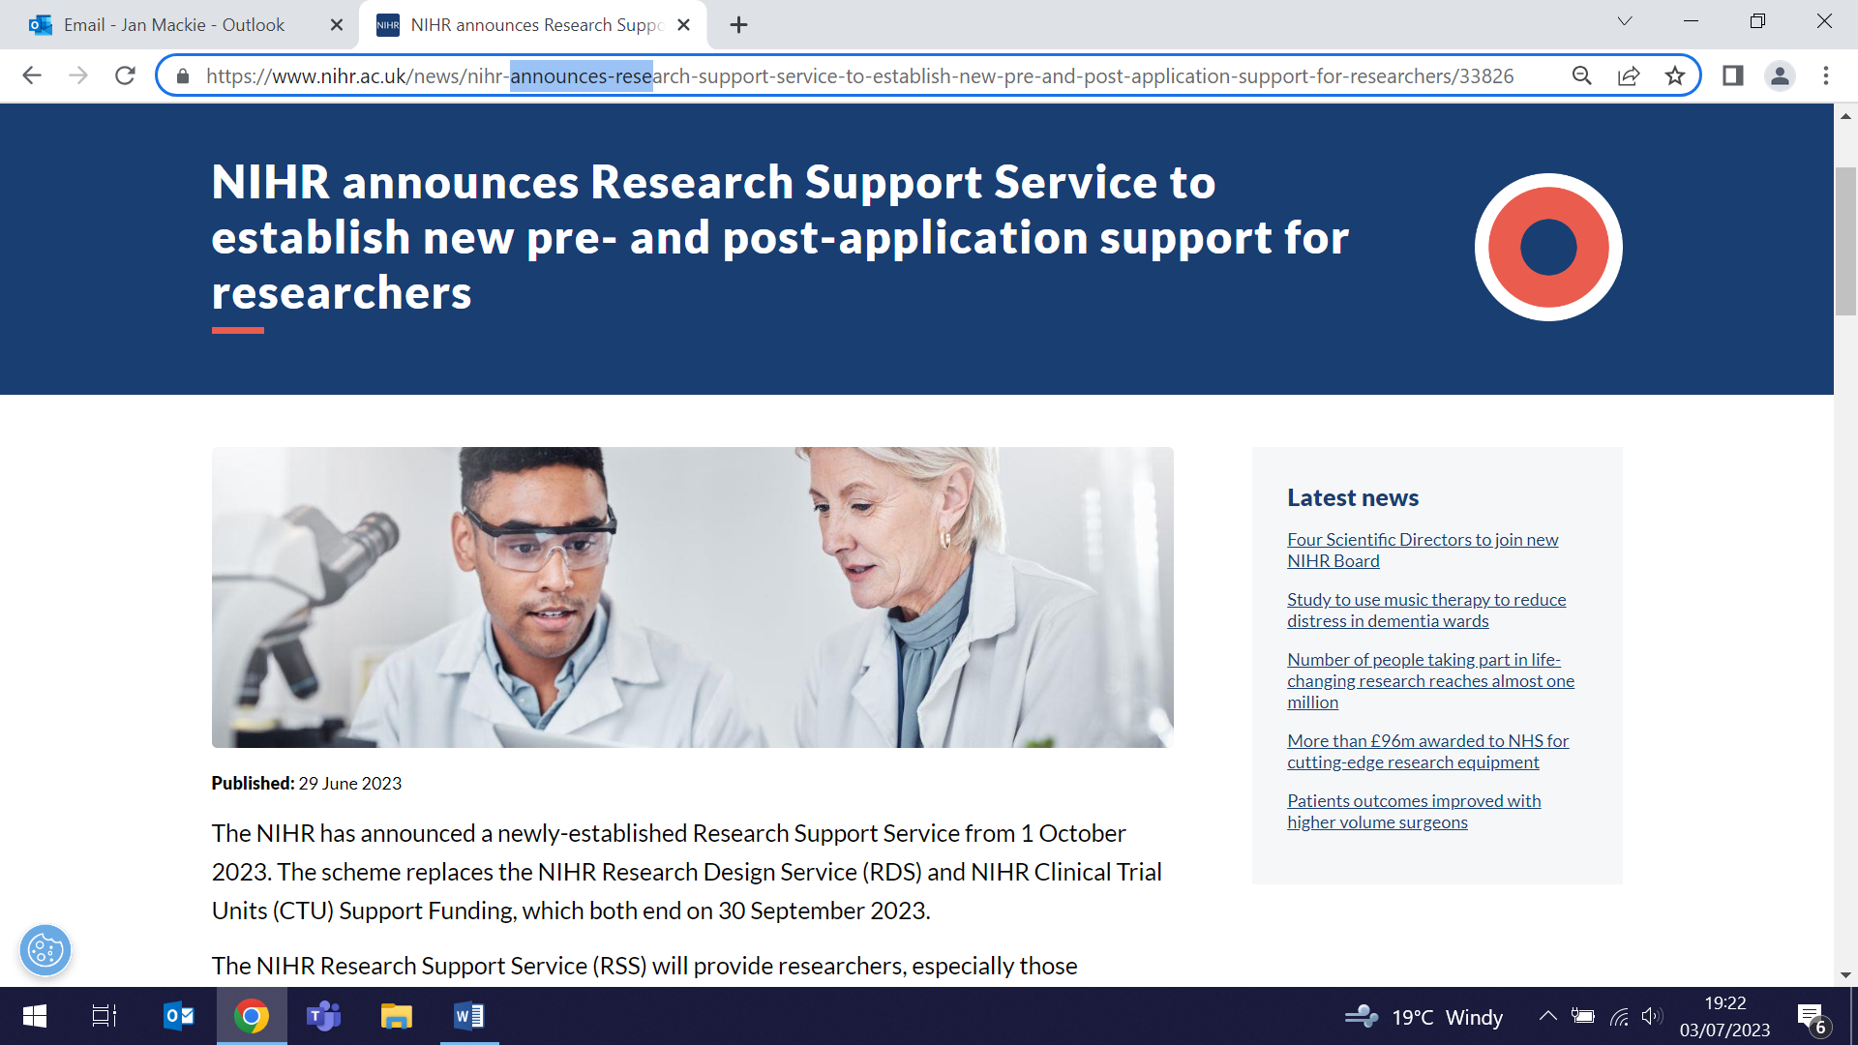
Ethnic differences in pandemic disruption to non-COVID healthcare
29 June (Rohini Mathur. Centre for Primary Care)

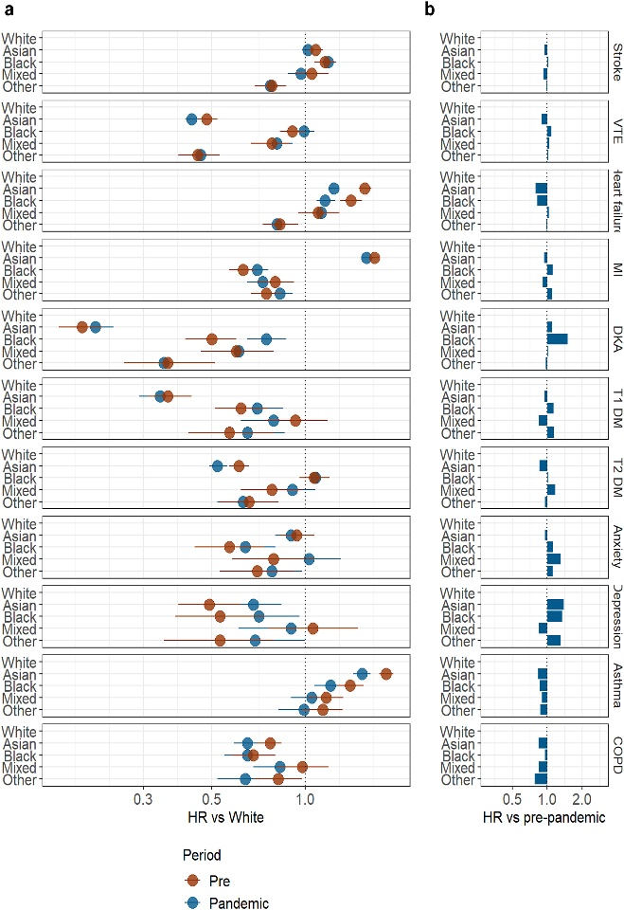 | An observational cohort study investigating whether pandemic-related disruptions to healthcare for non-COVID conditions may have had an impact on ethnic inequalities finds that, in clinical monitoring and hospitalisations, ethnic differences remained largely unchanged for most conditions. Using primary care electronic health records and hospital data for 14,930,356 adults, researchers examined ethnic differences in clinical monitoring frequency (blood pressure and Hba1c measurements, chronic obstructive pulmonary disease, and asthma annual reviews) and hospitalisations related to diabetes, cardiovascular disease, respiratory disease, and mental health. Results suggest that the pandemic had minimal impact on ethnic differences, except for hospitalisations for diabetic ketoacidosis and heart failure, the causes of which warrant further investigation.
Early/Mid-Career professionals focused on bipolar disorder: Factors for success
30 June (Georgina Hosang. Centre for Psychiatry and Mental Health)

A survey on factors restricting recruitment and retention of researchers and clinicians specializing in bipolar disorder (BPD) has been completed by 300 participants across 6 continents. Administered by the International Society for Bipolar Disorders Early Mid-Career Committee and available in English, Spanish, Portuguese, Italian, and Chinese, the survey covered transitional career stages, creating and fostering mentorship, research activities, raising academic profile, clinical-research balance, networking and collaboration, community engagement, work-life balance. Half of the responders identified as belonging to an under represented group in health-related sciences (eg. from certain gender, racial, ethnic, cultural, or disadvantaged backgrounds, including individuals with disabilities). Survey results identified unique challenges specific to scientific writing and grant funding, and highlighted mentorship as a key facilitator of success in research and clinical work. | 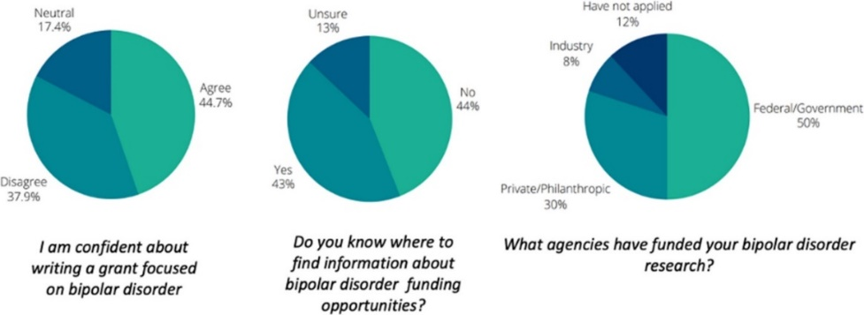  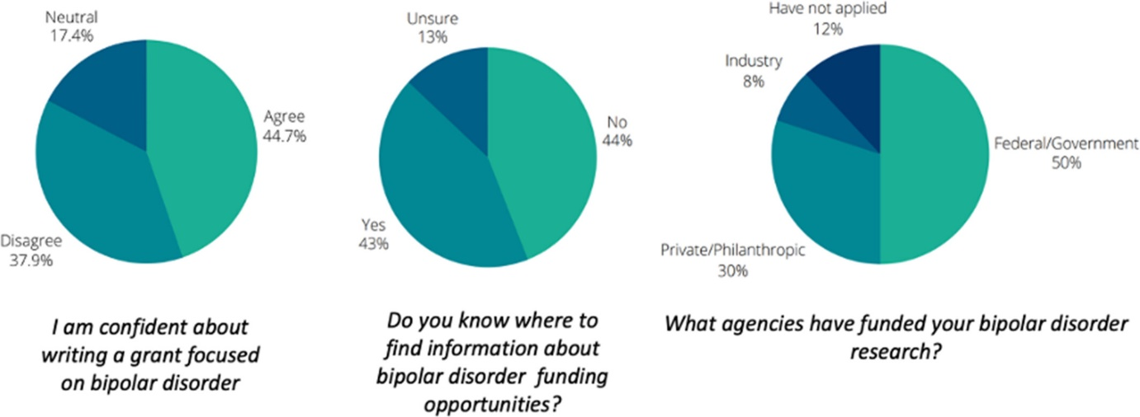
The order in which multi morbidities develop affects life expectancy
1 July (Carol Dezateux, Gill Harper. Centre for Primary Care)

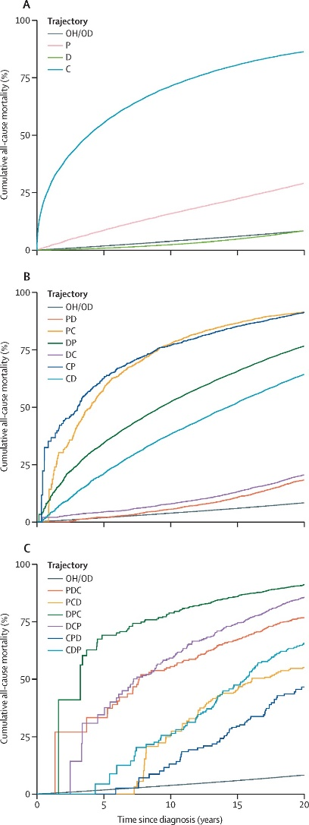  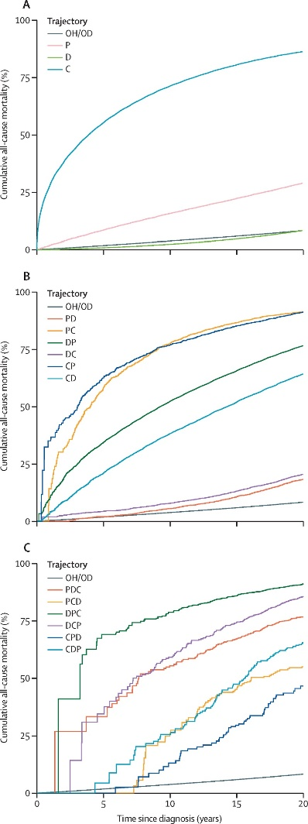  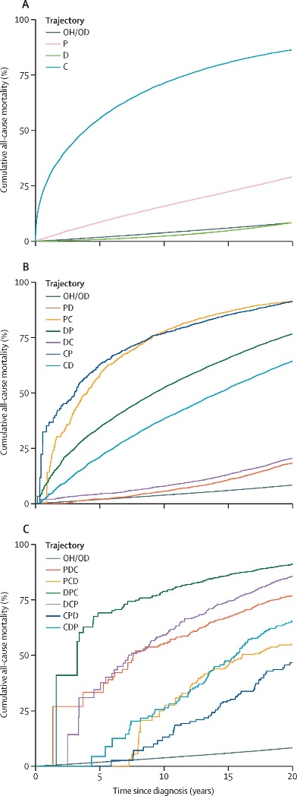 | Using data from the Wales Multimorbidity e-Cohort, researchers modelling the trajectories of psychosis, diabetes, and congestive heart failure in multimorbidity cases have found that the order of disease acquisition has an important and complex association with patient life expectancy. The study of 1,675,585 individuals found that those who developed diabetes, psychosis, and congestive heart failure, in that order (DPC), had reduced life expectancy compared with people who developed the same three conditions in a different order. Findings were robust in people of older ages, more deprived populations, and women, except that the trajectory of psychosis, congestive heart failure, and diabetes was associated with higher mortality in women than men. Authors conclude that multistate models can be used to assess temporal sequences of diseases and allow identification of periods of increased risk of developing subsequent conditions and death.
Sodium content targets for pre-packaged foods in China
1 July (Feng He, Mhairi Brown. Centre for Public Health and Policy)

A paper in the Bulletin of the World Health Organization provides the scientific rationale for government policy on setting targets for food sodium content in China. Researchers model the effects of four approaches to reduce sodium content of pre-packaged foods on population sodium intake in China. Using data on nutrient content and ingredients from 51,803 food products, and food consumption of 15,670 Chinese adults, they found that in 2021 pre-packaged foods contributed 1302.5 mg of sodium to the diet per day per adult, accounting for 30.1% of population sodium intake. Comparing the effects of setting maximum sodium content at different levels, authors propose 20% reduction targets, as these should result in substantial and acceptable reductions in sodium content for most food subcategories, and lead to overall sodium intake declining by 305 mg/day per person, and population intake declining by 6.1%. | 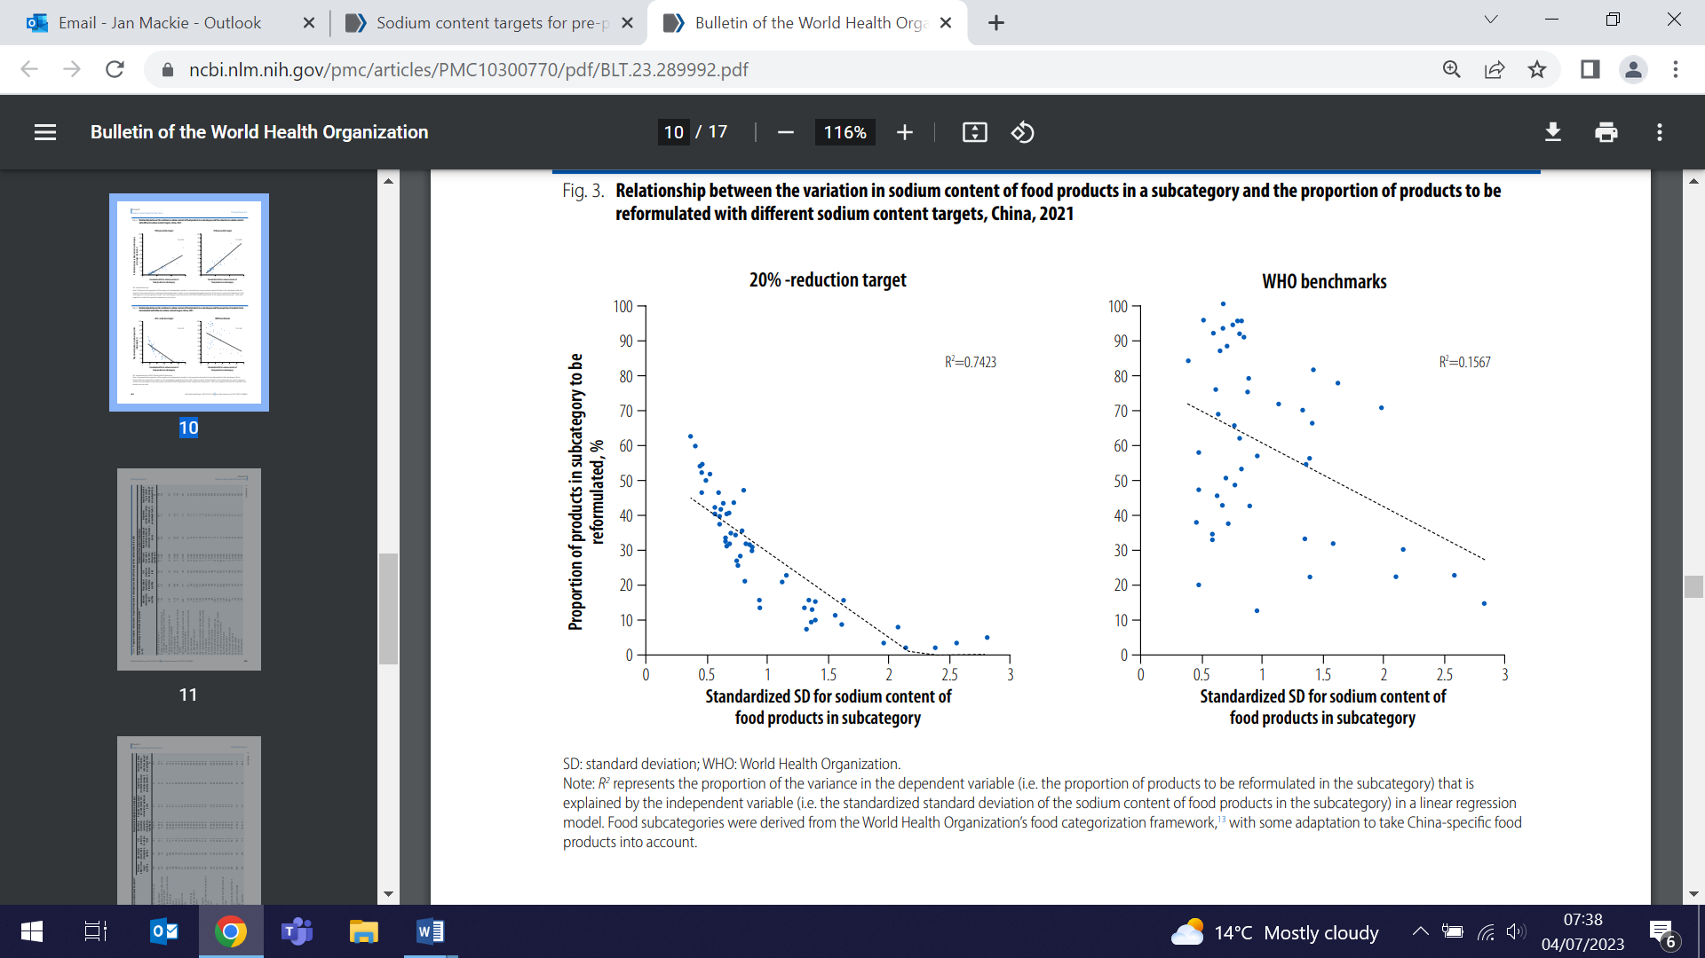
Five Health Experts Comment on the State of the NHS at 75
3 July (Graham MacGregor. Centre for Public Health and Policy)

  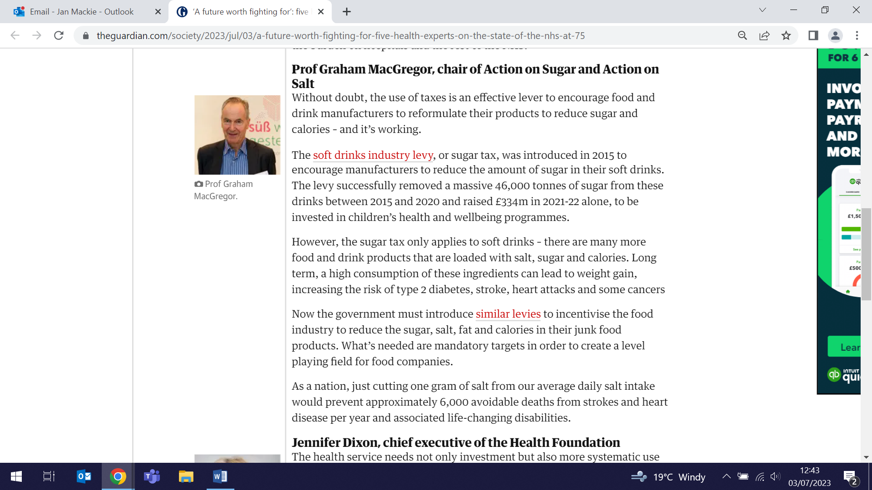 | A feature piece in the Guardian invites five leading UK health experts to assess the state of the NHS at 75, including Professor Graham MacGregor who writes about the need to introduce levies to incentivise the food industry to reduce sugar, salt, fat and calories in junk food products. Pointing to the success of the soft drinks industry levy (or sugar tax), which removed 46000 tonnes of sugar from our shelves from 2015-2020, and raised £334million in 2021-22 alone, to be invested in children’s health and wellbeing programmes. Graham said that mandatory targets can create a level playing field for food companies.
FORTHCOMING EVENTS AND NOTICES

Forum on Cancers in the Jewish Community
Weds 14 July, 8pm

Professor Ranjit Manchanda will conduct the panel at the forthcoming Forum on Cancers in the Jewish Community, to be held at the Belmont United Synagogue on 14 July. The Forum will discuss lifestyle, genetics and diagnosis, with a Q&A session. All are welcome. For more info and to book click here. | 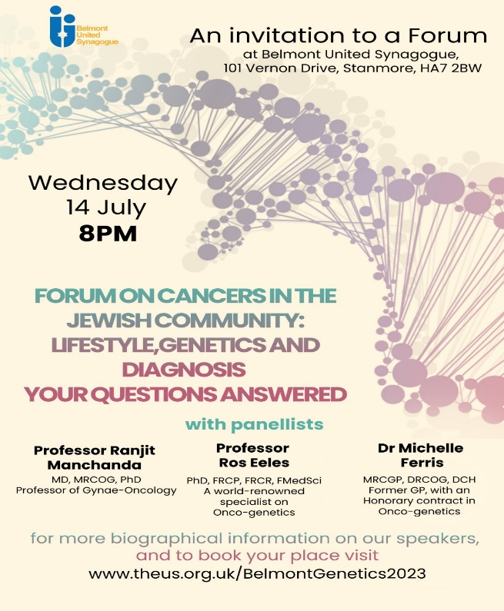
Many thanks to all who so enthusiastically contribute. Please send any news items for the next newsletter to j.a.mackie@qmul.ac.uk

