WOLFSON INSTITUTE OF POPULATION HEALTH
NEWSLETTER
ISSUE 38: 25 JULY 2023

In this issue of our Wolfson Institute of Population Health Newsletter, we celebrate the achievements and work of staff and students from late June and through July.

FROM OUR DIRECTOR
Dear All

As we draw towards summer holiday time, I’d like to extend warm thanks to everyone involved in delivering education for our MBBS and post-graduate students. I know that, for many of you, these last couple of months have been stretched with completing marking and assessments, but it makes it so worthwhile to see the joy of students and families at the wonderful graduation ceremonies taking place over the last week. I also had the great pleasure of attending the spectacular Rites of Passage in St Paul’s Cathedral (see photo below) with our new doctors and dentists plus their families.

I would also like to draw your attention to Professor Stephen Duffy’s attendance at the Houses of Parliament last week, when he was called to give oral evidence to the Health and Social Care Committee on innovative approaches to cancer detection and screening. He did magnificently, covering AI in mammography reading, detection of colorectal cancer, primary care pathways to cancer detection, fine tuning prostate cancer screening, and inequality in access to screening. Congratulations Stephen!

As we approach August please take the time to recharge batteries and get outside once the rain eases a bit. Happy holidays to those taking time away!

With warm wishes

Fiona



MEET WIPH

MEET WIPH – ESUBALEW ASSEFA
(Health Economist, Centre for Evaluation and Methods)

How would you describe your roles and responsibilities?

I am part of a team of health economists in the Health Economics and Policy Research Unit. We collaborate with colleagues both within WIPH and beyond, to design and execute economic evaluation of clinical trials and health interventions. Our team also works on equally exciting areas of health policy evaluation, modelling for economic evaluation, quality-of-life research, and the development of methodology in these areas. I am working currently on trials in mental health and perioperative interventions, which entails developing plans and approaches to assess cost-effectiveness of interventions, identifying and collecting relevant data, performing data analysis, and preparing reports.

What aspects of your role do you enjoy the most?

I enjoy working on different projects, interacting with a variety of people, and the supportive and collegial team and environment.

What would be your second choice as a profession?

I think perhaps a teacher. Both my parents were primary school teachers, and I have aunts and uncles who were and still are teachers as well. I have enormous respect for the profession and for teachers.

What do you enjoy doing outside work?  Depending on the day, I enjoy walking, swimming, visiting parks or having a meal or a drink with friends.  Something about you that most people don’t know?  I have a keen interest in agriculture and farming, and recently helped a friend set up an avocado orchard back home in Ethiopia. I find that there is some stillness and calmness about visiting a farm or rural areas. | 
FROM OUR LEADERSHIP TEAMS

Research News from Tor Kemp (Research Manager)

NIHR ARC North Thames Research Showcase | 11 September 2023
ARC North Thames invite you to join a special showcase event to see how their research is having a positive impact on the wellbeing of North Thames communities. The event will include an exciting mix of display, presentation, film, and interactive installations. Drop in and connect over a drink and a chat, celebrate the ARC journey so far, and co-create next steps, as the ARC continues to meet your local priorities and service needs through our findings, tools, and research capacity building opportunities. Register using the title link for the event on Monday 11 September, 1500-1800.

NIHR Research for Patient Benefit (RfPB) Methodologist highlight | Deadline 13 September
As part of NIHRs strategy to strengthen careers of under-represented disciplines and specialisms, the NIHR Research for Patient Benefit (RfPB) Programme has launched a series of highlight notices. The Methodologist highlight call currently open for applications will close on 13 September. Further details can be found on the funding opportunity and call specification pages. A webinar for this programme was held in May and the recording from the event is now available to watch.

NIHR Advanced Fellowship+ | NIHR Efficacy and Mechanisms Evaluation programme collaboration with NIHR Academy | Deadline extension to 14 September
This collaboration provides an opportunity, for those wishing to pursue an NIHR Advanced Fellowship, that will also support project funding to deliver and gain experience of leading a clinical study with appropriate mentorship. Interested applicants are encouraged to approach the CTUs to discuss support. The deadline for applications has been extended to 14 September.

NIHR new monthly community social media feature
To shine a spotlight on our community and celebrate the many talented researchers working across the country, NIHR would love to interview you about your role and what you love about it for our new monthly social media feature. Please complete the expression of interest form if you’d like to take part. If you are nominating a colleague or team, please check that they are happy to be 'in the spotlight'.

GENERAL INSTITUTE NEWS

Reaching across the political divide to address health inequalities
28 June (John Ford. Centre for Primary Care)

 | An editorial by John Ford and colleagues argues that public health should engage more with arguments of meritocracy and personal responsibility to make progress on health inequalities. The authors propose that public health should leverage the most relevant arguments across different political ideologies to promote a healthier and fairer society, and that we must demonstrate where structures and systems in society reduce opportunities, and highlight the root causes of lack of opportunities. Health inequalities may be a useful rallying cry to the left, but positive visionary language (eg. health-for-all) may be more helpful. Public health could remain in its comfort-zone, describing inequalities and arguing for equal distribution of the social determinants of health, but to engage across the political divide and make progress, authors say we must engage in the public discourse of meritocracy and deservedness.
Roy Castle Foundation Podcast Special
29 June. (Sammy Quaife. Centre for Prevention, Detection and Diagnosis)

The Roy Castle Foundation Let’s Talk About Lung Cancer Podcast series has featured a special edition on the launch of the new national lung cancer screening programme, featuring Sammy Quaife. Sammy discussed what lung screening entails, who it is for, and important considerations for how it is delivered to ensure that it is accessible to all. | 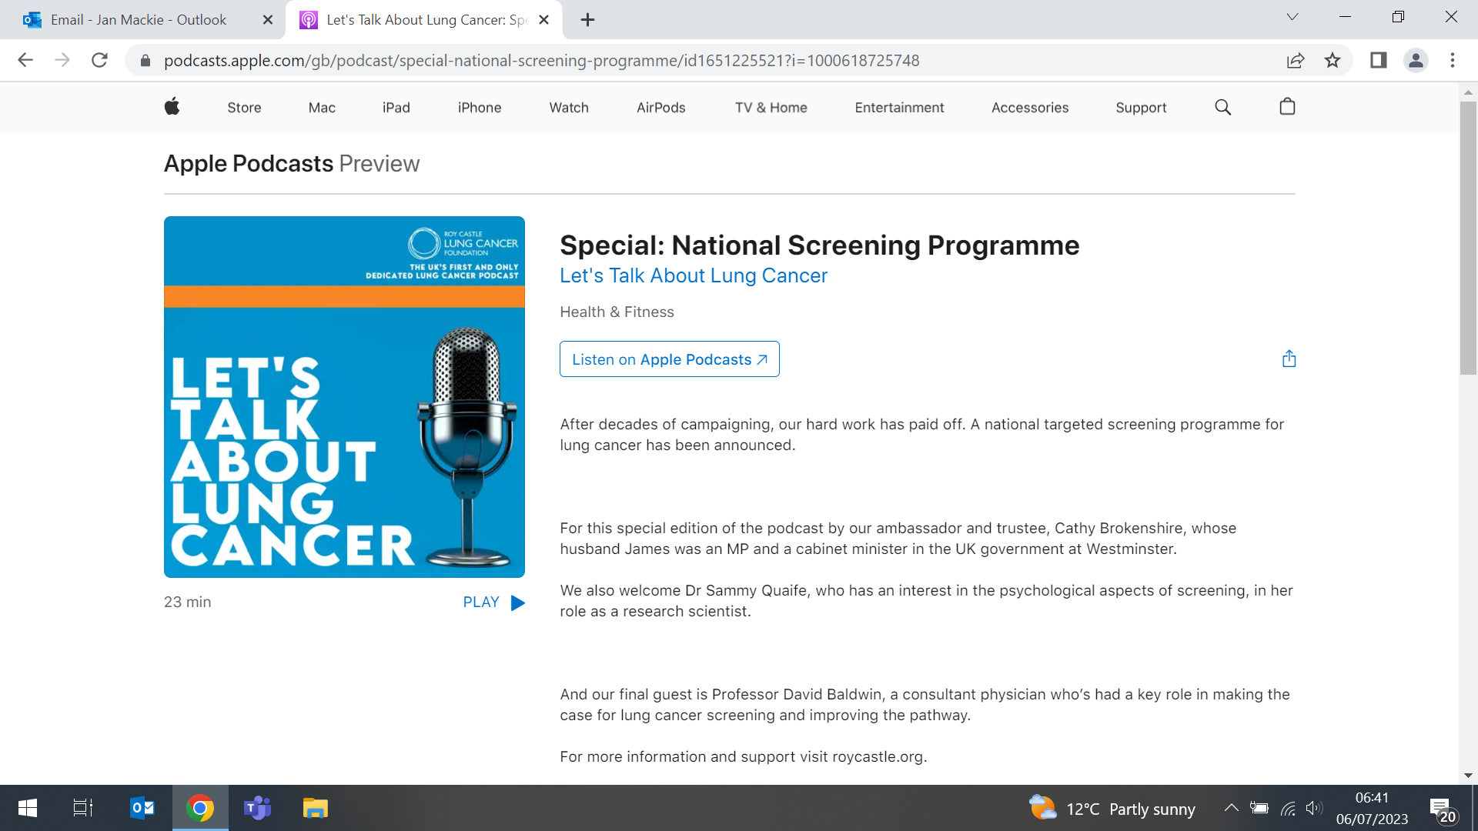
Awareness and use of low-Sodium Salt Substitutes in China
30 June (Feng He. Centre for Public Health and Policy)

 | A study of 4000 adults in 3 RCTs under Action on Salt China (ACS) shows that usage of low sodium salt substitutes (LSSS) in China is still very low, accounting for only about 1/10 families. In urban and rural areas in E. C. and W. China, awareness and use of LSSS were assessed using a questionnaire, and 24-h urinary sodium and potassium excretion were used to estimate dietary intake. Compared with those unaware of LSSS, participants who were aware of but not using LSSS and those using LSSS had lower 24-h urinary sodium excretion. In countries like China, where cooking salt is the main source of sodium, the promotion of LSSS should be considered as a key salt reduction strategy, in line with the recent WHO salt reduction report.
COVID–19, racial capitalism and the liberal international order
3 July (Andreas Papamichail. Centre for Public Health and Policy)

An article in International Affairs examining the effect of the COVID-19 pandemic on the liberal international order (LIO) reflects on why the predicted rupture in the order did not occur. Exploring the political economy of the dynamics of the global response to the pandemic (lockdowns, border controls and vaccine distribution), this piece argues that rather than causing a rupture, the pandemic reinscribed domestic and racial hierarchies. Border policies based on racial notions of who carries disease, and the intellectual property regime and profit motives of pharmaceutical companies that led to inequitable vaccine distribution are all linked with key ideational and material institutions of the LIO. The author concludes that domestic and global health policy needs to address the racial inequities that characterised the pandemic, ahead of future disease outbreaks. | 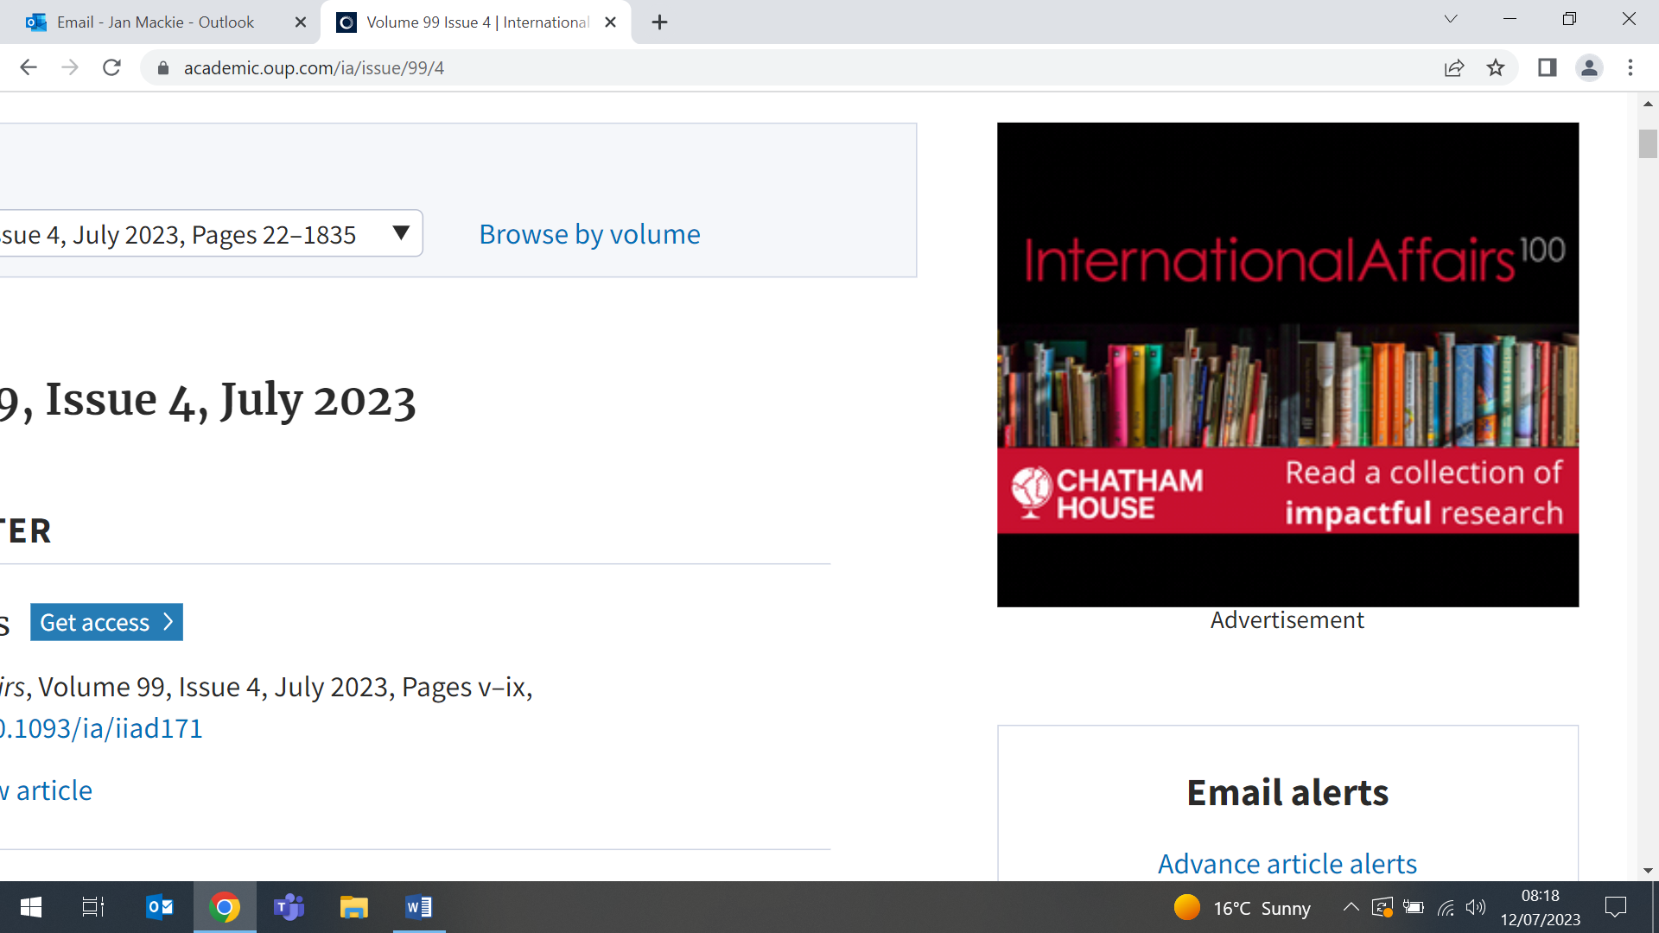

Symposium: South Asian labour migration - health and vulnerability

4 July (Dominik Zenner, Fiona Samuels. Centre for Public Health and Policy)

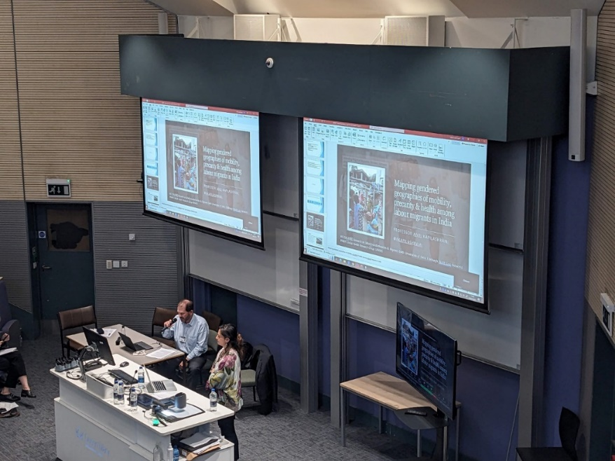 | On 4 July WIPH, in collaboration with the Queen Mary Global Policy Institute, hosted a symposium event focussing on the socioeconomic and health implications of South Asian labour migration. Co-chaired by Dominik Zenner and Fiona Samuels, the symposium was attended by around 50 participants, who heard from world leading experts providing insights into the vulnerabilities and health risks faced by South Asian labour migrants. Presentations included case studies from Nepal, Sri Lanka and the UK.
ULEZ discussion on the Today programme
4 July (Chris Griffiths. Centre for Primary Care)

In a Today programme about the planned extension of the London Ultra Low Emission Zone, Chris Griffiths noted that the effects of polluted air include “smaller size babies, premature deliveries, new cases of asthma, and when you get into adulthood, cardiovascular disease, respiratory disease, cancers and early onset dementia”. The broadcast was relayed to multiple local BBC Radio programmes. | 
Prediction models for heart failure in the community
5 July (Jianhua Wu. Centre for Primary Care)

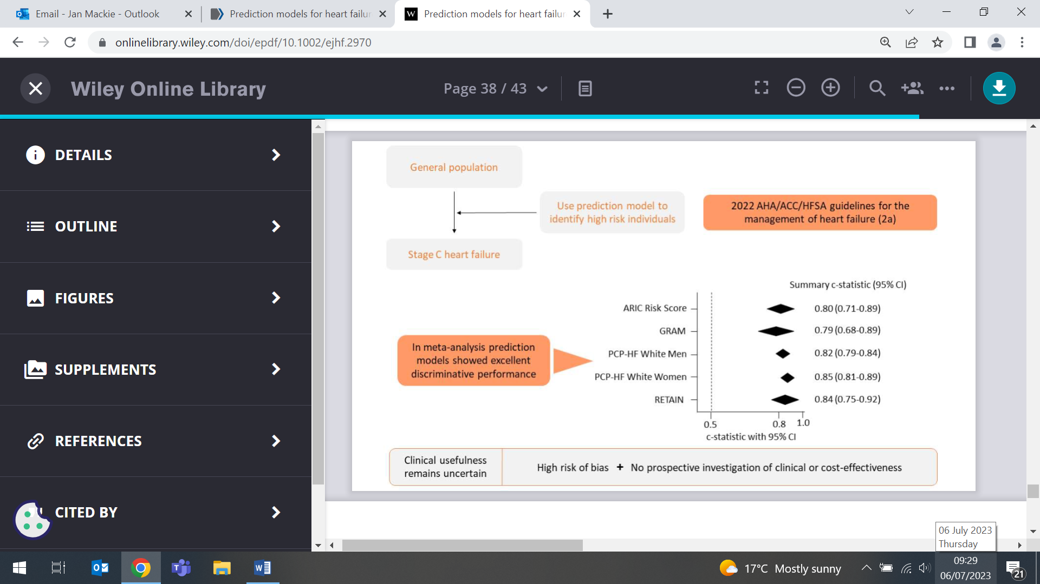 | A systematic review and meta-analysis of 36 studies with 59 prediction models shows that the usefulness of multivariate prediction models to estimate risk of heart failure in the general population remains uncertain due to high risk of bias, low certainty of evidence, and absence of clinical effectiveness research. In meta-analysis, the Atherosclerosis Risk in Communities Score, Graph-based attention model, Pooled Cohort equations to Prevent Heart Failure white men and white women models, and REverse Time AttentIoN Model had statistically significant 95% prediction interval and excellent discrimination performance. Results show that 77% of model results were at high risk of bias, certainty of evidence was low, and no model had a clinical impact study.
Is the UK ready for the treatment era for Alzheimer’s?
5 July (Charles Marshall. Centre for Prevention, Detection and Diagnosis)

Three drugs that may slow progression of Alzheimer’s if it is diagnosed early have been announced in the last 2 years, but an article in the Times notes that the drugs are needed early in disease progression, requiring fast, reliable, diagnoses. No requirement for quick diagnosis has previously existed, and so clinics in the UK are not set up for this. Charles Marshall told the Times that using these drugs would require a complete change in how we treat dementia: ‘Current NHS infrastructure will be unable to ensure universal early and equitable access to new treatments’. He added that at present ‘there are over 100 drugs currently in the pipeline for Alzheimer’s disease and these work in a range of different ways.' |   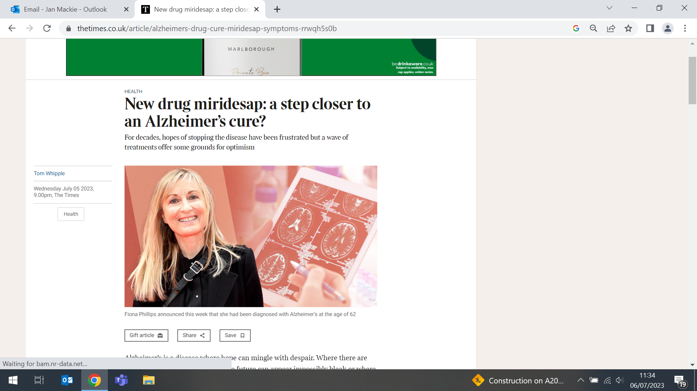
New tool pinpoints gaps in awareness of blood cancer symptoms
6 July (Georgia Black. Centre for Prevention, Detection and Diagnosis)

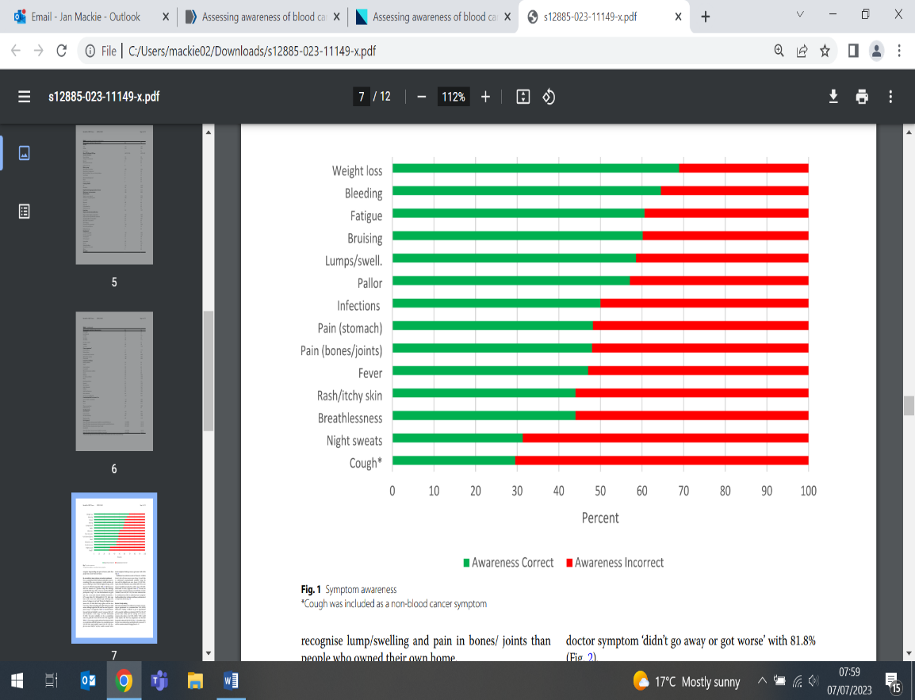 | A new tool to identify gaps in public knowledge about symptoms of blood cancer could help to shape future awareness campaigns, potentially saving countless lives. Blood cancer (including leukaemia, lymphoma, and myeloma) is the 3rd leading cause of UK cancer deaths. The new Cancer Awareness Measure for Blood Cancer (Blood CAM) is a validated online survey. In a nationally representative sample of 434 people, researchers found that 7% of respondents could not identify any blood cancer symptoms. Nearly 70% did not recognise night sweats and 56% did not identify rashes/itchy skin as indicators of the disease. Study PI Georgia Black said: ‘Our findings suggest avenues for equitable interventions and public messaging to improve outcomes for people with blood cancer.’
Addressing inequalities in East London Schools
6 July (Fiona Samuels. Centre for Public Health and Policy)

Fiona Samuels presented her report ‘Addressing Inequalities in Schools in East London: Establishing a Somali Parent Liaison Officer position in Morpeth School’ in Tower Hamlets on 6 July. The event was co-hosted by Morpeth school and the Women’s Inclusive Team, a charity that has supported Black and ethnic minority communities in Tower Hamlets since 2004. Fiona’s findings were discussed with an audience including representatives from the Tower Hamlet Mayoral office, the School governors association, and community based organizations working in East London and beyond. | 
Equitable implementation strategies for antiretroviral HIV therapy
9 July (Sara Paparini, Rachel Phillips. Centres for Public Health and Policy/Evaluation and Methods)

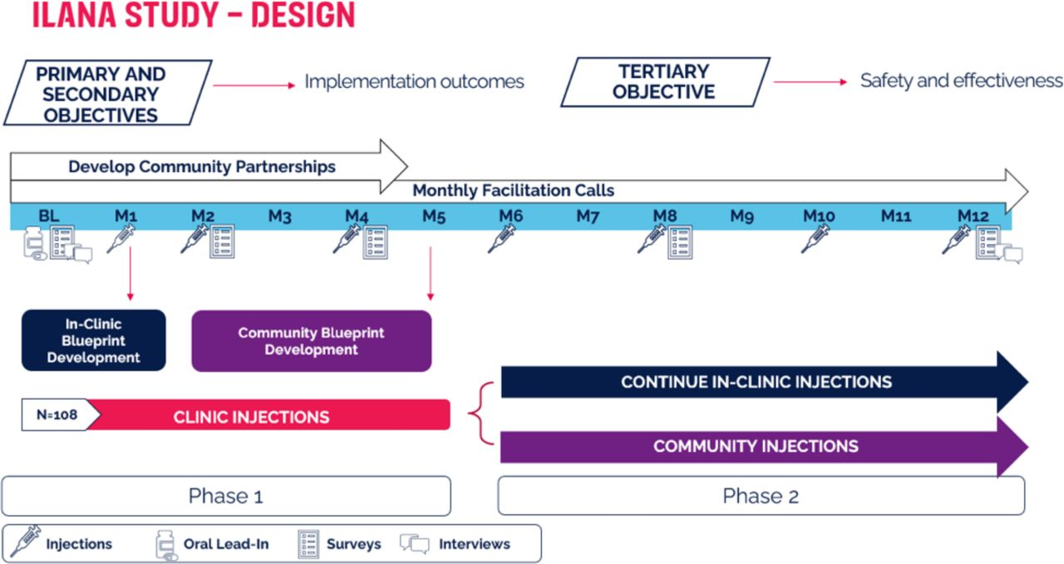 | The protocol has been published for the ILANA study, a qualitative multiphase longitudinal investigation to understand the implementation of long acting injectable therapy for HIV in both clinic and community settings in the UK, from the perspectives of participants and the clinical team. Long acting cabotegravir and rilpivirine (CAB-RPV- LA) allows people living with HIV to receive 2-monthly injectable treatment rather than daily pills. Recruitment caps have been set to ensure a representative study population: 50% women, 50% ethnically diverse people, and 30% aged 50+. The study will take place at NHS England HIV clinic sites at Barts, Chelsea and Westminster, Guy’s and St Thomas', Royal Free London, Royal Liverpool University Hospital and Royal Sussex County Hospital.
COVID-19 risk in people with MS who are seronegative after vaccination
11 July (Safiya Zaloum, Pooja Tank, Nicky Vickaryous, Katila George, Francesca Rios, Ruth Dobson. Centre for Prevention, Detection and Diagnosis)

A study of 647 people with multiple sclerosis investigates attenuated antibody response and clinical consequences following COVID-19 vaccination. At time of vaccination 524 participants were being treated with disease modifying therapies. Overall, 472/588 (73%) were seropositive after vaccines 1 and 2, and 222/305 (73%) after vaccine 3. Results show that seronegative status after vaccine 2 was associated with significantly higher risk (OR 2.35) of subsequent COVID-19 infection, but seronegative status after vaccine 3 was not (OR 1.05). Five people (0.8%), all seronegative after most recent vaccination, experienced severe COVID-19. Authors conclude that attenuated response to initial COVID-19 vaccination predicts increased risk of COVID-19 in people with MS but, overall, rates of severe COVID-19 were low. | 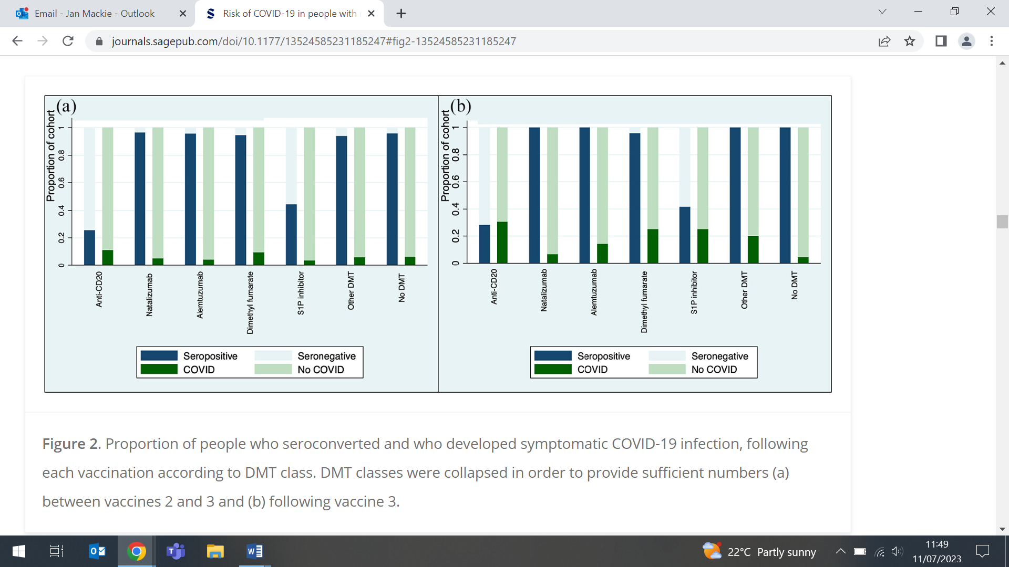  Proportion of people who seroconverted who developed COVID-19 (a) between vaccines 2 & 3 and (b) following vaccine 3
An online health community for adults with troublesome asthma
11 July (Georgios Karampatakis, Helen Wood, Chris Griffiths, Steph Taylor, Veronica Toffolutti, Victoria Bird, Bill Day, Clare Relton, Boby Mihaylova, Neil Walker, Anna De Simoni. Centres for Primary Care/Evaluation and Methods/Psychiatry and Mental Health)

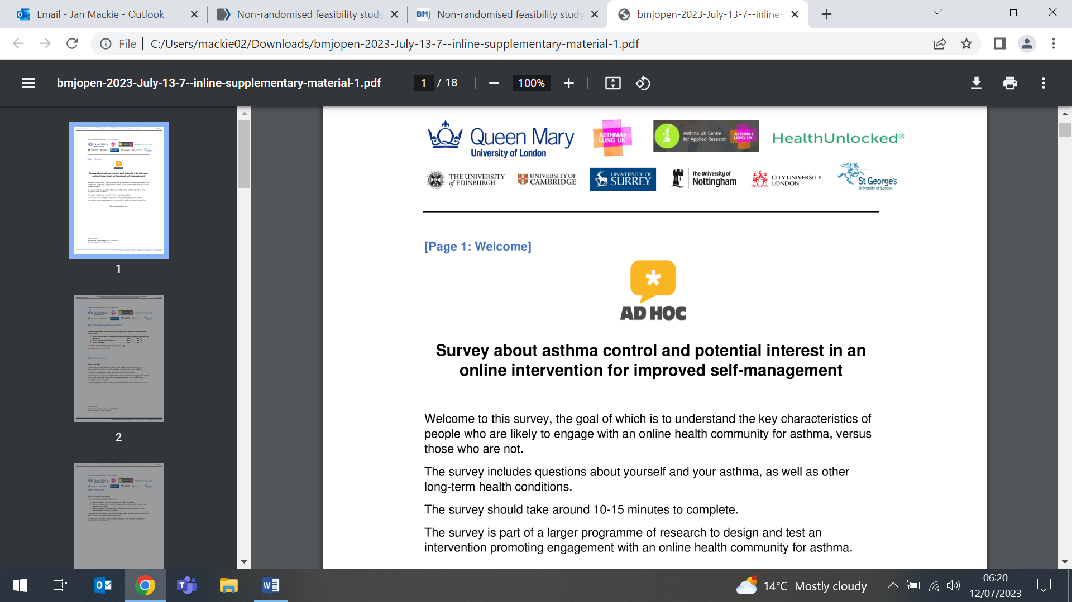 | One third of UK adults with asthma experience poor asthma control. A feasibility study to test an intervention promoting engagement in an online health community (OHC) for adults with troublesome asthma will invite patients from six London general practices to complete an online survey. From responses, 50 patients will be selected for the intervention, a one-off face-to-face consultation with a practice clinician to introduce online peer support, sign patients up to an established asthma OHC, and encourage OHC engagement. The published protocol predicts that the study will be completed in 9 months, with outcome measures collected at baseline and 3 months post intervention. Recruitment, intervention uptake, retention, collection of outcomes, and OHC engagement will be assessed.
Launch of new toolkit: Building equitable primary care
11 July (John Ford. Centre for Primary Care)

A practical toolkit and accompanying video for addressing unequal access to primary care was launched at an event at Coin Street Conference Centre in London on 11 July. Two academic groups, EQUALISE (led by John Ford, WIPH) and FAIRSTEPS, looked independently at what works to address inequalities in and through primary care, to produce a solution-focused toolkit. The kit brings together their findings to describe what equitable primary care looks like, and provide practical steps to help local decision makers address inequalities in health and healthcare. | 
Singapore Conferences
11 and 13 July (Rohini Mathur. Centre for Primary Care)

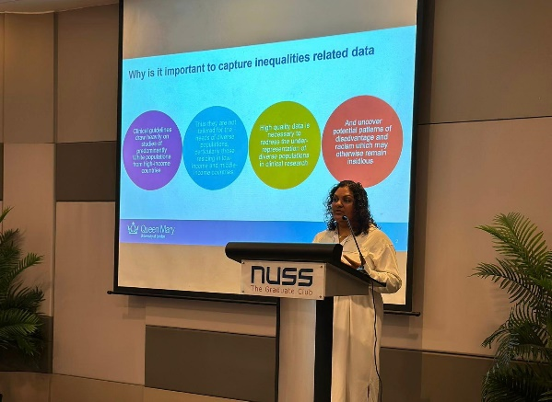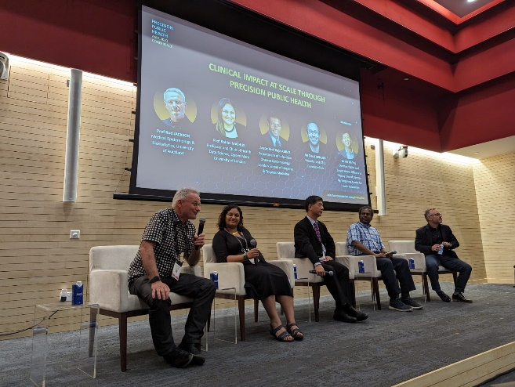 | Rohini Mathur presented at two conferences in Singapore in July. The first, Improving health outcomes through trusted data exchange and artificial intelligence was hosted by the British High Commission in Singapore & Singapore Health Technologies. The second, Precision Public Health Asia 2023, explored strategies for genomics, digital health, big data and AI, and how these can benefit public health in the developed and developing worlds.
Centre for Public Health and Policy Away Day
12 July

The CPHP Away Day on 12 July brought together the four research units for a range of activities fostering networking and collaboration. In addition to some fun challenges (‘human bingo’ and ‘mind boggling medical history’), the main event was the competition to create posters for possible research projects. Topics included: Impact of smoking/diet/weight/salt or sugar intake on fertility and during pregnancy, Global health governance and the commercial determinants of health, Health inequity and multimorbidity, and the winning project: How can East London solutions be implemented nationally/globally? | 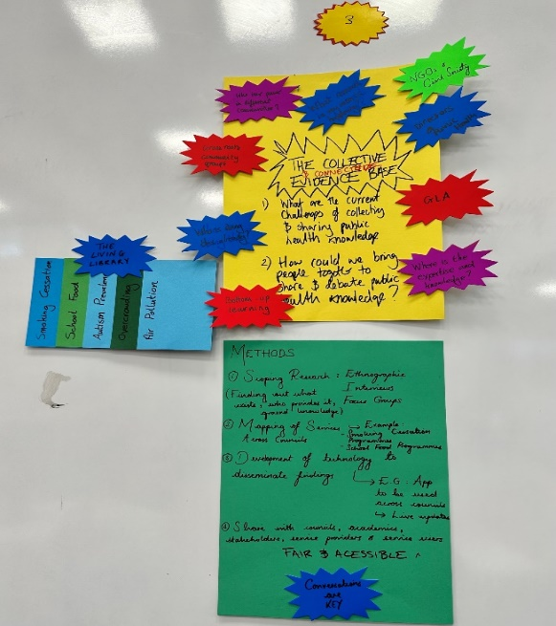
Benefit of repeat breast cancer screening participation on survival
12 July (Stephen Duffy. Centre for Prevention, Detection and Diagnosis)

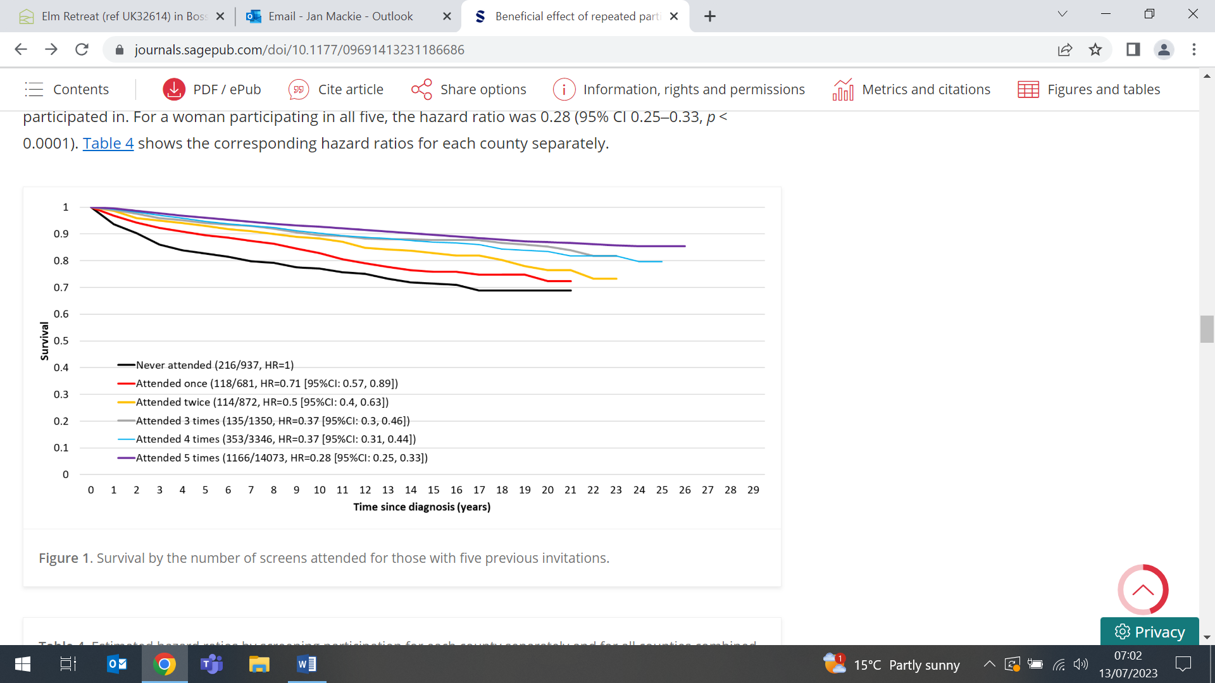 | Analysis of incidence and survival data on over 37,000 women who were diagnosed with breast cancer over 24 years in Sweden (4564 of whom subsequently died of breast cancer) shows successively better survival with increasing number of screens in which the women had participated. The study shows that, for a woman who participated in all five of her issued breast screening invitations before being diagnosed, compared with a woman who attended none, there was an approximate threefold reduction in the risk of dying from breast cancer.
Developing theoretically informed audit and feedback in IMP2ART
12 July (Liz Steed, Steph Taylor. Centre for Primary Care)

Researchers on the IMPlementing IMProved Asthma self-management as RouTine (IMP² ART) programme have designed and developed theoretically-informed audit and feedback, which is now being tested in a UK-wide cluster RCT. Aligned with the MRC complex intervention framework, the prototype audit and feedback was guided by and mapped to existing literature suggestions, with the theory developed in three phases: development, feasibility, and prepiloting. Through the multistage development process, the prototype audit and feedback confirmed feasibility and identified refinements, and prepiloting informed integration with other IMP² ART programme strategies. | 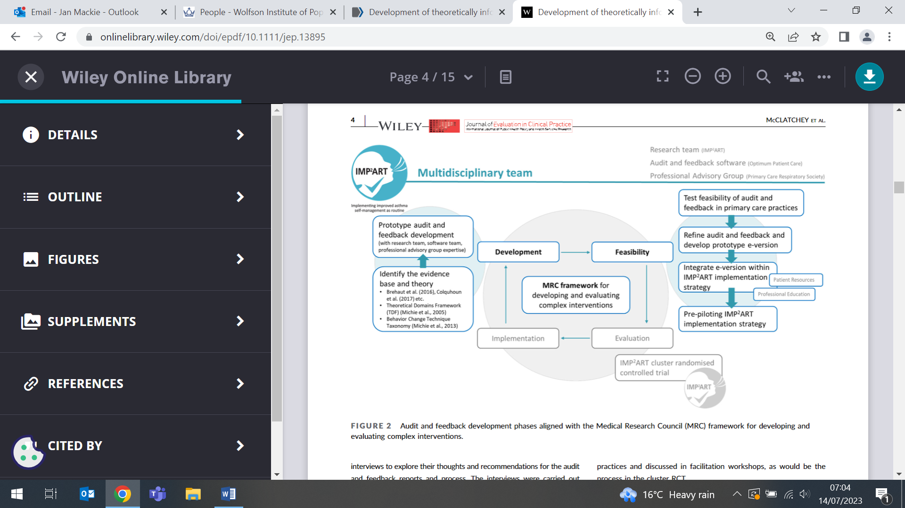

How England’s new lung cancer screening could save thousands of lives
13 July (Sammy Quaife. Centre for Prevention, Detection and Diagnosis)

  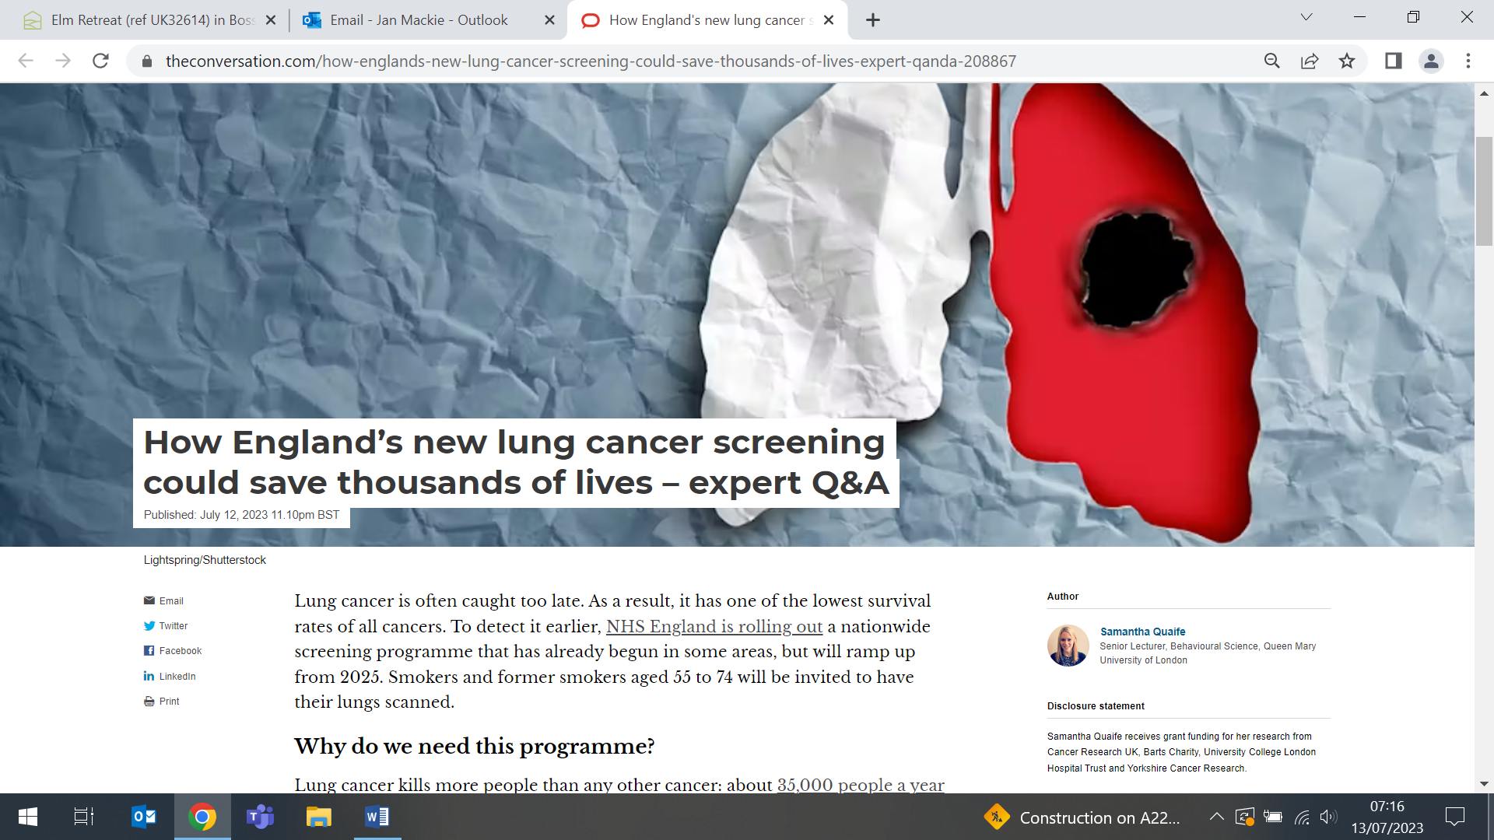  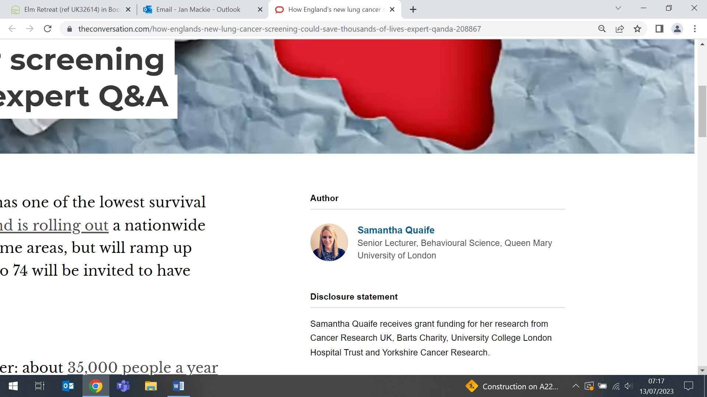 | In an Expert Q&A, Sammy Quaife tells The Conversation that the rollout of the NHS England National targeted lung cancer screening programme is expected to detect lung cancer in about 9000 people each year, with most of them found to have early-stage disease. She writes that because lung cancer is often detected too late, it has one of the lowest survival rates of all cancers, killing around 35,000 people each year in the UK. To detect it earlier, the NHS England nationwide screening programme, which has already begun in some areas, will ramp up from 2025, inviting smokers and former smokers aged 55-74 to have their lungs scanned.
How young people perceive the benefits of drama therapy for emotional disorders
13 July (Ellie Keiller, Aisling Murray, Megan Tjasink, Dennis Ougrin, Catherine Carr, Jennifer Lau. Centre for Psychiatry and Mental Health)

A review of publications reflecting participants’ perceptions of the active ingredients of dramatherapy as a treatment for child and adolescent emotional disorders (eg. anxiety, depression and trauma-related stress) identifies 6 analytical themes: dramatherapy as a (i) learning and (ii) social experience, and as a (iii) positive intervention which supports (iv) self-expression and (v) emotion regulation. When the findings of this synthesis were benchmarked against other interventions commonly offered to children and young people with emotional distress, 3 active ingredients (dramatherapy is fun, dramatherapy builds confidence, participants process difficulties through drama) were considered to be unique to dramatherapy. | 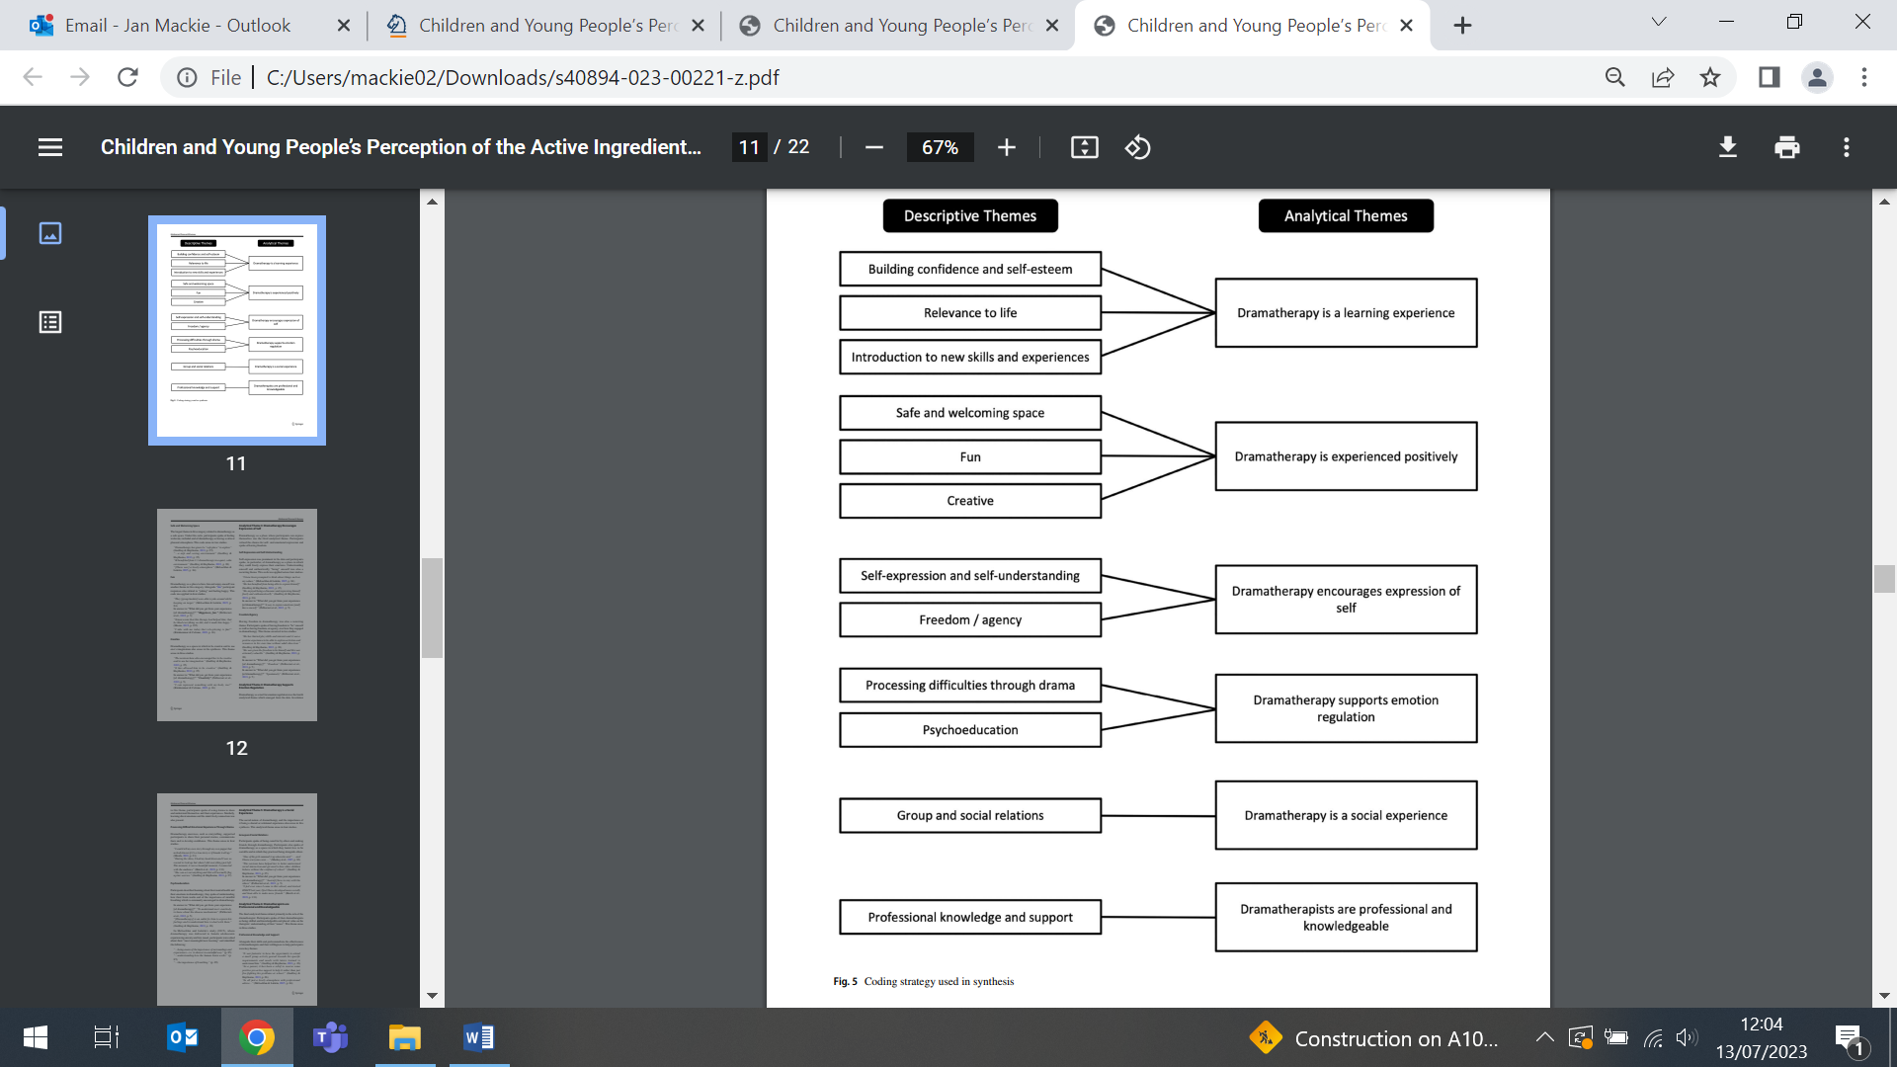
Talk by Professor Jon Emery
13 July (Early Cancer Diagnosis Team. Centre for Prevention, Detection and Diagnosis)

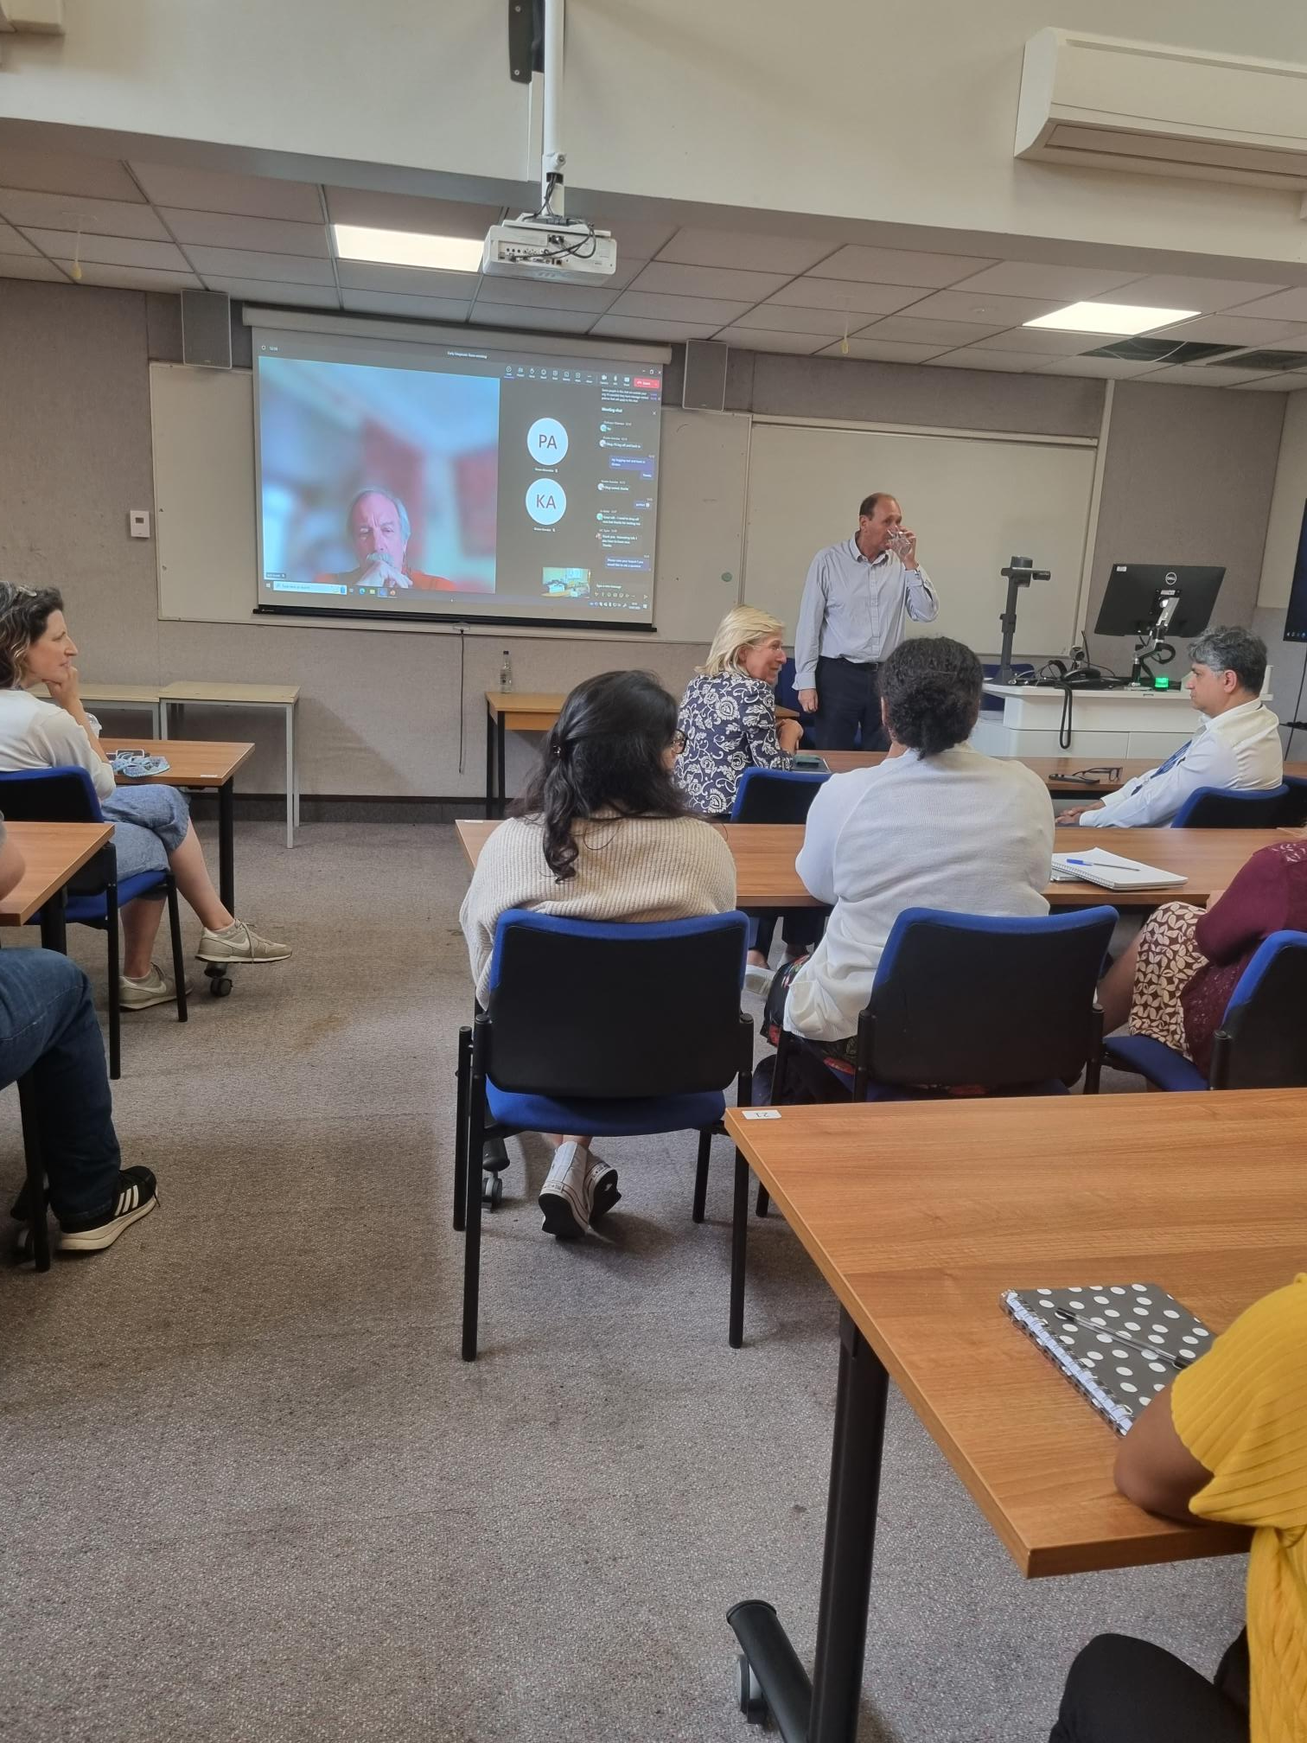 | A research meeting of the Early Cancer Diagnosis team in the Cancer Detection and Diagnosis Unit on 13 July welcomed Professor Jon Emery, who spoke about his work on risk stratified cancer screening and lung cancer. Professor Emery is the inaugural Herman Chair of Primary Care Cancer Research at the University of Melbourne, and Director of the Australian Primary Care Collaborative Cancer Clinical Trials Group.
The primary care medical workforce crisis in Europe
14 July (Giuliano Russo. Centre for Public Health and Policy)

Introducing a collection of articles in Human Resources for Health, an editorial reflects on how primary care medical workforce shortages in Europe are exacerbated by higher demand for services from aging populations, increased burden of chronic diseases, backlogs from the COVID-19 pandemic, and patient expectations. Simultaneously, primary care physician supply is constrained by rising retirement rates, migration, worsening working conditions, budget cuts, and increased burnout. Misalignment between national education sectors and labour markets compounds staff shortages and maldistribution. The editorial concludes that this region, with predominantly publicly funded health systems and following COVID-19, may be on the cusp of a primary care crisis, with almost every country reporting long delays for appointments, physician shortages, and unfilled vacancies, resulting in added pressure on hospital A&E services. | 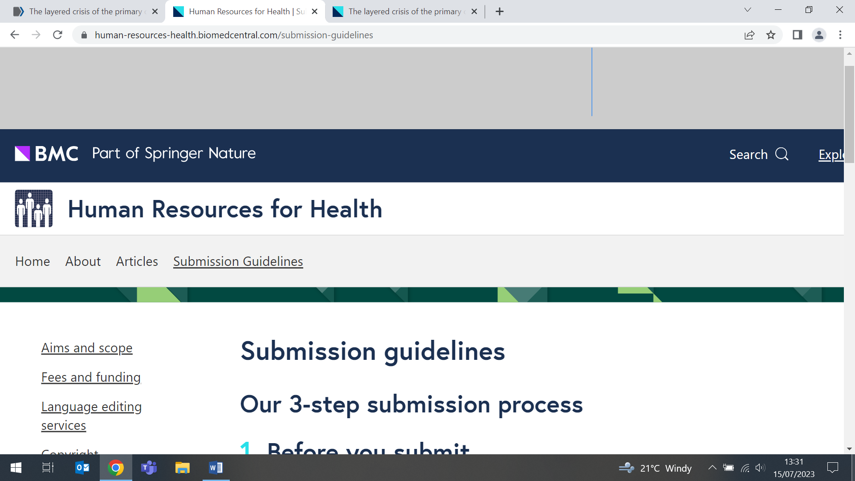  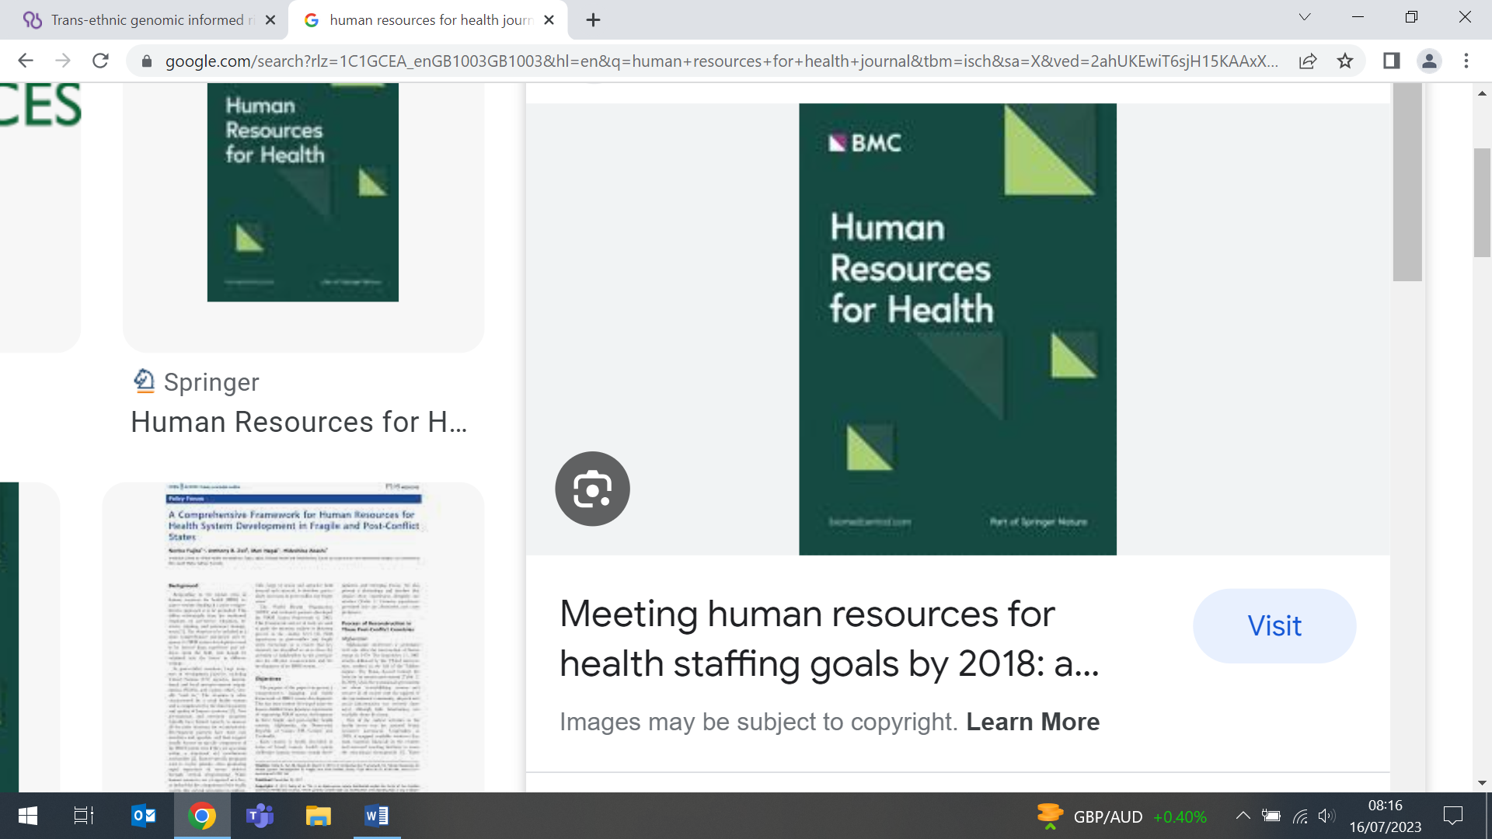
Ancestry and Sex Bias in Pharmacogenomics
14 July (Moneeza Siddiqui, Rohini Mathur. Centre for Primary Care)

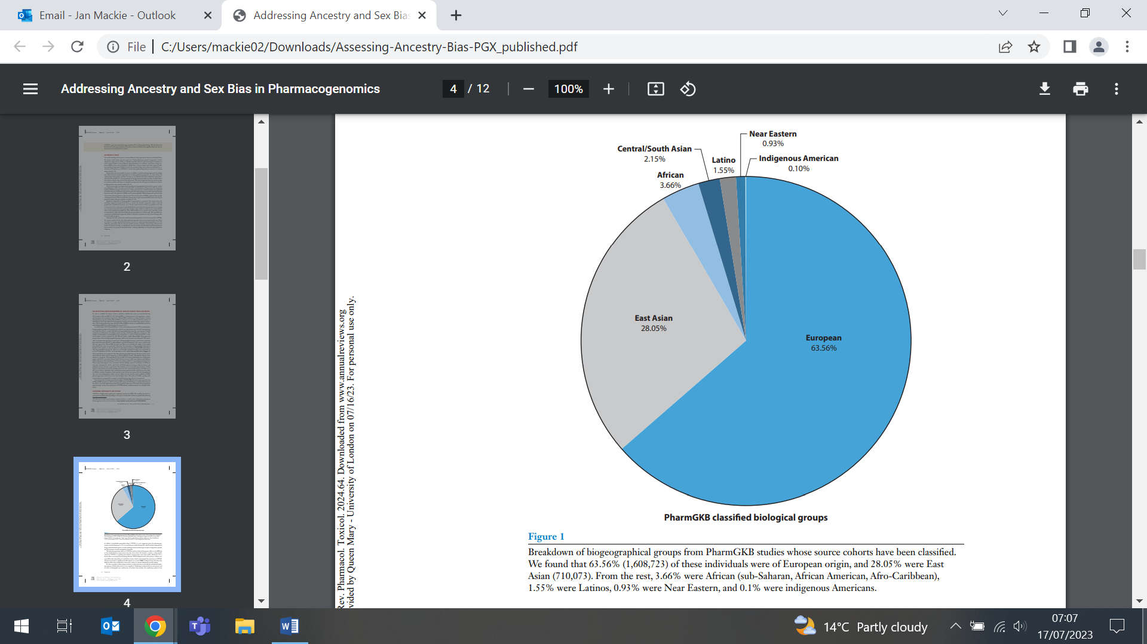 | Research in pharmacogenomics, the relationship between genetic variants and drug efficacy or toxicity, suffers from bias and underrepresentation of females and people from certain ancestry groups. A paper examining the representation of biogeographical populations in pharmacogenomic datasets in the PharmGKB repository of drug-gene annotations uses as a case study the CYP2D6 gene, which metabolizes around 1/4 of all prescribed drugs. Results show that most data from which pharmacogenomics knowledge is derived are based on European and East Asian males, with groups such as Africans, Latinos, and South/Central Asians comprising a minimal fraction of data. Researchers note that differential drug efficacy and safety profiles exist for males v females, and also for women across different stages of their life course. They conclude that addressing ancestry and sex bias in pharmacogenomics research can improve the accuracy and effectiveness of drug therapies, to ensure that all patients receive the best possible care.
Trans-ethnic genomic informed risk assessment for Alzheimer's disease
14 July (Naaheed Mukadam, Isabelle Foote, Charles Marshall. Centre for Prevention, detection and Diagnosis)

In an international collaborative effort between the International HundredK+ Cohorts Consortium and the Davos Alzheimer’s Collaborative, authors have brought together large scale cohorts of diverse international populations with genome-wide genotype data to create and validate a trans-ethnic genomic informed risk assessment (GIRA) algorithm for Alzheimer's disease. The GIRA model includes polygenic risk score calculated from the Alzheimer’s disease genome-wide association study loci, the apolipoprotein E haplotypes, and non-genetic covariates including age, sex, and the first three principal components of population substructure. Researchers then validated the performance of the model in different populations, concluding that GIRA has the potential to identify individuals at high risk of developing Alzheimer’s disease for future clinical applications. | 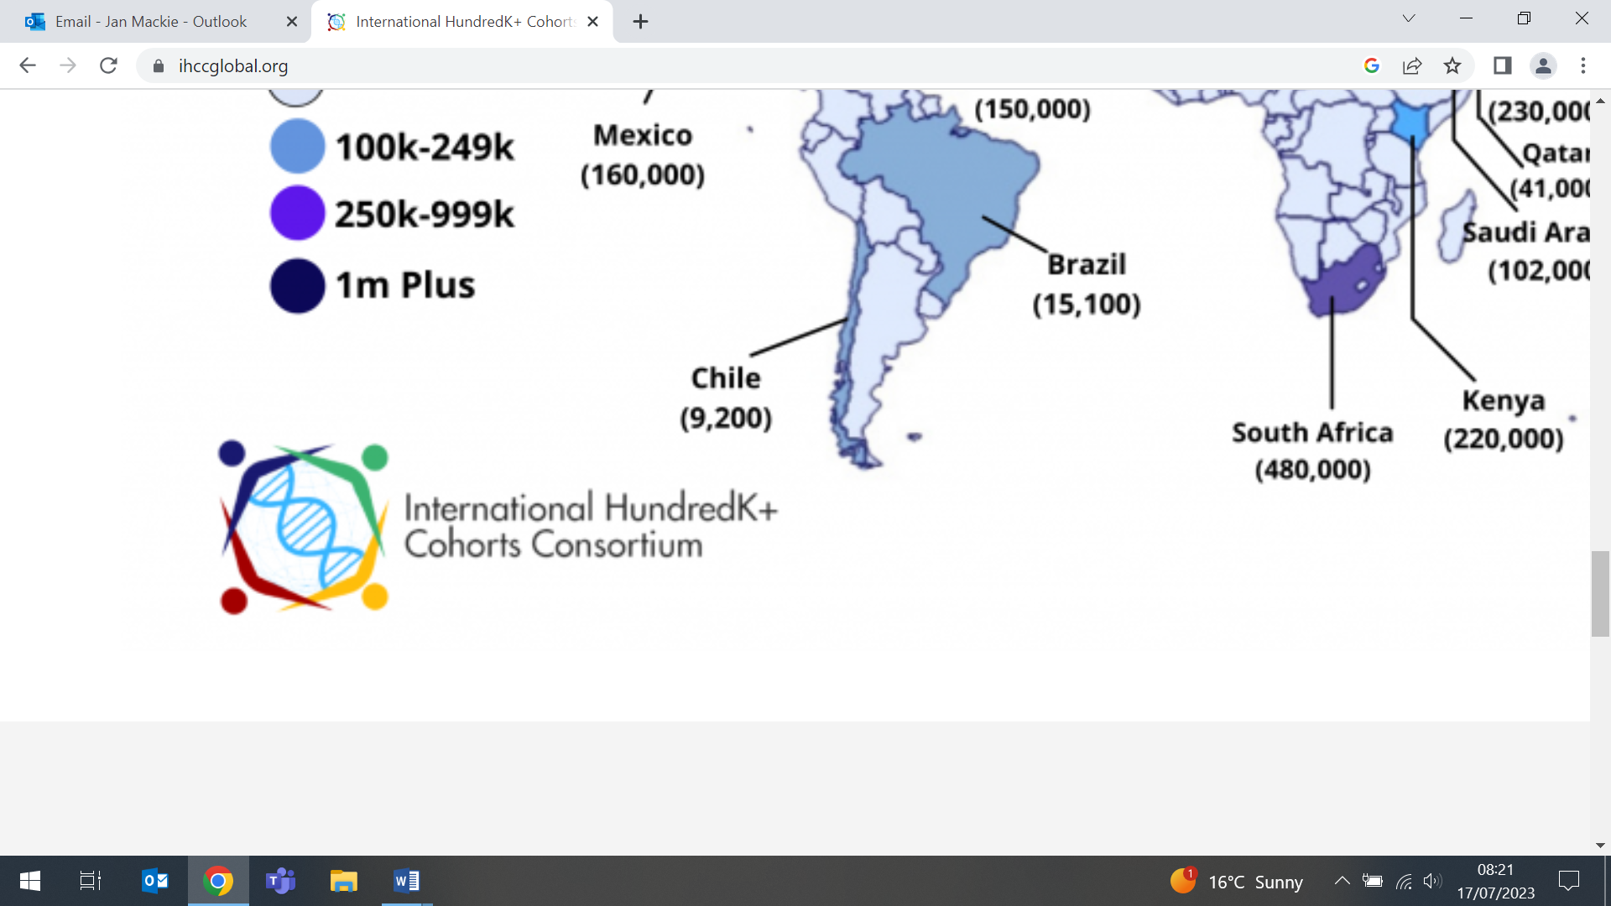  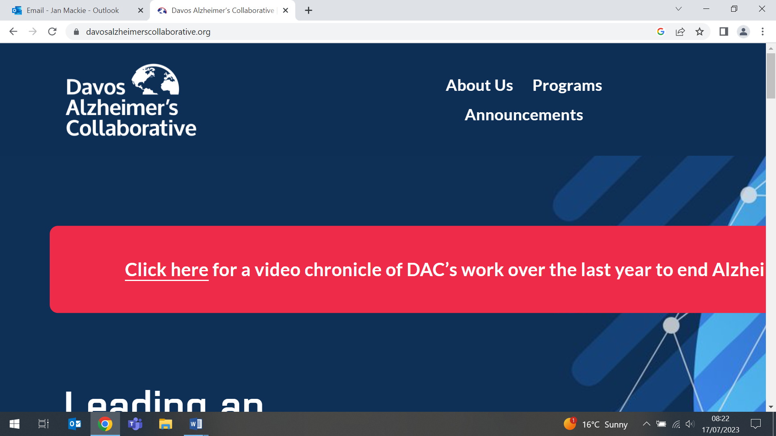  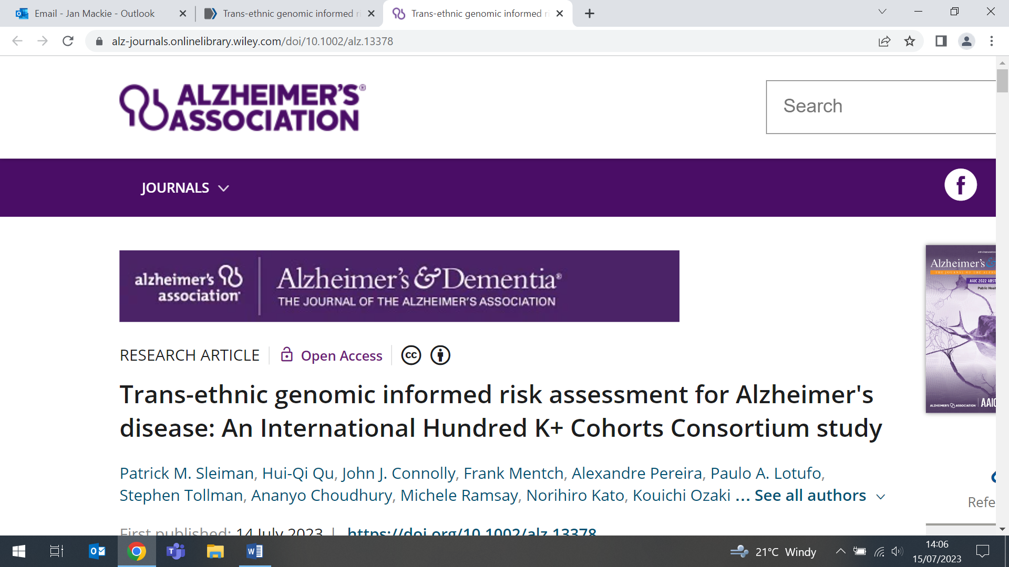
Subtyping malignant mesothelioma using multiple instance learning
17 July (Judith Offman. Centre for Prevention, Detection and Diagnosis)

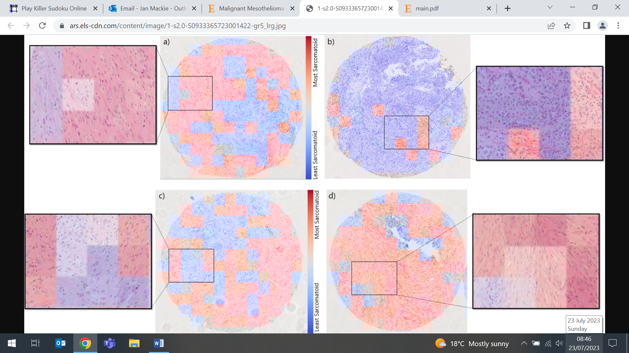 | The subtyping of Malignant Mesothelioma informs treatment, but subtyping, and specifically the recognition of transitional features from routine histology slides, has high inter-observer variability. New research proposes an end-to-end multiple instance learning (MIL) approach for subtyping, using an adaptive instance-based sampling scheme for training deep convolutional neural networks on bags of image patches, that allows learning on a wide range of relevant instances. The method was evaluated on a dataset of 234 tissue micro-array cores with an AUROC of 0.89 ± 0.05. The approach enables identification of subtypes of specific tissue regions from which a continuous characterization of a sample according to predominance of sarcomatoid v epithelioid regions is possible, avoiding the arbitrary and highly subjective categorisation by currently used subtypes.
New research outcomes reflect women's experiences of heavy menstrual bleeding
17 July (Natalie Cooper. Centre for Public Health and Policy)

New work to determine which research outcomes best reflect how heavy menstrual bleeding (HMB) affects women’s lives has contributed to the development of a core outcome set (COS) for HMB. Patient workshop discussions and telephone interviews conducted through an East London teaching hospital identified 5 main themes important to patients: restriction, relationships and isolation, emotions and self-perception, pain, and perceptions of treatment. Researchers observed coding nodes not previously reported as outcomes in HMB studies which, when consolidated, became 5 new outcomes (see table) for inclusion in the next stage of core outcome development. Giving patients a voice to explain how they are affected will ensure that future research asks questions that are applicable to women. | 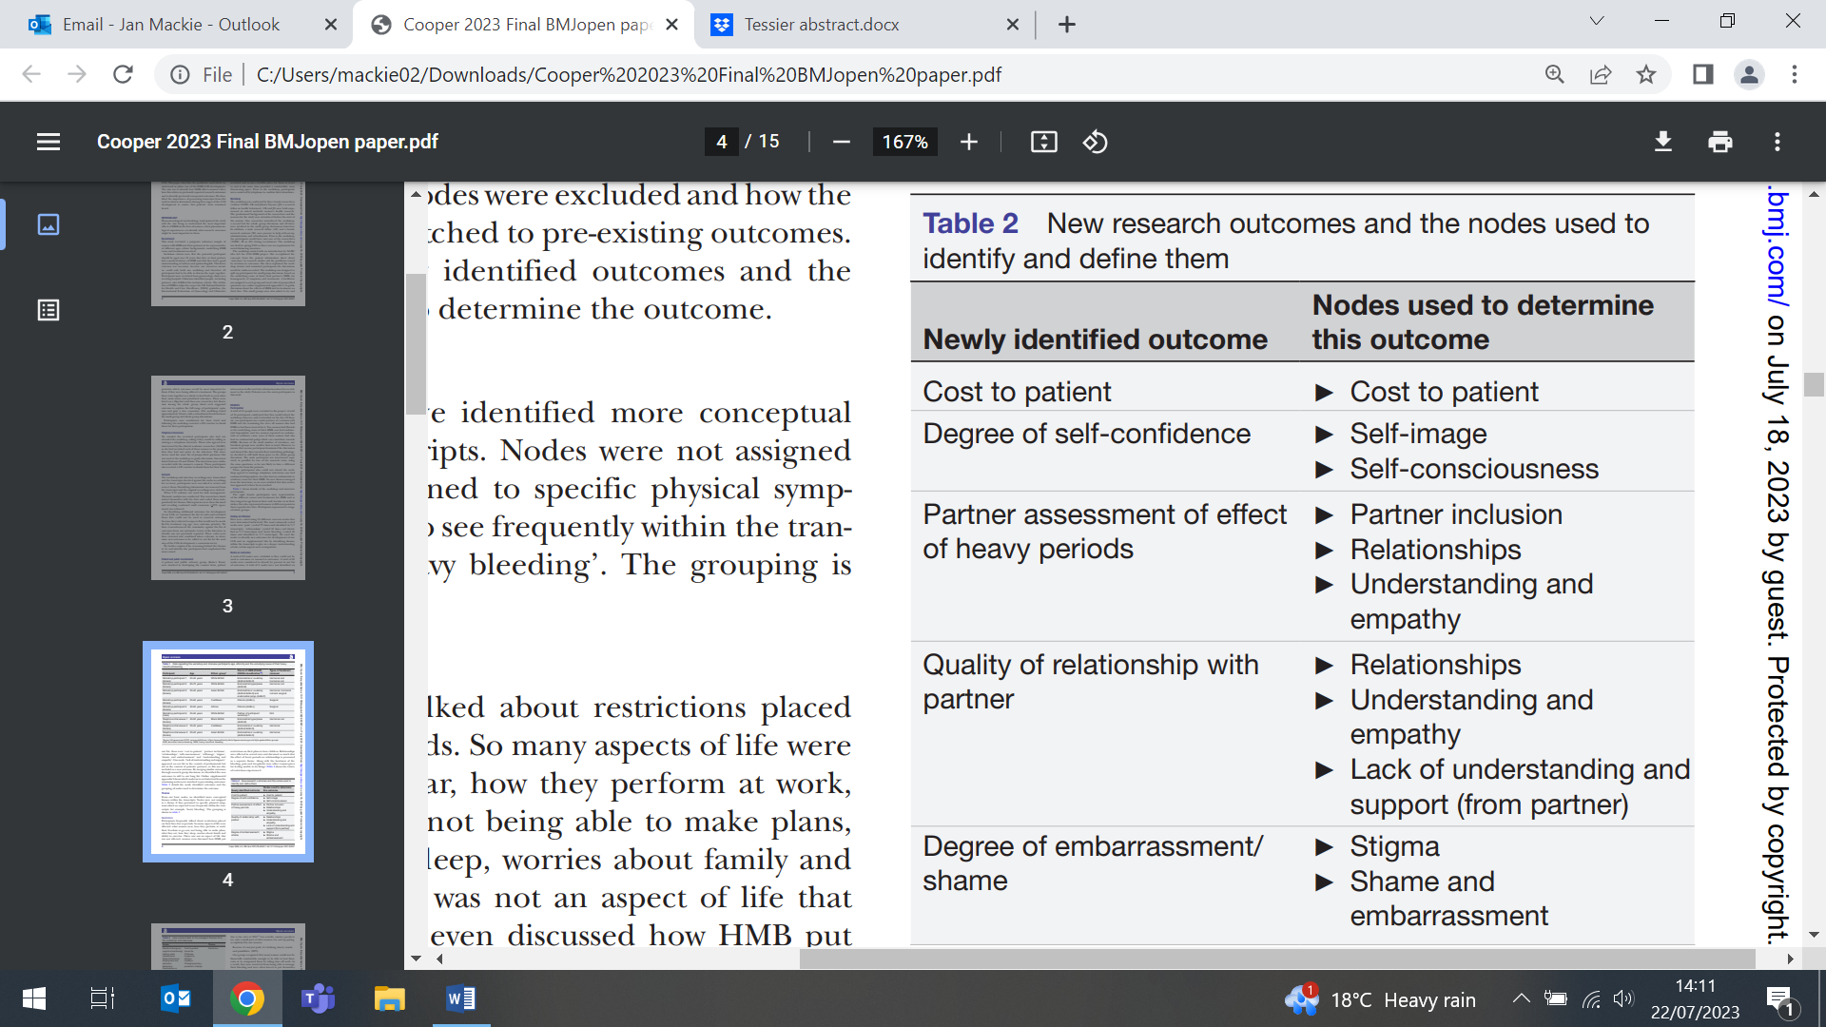
Expert Reaction to results from RCT of hearing aids for cognitive decline
18 July (Charles Marshall. Centre for Prevention, Detection and Diagnosis)

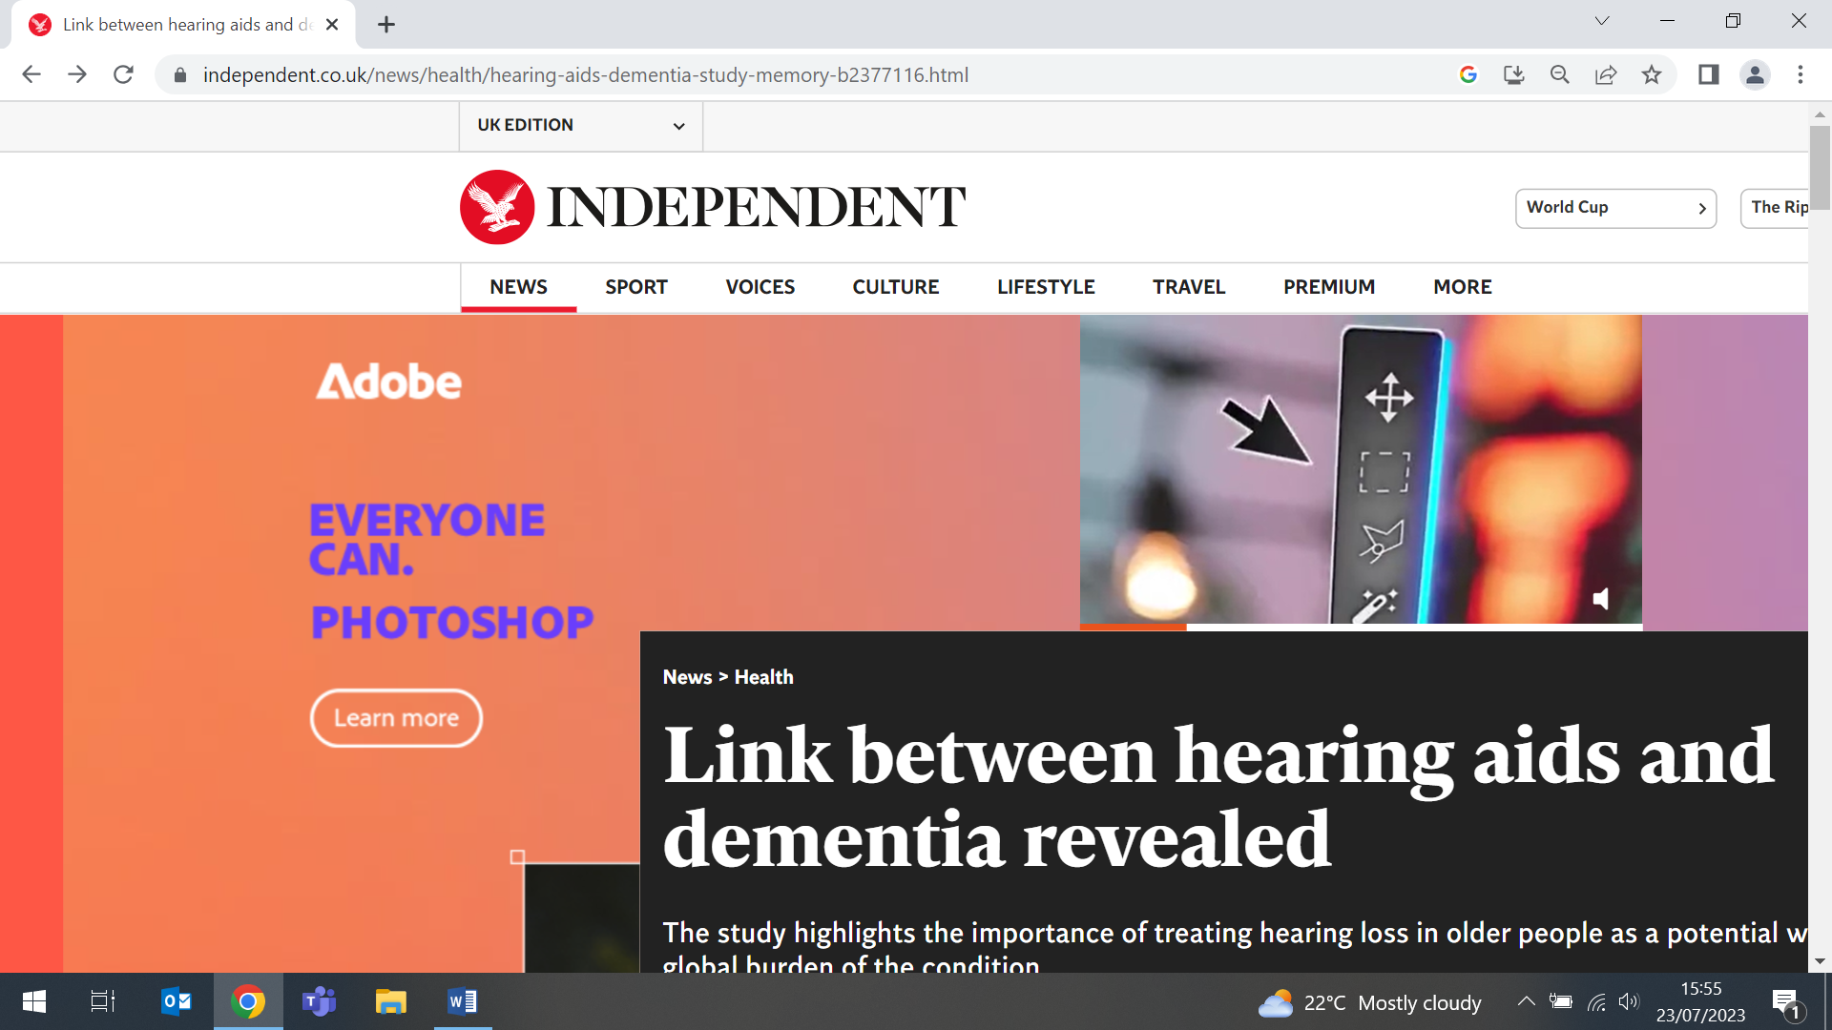  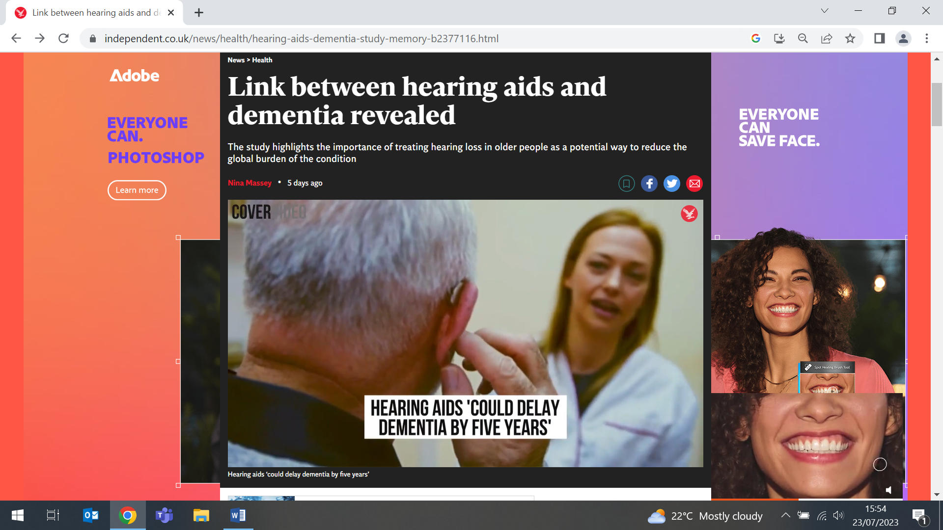 | Commenting on the Lancet publication of results from the Achieve trial, Charles Marshall was widely cited in media outlets, including The Times, Evening Standard, and Independent. The study of 977 US adults aged 70–84 with untreated hearing loss who were free from substantial cognitive impairment suggested that hearing aids might reduce cognitive decline in older adults, but only in those at higher risk of dementia. ‘These findings show us that there might be a small benefit of hearing aid use in reducing cognitive decline in an otherwise healthy population with hearing loss’ he said, ‘but they don’t yet tell us whether hearing aids are actually preventing dementia or just improving people’s ability to perform cognitive testing’.
Society for Academic Primary Care Annual Scientific Meeting
18-20 July (Alison Thomson, Centre for Prevention, Detection and Diagnosis. Rachel Barnard, Milena Marszalek, Michael Naughton, Stuart Rison, Centre for Primary Care)

WIPH speakers from CPCC and CPC presented at the SAPC Annual Scientific Meeting 2023 in Brighton from 18-20 July. Alison Thomson (CPDD) presented co-design output from the APOLLO-MM study in her talk: ‘Exploring Polypharmacy: A Storytelling-Based Co-Design Approach to Creating Patient-Centered Solutions’. Rachel Barnard (CPC) spoke on ‘Being boundaried: The costs of saying no and the costs of saying yes’. Three academic GPs from the CEG also presented, with Milena Marszalek delivering two talks: ‘Does a data-enabled Quality Improvement programme improve timeliness and equity of childhood immunisations across North East London?’ and ‘Are children who receive their first Measles Mumps and Rubella (MMR1) vaccination by 24 months more likely to share a household with older non-vaccinated children?’. Michael Naughton presented ‘A Cohort Study in the Clinical Practice Research Datalink to explore whether potentially inappropriate prescribing (PIP) in middle-aged adults is associated with increased healthcare utilisation and mortality’ and Stuart Rison talked on ‘Hypertension in the time of Corona - Whose hypertension did the pandemic most affect in North East London?’ | 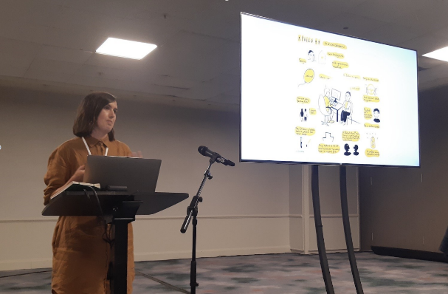  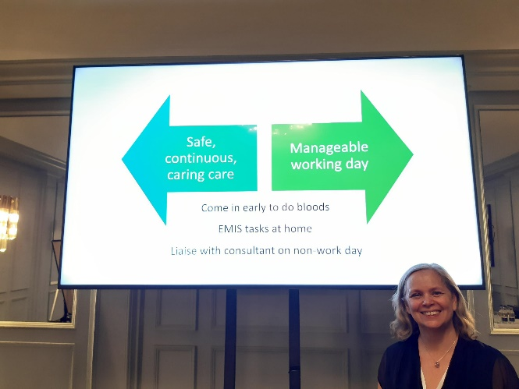  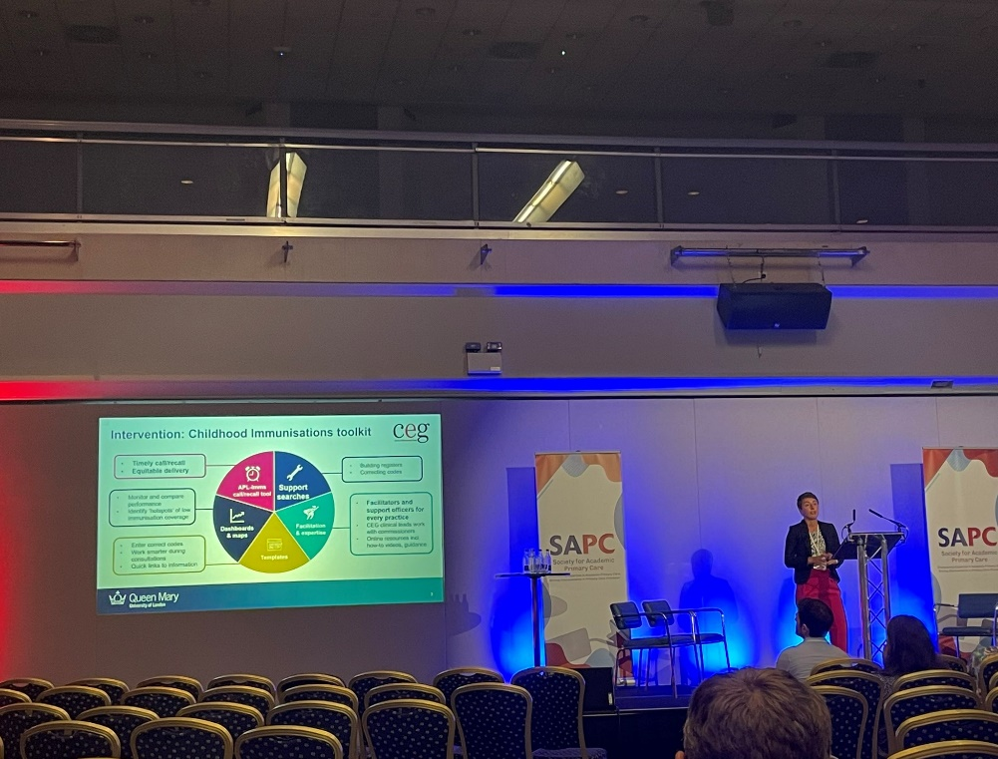
Evidence presented to UK Health and Social Care Committee Inquiry into Future Cancer
19 July (Stephen Duffy, Georgia Black, Judith Offman. Centre for Prevention, Detection and Diagnosis)

Following a submission on innovative screening and detection, written in collaboration with Georgia Black and Judith Offman, Stephen Duffy was called in person to the UK Health and Social Care Committee inquiry into future cancer at the Houses of Parliament. Stephen elaborated on elements of the submission, including examples of digital innovations to transform diagnosis of colorectal and breast cancer, and on bringing digital innovation into primary care. In his testimony on AI reading of mammography, Stephen told the Committee that AI systems have already been shown to effectively detect breast cancer from mammograms. He reflected that ‘the policy people are still treating this as a research issue…but the circumstances of staff pressures really dictate that we get on with it. Technology goes much faster than the research community can evaluate it, and we can’t always wait.’ Stephen’s comments were reported in the Evening Standard and Independent. | 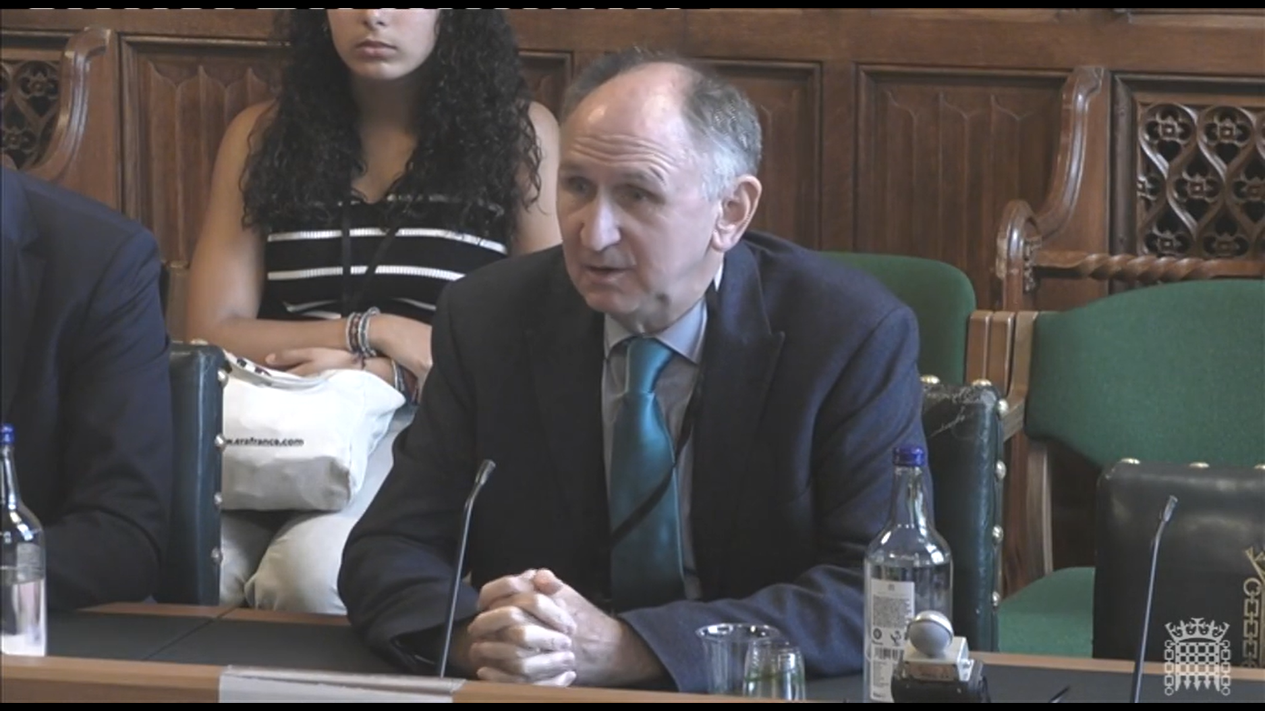  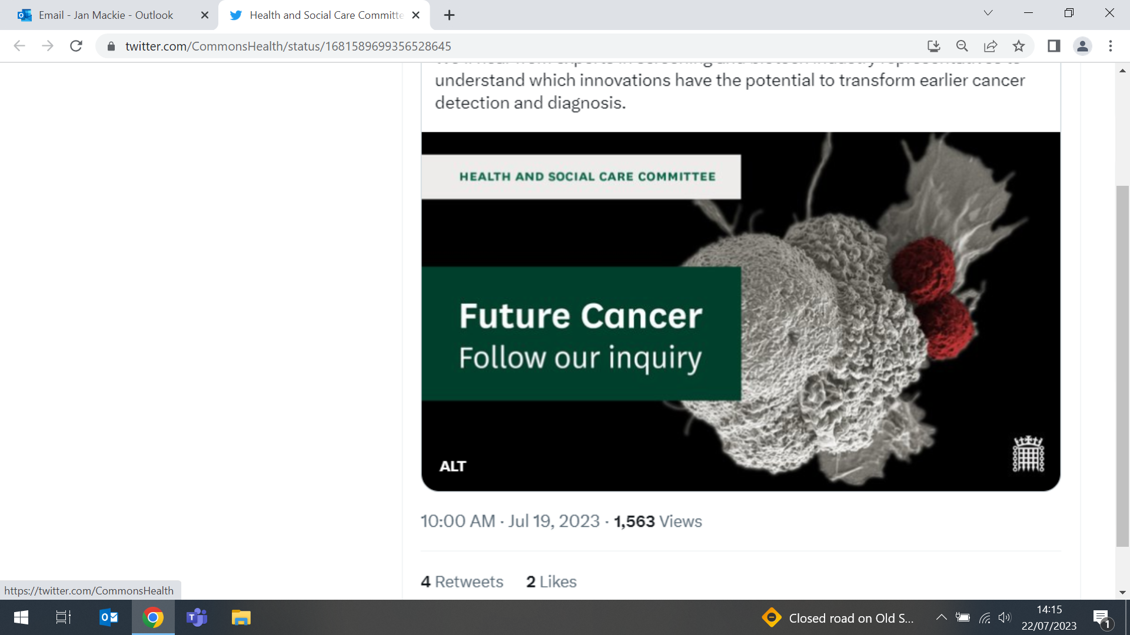
Alzheimer’s Association International Conference, Amsterdam
16-20 July (Claudia Cooper, Christine Carter, Jessica Budgett, Rosario Espinoza Jeraldo, Avinash Chandra, Rifah Anjum, and Phazha Bothongo. Centres for Psychiatry and Mental Health/Prevention, Detection and Diagnosis)

   | WIPH Teams from CPMH and CPDD attended the Alzheimer’s Association International Conference in Amsterdam from 16-20 July, presenting talks and posters. CPMH was represented by Claudia Cooper (APPLE-Tree remote secondary dementia prevention; opportunities for scalable public health interventions to reduce dementia risk), Christine Carter (Understanding the subjective experiences of memory concern and mild cognitive impairment diagnosis), and Jessica Budgett (The NIDUS-Family intervention for supporting goal attainment for people living with dementia and their family carers). The Preventive Neurology Unit team supported by Charlie Marshall included Rosario Espinoza Jeraldo (Dementia prevention strategies in Low and Middle Income Countries), Avinash Chandra (Influence of widowhood on amyloid positivity status in cognitively normal older adults), Rifah Anjum (Relationship between divorced status and in vivo beta-amyloid pathology in cognitively normal older adults), and Phazha Bothongo (Presentation: Ethnic variation in modifiable risk factors for Dementia, poster: Socioeconomic variation in modifiable risk factors for dementia).
Safety and efficacy of artesunate for trauma patients with major haemorrhage
20 July (Adam Brentnall. Centre for Evaluation and Methods)

In the TOP-ART trial, adult trauma patients who activated the major haemorrhage protocol were randomised to receive intravenous artesunate or placebo, to investigate safety and effectiveness of artesunate in reducing multiple organ dysfunction syndrome. Safety was evaluated based on the 28-day serious adverse event (SAE) rate, and efficacy on the 48hr sequential organ failure assessment (SOFA) score. The recruitment target was 105 patients, but the trial was terminated at 90 patients because of safety concerns. SAEs occurred in 31% of artesunate participants v 17% on placebo, and venous thromboembolic events (VTEs) occurred in 17% of artesunate participants v 3% on placebo. Superiority of artesunate was not supported by the 48hr SOFA score or any of the trial's secondary endpoints. Authors conclude that for critically ill trauma patients, artesunate is unlikely to improve organ dysfunction and might be associated with a higher VTE rate. | 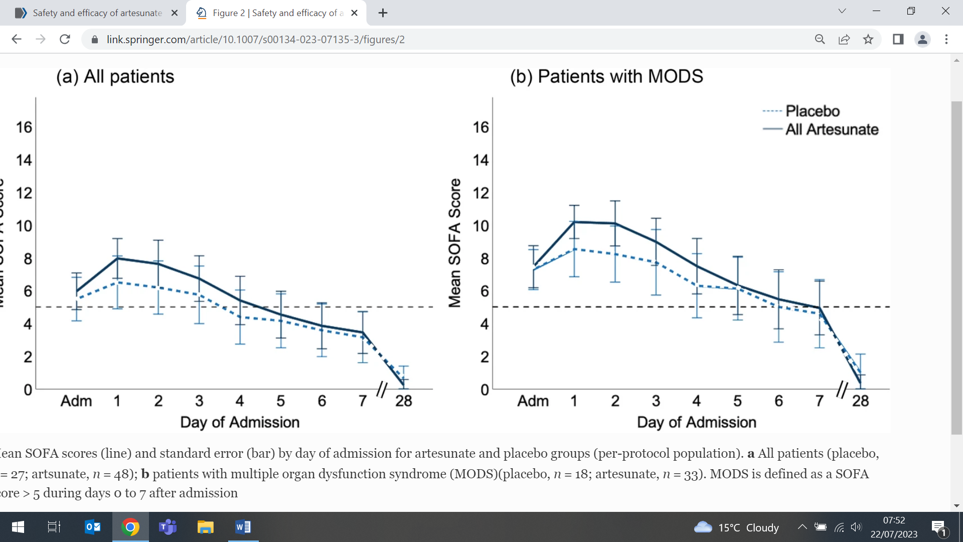
Recovery rates for young people with depression/anxiety not receiving treatment
21 July (Francois van Loggerenberg, Lauren Hounsell, Vicky Bird. Centre for Psychiatry and Mental Health)

 | A review of data from five studies with >1000 participants assesses 1yr recovery rates for young people with depression and/or anxiety who were not receiving mental health treatment. The studies show a 1yr recovery rate of 47-64%. Using meta-analysis, the overall pooled proportion of recovered young people was 0.54 (0.45-0.63). Authors conclude that after 1yr about 54% of young people with symptoms of anxiety/depression recover without any specific mental health treatment.
Prescribing in pregnancy: navigating risks and benefits
24 July (Ruth Dobson. Centre for Prevention, Detection and Diagnosis)

A commissioned editorial in Practical Neurology discusses the potential risk of avoidable harms resulting from either withdrawing medication or delaying its initiation due to concerns around medication use in pregnancy. As pregnant women and those planning pregnancy are excluded from the overwhelming majority of clinical trials, evidence to guide prescribing practice in and around pregnancy is lacking. The authors reflect that for women living with long term neurological conditions, preconception guidance about the potential impact of their health on pregnancy outcomes, as well as the impact of pregnancy on their neurological condition, should be provided. These discussions should be regularly revisited. Crucially, pregnancy outcomes must be monitored to provide real-world evidence, and to this end pregnant women should be encouraged to enrol in disease specific registers. | 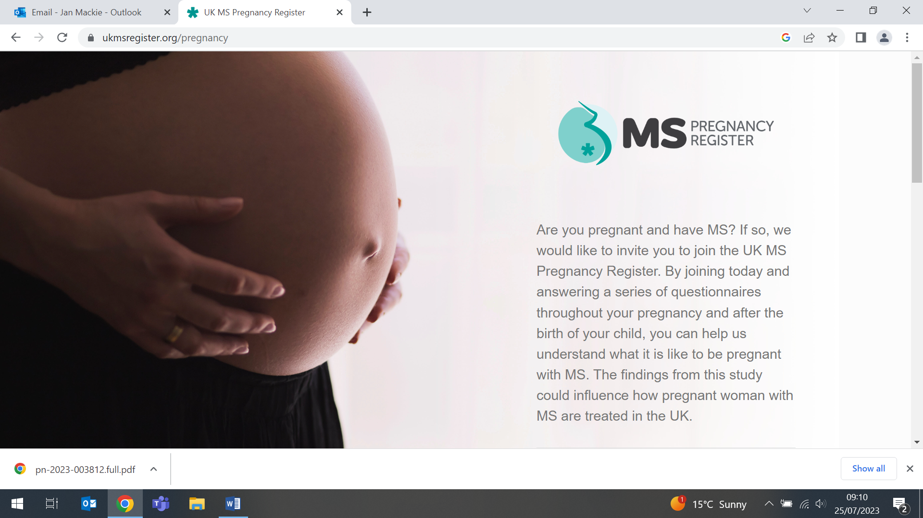  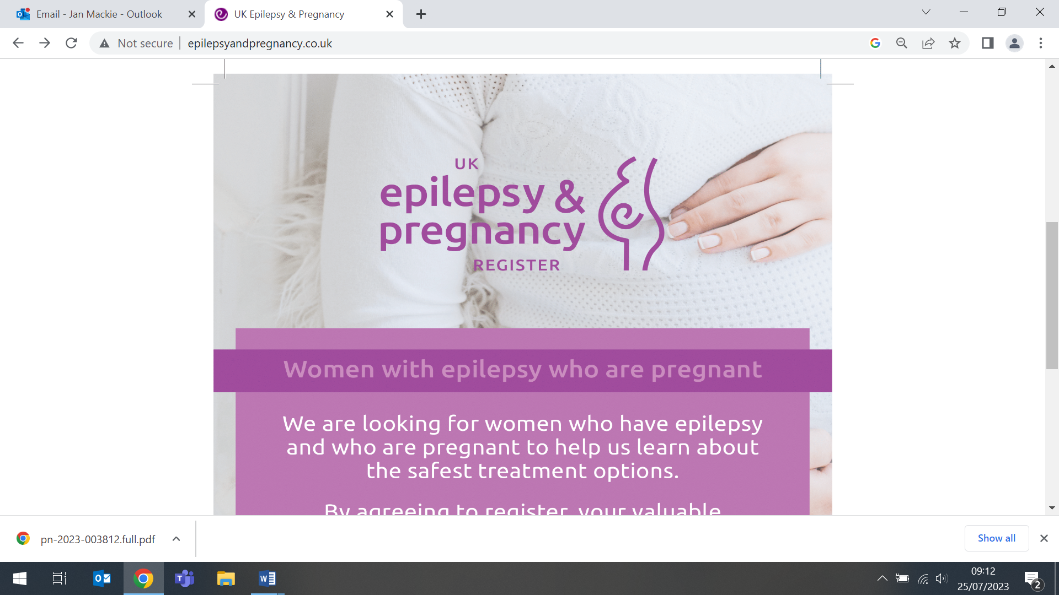
FORTHCOMING EVENTS AND NOTICES

Centre for Evaluation and Methods Showcase, 6 September

All are welcome to attend the WIPH Centre for Evaluation and Methods Showcase, to be held on Wednesday 6 September, from 2-6pm in the Arts2 Lecture Theatre at Mile End. The Showcase will feature work from across the Barts CTU, Pragmatic CTU, Health Economics and Policy Research Unit, and the Methodology Research Unit. The team will also be launching their Collaboration Requests Platform. Please register here to join us for this opportunity to network and celebrate our successes and future plans over drinks and nibbles. | 
Many thanks to all who so enthusiastically contribute. Please send any news items for the next newsletter to j.a.mackie@qmul.ac.uk

