WOLFSON INSTITUTE OF POPULATION HEALTH
NEWSLETTER
ISSUE 39: 15 AUGUST 2023

In this issue of our Wolfson Institute of Population Health Newsletter, we celebrate the achievements and work of staff and students in Late July and through the first half of August.

FROM OUR DIRECTOR
Dear All

Although we haven’t seen too much of the sun in recent weeks I do hope that everyone is taking a bit of time to relax and enjoy balmy August and the summer holidays.

As a result of a flurry of publications in the first half of August, we have now equalled the number of research papers produced by WIPH in the whole of 2022. The PUBMED articles count is a standard measure of academic productivity, but to achieve last year's total output by mid-August is unprecedented, and a testament to the hard work and dedication of our research teams across the Institute. Well done everyone!

We also have good news about some of our senior leadership positions, which were appointed for two years when the merged WIPH launched on 1 August 2021, and so came up for renewal at the beginning of this month. I’m delighted to announce that Mark Freestone (CPMH) has been re-appointed as our WIPH Director of Education, well supported by our Education Deputy Director Jonathan Filippon (CPHP), who only took up his role within the last year. Steph Taylor (CPC) has also been re-appointed as our WIPH Director of Research, ably supported by Belinda Nedjai (CPDD). Congratulations to all, and deepest thanks for all the support you’ve given us during the first two years of WIPH growth and consolidation. We shall be advertising further leadership roles in the Autumn so do keep an eye out for these.

With all best wishes

Fiona



MEET WIPH

MEET WIPH – GEORGIA BLACK (CPDD)

How would you describe your role/responsibilities?
I’m a Reader in Applied Health Research, and I tend to tell people that I’m interested in the ‘everyday’ aspects of healthcare that drive quality and safety. I’m leading a small team of qualitative researchers who are all interested in improving healthcare systems in primary care and in cancer diagnosis.

What has been your greatest professional achievement?
I was lucky to be awarded a THIS Institute postdoctoral fellowship which completely changed my outlook and enthusiasm for research through coaching, learning and peer relationships. It’s my greatest achievement in the sense that it was prestigious, but has also had more impact on my career progression than other grants.

What aspects of your role do you enjoy the most?
I really like working with people to interpret what has come from qualitative data – it’s the part of a project when everything starts to come together. It involves a lot of discussion and story-telling, and making sense of really complex phenomena. It’s always a struggle with a huge reward.

What would be your second choice as a profession?
If this is a complete fantasy, professional tennis player. I dream of Wimbledon glory.

What do you enjoy doing outside work?  Spending time outdoors with our two young boys, climbing trees, doing long walks and swimming in rivers.  Something about you that most people don’t know?  I spent some time working as a professional classical singer when I left university and I sometimes really miss it. I also play the piano, the recorder and when I was 16, learned to play a baroque instrument called the bandora. I was in a baroque band and everything - you can imagine how cool I was… | 
FROM OUR LEADERSHIP TEAMS

Research News from Tor Kemp (Research Manager)

FUNDING

Funding | RCGP Scientific Foundation Board annual research grants | Deadline 11 September
The RCGP Scientific Foundation Board are now accepting applications for their annual research grants, offering up to £30,000 funding for high-quality primary care research studies directly relating to patient care in the general practice setting. They support research studies on all topics linked to primary care, but this year are particularly keen to receive applications related to health inequalities and multimorbidity.

Funding | NIHR RIGHT Call 7 | Deadline 11 October
The NIHR Research and Innovation for Global Health Transformation (RIGHT) Call 7 is now open, seeking applications to develop and evaluate interventions that focus on early detection, effective treatment, and management of metabolic risk factors for CVD and stroke in primary and community care settings. Call closes 11 October. Find out more here

OPPORTUNITIES AND EVENTS

Learning Disability Knowledge Partnership
Professors Jennie Popay and Chris Hatton work on the Learning Disability Knowledge Partnership in the SPHR Health Inequalities Programme. The project will run till 28/2/24 and includes establishing a formal LD Knowledge Partnership, identifying candidate research ideas, and completing a proposal for a research focus. They are seeking someone from an SPCR member institution to join the team as an unfunded (at this stage) adviser, with a view to funded involvement in future bids. If you or someone you know are interested, please contact Claire Ashmore.

Event | NIHR SPCR Showcase Programme | 18 September
This event is open to all those based in an SPCR member department or contributing to an SPCR funded project (includes everyone in WIPH). The showcase will take place 18 Sept at BMA House, Tavistock Square London. Programme and registration here.

Event | “Findings from the latest Health Survey for England (HSE) reports” | 21 September
This free UCL HSE Seminar on 21 Sept offers the option to attend in person or via Zoom. The HSE is an annual survey of a nationally representative sample of the general population living in private homes in England. Each year the survey has a new sample and a different focus, in addition to the core elements. Findings from HSE 2021 published in May will be presented, including a focus on Physical Activity, and we will hear how HSE has been used in other research, including looking at cross-cohort changes, policy impact and international comparisons. Register here

Programme | NIHR Principal Investigator Pipeline Programme | Deadline 30 September
The new NIHR programme aims to equip research nurses and midwives with the necessary theoretical knowledge, leadership skills and practical experience to become a principal investigator responsible for conducting research at a site. Application deadline for the first cohort is 30 Sept. More details here

Event | NIHR “Successfully navigating your post-doctoral research career” | 6 November
The event will be held between 10am and 4pm on Monday 6 Nov in central Birmingham. Planned by members at this career stage, the day long hybrid conference will support post-doc researchers from all fields of health and social care research to successfully navigate this pivotal, and sometimes challenging stage of their career. The event will be open to any researchers at a postdoctoral career stage or in the final year of their PhD interested in pursuing their career with NIHR. Please complete the expression of interest form for further information.

GENERAL INSTITUTE NEWS

NHS digital diabetes prevention programme: Engagement with a behaviour intervention
12 July (Jamie Ross. Centre for Primary Care)

The NHS Digital Diabetes Prevention Programme is a 9-month digital behaviour change intervention for adults in England who are at high risk of developing type 2 diabetes. Intervention features include self-monitoring, goal setting, receiving educational content (via articles), and social support (via health coaches and group forums). An analysis of usage data, including time spent in app and frequency of use of the intervention features, shows that median App usage declined from 32 to 0 mins over the 9 months, although the rate at which the decrease occurred varied substantially between individuals and providers. | 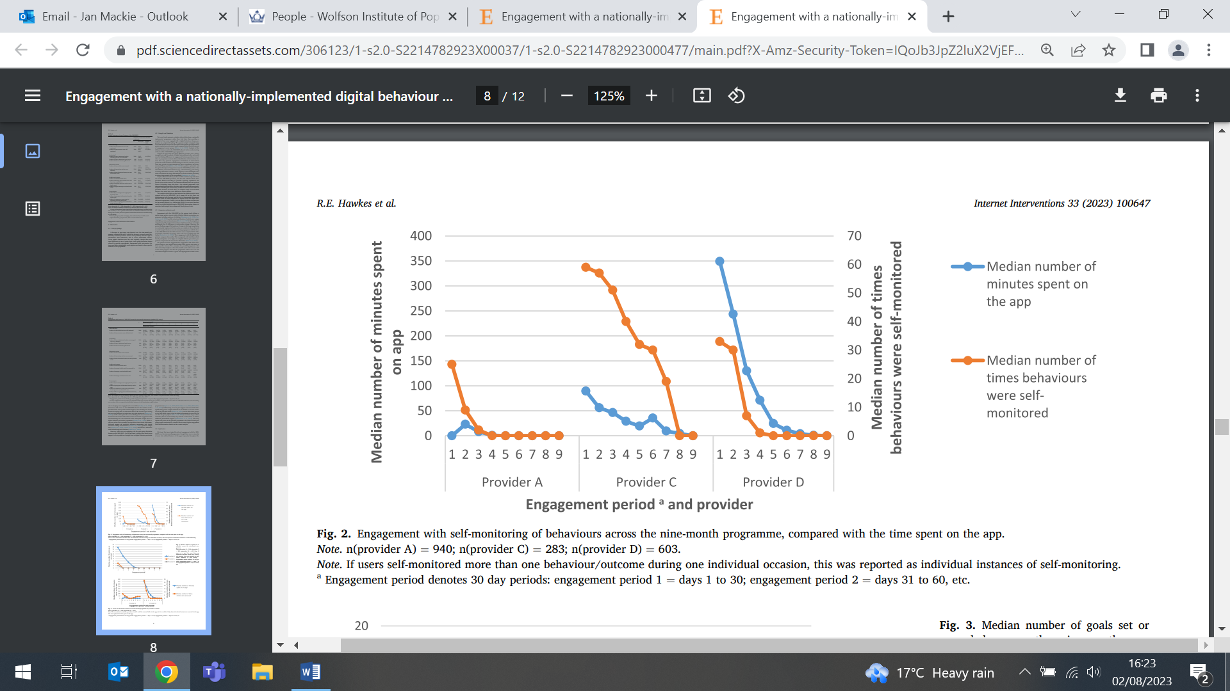
Task & Finish Group: Biomarkers of Diagnosis and Follow-up of Nitrous Oxide Abuse
18 July (Alastair Noyce. Centre for Prevention, Detection and Diagnosis)

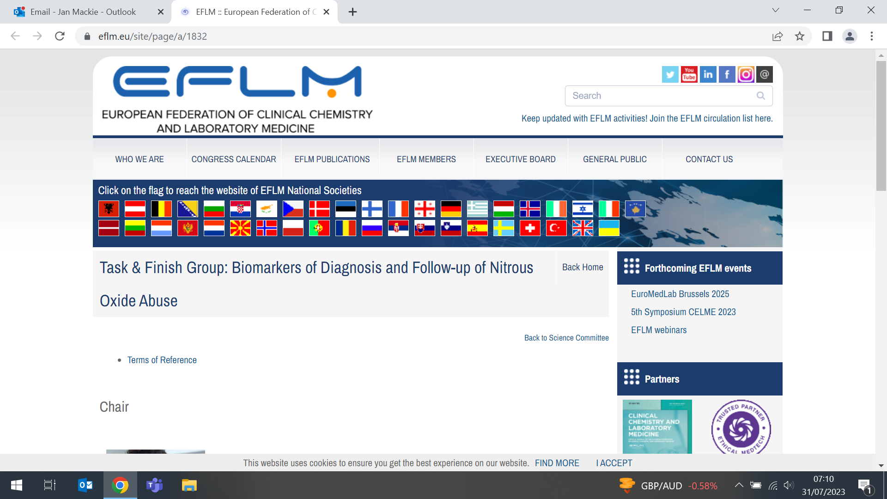 | Al Noyce has accepted an invitation to join the newly formed Task & Finish Group on Biomarkers of Diagnosis and Follow-up of Nitrous Oxide Abuse, set up under the auspices of the European Federation of Laboratory Medicine. During his 2yr appointment, the group will promote relations between neurologists and emergency clinicians to manage patients with N2O abuse, recommend biological markers for diagnosis and patient follow up, and produce a paper summarising the main findings of studies and clinical trials.
Electronic safety netting software for primary care cancer referrals
25 July (Georgia Black. Centre for Prevention, Detection and Diagnosis)

An evaluation of electronic safety netting software in primary care, based on interviews with staff across 5 NE London boroughs, reveals that while some found it beneficial, others were sceptical of its impact on clinical decision-making. The study found that when adopted through a whole practice the ‘C the Signs’ software led to improved referral form completion and tracking. Decision-support tools were used infrequently due to a lack of appreciation for their benefits. Authors conclude that use of safety netting software in primary care is unlikely to have a significant impact on earlier diagnosis of cancer, but that further work should address the whole practice context and setting of E-SN tools, not just their use in consultation. |   
UK Health Radio Interviews Oleg Blyuss on the SAICRED study
26 July (Oleg Blyuss. Centre for Prevention, Detection and Diagnosis)

   | In an interview broadcast on UK Health Radio, Oleg Blyuss spoke about the SAICRED study (Serial Artificial Intelligence/Machine Learning Classifiers For Personalised Risk Stratification and Early Detection of Lung, Bowel and Pancreatic Cancers in Women), one of five projects funded by the Bowelbabe Charity. Oleg explained the methodology of the project, and the advantages of using longitudinal data which allows natural personalisation, unlike data collected at a single time-point. He also talked about ways to avoid potential biases in research that is not hypothesis-driven, explaining the internal and external validation approaches, and about the AI approaches that may be used for the analysis of such complex data. The interview is also available on podbean.
Working through bereavement
26 July (Becca Muir. Centre for Primary Care)

In an article on employee experiences of bereavement in higher education institutions across the UK, PhD student Becca Muir writes that academic employers can do more to support grieving students and staff. Becca reflects on her own experience when her mother died, and cites results from a survey into the experiences of bereaved people in UK higher education, showing that workload and financial pressures can lead to premature return to work, and that many do not know their university has a bereavement policy. Line managers exercising discretion and offering leave using their own judgement can lead to inequitable outcomes, and creating hierarchies of grief, where bereavement policies dictate how much time off is needed according to normative ideas around families, can ignore the griever’s relationship to the deceased. Becca reflects that losses can carry unexpected emotional consequences and when policies are too narrow it can invalidate employees’ grief. | 
The Science behind the ULEZ expansion
28 July (Chris Griffiths. Centre for Primary Care)

 | Following approval by the High Court for expansion of the Ultra Low Emission Zone (ULEZ) to outer London boroughs, Chris Griffiths spoke to news outlet i about the scientific basis for the policy, saying that it was indisputable that the policy was working. ‘That air pollution from traffic harms health, and if you reduce air pollution levels you get a health benefit - this is unequivocal’ he said, noting that the London Assembly’s reports, which he said had been reviewed by world-leading experts, were ‘sound’. Chris added that the policy both deterred people from driving polluting vehicles into a heavily congested zone, and over time, it created a cleaner fleet of vehicles: ‘If you drive down those pollutant levels, which the data shows that’s been happening, you’ll have air which is cleaner, and there will be fewer health effects.’
Inequalities and behavioural non-communicable disease risk factors
28 July (Lola Oyebode. Centre for Public Health and Policy)

Research based on repeat health surveys in England from 2003-19 shows increasing levels of inequality in four risk factors – smoking, drinking above recommended limits, insufficient fruit and vegetable consumption, and physical inactivity - that cause non-communicable health conditions such as obesity, heart disease and diabetes. Prevalence of risk factors has reduced over time, but the study shows that this reduction has not been consistent across socioeconomic positions, with absolute and relative inequalities increasing for physical inactivity, and relative inequalities also increased for smoking. Persistent socioeconomic inequalities and clustering of behavioural risk factors experienced by those in lower socioeconomic positions contrasted with higher prevalence of excessive alcohol consumption among those in higher SEPs, an inequality that widened over the study period. |   
Patient financial incentives to improve asthma management
30 July (Anna De Simoni, Chris Griffiths. Centre for Primary Care)

 | A systematic review examines the effectiveness of financial incentives to patients to improve asthma management behaviours, including attendance at appointments, reduction in smoke exposure, and medication adherence. Attendance at appointment showed significant differences between interventions and controls in 3 studies: (73 v 49%, 46.3 v 28.9% and 35.7 v 18.9%) and in one study medication adherence showed significant change from 80% during intervention to 33% post intervention. Most studies were conducted in the USA where financial incentives may be more acceptable. Authors conclude that some evidence suggests that patient-directed financial incentives improve asthma management behaviours, but wide heterogeneity in study design and measured outcomes meant that determining overall effectiveness was challenging.
Hand movement tests for presymptomatic episodic memory impairment
30 July (Al Noyce. Centre for Prevention, Detection and Diagnosis)

A study of 1169 community participants without cognitive symptoms evaluates how two brief home-based online self-administered keyboard tapping tests predict episodic memory performance. Low-cost detection methods for early-stage Alzheimer's disease are a research priority, but hand motor tests have hardly been investigated. Results from the Tasmanian (TAS) Test keyboard tapping tests showed that the tests predict asymptomatic episodic memory impairment. Researchers conclude that this brief self-administered test may aid stratification of community cohorts. | 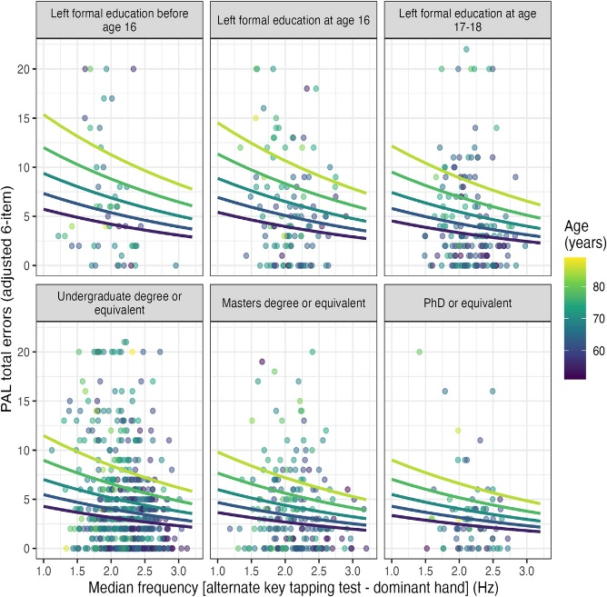
Imaging biomarkers highly predictive prognostic for more fatal breast cancers
31 July (Stephen Duffy. Centre for Prevention, Detection and Diagnosis)

  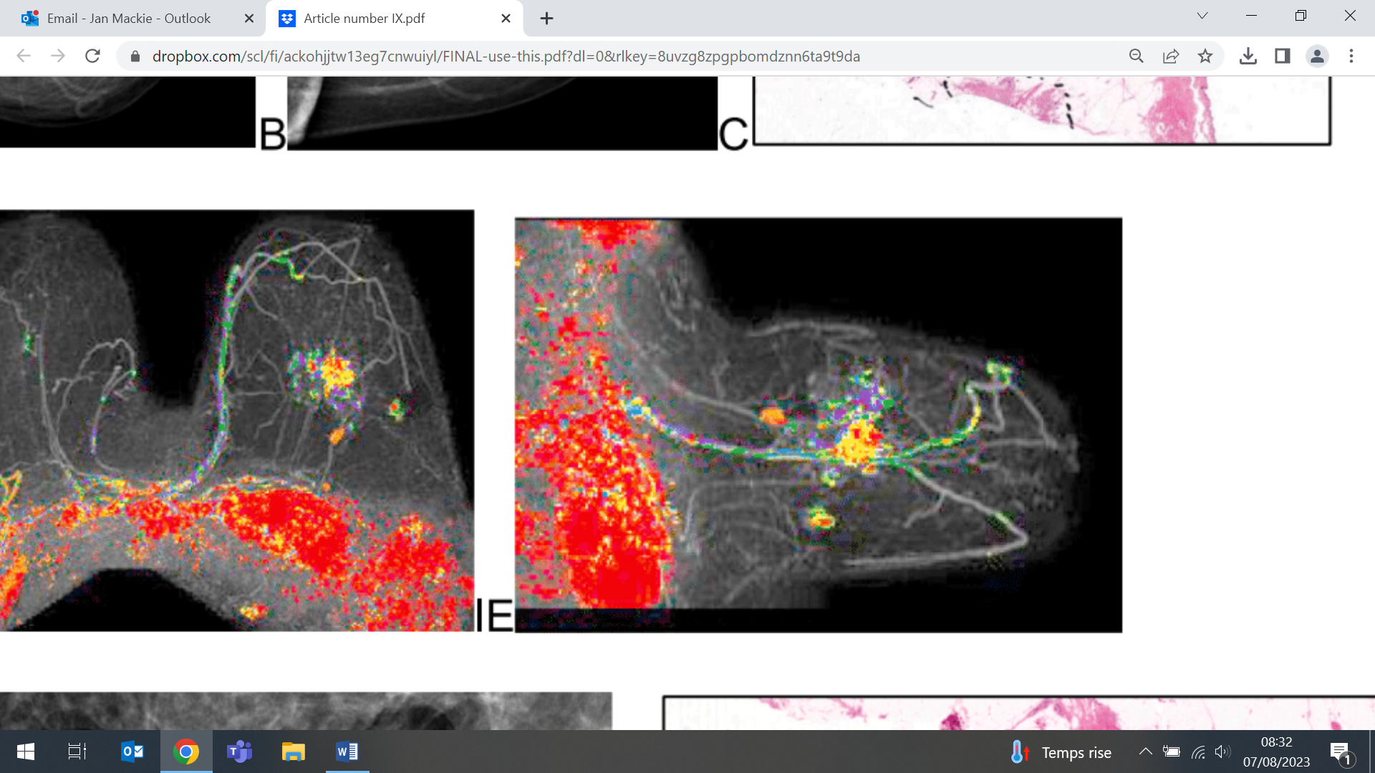 | A comparison of the predictive utility of conventional molecular v imaging biomarkers for breast cancer finds that imaging biomarkers are strongly predictive of long-term patient outcome. In 2236 breast cancer cases with complete data on both types of biomarker, researchers evaluated biomarker associations (both separately and when combined), with long term patient outcome. Molecular biomarkers were good predictors of outcome for unifocal acinar adenocarcinoma of the breast (AAB), but in diffuse breast cancers and in multifocal AAB cases, the molecular biomarkers misleadingly indicated favourable prognosis. The imaging biomarkers were highly reliable predictors of long-term patient outcome, including the multifocal AAB and diffuse breast cancer. Authors conclude that integrating imaging biomarkers into the diagnostic workup of breast cancer yields a more precise, comprehensive and prognostically accurate diagnostic report, and would help alleviate over- and under-assessment of disease extent, which carry risk of over- and under-treatment.
Challenges in postpartum anaemia measurement
31 July (Jahnavi Daru. Centre for Public Health and Policy)

An estimated 50-80% of postpartum women in low- and middle-income countries have anaemia, but there is no standard measurement or classification for postpartum anaemia. A review of 53 studies to identify and characterize postpartum anaemia measurement finds that timing of haemoglobin measurement, thresholds for diagnosis, and clinical outcomes reported vary considerably. Authors conclude that given the high prevalence, relatively simple treatment for non-severe cases, and the public health importance, it is crucial to develop common measures for postpartum anaemia. | 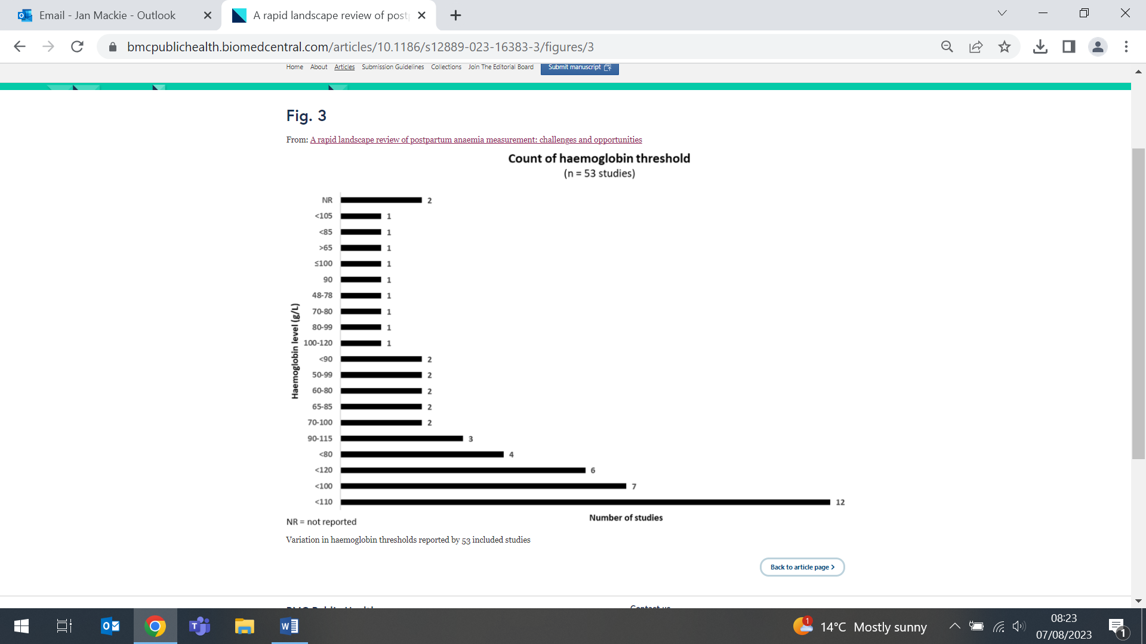
New NIHR Policy Research Unit to improve Dementia prevention, diagnosis and care
1 August (Claudia Cooper, Charles Marshall. Centres for Psychiatry and Mental Health/Prevention, Detection and Diagnosis)

 | A new NIHR Dementia and Neurodegeneration Policy Research Unit is to be co-led by QMUL and the University of Plymouth. Funded by a £3million NIHR grant, the DeNPRU, will produce research on prevention, diagnosis and treatment, care service, and workforce needs. From January 2024 under co-directors Claudia Cooper and Sube Banerjee (U. Plymouth) the unit will work to answer 4 key questions: i) how policy can help prevent these diseases by addressing risk factors and ii) improve people’s experience of a diagnosis, and ensure good quality ongoing care for everyone; iii) how technology and the way services are provided can support everyone with these diseases to receive care designed to meet individual needs; and iv) how to build a workforce with the right skills and positive attitudes towards people with these diseases.
E-cigarettes may be better than nicotine patches to help pregnant smokers quit
1 August (Dunja Przulj, Francesca Pesola, Katie Myers Smith, Chris Griffith, Peter Hajek. Centres for Primary Care/Public Health and Policy)

A Health Technology Assessment finds that e-cigarettes are probably more effective than nicotine patches in helping pregnant smokers quit, and that using e-cigarettes may also reduce the incidence of low birthweight in babies born to pregnant smokers. In an RCT 1140 pregnant smokers (12-24wks) were allocated to either e-cigarettes or nicotine patches. E-cigarettes were not significantly more effective than patches in the primary analysis, but regular use of e-cigarettes in the patches arm was more common than use of nicotine replacement products in the e-cigarette arm (17.8% v 2.8%). When this was accounted for, e-cigarettes were almost twice as effective as patches in all abstinence outcomes. In addition, participants in the e-cigarette arm had fewer infants with low (<2500g) birthweight (9.6%v14.8%), probably because e-cigarettes were more effective in reducing the use of conventional cigarettes. Current advice to smokers recommends switching from smoking to e-cigarettes but this research shows that the recommendation can now be extended to pregnant smokers. | 
Predicting inflammatory arthritis in people at risk
1 August (Jianhua Wu. Centre for Primary Care)

Simple score  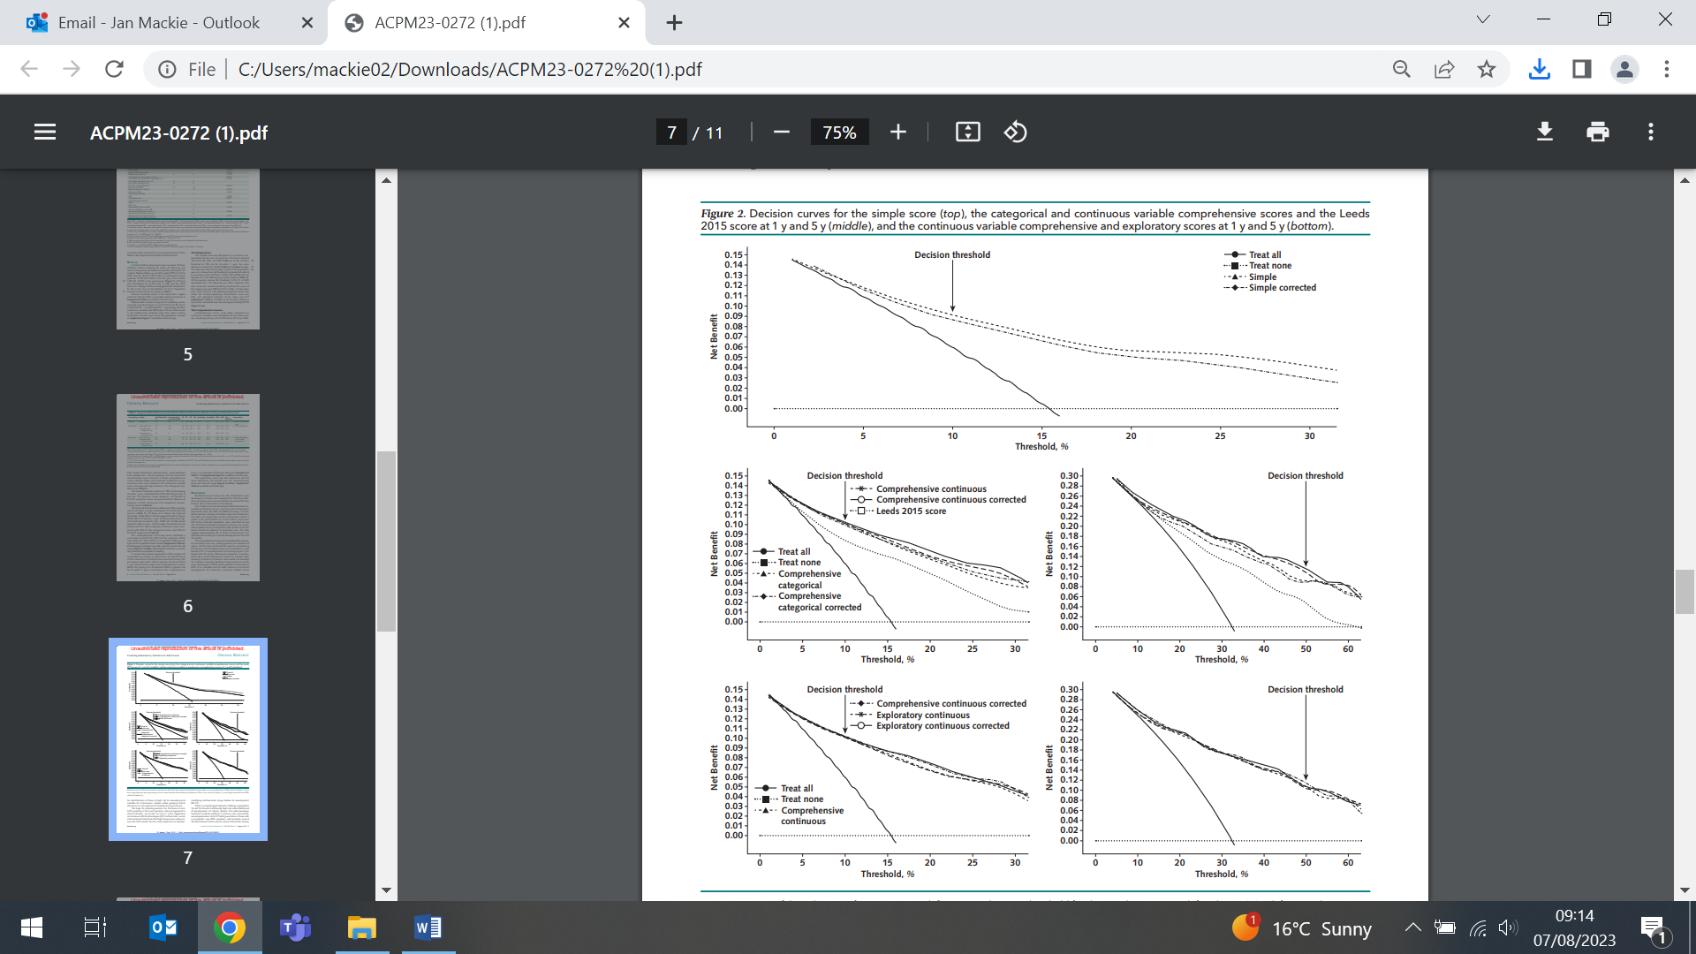  Continuous variable comprehensive and  exploratory scores at 1y and 5y | Two scores to predict development of inflammatory arthritis (IA) have been developed in a study following 455 subjects with new musculoskeletal symptoms. Of 148 subjects who developed IA, 70 developed it within 1yr. The simple score identified 249 low-risk participants with a false negative rate (FNR) of 5%, and 206 high-risk participants with a false-positive rate (FPR) of 72%. The comprehensive score identified 119 high-risk participants (FPR 29%) and 336 low-risk participants (FNR 19%). Of high-risk participants, 40% developed IA within 1yr and 71% within 5yrs. The simple score identified people at low risk for IA who were less likely to need secondary care, while the comprehensive score identified high-risk people who could benefit from risk stratification and preventive measures. Researchers conclude that both scores may be useful in clinical care, and also in clinical trials.
Dementia care navigator services
1 August (Claudia Cooper. Centre for Psychiatry and Mental Health)

Dementia Care Navigators (DCNs) work alongside clinical services to provide emotional and practical support to people living with dementia, but navigator services vary. A review of six studies of US-based services finds that reported different degrees of impact on service utilisation and on symptoms and mental well-being of people with dementia and their carers are based on insufficient evidence to draw meaningful conclusions, and that studies employ different outcome measures. One study evidenced greater impacts on people with more advanced dementia compared with earlier stages. Researchers say that further non-USA research, focusing on the impact on social care and social support service access and utilisation, and utilising similar established outcome measures is required. | 
Inequities in hypertension management
2 August (Stuart Rison, Chris Carvalho, Rohini Mathur, John Robson. Centre for Primary Care)

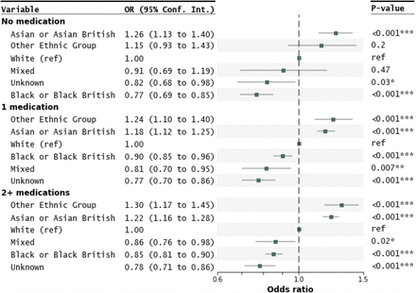  Odds ratios (BLOOD_PRESSURE_CONTROLLED)  by ethnicity for patients on 0, 1, or 2+ medications. | A study investigating health inequities in the monitoring, treatment, and control of blood pressure in adults with hypertension finds that people of Black ethnicity are less likely to have controlled blood pressure than those of white ethnicity (OR 0.89), and that people of Asian compared with white ethnicity were more likely to have controlled blood pressure (OR 1.29). Using data from 150,000 health records from general practices in NE London, the study also found that older adults (>50y) were more likely to have controlled hypertension than younger patients. Authors say that targeted interventions to control blood pressure in Black ethnic groups and younger people would be an important step in addressing unequal outcomes, in NE London and across the UK. The impact of medication costs in younger, working-age groups should be considered, with a view to reducing patient costs and improving adherence.
Expert Comment: AI use in breast cancer screening
2 August (Stephen Duffy. Centre for Prevention, Detection and Diagnosis)

In comments disseminated through the Science Media Centre and featured in the Guardian, the Sun, and The Times, Stephen Duffy provided expert opinion on results of a new trial that finds that AI use in breast cancer screening is as good as two radiologists and could slash waiting times. Stephen described the trial as ‘high quality’, but also noted that there may be concerns that AI-driven increases in breast cancer detection could include overdetection of relatively harmless lesions: ‘For example, the results of this paper include an increase in detection of ductal carcinoma in situ, which is thought to be potentially overdiagnosed.’ | 
Routine health record data for earlier detection of heart failure
3 August (Jianhua Wu. Centre for Primary Care)

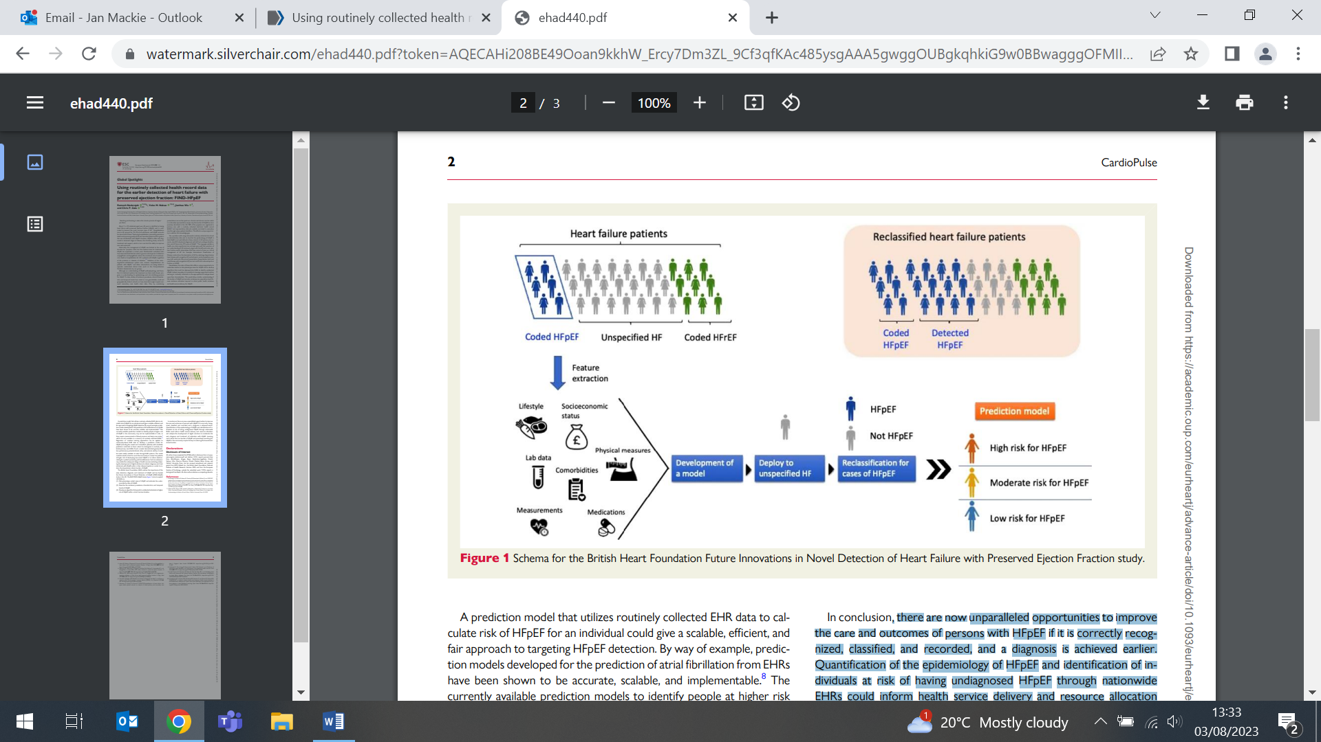  Schema for the BHF funded FIND-HFpEF study | The unique opportunity to risk stratify people registered in UK primary care for heart failure with preserved ejection fraction (HFpEF) will be investigated in the BHF-funded Future Innovations in Novel Detection of HFpEF (FIND-HFpEF) study. About 1 in 20 people >60yrs has HFpEF, with HF accounting for 1-2% of hospital admissions; 98% of people in the UK have a routinely collected electronic health record (EHR), with data linked to secondary care through unique patient identifiers. Existing models to identify HFpEF high risk people require blood pressure and BMI measurements, only available in a minority of routinely collected EHRs, so may not be implementable at scale. The FIND-HFpEF study will estimate the under recorded burden of HFpEF, describe the incidence, prevalence, characteristics, and temporal trends, and develop an algorithm to predict undetected individuals at higher risk. Learning more about the true burden of HFpEF and proactively searching for HFpEF in the community may be the key to reducing the downstream clinical burden.
Working with patient experience
3 August (Alison Thomson. Centre for Prevention, Detection and Diagnosis)

The second edition of The Routledge Companion to Design Research features a chapter by Alison Thomson on Working with patient experience. The chapter is organized around three different versions of ‘patient experience’ that variously operate in healthcare and design research. These different understandings of patient experience are demonstrated through practice-based design research projects to explore how these versions can be understood by design researchers. The chapter draws on examples of academic practice-based design research in the context of Multiple Sclerosis research and care based at Queen Mary University of London, in East London. Patient experience is a timely, complex, multifaceted object of study. It is not a topic of research restricted to healthcare, medicine nor design, but involves interconnected fields and practices. Design researchers can intervene and create opportunities to explore unique insights and raise new question about what it means to live with a chronic condition. | 
Meat v meat alternatives: which is better for the environment and health?
3 August (Lola Oyebode. Centre for Public Health and Policy)

 | Results from a study comparing nutritional parameters, greenhouse gas emissions (GHGEs) and price of meat products and their plant-based alternatives finds that meat alternatives are likely to be better for health, and more environmentally friendly, with lower GHGEs. Estimates for GHGEs were available for 97 products, on which nutritional information and cost data were collected from five UK supermarkets. Median values for nutritional value, GHGE (kgCO₂e) and price per 100 g were calculated. Meat alternatives contained significantly more fibre and sugar, were significantly higher in price, and had a significantly lower calories, saturated fat, protein and kgCO₂e than meat products. There was no significant difference in the amount of salt between meat and meat alternatives. Despite these findings, authors note that the higher price of these products may be a barrier to switching to meat alternatives.
MS and demyelinating disease in an Asian Americans
7 August (Ruth Dobson. Centre for Prevention, Detection and Diagnosis)

Race and ancestry influence the course of multiple sclerosis (MS). Using chart review data for 282 Asian American adults with demyelating disease, a new study finds that MS severity was similar between Asian and non-Asian American patients, but that region of ancestry was associated with differences in sociodemographics and MS severity. More patients with neuromyelitis optica spectrum disorder than MS were East and Southeast Asian (p=0.004). For MS patients, optic nerve and spinal cord involvement were similar across regions of ancestry. Asian MS patients were younger at symptom onset and diagnosis than non-Asian MS patients. MS Severity Scale scores were similar to non-Asian MS patients but worse among Southeast Asians (p=0.006). Further research is needed to uncover genetic, socioeconomic, or environmental factors causing these differences. | 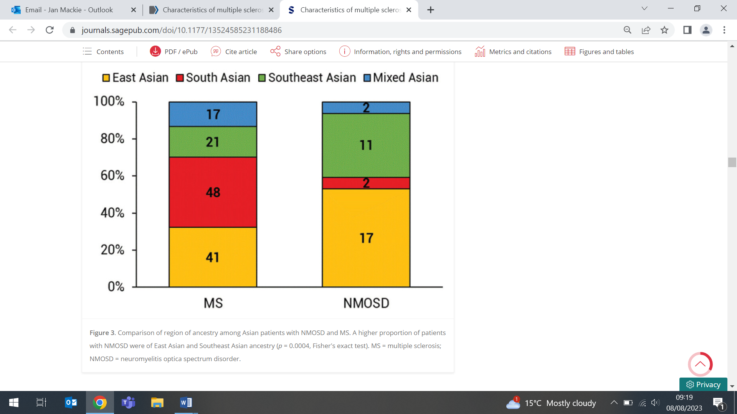  Comparison of region of ancestry among  patients with NMOSD and MS
Emergency department interventions to improve asthma outcomes
7 August (Imogen Skene, Chris Griffiths, Liz Steed. Centre for Primary Care)

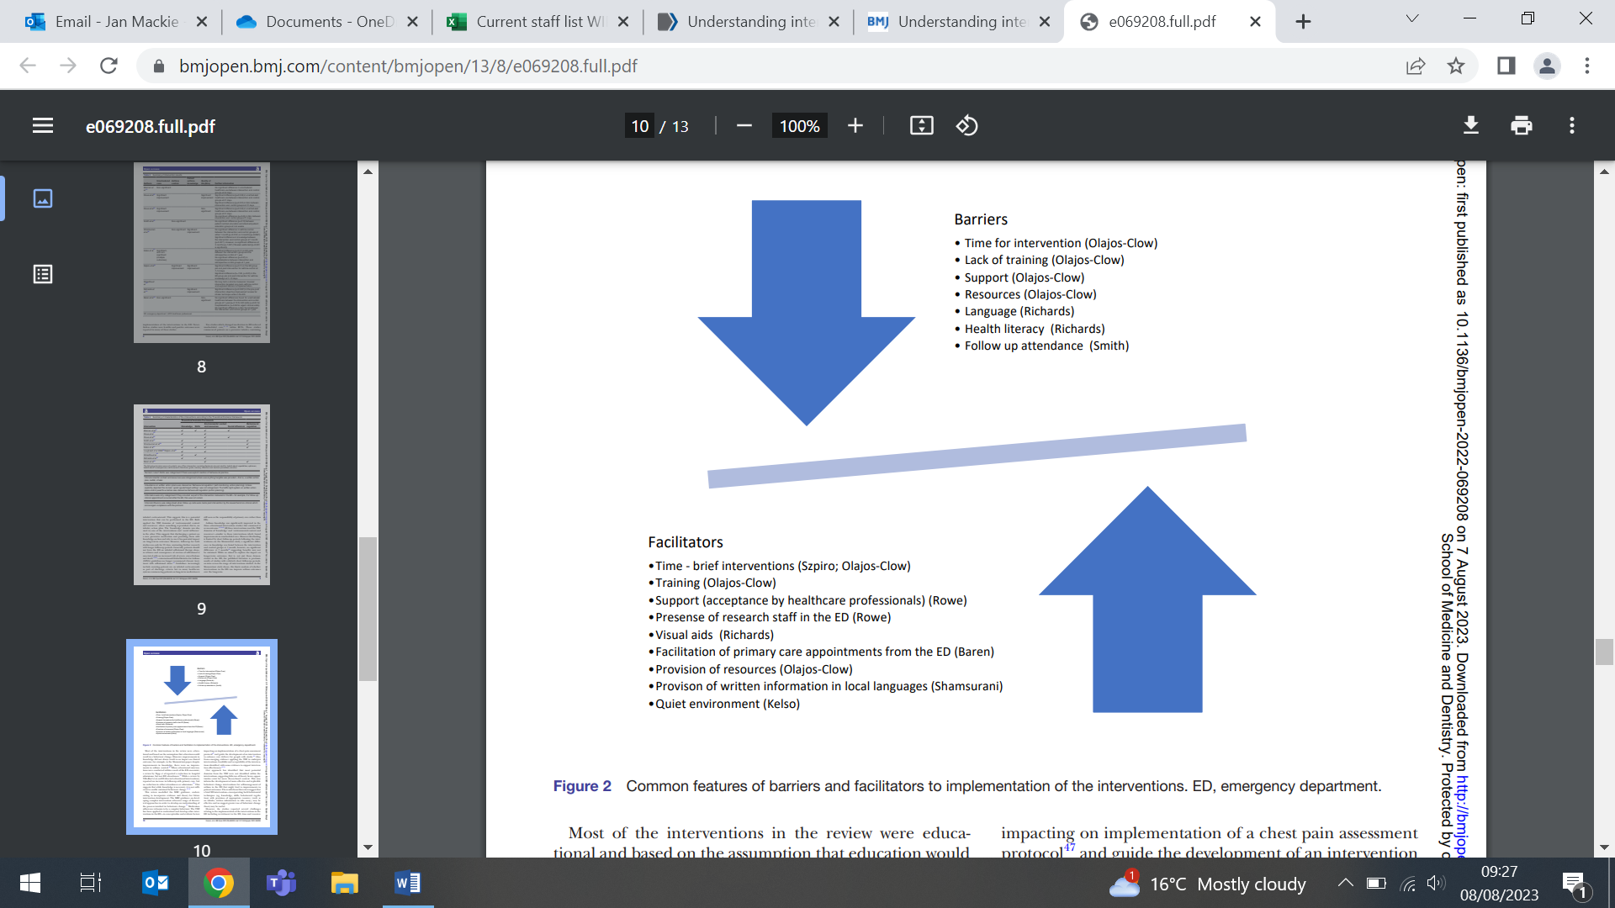 | A literature review of interventions delivered in the emergency department to improve long-term asthma outcomes finds that despite significant variation in the range of interventions, reported outcomes, and duration of follow-up, such intervention may be capable of improving long-term outcomes. From 12 papers, 10 unique interventions were identified, including educational and medication-based changes (from 6 RCTs and 4 non-randomised studies). Statistically significant improvements in one or more outcome measures relating to long-term asthma control, including unscheduled healthcare, asthma control, asthma knowledge or quality of life were reported in 6 trials. Only 1 intervention was explicitly underpinned by theory. Researchers say that future interventions would benefit from using behaviour change theory, such as constructs from the Theoretical Domains Framework.
CEG-NHS initiative to help GPs better care for patients with wider problems that may affect their health
7 August (Keith Prescott, Shazia Shahzad, Fae Wilkins, Chris Carvalho. Centre for Primary Care)

The CEG is working with NHS NE London on an initiative to help GPs provide better care for patients with wider problems that may affect their health. Around 500,000 adults in NE London are being asked 4 questions about problems with housing, if they have difficulty making ends meet, if they are lonely, and if they feel able to understand health information and advice. Responses will be visible in patients’ health records, and can be used to tailor health recommendations during consultations, or to signpost to community services to help address problems. Anonymised aggregated data will be shared with local authorities and NHS commissioners to help them anticipate and manage demand for services, and develop new initiatives targeted to the localities in need. It is hoped that the approach can be routinely implemented in the longer term to help address health inequalities. | 
Health labour markets in Brazil during the pandemic
9 August (Giuliano Russo. Centre for Public Health and Policy)

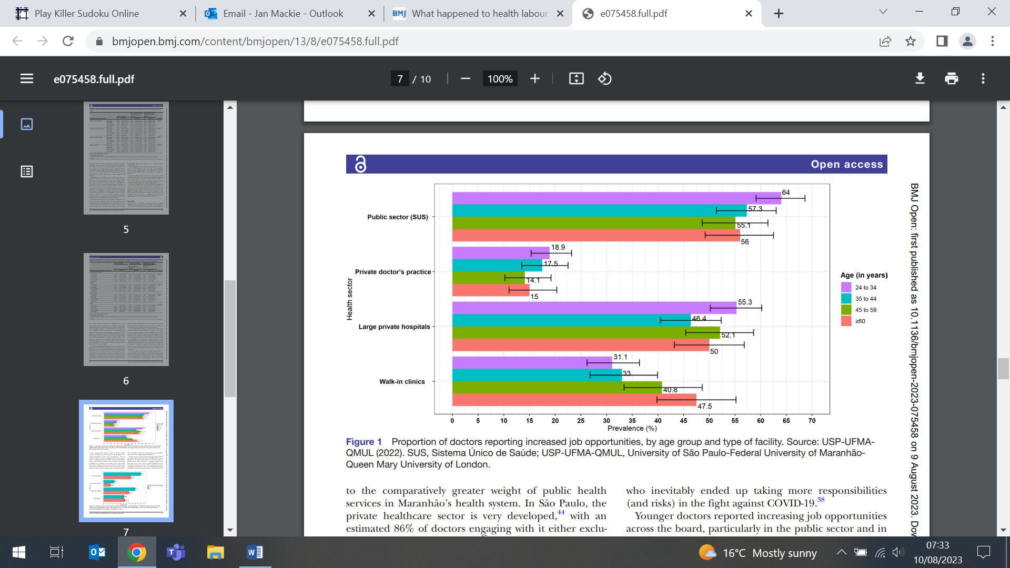 | Results from a survey of 1183 physicians in Brazil suggest that health labour markets in low/middle income countries may not shrink during epidemics, and that impacts of such events depend on the balance of public/private services in national health systems. Researchers examining physicians’ perceptions of changes in demand and supply of doctors during the pandemic found that most reported increased job opportunities in the public sector, but in the private sector the increase was only reported in large private hospitals.
Raised blood sugar levels and increased CVD risk
10 August (Rohini Mathur. Centre for Primary Care)

The largest study to date to investigate sex differences in risk of cardiovascular disease (CVD) across the glycaemic spectrum finds that men and women with raised blood sugar levels have a 30-50% greater risk of developing CVD, even when these levels are below the diabetes threshold. While relative increases in risk of developing CVD were higher for women than men, the sex differences largely disappeared after accounting for measures of obesity and the use of antihypertensive and statin therapies. The research, using UK Biobank data on 427,435 individuals, found that more men than women were on antihypertensive and statin therapies, suggesting that women are not prescribed these medications at the same rate as men with similar blood sugar levels. Authors say a study focusing on the factors behind this ‘prescribing gap’ is needed. | 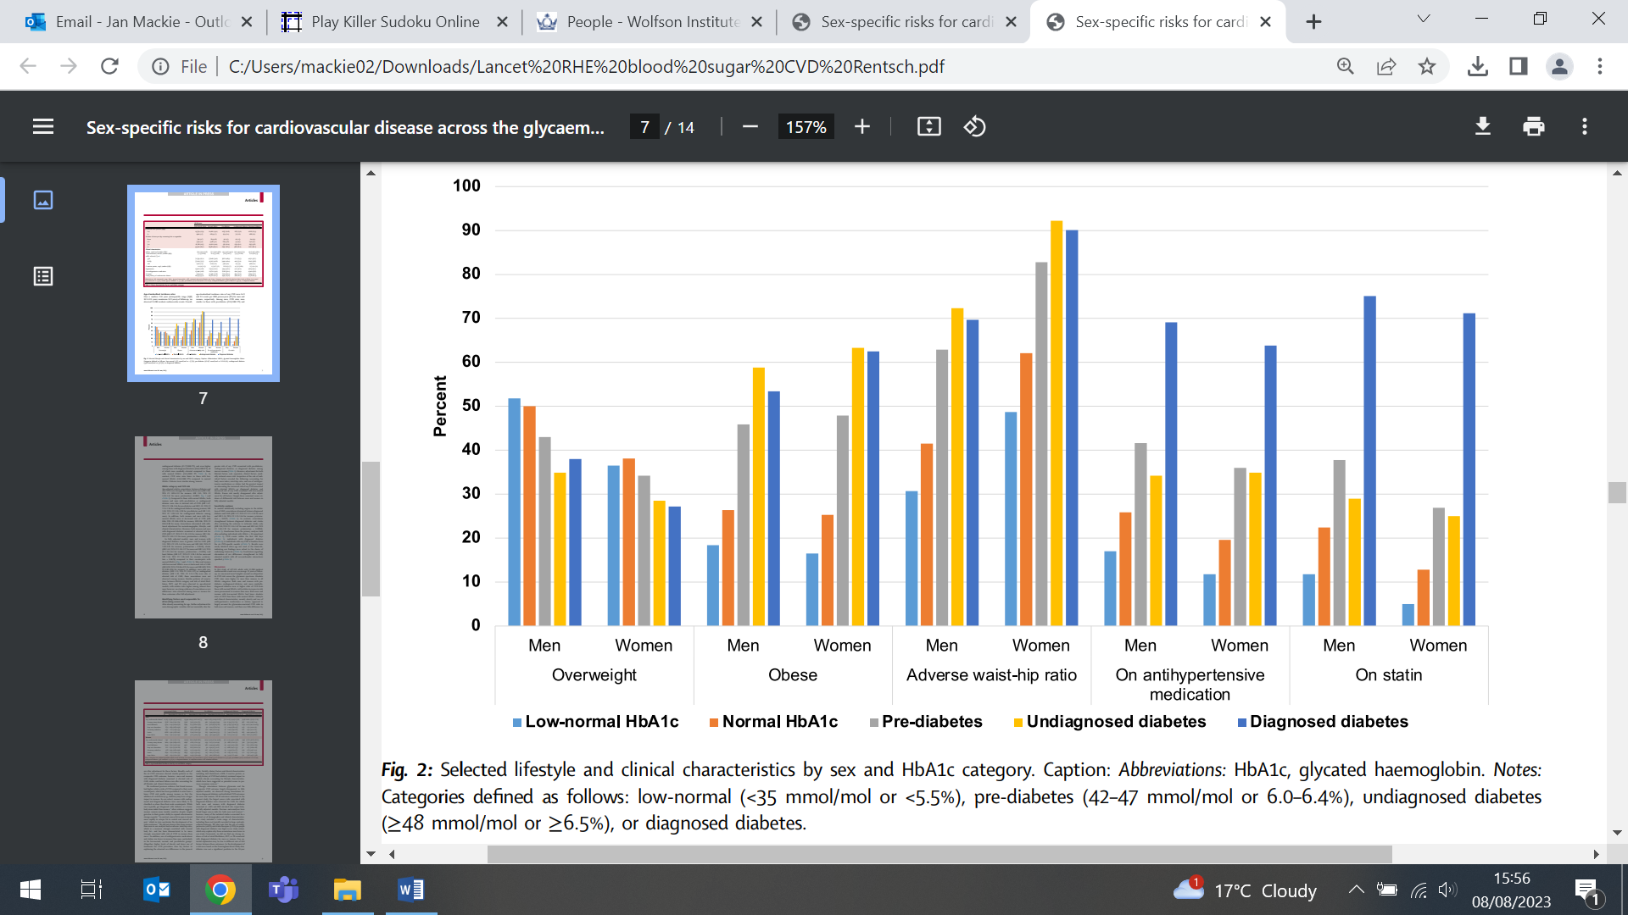
Neutrophil:lymphocyte ratio as a predictor of diabetic retinopathy incidence
10 August (Moneeza Siddiqui. Centre for Primary Care)

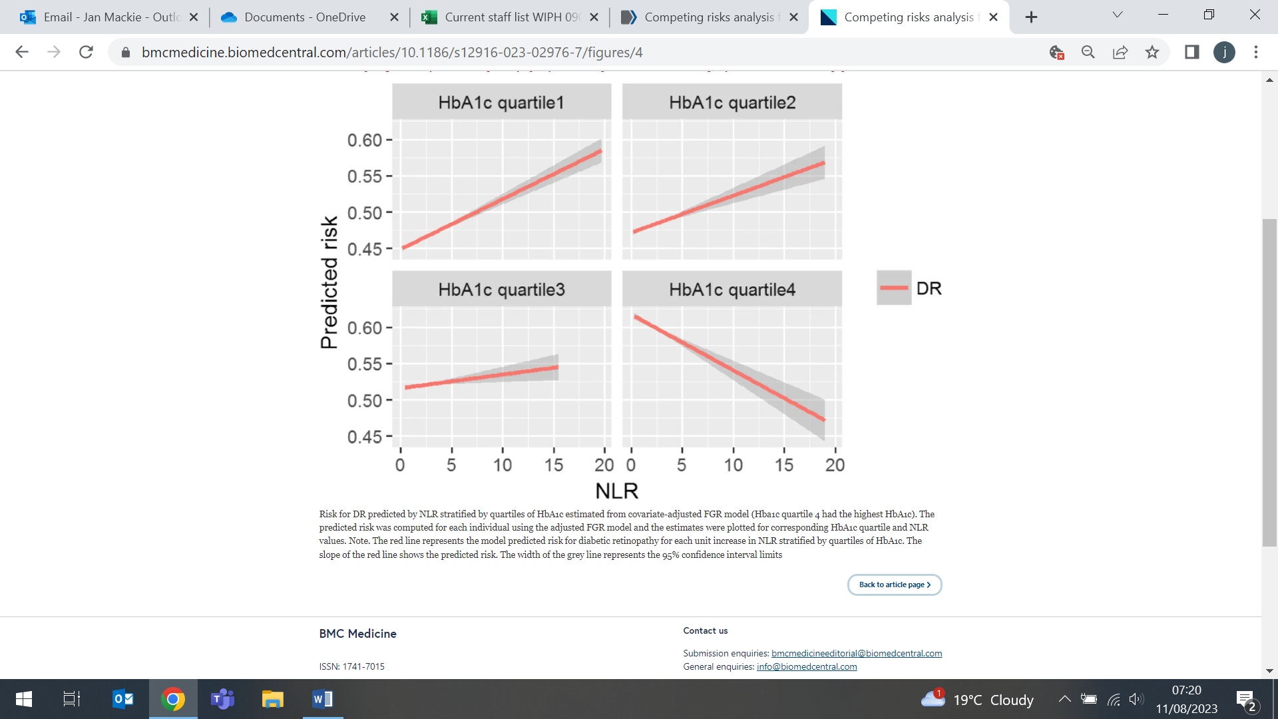  Red line = model predicted risk for DR  Grey line = 95% CI limits | Researchers examining the utility of neutrophil to lymphocyte ratio (NLR) as a predictor for the incidence of diabetic retinopathy (DR) in the Scottish population have found that NLR has promising predictive potential, especially in people aged <65 and in those with well-controlled glycaemic status. The study analysed data from 23,531 individuals, of whom 8416 (35.8%) had developed DR at 10yrs. The median NLR level was 2.04, and the optimal NLR cut-off value to predict retinopathy incidence was 3.04. Both age and HbA_{1c} were found to modulate the association between NLR and the risk of DR.
Effect of the pandemic on the mental health of people living alone
10 August (Rohini Mathur. Centre for Primary Care)

A study using data from both population-based surveys and diagnoses of mental illnesses in electronic health records (EHRs) shows that people living alone have poorer mental health and lower life satisfaction, but while this gap remained during the pandemic, there was a narrowing of the gap in service use. For both those living alone and with others, levels of reported distress increased during the pandemic, while healthcare-seeking dropped. Healthcare-seeking for common mental health conditions among those who live alone converged with those who live with others. Authors note that this may suggest greater barriers to treatment access among those who lived alone in this period, and say that the findings have implications for mental health service planning and efforts to reduce barriers to treatment access, especially for people living alone. | 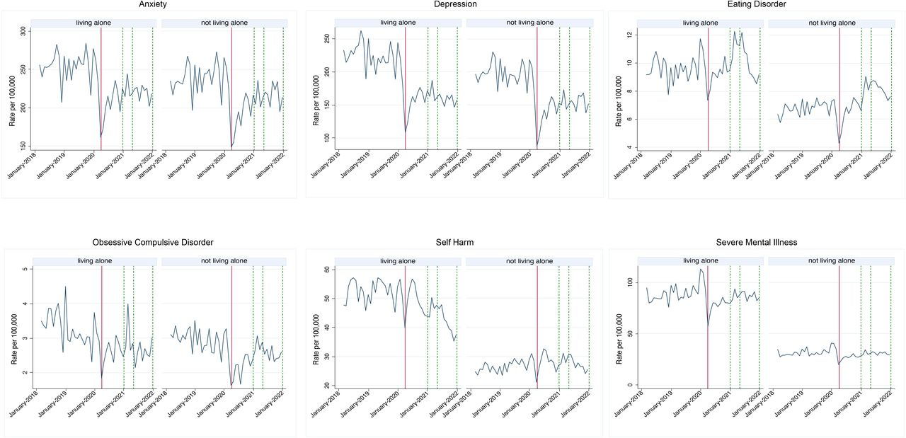
Strategies to communicate pregnancy complications
10 August (Ioannis Karapanos, Angeliki Bolou, Matina Iliodromiti, Elena Greco. Centre for Public Health and Policy)

 | In an investigation into strategies for healthcare professionals to effectively communicate unexpected news in pregnancy, researchers examined 43 studies dealing with miscarriage, increased risk screening, fetal conditions, and stillbirth. Key points for communication were outlined for each complication, and six common themes were identified from all the categories: Preparation - Referral - Individualized care - Clarity - Empowerment – Sensitivity (PRICES). Authors advocate for mandatory communications training for health care providers in pregnancy care settings, and suggest that their PRICES acronym could be a useful tool in these teaching scenarios.
Concurrent ILO or BPD in asthma patients
14 August (Anna De Simoni. Centre for Primary Care)

About 1in5 asthma patients also have breathing pattern disorders (BPDs) and inducible laryngeal obstruction (ILO), which are often misdiagnosed and mistreated as asthma. In discussions in a UK asthma online health community, researchers found that the undiagnosed symptoms of both disorders, and lack of effect of asthma treatment on symptoms, cause distress and affect relationships with healthcare professionals. Patients with undiagnosed ILO or BPD symptoms expressed frustration with the “one-size-fits-all” approach to diagnosis, with many feeling that their asthma diagnosis did not explain symptoms. Those formally diagnosed with BPD or ILO reported relief when they received appropriate management. Authors conclude that clinician education on diagnosis and management, as well as increased patient access to appropriate management, such as respiratory physiotherapy and speech and language therapy, are needed in primary care. | 
Adherence to Oral HIV Pre-Exposure Prophylaxis
14 August (Rosalie Hayes. Centre for Public Health and Policy)

 | The effectiveness of Oral HIV Pre-Exposure Prophylaxis (PrEP) relies on adequate adherence, but most PrEP users miss doses. Potential between-participant predictors of PrEP adherence have been well studied, but to investigate the substantial within-participant variation, researchers used a questionnaire to ask 67 men who have sex with men about an adherent and a non-adherent episode. Non-adherence was found to be associated with non-normality of the day, being out of the home, weekend days, having company, using substances, not using reminders, lower PrEP information, lower behavioural skills, and less positive affect. Authors conclude that adherence assessment could focus on supporting the construction of alternative strategies to facilitate adherence in situational variations.
Neglected tropical diseases in Ethiopia
14 August (Esubalew Assefa. Centre for Evaluation and Methods)

A scoping review maps the burden of neglected tropical diseases (NTDs) in Ethiopia. From 105 papers, researchers undertook detailed analyses of challenges and barriers in access to diagnostics, medicine and care for NTDs (eg: trachoma, leishmaniasis, soil-transmitted helminthiasis, scabies, schistosomiasis, lymphatic filariasis, podoconiosis, and onchocerciasis). They note the paucity of evidence on the suitability and potential benefits of novel diagnostic technologies and medicines in Ethiopia, concluding that although gains have been made in NTD prevention and control, the burden remains high. Poverty, poor quality of life, and underfunding of NTD programmes decelerate the process of NTD elimination in the country. | 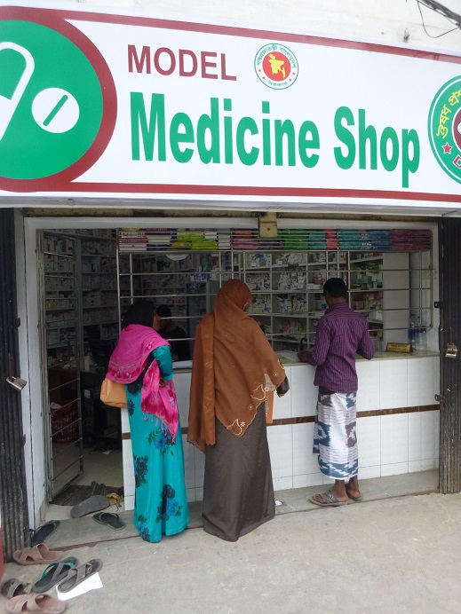
Many thanks to all who so enthusiastically contribute. Please send any news items for the next newsletter to j.a.mackie@qmul.ac.uk

