WOLFSON INSTITUTE OF POPULATION HEALTH
NEWSLETTER
ISSUE 41: 15 SEPTEMBER 2023

In this issue of our Wolfson Institute of Population Health Newsletter, we celebrate the achievements and work of staff and students through late August and the first half of September.

FROM OUR DIRECTOR
Dear Colleagues

I am delighted to announce that Jianhua Wu, Professor of Biostatistics and Health Data Science, and Dr Anna De Simoni, Clinical Reader in Primary Care, are taking on co-leadership of the WIPH Centre for Primary Care.

Jianhua’s expertise is in multidisciplinary research in advanced statistical and machine learning methods using electronic health records and other longitudinal and biomedical data sources to create insights into health and inequalities relevant to obesity, diabetes, cancer, and cardiovascular disease across the life course, while Anna’s is in improving self-management and adherence to medications in patients with long-term conditions. Together they will provide cross-cutting expertise and fresh leadership ideas.

Please join me in thanking Profs Steph Taylor and Carol Dezateux for the excellent leadership they have given the Centre since its launch in August 2021. During their tenure we have seen the Centre grow and thrive, welcoming new students, researchers and academics, delivering excellent teaching across a number of our student groups, and supporting quality outputs. Huge thanks to you both! Steph will continue in her role as WIPH Director of Research while Carol continues to lead our Heath data science theme.

Also a reminder that Ellie is hosting our WIPH late summer BBQ on the Charterhouse Square Lawn next Thursday (21 September 4.30pm). Do join us to meet up with colleagues from across our campuses. See you there!

With best wishes

Fiona


MEET WIPH

MEET WIPH - Angela Tuffuor-Williams (Director’s Office)

How would you describe your roles and responsibilities?

I joined WIPH in June as Executive Assistant to the Director, a role that involves organising a busy schedule, maintaining a complex and constantly changing diary, arranging meetings, and providing secretariat to the Executive Board. I also support recruitment for the Director’s Office team and for strategic Institute appointments, oversee administration for honorary contracts and visiting titles, and conduct event management (eg: the Inaugural Lecture Series). I line manage the Director’s Office PA and two other admin staff, and work closely with other colleagues in the Director’s team.
What has been your greatest professional achievement?

I served two terms as a Parent Governor at Connaught School for Girls (my own former secondary school) in Waltham Forest. I was interested to be part of the measures taken by the school from the parental viewpoint, and worked closely with the Chair, attending monthly meetings, participating in fund raising activities, and attending open days to talk to prospective students. One of my main contributions was offering ideas to the Finance Officer on how school funds might be spent, how they might affect families, and different ways to source funding for the science laboratory (in a state of disrepair). Many of my friends and family attended Connaught, and investing my time with the school in this way was worthwhile - something I would definitely repeat in the future.

What aspects of your role do you enjoy the most

I’m a “people person” with a hands-on approach, and enjoy being part of the Director’s office team, particularly the admin staff I manage. We communicate regularly on workloads and how to effectively deliver projects, but we also interact on a non-professional level - and share a lot of personal experiences.

What would be your second choice as a profession?

This question is easy for me – I would be an Estate Agent. I love all things to do with property, architecture and buildings, and watching property programmes like Grand Designs and Location Location Location. I sometimes drive to the countryside just to look at beautiful houses, and as my favourite internet search is Rightmove, I keep up to date with what the property market is doing.

What do you enjoy doing outside work?
Spending time with family, our two children and extended family in London, York, Hertfordshire, and Bedfordshire. I am an Aunty and Godparent, and there’s always lots to do with the family kids when we meet. I am a Sunday School teacher at the
local church, something that comes from my own childhood when I was part of The Girls’ Brigade and Girl Guides. I enjoy cooking, especially Ghanaian cuisine.  Something about you that most people don’t know?  I am a bit like Hyacinth Bucket in the tv show Keeping Up Appearances. I can be fussy, and I like spotless homes. Something I noticed immediately in the Wolfson building when I started was that the bathrooms are not so nice, and it is great to know they are going to have a refurb! | 
FROM OUR LEADERSHIP TEAMS

Complexity and Social Science Theme news
(Deborah Swinglehurst, Theme Lead)

New podcast on complexity and social science in health: The newly-launched APOLLO Social Science podcast explores the borderlands of social theory and health by inviting researchers to share the ideas that have inspired and shaped their own thinking and practice. Our first episode is with Duncan Reynolds, a postdoctoral researcher in the APOLLO research group working on the AI Multiply project. Duncan shares how his understanding of trust and Artificial Intelligence have been shaped by three big ideas. We will be releasing a new episode each month, and you can subscribe on any podcast platform or listen directly to the first episode here. If you are working in complexity and social science and would like to talk on the podcast about the ideas that have shaped your work and research, please contact Stephen Hibbs.

The monthly Curiosity Workshop returns for the 2023-2024 academic year! We invite all researchers curious to share and learn work-in-progress in qualitative research. We got off to a great start on 6 September with Alison Thomson sharing the design-led approach behind our newly published series of illustrated fictional story books Let’s Talk Differently About Medicines and seeking ideas about where to go next with the project. With 24 participants, we had a great discussion. Our next meeting is on 4 October, 10-11am online via Teams. If you would like to be added to the Curiosity Workshop mail list so that you can join in please email Charlotte.

Public Advisory Panel Theme News
(Megan Clinch, Theme Lead)

WIPH PPI newsletter: We have launched a WIPH Newsletter for Patient and Public Involvement contributors, through which we can share upcoming opportunities to be involved with research and teaching activities. Please contact Juliet Henderson if you have any PPI opportunities to circulate via the newsletters, or if you have any PPI contacts you would like to add to the newsletter mailing list.

Roadshow champions: We have started delivering Patient and Public Involvement Roadshows across East London to engage organisations and individuals in our work at WIPH. There are still opportunities for Champions to deliver these Roadshows. This is an excellent career development opportunity for PhD students, early career researchers and/or people interested in developing their PPIE practice. PhD students will be paid on a sessional basis for their time. You can sign up via this form - Please be sure to speak to your line manager before you commit.

PPI and community teaching: In addition to the Champion roles, we are also collecting examples of excellent PPIE or community based teaching. This could include testimonials from members of the public, community organizations, or health and social care professionals with whom you have collaborated, who will be paid for sharing their experience with us (using the NIHR Involve Payment Rates). If you would like to share your PPIE practice, please contact Juliet Henderson.

EDI News
(Evangelos Katsampouris – Equality Diversity and Inclusion Lead)

The WIPH EDI Group has developed guidance (now available on the WIPH staff Zone, under Equality, Diversity, and Inclusion) on Bullying and Harassment, aligned with the FMD and QMUL policies. We encourage all colleagues - students and staff - to look at the EDI section of the Staff Zone, and to use the Online Suggestion Form.

If you are keen to become involved in the WIPH EDI Group, or to raise and discuss an EDI-related issue, please email us.


Research News
(Tor Kemp, Research Manager)

Funding |NIHR Programme Development Grants (PDG) Round 2 | Deadline 25 October 2023
The call is open for applications and the link to the RMS application form is available on the funding opportunity post. NIHR have produced a short video about the funding opportunity, with an accessible video transcript, and have updated the FAQ page. To find out more, check out their webinar recording.

Eligibility criteria for this funding opportunity: Stream A is open to all who wish to apply. As per the guidance, Stream A seeks applications to develop, carry out, and evaluate novel and equitable partnership-based development activities that break new ground in research involvement and engagement. Unlike the usual PDG Stream A, applications to this call do not have to lead to a follow on Programme Grant. Any queries can be directed to Programme Manager Andrea Yáñez-Cunningham. Deadline to apply 13:00 on Wednesday 25 October.

Funding | NIHR Doctoral Local Authority Fellowship (DLAF) Round 3 | Deadline 7 December 2023
The NIHR Doctoral Local Authority Fellowship (DLAF) scheme supports individuals based within local authorities and supporting services to undertake fully funded PhDs. Round 3 Fellowship applications are now open. These fully funded doctoral fellowships allow awardees to retain their existing employment contracts and salaries, whilst protecting their time to undertake a research doctorate, academic training, professional development and some appropriate continued practice. When taken full-time, fellowships have a duration of three years, but can be taken over as long as six years when taken part-time. Click here to see a case study of a Fellow who made a successful application last year. Deadline to apply Thursday 7 December 2023

Webinar | Working effectively with public contributors | 31 October 2023
The NIHR ARC West and Bristol BRC invite you to join for a webinar on Tuesday 31 October 1-2pm about how to work effectively with public contributors. This webinar builds on the recently published guide and diagram developed by highly experienced public contributors. Book your place here.

GENERAL INSTITUTE NEWS

Exposure to medication for neurological disease in pregnancy
24 August (Chen Liu, Ruth Dobson. Centre for Preventive Neurology)

Evidence on long-term effects of treatments for common neurological conditions diagnosed in early adulthood (epilepsy, migraine & neuroinflammatory disorders, including multiple sclerosis) is examined in a literature review considering the implications for people who have not completed their families. Prescribing in pregnancy involves balanced assessment of potential risks and benefits to both mother and baby, but while data on short-term fetal outcomes is increasing, a gap exists in data on long-term offspring outcomes because pregnant women and those planning pregnancy are routinely excluded from clinical trials. Researchers conclude that full assessment of the impact of medication exposure will only be achieved through widespread implementation of pregnancy registries, and that collaborative efforts to gather this data must start now. | 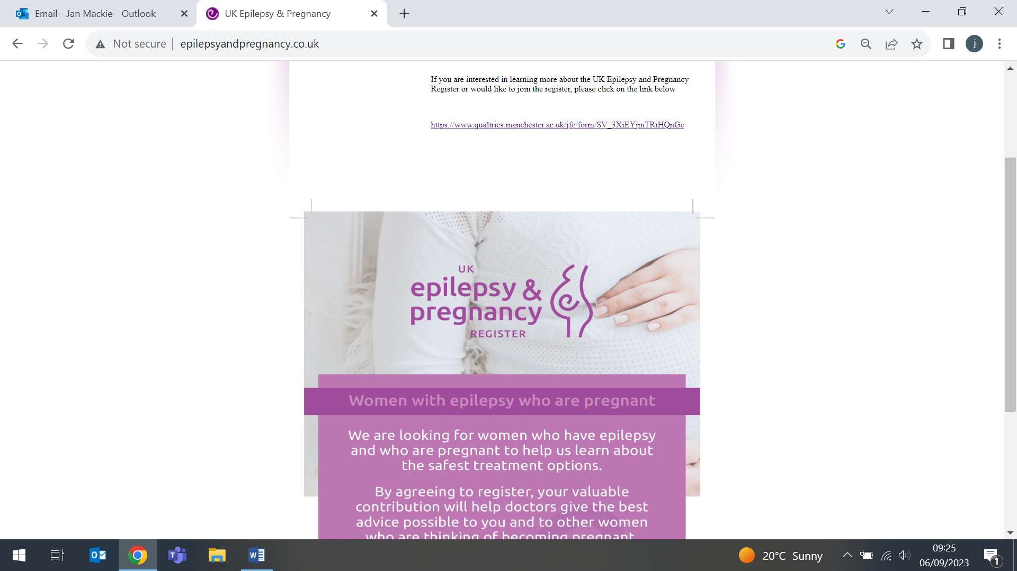      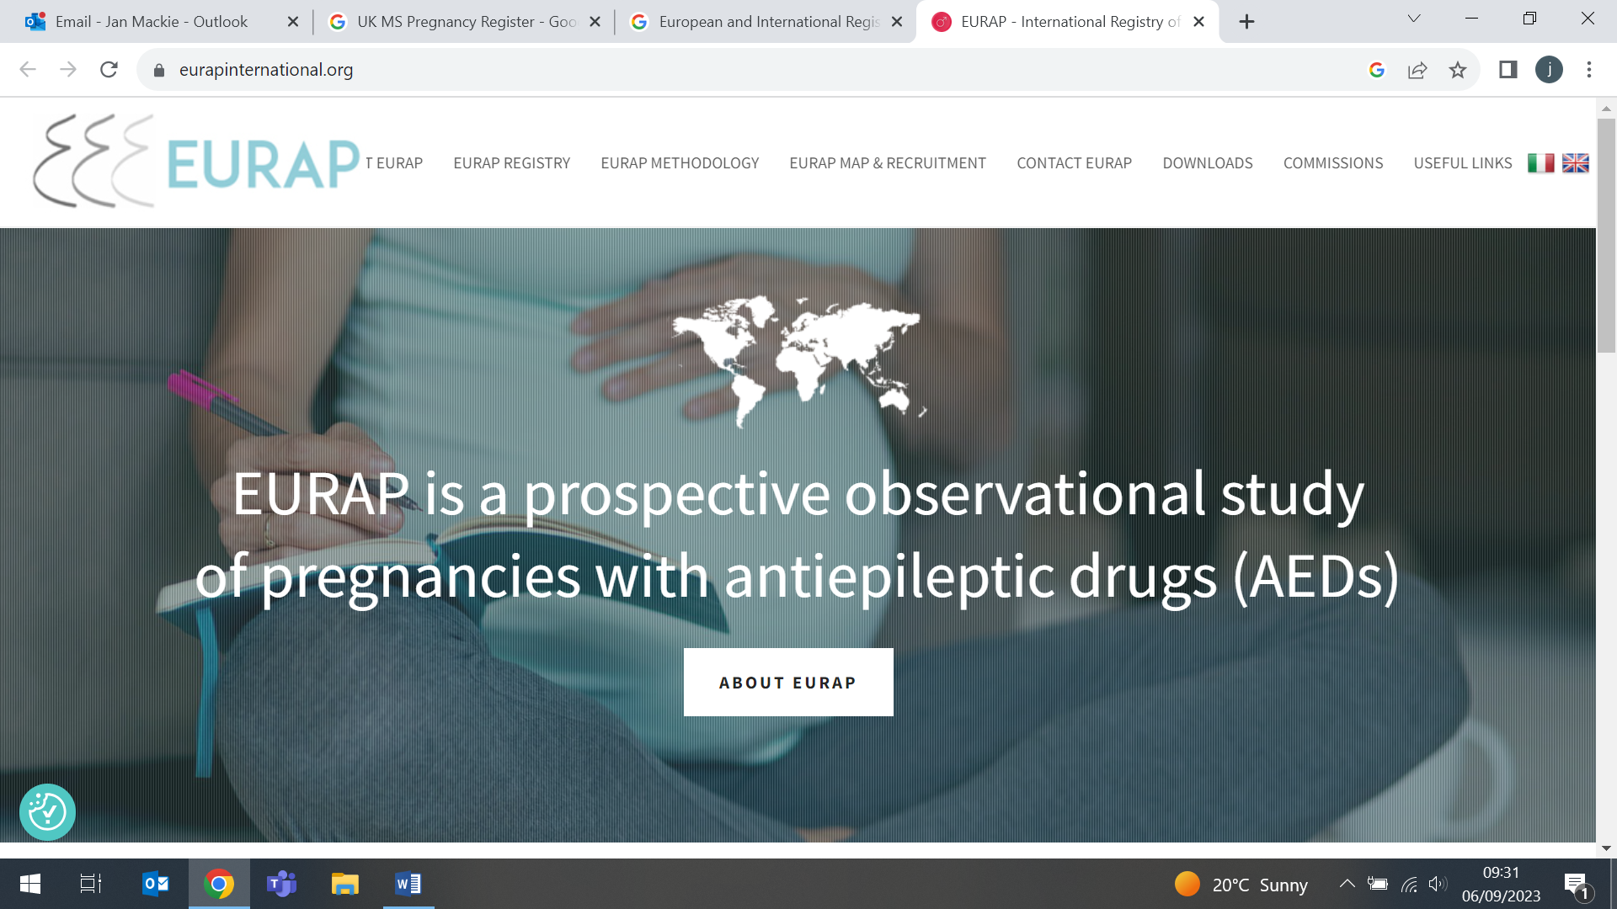
Care for patients with health records showing unspecified heart failure
24 August (Jianhua Wu. Centre for Primary Care)

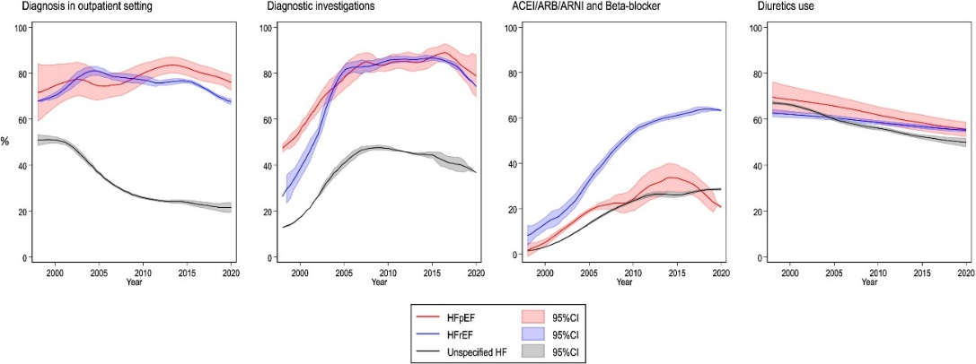  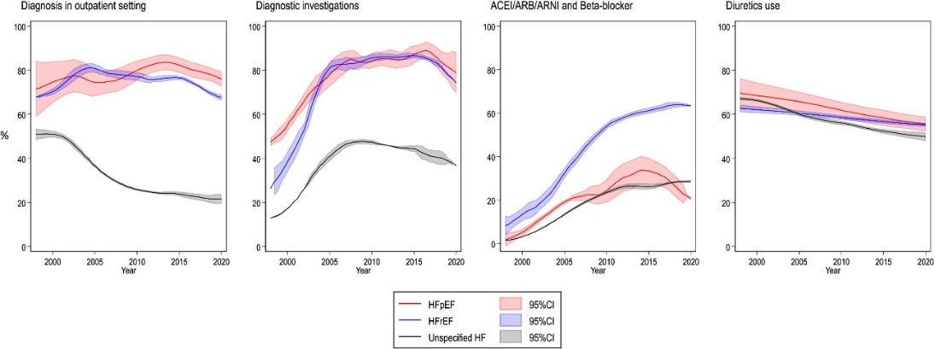  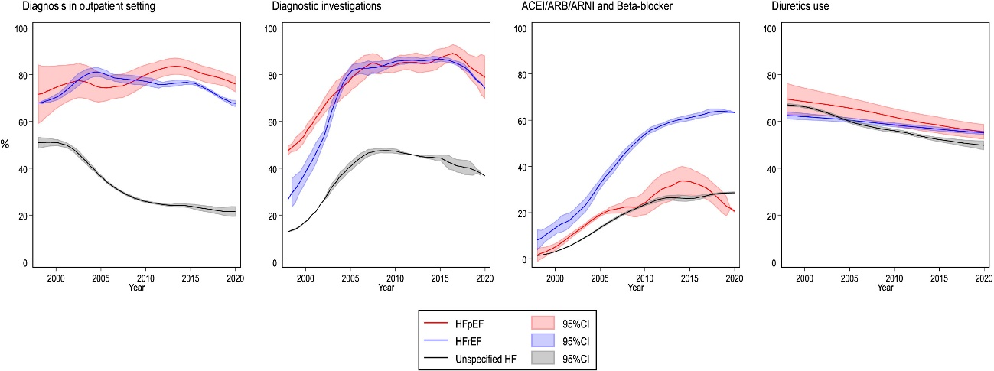 | Using electronic health records for adults with a new diagnosis of heart failure (HF) in England, researchers examine whether accuracy of phenotyping is associated with variation in prognosis and care provision. Results from 1271 patients recorded with HF with preserved ejection fraction (HFpEF), 10793 with HF with reduced ejection fraction (HFrEF) and 83198 as unspecified HF show that patients with unspecified HF were older, with a higher prevalence of dementia, and had significantly worse outcomes for hospitalisation and death. Compared with patients with a recorded HF phenotype, they were less likely to receive specialist assessment, echocardiography or natriuretic peptide testing in the peri-diagnostic period, or angiotensin-converting enzyme inhibitors, beta blockers or mineralocorticoid receptor antagonists up to 1yr after diagnosis. Authors conclude that absence of HF phenotype in records is inversely associated with clinical investigations, treatments and survival, representing an actionable target to mitigate prognostic and health resource burden. Whether the findings translate to other diseases merits further consideration.
Novel obesity treatments: Implications for cancer prevention and treatment
25 August (Andrea DeCensi. Centre for Cancer Screening, Prevention and Early Diagnosis)

A narrative review, exploring current knowledge on correlations between weight loss in obesity and cancer, highlights the potential utility of weight loss in clinical cancer treatment settings. The study identified extensive ongoing research on the effects of obesity treatment (especially glucagon-like peptide 1 receptor agonists GLP1-RAs) on occurrence and development of cancer. The research highlights increased potential for use in clinical cancer treatment settings, first in reducing obesity, and secondly in influencing cancer cells by altering proliferation, apoptosis, extracellular matrix remodeling and the response to chemotherapy. Further research is needed to evaluate the relationship between anti-obesity treatment and cancer risk and prognosis, and the long-term efficacy of these agents on weight control versus lifestyle or diet changes. | 
Protocol for youth cohort analysis of adversity and mental health in context of intersectionality
31 August (Georgina Hosang, Laura Havers, Chloe Shuai, Sania Shakoor. Centre for Psychiatry and Mental Health)

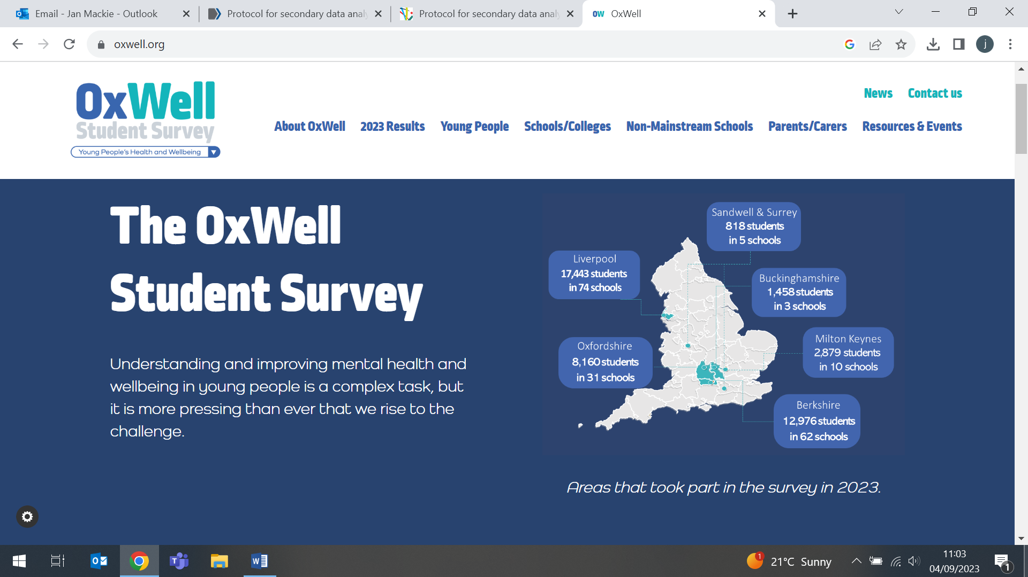    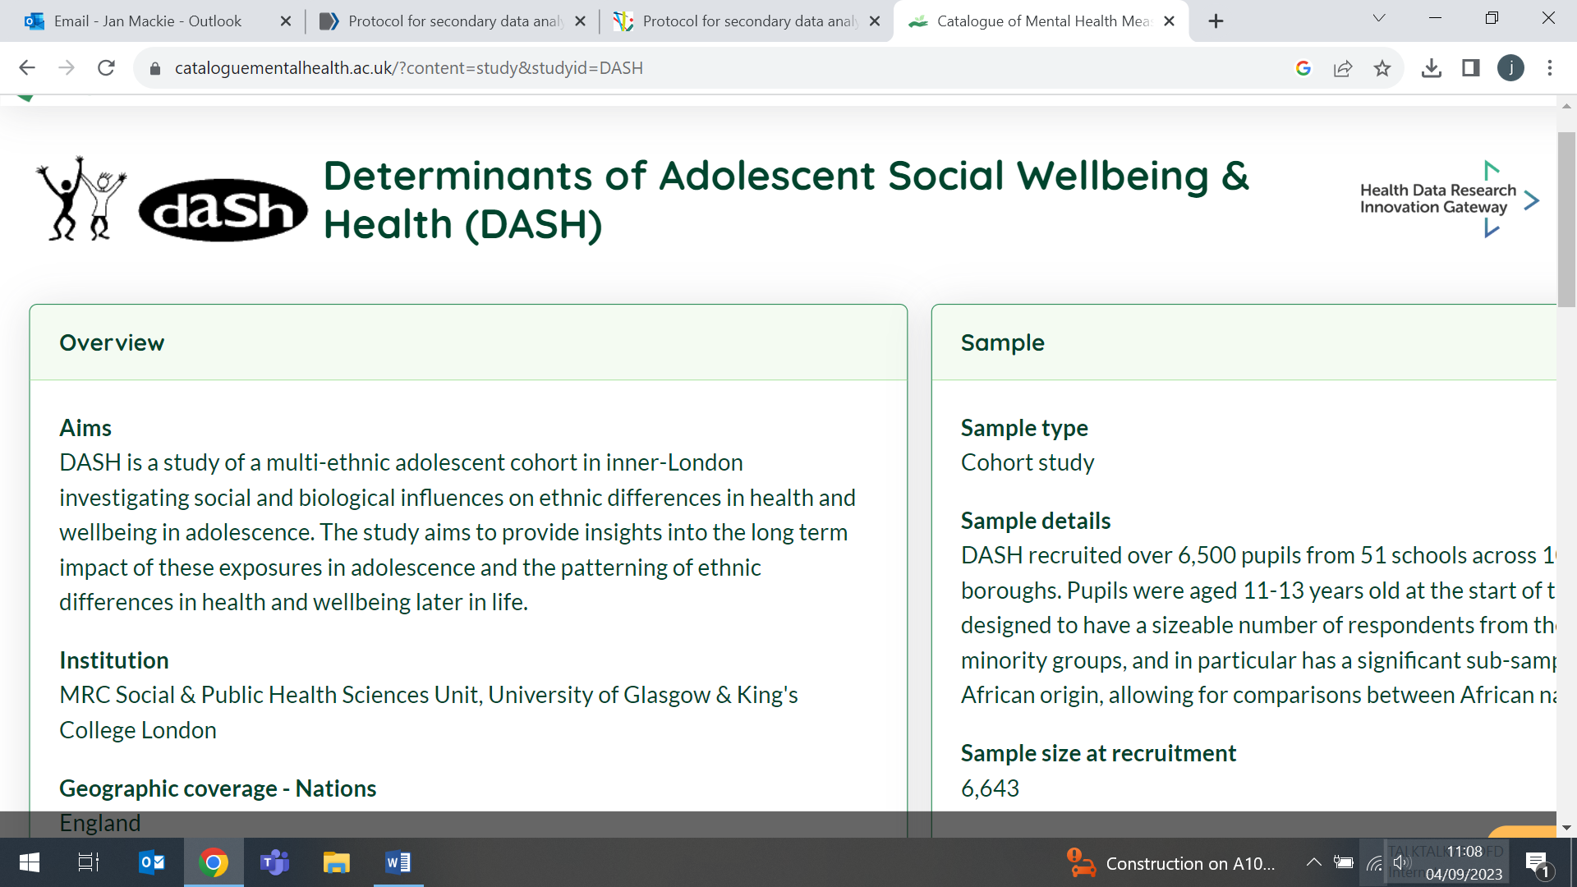  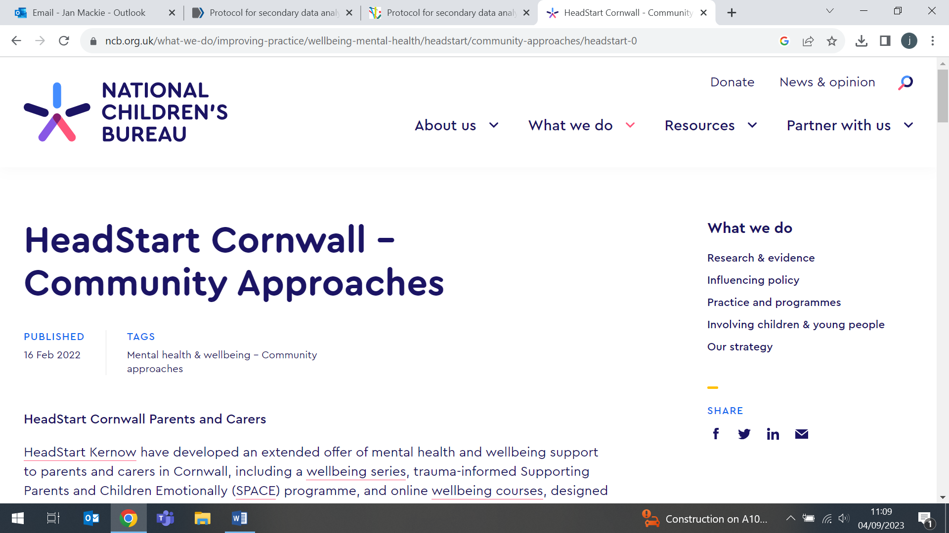 | Prevalence of youth adversity and rates of mental health problems vary by individual characteristics, identity or social groups (eg: gender and ethnicity), but little is known about whether the impact of youth adversity on mental health problems differs across intersections of these characteristics (eg. white females). The protocol for a study to investigate impact and mechanisms of adversity on depressive and anxiety symptoms in young people, according to intersectionality profiles describes structural equation and multilevel modelling to be used on data from 4 UK adolescent cohorts (HeadStart Cornwall, Oxwell, REACH, and DASH). The study aims to improve understanding of the association between youth adversity and mental health, including new information about intersectionality and related mechanisms in young people in the UK. The findings will inform future research, clinical guidance, and policy to protect and promote the mental health of those most vulnerable to the negative consequences of youth adversity.
Media coverage: government plans to classify nitrous oxide as a class C drug
31 August - 15 September (Alastair Noyce, Centre for Preventive Neurology)

Since 31 August Alastair Noyce has made multiple media appearances to plead the case against criminalising possession of nitrous oxide, voicing his primary concern that this government action will lead to a reluctance to seek medical care among young people suffering physical effects of nitrous oxide abuse, who fear a criminal record. Al appeared on a ten minute Newsnight special and BBC breakfast (31 August), the Andrew Marr show on LBC radio (5 Sept), the Vanessa Feltz show (6 Sept), and in The Face (13 Sept), drawing attention to the medical consequences of the forthcoming legislation. The story was also featured on the BBC website. Alastair is the lead author in a group of 15 neurological experts who have penned a letter to the Minister for Policing, setting out their disagreement with the proposed government policy. | 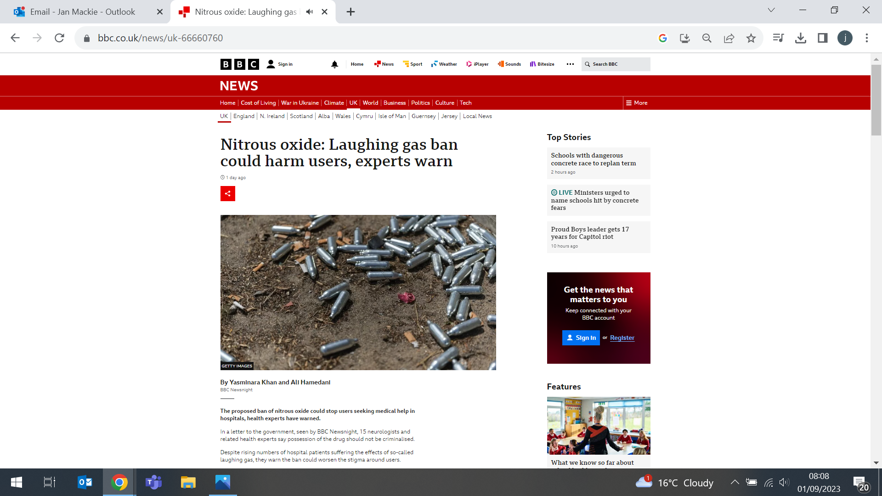  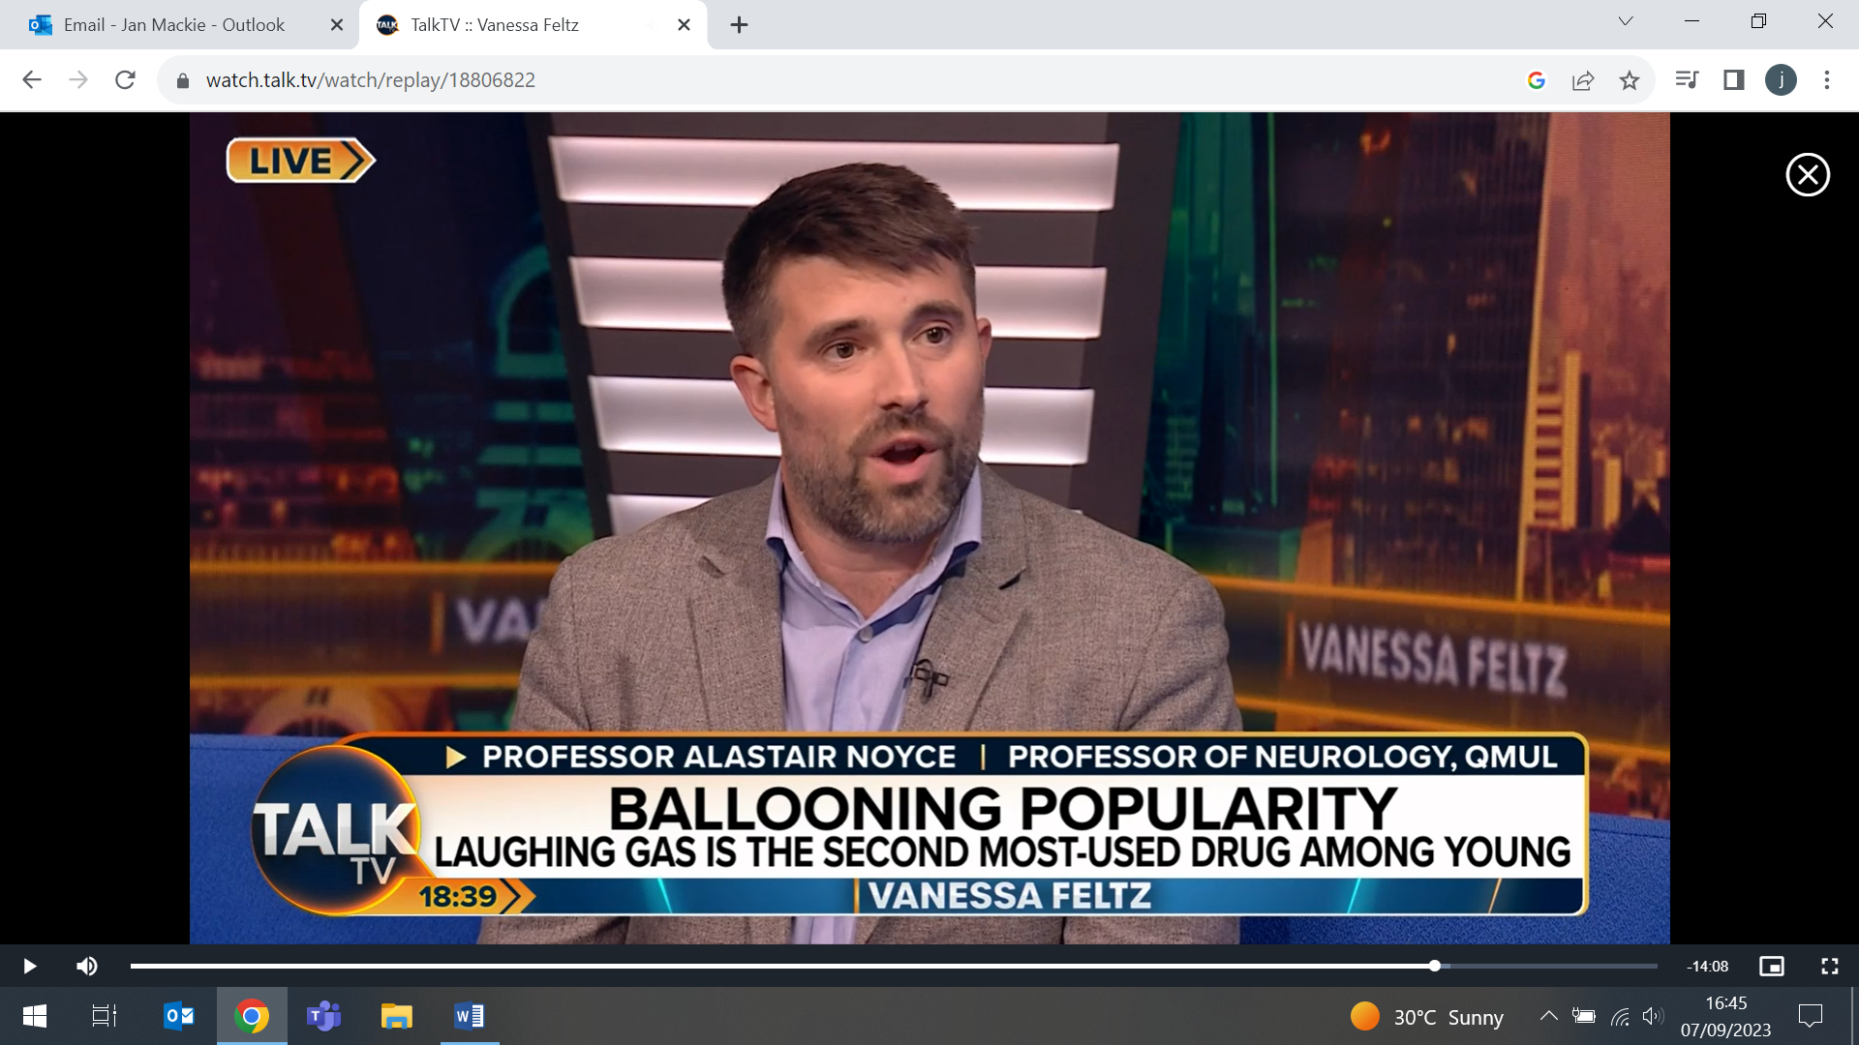
Radiology QA in the Yorkshire Lung Screening Trial
1 September (Rhian Gabe. Centre for Evaluation and Methods)

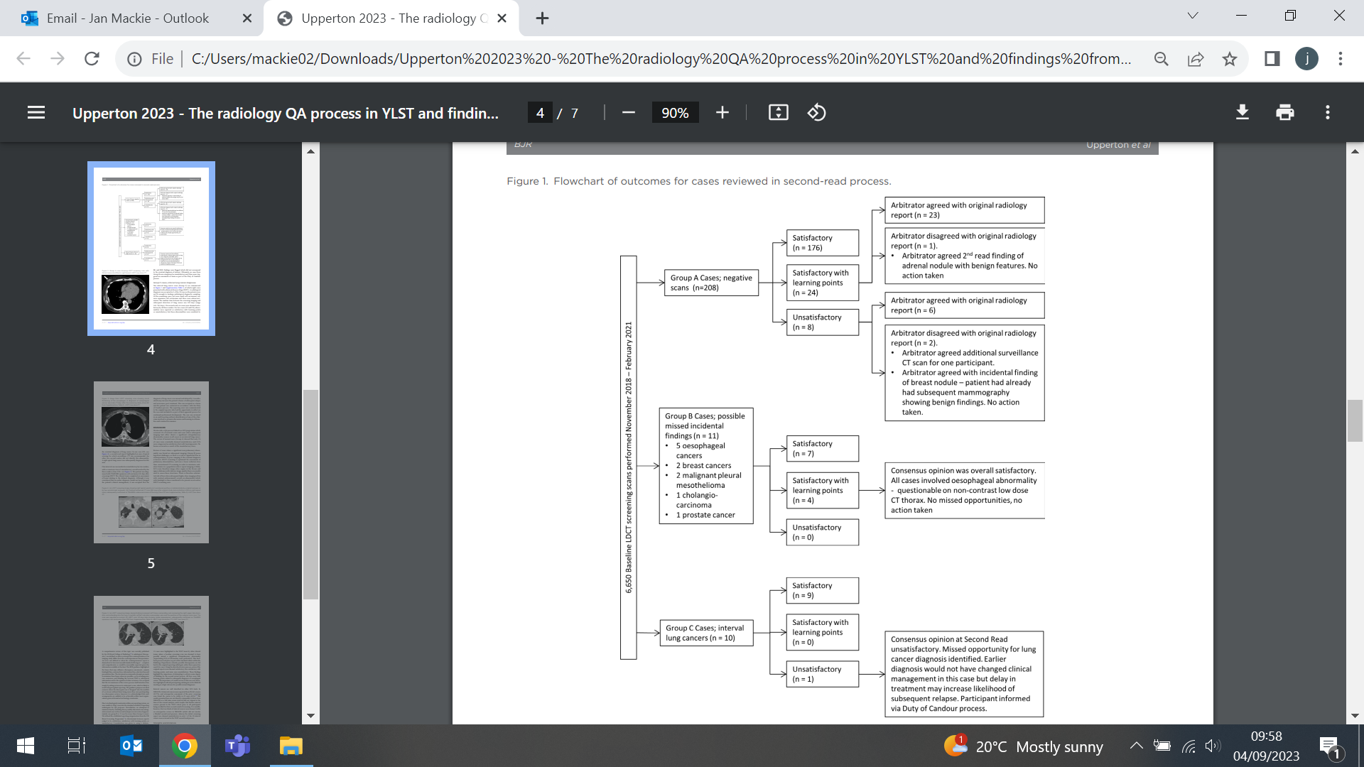 | In a study of the structured quality assurance (QA) process for low-dose CT (LDCT) scans in the Yorkshire Lung Screening Trial, radiologists reviewed a randomly selected 5% of negative scans (208) and all scans of cases with a subsequent diagnosis of extra-pulmonary cancer (11) or interval lung cancer (10) not detected on the baseline scan. The selected scans were single read after using computer-aided detection software. Only three reports were ultimately judged "unsatisfactory": two randomly selected negative scans (n = 2/208) and one interval lung cancer scan (n = 1/10). Of 5 cases judged "satisfactory with learning points", 4 were related to oesophageal abnormalities where the participant was subsequently diagnosed with oesophageal cancer. Researchers conclude that this QA process may represent a framework for future QA of national screening programmes.
Mapping clinical trials in cancer screening, prevention and early diagnosis
4 September (Dipesh Gopal, Centre for Primary Care)

Evaluating 2888 clinical trials focused on cancer screening, prevention and early diagnosis (SPED) that were published 2007-March 2020, a systematic mapping review identifies areas of unmet need and highlights research priorities. Results showed that studies on colorectal, breast, and cervical cancer, which cover 19.3% of global cancer deaths, comprised 61% of publications. In comparison, studies on lung and liver cancer, responsible for 26.3% of global cancer deaths, comprised just 6.4% of publications. Number of studies varied markedly according to geographical location, with 88% based in North America, Europe, or Asia. Researchers hope the findings will help drive future research effort so that resources can be directed towards major challenges in cancer SPED.

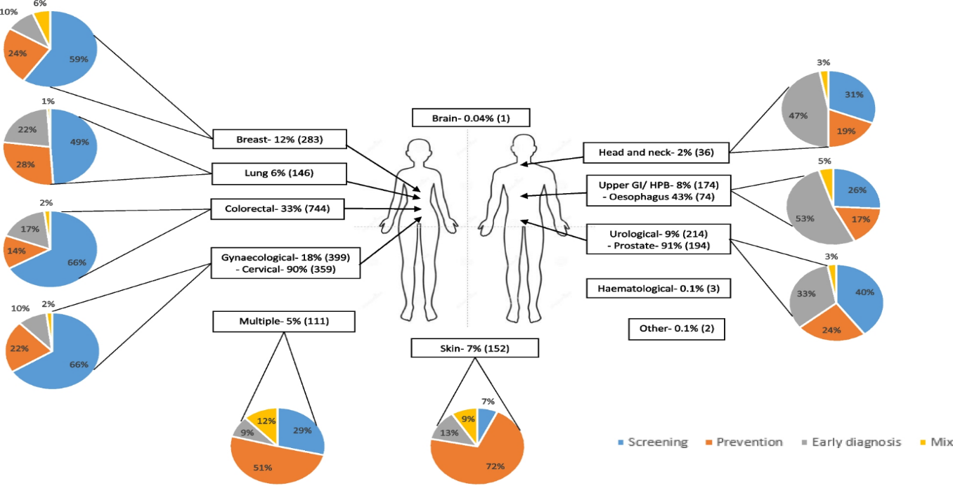
Prioritising determinants of improved care in multimorbidity
5 September (Beth Stuart. Centre for Evaluation and Methods)

 | A three round online Delphi study conducted in England to explore determinants of improved care in people with multiple conditions finds that care systems are still predominantly single condition focused. Findings from the research, which was conducted with health and social care professionals, data scientists, researchers, people living with multimorbidity and their carers, showed that 'person-centred and holistic care' and 'coordinated and joined up care', were highly rated determinants in relation to improved care for multimorbidity. Researchers also identified a range of non-medical determinants that are important to providing holistic care for this cohort. They conclude that a move is required from a single condition focused biomedical model to a person-based biopsychosocial approach.
Westminster Food and Nutrition Forum
5 September (Hattie Burt. Centre for Public Health and Policy)

Senior policy and international projects officer for World Action on Salt, Sugar and Health in the Health and Lifestyle Research Unit, Hattie Burt, presented at the Westminster Food and Nutrition Forum policy conference: ‘Next steps for data transparency in the food system’ on 5 September. The conference examined proposals for a more transparent food system following the Government Food Strategy published last year, which announced the launch of the Food Data Transparency Partnership. In her presentation, Hattie made the case for mandatory reporting of key health and nutrition metrics, using sugar as a case study. She highlighted how a lack of data hindered progress reporting of the voluntary sugar reduction programme, and that current reporting by companies is sparce and inconsistent. She concluded with recommendations for the metrics needed to drive food companies to make healthier products. | 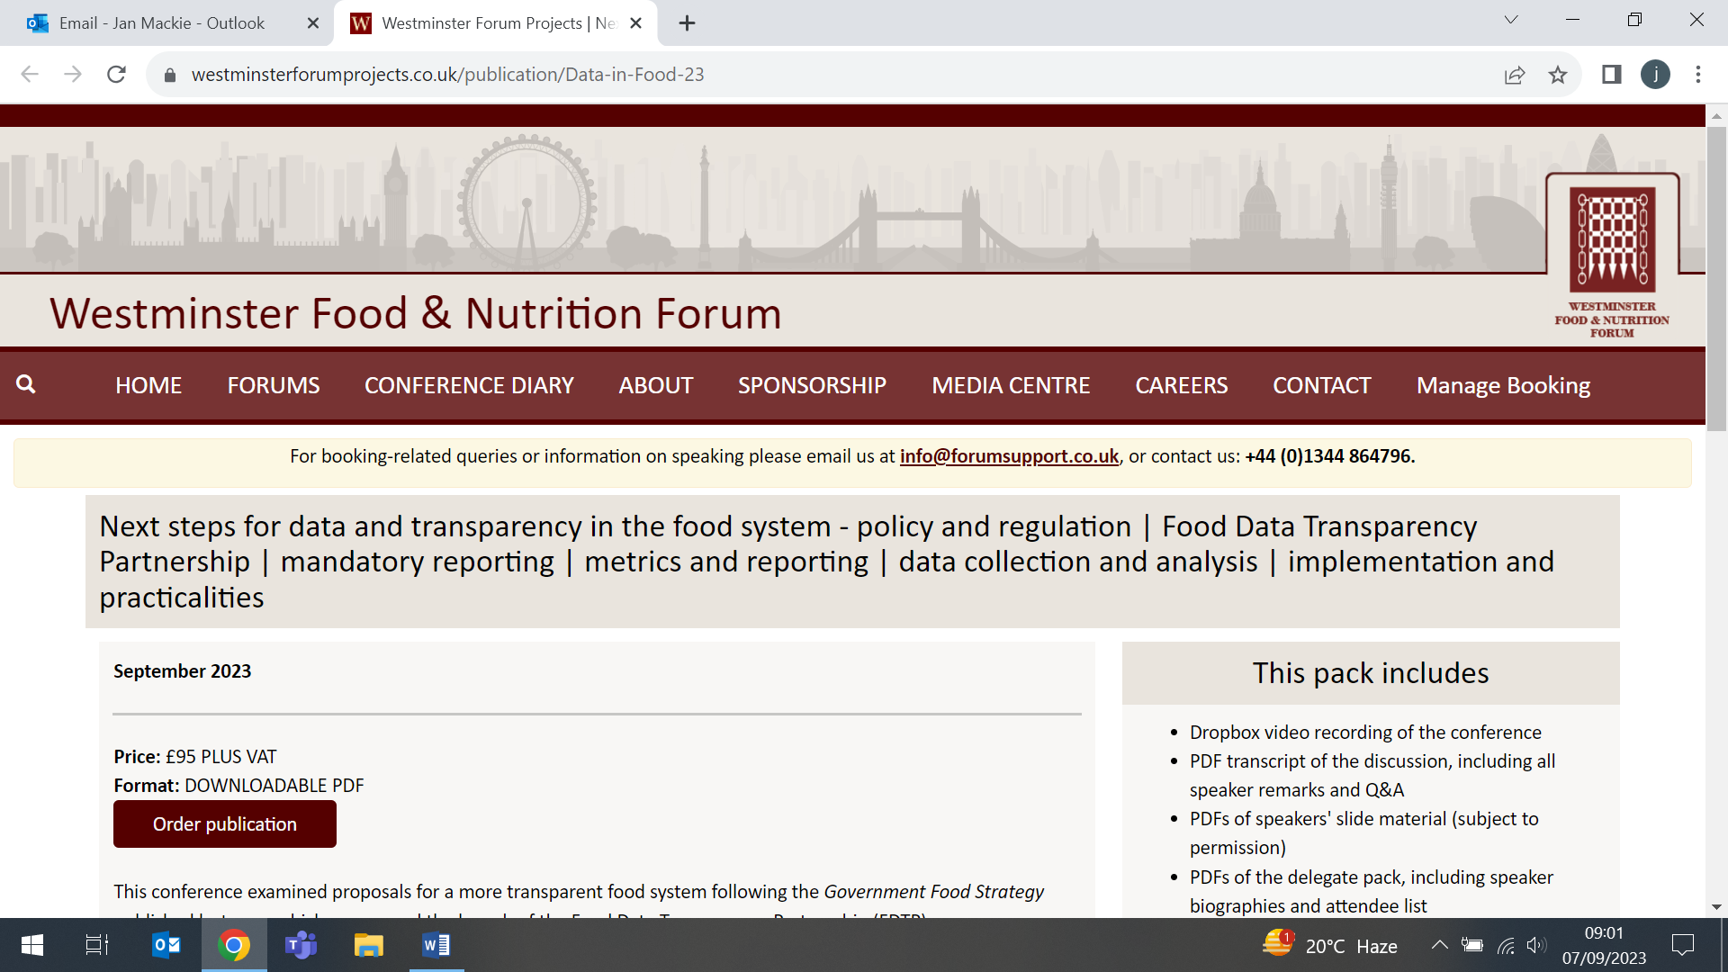  
UK Dermatology Clinical Trials Network: New Chair
5 September (Beth Stuart. Centre for Evaluation and Methods)

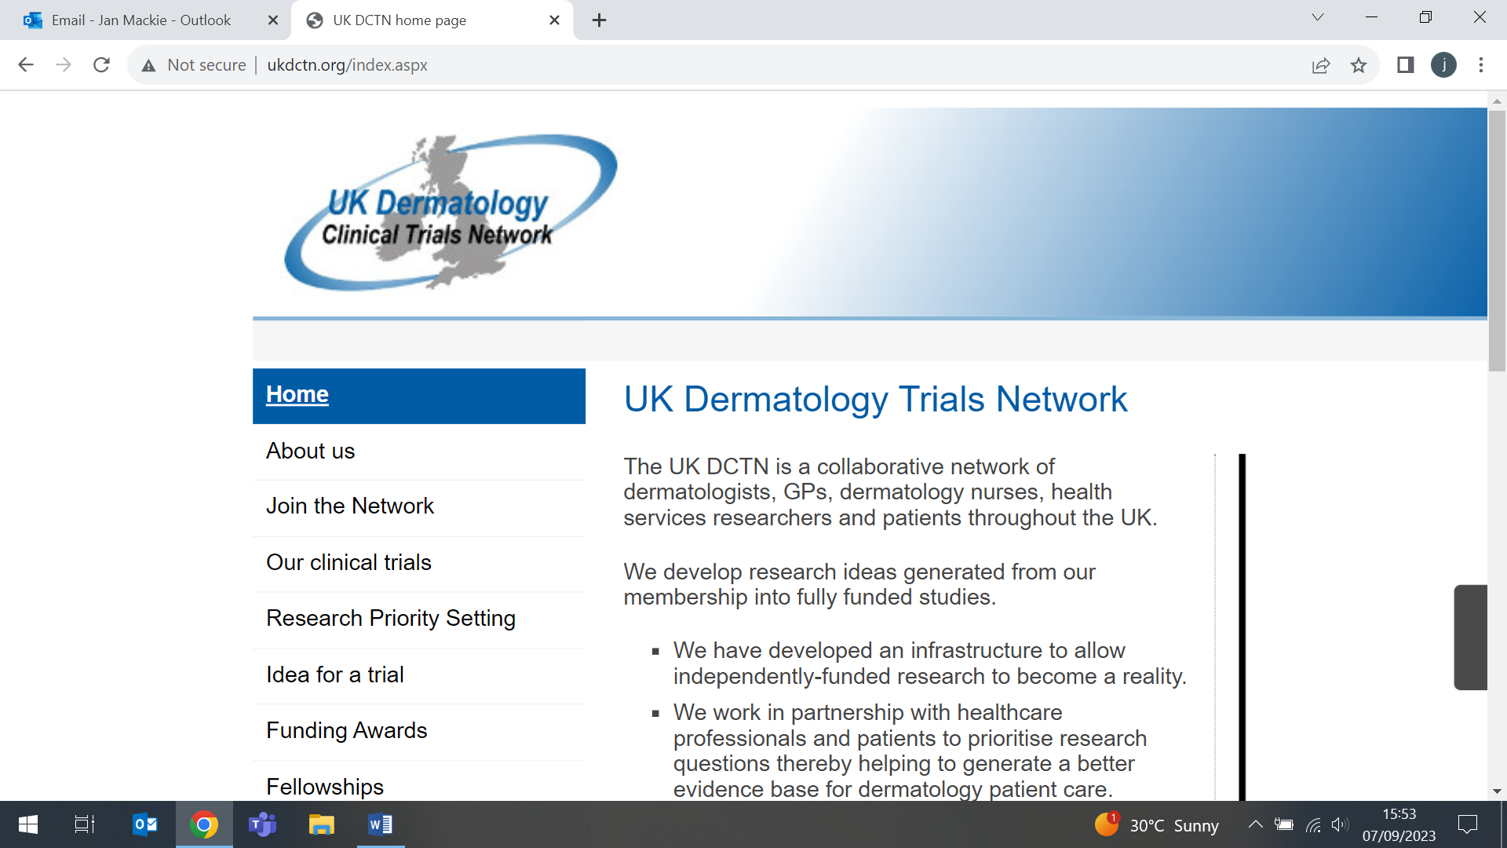   | The UK Dermatology Clinical Trials Network (DCTN) has announced the appointment of their new Chair, Professor Beth Stuart. Beth has now taken up her new role, and will attend her first Steering Committee Meeting as Chair on 17 October. The DCTN is a UK collaborative network of dermatologists, GPs, dermatology nurses, health services researchers, and patients, working to prioritise research questions and to help to generate a better evidence base for dermatology patient care. Beth said: I am very much looking forward to helping UK DCTN to continue the amazing collaborative work that it does, ensuring that dermatology research answers the questions that are important to clinicians and patients, and supporting the next generation of researchers through the fellowship scheme.
Lucy Letby isn’t a psychopath
6 September (Mark Freestone. Centre for Psychiatry and Mental Health)

In an analysis article in Unherd, Professor Mark Freestone suggests that media characterisations of Lucy Letby as a psychopath are not well-founded, and another explanation for her behaviour may emerge if we consider misdirected drives. Mark cites his experience working with wounded healers, who choose to follow a medical profession because of their own life experiences. Letby being told that nurses saved her life at birth is cited as her motivation to become a nurse, perhaps out of a sense of debt, although the idea of having power over life may have been an influence. He reflects that working daily with suffering people can be more oppressive and harrowing than life-affirming, forcing confrontation with one’s own past traumas, and leading to compassion fatigue. For Letby, the natural response to this fatigue would be to try to exert some kind of control over it, to show that the life-affirming experience of her birth could be repeated through an equally potent act. Mark concludes that lacking the skill to save truly sick babies, Letby’s only way to exert this power, “to show that she still lived and her life was worth living, was to take the lives of others in her care”. | 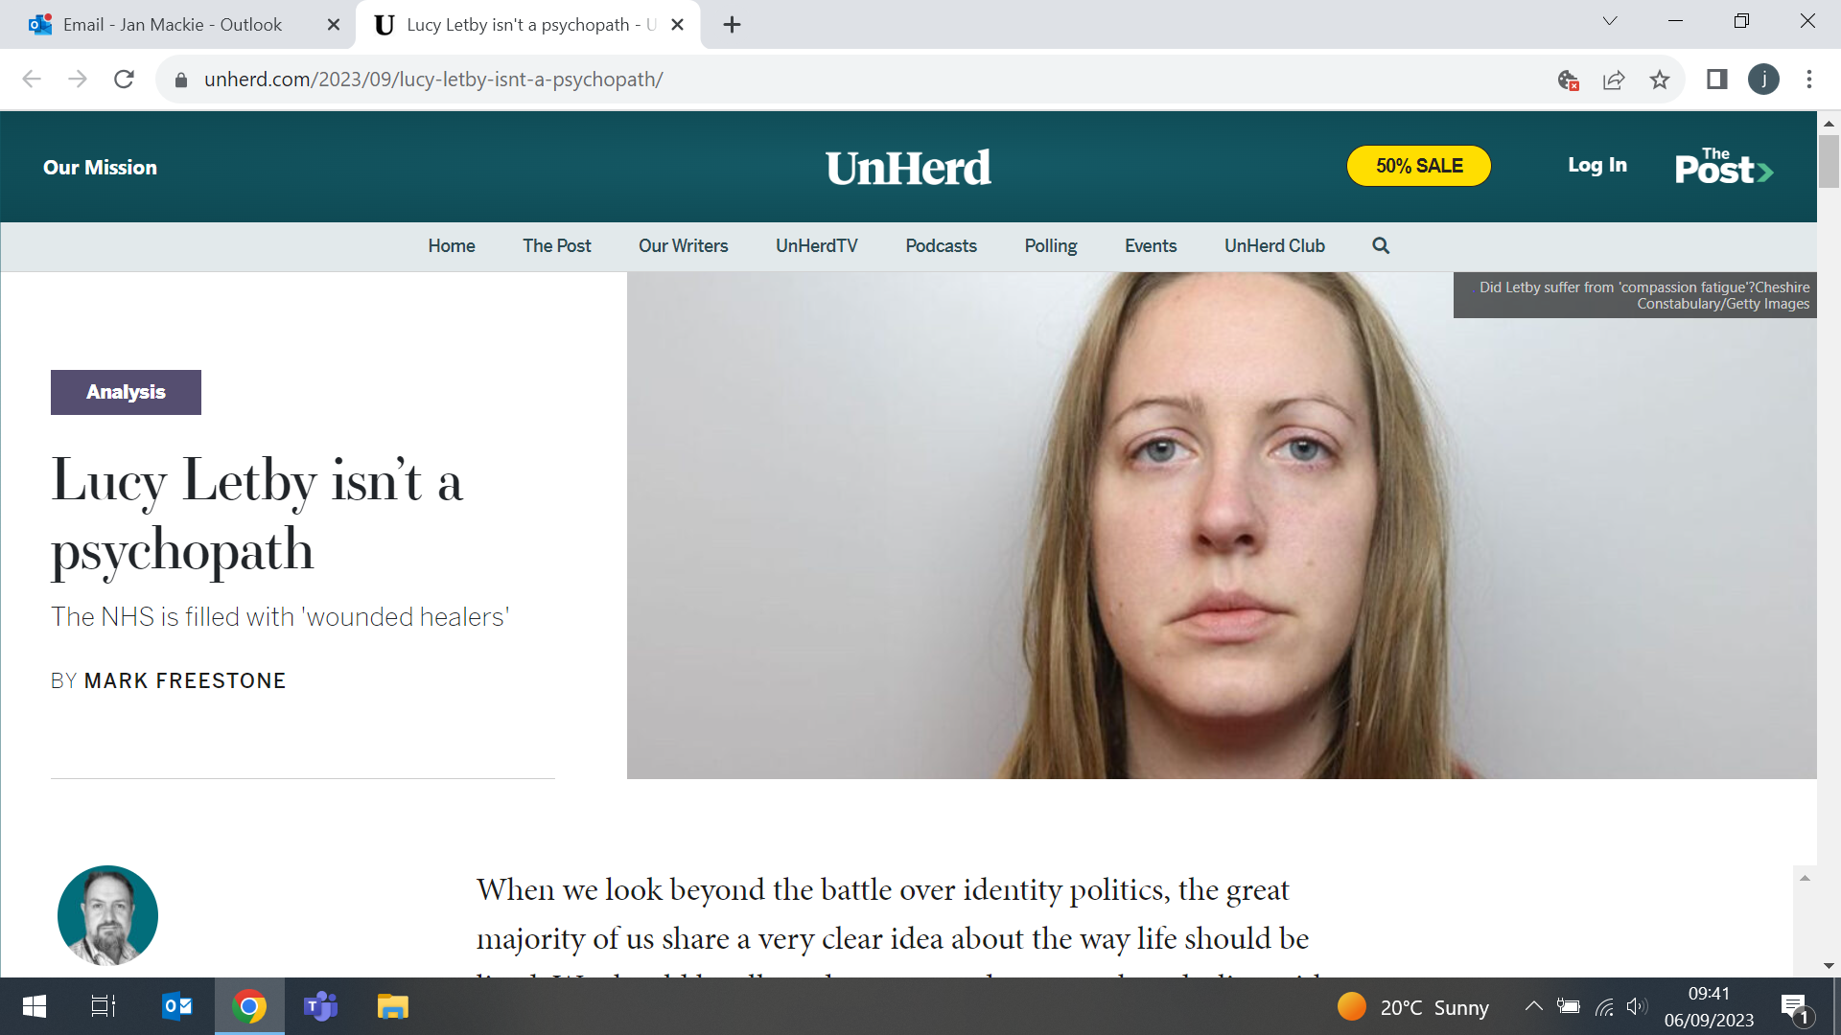
Expert Opinion on study of global cancer cases among those under age 50
6 September (Stephen Duffy. Centre for Cancer Screening, Prevention and Early Diagnosis)

  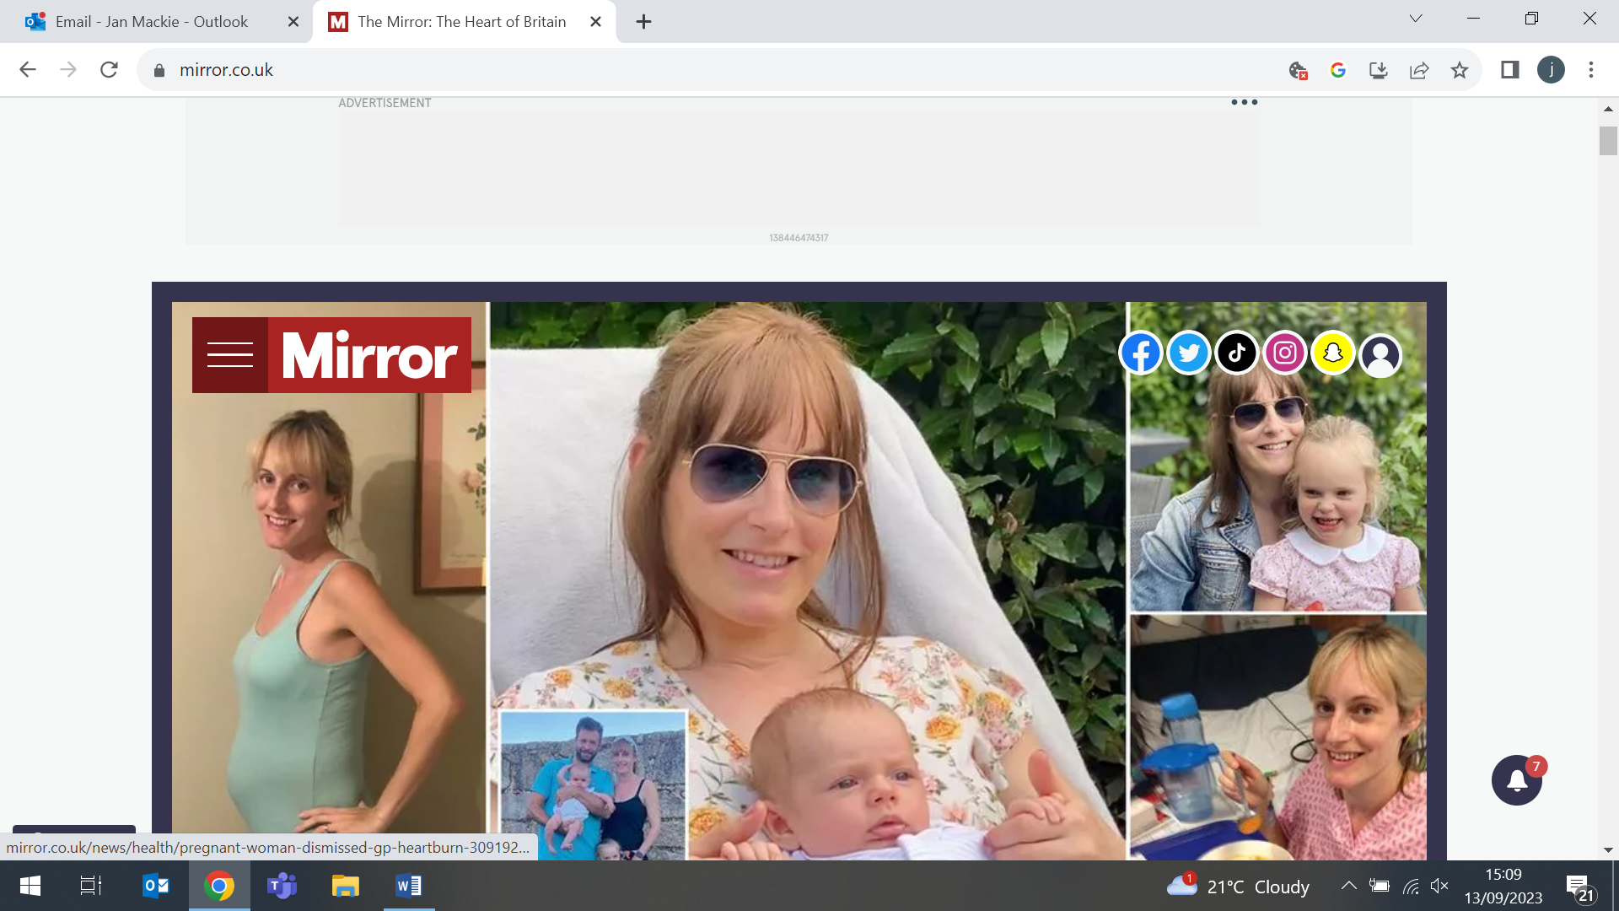    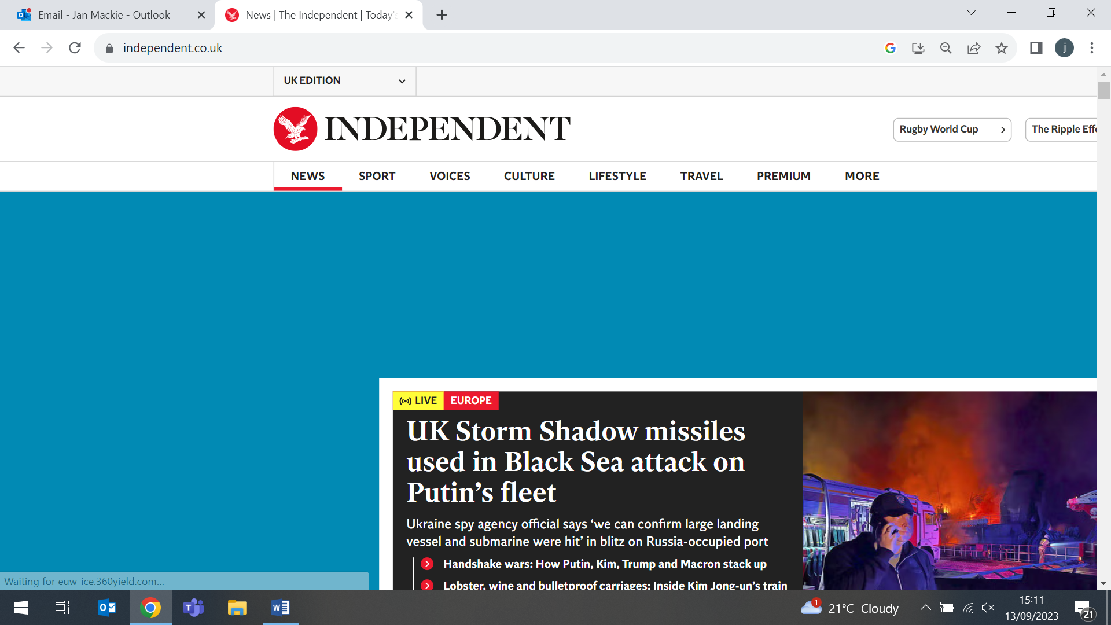 | Commenting on a paper published in BMJ Oncology drawing a global picture of cancers among those aged under 50 over the past three decades, Stephen Duffy highlighted the strong decreasing trend in liver cancer incidence, and increasing trend in nasopharyngeal cancer incidence, as both have large numbers attributable to infectious causes. “In the case of liver cancer, large numbers are caused by hepatitis B virus, for which there is effective vaccination, whereas for nasopharyngeal cancer, large numbers are caused by the Epstein-Barr virus, for which we do not have effective vaccination.” Stephen was quoted in the Financial Times, The Times, the Mirror, and the Independent.
Modifiable MS risk factors have similar effects across ethnic backgrounds
7 September (Ben Jacobs, Jon Bestwick, Alastair Noyce, Charles Marshall, Rohini Mathur, Ruth Dobson. Centres for Preventive Neurology/Primary Care)

Research on almost 10,000 UK patients with multiple sclerosis (MS) shows that modifiable risk factors (eg: infectious mononucleosis, smoking, and obesity during adolescence/early adulthood) have a consistent effect across ethnic groups. In the nested case-control study using electronic healthcare records, age at MS diagnosis was earlier in Black and Asian groups than in the White cohort, and there was female predominance in all ethnic groups. Established modifiable MS risk factors were consistently associated with MS in the Black and S. Asian cohorts, and the magnitude and direction of these effects were broadly similar across all ethnic groups examined. No evidence was found of statistical interaction between ethnicity and any tested exposure, or suggesting that differences in area-level deprivation modifies these risk factor-disease associations. Efforts to tackle these risk factors need to be inclusive of people from diverse ethnicities. | 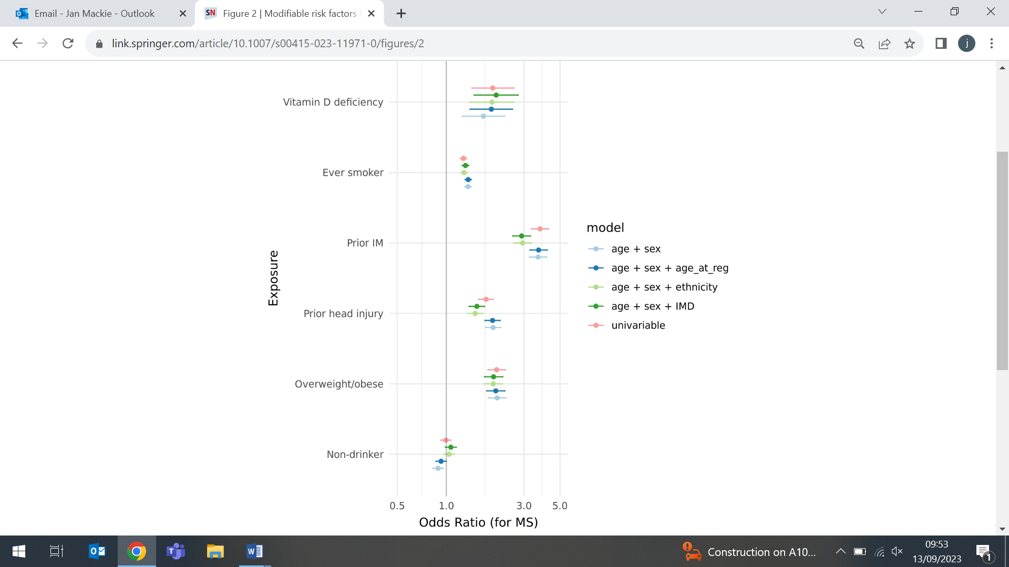  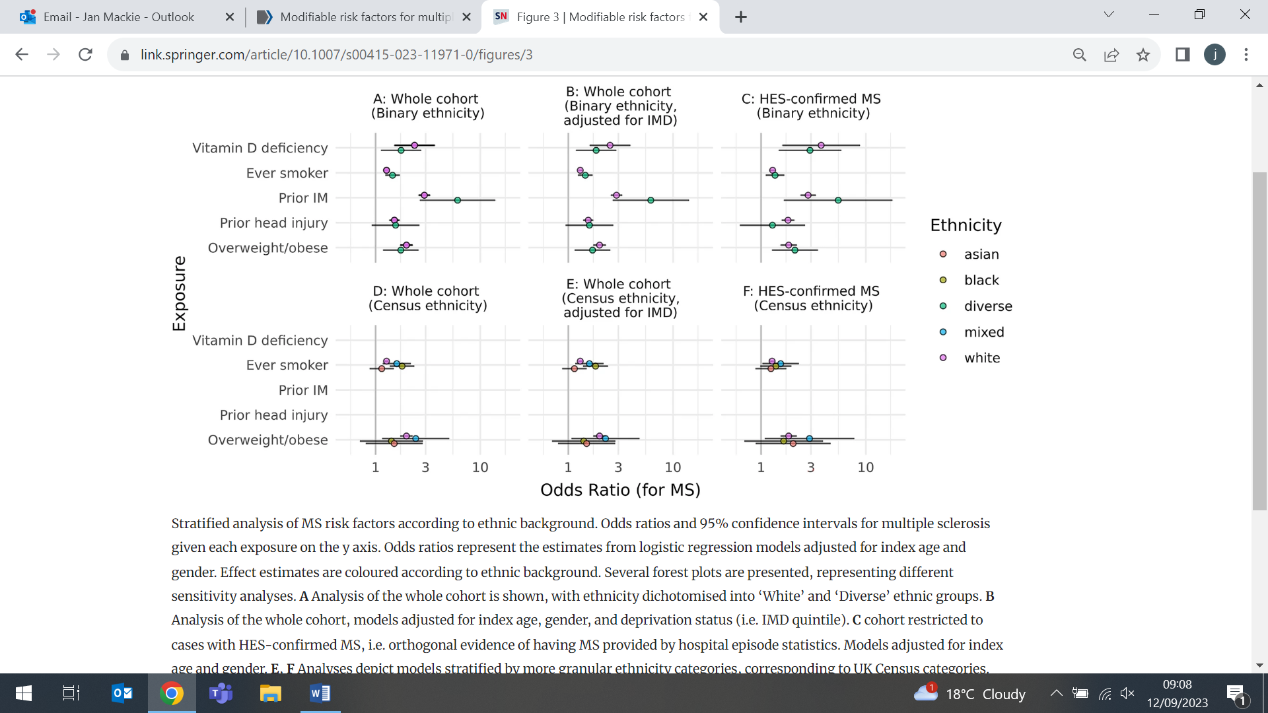

The Challenge of TB in the 21st Century
9 September (Dominik Zenner. Centre for Public Health and Policy)

 | In a new European Respiratory Society monograph, Tuberculosis in the 21st Century, Dominik Zenner co-authors a chapter entitled: ‘How do migrations affect TB burden? TB Control among migrant populations’. The chapter discusses how migrants, especially those who are undocumented, are at increased risk of tuberculosis (TB), and poor treatment outcomes. TB risk in migrants differs by factors including reasons for migration, socioeconomic status, mode of travel and TB risk in transit, and healthcare provision in country of origin and host country. The chapter concludes that migrant sensitive strategies including access to TB prevention and care, interpreters and trained health care providers are essential for TB control.
Tower Hamlets Stop Smoking Service Launch Event
12 September (Peter Hajek, Shamsia Begum, Sabir Ahmed, Centre for Public Health and Policy)

The launch of the next phase of the Tower Hamlets Stop Smoking Service was held at the Mile End Arts Pavilion on 12 September, attended by stakeholders, members of the community, and past service users. The relaunched Quit Right Tower Hamlets is a five year collaboration between the Borough and the Health and Lifestyle Research Unit Stop Smoking team, rolling forward on the success of the previous service which ran from 2017. Guest speakers included Councillor Choudhury (Lead Member for Health, Wellbeing & Social Care), Peter Perren (a past service user), and members of the WIPH Health and Lifestyle stop smoking team. | 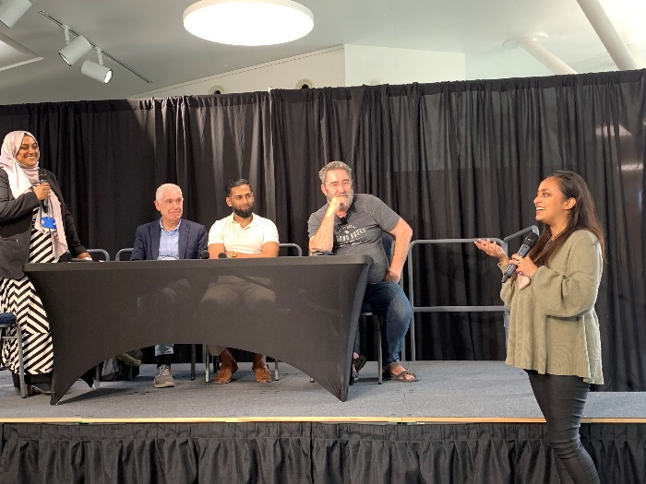  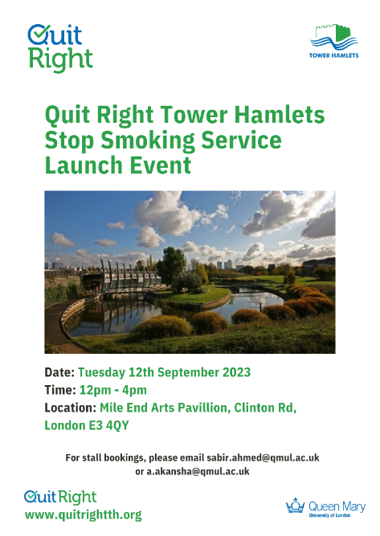
Interventions to increase mental health care help-seeking in LMICs
13 September (Diliniya Sureshkumar. Centre for Psychiatry and Mental Health)

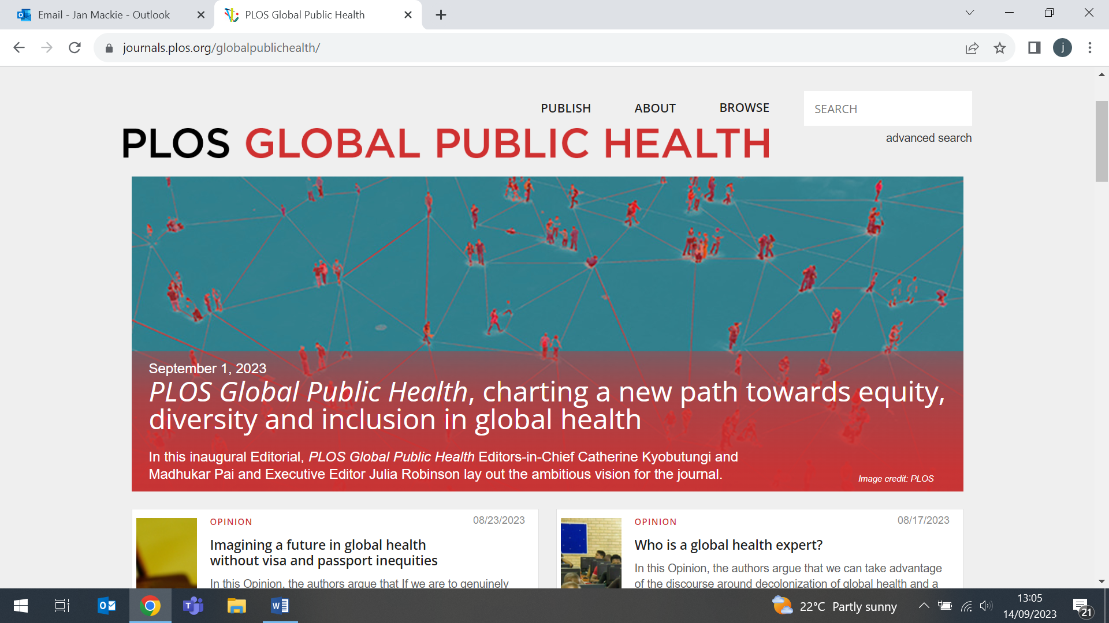 | Most people with mental health problems remain untreated, particularly in low- and middle-income countries (LMIC). A systematic review synthesising evidence to improve help-seeking for mental health problems in LMICs identifies 3 intervention categories: raising mental health awareness in the general population, identifying individuals experiencing mental health problems, and promoting help-seeking among people in need of mental health care. Most interventions (80%) included components in a combination of these categories, and study outcomes show a clear trend in favour of interventions with components from more than one category. Of 42 studies, 10 yielded a statistically significant effect of the intervention on help-seeking and all targeted a combination of the 3 categories.
CEG present four major work programmes to annual EMIS conference
13-15 September (Karishma Bhuruth, Michael Naughton, Shazia Shahzad, Fae Wilkins, Michael O’Hanlon, Chris Carvalho, Jayne Callaghan. Centre for Primary Care)

Facilitators and GPs from the WIPH Clinical Effectiveness Group (CEG) are presenting four of their major work programmes to national GP teams at the EMIS National User Group Annual Conference in London. The conference is attended by users of EMIS, the most commonly used clinical system for managing electronic health records in GP practice. The CEG team are showcasing their clinical effectiveness approach, demonstrating their resources and work with GP practice teams across North East London to improve population health. The four sessions focus on: Increasing physical health checks for people with severe mental illness, Improving demand and capacity management in general practice, Supporting vulnerable people including refugees and people who are homeless, and Optimising care for patients with chronic kidney disease.
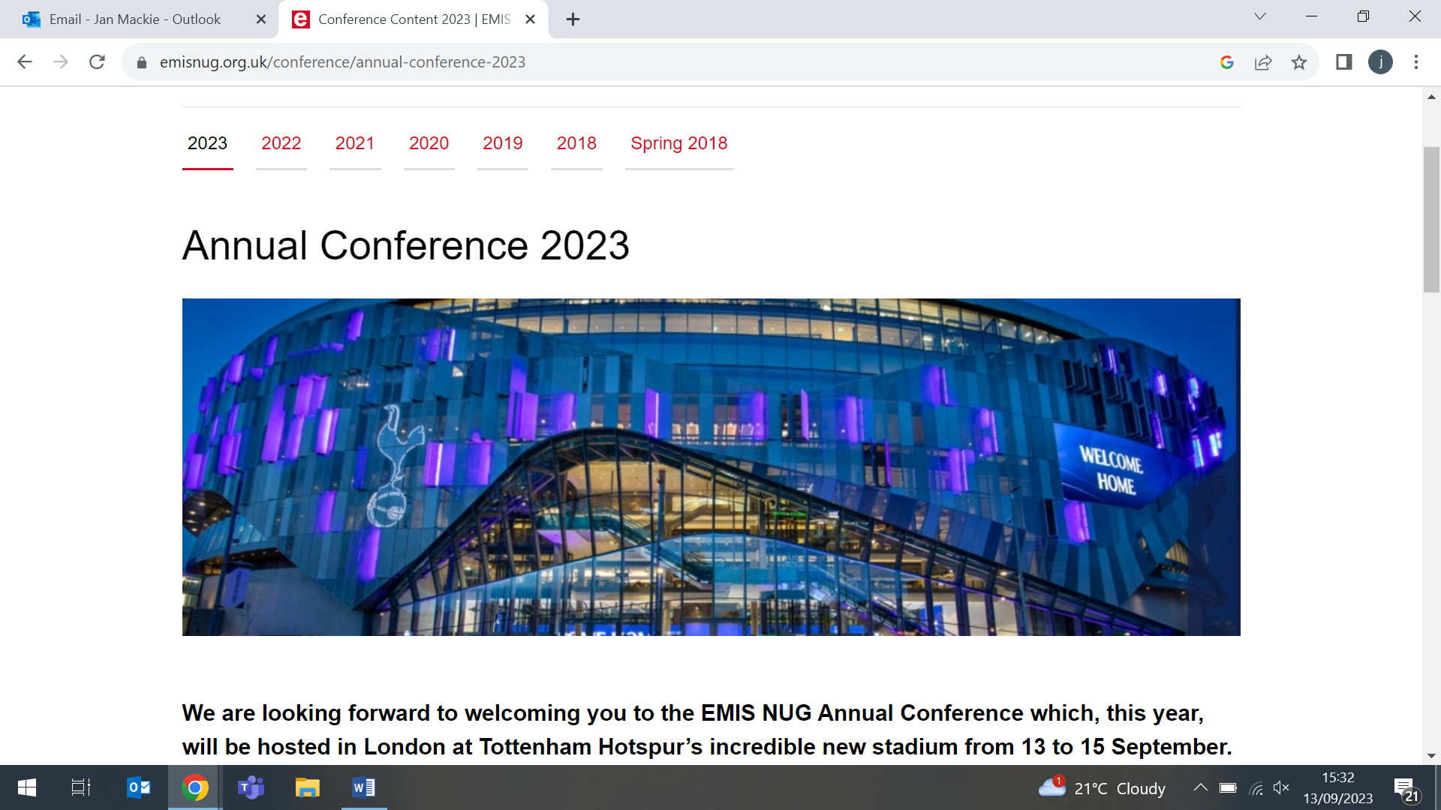
Are women having unnecessary mastectomies after DNA tests for cancer risk?
15 September (Ranjit Manchanda. Centre for Cancer Screening, Prevention and Early Diagnosis)

Ranjit Manchanda spoke to Times Radio Breakfast about a new U. Exeter paper in Lancet eClinical Medicine, showing that women with pathogenic cancer syndrome variants may be at a less elevated risk of cancer in the absence of a first-degree family history. The paper concludes that family history should be considered when counselling patients on the risks and benefits of potential follow-up care. A Times report suggests that women are having unnecessary mastectomies after paying £1000 for private DNA cancer risk tests. Ranjit told Rosie Wright that, while he couldn’t comment on privately offered tests, the risk in the study was only calculated to age 60, not lifetime risk (women live to >80), and that lifetime risk estimates would be much higher than the study reported. The risk with BRCA is significantly high even after adjustment for family history, and other studies show this level lies well above the threshold of clinical intervention (>30-40% lifetime risk for mastectomy). |   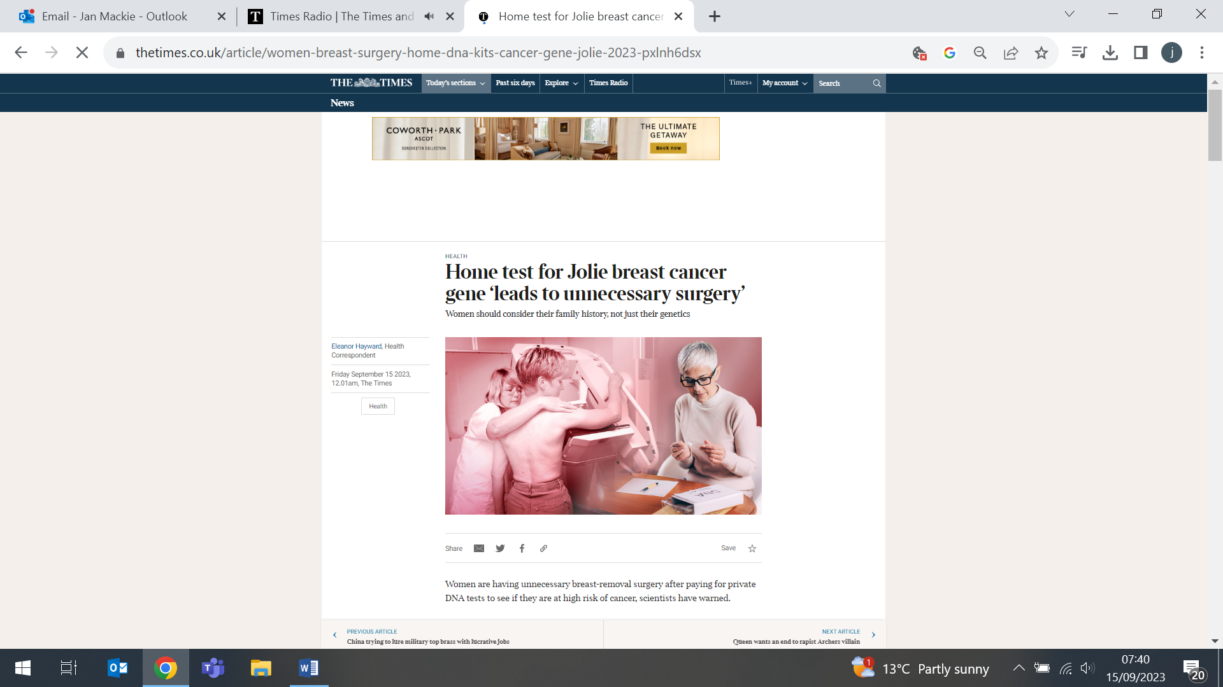
FORTHCOMING EVENTS

Can cancer be detected earlier by employing wearable technologies?
20 October (Suzanne Scott, Centre for Cancer Screening, Prevention and Early Diagnosis)

Suzanne Scott will speak at a workshop on ‘Can Cancer be Detected be Employing Wearable Technologies?’ in Cambridge on Friday 20 October. Her presentation at 11:25 will be on Symptoms, help-seeking and the use of wearables: considerations from behavioural science. Poster submission and registration is now open. Click here for details and registration. | 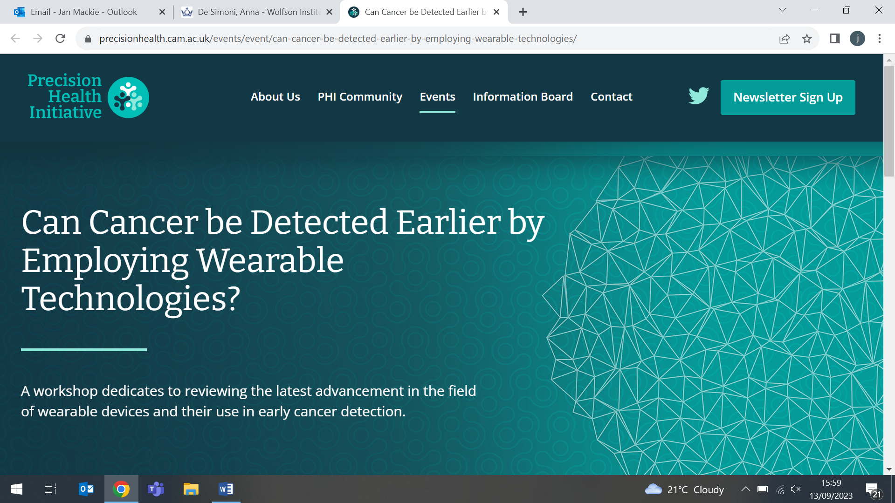
Many thanks to all who so enthusiastically contribute. Please send any news items for the next newsletter to j.a.mackie@qmul.ac.uk

