WOLFSON INSTITUTE OF POPULATION HEALTH
NEWSLETTER
ISSUE 42: 28 SEPTEMBER 2023

In this issue of our Wolfson Institute of Population Health Newsletter, we celebrate the achievements and work of staff and students through the second half of September.

FROM OUR DIRECTOR
Dear Colleagues

It’s been a busy start to the new academic year, as we welcome all our new and returning students.

Over the last fortnight, many of our staff have been presenting their work and representing WIPH around the world. CPC researchers Najia Sultan and Esca van Blarikom have been in Norway at the Developments in Symptom Research in Primary Care conference in Tromsø, and Nicola Firman and Marta Wilk presented their data analyses on household weight to the UK Congress on Obesity at Queens University Belfast.

Even further afield, Suzanne Scott (CCSPED) attended the World Dental Federation Congress in Sydney, speaking on new strategies for the prevention and management of oral cancer.  It is wonderful to see the international reach of our teams, and I am enormously proud of how our work is being showcased on a global scale.  With best wishes  Fiona | 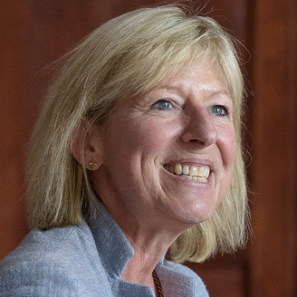
MEET WIPH

MEET WIPH – SABIR AHMED (Centre for Public Health and Policy)

How would you describe your role/responsibilities?
I oversee all marketing, communications and engagement work in the Health and Lifestyle Research Unit, which includes three stop smoking services in Tower Hamlets, Newham and Waltham Forest. My role includes managing the website, the services’ social media platforms and activities, digital marketing, events and projects, and also producing graphic design material. Working on different campaigns involves interacting with stakeholders across QMUL, council comms teams, Public Health, and local community organisations.

What has been your greatest professional achievement?
Having my work and designs displayed across the local boroughs to promote campaigns, but also seeing the impact and the difference my work achieves for people who want to make a change and better their health.

What aspects of your role do you enjoy the most?
My role is so varied, but I enjoy every aspect - from campaign planning, to creating engaging posts for social media and marketing, and using my creativity to design new campaign material.

What would be your second choice as a profession?
I would have to say a footballer. I think that’s the dream for many boys when they’re little, but football is something I've always loved and enjoyed, and to maybe represent England one day would be a dream!

What do you enjoy doing outside work?  As well as playing sports, I love travelling - exploring new countries and adding stamps to my passport! I enjoy visiting countries steeped in rich history and culture that I haven’t been to before.  Something about you that most people don’t know?  When I was younger I used to compete in athletics, and came 3rd in my age group in England for the 200m. | 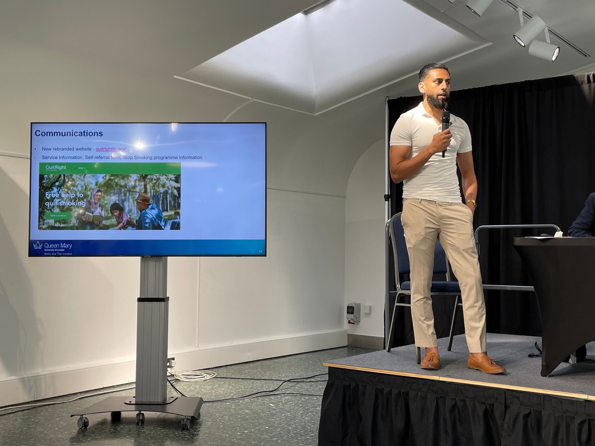
FROM OUR LEADERSHIP TEAMS

Health and Safety Update (Tracy Connelly, Deputy Institute Manager)

Following the launch of our Staff Zone, this is a prompt to signpost to our H&S pages and the content which will be relevant to you at some point. From knowing your emergency contacts to reporting an incident to finding guidance of self-help.  There is an area for important documents / generic guidance which includes:  ▪Risk Assessment (events, trips, travel, seminars)  ▪Lone working  ▪Support for staff  ▪Stress / Wellbeing  If you have any queries or issues, or would like to be involved in H&S matters, please speak to your H&S Officer as your first point of contact.  Tracy Connelly  WIPH H&S Coordinator | 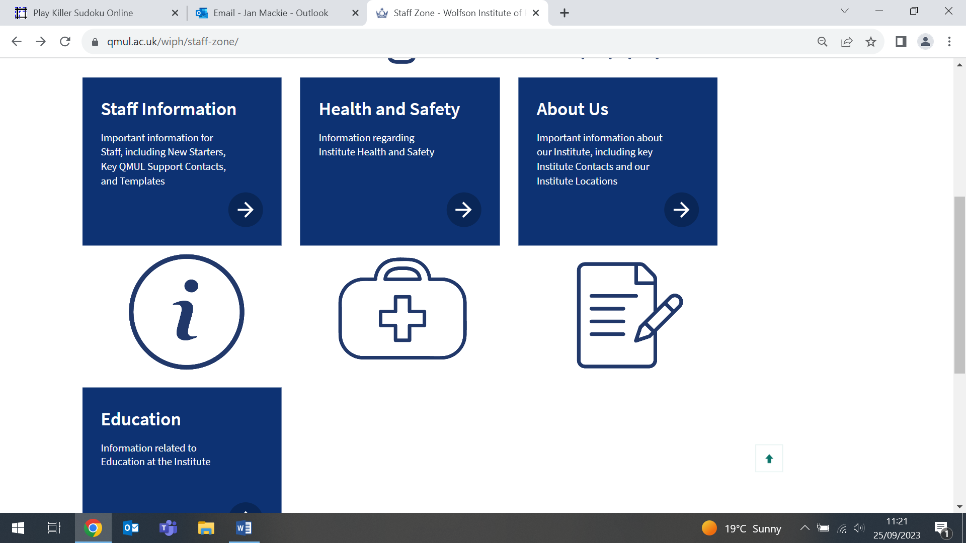  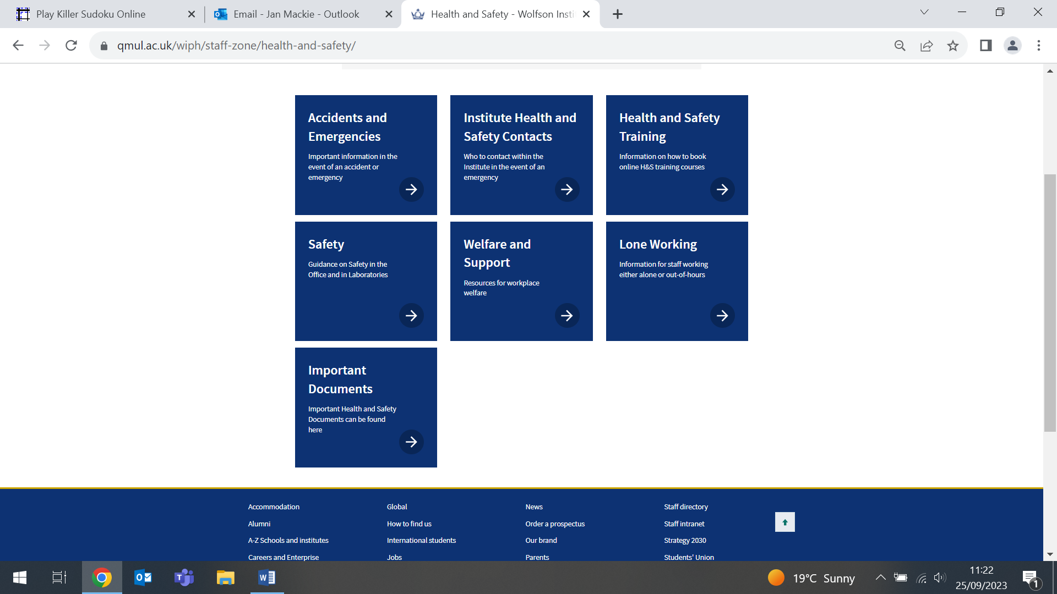
Complexity and Social Science Theme news

Revealing what is hidden - Thinking Between the Lines workshop
(Meredith Hawking, Nina Fudge, Lucie Hogger. Centre for Primary Care, Complexity and Social Science theme)

On 21 September the Thinking Between the Lines (TBTL) network hosted a one day workshop at Toynbee Studios for 30 early career researchers and PhD students working with qualitative methods in health research. Attendees were treated to some fantastic talks from guest speakers Rachel O’Neill (LSE), Jackie Walumbe (Oxford), Mel Ramasawmy (UCL), and Duncan Reynolds (QMUL). A speed networking session sparked new relationships across institutions, and in the afternoon Nina Fudge led a practical session on Video Reflexive Ethnography. The TBTL network exists to build connections between qualitative researchers across QMUL institutes and other universities. Monthly meetings provide a friendly space for sharing and discussing work in progress, being inspired and learning from each other, and engagement with qualitative methodology. If you are interested in joining the network please contact Meredith Hawking.

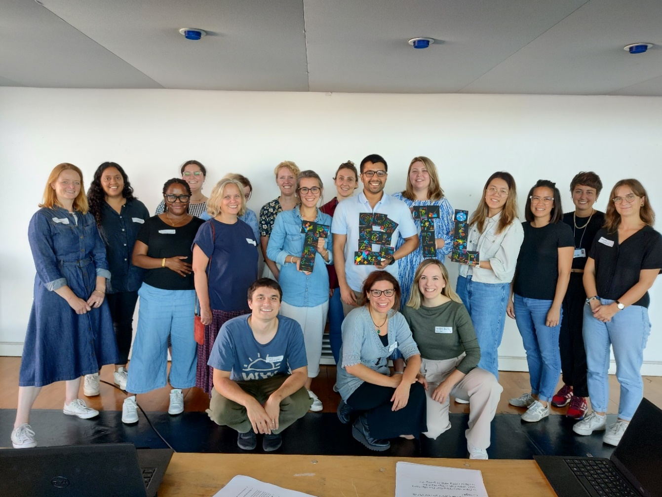
Equality, Diversity and Inclusion News
(Evangelos Katsampouris – EDI Lead)

The EDI Group encourages all WIPH colleagues, students and staff to:
1) Undertake the Queen Mary Bystander Course training, available through QMPlus
2) Use the Online Suggestion Form, available through the EDI section on the Staff Zone, to recommend improvements or to report issues.

If you are keen to become involved in the WIPH EDI Group, or to raise and discuss an EDI-related issue, please email us.

Research News (Tor Kemp, Research Manager)

Earlier this month the Research Team launched the Publication Writing Workshop Series, with fantastic attendance, peaking at 65. A huge thank you to Ruth Dobson for leading the first session, and we look forward to welcoming back Anika Knuppel from Lancet Public Health later in the series. The next session ‘Setting yourself up to write: your abstract as an elevator pitch’ with Claudia Cooper and Alison Thomson will be on Thursday 5 October 12:15-13:00. Please contact Tor if you don’t have the invitation in your diary.

The Research Team will also be launching several new research support initiatives throughout October and beyond - please do look out for comms coming out soon for the WIPH Whiteboard sessions, and a WIPH Health Inequalities Grant Clinic.

And finally a reminder to all PIs, and those colleagues supporting bids, that two new policies from FMD became effective 1 September 2023. Firstly, for all grant proposals to be submitted by (clinical and non-clinical) Early Career Researchers, Lecturers and Senior Lecturers when they are the PI, please follow the FMD Research Grant Peer Review Process. Secondly, FMD have initiated a new Barts Charity Approvals Process. Please find details of both policies and how they fit with other pre-award process on the staff zone page.

GENERAL INSTITUTE NEWS

Does proxy raters’ mental health affect their reporting of health related QOL
12 September (Afia Ali. Centre for Psychiatry and Mental Health)

Health-related quality of life (HRQoL) in adults with an intellectual disability is often measured by proxy report. A study investigating whether the mental health of proxy raters affects the way they rate HRQoL found that, among 110 carers of adults with an intellectual disability, those experiencing more psychological distress tended to rate their own and the care recipients' subjective HRQoL more similarly. Carers completed measures of psychological distress and HRQoL about their own HRQoL and that of the care recipient. Differences between HRQoL scores as rated by the carer about themselves and the care recipient were calculated (convergence scores). Results showed significant association between psychological distress and subjective HRQoL convergence scores, but no association between psychological distress and objective HRQoL convergence scores. The association between psychological distress and HRQoL scores was no longer present when models did not include convergence scores. Authors suggest that the results require replication. | 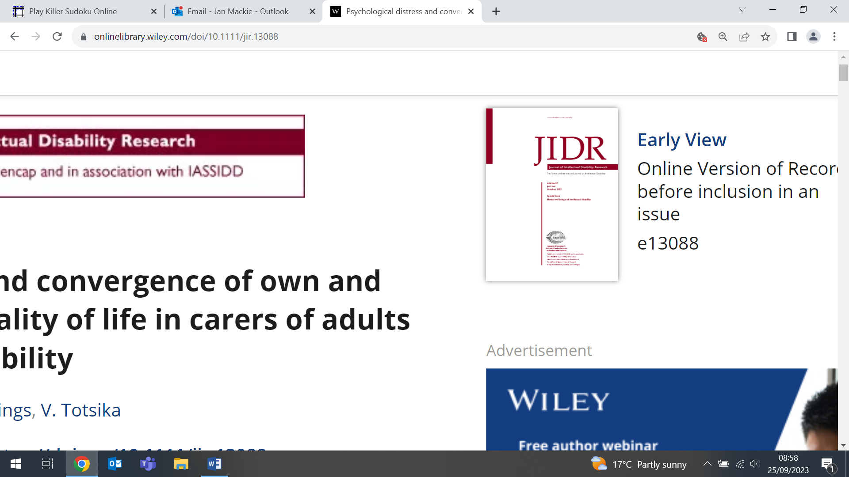
Harbouring Illness: Film Screening and Photography Exhibition
13 September (Esca van Blarikom. Centre for Primary Care)

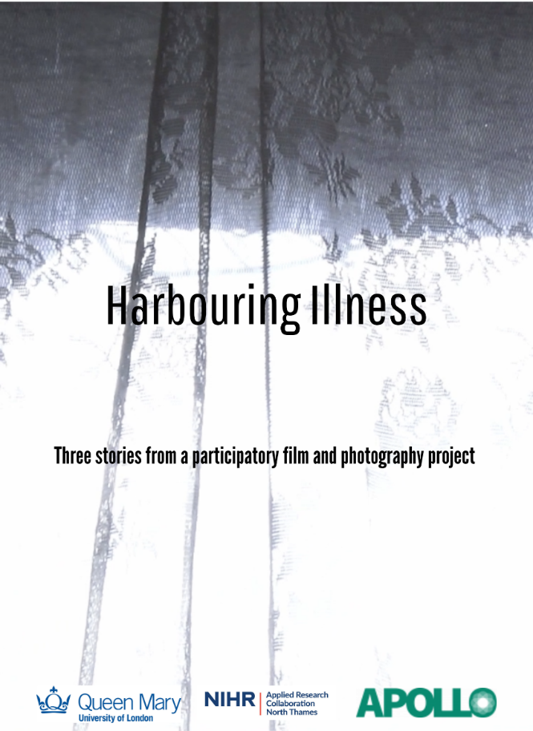 | PhD candidate Esca van Blarikom held a screening for a short film, Harbouring Illness, in conjunction with a photo exhibition at Mile End on 13 September. The film emerged from a Photovoice project organised in the context of Esca’s PhD, and was made in collaboration with three participants. The project explores the experiences working-age residents of Tower Hamlets who live with multiple long-term health conditions, and the film and photographs on display gave insight into their stories of the everyday challenges of living with long-term illness. The screening, attended by local GPs, policymakers, representatives from patient groups, and researchers, was followed by a Q&A with Esca and the three participants, during which challenges related to polypharmacy and the navigation of complex care systems were discussed in more depth.
Protocol for a systemic approach to discharge planning (MINDS Study)
13 September (Frank Rohricht. Centre for Psychiatry and Mental Health)

Integrated and systemic planned discharge from mental health hospitals supports transition and reduces risk of relapse, readmission and suicide. The protocol for the MINDS study describes a process to codesign and evaluate the implementation of a systemic discharge intervention for inpatient mental health settings, to improve the process for people being discharged, their carers/supporters and mental health services staff. The 3-stage process includes (1) review and evaluation of theories of discharge planning, (2) using an Engineering Better Care framework to codesign a novel systemic discharge intervention, and (3) evaluation of the process and economic factors. The programme theories and resulting care planning approach will be refined throughout the study, in readiness for a future clinical trial. | 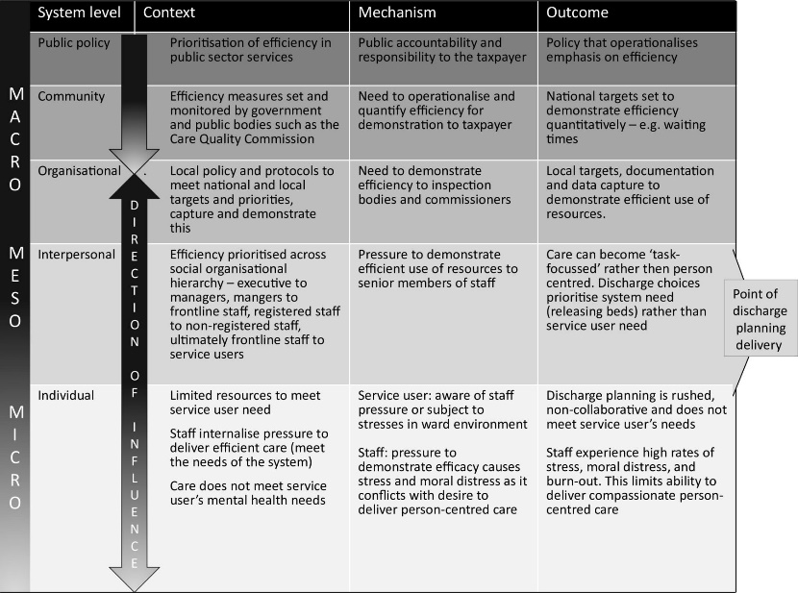
Unlocking the potential of health data research
13 September (Caroline Morton, Rohini Mathur. Centre for Primary Care)

 | Caroline Morton and Rohini Mathur participated in a roundtable discussion on Unlocking the potential of health data research at the SurrealDB World Conference on 13 September. SurrealDB is a database service startup. The panel discussion included conversations about the challenges of cleaning and interpreting coded health data, the role of ‘synthetic data’ in validating and training machine learning models, and how we can usher in a cultural shift towards open methods in research. Caroline also participated in the keynote talk.
Optimising the approach to equity-focused evidence synthesis
14 September (Lucy McCann, Lucy Johnson, John Ford. Centre for Primary Care)

An editorial by WIPH authors reflects on the success and limitations of the PROGRESS-Plus framework, which was developed to consider health equity within systematic reviews. The authors identify three notable limitations: 1) the categories stratify determinants of inequity into discrete groups, disregarding complexity (such as intersectionality and the interaction between multiple aspects of disadvantage); 2) inclusion health groups (eg: people experiencing homelessness, asylum seekers, or street-based sex workers) are not explicitly mentioned; 3) the framework inconsistently prioritises some groups over others (eg: occupation has its own category, but sex and gender are conflated into one). They note that factors in the ‘Plus’ component have much less emphasis and are easily forgotten, and conclude that a more detailed conceptual framework is required to reflect the complexities of health inequalities and highlight the difference between interventions aimed at closing the gap, and those targeted at disadvantaged groups. | 
UK Congress on Obesity
14-15 September (Nicola Firman, Marta Wilk. Centre for Primary Care)

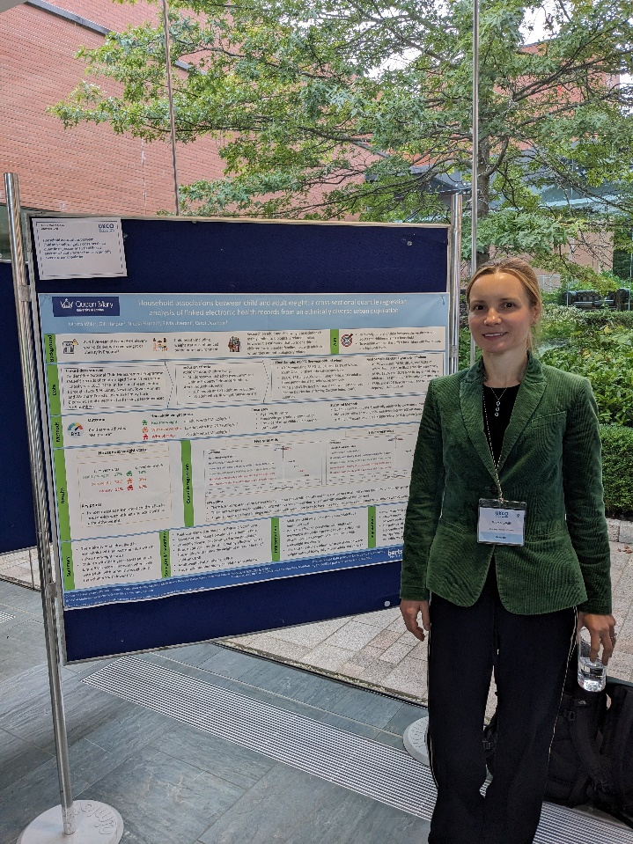  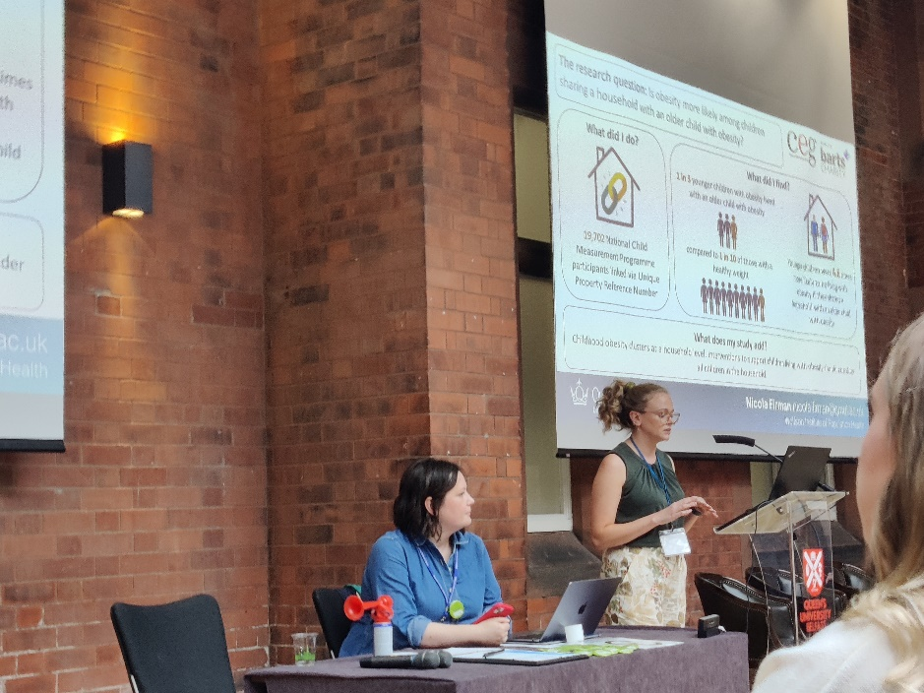 | Nicola Firman and Marta Wilk presented their data analyses on household weight to the UK Congress on Obesity at Queens University Belfast on 14-15 September. Nicola’s summary of her research in the ‘3-minute thesis’ competition, showing that younger children were 4.6 times more likely to be living with obesity if they shared a household with an older child with obesity, won the public vote. Marta shared a poster of her cross-sectional quantile regression analysis investigating household associations between child and adult weight, in which she found that adult and child weight were strongly associated at a household level. The effect was present across the child BMI distribution, but was strongest for children living with overweight and obesity. Marta’s poster was shortlisted in the top 10 ECR posters.
Increased salt intake in England from 2014-18
19 September (Jing Song, Monique Tan, Changqiong Wang, Mhairi Brown, Sonia Pombo-Rodrigues, Graham MacGregor, Feng He. Centre for Public Health and Policy)

A study of changes in salt intake in England shows that, following a reduction from 9.38 to 7.58g/day from 2003-14, intake increased to 8.39g/day by 2018. Reductions in stroke and ischaemic heart disease mortality rates in England were also observed during the height of the UK salt reduction programme from 2003-14, but from 2014-18 these figures plateaued. Similarly, for blood pressure measurements, decreases achieved from 2003 ceased to continue after 2014. The paper concludes that the success of the 2003-14 UK salt reduction programme, which saved more than 9,000 lives a year, stalled when the government handed responsibility for salt policy to food industries. If the programme had continued, a further reduction of 1.45 g/day in salt intake would have occurred from 2014-18, preventing over 38,000 deaths from strokes and heart disease. Researchers call for urgent action to reinvigorate the UK’s once world-leading salt reduction programme. This paper received widespread media coverage. | 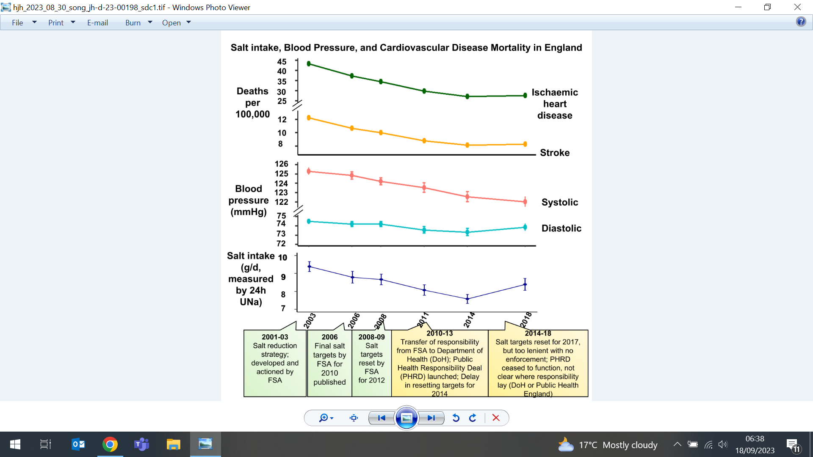
Neurological harms of Nitrous Oxide abuse
20 September (Alvar Paris, Devan Mair, Safiya Zaloum, Alastair Noyce. Centre for Preventive Neurology)

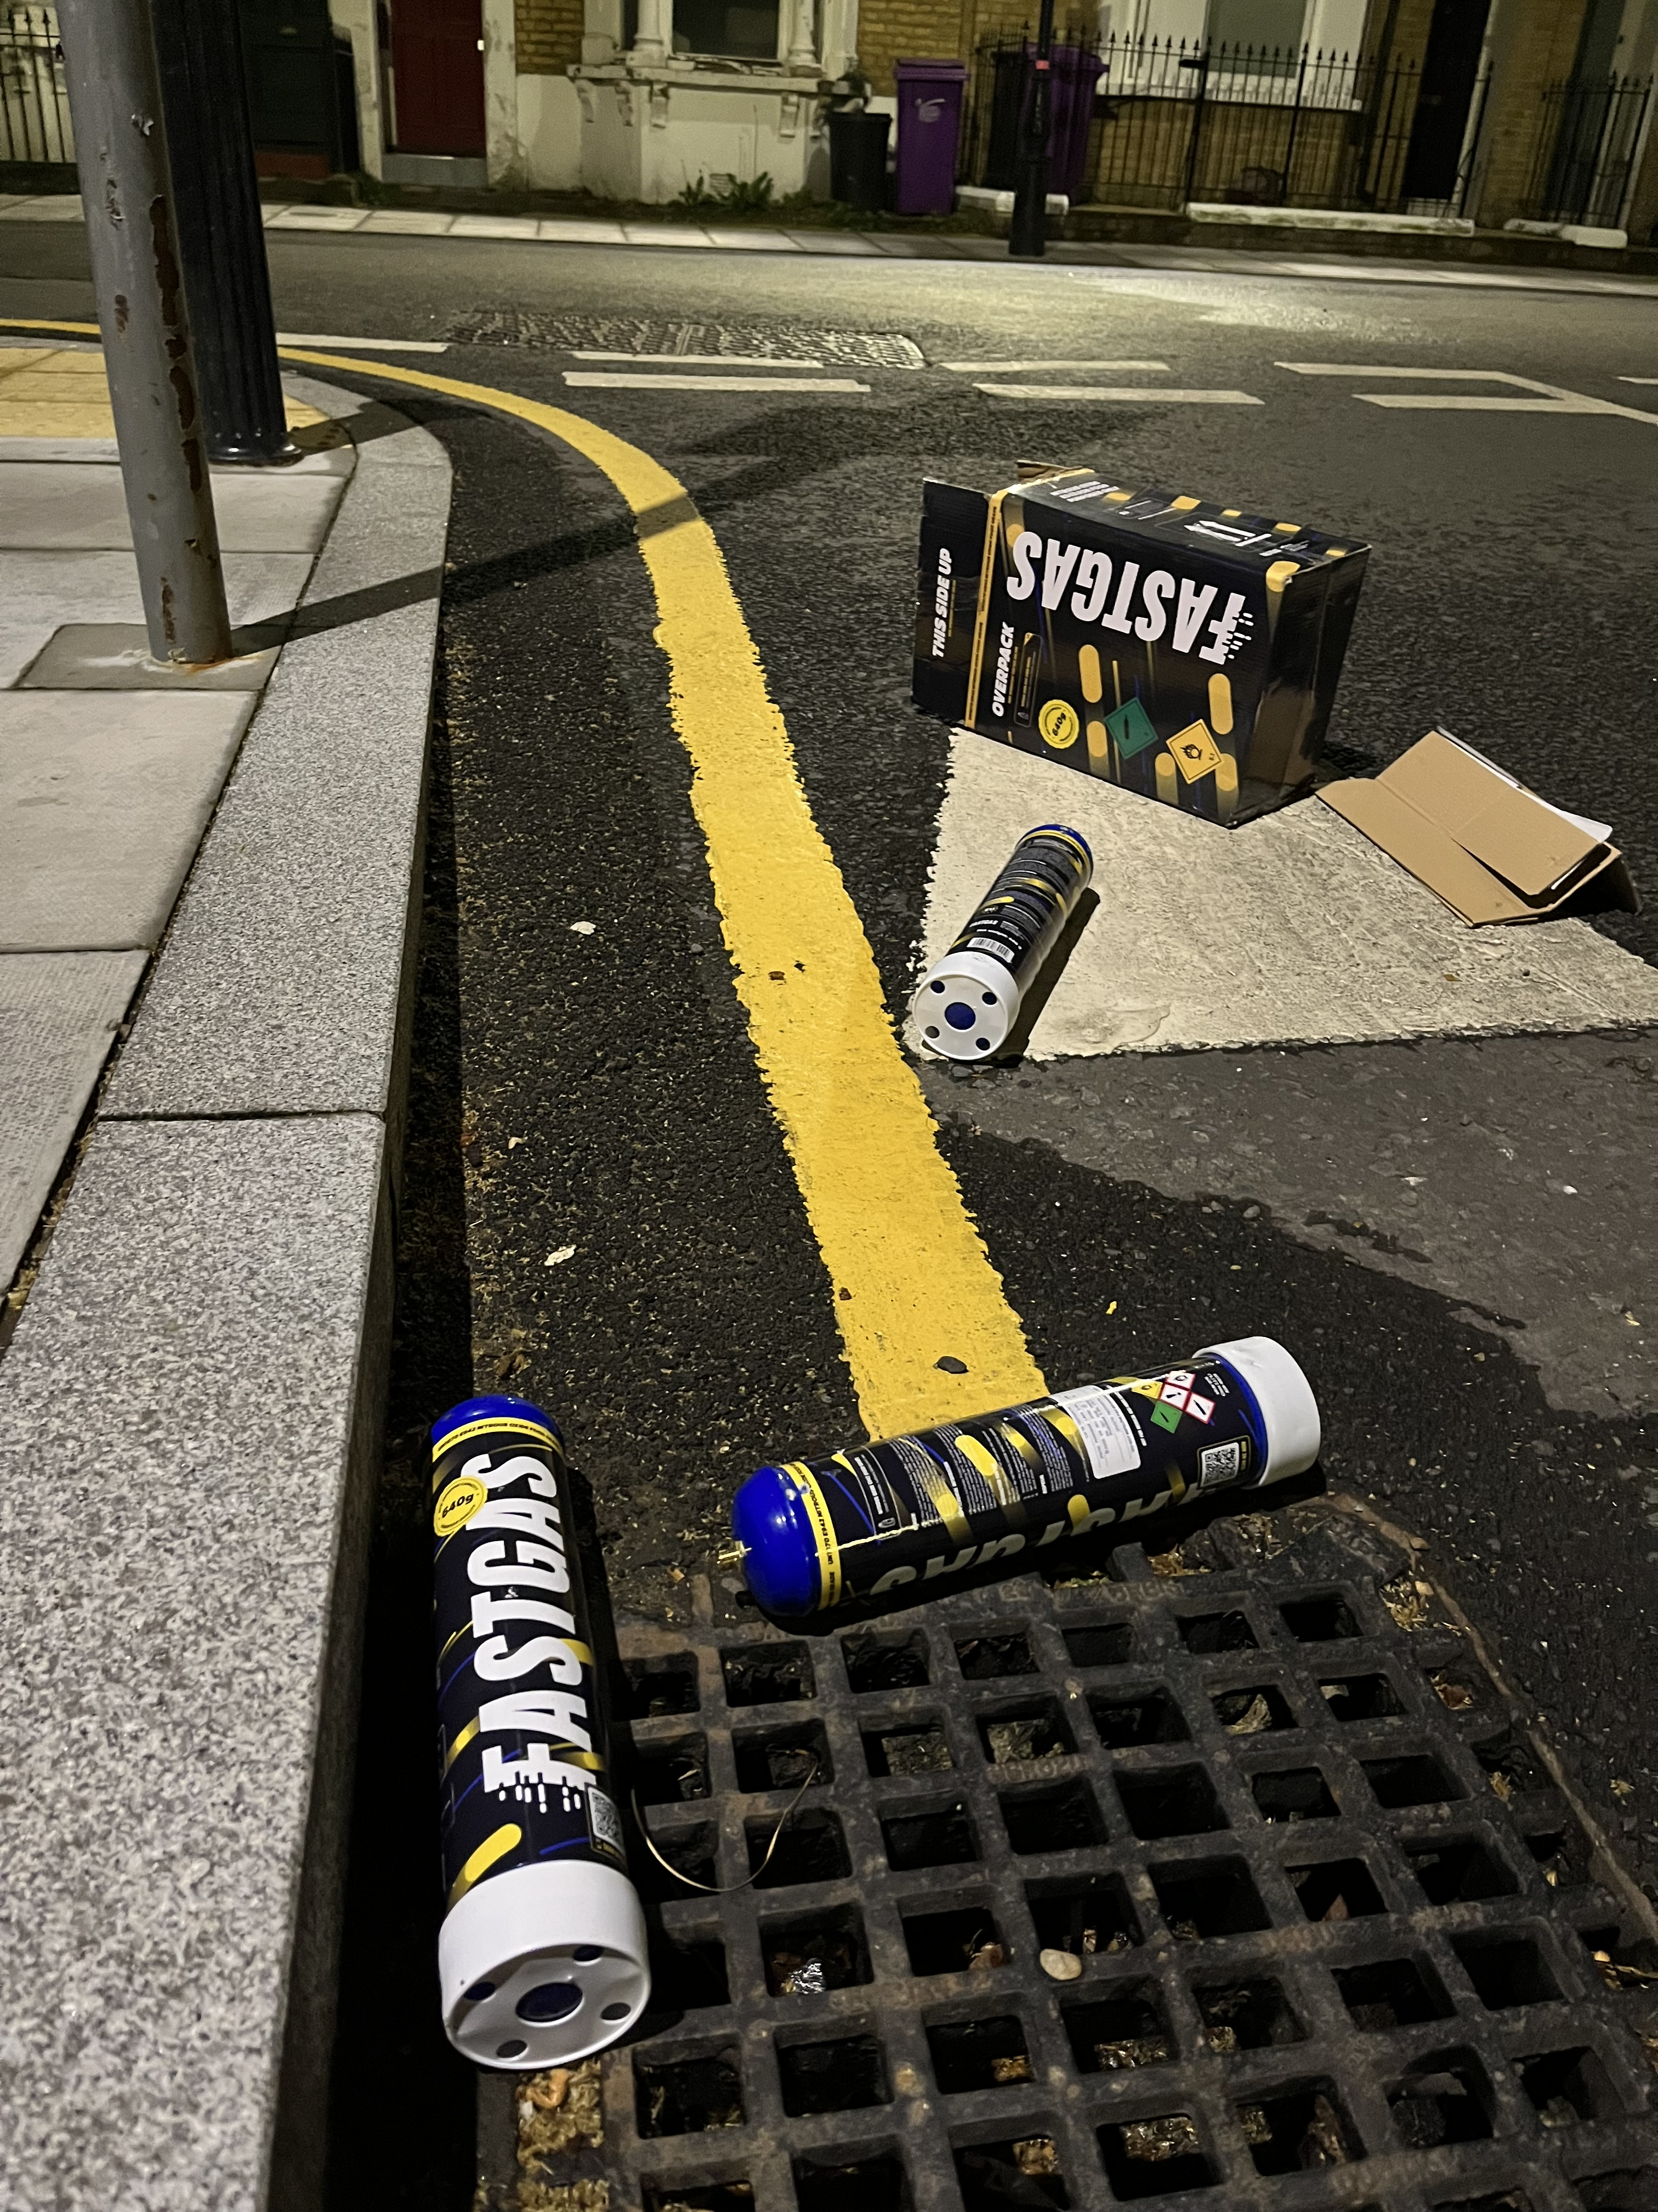 | In a letter in Lancet Neurology, clinicians raise concerns over the plan to make nitrous oxide (N₂O) a Class C drug under the Misuse of Drugs Act 1971, asserting that criminalisation of possession is not the answer to the concerning rise in neurological harm from N₂O abuse. The authors say many N₂O users also use other (already illegal) drugs, and are unlikely to be deterred by a Class C schedule, but their primary concern is that this legislation may cause further harm from poor engagement with healthcare services. Those suffering harm from N₂O abuse are most often adolescents and young adults (some of whom are already vulnerable), and delays in presenting because of criminalisation may decrease potential reversibility of neurological damage. Any resultant long-term disability will further widen socioeconomic inequality, and propagate the poverty-disability cycle. They call on the government to prioritise legislative efforts to effectively curb the sale of nitrous oxide destined for recreational use.
2023 William L. McGuire Memorial Lecture Award
21 September (Jack Cuzick. Centre for Cancer Screening, Prevention and Early Diagnosis)

Professor Jack Cuzick will receive the William L. McGuire Memorial Lecture Award at the 2023 San Antonio Breast Cancer Symposium (SABCS). The Award was established in 1992 to commemorate McGuire's significant contributions to breast oncology. Currently the QMUL John Snow Professor of Epidemiology in the Wolfson Institute of Population Health, Professor Cuzick is being recognized for his unparalleled contributions to the prevention and treatment of breast cancer and his commitment to transdisciplinary collaboration and leadership in the field. Professor Cuzick’s, whose award lecture will be presented on 6 December at the Henry B. Gonzalez Convention Center in San Antonio, Texas said: I am very honoured to receive this award. It has been a long, but immensely satisfying journey from pure mathematics to cancer prevention. Substantial progress has been made, but breast cancer is still the commonest cancer in women, and there’s a lot more to be done. | 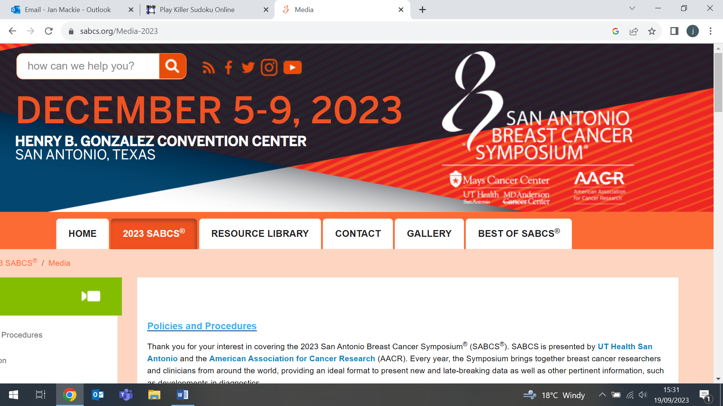  
E-cigarettes not a gateway into smoking
21 September (Francesca Pesola, Anna Phillips-Waller, Peter Hajek. Centre for Public Health and Policy)

     | The most comprehensive study to investigate whether e-cigarettes are a gateway into or out of smoking finds that, at the population level, there is no sign that e-cigarettes and other alternative nicotine delivery products promote smoking. The NIHR-funded study found some evidence that these products compete against cigarettes, so may be speeding up the demise of smoking, but more data are needed to determine the size of the effect. Researchers compared the time course of use and sales of e-cigarettes with that of smoking rates and cigarette sales in countries with historically similar smoking trajectories, but differing current e-cigarette regulations (UK&USA v Australia, where e-cigarettes sales are banned). The decline in smoking in Australia has been slower than in the UK, and slower than in both the UK and USA among young people and in lower socioeconomic groups. The decline in cigarette sales has also accelerated faster in the UK than in Australia. Authors note that because people may use both cigarettes and alternative products, prevalence figures for these products overlap, so more time is needed for effects of exclusive use of the new products on smoking prevalence to emerge. This story received international press.
Everything you need to know about Parkinson’s
21 September (Alastair Noyce. Centre for Preventive Neurology)

In a special Telegraph feature on Parkinson’s disease, Alastair Noyce is quoted extensively, explaining what Parkinson’s is, the symptoms, warning signs, causes, life expectancy, and treatment. He notes that some early warning signs are common and well known, but others may be subtle, ‘such as loss of arm swing on one side when you walk, and changes in your handwriting - it typically becomes small and untidy, words tend to be spaced out, but letters cramped together, and your handwriting tends to curve upwards.’ On the question of causes he says ‘there will always be a proportion of people for whom, even with a full understanding, no cause is clear. Sometimes it’s just stochastic – a random event that happened that’s bad luck but there’s no obvious cause.’ Alastair reflects that while the drug of choice to control motor symptoms is Levodopa, there are now ‘lots of other treatments we can use alongside to manage motor and non-motor symptoms’. |   
Disease trajectories following myocardial infarction
21 September (Jianhua Wu. Centre for Primary Care)

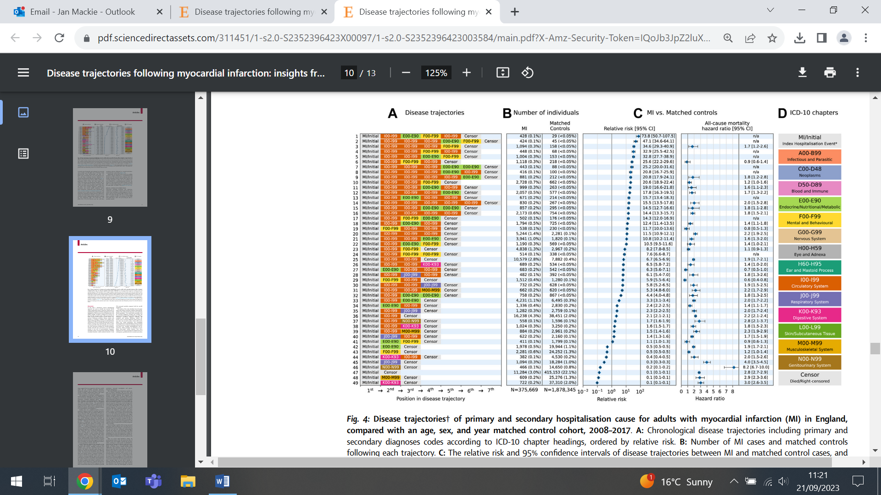 | A retrospective cohort study profiling sequential disease trajectories after myocardial infarction (MI) in 375,669 patients in England assesses the differential impact of such trajectories on long-term outcomes. Researchers identified 28,799 unique disease trajectories, with findings showing that accrual of multiple circulatory diagnoses was more common amongst MI patients and conferred an increased risk of death compared with matched controls. Trajectories featuring neuro-psychiatric diagnoses following circulatory disorders were markedly more common and had increased mortality post MI compared with non-MI individuals. The study concludes that these results provide an opportunity for early intervention targets for survivors of MI (eg. increased focus on the psychological and behavioural pathways) to mitigate ongoing adverse disease trajectories, multimorbidity, and premature mortality.
Developments in Symptom Research in Primary Care Conference
21 September (Najia Sultan, Esca van Blarikom. Centre for Primary Care)

NIHR in-practice fellow Najia Sultan and PhD candidate Esca van Blarikom presented at the Developments in Symptom Research in Primary Care conference in Tromsø, Norway. This interdisciplinary conference explored new perspectives on the clinical, experience-based and existential dimensions of symptoms within primary care settings. In her talk on symptom interpretation and health-seeking in British Pakistanis, Najia presented findings from a narrative interview study, highlighting that the most pressing issue emerging from patients’ narratives is the perceived burden to access timely and quality care services in the NHS. Esca presented her research on the experiences of working-age adults with multiple long-term conditions, exploring how interconnected symptoms become fragmented into single-disease categories once patients enter clinical settings, and proposing a more pragmatic approach to diagnosing in the context of multimorbidity. |   
Parkinson’s UK approve funded extension to PREDICT-PD
22 September (Alastair Noyce, Brook Huxford, Aneet Gill, Helen Sonderegger. Centre for Preventive Neurology)

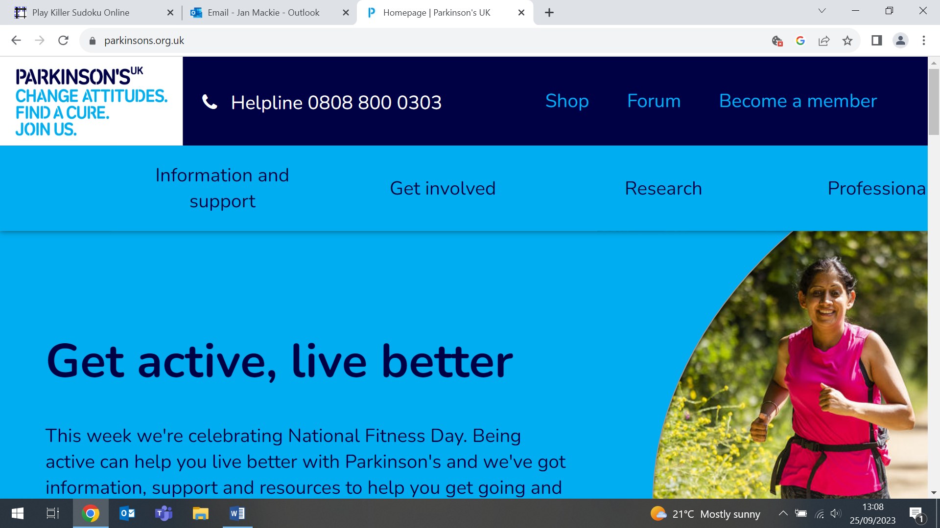 | Parkinson’s UK have approved funding of almost £200k for a 12 month extension of the PREDICT-PD study, a ground breaking project using simple tests to identify people at high risk of Parkinson’s disease before symptoms appear. The grant extension to December 2025 will fund a new stream of work to embed diagnostic testing for Parkinson’s disease in the PREDICT-PD cohort, using a newly developed technique, synuclein amplification assay (SAA). Parkinson’s is the second most common degenerative disease of the brain, but the number of people being diagnosed is growing faster than any other neurological condition.
NHS England Jewish BRCA Testing Programme
22 September (Ranjit Manchanda. Centre for Cancer Screening, Prevention and Early Diagnosis)

The launch of the NHS England Jewish BRCA Testing Programme in 2024 is celebrated in an article by Ranjit Manchanda in the Together Magazine published by Chai Cancer Care, the Jewish community’s cancer support organization. The saliva test will be free to adults with a Jewish grandparent, and can be done at home. Ranjit writes that the opportunity Jewish BRCA population testing offers cannot be underestimated, and will more than double the number of BRCA carriers identified, and save lives and money for the NHS. | 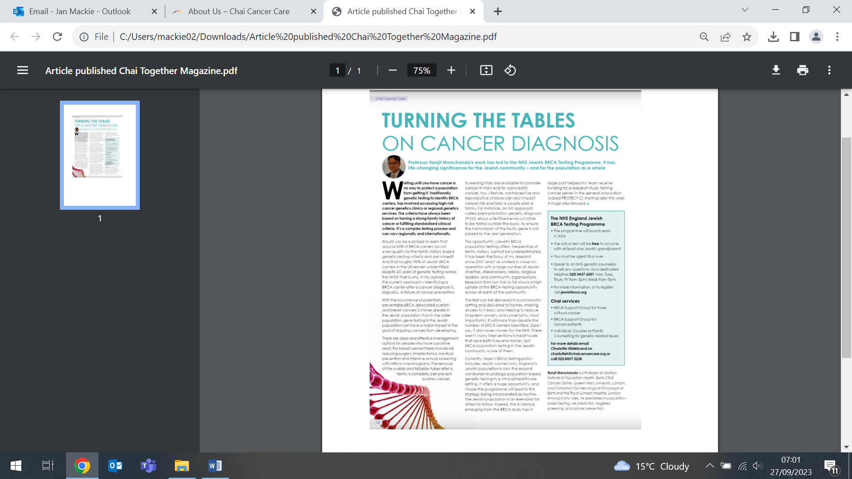  
2023 World Dental Congress, Australia
24 September (Suzanne Scott. Centre for Cancer Screening, Prevention and Early Diagnosis)

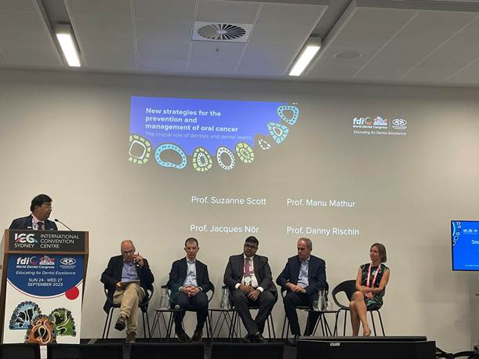 | Suzanne Scott attended the FDI World Dental Federation Congress in Sydney. The Congress is a flagship continuing-education event for the World Dental Federation, and a unique opportunity to strengthen ties and foster collaboration within the global oral health community. Suzanne was a panellist and speaker at the Science Committee Forum on New strategies for the prevention and management of oral cancer: the crucial role of dentists and dental teams.
Is TB elimination still achievable?
26 September (Dominik Zenner. Centre for Public Health and Policy)

The European Respiratory Society (ERS) Respiratory Channel hosted an ERS Vision Live online panel discussion on 26 September, featuring Dominik Zenner as an expert panellist. The panel discussed key areas in this research, including: the history of TB elimination, why and for which countries; What countries can do to prepare for elimination; and What can scientific societies and pulmonologists do to sustain the process. The ERS Vision live discussions form part of the Society’s learning resources. | 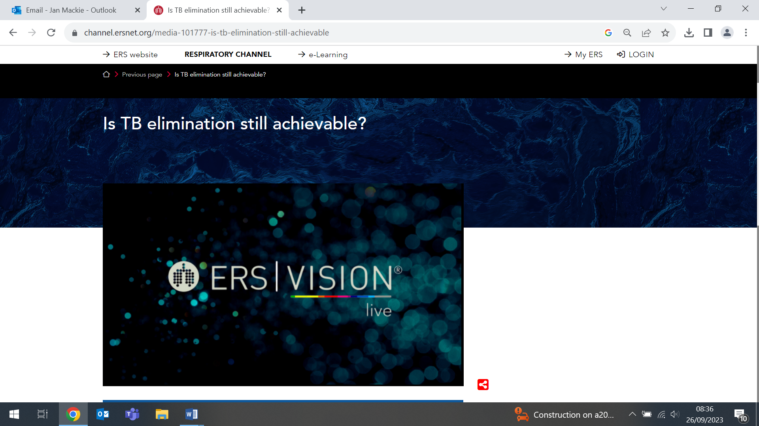
Impact of New Cardiovascular Events on QoL and Hospital Costs (UK & USA)
26 September (Boby Mihaylova. Centre for Evaluation and Methods)

A study estimating short and long term impacts of new major cardiovascular disease (CVD) events on quality of life (QoL) and hospital care costs in the UK and US health systems finds that stroke, heart failure, and non coronary revascularization procedures substantially reduce QoL. No QoL reductions were observed for myocardial infarction and coronary revascularization. Coronary and non coronary revascularization procedures were associated with the largest additional hospital costs. The study used data from 21,820 participants in the REVEAL trial, followed up for 4 yrs. Authors say their finding could inform cost effectiveness evaluations of newer interventions for secondary CVD prevention in the UK and USA.
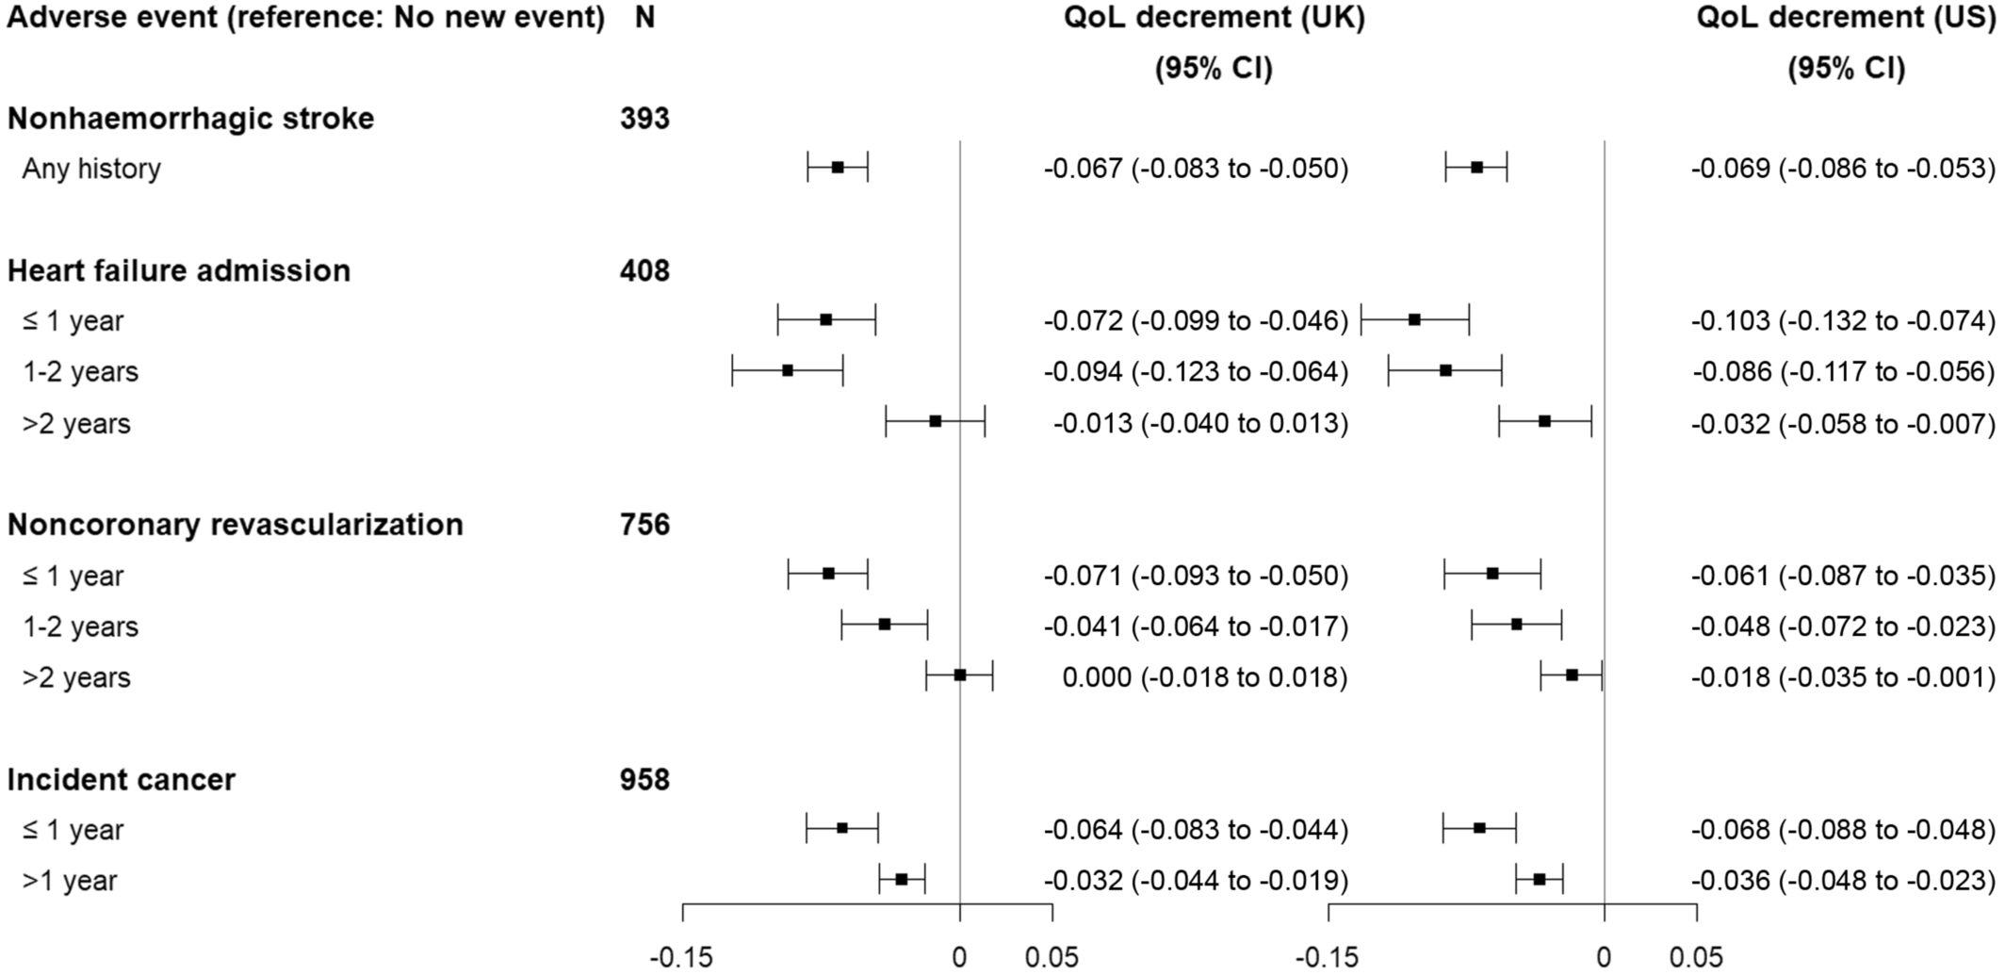

Patient decision aids in genetic testing for women with ovarian cancer
26 September (Monika Sobocan, Michail Sideris, Oleg Blyuss, Caitlin Fierheller, Ashwin Kalra, Jacqueline Sia, Li Sun, Olivia Evans, Sadiyah Robbani, Ranjit Manchanda. Centre for Cancer Screening, Prevention and Early Diagnosis)

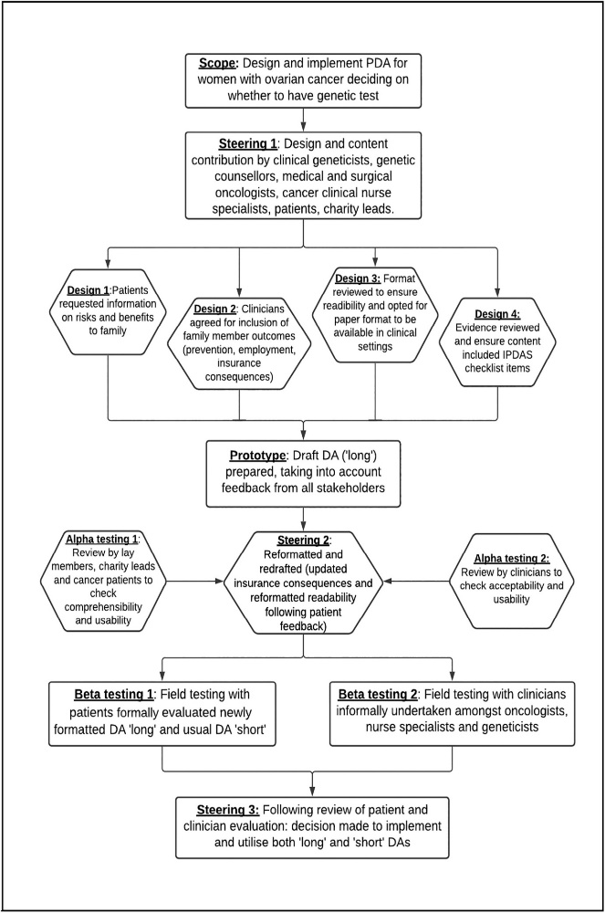 | Researchers conducting a prospective cohort study to evaluate patient preferences on decisions aids (DA) for genetic testing at ovarian cancer diagnosis have produced a long DA that resulted in higher satisfaction without increasing emotional distress. Working with women with high grade non-mucinous epithelial ovarian cancer in the SIGNPOST study, conducted in North East London, the team used patient and stakeholder input to develop the DA, which was evaluated alongside an existing short decision aid by unselected patients attending oncology clinics. Women reported improved understanding, and found the amount of information provided was right in the long compared with the short DA, with 74% of patients preferring the long DA. Older women and those undergoing treatment/recurrence preferred less extensive information, while those in remission preferred a longer DA.
NIHR Team Science Camp
26-28 September (Ratna Sohanpal. Centre for Primary Care)

From 26-28 September Ratna Sohanpal attended the NIHR Team Science Camp at the De Vere Cranage Estate in Crewe. Representing the COPD and Assistive Technology Study, Ratna was selected as a participant on the Multiple Long Term Conditions (MLTC) Theme. The Camp brought together researchers with an interest in MLTC from a variety of disciplines and with a wide range of experiences to tackle complex current and emerging health and care challenges. Attendees were coached in the ethos of Team Science and supported to develop multi-disciplinary teams. The teams will be eligible to apply for an award to provide funding and support to develop further funding applications. | 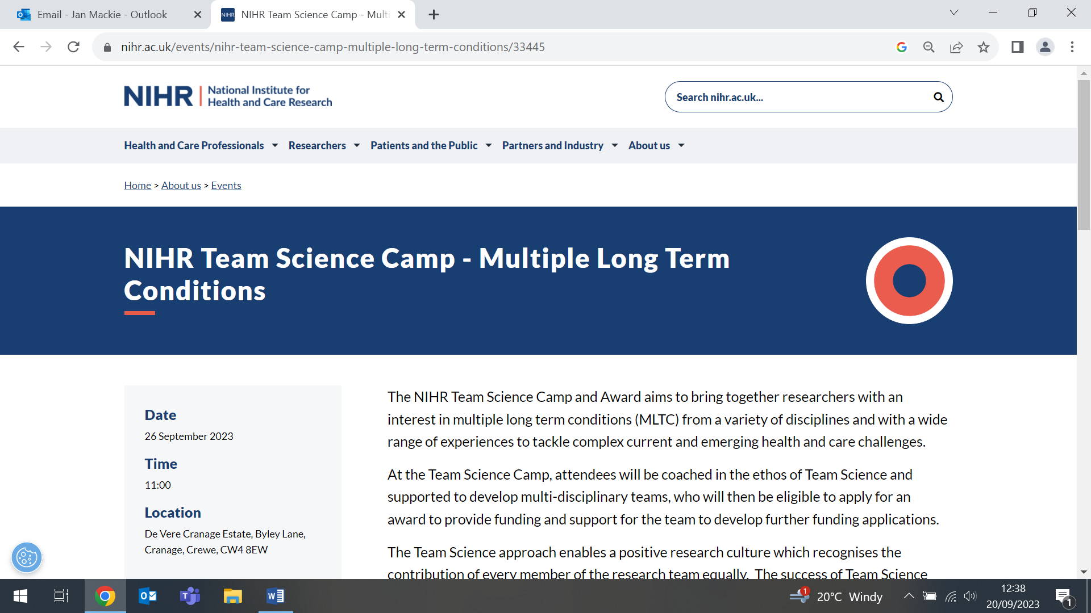  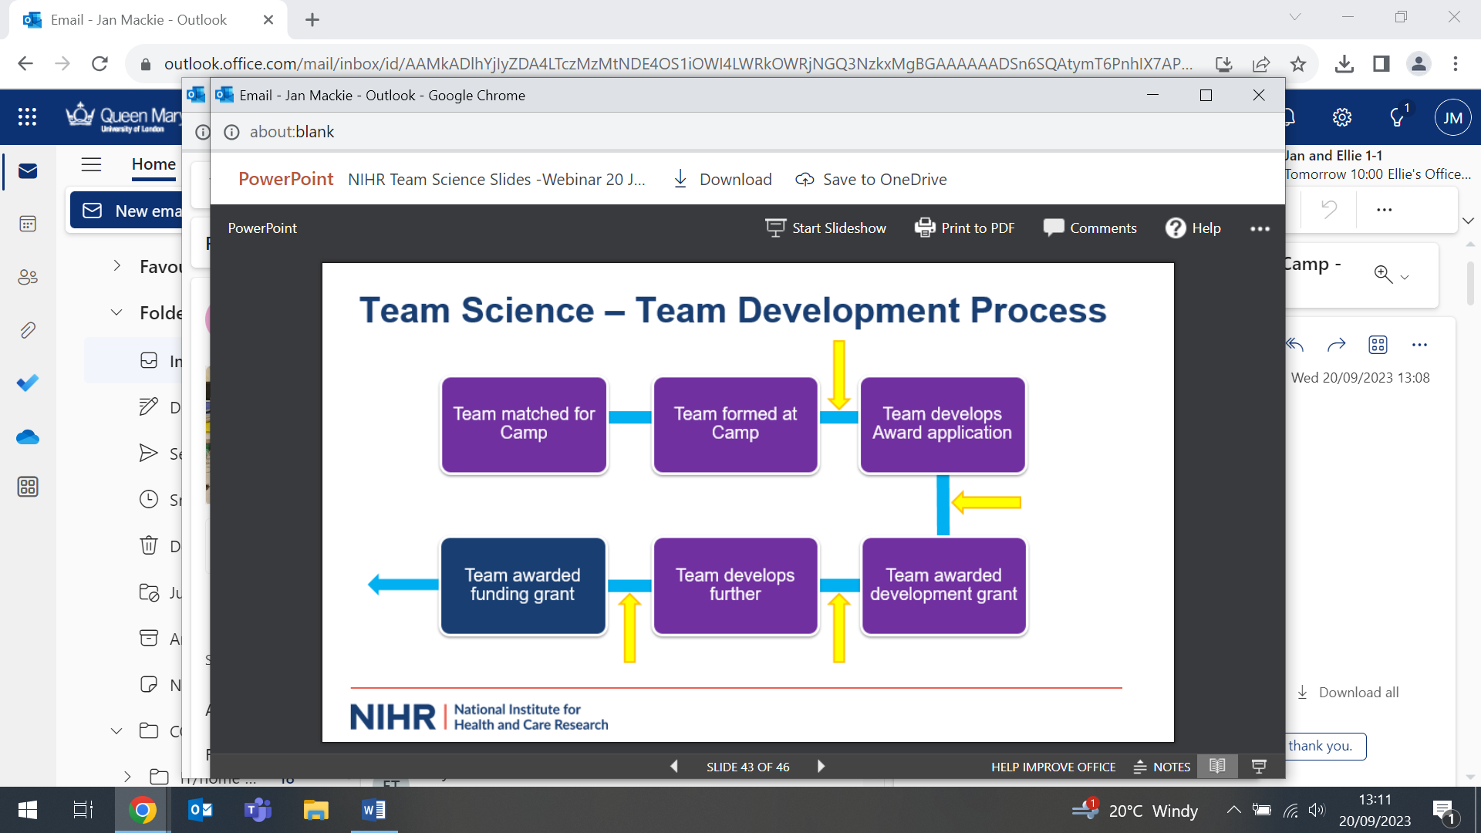
Considerations for Promoting Digital Social Interventions in Primary Care
27 September (Georgios Karampatakis, Helen Wood, Chris Griffiths, Neil Walker, Anna De Simoni. Centres for Primary Care/Evaluation and Methods)

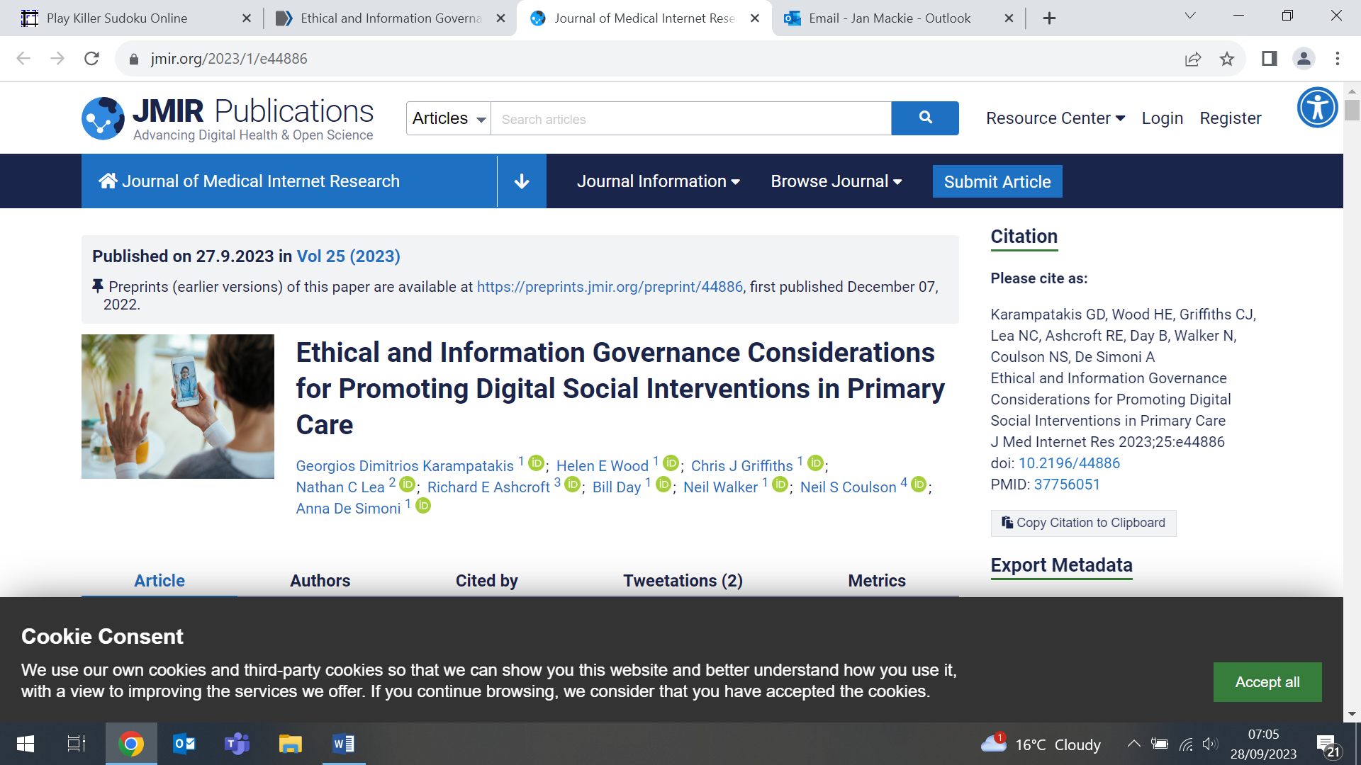  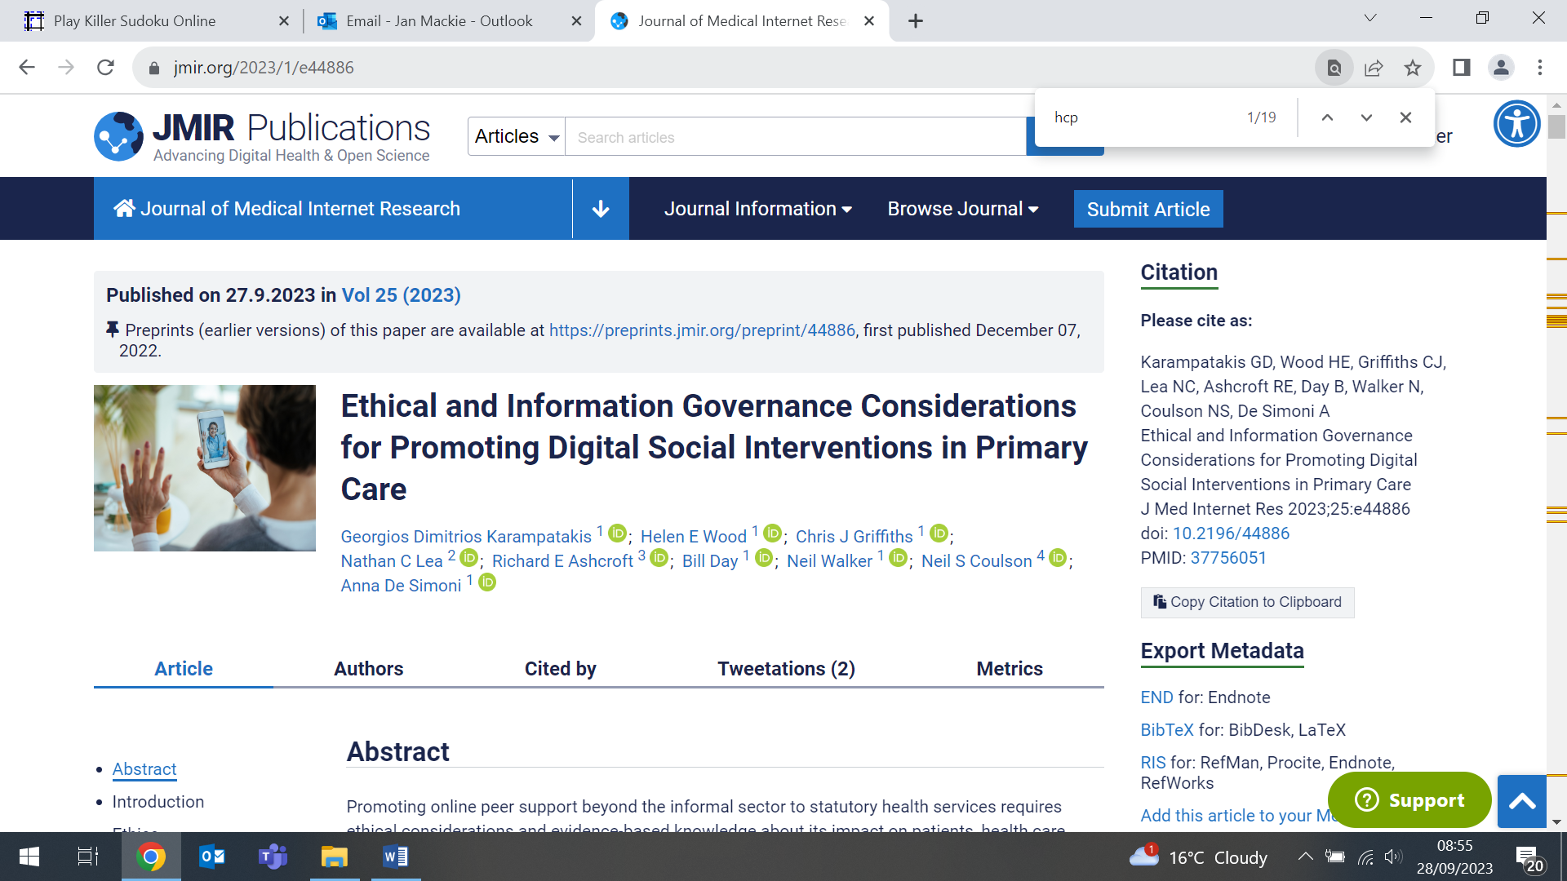 | In primary care services, promoting online health communities to improve the self-management of patients at scale could make a major contribution to improving health and reducing the burden of care for patients with long-term conditions on health care providers and health systems. Definitive guidance is lacking on the ethical concerns arising from the use of social media for health-related interventions and research. A paper addressing the ethical and information governance aspects of undertaking research on the promotion of online peer support to patients by primary care clinicians examines issues relating to engagement, access, equality, privacy, consent, and potential for harm. Authors hope that the information presented will assist policy makers to strategically foster self-management in primary care patients and inform health care professionals and researchers on how to remain on robust ethical grounds when developing, promoting, and studying digital social interventions.
Many thanks to all who so enthusiastically contribute. Please send any news items for the next newsletter to j.a.mackie@qmul.ac.uk

