WOLFSON INSTITUTE OF POPULATION HEALTH
NEWSLETTER
ISSUE 44: 30 OCTOBER 2023

In this issue of our Wolfson Institute of Population Health Newsletter, we celebrate the achievements and work of staff and students through October.

FROM OUR DIRECTOR OF RESEARCH, STEPH TAYLOR
What do Tai chi, ready meals, statins and global migration have in common? The answer is that they all feature in recent research presented, published, or assessed by members of WIPH. Our fortnightly newsletter never fails to remind me of the variety and strength of research within our Institution, and this edition is no different. Special congratulations to Paris Baptiste (CPC) who won the prize for best cardiovascular poster at William Harvey Day, for her submitted entry on the Comparative effectiveness of Ace inhibitors and ARBs and risk of angioedema among different ethnic groups in England!

The WIPH Research Team is doing its bit to support research, with a particular emphasis on supporting early and mid-career researchers, so check out what our Research Manager Tor Kemp has written about three recent initiatives to support researchers. And if you have any suggestions for speakers, training or other developmental activities to support research, please let the Research Team know.

Patient and public involvement is the cornerstone of the research conducted across WIPH, and I'd like to take this opportunity to acknowledge the hard work of Meg Clinch, Ellie Stewart and colleagues who have been working tirelessly with Finance to try to smooth the path to easier and faster reimbursement for our PPI contributors. Their work will make all our research better.  Finally, if you, like me, enjoy a good podcast I can recommend Deborah Swinglehurst’s podcast on the Apollo website - the perfect way to enjoy a stimulating and informative 45 minutes as the winter draws in!  Steph | 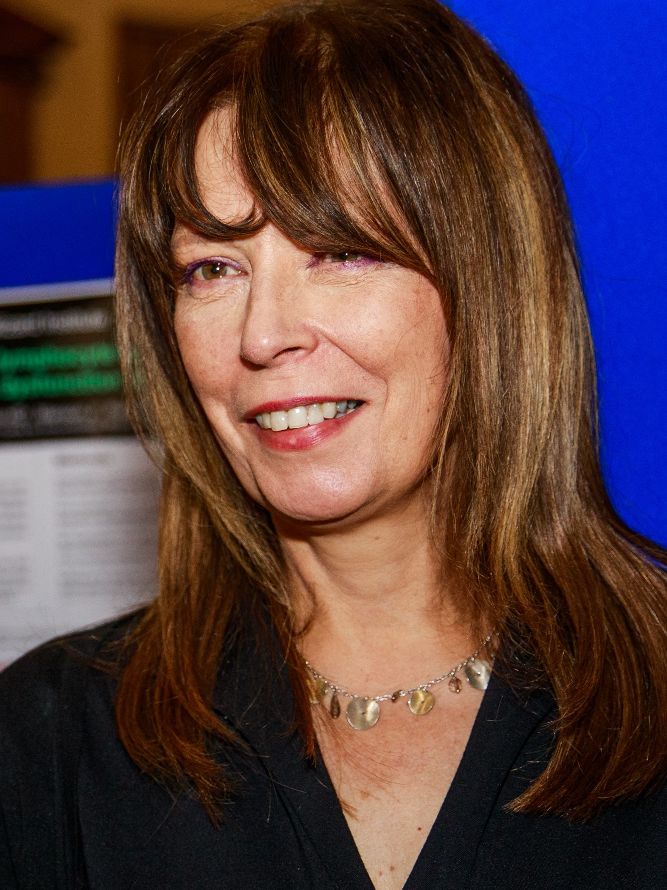
MEET WIPH – RUNGUO WU, Senior Health Economist (CEM)

How would you describe your roles and responsibilities?
As a health economist, my primary responsibility is to conduct cost-effectiveness analyses for new health interventions, providing essential information for decision-makers. Collaboration is pivotal in this role, as it depends on high-quality data from various sources (trial, routine, and cohort data), and due to the complexity and volume of data involved, it often requires a collaborative effort involving colleagues such as clinicians, statisticians, epidemiologists, trialists, and other health economists. Together, we synthesize data to assess the effectiveness of new interventions and estimate costs across different pathways. In cases where lifelong estimations are required, we either develop or adapt simulation models to make long-term predictions.

What has been your greatest professional achievement?
I am a key researcher in a team which has just completed a 3-year project, led by Prof Mihaylova, conducting a cost-effectiveness analysis of statins across different categories of people in the UK. Through this project, I gained a deep understanding of cardiovascular disease epidemiology and both primary and secondary prevention strategies. I have presented our findings at international conferences, and authored or co-authored several papers in peer-reviewed journals related to our research. We are currently in the process of publishing remaining findings, aiming to contribute to cardiovascular prevention strategies in the UK.

What aspects of your role do you enjoy the most?
I particularly enjoy the flexibility of my role offers. Unlike my past experiences in lab experiments during my biological and neuroscience studies, which required strict time and location commitments and labour-intensive work, my current work primarily involves using computers, including remote high-performance computers. This flexibility allows me to work more freely and efficiently.

What would be your second choice as a profession?
Probably, a chef. I have a passion for good food, and enjoy learning to cook by following recipes or watching cooking videos. My only reservation about pursuing a career as a chef would be that it can be somewhat reminiscent of lab experiments.

What do you enjoy doing outside work?  Playing video games and reading The Economist.  Something about you that most people don’t know?  My surname (Wu) in Chinese sounds the same as words that mean "no", "not" or “without”, so it's a bit challenging to choose first names when combining a positive meaning name with this surname can often create opposite meanings. | 
FROM OUR LEADERSHIP TEAMS

Public Advisory Panel Theme News (Megan Clinch, Theme Lead)

A big thank you to Ratna Sohanpal, who led our first topic based PPI drop in session. Ratna shared how she worked with her PPI collaborators to develop pictorial consent forms and information sheets for a recent study, including the process to gain ethical approval. The next drop in session will be 11.30-12.30, Monday 13 November. Details will be circulated shortly.

On the 21 November the NIHR are running a recorded webinar, Let's Talk: Doing Diversity Differently, that will focus on the importance of diversity for public involvement. The webinar will be facilitated by NIHR public contributor and Race Equality Public Action Group member André Tulloch. Details here. We will add the recording to the PPI pages on the Staff Zone.

Finally, a reminder about the WIPH Newsletter for Patient and Public Involvement contributors. Please contact Juliet Henderson if you have any PPI opportunities you would like circulated via the newsletters, or if you have any PPI contacts to add to the newsletter mailing list.

Research News (Tor Kemp, Research Manager)

The Research Team have now launched a number of offerings, with support from many staff in the planning and delivery stages - thank you all! We understand this is a lot of calendar time alongside other special interest groups and centre/unit events, so please see these items as a buffet from which to pick those elements relevant to you!

We had a very interesting and thought-provoking talk last week from Esca Van Blarikom ‘Harbouring Illness: A collaborative film’. A couple more seminars are coming up before the end of the year, including Nathan Davies, Director for the Centre for Ageing Population Studies, on ‘Identifying, managing and supporting complexity and uncertainty in dementia care’ on Tuesday 21 November, online 12:15-13:00. The new year will see an exciting line-up of talks from beyond WIPH, with great thanks to ongoing work from our Research Seminar Series Committee. Please contact Patrick with additional suggestions and we will try to accommodate.

Following your requests, we’ll be running another writing retreat in the DERI basement Tuesday 19 December, in-person 10am-4pm. If you are interested in attending please email Patrick by 8 November.

After the success of the launch event for the Health Inequalities Clinic, we have the second instalment Thursday 9 November, online 1-2pm with Alison Thomson and Vanessa Apea. These sessions provide coordinated expert support for bids in development with a focus on health inequalities.

The next Publication Writing series session is on Friday 10 November, online 12:15-13:00, with a chance to ask two of our statisticians, Adam Brentnall and Tom Hamborg, all about data presentation and statistical analyses. Look out for preparatory material next week: circulation of two pre-recorded videos (for which we’ll have a Q&A in the live session) and a call for topics you’d like advice on during the session.

To better support our researchers and create a stronger research environment, the WIPH Research Team have set up a monthly research drop-in clinic. We invite you to come and discuss in an open forum any research-related problems you’re experiencing or ideas you may have for workshops and other support we can provide. First clinic is Thursday 16 November, online 10-11am.

We have our first Whiteboard session on Thursday 30 November, in-person 10-11am. This in-person only event will take place in the Yvonne Carter Building, Whitechapel campus. Francois van Loggerenberg will be presenting his early ideas for DIALOG+ for AI, can a therapeutic conversation be delivered by an artificial intelligence system?. The success of the session will come from broad attendance from across the Institute and constructive input from colleagues with varied expertise.

Other Upcoming Research Events

Establishing a Whitechapel Postdoc Forum (9 November)
The Precision Healthcare University Research Institute (PHURI) are looking to establish a Whitechapel postdoc forum. They invite you for lunch on 9 November from 12:00-14:00 in the basement at Empire House, to meet other postdocs based at Whitechapel, to find who else is working in the area, what they’re working on, and discuss what you’d like from a community of postdocs based there. This could include a place to socialise, get advice or support, or invite speakers to talk on topics that matter to you. Register via the Eventbrite link. Whitechapel campus map here. For any queries please contact phuri@qmul.ac.uk

FMD Industry Connect Day: Cardiovascular & Metabolism (22 November)
QMUL & Barts Health Trust invite you to discover our cardiovascular & metabolism research and support academic-industry partnerships. Presentations from QMUL's leading academics and industry partners in cardiovascular and metabolism research will enable discussions on the direction of the field, and a dedicated networking session will provide collaborative partnering opportunities. Topics will include diagnostics, genomics, prevention, health economics, biobanking, precision medicine, and clinical trials all focused within the cardiovascular and metabolism fields. Register here to secure your place and receive agenda updates. The event is taking place 22 November 12:00 - 17:00 in the Wolfson Building, CHSQ.

GENERAL INSTITUTE NEWS

APOLLO Social Science Podcast
6 October (Deborah Swinglehurst. Centre for Primary Care)

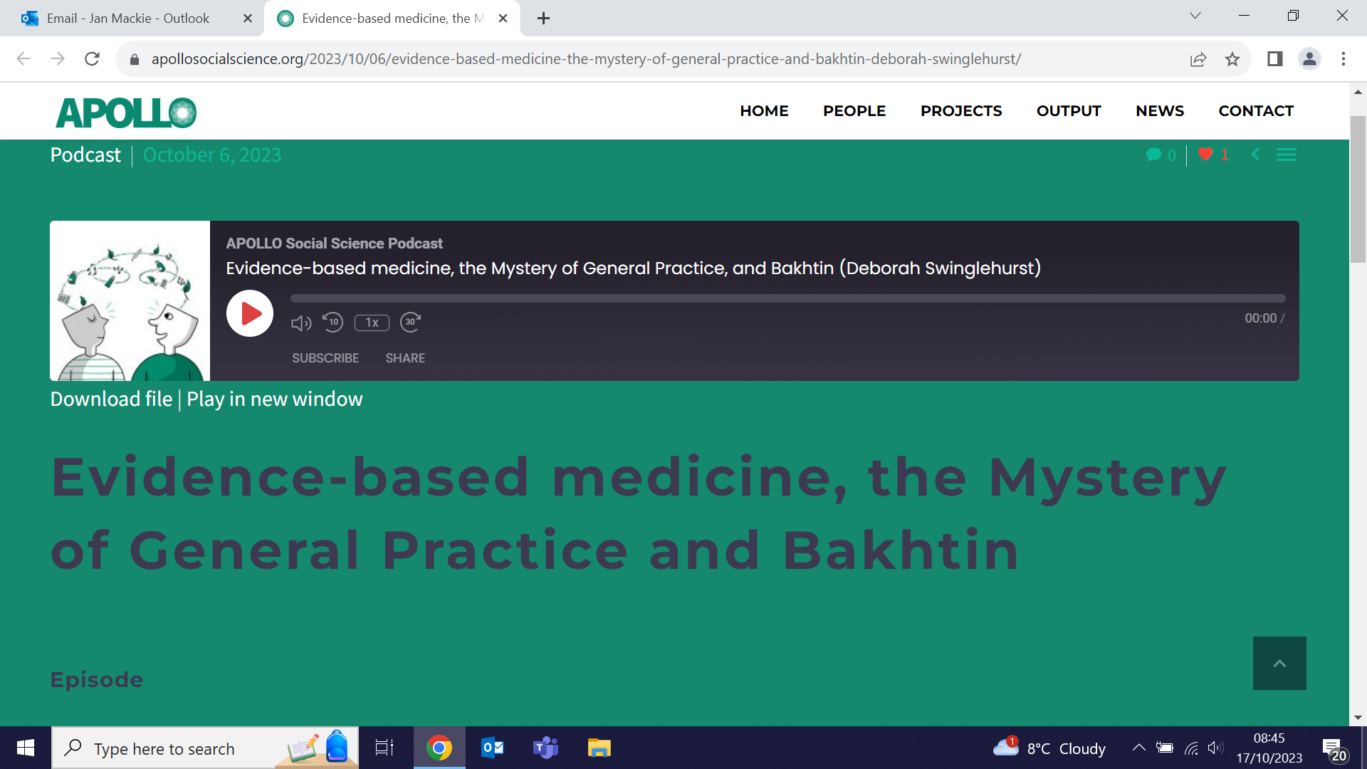 | The CPC APOLLO Social Science Research Group have released a second podcast: Evidence-based medicine, the Mystery of General Practice and Bakhtin. In this instalment, APOLLO group leader Deborah Swinglehurst talks about her journey from an evidence-based medicine practitioner to developing academic interests in complexity and multivocality, and explains how both come together in her role as a practising GP. She discusses the 3 themes that allow us to understand language in radically different ways. New episodes released each month explore the borderlands of healthcare and social science.
QM and Cornell University Academics meet to discuss migration
9-10 October (Lola Oyebode, Dominik Zenner. Centre for Public Health and Policy)

QM and Cornell academics held a workshop on transnational migration on the Queen Mary Malta campus in Gozo on 9-10 October, with discussions on the history and contemporary dimensions of global migration. The meeting included presentations from Dominik Zenner (Health and illness among Europe-bound refugees and asylum seekers) and Lola Oyebode (Preconception health among migrant women in England) and was described by Cornell colleagues as an incredibly fruitful collaboration. | 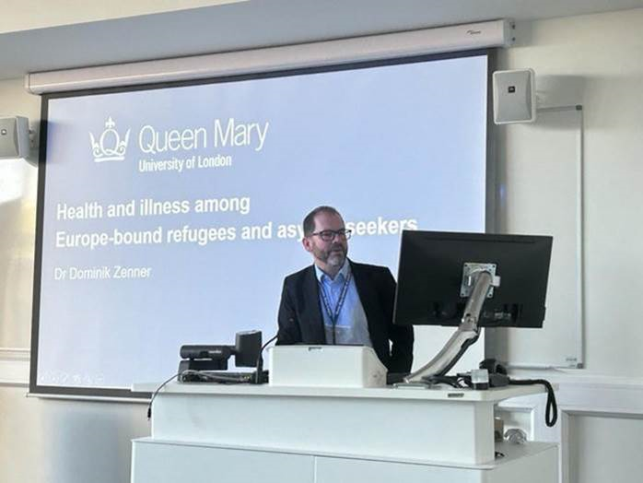  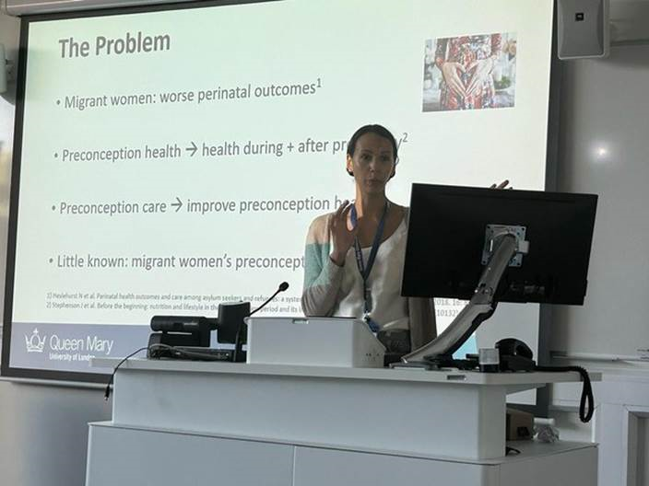
Artificial intelligence for dementia prevention
14 October (Charlie Marshall. Centre for Preventive Neurology)

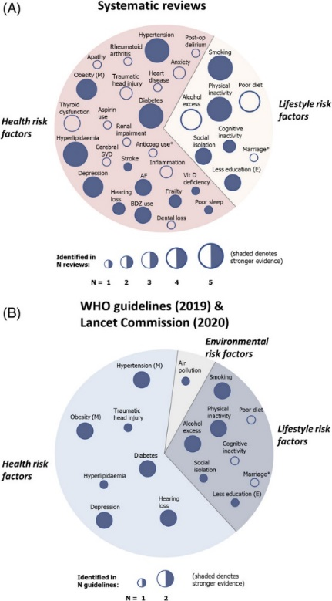  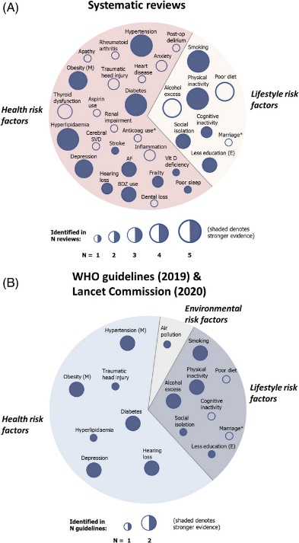 | An evaluation of the potential roles of machine learning (ML) and artificial intelligence (AI) in dementia prevention finds that new risk-profiling and trial-recruitment tools underpinned by ML models may effectively reduce costs and improve future trials, and that ML can inform drug-repurposing efforts and prioritization of disease-modifying therapeutics. Researchers conclude that, while not yet widely used, ML has considerable potential to enhance precision in dementia prevention, and that AI will help personalize risk-management tools for dementia prevention, and could target specific patient groups that will benefit most for clinical trials.
Variations in Post Gynaecological Oncology Surgery Morbidity & Mortality
16 October (Oleg Blyuss. Centre for Cancer Screening, Prevention and Early Diagnosis)

A prospective cohort study of 1820 women undergoing surgery for gynaecological malignancies in 27 countries finds that, although women in low and middle income countries (LMICs) are affected by gynaecological malignancies at higher rates than those in high income countries (HIC), LMICs and HICs are associated with similar post-operative major morbidity. Results from the GO SOAR1 study show that minor morbidity was 26.5% for both LMICs and HICs; major morbidity was 8.2% and 7% respectively. Major complications were 3x more likely with junior than senior surgeons, with 50%v25% of surgeries performed by junior surgeons in LMICs/HICs respectively. Researchers conclude that capacity to rescue patients from surgical complications is a tangible opportunity for meaningful intervention. | 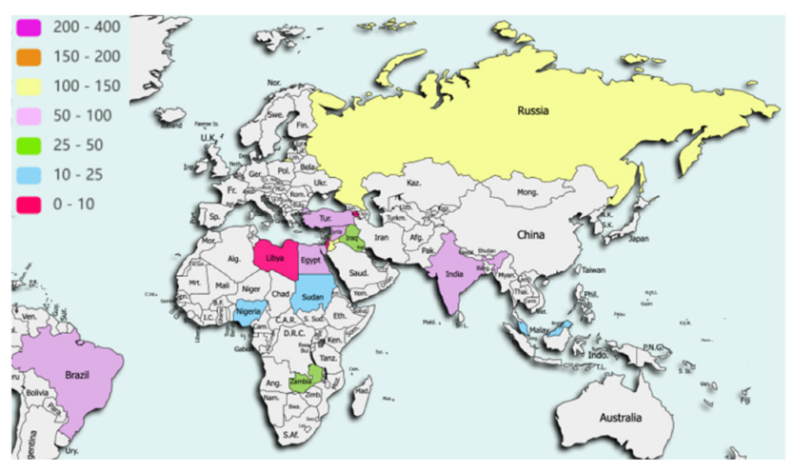  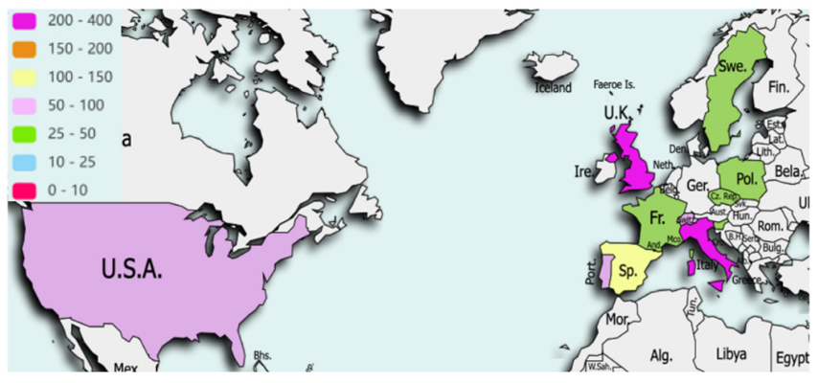
Cost effectiveness of risk stratified breast screening in the UK
17 October (Peter Sasieni, Judith Offman, Stephen Duffy. Centre for Cancer Screening, Prevention and Early Diagnosis)

 | Research evaluating 8 risk-stratifying breast screening regimens compares their cost effectiveness with both current national UK screening and no national screening. In risk stratified breast screening, individualised risk assessment may inform screening frequency, starting age, screening instrument used, or decisions not to screen. Using a microsimulation model to estimate health-related quality of life, cancer survival, and NHS lifetime costs for the eligible UK breast screening population, results showed that, compared with current/no screening, risk-stratified regimens generated additional costs and quality adjusted life years, and had a larger net health benefit. The likelihood of current screening being the optimal scenario was <1%. No screening amongst the lowest risk group, and triannual, biennial and annual screening amongst the 3 higher risk groups, respectively, was the optimal screening strategy evaluated.
Physical activity in older adults
17 October (Dharani Yerraklava. Centre for Cancer Screening, Prevention and Early Diagnosis)

Academic GP Dharani Yerrakalva featured in a BBC radio 4 Inside Health episode about physical activity in older adults. With other guests on the programme, Dharani discussed the question: What’s stopping us from exercising in older age?, addressing issues around juggling caring or work commitments, mental and physical barriers, and how bodies change with age. | 
Breast Cancer Now Parliamentary Research Fair
18 October (Jo Waller. Centre for Cancer Screening, Prevention and Early Diagnosis)

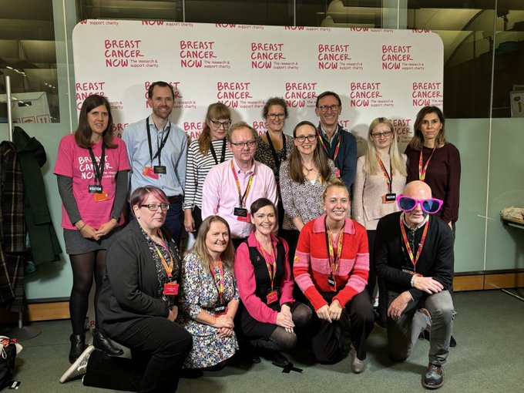 | Jo Waller attended a Parliamentary Research Fair organized by breast cancer research and support charity, Breast Cancer Now, to spread the word about research into attitudes to risk-stratified breast screening. The event, at Portcullis House in London, aimed to showcase the importance of breast cancer research for Members of Parliament.
Racism on mental health wards creates unhealthy atmosphere
18 October (Phuong Hua, Sania Shakoor, Mark Freestone, Kam Bhui. Centre for Psychiatry and Mental Health)

Using data from the EURIPIDES study, which assessed how patient experience data were used to improve the quality of care in NHS mental health services, a secondary analysis examines interviews in which expressions of racialisation were reported. The interviews, conducted in 4 NHS England mental health trusts, highlighted an absence of safe spaces to discuss racialisation, which silenced and isolated patients, and strained communication and power imbalances, which shaped a process of mutual racialisation by patients and staff. Non-reporting of racialisation and discrimination elicited emotions such as feeling othered, misunderstood, disempowered and fearful. The paper concludes that racialisation in mental health trusts reflects lack of psychological safety which weakens staff-patient rapport and has implications for authentic patient engagement in feedback and quality improvement processes.

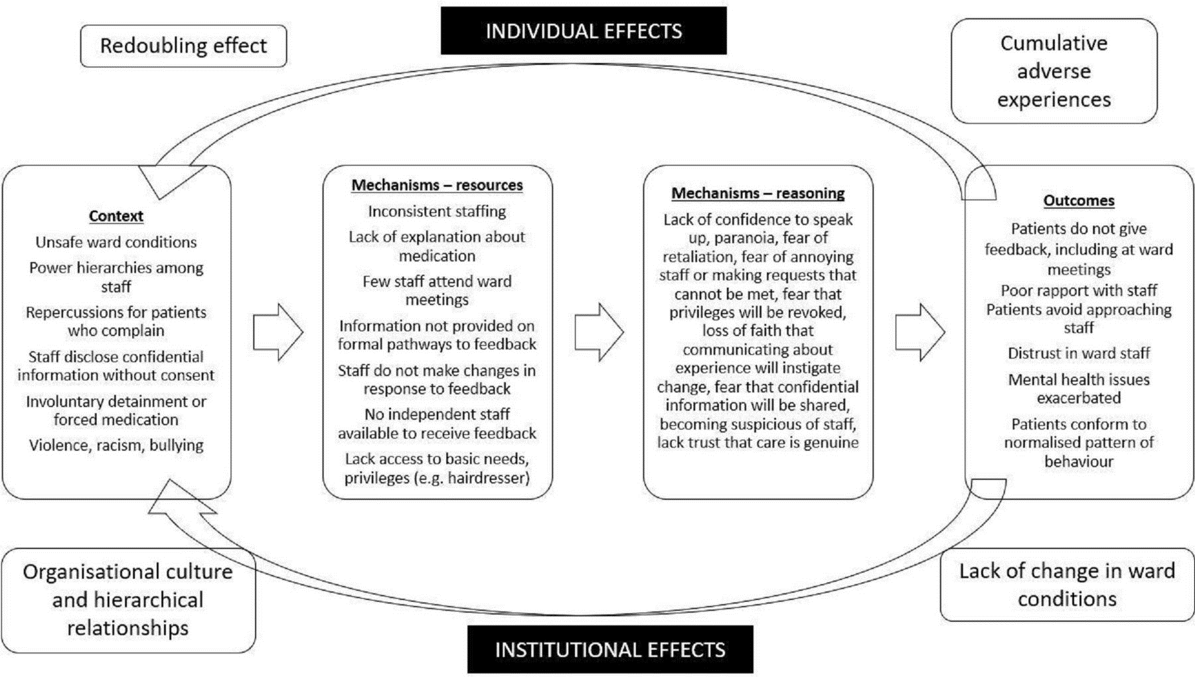
Impact of MS risk alleles on the plasma proteome
18 October (Alastair Noyce, Ruth Dobson, Ben Jacobs. Centre for Preventive Neurology)

 | Over 200 genetic loci have been implicated in multiple sclerosis (MS) susceptibility, but how genetic variants influence disease pathogenesis is unclear. Expanding on recent findings reporting the association of MS with genetically-predicted levels of five proteins, researchers used data from a 10x larger cohort to show that MS risk alleles alter plasma levels of four proteins involved in the immune response. Findings show that MS risk alleles are associated with elevated plasma CD58, and lowered CD40, TNFRSF1A, and FCRL3. Authors hope these results may help to prioritise the four proteins for further experimental work and development/repurposing of drugs for MS.
William Harvey Day 2023 – WIPH Presentations
19 October (Francois van Loggerenberg, Megan Clinch, Vanessa Apea, Boby Mihaylova. Centres for Psychiatry and Mental Health/Public Health and Policy/Primary Care/Evaluation and Methods)

WIPH work featured prominently in the main hall presentations at the Faculty’s showcase event for research, William Harvey Day 2023. The agenda included Francois van Loggerenberg speaking on youth resilience in urban health, Boby Mihaylova on new insights into the value of statin treatment across the population, Vanessa Apea on MPox and also her research exploring the lived experiences of Black women in East London, as well as a Global Health Session co-chaired by Megan Clinch. | 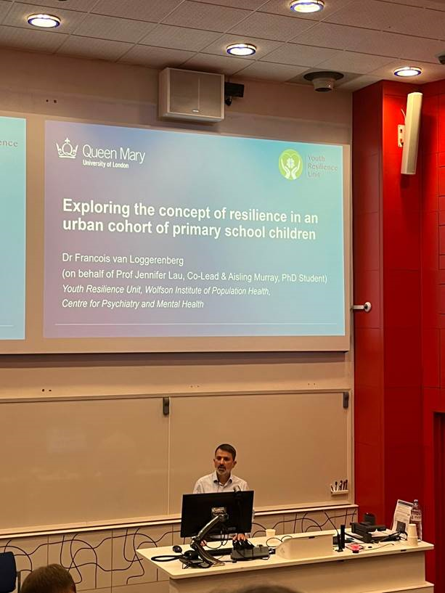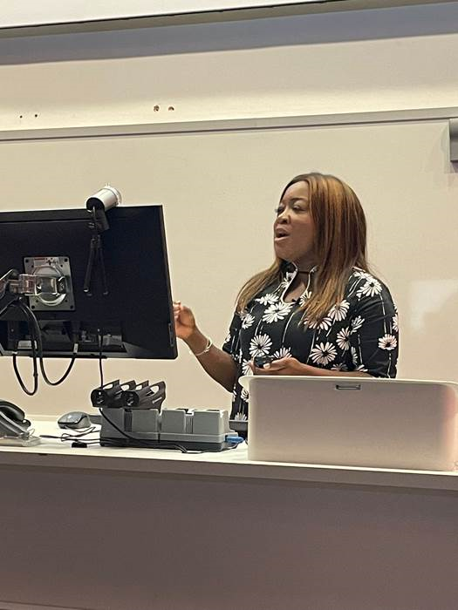
William Harvey Day 2023 Poster competition
19 October (All WIPH centres represented)

WIPH fielded a fabulous crop of nine posters in this year’s William Harvey Day poster competition, with congratulations in order for Paris Baptiste (Centre for Primary Care), who won the prize for best cardiovascular poster (Comparative effectiveness of ACE inhibitors and ARBs and risk of angioedema among different ethnic groups in England). Representing all six centres, our other posters were submitted by teams led by Hui Zhen Tam (Body composition changes during breast cancer preventive therapy with anastrozole), Charis Xuan Xie (Development of a conceptual framework for defining trial efficiency), Laura Havers (Youth adversity and the development of depression and anxiety in adolescence in the context of intersectionality), Vidhya Sasitharan (Role of Policy in Shaping Pesticide Poisoning Experiences), Sanjula Arora (Understanding patients attitudes to a holistic approach to management of itch in atopic dermatitis), Xia Wei (Cost-effectiveness of cancer susceptibility gene specific prevention strategies for ovarian and breast cancer), Ruth Evans (Opportunities to Raise Cancer Awareness after urgent referral: the ORCA project), and Roberta Torricelli (Gene-environment interactions for Parkinson’s disease).


RCGP Annual Primary Care Conference
19 October (Victoria Tzortziou Brown. Centre for Primary Care)

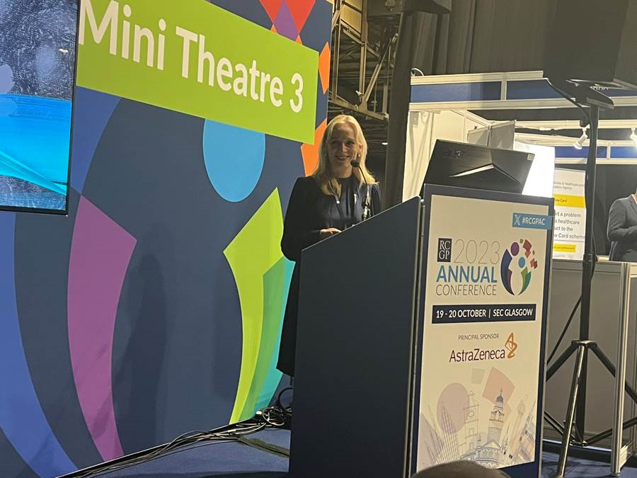 | On day 1 of the 2023 RCGP Primary Care Conference in Glasgow, Victoria Tzortziou Brown presented a short clinical paper on her research project: Remote access to general practice and inclusion health-a qualitative study of patient perspectives. On day 2 she ran a session on Integrating, embedding and modernising primary care research, speaking on the enablers covering data, funding, and workforce opportunities.
Michael J Fox Foundation PD Therapeutics Conference
19 October (Alastair Noyce. Centre for Preventive Neurology)

Alastair Noyce presented work from the London-Dhaka project on the prevalence and assessment of cognitive impairment in Parkinson’s Disease at the 15th Annual PD Therapeutics Conference in New York. The meeting and the project are sponsored by the Michael J Fox Foundation for Parkinson’s Research. | 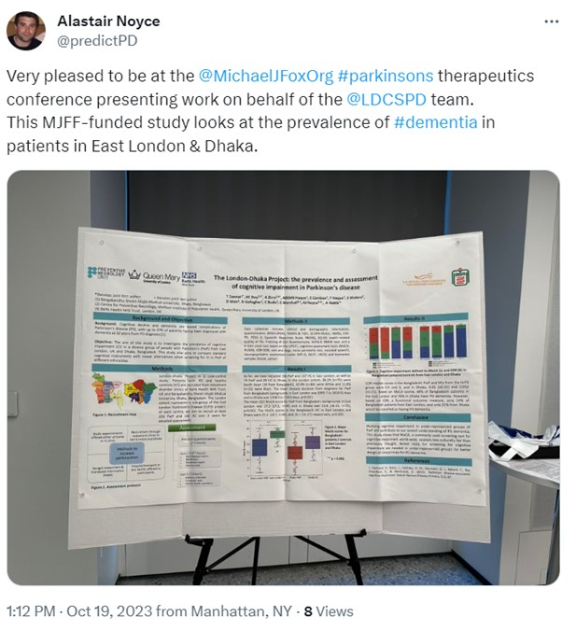
Wellbeing among Coventry City of Culture City Host volunteers
19 October (Lola Oyebode. Centre for Public Health and Policy)

 | A study exploring how the City Hosts programme (part of the Coventry UK City of Culture 2021 event) affected the wellbeing of city host volunteers used interview and survey data to find that the programme offers lessons for others designing volunteering programmes. Programme strengths included facilitating the full range of mechanisms of change that mediate improved volunteer wellbeing, particularly promoting social connections and developing a strong role and group identity, and flexibility around what volunteers do, how much, and how often. Authors also identified evidence that exposure to culture may be a mechanism by which volunteering can improve wellbeing.
TB incidence in foreign-born people residing in European countries in 2020
19 October (Dominik Zenner. Centre for Public Health and Policy)

To identify which groups of foreign-born European residents benefit most from targeted TB prevention screening, a study has determined numbers of patients in EU countries, Iceland, Norway, Switzerland and the UK who originated from the 10 countries with the highest numbers of TB cases. TB incidence rates (IRs) in countries of residence were compared with countries of origin. Main origin countries were Eritrea, India, Pakistan, Morocco, Romania and Somalia, and TB IRs were highest in patients from Eritrea and Somalia residing in Greece and Malta (both >1,000/100,000). IRs were mainly lower in residence than origin countries, but IRs among Eritreans and Somalis in Greece and Malta were 5x higher than in Eritrea and Somalia, and IRs among Eritreans in Germany, Netherlands and UK were 4x higher than in Eritrea. Authors conclude that country of origin TB IR is an insufficient indicator when targeting foreign-born populations for active case finding or TB prevention policies in the countries covered here. | 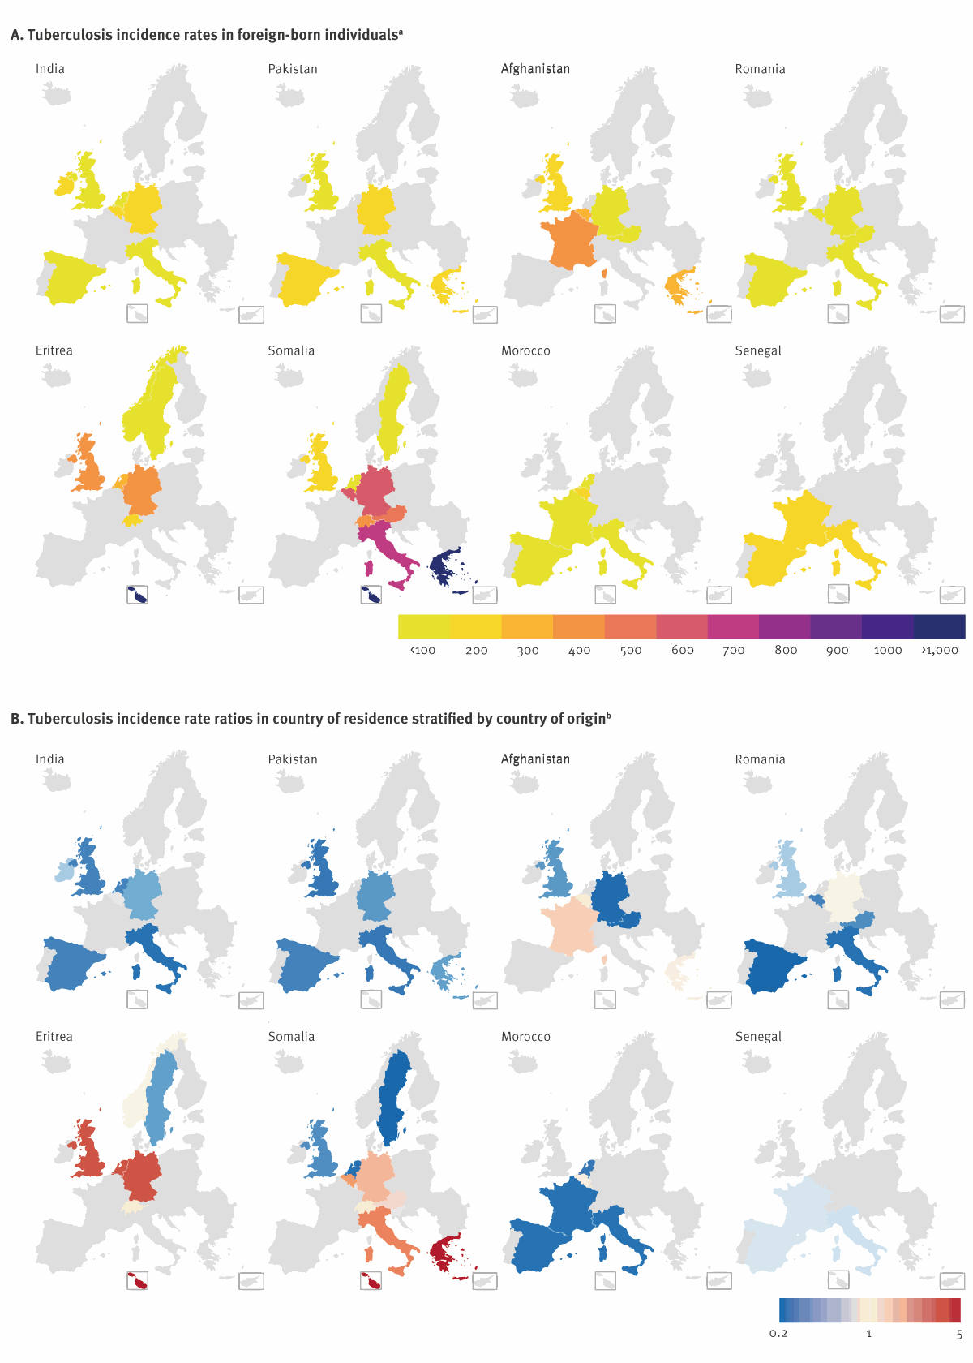
Top 10 2023 most viewed Cancers papers on causes, screening and diagnosis
19 October (Oleg Blyuss, Samuel Oxley, Ranjit Manchanda. Centre for Cancer Screening, Prevention and Early Diagnosis)

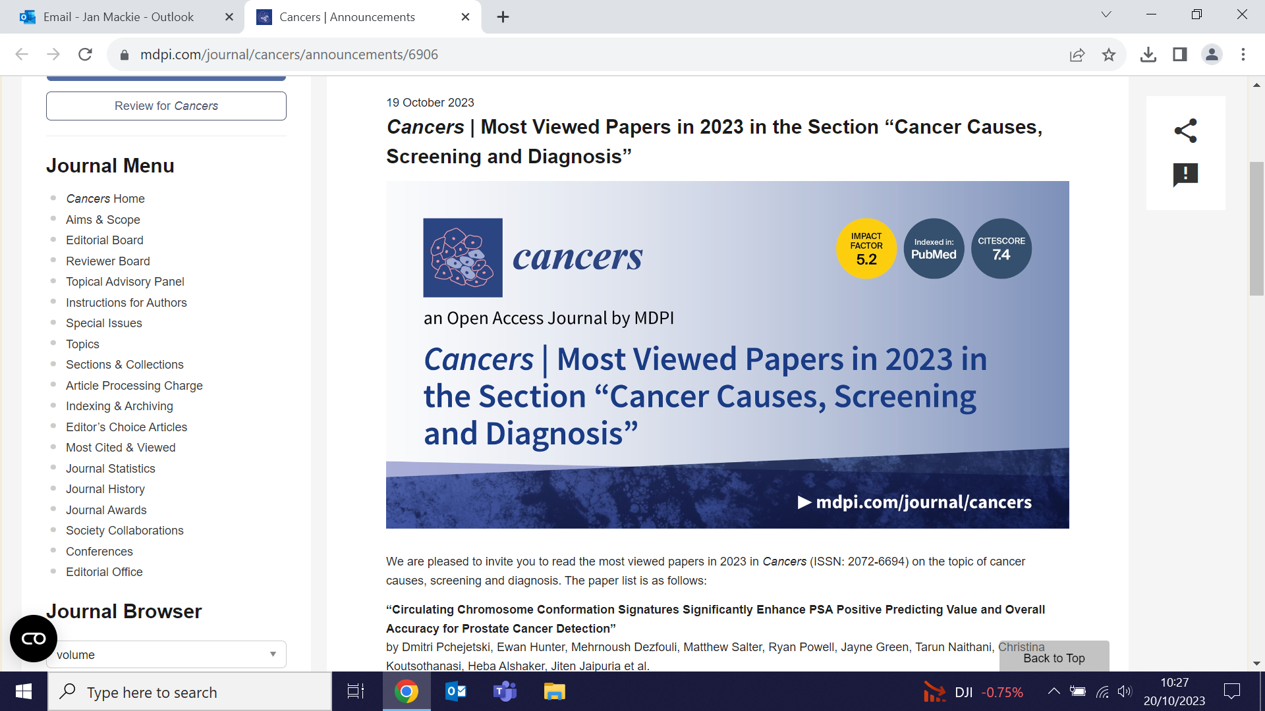 | A paper by WIPH authors is featured in a 2023 top 10 most viewed list for the Journal Cancers. Breast cancer risk and breast cancer specific mortality following risk reducing salpingo-oophorectomy in BRCA carriers: a systematic review and meta-analysis is in the top 10 for papers on cancer causes, screening and diagnosis.
Participant sociodemographic characteristics: NHS-Galleri Trial
22 October (Adam Brentnall, Jo Waller, Peter Sasieni. Centres for Evaluation and Methods/Cancer Screening, Prevention and Early Diagnosis)

A poster presented at the European Society for Medical Oncology Congress in Madrid, and simultaneously published in the Annals of Clinical Oncology, describes enrolment approaches and participant sociodemographic characteristics in the NHS-Galleri trial. The research trial will determine how well the Galleri blood test, which can detect signs of many different types of cancer, will work in the NHS setting. Around 140,000 volunteers have registered to participate.

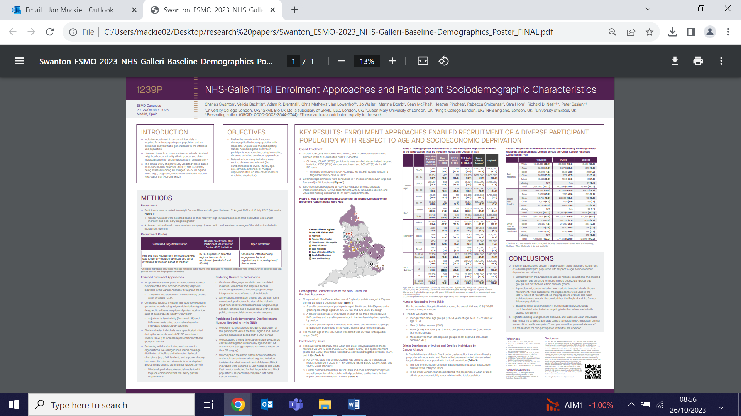
NIHR Grant to analyse GP ‘winter pressures’ and the impact on patients
23 October (Rohini Mathur. Centre for Primary Care)

A £2.2 million grant to examine winter pressures in general practice and understand the impacts on patient outcomes has been awarded to a team including the CEG’s Rohini Mathur as a co-applicant. Led by the LSHTM and with other co-applicants from the Universities of Oxford and Bristol, and clinical software provider TPP, the 3 year project will: i) Measure winter pressures in general practice and analyse the causes, including patient, practice and disease factors; ii) Develop and test models to predict the onset and intensity of excess pressure in an individual GP practice, and predict which practices are most susceptible; iii) Estimate downstream effects on patients, including hospital attendance, mortality, and impact on health inequalities; and iv) Analyse potential vaccination strategies for the common respiratory viruses that contribute to winter pressures (using transmission modelling and economic analysis), and develop evidence based recommendations. | 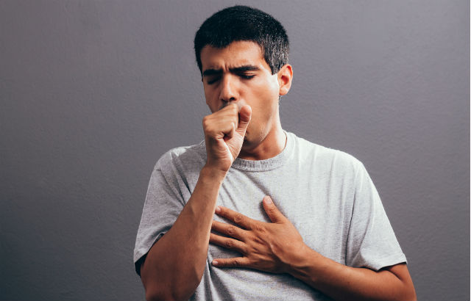  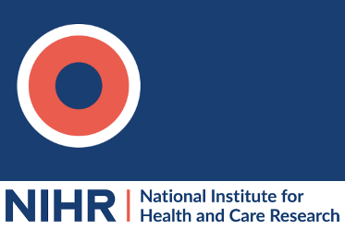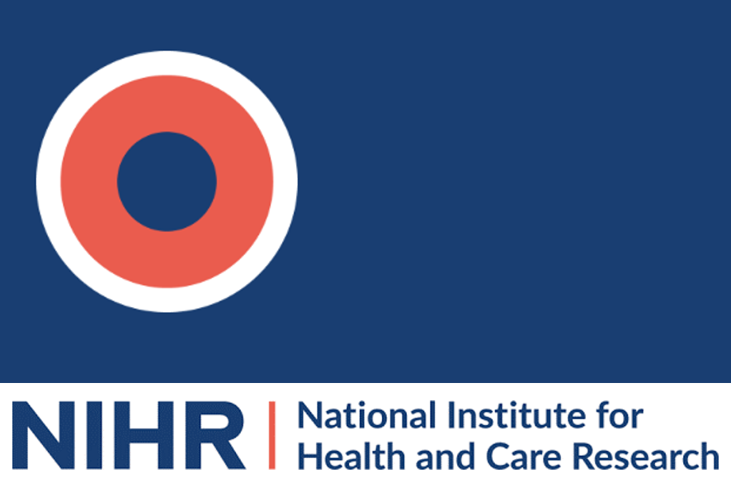
Study identifies 158 novel genetic associations with TSH
23 October (Daniel Stow, Ben Jacobs. Centre for Preventive Neurology)

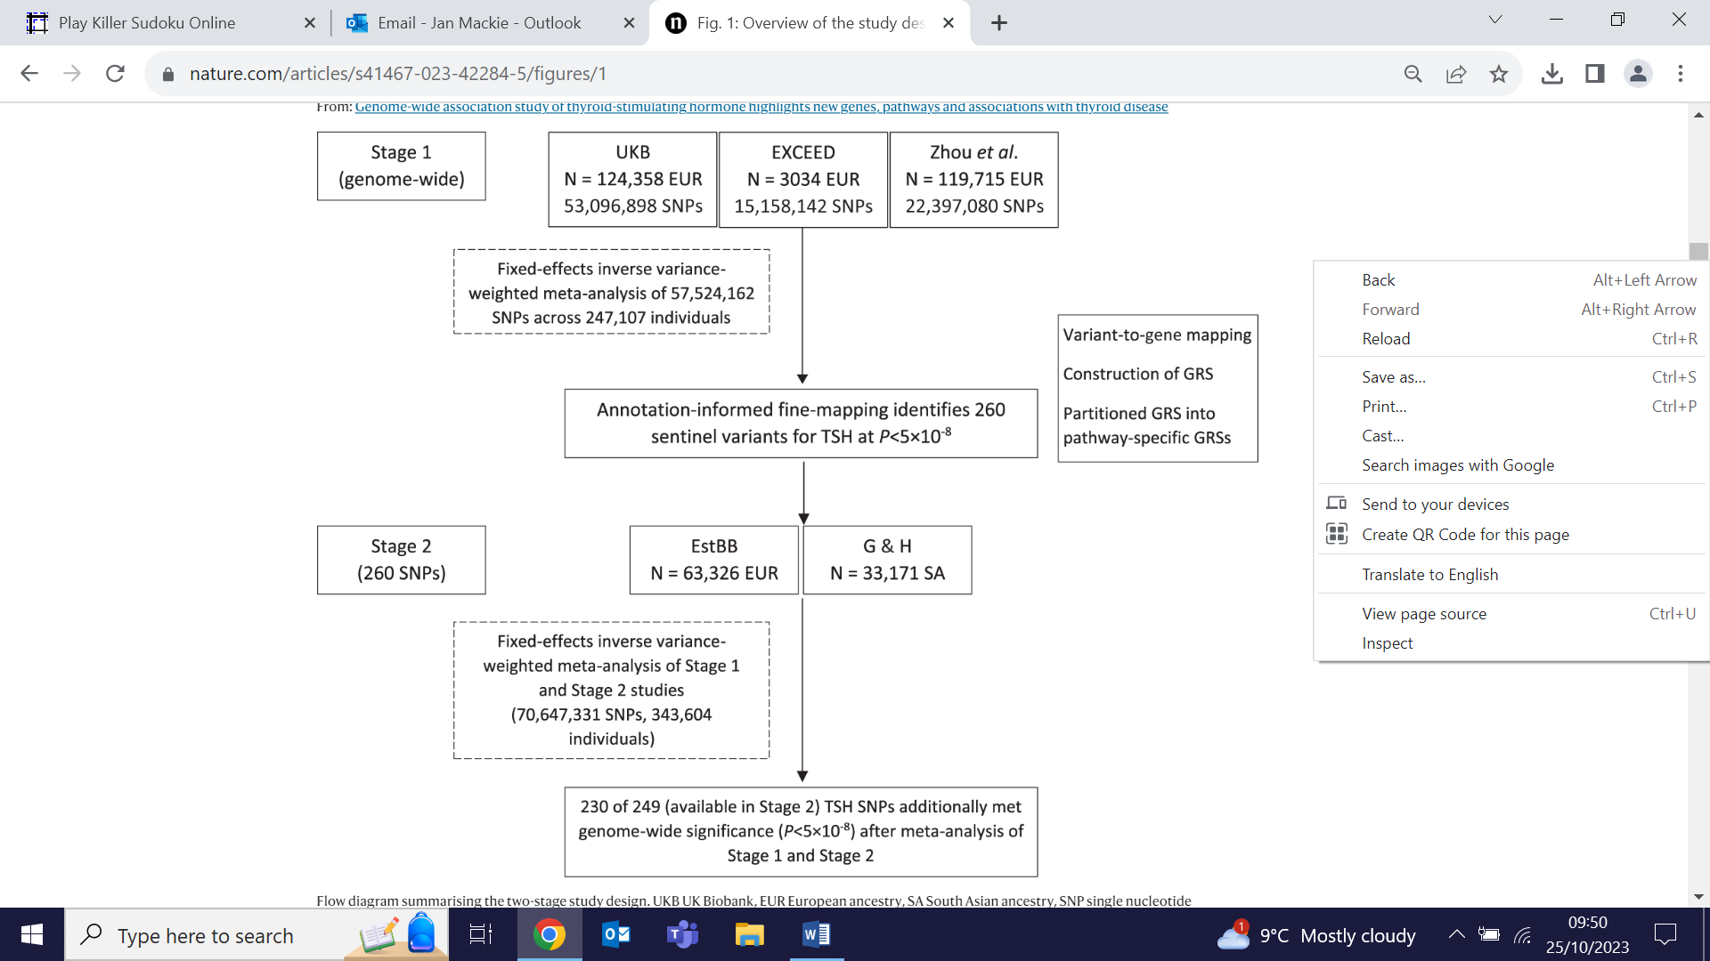 | Using e-health records in a genome-wide association study of thyroid-stimulating hormone (TSH) levels, researchers have identified 158 novel genetic associations with TSH, and identified 112 putative causal genes, of which 76 have not been previously implicated. The results more than double the number of previously known genetic associations with TSH. Findings show that a polygenic score for TSH is associated with TSH levels in African, S. Asian, E. Asian, Middle Eastern and admixed American ancestries, and associated with hypothyroidism and other thyroid disease in S. Asians. In Europeans the TSH polygenic score is associated with thyroid disease, including thyroid cancer and age-of-onset of hypothyroidism and hyperthyroidism. Authors say their findings demonstrate the potential utility of genetic associations to inform future therapeutics and risk prediction for thyroid diseases.
Knowledge of HPV and primary HPV screening among women in Britain
24 October (Jo Waller, Laura Marlow. Centre for Cancer Screening, Prevention and Early Diagnosis)

An online population based survey shows that just 12% of women in Great Britain understand the role of HPV testing in cervical screening. The study explored HPV awareness and knowledge about primary screening in England, Scotland and Wales, ahead of implementation of extended screening intervals. Most (61.5%) of the 1995 women surveyed had heard about the virus in the context of cervical screening or HPV vaccination, and 72.8% knew that an HPV-positive result does not mean a woman will definitely develop cervical cancer, but far fewer (18.7%) were aware of the long timeline for HPV to develop into cervical cancer. The results highlight continued need for awareness-raising campaigns to ensure informed choice about screening and to mitigate public concern when screening intervals are extended. This paper was featured in multiple media outlets. | 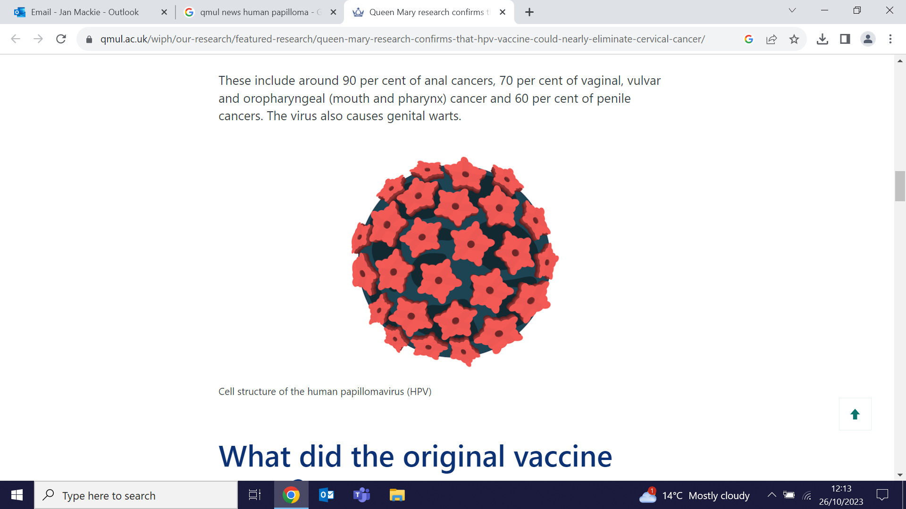
Mental health of parents with and without borderline intellectual functioning
25 October (Afia Ali. Centre for Psychiatry and Mental Health)

 | An analysis comparing differences in socio-demographic, mental health and service-use characteristics in parents and non-parents with and without borderline intellectual functioning (BIF) finds that being a parent is associated with elevated rates of common mental disorders, and that there is a higher burden of mental health problems and service use in people with BIF. Data from the 2013 Adult Psychiatric Morbidity Survey showed that BIF parents had higher odds of common mental disorder, severe mental illness, post-traumatic stress disorder, self-harm/suicide, and were more likely to see their GP and to receive mental health treatment than non-BIF parents, but BIF parents did not have a higher prevalence of mental health problems than BIF non-parents. Researchers say greater provision of specialist support services is indicated for this group.
Ready Meals: The Shocking Truth
25 October (Zoe Davies. Centre for Public Health and Policy)

Zoe Davies from the Research and Action on Salt and Obesity Unit appeared in an episode of the new channel 5 series, 'The shocking truth', talking about ready meals. In the segment on vegan meals Zoe discussed the health halo effect, where people presume that vegan food is healthier than it actually is, and talked about the hidden salt in these products. | 
Expert comment on effect of Tai Chi on Parkinson’s symptoms
25 October (Alastair Noyce. Centre for Preventive Neurology)

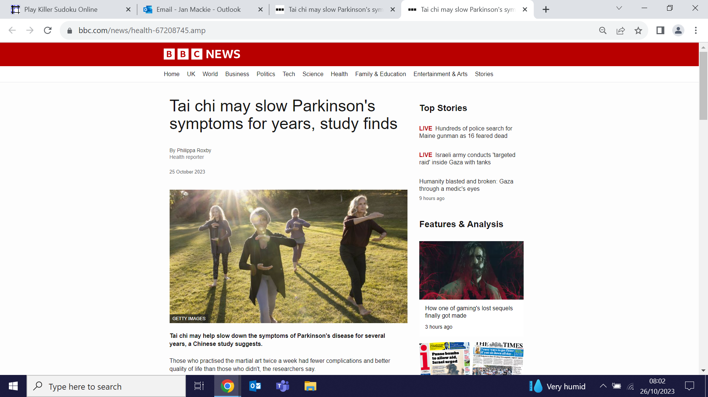 | Commenting on a new study showing that Parkinson’s disease progressed more slowly in a group practising tai chi than those who did not, Alastair Noyce told the BBC that although this is an important study, there were design limitations, and further work was needed: ‘We already recommend tai chi, as well as other forms of exercise, but understanding which forms of exercise are most beneficial is an important goal to enhance the long-term management of patients’.
Implementing psychological interventions for people with COPD
25 October (Moira Kelly, Liz Steed, Ratna Sohanpal, Steph Taylor. Centre for Primary Care)

An interview study conducted with NHS stakeholders to understand barriers and facilitators for implementing psychological interventions for people with chronic obstructive pulmonary disorder (COPD) has found that healthcare for physical and psychological symptoms of COPD should be provided holistically, and that respiratory healthcare professionals are able to provide psychologically informed approaches, but resources are needed for training, staff supervision and service integration. | 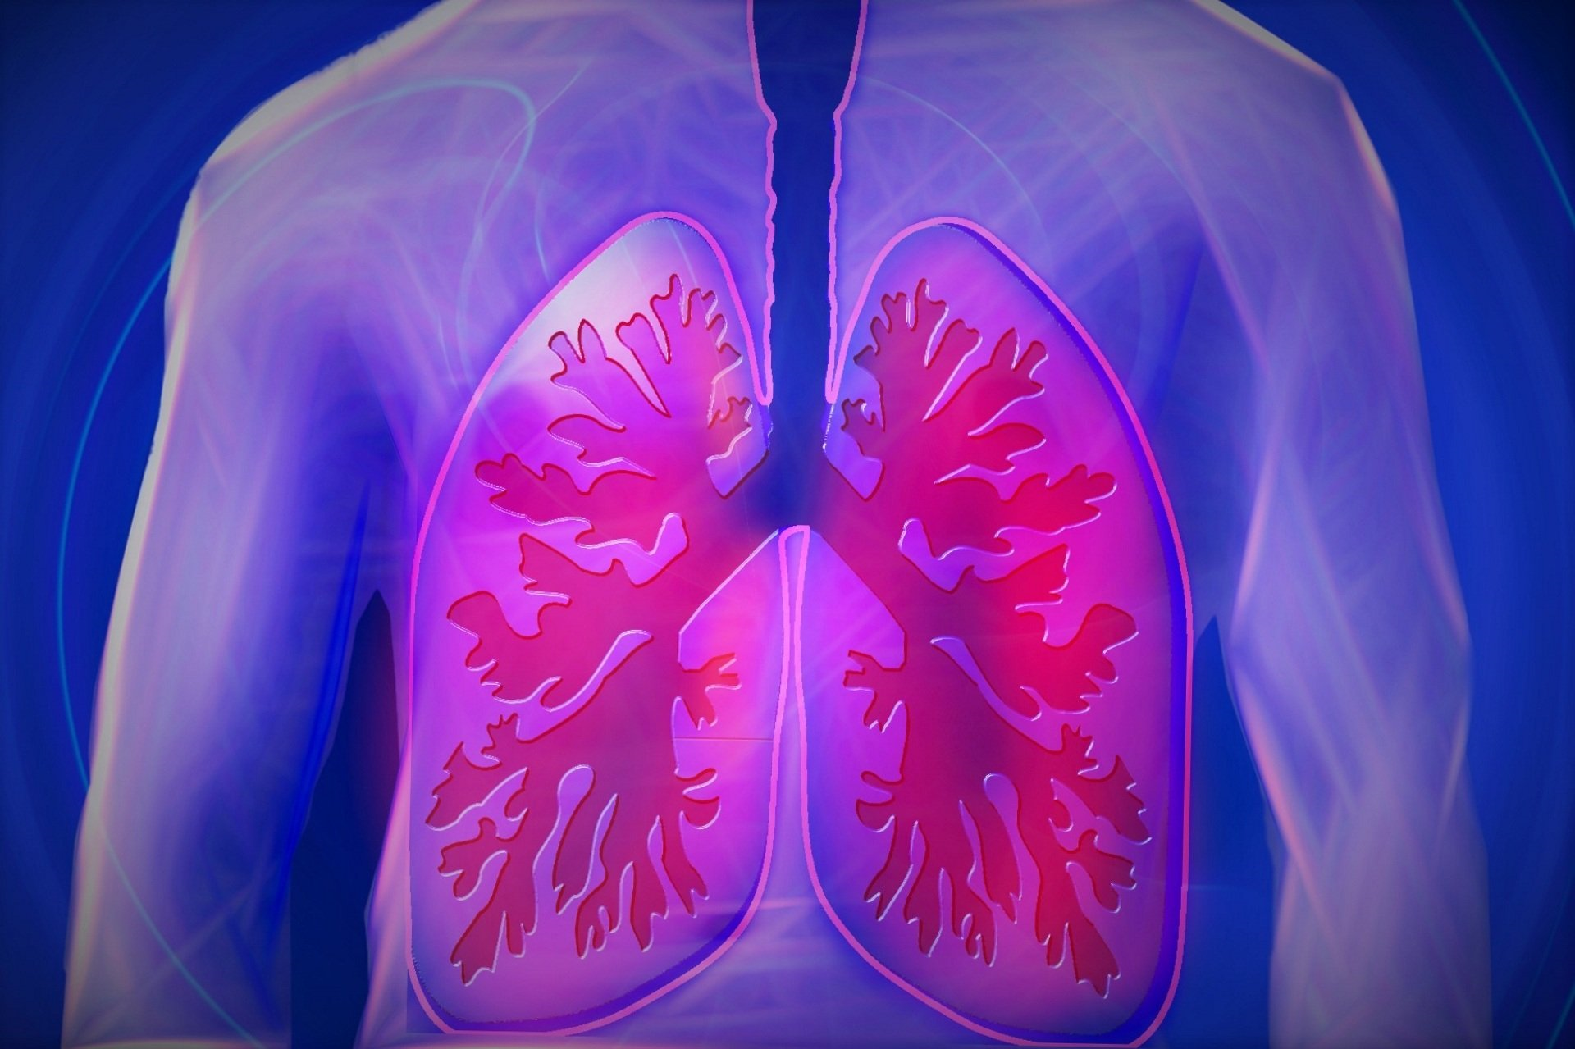
Antibiotic prescribing in COVID-19 patients in China and other LMICs
26 October (Beth Stuart. Centre for Evaluation and Methods)

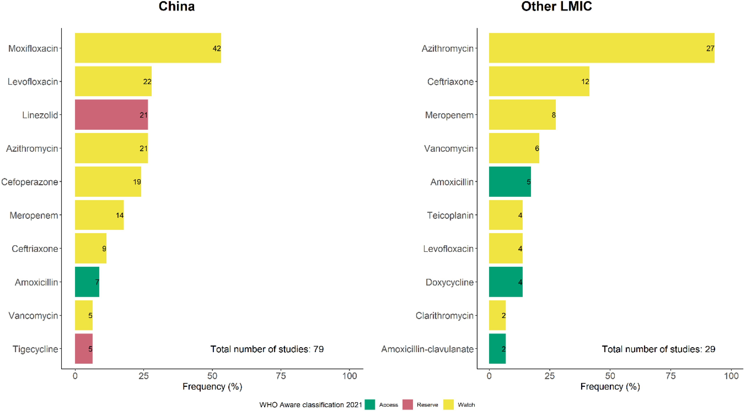 | A systematic review and meta-analysis examining data from 284 studies in 19 countries finds inappropriate antibiotic use and high prevalence of antibiotic prescribing in COVID-19 inpatients during the pandemic in many low- and middle-income countries (LMICs). Antibiotic prescribing rates (APRs) in COVID-19 inpatients were 71.7% in China and 86.5% in other LMICs. High APRs were found among pregnant women and the elderly in China, and several antibiotics on the WHO 'Watch' and 'Reserve' lists were prescribed frequently in LMICs. Researchers note that LMICs are particularly vulnerable to the threat of antimicrobial resistance.
Inequities in hypertension management: how can we do better?
26 October (Stuart Rison, Rohini Mathur, Chris Carvalho, John Robson. Centre for Primary Care)

An editorial exploring obstacles to the effective management of hypertension considers 2 papers in this month’s British Journal of General Practice. The first, from Hong Kong, finds that patients with hypertension managed by the same physician-team are less likely to develop CVD or die than those cared for by a wider range of teams. A second paper explores health inequalities in NE London, finding that individuals with hypertension from Black ethnic groups here were almost 10% less likely to have controlled blood pressure than those in White ethnic groups. Authors conclude that the C20th model of a single doctor providing all care is no longer sufficient for the needs of a C21st society, and that there is a need to reach out to underserved communities to co-develop appropriate services. Access need not necessarily be more frequent, but rather simpler, more efficient, and patient centred. Recognising who needs what kind of additional support is the first step toward addressing the problem. | 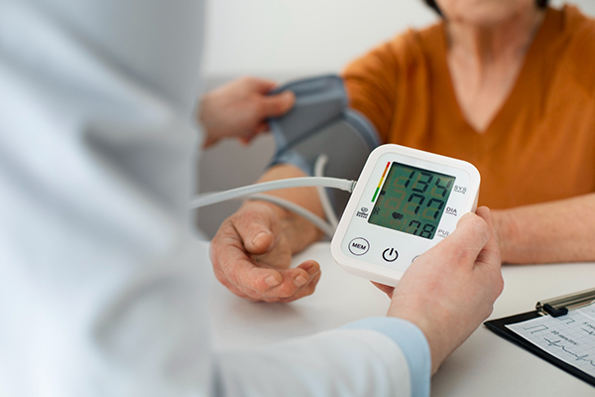
Society of Apothecaries Galen Medal in Therapeutics
27 October (Jack Cuzick. Centre for Cancer Screening, Prevention and Early Diagnosis)

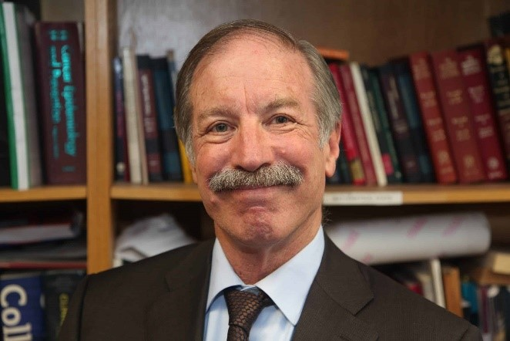   | In recognition of his work ‘transforming identification of women at high risk of breast cancer and pioneering modern prevention cervical screening strategies that have been adopted worldwide’, Jack Cuzick has been awarded the Society of Apothecaries Galen Medal in Therapeutics for 2024. The medal is the Society’s most prestigious honour and has been presented annually since 1925. Jack will receive the award at the annual Galen dinner at Apothecaries’ Hall on 23 May 2024.
Ethnic differences in early onset multimorbidity
27 October (Fabiola Eto, Miriam Samuel, Tahania Ahmad, Sally Hull, Sarah Finer, Rohini Mathur. Centre for Primary Care)

A study of early onset multimorbidity (≥2 long-term conditions in individuals) among 837,869 16-39 year olds in England finds that early onset multimorbidity is more common among S. Asian (59%) and Black (56%) v White groups (42%). In White groups, the cluster with the highest rates was predominantly male (54%) and more socioeconomically deprived than the cluster with the lowest rates. Black and S. Asian groups were more socioeconomically deprived than White groups, with a consistent deprivation gradient across all multimorbidity clusters. Among the early onset multimorbidity populations at the end of the study, 4% of the white group had died v 2% of the S. Asian and Black groups, though the latter groups died younger and lost more years of life. Authors conclude that their findings emphasise the need to identify, prevent, and manage multimorbidity early in the life course, and to ensure equitable healthcare improvements.

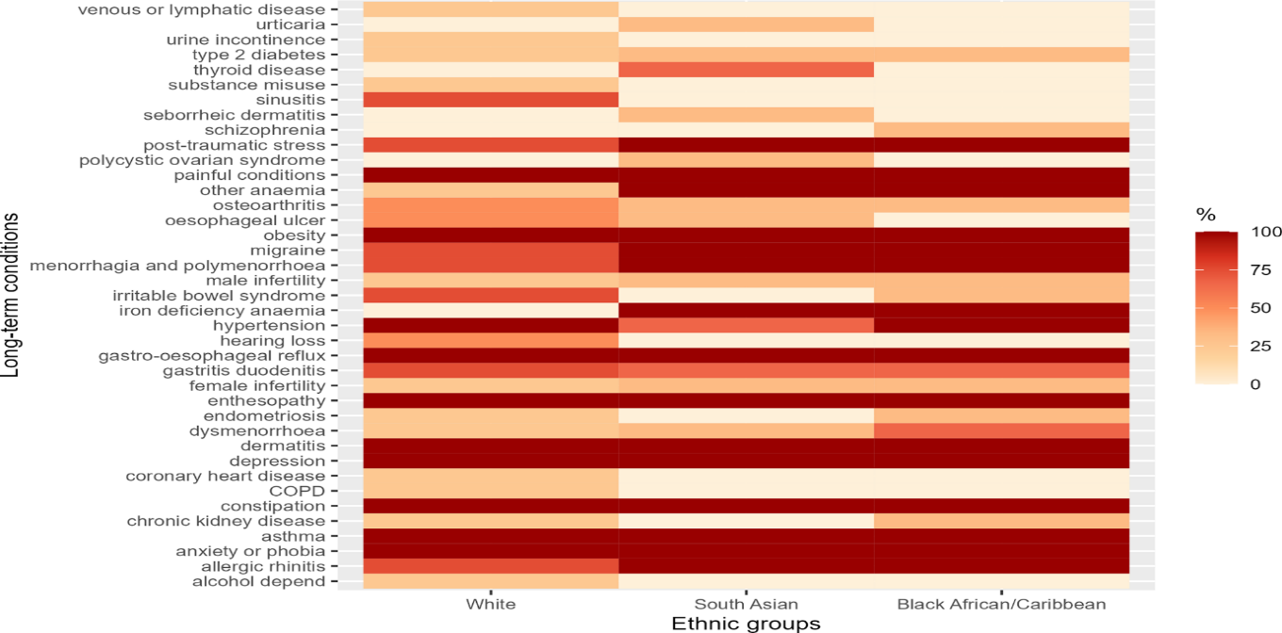

Sugar Pollution: Curbing sugar supply for health and the environment
28 October (Action on Sugar team. Centre for Public Health and Policy)

A new report, Sugar Pollution: Curbing sugar supply for health and the environment has been released by the Research and Action on Salt and Obesity unit. Written by the Action on Sugar team in collaboration with environment NGO Feedback Global, the report examines the impacts on public health and the environment of producing, importing, and consuming too much sugar, including the links to obesity and the irreversible damage to soil. It also sets out action that could be taken to steer a different course, to tackle both the oversupply and overconsumption of sugar in an integrated way, and harness existing public support for strong and visible political leadership on food. This story was covered in the Observer. | 
FORTHCOMING EVENTS

Research Seminar: An AI-based algorithm to predict atrial fibrillation in general practice
2 November, 13:30-14:20 (Jianhua Wu. Centre for Primary Care)

This new online monthly Population Health Data Science research seminar series will share examples of research excellence in health data science from across WIPH, BCI, Barts Health, and more widely. We will h​ear from colleagues using a wide range of data resources and techniques, meet new collaborators, and exchange expertise in using electronic health records and multimodal health-related data to improve population health. The first seminar on 2 November will be introduced by Carol Dezateux and Rohini Mathur, and the presentation will be made by Jianhua Wu. Click here to join the meeting (passcode: hDGtsf). | 
Webinar: Using CPRD data via Queen Mary’s Multi-Study Licence
20 November 10am (Clinical Effectiveness Group, Centre for Primary Care)

QM now has a Multi-Study Licence to access data from Clinical Practice Research Datalink (CPRD), a longitudinal dataset from primary care health records of 60 million patients representative of the UK population. The data can be linked to a range of other health-related data. The QM licence, which enables staff and PhD students to access the data for approved studies at a reduced cost, is funded by Barts Charity until 2027 as part of the Precision Health: Population Health Data Science research programme, jointly led by the CEG and the BCI. For information about fees and a step-by-step guide to accessing CPRD data via the licence, contact the team. More information is also available on the CEG website. Click here to join the meeting on Teams on Monday 20 November to hear from colleagues who are already using CPRD data, and to find out more about the Licence. | 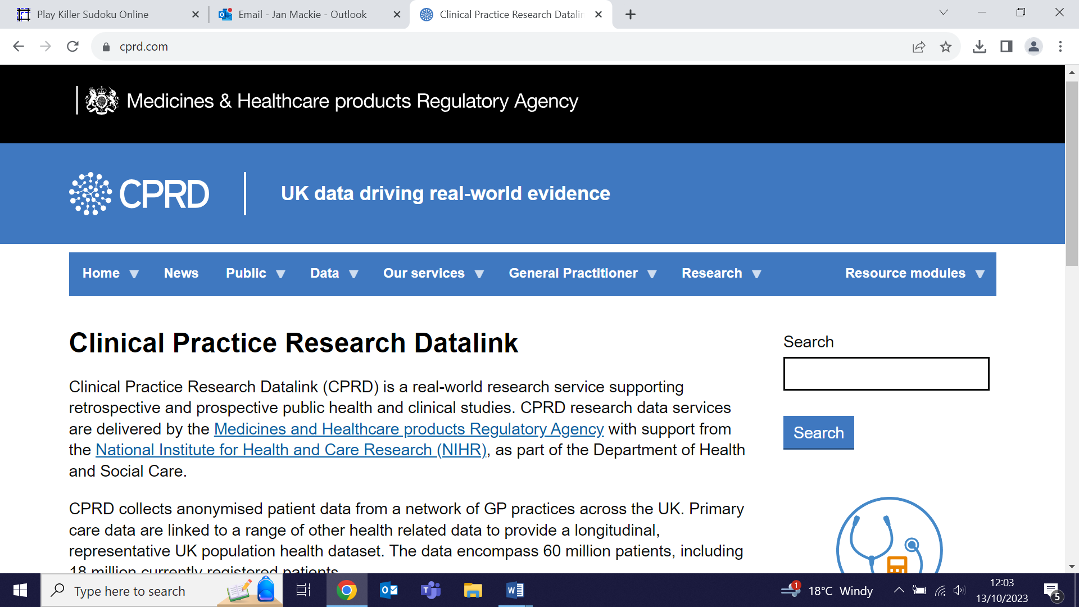
Many thanks to all who so enthusiastically contribute. Please send any news items for the next newsletter to j.a.mackie@qmul.ac.uk

