WOLFSON INSTITUTE OF POPULATION HEALTH
NEWSLETTER
ISSUE 45: 14 NOVEMBER 2023

In this issue of our Wolfson Institute of Population Health Newsletter, we celebrate the achievements and work of staff and students in late October and the first half of November.

FROM OUR DIRECTOR
Dear Colleagues

It’s London Global Cancer week, so I’ve a full diary. Yesterday it was a privilege to attend a meeting at the Gordon Museum, Guy’s Hospital, where we heard about the challenges of providing cancer care in war zones and for displaced people, with moving insights from Ukraine and Iraq and the surrounding countries, as well as examples of working with local communities across India and Africa. With our recent successes at gaining global health funding we have a lot to contribute to, and gain from, these international gatherings.

Closer to home, it’s one of the busiest times of the year for us. Many of you have become Academic Advisors (replacing MEDPRO) to MBBS students across the year groups. As we get to know our students, thank you for these worthwhile endeavours to provide pastoral and academic support.
Delivery of our packed educational programmes is also in full swing, and thanks to all involved here too.  As you’ll see in this newsletter, our Institute colleagues continue to have outstanding publications with significant impact. Congratulations to all, and keep up the great work. Finally, please do look out for the many talks and seminars coming our way over the next few weeks.  Very best wishes  Fiona | 
MEET WIPH - KATILA GEORGE (Senior Clinical Trials Nurse, CPN)

How would you describe your roles and responsibilities?

I work on investigator- and pharma-led clinical studies, in particular OPTIMISE, a multicentre pharmacovigilance study looking at incidence and comparing risks of serious adverse events in disease modifying treatments (DMTs) in Multiple Sclerosis, and its sub-study, the OPTIMISE MS Pregnancy Registry, which investigates the risks and benefits of DMTs during pregnancy in women with MS. I recruit participants from the Royal London, and manage data entry for that site in the study database. I also collaborate in managing 6 other sites in England and Scotland, assisting with training, recruitment, and monitoring. My day to day work also includes organising clinical visits, corresponding with study sponsors and third party vendors or other sites, and conducting training sessions. I also lend clinical support on my colleagues’ projects.

What has been your greatest professional achievement?

Undoubtedly that I am still enjoying my job after 22 years! My career has had ups and downs, but overall the balance is positive. I have been granted amazing opportunities, meeting wonderful people, travelling to other countries, working in the best hospitals in Portugal and the UK, and being at the forefront of clinical research and patient care. I hope to continue with the same enthusiasm, willingness to learn, and feeling of purpose until the end of my working life.

What aspects of your role do you enjoy the most?

I enjoy direct patient contact, learning new things every day, teaching the principles of clinical research to young researchers and new research nurses, finding solutions for complex problems and, of course, working with people who are invested in giving their best every day.

What would be your second choice as a profession?  I think I would have been a pharmacist (very boring, I know!), but the training was very long…  What do you enjoy doing outside work?  Cooking (Portuguese food), baking (for CPN MS fund raising events), gardening, and spending time with family.  Something most people don’t know about you?  That I am a ‘football mum’, and also that I am completing an MSc in Pharmacovigilance - so I am a student too! | 
FROM OUR LEADERSHIP TEAMS

Public Advisory Panel Theme News (Megan Clinch, Theme Lead)

We will be using our December PPI drop in session to gather feedback on the PPI pages on the WIPH staff zone. Your in-puts would be greatly appreciated, so please do try to attend if you can. The drop in will be on Wednesday 6 December from 11.30-12.30, in a hybrid format. Diary invite will follow shortly.

Equality, Diversity and Inclusion News (Evangelos Katsampouris – EDI Lead)

The EDI Group strongly encourages all WIPH colleagues, students and staff to:
1) Undertake the Queen Mary Bystander Course training, available through QMPlus
2) Use the Online Suggestion Form, available through the EDI section on the Staff Zone, to recommend improvements or to report issues. If you wish to raise and discuss an EDI-related issue, please email us.

Research News (Tor Kemp, Research Manager)

From the Research Team

In the last newsletter, we compared our offering to a buffet - that’s something for everyone! See below for what’s been happening and what is on the menu in the weeks ahead.

This week we invite Dr James Flory and Dr Andrew Vickers from the Memorial Sloan Kettering Cancer Centre to discuss an exciting new trial design they have recently published, in a talk titled “Decision architecture randomisation: extremely efficient clinical trials that preserve clinician and patient choice?” This talk will take place TODAY - Tuesday 14 November, online 12:15-13:00. Please feel free to contact Patrick Mullan with additional speaker suggestions, and we will try to accommodate.

We’ve delivered another thought-provoking Health Inequalities Grant Clinic, and are very grateful to Helena Painter for sharing her bid with us. These sessions provide coordinated expert support for bids in development with a focus on health inequalities. The next session will take place Tuesday 12 December, online 10-11. Please submit paperwork by midday Friday 8 December, or just come along to the open forum to learn together!

Adam Brentnall and Tom Hamborg delivered the third session in the Publication Writing Series last week, on data presentation and common statistical errors to avoid (recording now available on the staff zone). Alongside the presentation, attendees posted related memes in the chat, with Nefeli Kouppa winning by the people’s choice, highlighting the importance of reproducibility in research. | 
The next session is Thursday 7 November, online 12:15-13:00. We’ll be inviting back Anika Knuppel, Senior Editor The Lancet Public Health, who will be joined by Liz Steed and Richard Hooper to demystify the editorial process. Please join on us on MS Teams for an interesting discussion - we particularly encourage PhDs, ECRs and MCRs to attend.

Also upcoming in the next two weeks are the WIPH Research Team drop in this Thursday 16 November, online 10-11am, and our first WIPH Whiteboard session, with Francois van Loggerenberg on Thursday 30 November, in-person 10-11am.

Please email Tor Kemp if you have questions about any of these opportunities!

Other upcoming research events

FMD Industry Connect Day: Cardiovascular & Metabolism | 22 November
QMUL, with Barts Health Trust, invites you to discover our cardiovascular & metabolism research and support academic-industry partnerships. The event is taking place Wed, 22 Nov 2023 12:00-17:00 in the Wolfson Building, CHSQ. You are invited to submit to the poster competition. Please email your abstract to fmd-research@qmul.ac.uk by close of play TODAY, Tuesday 14 November.

GENERAL INSTITUTE NEWS

Invisible Infrastructure in Haematology: ANC Ranges and the Duffy-null Phenotype
27 October (Stephen Hibbs, Centre for Primary Care)

HemaSphere Scientific Editor Stephen Hibbs in conversation with Dr Lauren Merz discusses her work on absolute neutrophil count (ANC) ranges for individuals who are Duffy null, the limitations of ethnicity as a concept, and other unquestioned practices in haematology. The mechanism for ANCs of <1500/μL without increased risk of infection is a polymorphism in the Duffy antigen receptor for chemokines (DARC) gene. Individuals with Duffy-null phenotype have reduced susceptibility to Plasmodium vivax. The polymorphism is more common in those whose ancestors lived in malaria-endemic regions such as Sub-Saharan Africa and the Arabian Peninsula. | 
Report on QMUL economic and social impact
30 October (Stop Smoking Services team, Centre for Public Health and Policy; Genes & Health team, Centre for Primary Care)

 | A QMUL-commissioned report on the economic and social impact of the university highlights the work of two of our WIPH units, the Health and Lifestyle Research Unit’s Stop Smoking Services, and the Genes & Health Project's longitudinal study of 100,000 people of Bangladeshi and Pakistani ethnicity, many of whom come from our local community. It notes that ‘Delivering 23 years of tobacco cessation services has made a profound impact on public health across North East London’ and that the Genes & Health project is 'paving the way in the identification of genetic determinants for specific illnesses affecting the community'. The London Economics report shows that the QMUL financial contribution to the UK economy is £4.4 billion, and that for every £1 QMUL spent in 2021/22, it generated £7 for the UK economy, a ratio significantly higher than other similar universities.
What to know about MS and pregnancy
30 October (Ruth Dobson. Centre for Preventive Neurology)

In a community blog for the MS Society Ruth Dobson provides answers to questions about fertility, pregnancy, childbirth and Multiple Sclerosis (MS). Through her work in MS clinics Ruth identified an information gap: ‘All these people come through clinics asking: What do I do around pregnancy? And there weren't any guidelines for how people should be treated’ which she subsequently filled, as lead author on the Association of British Neurologists guidelines for pregnancy and MS. She also played a key role in setting up the MS Pregnancy Register, to help understand the experiences of pregnant women with MS in the UK ‘to work out what we can do to better support people’. |   
Higher than expected cancer risk after ‘all clear’ at suspected cancer referral
31 October (Suzanne Scott, Ruth Evans. Centre for Cancer Screening, Prevention and Early Diagnosis)

 | Patients referred for urgent suspected cancer who are found not to have cancer at that time have a higher risk of subsequent cancer in the 1-5 years following the ‘all clear’ than those not seen in urgent referral pathways, according to a study looking at health data of >1 million NHS patients in England. The risk of any cancer in this group was 4.5% over 5yrs, which is higher than in people of similar age/gender in the general population. The results suggest that the higher than expected cancer risk is not due to cancers being missed in the initial referral, but that the subsequent cancers are likely to be caused by high risk factors such as poor diet, smoking, or alcohol consumption. Authors believe that an opportunity exists to provide additional support to patients without a cancer diagnosis on the referral pathway.
Understanding cancer risk in lower-risk patients
31 October (Yin Zhou, Fiona Walter. Centre for Cancer Screening, Prevention and Early Diagnosis)

A comment published in Lancet Oncology calls for more refined guidelines and risk stratification approaches for UK Primary care physicians to manage patients with a range of cancer risks. Most evidence relating to cancer risk estimation considers the higher-risk patients at time of presentation, but patients are much more likely to present with non-alarm symptoms, which confer lower risk for cancer. Authors say guidelines on lower-risk and persistent symptoms are either non-existent or ambiguous, and that optimising risk stratification in patients who present with lower-risk symptoms, but who may have intermediate risk of cancer, could have substantial positive impacts on patient experiences and clinical outcomes at population level, and improve health system efficiency. | 
Six unanswered questions about primary progressive aphasia
31 October. (Charlie Marshall. Centre for Preventive Neurology)

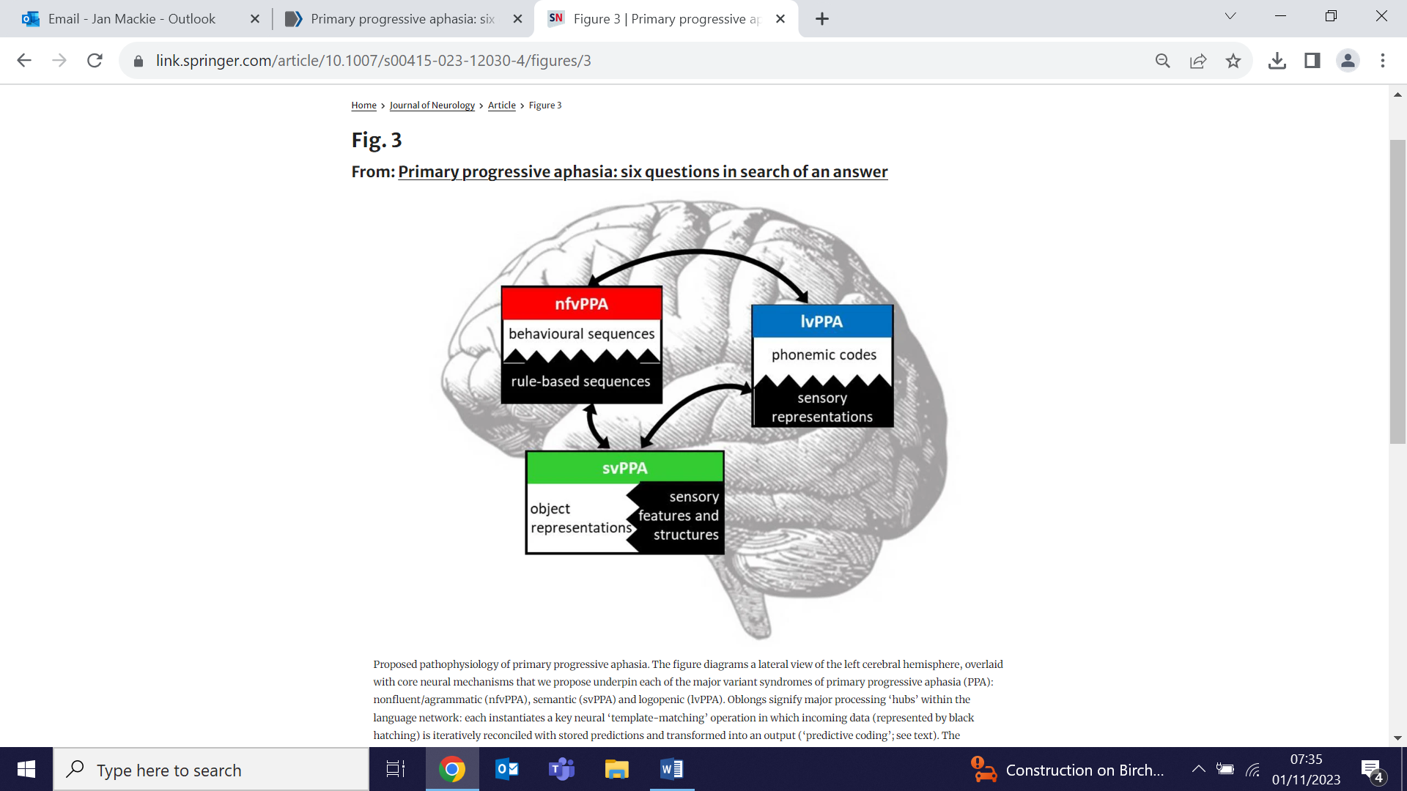 | Authors reviewing recent progress in the diagnosis and management of primary progressive aphasia (PPA) and language-led dementias suggest that existing diagnostic criteria do not capture the complexity and heterogeneity of these diseases, and that a reappraisal is needed. They pose 6 key questions that challenge current assumptions and highlight unresolved difficulties around these diseases: How many PPA syndromes are there and is syndromic diagnosis even useful? Are these truly 'language-led' dementias? How can we better diagnose and track PPA? Can brain pathology be predicted in these diseases? What is their core pathophysiology? and How can PPA best be treated? The paper concludes that pathophysiological mechanisms linking proteinopathies to phenotypes may help resolve the clinical complexity of PPA, suggest novel diagnostic tools and markers, and guide deployment of effective therapies.
Research engagement during the monkeypox pandemic
31 October (Sara Paparini, Vanessa Apea. Centre for Public Health and Policy)

A study of clinical research engagement during the monkeypox pandemic finds that both rates of engagement and diversity among research-active clinicians were significantly lower in the UK compared with the EU or USA. Reduced engagement was most pronounced at earlier stages of training, in women, and in those from racially minoritised backgrounds. None of the 139 UK survey respondents identified themselves as clinical researchers, and overall research engagement was lowest in the UK (15.1%) vs EU and USA (36.7%, 37.9%). In research-active respondents, measurable research achievements by journal publications/submissions and grant funding were significantly higher in older, male, White, consultant physicians. Authors conclude that evaluation of existing UK-based recommendations is needed to improve the clinical academic pipeline and to increase research engagement and diversity. | 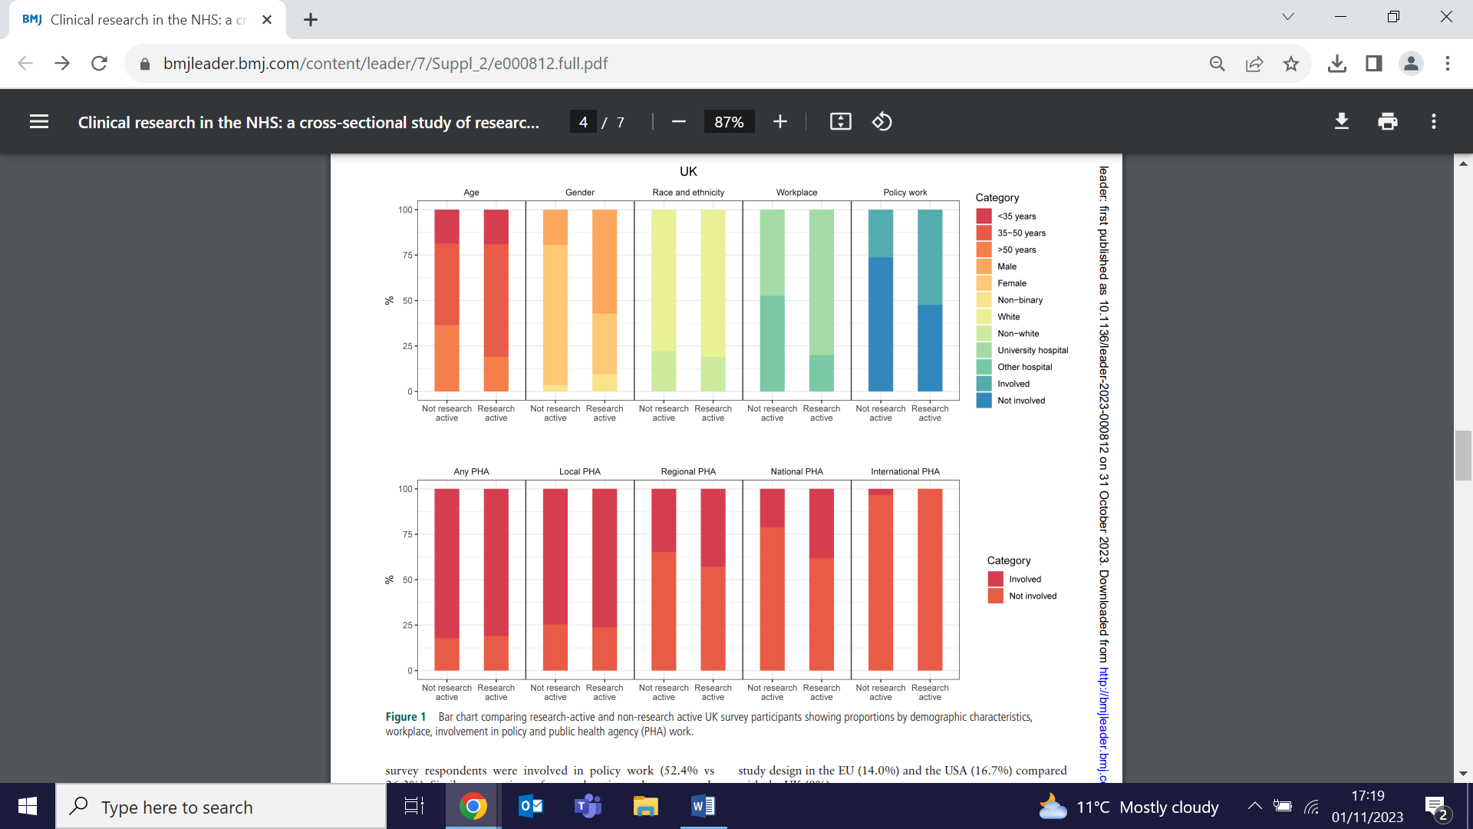
HTA Review: Exercise therapy for tendinopathy
31 October (Victoria Tzortziou Brown. Centre for Primary Care)

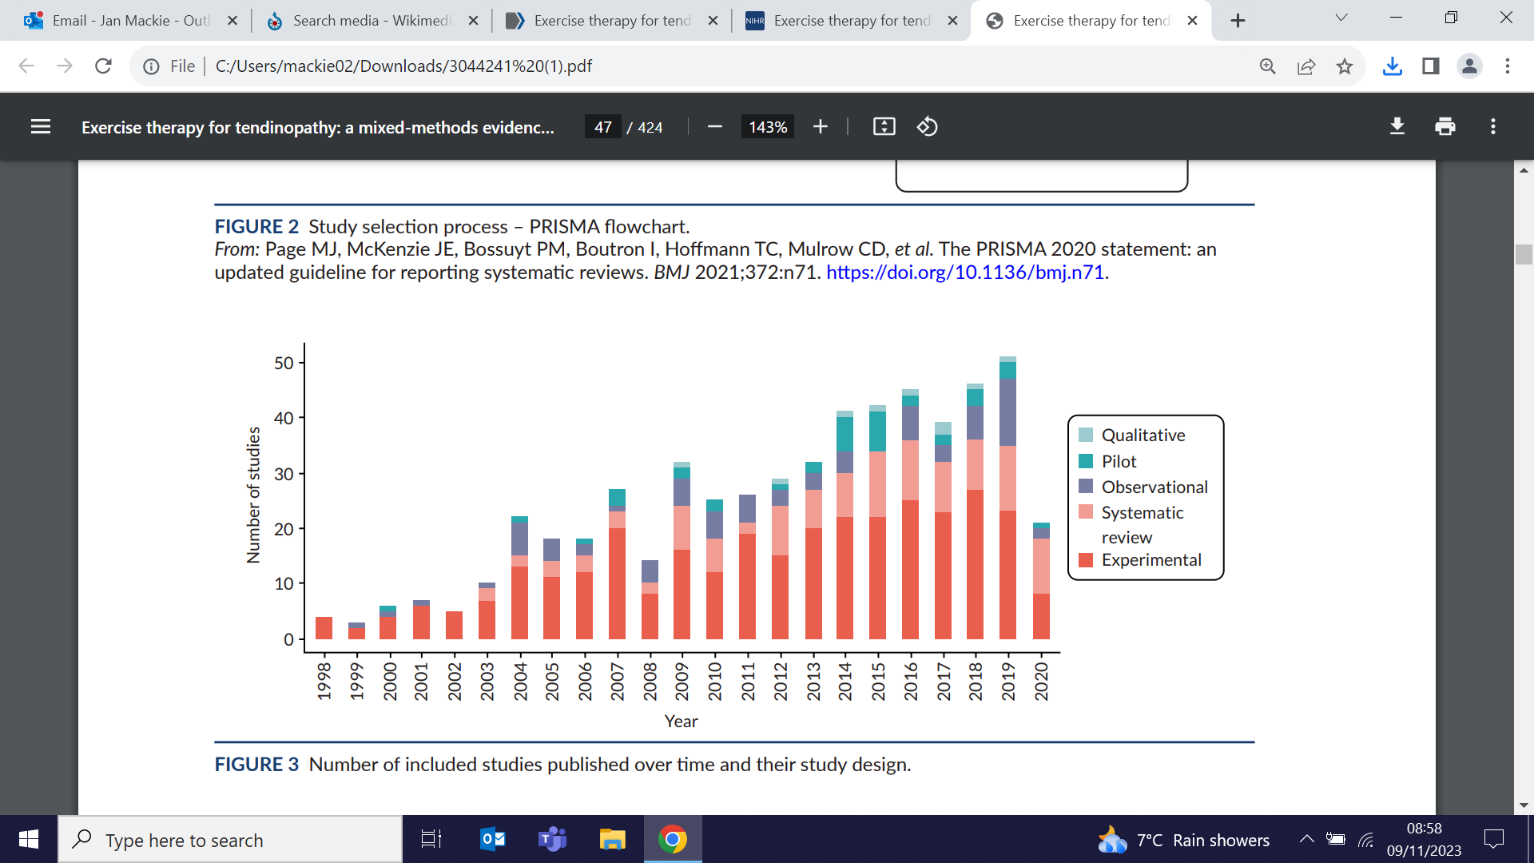  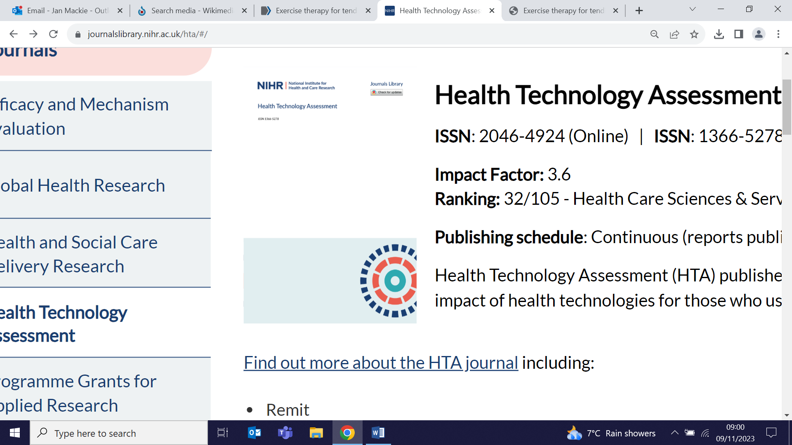 | An HTA review investigating interventions for tendinopathy finds that, despite a large body of literature on exercise for tendinopathy, methodological and reporting limitations influence the recommendations that could be made. The review findings provide some support for the use of exercise combined with another conservative modality, flexibility and proprioception exercise for the shoulder, and a combination of eccentric and concentric strengthening exercise across tendinopathies, but authors note that these must be interpreted within the context of the quality of the available evidence. They conclude that there is an urgent need for high-quality efficacy, effectiveness, cost-effectiveness and qualitative research that is adequately reported, using common terminology, definitions and outcomes.
East London Foundation Trust Research and Innovation Conference
1 November (Aisling Murray, Nicki Power, Kelly Wintsch, Natalia Chemas, Ben Wong, Afia Ali, Frank Rohricht. Centre for Psychiatry and Mental Health)

The Centre for Psychiatry and Mental Health was ably represented at the East London Foundation Trust Research and Innovation Conference, held at the QM Innovation Centre in Whitechapel on 1 November. Showcased work from the Youth Resilience and Social and Community Psychiatry Units included Body mapping in primary schools - the DEER study (Aisling Murray), Group group arts therapy for and with people with learning disabilities (Nicki Power), the OPAL study (Kelly Wintsch), Sex life satisfaction among people with psychosis (Natalia Chemas), and The importance of continuity of care in mental health services (Ben Wong). The opening session was chaired by Afia Ali, and closing remarks were delivered by Frank Rohricht. | 
Joe Marler Show Podcast: About Germs
1 November (Jon Kennedy. Centre for Public Health and Policy)

 | Jon Kennedy continues to extend the reach of his messaging, with a whole new sector of the population entertained (and potentially terrified?) by his talk about zombie ants, extinction-threatening viruses, and the most bacteria-infested places in our houses via his recent podcast appearance on the Joe Marler Show.
British S. Asian views on taking part in genetic research to tailor medications
1 November (Mehru Raza, Genes & Health Research Team, Megan Clinch. Centres for Primary Care/Public Health and Policy)

Using focus groups drawn from participants in the Genes & Health cohort study (52% born in Bangladesh, 17% in Pakistan) researchers investigating British S. Asian ancestry community perspectives on pharmacogenomic implementation and sharing pharmacogenomic clinical data for research find that trust is the most important factor in encouraging this group to engage with genetic testing. Respondents felt that personalised prescribing with genetic information could enhance trust and contribute to people adhering to prescribed medication, and that community presence in research cohorts enhanced trust, as did education, outreach, and communication. Concerns raised about use of genetic testing included issues such as privacy, data ownership, and transparency in case of data breaches, and the possibility that use of this data could make medicines more expensive for the community. Authors say that trust drives data sharing, which would enable enhanced representation in research. | 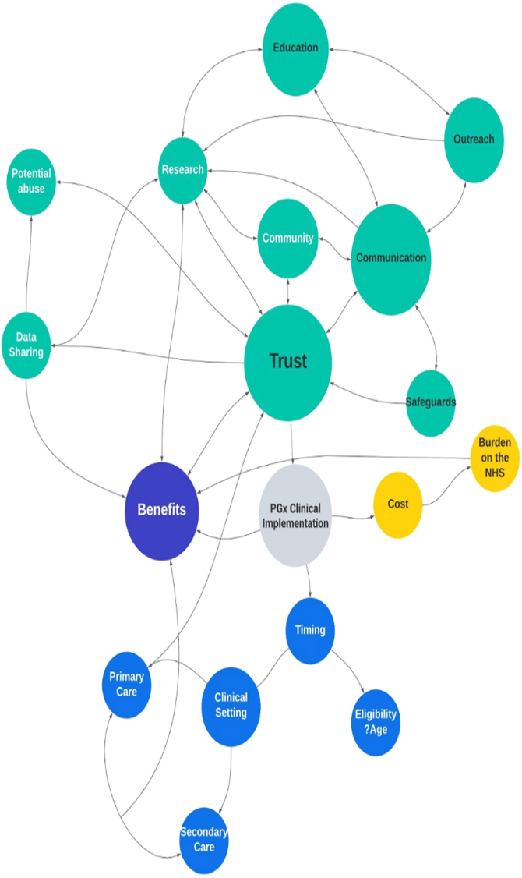
WHO European Mental Health Coalition: ‘Youth engaged for mental health’
1-2 November (Dennis Ougrin, Jennifer Lau, Mariana Steffen. Centre for Psychiatry and Mental Health)

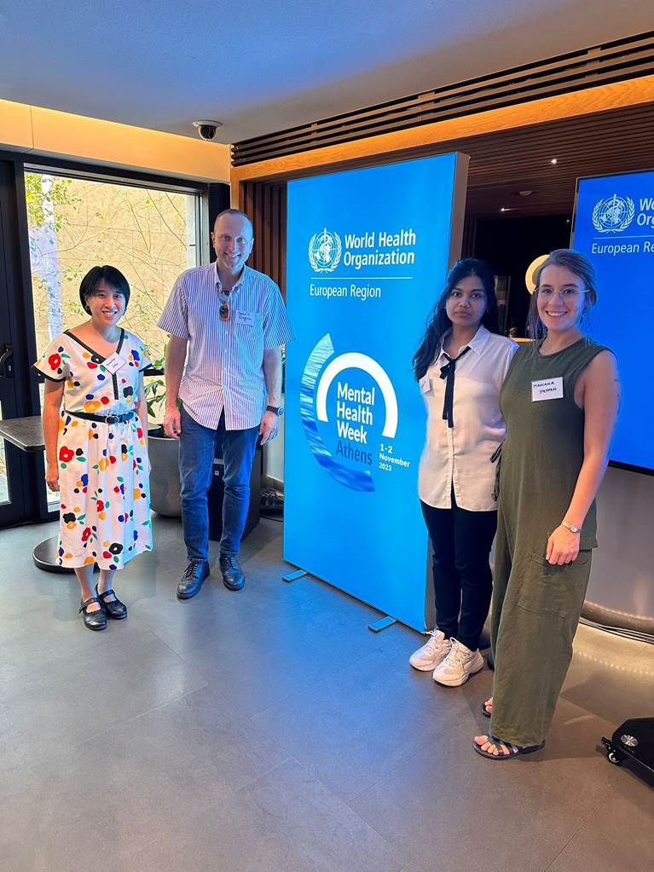 | At a meeting in Athens the World Health Organization has launched a new publication, Youth engaged for mental health: A framework for youth participation under the WHO pan-European mental health coalition. In attendance were Dennis Ougrin and Jennifer Lau, both members of the WHO pan-European mental health coalition who have been involved in the child and adolescent mental health work package for over a year as part of the WHO collaborating centre status of the WIPH Unit for Social and Community Psychiatry. PhD student Maria Steffen also joined the event, to share details of youth involvement in the project.
Vestibular disorders and psychological distress
1 November (Laura Smith. Centre for Preventive Neurology)

Results from an interview study show that vestibular disorders affect diverse aspects of patients' lives, and that daily activity limitations, social participation restrictions, and psychological distress can interact to affect quality of life, sense of self, and clinical recovery. Interviews revealed that being unable to engage in valued activities or fulfil social roles contributed to feelings of grief and frustration, affecting identity, confidence, and autonomy. Anxiety and low mood contribute to negative thought processes, avoidance, and social withdrawal, which can impede clinical recovery through reduced activity levels, and end engagement with treatment. Authors suggest that an individualised and comprehensive approach that concurrently addresses mental, physical, social, and occupational needs is likely to be beneficial. | 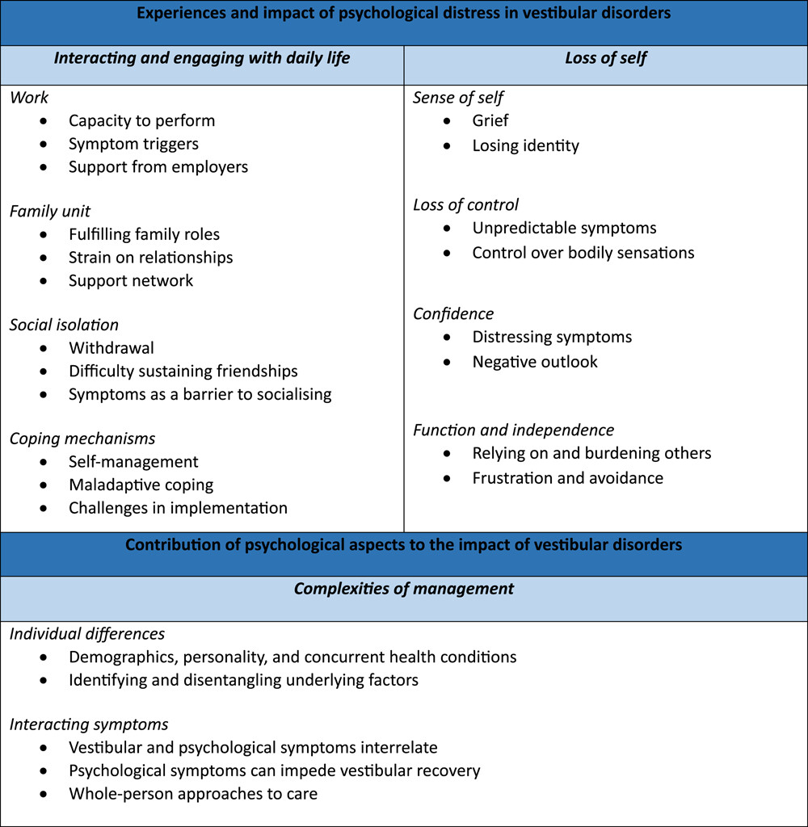
RCT protocol: Evaluating the Passport social/emotional learning intervention
2 November (Jennifer Lau. Centre for Psychiatry and Mental Health

 | An RCT to investigate the impact of the ‘Passport’ universal social and emotional learning intervention on 2400 students aged 9-11 at 60 primary schools across Greater Manchester will examine the effect on internalising symptoms, emotion regulation, well-being, loneliness, social support, bullying, academic attainment, and health-related quality of life. Schools will be allocated to the intervention arm to implement Passport over 18 weekly sessions or to the control arm to implement the usual school curriculum. The published protocol notes that, if found to be both efficacious in reducing internalising symptoms and cost-effective, Passport may offer high potential for widespread implementation as a preventive intervention.
First Population Health Data Science Research Series Seminar now online
2 November (Jianhua Wu. Centre for Primary Care)

The Population Health Data Science Research Series inaugural seminar, An AI-based algorithm to predict atrial fibrillation in general practice, presented by Jianhua Wu on 2 November, is now available online. The seminars provide an opportunity to see and share examples of research excellence in health data science from across WIPH, BCI, QMUL, Barts Health, and more widely. | 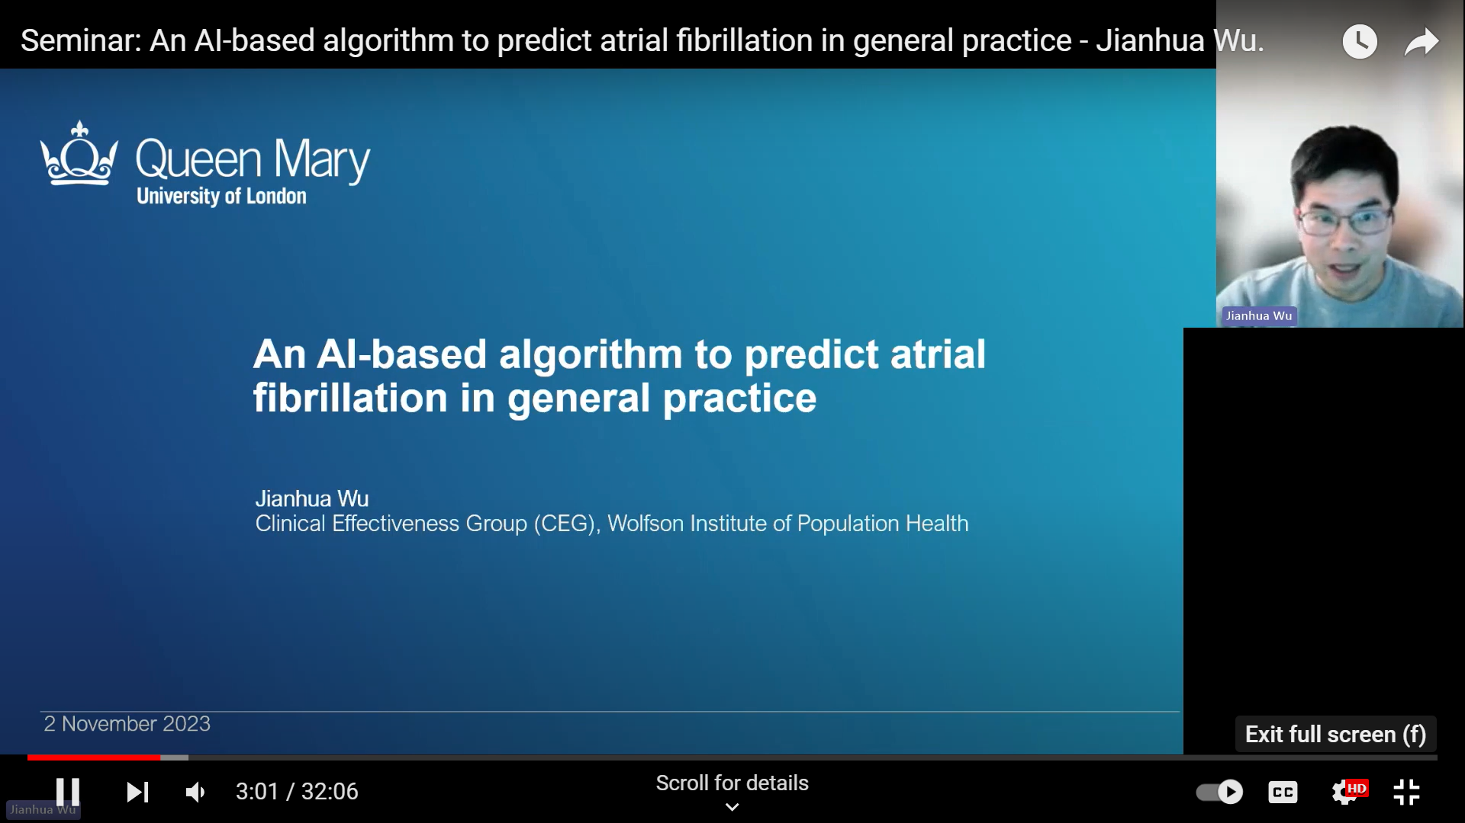
American Society of Human Genetics Conference 2023
3 November (Jeff Kim. Centre for Preventive Neurology)

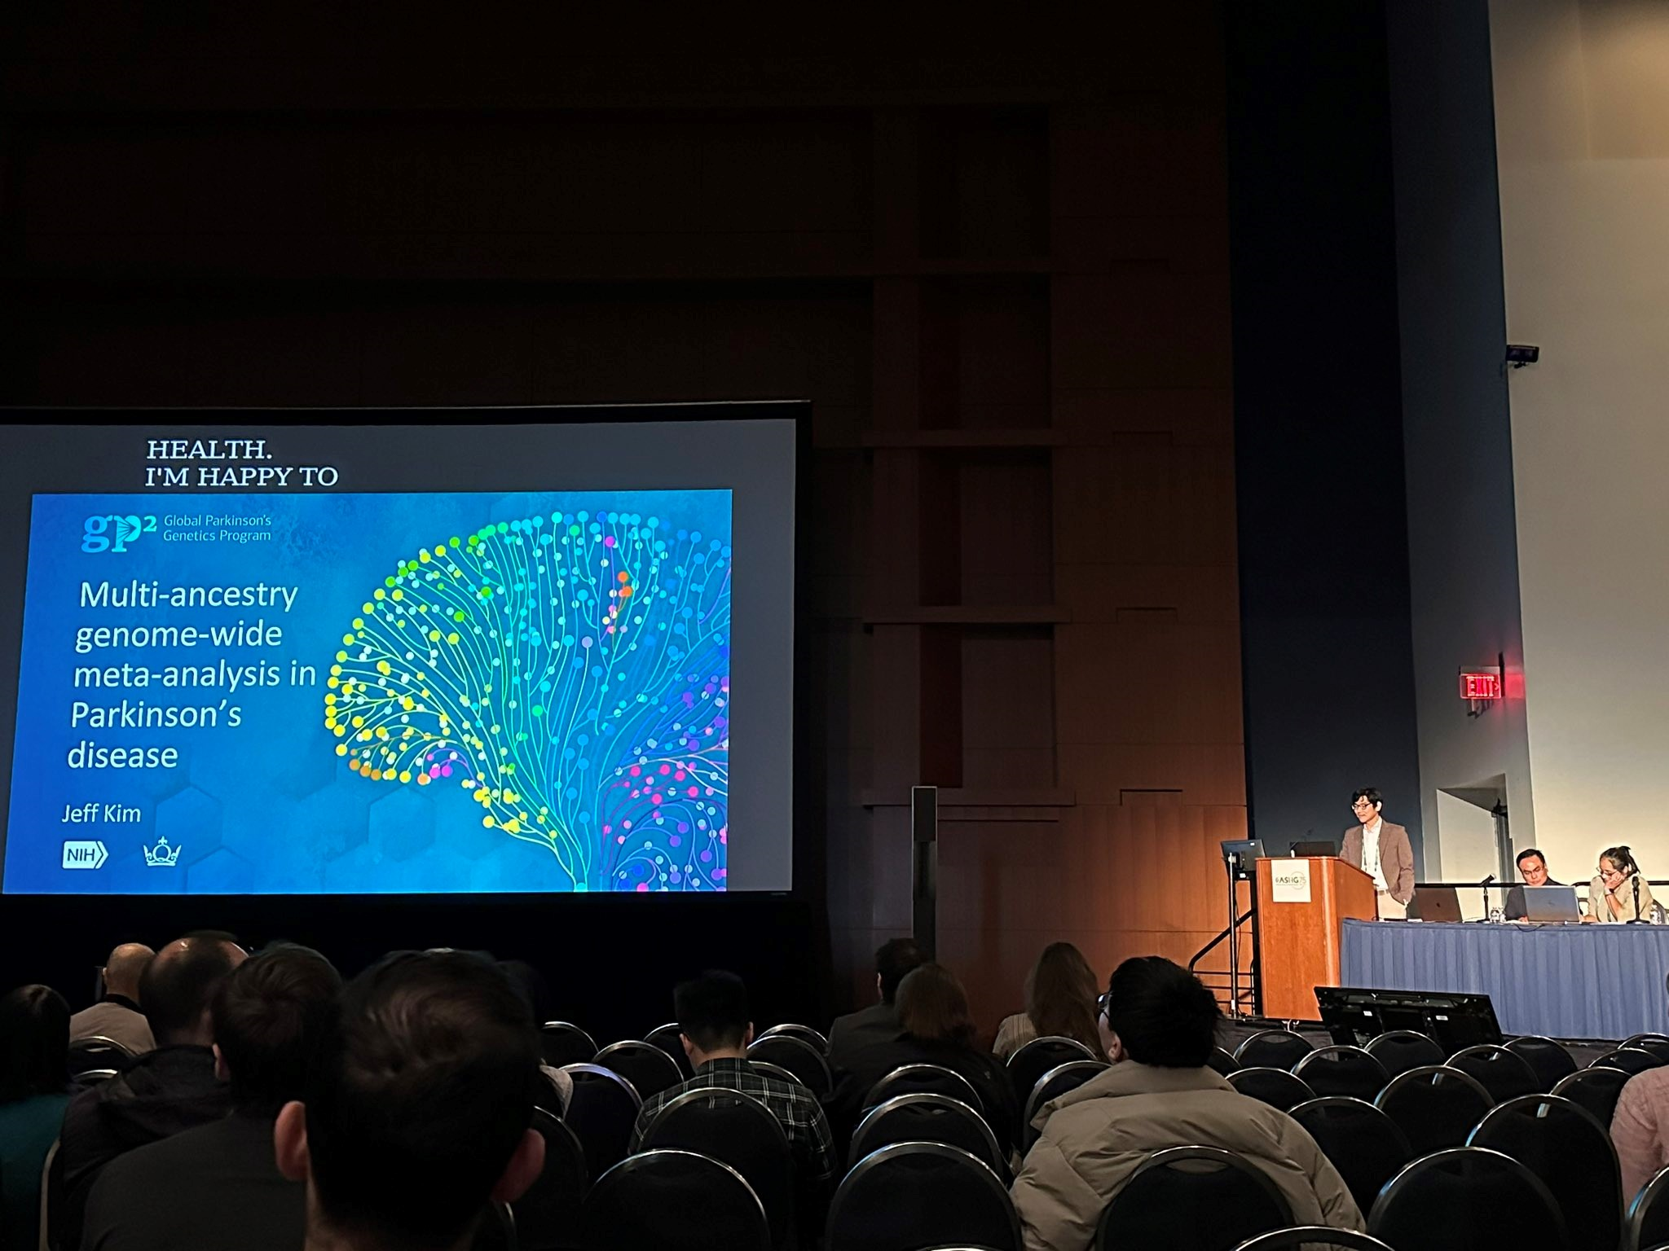 | PhD student in the Centre for Preventive Neurology, Jeff Kim, presented his work on multi-ancestry genome wide analysis in Parkinson’s disease at the American Society of Human Genetics 2023 conference in Washington DC.
GBA1 variants in people with and without Parkinson's disease
3 November (Harneek Chohan, Jon Bestwick, Al Noyce. Centre for Preventive Neurology)

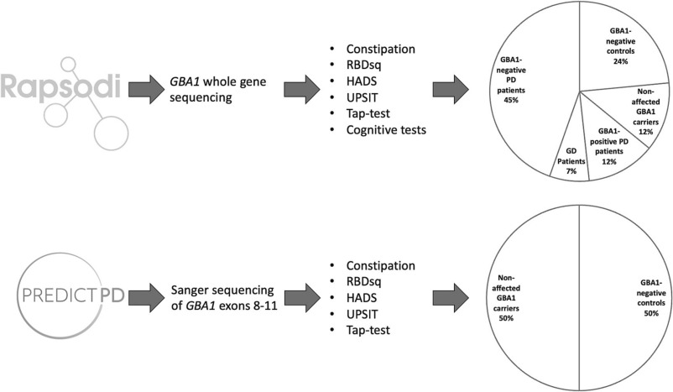 | Variants in the GBA1 gene are risk factors for Parkinson's disease (PD) and modify the expression of the PD phenotype. Using baseline assessment results from the RAPSODI study and data from the PREDICT-PD cohort, researchers comparing GBA1 carriers and non-carriers have found that GBA1-positive PD has a specific phenotype, with more severe non-motor symptoms. GBA1-positive PD patients showed worse performance in visual cognitive tasks and olfaction compared with GBA1-negative PD patients, but no differences were found between non-affected GBA1 carriers and GBA1-negative controls, and no phenotypic differences were observed between any of the non-PD groups.
Impact of London's ULEZ on children's health: the CHILL study protocol
4 November (James Scales, Rosamund Dove, Harpal Kalsi, Helen Wood, Ann Thomson, Florian Tomini, Aisling Murray, Wasim Hamad, Boby Mihaylova, Sandra Eldridge, Chris Griffiths. Centre for Primary Care/Evaluation and Methods/Psychiatry and Mental Health/Cancer Screening, Prevention and Early Diagnosis)

The published protocol for the Children’s Health in London and Luton (CHILL) study describes a prospective two arm cohort investigation that will enable robust conclusions to be drawn on the effectiveness of the London Ultra Low Emission Zone (ULEZ) in improving air quality and delivering improvements in children's respiratory health. Authors say that while low emission zones are a public health policy intervention aimed at reducing traffic-derived contributions to urban air pollution, evidence that they deliver health benefits is lacking. The study will include children aged 6-9 from schools in Central London and a comparator site in Luton, and has a primary outcome of the impact of changes in air pollutant exposures on lung function growth, measured over five years.

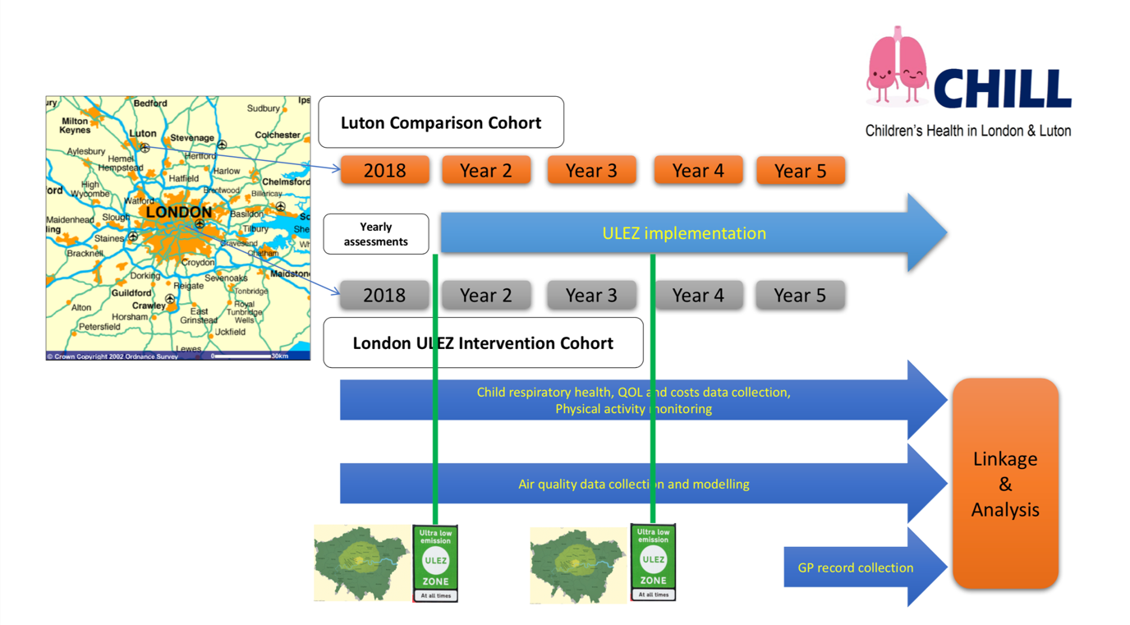
IGCS Annual Global Meeting, Seoul
5 November (Ranjit Manchanda. Centre for Cancer Screening, Prevention and Early Diagnosis)

Ranjit Manchanda has chaired and presented at the 2023 International Gynecologic Cancer Society Annual Global Meeting in Seoul. Ranjit co-chaired the session ‘Real world data in gynecologic cancer - Genetics in Gynaecologic Oncology: An update’, in which he also spoke on ‘Scaling up implementation of genetic testing strategies at cancer diagnosis’. | 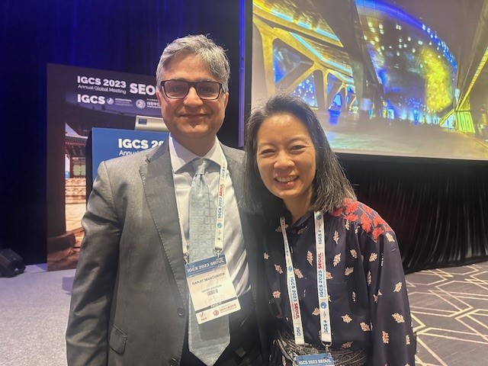
Voice of Nursing Podcast
6 November (Katila George. Centre for Preventive Neurology)

 | The Voice of Nursing podcast has featured Katila George as its 66th episode. Katila speaks about her remarkable journey from Angola to Portugal and then to the heart of critical care in the UK. Voice of Nursing describe Katila’s career path as a source of inspiration for nurses and aspiring healthcare professionals alike.
Epigenome-wide methylation and progression to CIN2+
6 November (Belinda Nedjai, Makis Ladoukakis. Centre for Cancer Screening, Prevention and Early Diagnosis)

An epigenome-wide association study of CpG methylation and progression to high-grade cervical intraepithelial neoplasia (CIN2 +) following an abnormal screening test has detected associations between CADM1-, DAPK1-, PAX1-, and RARB-related CpGs and cervical disease progression, and identified 336 novel progression-associated CpGs. The study assessed continuous CpG M values for 9 cervical cancer-associated genes and time-to-progression to CIN2+ in a prospective US cohort of 289 colposcopy patients with normal or CIN1 enrolment histology, followed for up to 5 years. Greater methylation levels were associated with a shorter time-to-CIN2+ for CADM1 cg03505501 and RARB Cluster 1, with evidence of similar trends for DAPK1 cg14286732, PAX1 cg07213060, and PAX1 Cluster 1. Researchers say that methylation levels at novel CpG sites may help identify individuals with ≤CIN1 histology at higher risk of progression to CIN2+ and inform risk-based cervical cancer screening guidelines. | 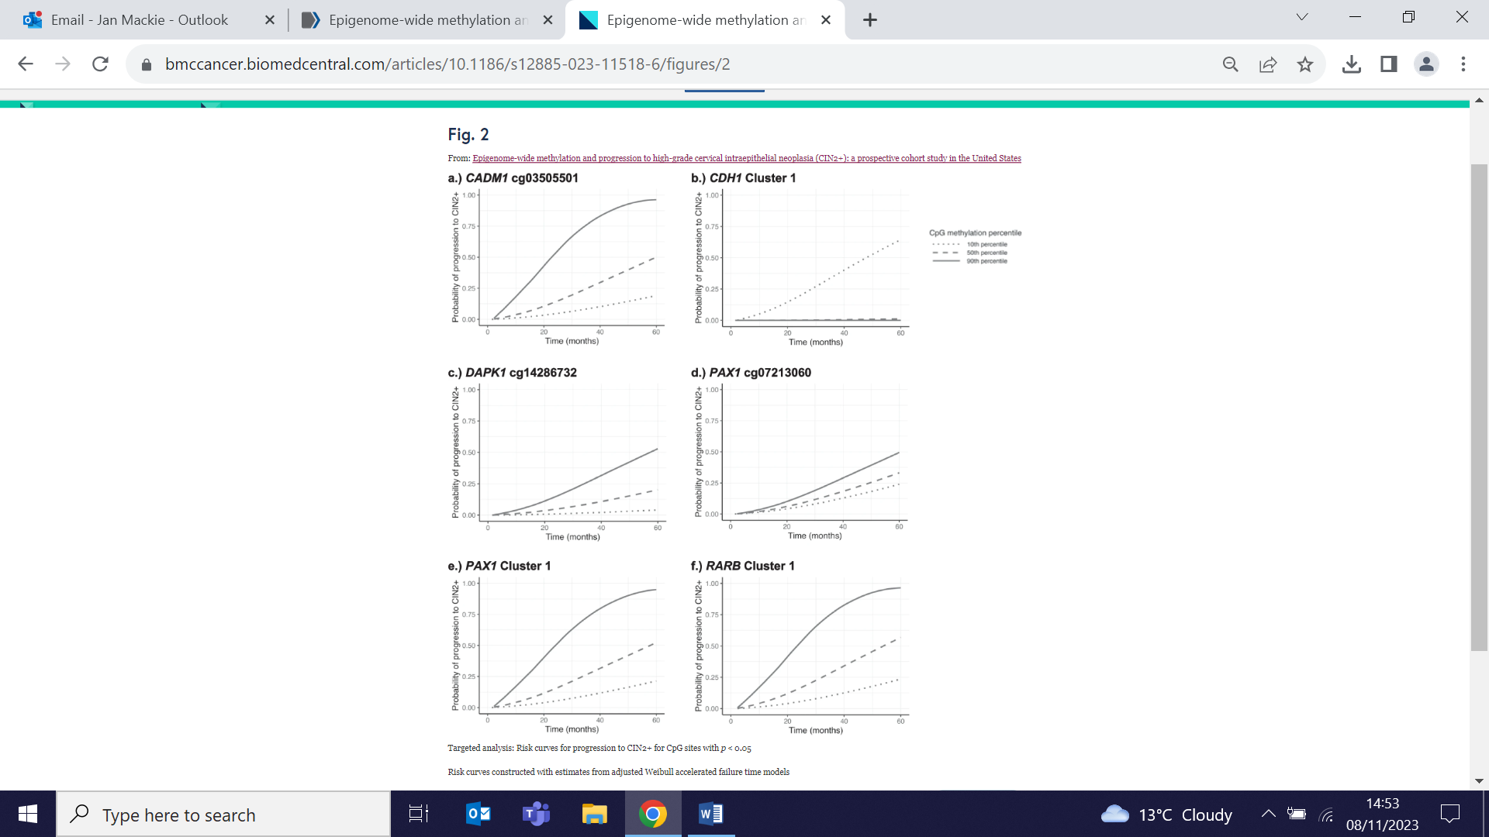
APOLLO Social Science Podcast
6 November (Lucy Hogger, Stephen Hibbs. Centre for Primary Care)

 | In this month’s APOLLO Social Science podcast, Lucie Hogger interviews Stephen Hibbs about three ideas that have influenced his trajectory as a clinician and researcher. He talks about Narrative Medicine and The Wounded Storyteller by Arthur Frank, the Righteous Dopefiend ethnography, and reflects on his experiences of co-production in research.
WIPH Research leads to approval of Anastrozole for breast cancer prevention
7 November (Jack Cuzick, Centre for Cancer Screening, Prevention, and Early Diagnosis)

Based on results from the IBIS-II study, led by Jack Cuzick, Anastrozole has been authorised by the MHRA for breast cancer preventive use. The approval means that around 289,000 postmenopausal women in England who are at moderate or high risk of breast cancer, for genetic reasons or a significant family history of the disease, could be eligible for the drug. If 25% of these women choose to take Anastrozole, around 2000 cases of breast cancer could be prevented in England, saving the NHS around £15 million in treatment costs. | 
A rights-based reform of the global food system
7 November (Lola Oyebode. Centre for Public Health and Policy)

   | Reflecting on the failure of the current global food system, Lola Oyebode calls for a comprehensive treaty to address the issue. In a commentary for Project Syndicate she notes that, with 828 million people undernourished last year and nearly 148 million children under age 5 affected by stunting, the first step must be a UN treaty to mitigate the health and environmental harms and reflect the needs and priorities of low-income countries and vulnerable groups. Lola suggests that the NOURISHING policy framework developed by the World Cancer Research Fund could offer valuable lessons, and says that with hunger now at the top of the global agenda, this is ’a golden opportunity to adopt a human rights-based approach to food and lay the groundwork for a healthier, more equitable and more sustainable future’.
Podcast: The health economics of newborn genome sequencing
7 November (James Buchanan. Centre for Evaluation and Methods)

CEM Senior Lecturer in Health Economics, James Buchanan, features as one of four panel members in a discussion on Newborn Sequencing: What Evidence Is Enough? for the Mendelspod podcast. The podcast speakers discussed developments from the International Conference on Newborn Sequencing held last month at the Royal Institution, at which James was also a panellist, presenting on the health economics of newborn sequencing. Podcast panellists provided insights into the key discussion topics at the conference, and shared their thoughts on the future of the field. |   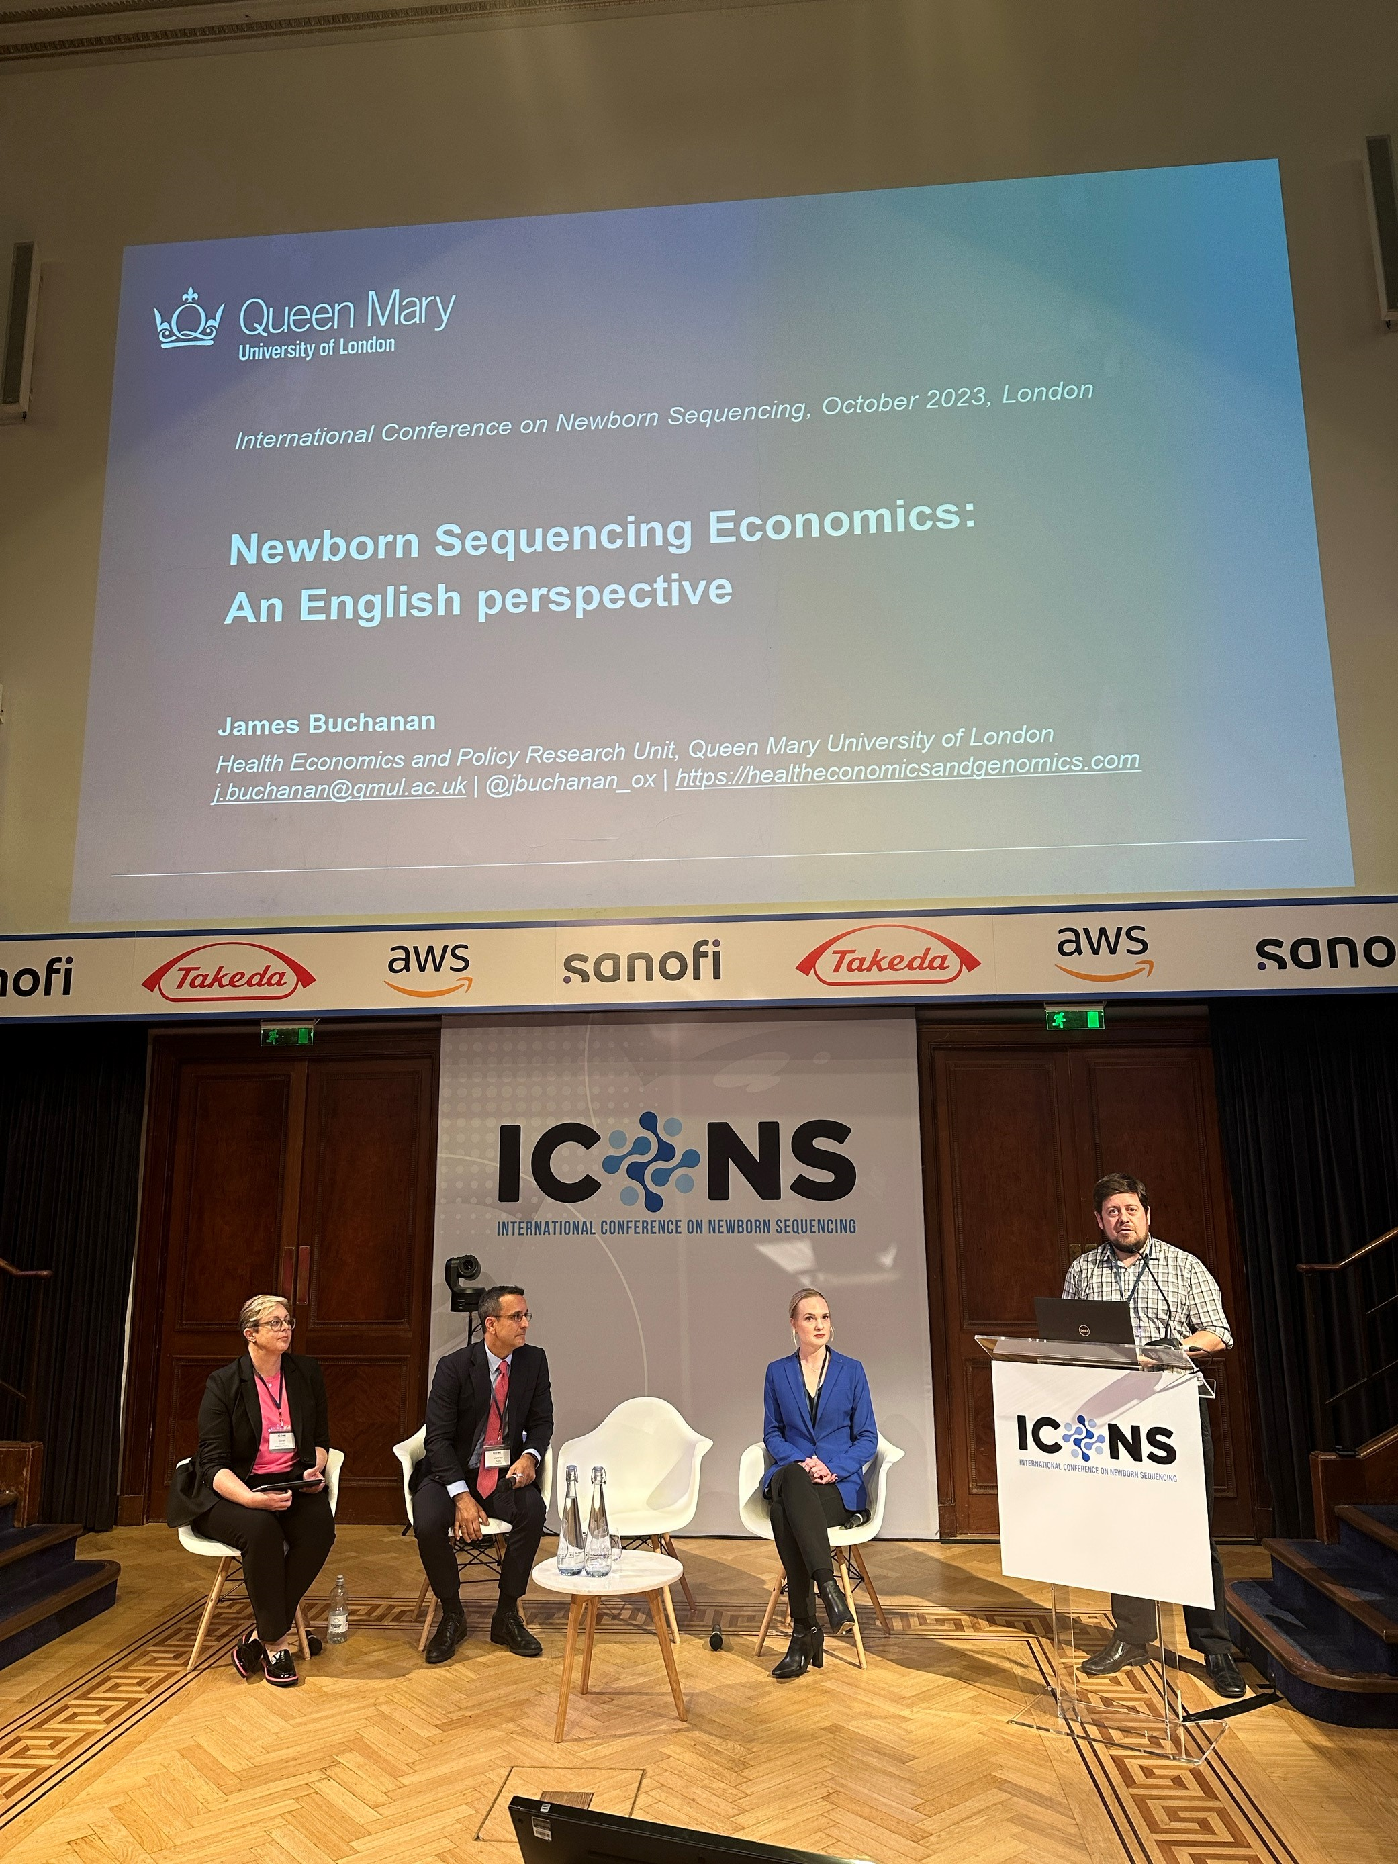
Conference audience participation and gender/ethnicity of panels
8 November (Sara Paparini. Centre for Public Health and Policy)

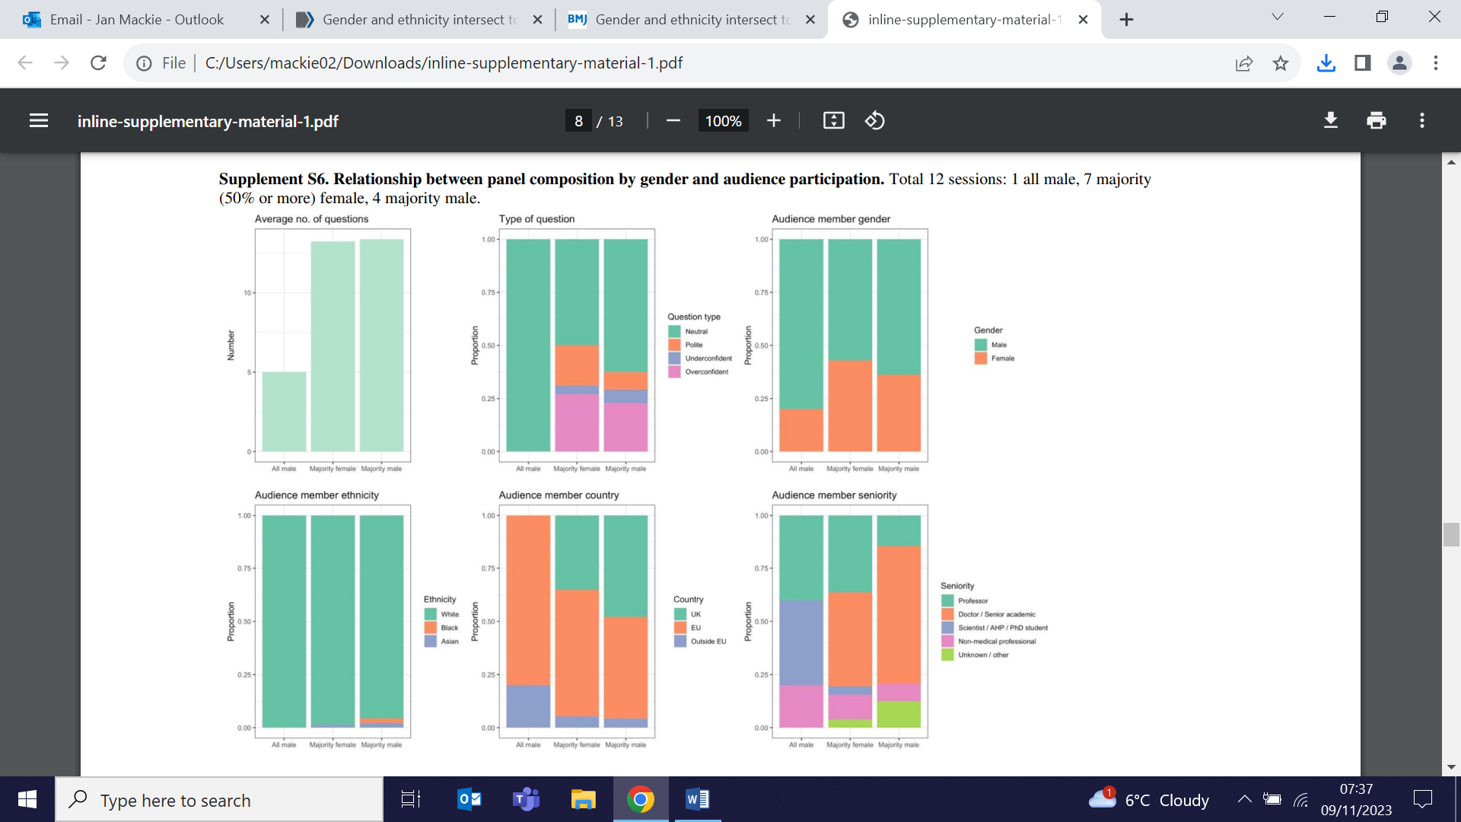 | Using data collected from the 2021 European AIDS Clinical Society Conference, researchers examining the compositions of panels (ethnicity and gender) and the number and type of questions posed (and not posed) by delegates find that >95% of questions came from people from white ethnic groups. Over 61% of questions came from men, and men were also more likely to ask multiple questions. The fewest questions were asked in the sessions with the least diverse (for ethnicity and gender) panels. Authors suggest that their results may help conference organisers improve leadership, equality, diversity and inclusion in the professional medical conference setting, which will support equitable dissemination of knowledge and improve education and engagement of delegates.
Population genomic screening for three high-risk conditions in Australia
8 November (Ranjit Manchanda. Centre for Cancer Screening, Prevention and Early Diagnosis)

A modeling study compares the impact of offering combined genomic screening for hereditary breast and ovarian cancer, Lynch syndrome, and familial hypercholesterolaemia to all 18-40 yr olds in Australia with current practice of clinical criteria-based testing for each condition separately. Genomic screening, assumed as an up-front single cost in the first annual model cycle, would detect pathogenic variants in 7 high-risk genes. Outcome measures were morbidity and mortality due to cancer (breast, ovarian, colorectal and endometrial) and coronary heart disease (CHD) over a lifetime horizon (to age 80) from 2023, based on 50% testing uptake in a population of >8.3 million. The model estimated that genomic screening would lead to 31,094 quality adjusted life years gained by preventing 2612 cancers, 542 non-fatal CHD events, and 4047 total deaths. At AU$200/test, genomic screening would require an investment of AU$832 million to screen 50% of the population. The findings suggest that the model would be cost-effective in the Australian public healthcare system, at currently realistic testing costs. | 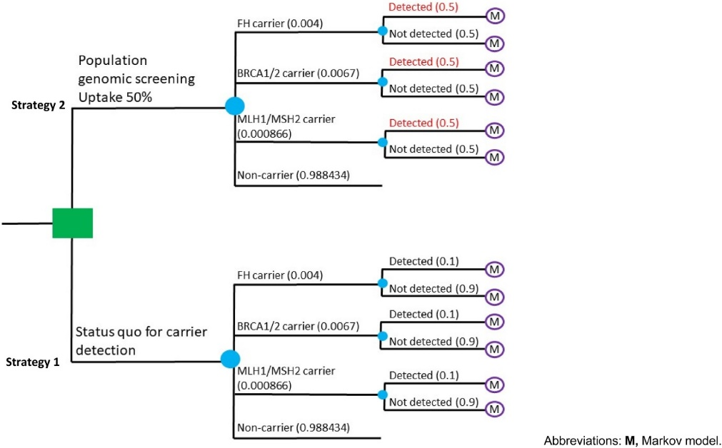
Characteristics of adolescents with persistent loneliness during COVID-19
8 November (Laura Riddlestone, Jennifer Lau. Centre for Psychiatry and Mental Health)

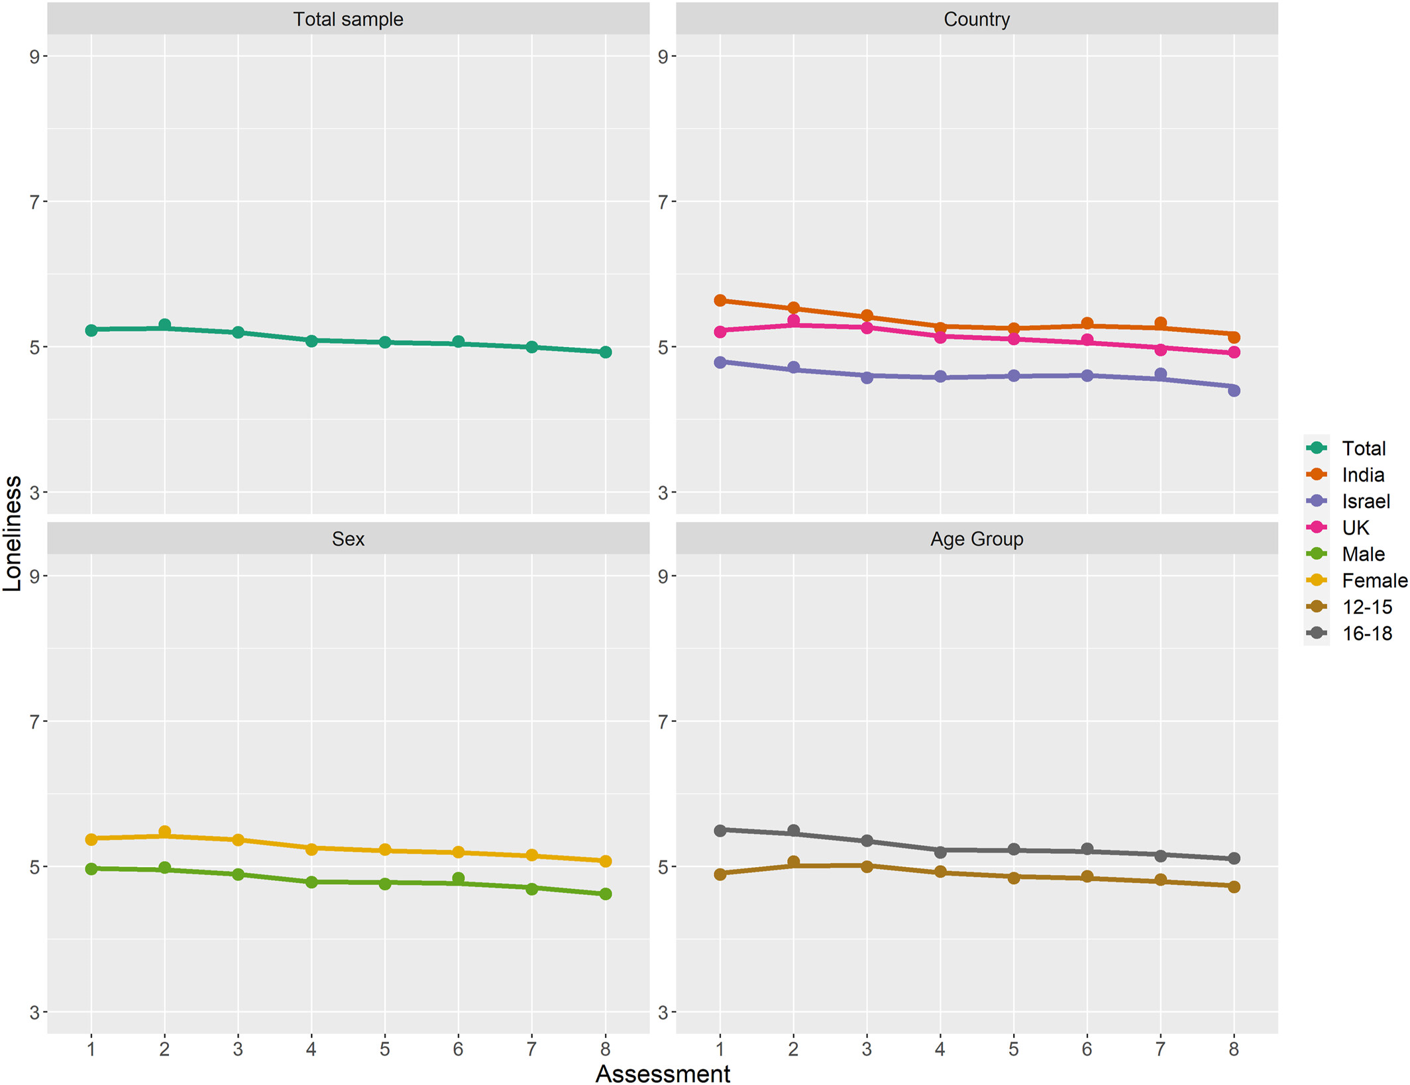 | Using data from 1039 participants aged 12-18 from three sites (UK, Israel, and India), a longitudinal study examines adolescent loneliness profiles across time, and the demographic predictors (age, sex, and country) of more severe trajectories. Participants completed loneliness measures fortnightly over 8 timepoints during the pandemic. Latent class growth analysis suggested 5 distinct trajectories: low stable (33%), low increasing (19%), moderate decreasing (17%), moderate stable (23%), and high increasing (8%). Females and older adolescents were more likely to experience persistently high loneliness. Authors conclude that there is a need for interventions to reduce loneliness in adolescents as we emerge from the pandemic, particularly for highest risk groups.
Developing high-quality evidence for Proton Beam Therapy through RCTs
8 November (Jo Haviland. Centre for Evaluation and Methods)

Three current UK multicentre phase II randomised controlled trials (RCTs) comparing proton beam therapy (PBT) with photon radiotherapy for oropharyngeal squamous cell carcinoma (TORPEdO), breast cancer (PARABLE) and oligodendroglioma (APPROACH) are cited as exemplars for the work of the UK radiotherapy research community in developing and delivering an internationally impactful PBT research portfolio. All 3 focus on the reduction of long-term radiotherapy-related toxicities and evaluate patient-reported outcomes and health-related quality of life, which will address key uncertainties regarding the clinical benefits of PBT. Researchers say the NHS strategy for delivering PBT provides a unique opportunity to deliver high-quality evidence for PBT through RCTs, and that the combination of data RCTs provide, with prospectively collected data from a national PBT outcomes registry, will create an innovative, high-quality repository for PBT research, and the platform to design and deliver future PBT trials. | 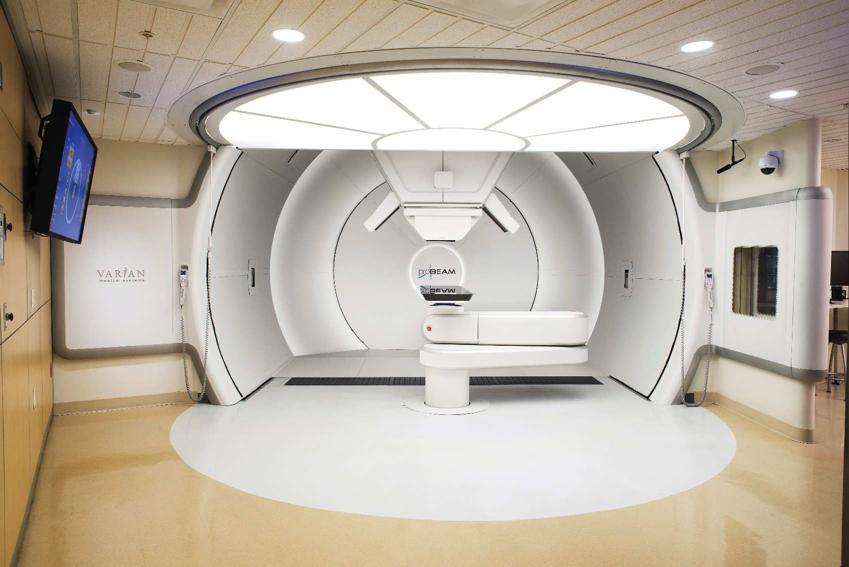
Expert Comment in The Times: Blood tests for Alzheimer’s disease
9 November (Charlie Marshall. Centre for Preventive Neurology)

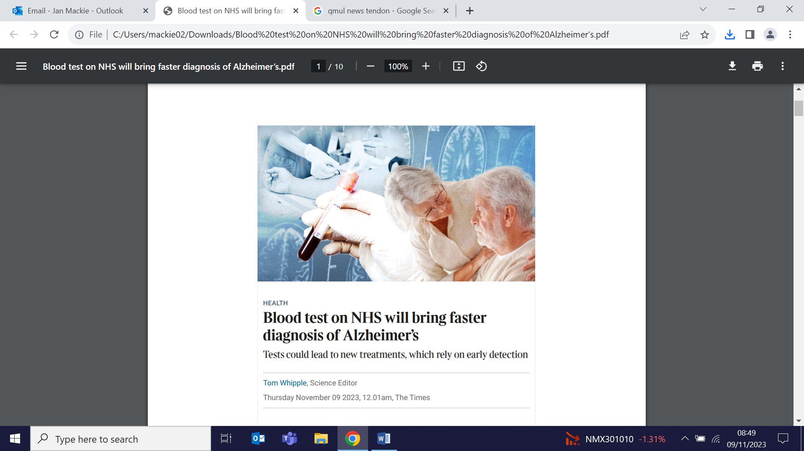 | Charlie Marshall has provided expert commentary for an article in The Times, heralding blood tests for Alzheimer’s disease that could be available on the NHS within five years, and which would lead to faster, wider diagnoses and earlier treatment. The drugs, which slow progression by around a third, are being assessed by NICE. Charlie told The Times: ‘We desperately need better ways to diagnose the diseases that cause dementia that can be used throughout the NHS’.
Costing disease states using generalized linear models
10 November (Runguo Wu, Boby Mihaylova. Centre for Evaluation and Methods)

A tutorial on estimating healthcare costs associated with disease states in decision analytic models presents a guide to how individual participant data can be used to estimate costs over discrete periods for participants with particular characteristics, based on the generalized linear model framework. Focusing on the practical aspects of cost modelling, from conceptualization of the research question to the derivation of costs for an individual in particular disease states, authors provide an example cardiovascular disease model with step-by-step R code illustrating the process of modelling hospital costs associated with disease states. | 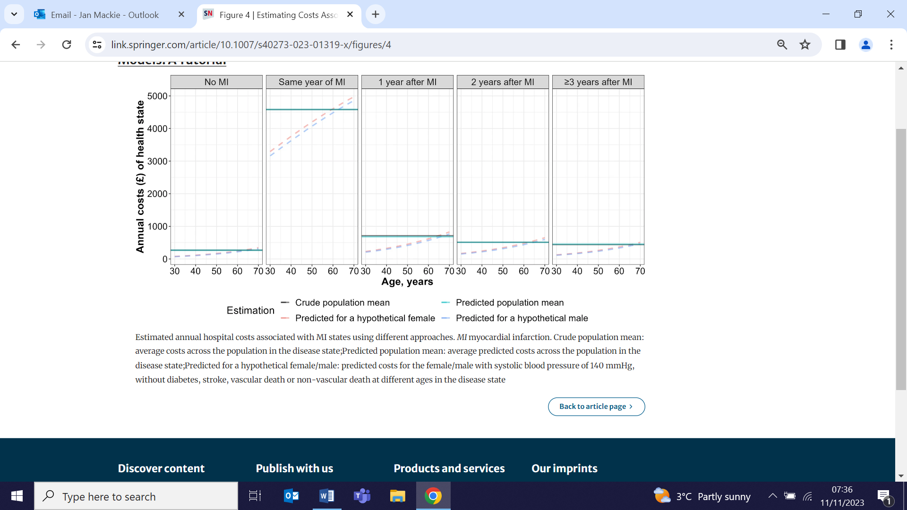
Evaluation Evolution: Principles for Meaningful and Fair Evaluation
10 November (Meg Clinch, Celeste Danielle and Sara Paparini. Centre for Public Health and Policy)

 | A QMUL-CPE funded project ‘Evaluation from the bottom up: empowering community organisations to communicate the value of their work’, engaged with >40 stakeholders from community organisations, the NHS, local authorities, and charity funding organisations in discussions from February to June 2023, to gather insights about experiences of evaluation and feed them into the development of a short evaluation course for community organisations. Stakeholders developed a shared understanding of current evaluation challenges and agreed on how fairer and more meaningful evaluation practice could be achieved in the future, producing a document: ‘Evaluation Evolution: Principles for Meaningful and Fair Evaluation’.
Quality Standards Advisory Committee for Ovarian Cancer for the NHS
13 November (Ranjit Manchanda. Centre for Cancer Screening, Prevention and Early Diagnosis)

Congratulations to Ranjit Manchanda, who has been appointed as a specialist committee member to the Quality Standards Advisory Committee for Ovarian Cancer for the National Institute for Health and Care Excellence (NICE). He will join the committee from the first 2024 meeting on 22 February. | 
Chronic crisis: multimorbidity in a socially disadvantaged London borough
13 November (Esca van Blarikom, Nina Fudge, Deborah Swinglehurst. Centre for Primary Care)

 | An ethnographic interview study among adults in an East London borough with a high income deprivation score and in which 1 in 5 residents live with long term illness explores how people with multimorbidity navigate conditions of ‘chronic crisis’, encompassing ill health, over-medicalization, polypharmacy, and social exclusion. Researchers found that participants frequently experienced ‘existential stuckness’, and suggest that priority should be given to the notion of ‘flourishing’ over cure. They advocate for a dialogical turn in diagnostic processes to enable better support for patients’ existential needs in the context of long term illnesses.
The definition of unexplained infertility
13 November (Claudia Raperport, Aparni Balaji, Priya Bhide. Centre for Public Health and Policy)

To address the lack of consensus on tests for unexplained infertility, a review paper proposes standardised criteria for use in both clinical diagnosis and future research studies. Based on data from 258 studies with defined inclusion criteria, researchers recommend that, until an international definition is agreed, semen analysis, tubal patency, ovulatory status, and uterine cavity assessment should be used. | 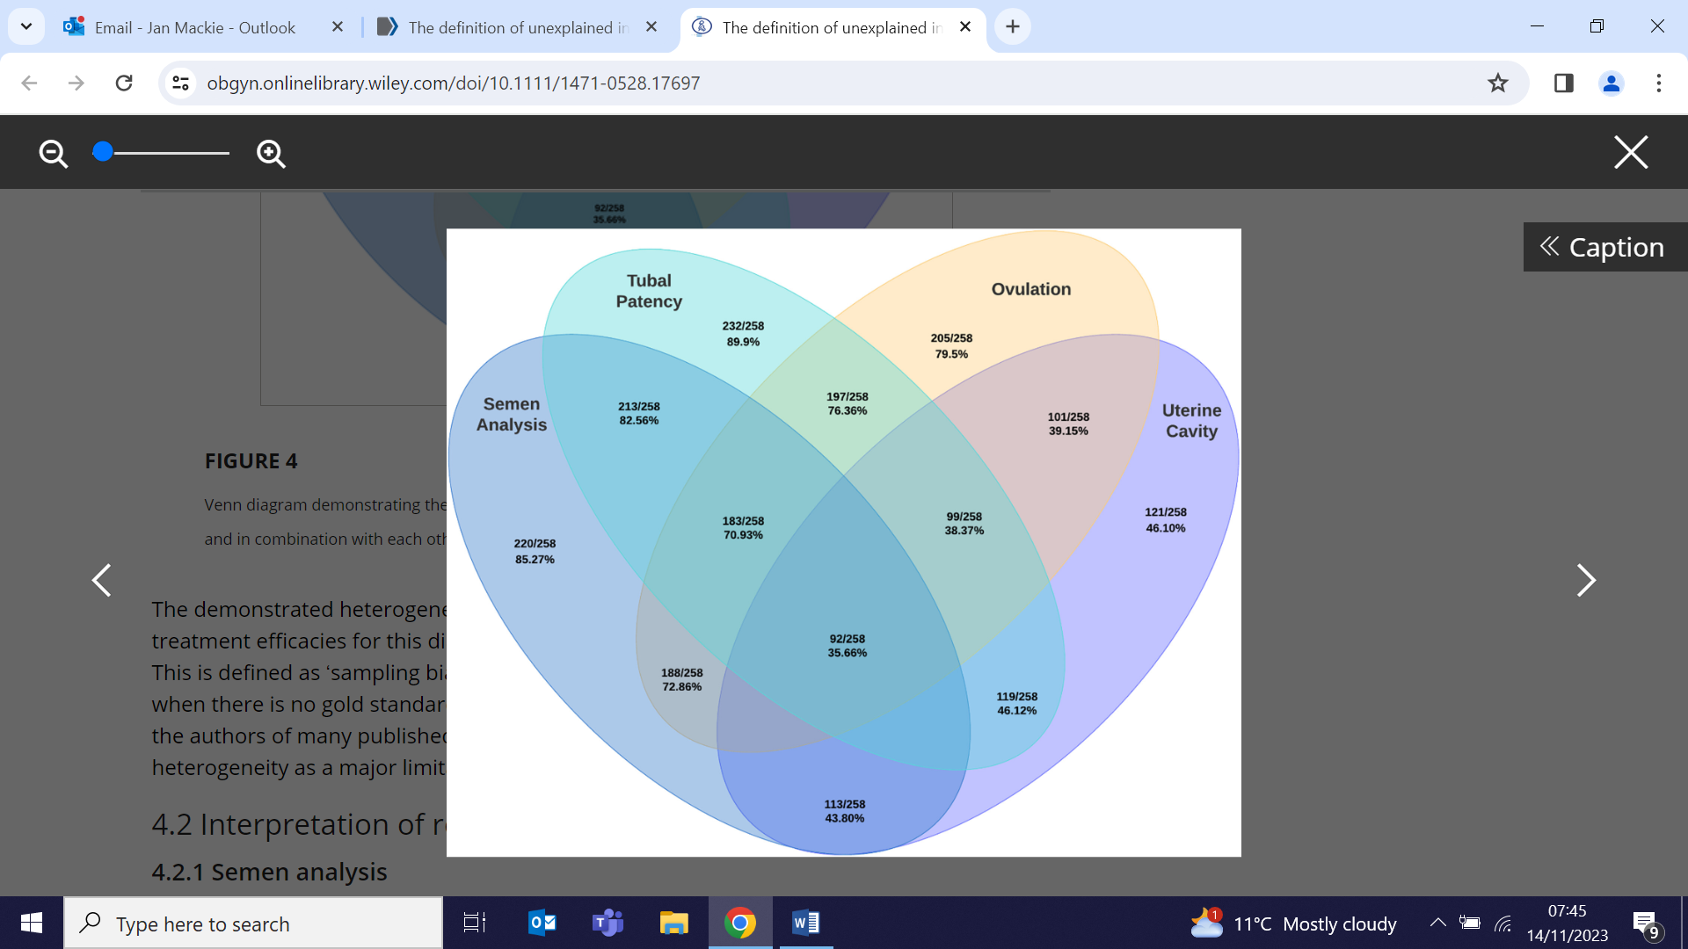
Communication of genetic risk for cardiometabolic diseases
13 November (Law JH, Sultan N, Finer S, Fudge N. Centre for Primary Care)

In the context of cardiometabolic diseases, a review study explores how the effects of genetic risk tools can be fully harnessed and questions the theoretical basis for current interventions communicating genetic risk information, that focus predominantly on the ‘self’ and targeting individual-level cognitive appraisals such as perceived risk and perceived behavioural control. Researchers developed a synthesising argument ‘beyond the ascetic subject of compliance’, addressing 3 major limitations of this perspective: difficulty applying existing theories/models to diverse populations, the role of familial variables, and the need for a life course perspective. They conclude that interventions communicating genetic risk information should consider wider influences that can affect individuals' responses to risk at different levels, including through interactions with their family systems, socio-cultural environments and wider health provision.

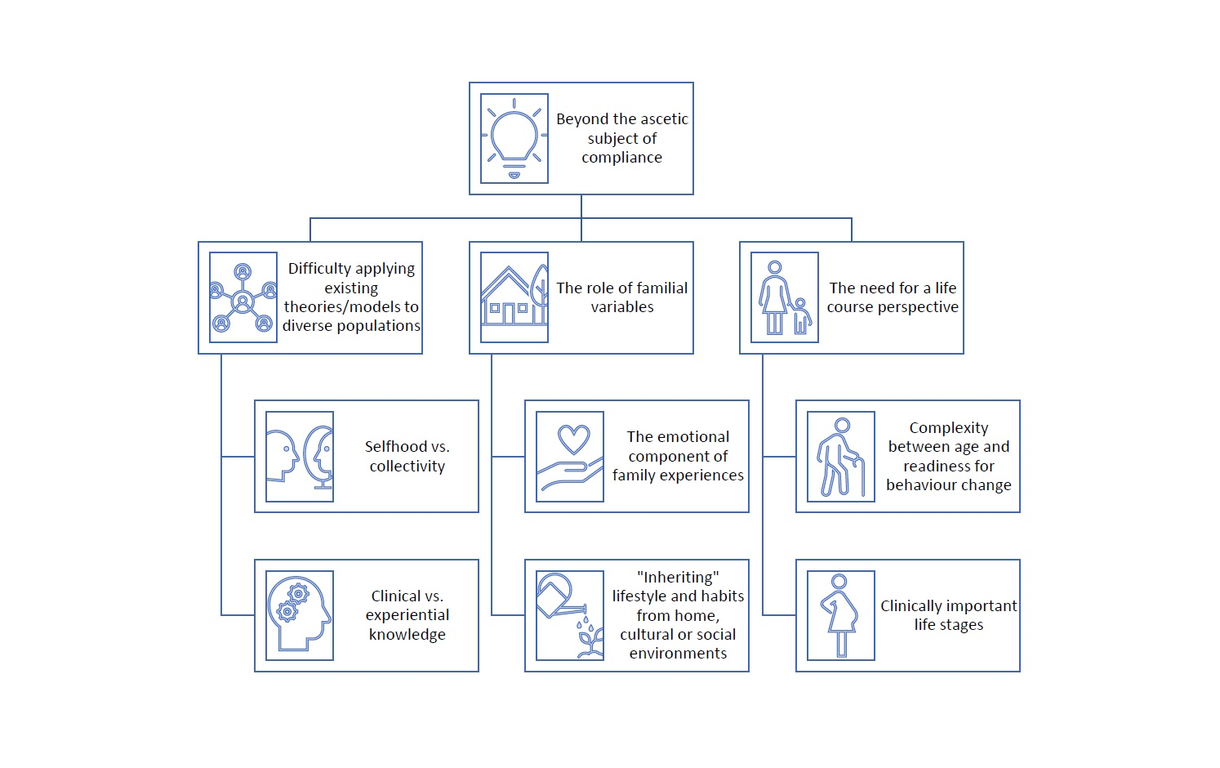

FORTHCOMING EVENTS

Webinar: Using CPRD data via Queen Mary’s Multi-Study Licence
20 November 10am (Clinical Effectiveness Group, Centre for Primary Care)

QM now has a Multi-Study Licence to access data from Clinical Practice Research Datalink (CPRD), a longitudinal dataset from primary care health records of 60 million patients representative of the UK population. The data can be linked to a range of other health-related data. The QM licence, which enables staff and PhD students to access the data for approved studies at a reduced cost, is funded by Barts Charity until 2027 as part of the Precision Health: Population Health Data Science research programme, jointly led by the CEG and the BCI. For information about fees and a step-by-step guide to accessing CPRD data via the licence, contact the team. More information is also available on the CEG website. Click here to join the meeting on Teams on Monday 20 November to hear from colleagues who are already using CPRD data, and to find out more about the Licence. | 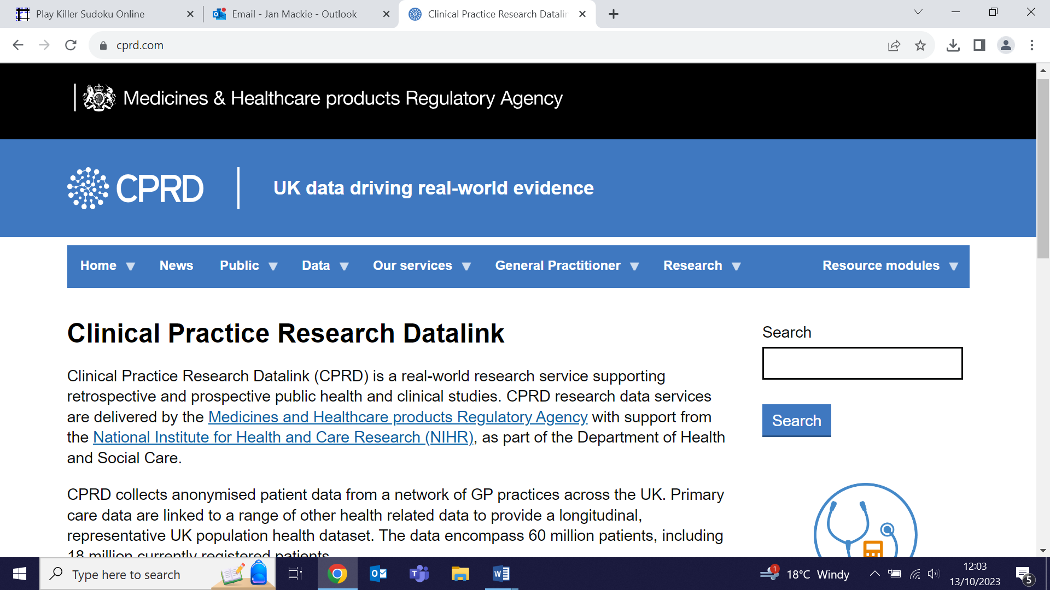
Many thanks to all who so enthusiastically contribute. Please send any news items for the next newsletter to j.a.mackie@qmul.ac.uk

