WOLFSON INSTITUTE OF POPULATION HEALTH
NEWSLETTER
ISSUE 16: 8 JULY 2022

In this issue of our Wolfson Institute of Population Health Newsletter, we celebrate the achievements and work of staff and students through the second half of June and the first week of July.

FROM OUR DIRECTOR
Dear Colleagues

This week I attended the Class of 2022 QMUL Malta Campus MBBS Graduation Ceremony, along with VP Health Prof Sir Mark Caulfield, BLSU President Rob Tucker, and other Malta and QMUL colleagues (see image below). The ceremony was held in the wonderful Cathedral of the Assumption (Citadel) in Victoria, Gozo. Maltese support for this enormously successful venture was evidenced by the strong government presence at the graduation, including the Minister for Health, Prime Minister, and President of Malta (a wise GP who had practiced for 47 years), who are seated directly in front of me in the second image. This inaugural graduation is a testimony to the success of this enterprising QMUL venture into expanding international medical education.

 | 
I should take this opportunity to encourage you all to attend our WIPH Showcase event, which promises to be a wonderful celebration of all of our achievements during our first year as the new Institute. The showcase will be held next Tuesday, 12 July, from 1pm-4:15pm in the Willoughby Lecture Theatre, Sir John Vane Building, Charterhouse Square. The showcase will be followed by a reception and BBQ on the lawns.

Very best wishes

Fiona

FROM OUR LEADERSHIP TEAMS AND REPRESENTATIVES

MEGAN CLINCH – THEME LEAD, PUBLIC ADVISORY PANEL

A huge thank you to Juliet Henderson, who has been working on setting up a mailing list so we can approach local people and community organisations to get involved in research, education and engagement activity. It is far from a straightforward task that has required a lot of careful work. Further details to follow in the next month, but all staff will be able to use this mailing list to publicise an array of opportunities. Please also watch for details on our Public Advisory Panel audit, through which we hope to get a sense of the many civically-engaged research, education and other activities already undertaken by the WIPH. This will help us to understand how we can support, build on, and learn from this pre-existing work in the development of the Public Advisory Panel theme.

GENERAL INSTITUTE NEWS

Mad Hearts 2022 10 and 11 June (Maria Turri. Centre for Psychiatry and Mental Health)

Mad Hearts 2022, the annual conference on the multiple intersections between the arts and mental health took place on 10 and 11 June, with more than 50 participants attending on both days, including academics, artists, clinicians, students, and people with lived experience of the mental health services. Organized by the MSc Creative Arts and Mental Health team, the 2022 theme was Masked/ Unmasked, which gave rise to lectures, interviews, conversations and performances related to Covid, identity, autism and a rich range of related subjects. MSc students collaborated in performing their theatre practice-based work and co-chairing panel discussions. One student was a speaker on our panel on Masking and Masculinity, and two contributed to Maria Turri's keynote 'Sketch for a Manifesto for the Arts and Mental Health'. Feedback was enthusiastic, including a note from one participant: “I had never thought about masking like this, especially as a social concern and as a mechanism which should be addressed for so many different reasons.” | 

The shared genetic architecture of modifiable risk for Alzheimer's disease
11 June (Isabelle Foote, Ben Jacobs, Georgina Mathlin, Cameron Watson, Phazha Bothongo, Sheena Walters, Ruth Dobson, Alastair Noyce, Kam Bhui, Ania Korszun, Charles Marshall. Centres for Psychiatry and Mental Health/Prevention, Detection and Diagnosis)

 |  | Targeting modifiable risk factors may help prevent Alzheimer’s disease, but the pathways by which these factors influence risk of Alzheimer’s have been incompletely understood. To investigate this, researchers identified genome-wide association studies for Alzheimer’s disease and its major modifiable risk factors, calculated the genetic correlation among these traits, and applied genomic structural equation modelling. In a paper in Neurobiology of Aging, they identify complex networks of genetic overlap among Alzheimer’s disease risk factors, but find that Alzheimer’s disease itself is largely genetically distinct. The findings suggest extensive shared genetic architecture between modifiable risk factors, but this is largely independent of Alzheimer’s disease genetic pathways. Shared genetics among risk factors may underpin multimorbidity or decreased cognitive reserve.
Socioeconomic status and dietary sodium intake in UK children
21 June (Jing Song, Graham MacGregor, Feng He. Centre for Public Health and Policy)

A study of children’s salt intake suggests that the UK salt reduction programme may help reduce health inequality, benefitting in particular the more socially deprived, who are at greater risk of high blood pressure, stroke, and heart disease. Little has been known about whether children’s salt intake has been affected by efforts to reduce population salt consumption in the UK. This paper assessed salt intake trends in 6281 UK children aged 4-18 from different socio-economic backgrounds from 2008 to 2019. Using data from the National Diet and Nutrition Survey, salt intakes in children (mean age 11) were 5.1g/day in 2008/09-2011/12, and decreased to 4.2g/day by 2016/17-2018/19. Results demonstrated socioeconomic inequalities in salt intake, with an inverse association between household occupation/income and salt intake. The greatest reduction (15%) was seen in children from families with parents in routine and manual occupations, with reductions of 9% in children from families designated as having intermediate occupations, and 12% in those with higher managerial, administrative and professional occupations. The occupational differences in salt intake became smaller over time and were no longer significant in 2016-17 to 2018–19. Authors conclude that the UK salt reduction programme could potentially help reduce health inequality related to sodium intake in children. | 
Efficacy and safety of replacement fluids in therapeutic plasma exchange
21 June (Ruchika Kohli, Peter MacCallum. Centre for Prevention, Detection and Diagnosis)

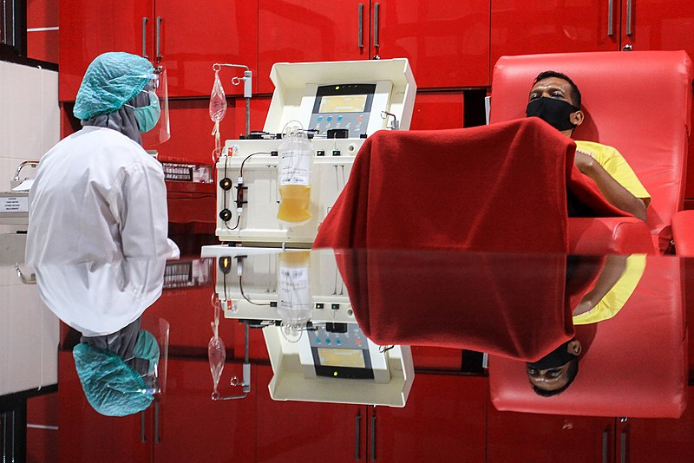 | A systematic scoping review of outcome measures in clinical studies using therapeutic plasma exchange as an intervention has found that for many conditions, disease-specific outcomes were poorly reported, and that safety outcomes were mainly related to replacement fluid type rather than being disease-specific. The review included 42 studies, 37 RCTs and 5 prospective cohort studies. Disease-specific efficacy outcomes were dependent on the clinical setting of the population receiving plasma exchange. Most of the trials were undertaken in patients with neurology conditions where clear, disease-specific, clinical outcome measures were used, including neurological disability scales, change in neurological examination, and functional improvement scores. For other conditions disease-specific outcomes were poorly reported. The most common outcome reported was hypotension, primarily in patients exchanged with albumin. The paper concludes that future clinical studies to determine which fluid replacement option is most efficacious and safe should use disease-specific outcomes, as a trial in one therapeutic area may not necessarily translate to another.
Salt: The Forgotten Foe in Public Health Policy
21 June (Hattie Burt, Mhairi Brown, Feng He, Graham MacGregor. Centre for Public Health and Policy)

The UK has lost ground in its efforts to cut salt consumption and must push industry to further reduce salt in food products and save lives, according to a BMJ analysis. The UK’s once pioneering voluntary salt reduction programme needs major changes to keep pace with other countries, 19 of which have mandatory salt reduction targets. In the early 2000s the UK implemented a voluntary salt reduction programme, managed by the Food Standards Agency, which collaborated with the food industry to gradually reduce the salt added to processed foods. Salt intake fell by 15% in the adult population, with subsequent falls in blood pressure and an estimated 9,000 deaths from stroke and heart attacks prevented per year, generating annual cost savings of £1.5 billion for the NHS. When responsibility for salt reduction moved to the Department of Health, the voluntary policy with industry stopped working. Salt intake has not fallen since that early success, and at 8.4g/day is 40% higher than the maximum recommended limit of 6g/day. Authors highlight several important measures that are now needed: mandatory salt reduction targets and supported by effective and transparent monitoring, and front of pack labels on all products to reveal high salt content. | 
Review: diagnostic procedures for isolated REM sleep behaviour disorder
24 June (Alastair Noyce. Centre for Prevention, Detection and Diagnosis)

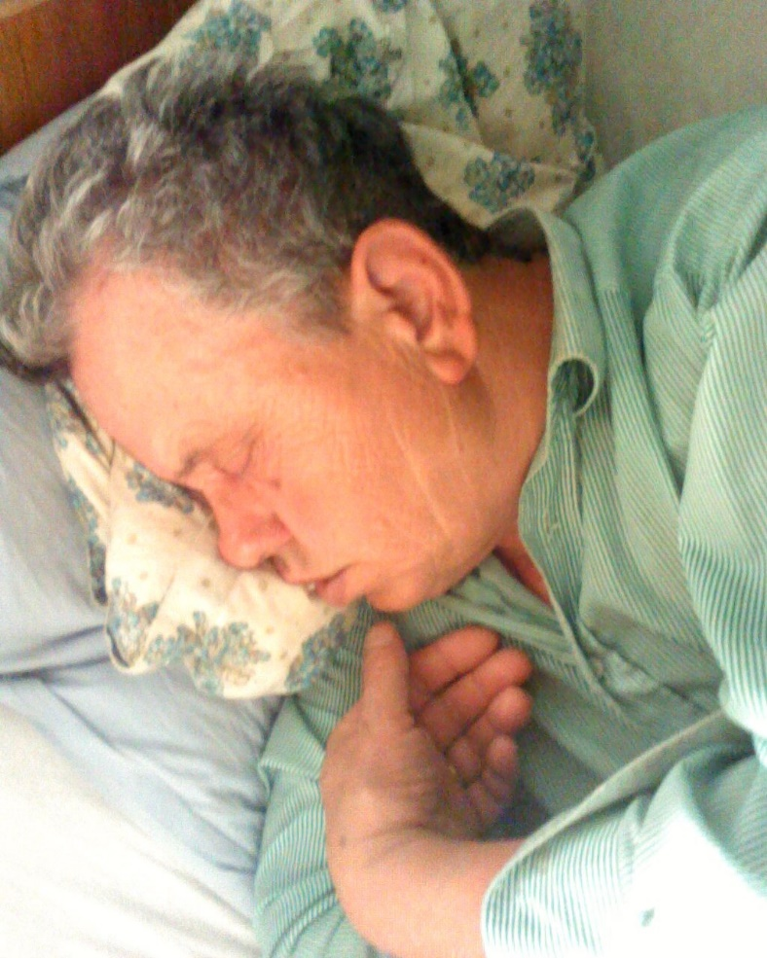 | Around 80% of people with isolated REM sleep behaviour disorder (iRBD), characterised by dream enactment behaviours, such as kicking and punching while asleep, and vivid/violent dreams, will develop dementia, with Lewy Bodies, Parkinson’s disease, or another degenerative brain disease, within 10 years. Early accurate diagnosis of iRBD is clinically challenging due to delayed referral, symptom overlap with other disorders, and uncertainty about how to confirm a diagnosis. Available methods of assessment include clinical interview, screening questionnaires, and video polysomnography or ‘sleep study’. A collaboration between the PNU and the University of Tasmania has produced a review to support clinical neurologists in assessing people presenting with symptoms suggestive of iRBD. The review describes the usefulness and limitations of diagnostic methods currently available in clinical practice, and presents recent research on the utility of new wearable technologies to assist with iRBD diagnosis, which may offer a more practical assessment method for clinicians. This work highlights the importance of thorough clinical investigation when patients present with suspected iRBD, and emphasises the need for easier access to diagnostic procedures for accurate and early diagnosis.
Methodological challenges in conducting early-stage trials
24 June (Saskia Eddy. Centre for Evaluation and Methods)

In a presentation entitled ‘Methodological challenges experienced by health researchers conducting early-stage trials’ at the annual NIHR Statistics Group conference, WIPH PhD student Saskia Eddy presented her research on the sample size of pilot trials. In 14 semi-structured interviews with health researchers, Saskia identified that health researchers tended to justify their sample size using the rationales: precision-based; approximation; rule of thumb; and "nice round number." The talk described the methodological difficulties that health researchers confront while conducting pilot trials, as well as the difficulties Saskia encountered when conducting the interviews. The primary problems health researchers faced were the amount of resources committed to pilot trials, what funders would accept as a pilot study, and the range of sample size guidance available. | 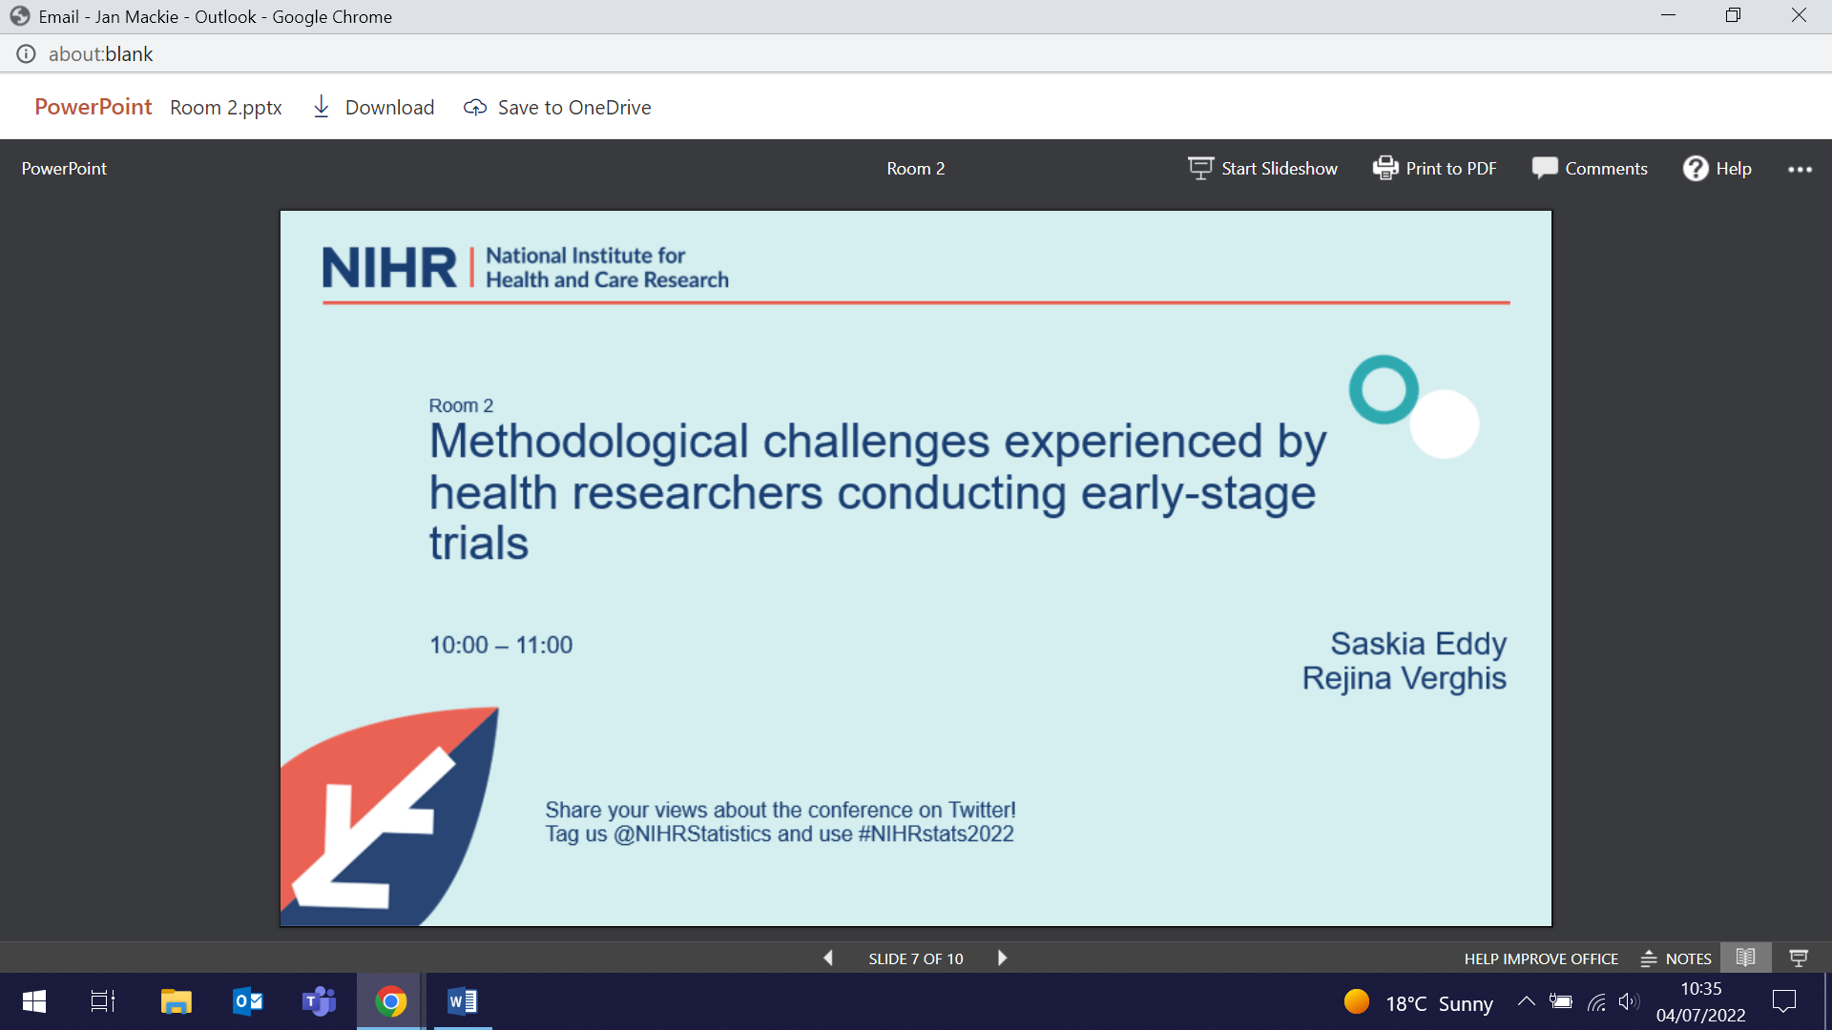

Comparing measurements of continuity of care in general practice
28 June (Sally Hull, Crystal Williams, Kambiz Boomla. Centre for Primary Care)

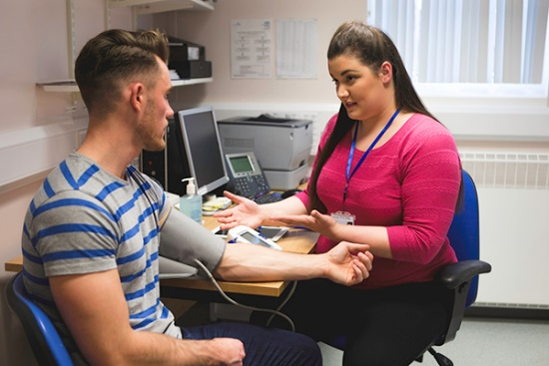 | Despite well documented clinical benefits of longitudinal doctor-patient continuity in primary care, including lower mortality, fewer hospital admissions, better care for chronic disease, and greater patient satisfaction, few practices measure continuity, and measurement is not supported by health policy. A retrospective, cross sectional study of records for 1.06 million adult patients across 126 practices in the mobile, multi-ethnic population of east London, has used the Usual Provider of Care (UPC) score to measure continuity of care, and compared these scores with annual General Practice Patient Survey responses to questions on GP continuity. The study population included patients who consulted three or more times in 2017 and 2018. Using the UPC score, researchers found a strong correlation between patient measures of continuity and practice UPC scores. The mean UPC score for all 126 practices was 0.52. Smaller practices had higher scores, and higher continuity was found for patients aged >60 and women. The authors conclude that it is possible to measure continuity across all practices in a local health economy, but that improving continuity will require incentivization, and regular measurement to support change. This paper was covered in the Guardian and Daily Mail.
STOP: An intervention to optimise smoking cessation treatment in pharmacies
28 June (Sandra Jumbe, Florian Tomini, Borislava Mihaylova, Sandra Eldridge, Centre for Evaluation and Methods. Liz Steed, Ratna Sohanpal, Steph Taylor, Chris Griffiths, Robert Walton, Centre for Primary Care)

NHS Stop Smoking Services across England and Wales help people stop smoking, and are available from a range of providers, including community pharmacies, but pharmacy quit rates, at 19%, are lower than those in other settings. An RCT conducted in 60 community pharmacies in east London, Coventry, and South Wales evaluated an intervention to improve quit rates by providing training to pharmacy staff. The Smoking Treatment Optimisation in Pharmacies (STOP) programme intervention was compared with usual practice, with a primary outcome of the number of smokers attending an initial consultation and setting a quit date. Pharmacy staff were positive about the intervention with 90% stating that it had improved their skills, however, researchers found that the intervention made no significant difference in setting a quit date, retention, or quit rate. As participants in both trial arms had acceptable quit rates, the authors conclude that funding into pharmacy-led smoking cessation should be reprioritised. | 

Detecting ovarian cancer in primary care: can we do better?
30 June (Fiona Walter. Centre for Prevention, Detection and Diagnosis)

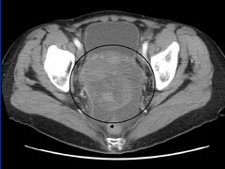 | A BJGP editorial examining the diagnostic challenges of ovarian cancer detection in primary care calls for an urgent review of national guidelines. Fewer than half of UK women with ovarian cancer are diagnosed at early stage, and 5-year net survival rate is 43%. In the absence of screening, most are diagnosed following onset of symptoms, but these are generally non-specific, posing a diagnostic challenge. In the UK, a third of women present to primary care with relevant symptoms ≥3 times before specialist referral, and a quarter wait ≥160 days to diagnosis. NICE primary care guidelines developed over a decade ago recommend CA125 testing followed by transvaginal ultrasound if CA125 is ≥35 U/ml, meaning that a significant proportion of women with levels below the cut-off are not further investigated for ovarian cancer. The authors note that recent evidence indicates that the positive predictive value of CA125 at the ≥35 U/ml cut-off is 12 times higher than the estimates used in the NICE recommendations, and suggest that a lower CA125 cut-off and less stringent criteria for 2-week wait referral may be appropriate. They conclude that while guidelines have been developed to reduce waiting times in secondary care, timely diagnosis depends on the pathway as a whole, and ensuring that the best available tests are being used in the best possible way in primary care is central to driving earlier ovarian cancer detection.
Research Fellowship awarded for Parkinson’s research
30 June (Alex Zirra. Centre for Prevention, Detection and Diagnosis)

The Medical College of St Bartholomew’s Hospital Trust has awarded a three-year Research Fellowship to Alex Zirra, to study the cognitive and neuropsychiatric features of Parkinson’s disease in a diverse population. The Fellowship will run from February 2023, and Alex will work under the supervision of Alastair Noyce and Charles Marshall in the Preventive Neurology Unit. The project will examine the inflammatory basis for cognitive impairment and neuropsychiatric features in Parkinson’s Disease, and will be conducted through the East London Parkinson’s Disease platform in order to recruit the most diverse population (in terms of ethnicity, socioeconomic status and disability) possible. Alex said: “This PhD award is my first step to becoming an academic clinician in Neurology, by undertaking a very exciting clinical project in the supportive environment of the PNU.” |     
Evaluating psychosocial vulnerability in pregnant women
30 June (Esca van Blarikom. Centre for Primary Care)

 | In an analysis of semi structured interviews with Dutch maternity providers, new work explores how care providers interpret and evaluate psychosocial vulnerability in pregnant women. Standardised screening for vulnerability requires discussion of sensitive issues, and women may have limited trust in their care providers or health system. This study found that care providers conceptualise vulnerability as primarily based on risk, which contributes to an imbalanced focus on mothers, rather than both parents and the social context. The findings highlight care providers' concerns around 'care avoidance', seen as a risk factor affecting vulnerability during pregnancy, and as a possible consequence of risk screening. Care providers interviewed employed “in between-strategies” based on intuition, emotion, and trust to address the risk that comes with risk work, in terms of its potential impact on relationships of trust and open communication. Authors conclude that vulnerability should be understood as a multi-layered, situated, relational concept rather than simply as an epidemiological category, and that policy should recognise providers' "in between-strategies" to embed epidemiological understandings of risk in the context of everyday risk work.
Spot urinary sodium to monitor relative changes in population salt intake
1 July (Monique Tan, Changqiong Wang, Jing Song, Feng He, Graham MacGregor. Centre for Public Health and Policy)

Monitoring population salt intake is essential to implement effective salt reduction measures, but most countries lack the resources to conduct 24-hour urinary sodium excretion surveys, which are the most accurate assessment method. Spot urine samples may be a simpler alternative, but formulas to estimate salt intake from the spot sodium concentration have all proven unreliable. A new study examines whether testing spot sodium concentration alone (ie. without formulas) is a feasible method to monitor relative changes in population salt intake. Comparing 24-hour and spot urine samples from adults in separate, cross-sectional, nationally representative surveys in England, repeated between 2006 and 2014, this study found that spot sodium concentrations accurately reflected relative changes in population average 24-hour urine samples, and therefore also in population salt intake. Formulas commonly used to estimate 24-hour samples were unsuitable for assessing spot urine samples. The study authors conclude that spot urine surveys could complement 24-hour urine surveys for closer monitoring and, significantly, that salt reduction efforts in resource-constrained settings need not be delayed due to lack of capacity to carry out a baseline 24-hour urine survey. | 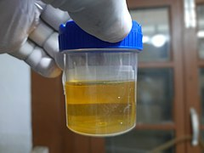

Participation in the Yorkshire Lung Screening Trial
1 July (Rhian Gabe, Centre for Evaluation and Methods. Panos Alexandris, Samantha Quaife, Centre for Prevention, Detection and Diagnosis)

   | Low dose computed tomography (CT) screening reduces lung cancer mortality, but the most effective way to optimise screening participation is unknown. Results from the Yorkshire Lung Screening Trial, an RCT of low dose CT screening conducted in Leeds, show that telephone risk assessment, followed by a community-based Lung Health Check with access to a CT scan, is an effective screening strategy, but that there appears to be lower participation among current smokers and the socio-economically deprived. Ever-smokers aged 55-80 were randomised either to invitation to telephone lung cancer risk assessment, or usual care. The invitation strategy included GP endorsement, pre-invitation, and two reminder invitations. Of 44943 subjects invited, 22815 underwent telephone triage; 7853 subjects identified as at higher risk were offered a Lung Health Check, which 6819 attended. Lower uptake rates for both the invitation to telephone triage and the Health Check were observed for current smokers and among the socio-economically deprived, and non-attendance increased with age. The response to invitation observed in this trial, considerably higher than recently reported participation rates in the US, may relate to the invitation strategies, including the use of a second reminder letter which appeared to augment response rate by 7%. Author Rhian Gabe said: “We urgently need to address participation barriers in these populations to maximise the lives saved by screening and ensure equitable access to services for those most at risk of lung cancer.”
Feasibility cluster randomised trials of interventions to improve UK pupil health
2 July (Saskia Eddy, Sandra Eldridge. Centre for Evaluation and Methods)

Cluster randomised trials (CRTs) are increasingly used to evaluate interventions to improve pupil health outcomes, and feasibility studies can identify challenges in implementing interventions and delivering trials. A systematic review of UK school-based feasibility CRTs has found that better use could be made of these trials to assess challenges specific to the cluster design. A medline search identified 24 suitable studies, of which five provided justification for using the CRT design, and three provided details of a formal sample size calculation, only one of which allowed for clustering. The most common feasibility objectives were to assess the potential effectiveness and acceptability of the intervention, and estimate recruitment/retention rates. Only one study assessed whether cluster randomisation was appropriate. None of the studies that randomised clusters before recruiting pupils assessed the possibility of recruitment bias. Apart from potential effectiveness, cost-effectiveness, and the intra-cluster correlation coefficient, no studies quantified the precision of the feasibility parameter estimates. The average sample size of included studies was large enough to estimate pupil-level feasibility parameters (eg. % followed up) with reasonable precision. The review highlights the need for clearer sample size justification and better reporting of the precision with which feasibility parameters are estimated. | 
Lifestyle outcomes after population BRCA screening among Ashkenazi Jewish people
4 July (Monika Sobocan, Ranjit Manchanda. Centre for Prevention, Detection and Diagnosis)

 | An RCT comparing population-based BRCA genetic screening with family history screening in Ashkenazi Jewish people has found that undergoing either of these testing regimes has similar lifestyle impacts. From a north London Ashkenazi Jewish population, 1034 study participants were recruited, allocated to either the population screening or family history arm. The intervention included genetic-testing for three Ashkenazi Jewish BRCA-mutations, undertaken for all participants in the population screening arm and in those fulfilling family history clinical criteria in the family history arm. Lifestyle information was collected through questionnaires at baseline, and years 1, 2, and 3. No significant difference was identified between participants in the two arms for fruit/vegetable/meat consumption, vitamin intake, alcohol quantity/frequency, smoking behaviour, physical activity, or routine breast mammogram screening behaviour. Outcomes were not affected by BRCA test result. BRCA testing was found to increase vitamin use. Cancer-risk perception decreased with time following BRCA-testing with no difference between the two screening approaches, and risk lowest in BRCA-negative participants.
Inaugural WIPH Graduate Studies Day
5 July (Patrick Mullan, Research Administrator)

The inaugural WIPH Graduate Studies Day took place on 5 July at the Willoughby Lecture Theatre in the John Vane Building. Over 40 students attended the day, and we saw fantastic presentations from 16 of them, discussing their research and the student experience so far. This event showcased the fascinating and diverse research being carried out by our students, and was a wonderful celebration of our Postgraduate Research community. The speakers were judged by a panel, and the three highest scoring speakers, Brook Huxford, Ashwin Kalra, and Eleanor Keiller were awarded prizes - congratulations to them! The day ended with a convivial BBQ on the Charterhouse Square lawn. We will have a further opportunity to hear three of the students give their presentations at the Institute Showcase event on 12 July. | 
FORTHCOMING EVENTS

12 July: Inaugural Showcase Event

Our Inaugural WIPH Showcase Event and Celebration will be held on 12 July, to mark our first year as an Institute. All staff are invited to attend. The event will be held from 1-4pm in the Willoughby Lecture Theatre, Sir John Vane building, Charterhouse Square, and will include presentations from students and staff, and a guest lecture. A reception with drinks and BBQ will follow on the Charterhouse Square lawn. Please RSVP to Vesna Florijancic. | 
21 July Webinar: Designing stepped wedge trials with continuous recruiting

Richard Hooper will present an NIH Office of Disease Prevention Mind the Gap webinar on “Designing stepped wedge trials with continuous recruitment” on 21 July, 5-6pm (UK time). He will focus on optimal solutions to three design problems for longitudinal cluster trials: (1) a parallel groups design with a prospective baseline period in both arms, (2) a stepped wedge design where each of a large number of clusters may cross over to the intervention at a different time, and (3) an incomplete stepped wedge design where he restricts recruitment to particular time intervals in particular clusters to minimize the burden of participation. NIH already include four of Richard’s articles in their Research Methods Resources on stepped wedge trials. |   
Many thanks to all who so enthusiastically contribute. Please send any news items for the next newsletter to j.a.mackie@qmul.ac.uk

